菏泽市二O二三年初中学业水平考试(中考)
英语试题
注意事项：
1.本试题分选择题和非选择题两部分。选择题，80分；非选择题，40分；共120分。考试用时120分钟。
2.请务必在答题卡规定的答题区域内作答，选择题须用2B铅笔填涂，非选择题须用0.5毫米的黑色墨水签字笔书写。
选择题(共 80分)
一、听力(共四节，满分30分)
做题时，先将答案标在试卷上。录音内容结束后，请将试卷上的答案转涂到答题卡上。
第一节(共5个小题；每小题1.5分，满分7.5分)
听下面5个句子，每个句子后有三幅图画。每个句子仅读一遍。请你从每题所给的A、B、C三个选项中选出与句子内容相符的图画，并标在试卷的相应位置。
1. A. 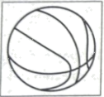 B.  C. 
2. A. 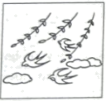 B. 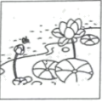 C. 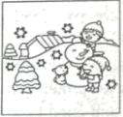
3. A. 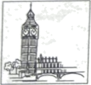 B. 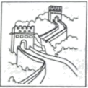 C. 
4. A. 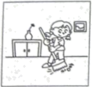 B. 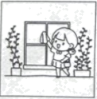 C. 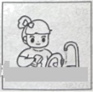
5. A. 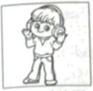 B. 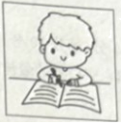 C. 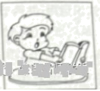
第二节(共5个小题;每小题1.5分，满分7.5分)
听下面5个句子,每个句子后有一道小题。每个句子读两遍。请你听完句子的第二遍朗读后，从每题所给的A、B、C三个选项中选出最佳答语,并标在试卷的相应位置。
6. A. Yes I can. B. They're yellow. C. No, thanks.
7. A. Next to the bank. B. About two kilometers. C. Once a week.
8. A. It's sunny. B. Let's go shopping. C.1 have a headache.
9. A On November 29,2022. B. By plane. C. In China.
10. A. It doesn't matter. B. The Monkey King. C. Enjoy yourself.
第三节(共5个小题;每小题1.5分,满分7.5分)
听下面5段对话,每段对话后有一道小题。每段对话和问题读两遍。请你听完对话和问题的第二遍朗读后，每题所给的A、B、C三个选项中选出最佳选项,并标在试卷的相应位置。
11. Who is the girl on the left?
A. Sally's mother. B. Sally. C. Sally's sister.
12. How does Tom usually get to school?
A By bus. B. By bike. C. On foot.
13. What does Li Ming advise Alice to do?
A. Talk to her parents. B. Ask the teacher for help. C. Help each other.
14. Where will they probably go tonight?
A. A city park. B. A supermarket. C. A movie theater.
15. What's the relationship between the speakers?
A. Husband and wife. B. Classmates. C. Doctor and patient.
第四节(共5个小题;每小题1.5分，满分7.5分)
听下面一段短文,短文后有五道小题。短文和问题读两遍。请你听完短文和问题的第二遍朗读后，从每题所给的A、B、C三个选项中选出最佳选项,并标在试卷的相应位置。
16. Where is Wang Yongheng from?
A Hunan Province. B. Shandong Province. C. Hubei Province.
17. Who jumped into the water to save Wang Yongheng's son?
A. A boy. B. A girl. C. Wang Yongheng.
18. Why did Wang Yongheng volunteer to join a team?
A. To look after his little son. B. To teach people how to swim.
C. To pass down the good spirits.
19. How may people has Wang Yongbeng saved over the past ten years?
A. 58. B. Less than 30. C. More than 30.
20. What do you think of Wang Yongheng?
A. Helpful. B Quiet. C. Polite.
二、英语知识运用(共两节，满分20分)
第一节 单项填空(共10小题；每小题1分，满分10分)
从A、B、C三个选项中，选出可以填入空白处的最佳选项，并在答题卡上将该项涂黑。
1. —Is this your pen?
—No, it isn’t. ________ red one is mine.
A. A B. An C. The
2. —What club do you want to join?
—I want to join a ________ club. I can sing and dance.
A. sports B. music C. chess
3. —I think Wu Jing acts ________ in the movie The Wandering Earth II.
—Me, too. He is one of my favorite Chinese actors.
A. best B. worst C. earliest
4. —Can you ________ what our life will be like in 100 years?
—Yes. Everybody can travel to the moon freely.
A. imagine B. produce C. improve
5. —Hurry up! The bus is leaving soon.
—Don’t worry. There is ________ time left.
A. no B. little C. a little
6. —Teenagers these days ________ their parents too much.
—Yes, I think they should learn to be independent.
A. depend on B. take after C. cheer up
7. —Tina, I called you just now but nobody answered.
—Oh, I ________ a shower.
A. am taking B. was taking C. has taken
8. —Where are you going this summer vacation?
—I ________ go to Zibo, but I’m not sure.
A. must B. needn’t C. might
9 —Could you please tell me ________?
—It will start at 8:00 this evening.
A. when the concert will start B. when will the concert start C. where the concert will be held
10. —Excuse me, would you mind if I sit here?
—________. Sit down, please.
A. I’m sorry B. Of course not C. Don’t say that
第二节 完形填空(共10小题；每小题1分，满分10分)
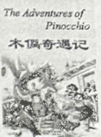
Pinocchio promises the Fairy (仙女) to be good and to study hard, because he wishes to become a real boy.
“Can I go out to give out the invitations?” Pinocchio asked the Fairy.
“Of course, but remember to ___11___ home before dark.”
“I’ll be back in one hour. I promise,” answered Pinocchio. In less than an hour, all his friends were invited except Romeo who was his best ___12___. Romeo was the laziest boy in school and the biggest trouble maker, but Pinocchio loved him the most.
Pinocchio searched everywhere and ___13___ found him hiding near a farmer’s wagon (车).
“What are you doing here?” asked Pinocchio.
“I am waiting for midnight”
“Why?”
“To go far, far away!”
“Where are you going?”
“To Toyland. It’s the most ___14___ country in the world! Come with me, Pinocchio!”
“Me? No, I can’t!”
“Believe me! You’ll be really sorry ___15___ you don’t come There are no schools in Toyland. Every day is a Saturday except for Sunday.”
“How do people ___16___ their days in Toyland?”
“Days are spent in play and enjoyment. At right one goes to bed happy and satisfied, and the next morning, the good times ___17___ all over again. What do you think of that?”
“Hmm...,” said Pinocchio, “That’s the kind of ___18___ I’ve always wanted.”
“So are you coming with me, then? Yes or no? You have to ___19___ your own decision.”
“No, no!” said Pinocchio, “I promised my kind Fairy that I would become a good boy, and I want to keep that ____20____. The sun is setting now, and I must leave you and run home, Goodbye and good luck to you!”
11. A. love B. build C. return
12. A. teacher B. friend C. student
13. A. easily B. seriously C. finally
14. A. wonderful B. delicious C. boring
15. A. although B. if C. unless
16. A. spend B. miss C. forget
17. A. begin B. finish C. fly
18. A. toy B. life C. book
19. A. see B. sell C. make
20. A. promise B. day C. diary
三、阅读理解（共两节，满分40分）
第一节（共15小题；每小题2分，满分30分）
阅读下列短文，从每题所给的A、B、C三个选项中，选出最佳选项，并在答题卡上将该项涂黑。
A
Sixteen-year-old Yang Shuncheng of China won in the Artistic Swimming World Cup in Somabay, Egypt on Saturday, May 13, 2023.  With the theme of The Cello Song by The Piano Guys, Yang challenge a difficulty sore of 27.0, higher than all other six players, and received 232.5792 points.  “I thought about the victory but did not think much. It was my first international competition and I was very nervous before the race. I was lucky to win and feel the taste of gold medals. I expect a more challenging competition tomorrow,” said Yang. | 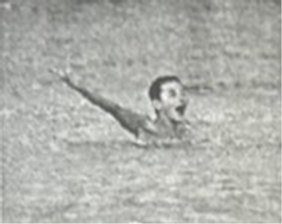
Forty kilometers norh of central Chengdu, the Sanxingdui site is rgrded as one of the most imporant dscveries of the 20th century. Visitors can see thousands of treasures dating back to the Shang Dynasty (1600—1046 BC) in Sanxingdui Museum.  This one-day Chengdu tour not only takes you to visit the lovely kingdom of giant pandas, but also the mysterious Sanxingdui illizaion. The protected pandas and Sanxingdu’s relis (遗迹) are both considered national treasures. | 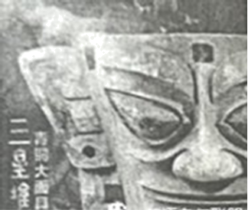
Yan Yan Gu Shi (Salt and Words Story), a new app (应用程序) for storytellers to share short stories which can be mostly finished in 10 to 20 minutes, appeared for the first time on China’s largest Q & A platform (平台) Zhihu on May 18, 2023.  An exhibition (展览), which was held in Bejing Fun in Qianmen Street between May 18 and 28, showed the painted props(道具) of some of the most popular stories on the app, providing visitors with an experience to play the roles. | 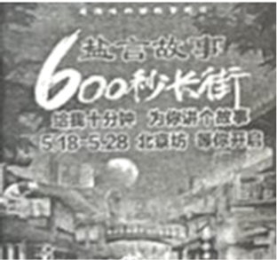

21. Who got the gold medal in the Artistic Swimming World Cup in Egypt?
A. Yang Shuncheng. B. The Piano Guys. C. The six players.
22. Where can visitors see thousands of treasures dating back to the Shang Dynasty?
A. In Somabay. B. In Sanxingdui Museum. C. In the kingdom of pandas.
23. What is Yan Yan Gu Shi?
A. It’s a new app for storytelling. B. It’s a platform to sell paintings. C. It’s an exhibition in Beijing Fun.
B
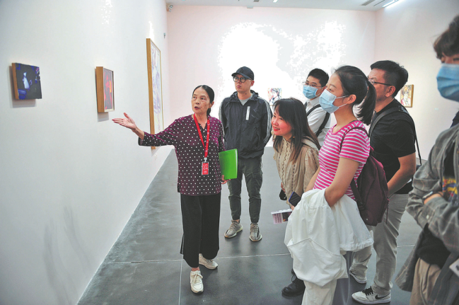
Chen Shaoqin, a volunteer on art, guides visitors at an art center in Beijing on March 8. [Photo by WANGWEI/for China Daily]
At the age of 73, Chen Shaoqin from Beijing has shown the world how life should be lived.
Although she only had a middle school education, Chen began studying English at the age of 40 and passed a college entrance exam, making herself from a factory worker to a white-collar clerk in an international trade company. Chen continued to study art after retirement(退休) and finally became an art guide at the age of 67. Over the past five years, she has guided visitors at an art center for three days a week, totaling 3,500 hours.
From an old lady who knew nothing about modern art to a volunteer guide, Chen’s hard work and love for learning have encouraged many people. She said that she must continue to learn because she did not understand that. As a guide, she is able to attend professional training courses and has the chances to learn from artists and curators (馆长), which gives her encouragement to continue.
Chen has guided many exhibitions over the years, including those of famous artists like Zeng Fanzhi, Xu Bing, Qiu Zhijie and Pablo Picasso. She believes that every tour is a beautiful journey and a new chance to learn and be moved. Her effort of learning and her ability to mix many subjects have made her an excellent guide. After turning 73 this year, she believes that the width of one’s life can be expanded (扩展) through self-improvement and learning.
Chen Shaoqin is a best example that anyone can find their passion (热爱) and then learn, grow and share with others.
24. How old was Chen Shaoqin when she started learning English?
A. 73. B. 40. C. 67.
25. Chen Shaoqin finally became _________ after retirement.
A. an artist B. a curator C. an art guide
26. What can we learn from Chen Shaoqin?
A. It’s never too old to learn. B. A good friend is like a mirror. C. Failure is the mother of success.
27. Where is this passage probably taken from?
A. A course plan. B. A website. C. A dictionary.
C
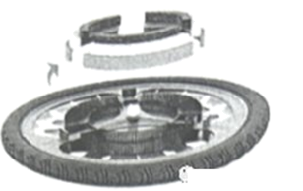
Kristen Tapping, a graduate from London South Bank University, has invented a bike wheel that she says can help clean pollution from the air. It’s called Rolloe.
The wheel uses fins to pull in air as it turns, It then uses filters (过滤器) to take in polluted air and give off clean air back into the environment. The wheel can filter more air if it goes faster, although it still works at low speeds.
Tapping said users would need to change the filter every week, or after about 250 kilometers, to make sure the wheel continues to work well. The wheel fits in the front of a standard bike and weighs about one kilogram.
Tapping said she was encouraged to create the wheel when she was biking around London. “In traffic, you always notice the pollution; the heat, the gases and the smell,” she said. She predicts that if 10 percent of cyclists (骑自行车的人) in London had a Rolloe on their bike, they could filter about 266,865 m³ of air a day, although this has yet to be tested.
A recent report shows that London’s health costs because of air pollution are the highest out of the 432 European cities. The World Health Organization (WHO) has also said that outdoor air pollution causes about 4.2 million deaths around the world each year.
Tapping wants to use the wheel on shared bike projects at first, with the aim of making the wheels available for all bikes to use. She says she would also like to create a wheel that would fit in the back of a bike, as well as making them available in different sizes.
28. What is Rolloe?
A. A university. B. An invention. C. Air pollution.
29. Why should the user need to change the filter?
A. To let the bike run faster. B. To help people lose weight. C. To make the wheel work well.
30. What is Kristen Tapping’s future plan?
A. To clean about 266,865 m³ of air a day.
B. To travel around 432 European cities by bike.
C. To make the wheels available for all kinds of bikes.
31. What is the passage mainly about?
A. A bike wheel created to clean the polluted air.
B. A project that encourages people to ride bikes.
C. A standard bike which weighs about one kilogram.
D

The Heze Peony International Communication Forum(HPICF) was recently held in Heze, a city in Shandong Province. Heze, known as the “Peony Capital of China”, was put on the world stage. People from home and abroad came to the city and shared their ideas. The HPICF provided a platform for promoting (促进) peony cultural exchanges.
Flowers are very important in every culture and they stand for love, friendship and happiness. Heze peonies have become a bridge to spread love and friendship around the world. The flower has a meaning of wealth, luck and prosperity (繁荣). In recent years, Heze peonies have shown in many important moments and also served as a special symbol to promote exchanges between China and the other countries.
Heze has a history of more than 1,500 years of peony planting. It now has a peony planting area of about 26,667 hectares (公顷) and 1,280 kinds of peonies. In the near future, peony gardens will be built all over the world to promote cultural exchanges.
Heze sets an example of how a city can make use of its treasure, like the peony culture, to connect with the world. The city has taken full advantage of its peony culture not only through the beauty, the poetry and art, but also through the international trade. The peony business in Heze has included both sightseeing (观光)and different kinds of products, such as seed oil, tea, cosmetics and healthy food. Its peony products have been brought to over 30 countries around the world.
32. Why was the Heze Peony International Communication Forum held?
A. To build a bridge in Shandong Province.
B. To help people from home and abroad.
C. To promote peony cultural exchanges.
33. The peony has a meaning of ________ according to Paragraph 2.
A. wealth, luck and prosperity
B. sharing, speed and friendship
C. kindness, health and happiness
34. What can we know about Heze peony?
A. It has 1,280 different kinds of colors.
B. It has a planting history of over 1,500 years.
C. It’s grown in a garden of about 26,667 hectares.
35. What does the underlined word “cosmetics” refer to?
A. A manager who sells peonies. B. A place of peony planting. C. A kind of peony product.
非选择题(共40分)
温攀提示；请将答案书写在答题卡的指定位置。
三、阅读理解(共两节，满分40分)
第二节(共5小题；每小题2分，满分10分)
阅读下面短文，完成相关任务。
It was early winter several years ago. I had pulled out my old winter coat for another year’s use. It was still in pretty good shape after so many winters’ wear. I didn’t really need a new one but I wanted one and casually (不经意地) mentioned it to my daughter one day. She is such a sweet, loving soul that I should have guessed what would happen next. A few weeks later she gave me a gift of a bright red, brand new, winter’s coat.
I put the old one in my closet (壁橱) and started to wear the new coat every day. Each day, though, when I opened my closet something upset me. It seemed a shame that my still good, old coat should just sit there keeping no one warm during the cold, winter days. After a few weeks I took it out and drove to a local charity (慈善机构). I knew that there someone who couldn’t afford a coat might get my old one. I dropped it off and walked out the door. Then I saw a shivering (瑟瑟发抖的) man in only a thin jacket walking in. I wondered if he would end up in my old coat. Then I smiled and went home with a warm heart.
My new coat is old now. It is in too bad of shape to even give away to charity. I wonder if I should buy a new one soon but I think I will wait a while. I don’t really need a new one and maybe I can find a few more things to give to the charity instead.
Perhaps the best way to deal with our wants is to give. Love, after all, brings us the most joy. And the more of it you give away, the more of it you have. May all of your days be full of Warmth! May all of your days be full of Giving! May all of your days be full of Love!
36. 请回答问题。Who bought a new winter coat for the writer?
_____________________________________________
37. 请把文中划线句子翻译成汉语。
_____________________________________________
38. 请从文中找出与下面所给句子意思相近的句子。
It is in such bad shape that I can’t give it away to charity.
_____________________________________________
39. 请给短文拟一个恰当的英文标题。
_____________________________________________
40. 请结合自身实际回答问题。How do you usually deal with your old clothes?
_____________________________________________
四、综合填空(共10小题；每小题1分，满分10分)
阅读下面短文，用方框内所给词汇的适当形式填空，使短文语义完整。
smoke and see quickly chopstick be it gift husband into
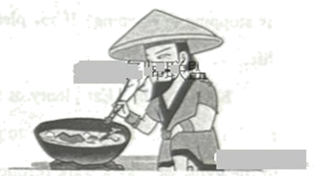
There is an interesting legend about how chopsticks were invented. It is said that Jiang Ziya and his wife once lived a poor life in the Shang Dynasty. The cruel wife was not satisfied with their life and always wanted to hurt her ____41____.
One day, Jiang Ziya’s wife cooked some meat and put something into it secretly. When Jiang Ziya was about to take the meat, a bird flew in through the window ___42___ pecked (啄) him. He didn’t eat the meat and hurried off to catch the bird. Jiang Ziya knew it ___43___ a fairy bird, so he pretended (假装) to drive the bird and ran after it out to a hillside. The fairy bird stopped on a bamboo, shook off two bamboo sticks and whispered, “Jiang Ziya, you should pick up the meat with these bamboo sticks.”
Jiang Ziya ___44___ picked the two bamboo sticks and returned home.
When his wife asked him to eat the meat again, Jiang Ziya put the two bamboo sticks ___45___ the bowl to hold the meat. Suddenly, he ___46___ the bamboo sticks hissing (发出“嘶嘶”声) out green smoke. Jiang Ziya pretended not to know about the truth and said to his wife, “How can the meat ___47___? Is there anything wrong with the meat?” As he said it, Jiang Ziya picked up the meat and offered ___48___ to his wife’s mouth. His wife’s face turned white and she hurried out of the door.
Jiang Ziya knew that these bamboo sticks were a ___49___ sent by the fairy bird. From then on, he used the two bamboo sticks for every meal.
After the story was told not only did his wife dare not hurt him again, but also the neighbors learned to eat with bamboo sticks. Later, more and more people ate with ____50____, and the custom was passed down from generation to generation.
五、写作(共两节，满分20分)
第一节 信息归纳(共5小题；每小题1分，满分5分)
阅读下面短文，用英语完成思维导图。
Everyone sometimes feels that their life is going nowhere. Do you think that your life is stopping developing? If so, please read our list of things to increase the quality of your life.
Keep healthy. Eat plenty of fruit and vegetables, drink lots of water, and avoid too much red meat. Take exercise to improve your mood and outlook. Go running, get down to the gym, or take a walk through nature.
Make a daily plan. Do you wake up in the morning with a bad feeling because there is just so much to get done? Start each day by focusing on what to do, then make a list for that day. A few minutes spent making a list will prevent you from forgetting something important, and will help you order your tasks. Crossing completed jobs off your list will make you feel good.
Learn a skill. It is one of the most satisfying things you can do. A great way to learn a skill is to join a class. Not only will you learn, but you will make new friends. Whether it’s learning a foreign language or playing a musical instrument, there will be a class near your home.
Help others. Helping others is helping yourself. Not only do you feel good about yourself, but other people will benefit from your kindness. You might offer to help do some gardening for an older person. Helping others will make you feel that you have something to offer the world.
Follow the suggestions above and you will surely increase the quality of your life. Be positive, and be happy.
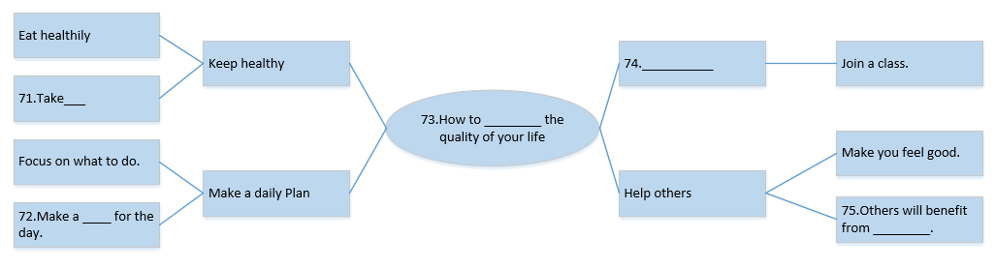

____51____ ____52____ ____53____ ____54____ ____55____
第二节 书面表达(15分)
56. 假如你是李华，某英语报正在开展以“My Favorite English Homework”为题的征文活动，请你根据图表中的调查结果，用英语写一篇短文投稿。
要点如下：
1.描述调查结果；
2.介绍你最喜欢的作业形式并陈述理由。
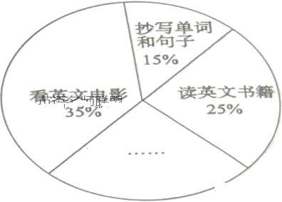
学生最喜欢的英语作业调查结果(人数百分比)
要求：
1.字数：100词左右；
2.可适当发挥，以使行文连贯。
_______________________________________________________________________________________________________________________________________________________________________________________________________________________________________________________________________________________________________________________________________________________________________________________________________________________________________________________________________________________________________________________________________________________________________________________________________________________________________________________________________________________________________________________________________________________________________________________________________________________________________________________________________________________

