2022年内蒙古通辽市初中毕业生学业考试试卷
英语

注意事项：
1. 本试卷共12页, 8道大题, 满分为120分, 考试时间为120分钟。
2. 根据网上阅卷需要, 本试卷中的所有试题均按要求在答题卡上作答, 答在本试卷上的答案无效。
3. 考试结束后, 将本试卷与答题卡分别封装一并上交。

听力部分（共30分）
一、听句子, 选择图片。（每小题1分, 共5分）第一节 听句子, 从每小题A、B、C选项中选择最佳图片。（每个句子读一遍）
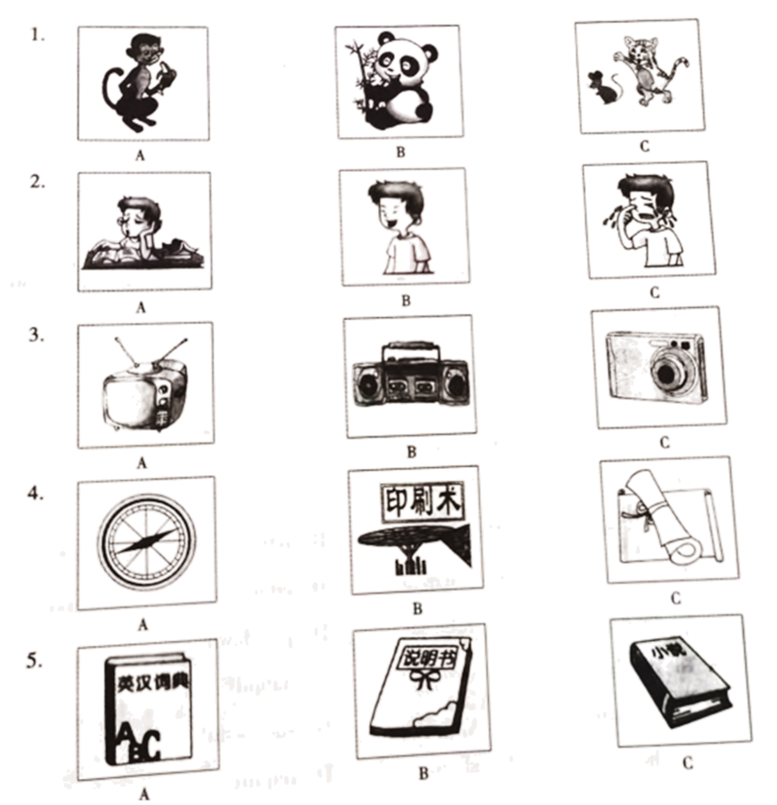

二、听句子、对话和短文。（每小题1分, 共15分）
第二节 听句子, 从每小题A、B、C选项中选择能对句子做出适当反应的答语。（每个句子读两遍）
6. A. It's fine. B. It's Monday. C. It's April 12th.
7. A. Yes, I can. B. No, I can't. C. It's hard to say.
8. A. Don't be shy. B. Don't mention it. C. Don't say that.
9. A. Good luck! B. Congratulations! C. That's a good idea.
10. A. You are kidding. B. They are very nice. C. Sorry, I won't wear it again.
第三节听对话, 从每小题A、B、C选项中选择能回答所给问题的最佳选项。（每段对话读两遍）
听下面一段对话, 回答第11至12小题。
11. How often does Helen have tennis lessons?
A. Once a week. B. Twice a week. C. Three times a week.
12. What time will Tom probably come to meet Paul?
A. At5: 00. B. At 6: 30. C. At 7: 20.
听下面一段对话, 回答第13至15小题。
13. What did the man go to Beijing for?
A. For visiting friends. B. For a trip. C. On business.
14. Why was the factory closed?
A. Because it caused too much noise.
B. Because it caused water pollution.
C. Because it caused air pollution.
15. What is the government building?
A. A modern factory. B. A primary school. C. A new farm.
第四节 听短文, 根据所给问题选择最佳选项。（短文读两遍）
16. What was the matter with David?
A. He had no hands. B. He was blind. C. He was deaf.
17. How did David's mother teach him about the world?
A. By sending him to a school.
B. By taking him on trips.
C. By telling him everything she saw.
18. When did David start learning computer science?
A. At the age of 7. B. At the age of 8. C. At the age of 10.
19. What can you learn about David?
A. He achieved his dream.
B. He couldn't speak clearly.
C. He always depended on his mother.
20. What does the speaker want to tell us?
A. Mothers always play an important role in children's growth.
B It's necessary and important to get a good education.
C. We shouldn't let difficulties stop our dreams coming true.
三、听短文, 填表格。（每小题2分, 共10分）
第五节 听短文, 根据短文内容填写表格, 每空一词。（短文读两遍）
A New Olympic Sport-Breaking
Breaking will ___21___ in the 2024 Paris Olympic Games.
___22___ | It first appeared on the streets of New York in the 1970s.  It became ___23___ among young people worldwide in the 1980s.
Reason | Young people have become ___24___ interested in the Olympics.  It must be widely practised around the world.
Conditions | It must be competitive and it requires ___25___
笔试部分（共90分）
四、完形填空（完成26～35小题, 每小题1分, 共10分）
阅读下面短文，掌握其大意，然后从A、B、C、D四个选项中选择最佳选项。
Every one of us goes through ups and downs in life. I led an easy life. I didn’t have too many difficulties ___1___ money for the family. But I always wanted to do something that would make my family feel ___2___ of me. I started working as a salesman in a factory. To get more orders and sell more products, I ___3___ nearly half of all the stores that might have an interest in my products in New York. From carrying boxes of goods to filling sales sheets, I did almost everything I could. It wasn’t a wonderful job. But everything had an effect on my learning. Every day, I wondered ___4___ this could bring me success. Later I found that my aims (目标) should be a bit ___5___ and I should learn more. I was getting extra money to support my own ___6___ so I went to study after work.
Occasionally, I got the chance to join a software (软件) house. This was my beginning into the technological world, where I wanted to stay. I started digging deeper into the new world and was able to ___7___ things from the people I was working with quickly. My growing knowledge made me be able to speak at important public meetings. For two years, I carried on working hard on big or small businesses and ___8___ ended up joining a big company.
Today I’m proud to say that I have been very ___9___. It has been quite a hard journey—from carrying boxes of goods to an important role of a company. And it just goes to ___10___ that one can always make his dreams come true if he tries his best to explore a new world by learning and working hard. After all, nothing is impossible if you put your heart into it.
1. A. get B. gets C. got D. getting
2. A. proud B. pride C. nervous D. creative
3. A. stole B. took C. visited D. refused
4. A. what B. if C. where D. which
5. A. bigger B. easier C. smaller D. later
6. A. hobby B. pleasure C. company D. education
7. A. pick up B. take up C. take off D. put down
8. A. quietly B. finally C. carefully D. happily
9. A. patient B. organized C. powerful D. successful
10. A. learn B. show C. share D. require
五、阅读理解（完成36～50小题, 每小题2分, 共30分）
阅读短文, 从每小题所给的A、B、C、D四个选项中, 选择最佳选项。
A
Here are three kinds of forms of Chinese art.
Calligraphy (书法) | The ancient Chinese thought of writing as an important form of art. Calligraphy is a popular form of writing. To produce Chinese characters one needs a brush, paper, inkstick (墨) and inkstone. These are called the “Four Treasures of the Study”. It’s necessary to learn these tools in order to learn calligraphy.
Poetry | It was an important part of art. Li Bai, Du Fu and Su Shi are considered among the best ancient poets, and there are five major kinds of ancient poetic styles called Shi, Ci, Ge, Qu and Fu. During the Tang Dynasty, poetry became so important that writing poetry was part of the examinations to work for the government.
Opera | Chinese opera is considered as one of the three oldest dramatic art forms in the world. It’s a combination of music, art and literature. During the Tang Dynasty, Emperor Taizong set up an opera school.

11. _________ are called the “Four Treasures of the Study”.
A. A pen, a book, inkstick and inkstone
B. A pen, paper, inkstick and inkstone
C. A brush, paper, inkstick and ink box
D. A brush, paper, inkstick and inkstone
12. How many major kinds of poetic styles are there in ancient China?
A. Three. B. Four. C. Five. D. Six.
13. If you wanted to work for the government, you had to learn to write poetry during ________.
A. the Tang Dynasty B. the Song Dynasty
C. the Yuan Dynasty D. the Qing Dynasty
14. What’s a combination of music, art and literature?
A. Poetry. B. Opera. C. Calligraphy. D. Painting.
15. From the passage, we can learn that ________.
A. Emperor Taizong of the Song Dynasty set up an opera school
B calligraphy is one of the three oldest art forms in the world
C. Shi and Qu are the two most important poetic styles in ancient China
D. if you want to learn calligraphy, you must learn the “Four Treasures of the Study”

B
I prefer to go slowly when I drive in the mountains of my home, because the forest scenery is beautiful no matter what the season is. This morning I was driving slower than usual because an early March snow had made the roads slippery (湿滑的). Going up a mountain road, I had to slow down as I rounded a sharp, snowy curve (转弯处). That was when I saw a strong and handsome male deer standing in the middle of the road. I came to a full stop and for a few seconds we just looked at each other. His eyes seemed wise and calm. Finally, he nodded his head at me. I nodded in return and waved with my hand for him to go on. He then jumped and ran across the road, up the hill, and back into the woods. I drove on smiling at the magic of this moment and thanked that I had been going slowly enough not to hit this beautiful creature.
Most of us rush through this life not knowing what we are missing. We hardly get to enjoy what each day brings us. Wouldn’t it be better to go slowly through our days here? Life is meant to be savored. Moments are meant to be valued. Days are meant to be lived in love and joy not flown through at a crazy speed.
The next time you find yourself going too fast, slow down. Take the time to watch the sunrise fill the world with light. Take the time to smile, laugh and sing. Take the time to read and relax. Take the time to live your life with love and delight in all the miracles each day brings you. If you do, your life will be much better and more beautiful. And you might even end up not hitting a deer on your way home.
16. Why does the writer like to go slowly in the mountains?
A. Because there is much snow.
B. Because the forest scenery is beautiful.
C. Because the road is dangerous.
D. Because there is a male deer.
17. What might the writer regret most if he drove too fast in the mountains according to Paragraph 1?
A. Missing the beautiful scenery of the mountains.
B. Missing the chance of spending time with animals.
C. Missing the chance of enjoying an early March snow in the mountains.
D. Missing the chance of having magical communication with a deer.
18. How did the writer feel after meeting the deer?
A. Upset. B. Thankful. C. Worried. D. Lucky.
19. What does the underlined word “savored” mean in Chinese?
A. 积极 B. 创造 C. 品味 D. 勇敢
20. What’s the best title of this passage?
A. Enjoy Life B. Love Nature
C. Protect Animals D. Drive Slowly

C
Home to the yearly World Internet Conference (WIC) Wuzhen, a water town in East China’s Zhejiang Province, has always been connected with technology.
Wuzhen’s People’s Park was built in the 1950s. But this traditional park is now a center with the latest technologies. Powered by technologies including 5G, AI and AR, 23 interactive displays have been set up in the park.
An AI assistant is placed at the park’s entrance. From the weather forecast to the price of meat and vegetables, it provides daily-life information for the local people.
Square dancing is popular in China. A big screen has been put up in the park’s square, and dancers can learn routines (路线) from the screen or use it as a music player. Using AR, dancers can see themselves through the special camera, making the screen a “mirror”.
The rubbish cans here are smart, too. The rubbish can opens by itself when it senses something moving near. It then sorts the rubbish and tells you which kind it falls in.
The virtual (虚拟的) zoo in the park is the children’s favorite. By using the park’s app to scan (扫描) the area, visitors can check out virtual animals by AR cameras.
The park is not just a collection of technologies put together for no reason. All the services were designed according to people’s actual needs, which showed us what “technology +” could be like in the future.
21. What is Wuzhen famous for according to the text?
A. AR. B. A water town. C. Technologies. D. The People’s Park.
22. What will you first see when you go to Wuzhen’s People’s Park?
A. AR cameras. B. A big screen. C. Smart rubbish cans. D. An AI assistant.
23. What will the rubbish can do when something moves near?
①It opens.
②It scans people.
③It sorts the rubbish.
④It tells people which can to drop.
⑤It puts the rubbish people throw in the right can by itself.
A. ①③⑤ B. ①③④ C. ②④⑤ D. ②③④
24. Why do children like the virtual zoo in the park?
A. Because they can use the park’s app.
B. Because they can see the animals on TV.
C. Because they can play mobile phones freely.
D. Because they can see many kinds of virtual animals there.
25. What may our future life be like according to the text?
A. The technologies will serve people better.
B. People can go anywhere by car for free.
C. All the AI assistants will be here and there.
D. All the people must learn technologies.

六、读写综合（完成51～60小题, 每小题2分, 共20分）
A
DNA is the whole “map” of the human body. It is something that all humans have, and it tells the body what to do. DNA is the reason that we look like our parents, because we get some of their DNA to make our own.
People have been trying to understand the human body for a long time. In 1860, Mr. Mendel discovered why we look similar to other people in our family. It is because of small things called “genes” in our body. In 1953, two scientists, Watson and Crick, found out that those small parts are real messages. They are written in the DNA with a special language.
In 1961, another two scientists found the first “word” that they could understand in that language. It shows how DNA tells the cell （细胞） to build its parts. So far, scientists have found all the words in the DNA map, but we do not understand what they all do. By understanding what just one “word” means, we can help to save people from several illnesses. So the more we understand, the more doctors will be able to do.
Most people hope that this will help to make better medicine to help sick people. Other people worry that when we learn more “words” and find out more information we will use it in the wrong way, just to make people more attractive, or stop sick people getting jobs.
根据短文内容，请用完整句子回答下列问题。
26. Why do we look like our parents?
__________________________________
27 What did the two scientists find in 1961?
__________________________________
28. How can we help sick people if we understand more “words” in the DNA map?
__________________________________
29. What does the underlined word “They” refer to?
__________________________________
30. What can we know from the last paragraph?
__________________________________

B
阅读短文，根据语篇意义填空，使短文通顺，意思完整，每空限填一词。
All around the world, families celebrate special days together. Traditions for these days ___31___ been very different. Some of them may surprise you.
Families in most countries have a special day to celebrate mothers. In Serbia, this day is on ___32___ second Sunday before Christmas. On that day, children sneak (溜) into their mother’s bedroom and tie her feet with ribbon so that she can’t get out of bed. Then they shout, “Mother’s Day, Mother’s Day! What will you pay ___33___ get away?” Then the mother gives them presents so that the kids “free” her.
In China, they say that babies are one year old when they are born. After that, all children celebrate their birthdays on New Year’s Day because that’s when they grow a year ___34___. Actual birthdays are usually celebrated with a big family meal. The tradition is that the “birthday boy” or “birthday girl” should fill their mouth with as ___35___ long noodles as they can and then eat them. This is because in Chinese culture, long noodles are a symbol of long life.
七、完成句子（完成61～65小题, 每小题2分, 每空1分, 共10分）
根据所给中文意思完成句子, 每空一词。
36. 温故而知新。
_________ the new while __________ the old.
37. 必须制定更多法规来防范任何可能的危险。
More laws must be __________ to __________ against any possible dangers.
38. 这个作家兼演讲家现在正在她的家乡做关于中国文化的讲解。
The writer and speaker _______ _______ a speech on Chinese culture in her hometown now.
39. 孔子是一位著名的哲学家，他的至理名言对不同国家的许多人产生了影响。
Confucius was a famous philosopher __________ wise sayings have __________ many people in different countries.
40. 无论我走到哪里，没有什么能把我和我的祖国分开。
Wherever I go, nothing can make me __________ __________ my motherland.
八、书面表达（共20分）
41. 最近你班召开了“学生是否应该上网”为主题的班会，同学们就此话题进行了热烈的讨论。
下表为讨论结果，请根据下表写一篇短文，表述讨论结果并阐述你的观点。
Opinions | Reasons
68%赞成 | 1. 可以从网上得到各种信息并且有利于学习。  2. 可以网上购物、聊天、交朋友……
32%反对 | 1. 网上的信息并非都是真实的。  2. 学生们沉迷于网络游戏……
你的观点 | ……
要求：
1. 语言通顺，逻辑清晰，字迹工整。
2. 必须包括表格中所给的提示信息，可以适当发挥，以使行文连贯。
3. 文中不得出现真实的人名、校名和地名。
4. 词数：不少于80词。
Whether Students Should Surf the Internet
_________________________________________________________________________________________________________________________________________________________________________________________________________________________________________________________________________________________________________________________________________________________________________________________________________________________________________________________________________________________________

