英 语
A卷（共100分）
第一部分 听力（共30小题；计30分）
一、听句子，根据所听到的内容选择正确答语。每小题念两遍。（共5小题；每小题1分，计5分）
1. A. I'm OK. B. Nice to meet you! C. What about you?
2. A. You're right. B. It's very nice. C. Thanks.
3. A. It doesn't matter. B. Sorry, I won't. C. I don't know.
4. A. Sure, you can. B. Good luck. C. I'm sorry to hear that.
5. A. Good job. B. My pleasure. C. I agree.
二、听句子，选择与所听句子内容相符的图片。每小题念两遍。（共5小题；每小题1分，计5分）
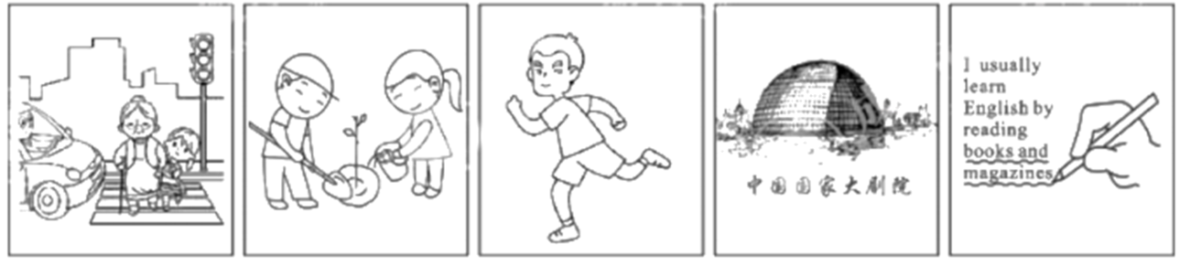
A B C D Ε
6. ___________ 7. ___________ 8. ___________ 9. ___________ 10. ___________
三、听对话，根据对话内容及问题选择正确答案。每小题念两遍。（共10小题；每小题1分，计10分）
11. A. History. B. Music. C. Art.
12. A. In the bag. B. On the sofa. C. On the table.
13 A. At 8:15. B. At 8:45. C. At 9:15.
14. A. See a movie. B. See a doctor. C. Have lunch.
15. A. Waiter and customer. B. Host and guest. C. Father and daughter.
16. A. It's fun. B. It's difficult. C. It's cool.
17. A. On the street. B. In the subway station. C. At the police station.
18. A. Excited. B. Shocked. C. Worried.
19. A. Leaders. B. Flowers. C. Heroes.
20. A. Be an English expert. B. Keep on learning. C. Push himself harder.
四、听短文，根据短文内容选择正确答案。短文念两遍。（共5小题；每小题1分，计5分）
21. How often does the club get together?
A. Every Tuesday. B. Every Sunday. C. Twice a week.
22. Where will club members run when it rains?
A. In the forest. B. In the park. C. In the club.
23. What is held by the club once a year?
A. A special club day. B. A theme party. C. A picnic.
24. What are talked about in this speech?
① time for running ② skills for running ③ places for running
A. ①② B. ②③ C. ①③
25. Why does the speaker give the speech?
A. To give thanks to club members. B. To ask more people to join the club.
C. To provide information for club members.
五、听短文，根据短文内容完成图表中所缺信息。短文念三遍。（共5小题；每小题1分，计5分）
Make your 26 life one of the best times
Tips | Details
Be who you really are. | Lean to overcome pressure. But remember it's 27 to make a change by yourself.
Make friends with others. | Start a conversation with people including 28 so that your life can be more 29 .
Develop a good 30 with teachers. | Be kind and friendly to teachers. Talk with them when possible.
第二部分 基础知识运用（共30小题；计40分）
六、选择填空（共15小题；计20分）
A. 从以下各题的A、B、C三个选项中选择最佳选项。（共10小题；每小题1分，计10分）
1. —Where did you get this sky lantern?
—I made it by _______.
A. herself B. itself C. myself
2. My mother often tells me it’s impolite to hit an empty bowl _______ chopsticks.
A. in B. on C. with
3. —There is a new art museum in our city. You _______ miss it.
—Thank you. I won’t.
A. can’t B. must C. needn’t
4. _______ medical book Tian Hui Yi Jian by Bian Que and Cang Gong has come out in Chengdu.
A. The B. An C. A
5. In the future, vocational（职业的）students _______ it easier to get jobs.
A. found B. have found C. will find
6. Rome is an ancient city _______ is full of places of interest.
A. where B. which C. who
7. The 21.58-meter-long 3D-printed bridge in Chengdu, with its _______ part reaching 8 meters and highest point hitting 2.68 meters, is really amazing.
A. biggest B. widest C. longest
8. Some groups _______ prizes on April 15, 2022 by the Central Committee of the CYLC（共青团中央）.
A. were given B. were giving C. will be given
9. Mary has learned a lot about the history of Sichuan _______ she can be a tour guide.
A. even if B. as soon as C. so that
10. —I wonder _______ life will be different in the future.
—Maybe we will be able to live on another planet with the development of space technology.
A. when B. how C. what
B. 补全对话 根据对话内容，从右边方框中选出适当的选项补全对话。（共5小题；每小题2分，计10分）
Man: Good morning, welcome to the Art School.
Woman: Thanks. I’d like to join one of your evening art courses.
Man: OK. ___11___
Woman: Chinese painting course. I like Chinese painting. ___12___
Man: Yes, it is. Very beautiful. Now let’s fill in this form. ___13___
Woman: Lucy Green.
Man: Which country are you from?
Woman: Well, ___14___ But actually I’m American.
Man: I see Next question. Can you tell me where you live?
Woman: ___15___
Man: Thanks. Now, I’ll give you some information.
A It’s so beautiful.
B. Which course?
C. I work here in England.
D. What’s your name, please?
E. Yes, it’s 58 Charnwood Road.
七、完形填空阅读下面两篇短文，根据短文内容，从A、B、C三个选项中选出可以填入空白处的最佳选项。（共15小题；计20分。A篇每小题2分，计10分；B篇每小题1分，计10分）
A
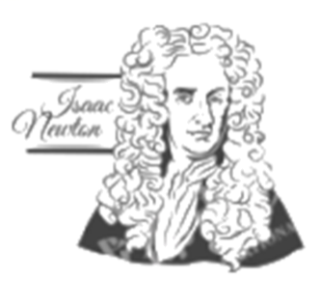
Sir Isaac Newton was a scientist who discovered the law of gravity（重力）. People have learned that Isaac Newton once ___16___ when he was thinking under an apple tree. ___17___ he was woken up by an apple falling on his head. He jumped up, shouting, “Gravity made the apple fall!”
Did the apple really fall on him? No one ___18___ for sure. The story of the apple may have some ___19___, but people who knew him have written that it never happened. Newton had actually been studying gravity and thinking about how apples fell down from a tree and not ___20___ for many years.
16 A. fell over B. fell asleep C. fell ill
17. A. Suddenly B. Slowly C. Usually
18. A. promises B. forgets C. knows
19. A. truth B. purpose C. requirement
20. A. inside B. off C. up
B

Albert was mad about computer games. When people encouraged him to return to ___21___ life, he would say, “This is my doorway to the world.”
In one of his favorite games, he would ___22___ as many turtles as he could. ___23___ else could collect more than he did. But Albert still wanted more. One day, when he got home from school, he found two real turtles in his bedroom.
Albert’s parents decided to make them his ___24___. Albert had to learn all he could to look after the turtles. He also ___25___ to trick them into leaving his room, but it never worked. Gradually, he got used to living with the turtles, and ___26___ began to enjoy it. And other people loved hearing Albert’s stories and his growing knowledge about ___27___.
One day, the turtles disappeared. His parents ___28___ that he would return to his games, but that didn’t happen. ___29___, he went to buy some pets and looked after them in his spare time.
Now whenever people ask him about it, he points at his ___30___ and says, “They are my doorway to the world. There’s a lot more to them than you’d realize.”
21. A. normal B. hard C. similar
22 A. hide B. draw C. collect
23. A. No one B. Anyone C. Someone
24. A. invention B. job C. secret
25. A. refused B. remembered C. tried
26. A. once B. still C. even
27. A. computers B. nature C. bedrooms
28. A. worried B. hoped C. ordered
29. A. Anyway B. Instead C. Besides
30. A. games B. pets C. rooms
第三部分 阅读理解（共15小题；计30分）
八、阅读下面短文，根据短文内容判断句子正误。正确的涂“A”，错误的涂“B”。（共5小题；每小题2分，计10分）
Tuesday 23rd May  Hi Silvia  We’re having great time in Scotland. The people are very friendly, but they speak with a strange accent. I can’t always understand what they say! We left Edinburgh yesterday and are now heading north. Tomorrow we are going to go looking for the Loch Ness Monster. Have you heard of it?  Say hello to everyone at school. See you on the 29th!  Hans | 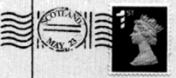  Ms Silvia Toti  32 King’s Road  BRIGHTON  Sussex  BR24 7PQ

31. Hans has difficulty in communicating with the people in Scotland.
32. Loch Ness is in the north of Edinburgh.
33. Silvia will meet Hans the next Wednesday.
34. Silvia’s address is on the right side of the postcard.
35. Hans writes to invite Silvia to see the Loch Ness Monster.
九、阅读下面两篇短文，根据短文内容选择最佳选项。（共10小题；每小题2分，计20分）
A
a  Teens help students in remote areas    Luo, Chinese university student, only turned 18 in January, but he’s already made a big difference to the lives of many poor young people living in China’s remote（偏远的）areas. His online English lessons have offered them a chance to know a world they could only imagine before. Many have achieved university dreams. | b  Luban Lock: magic Chinese puzzle    2,000 years ago, a famous Chinese carpenter named Luban created a magic Chinese puzzle called “Luban Lock”, which he used to test how smart his son was. Watch as Rachel learns to make this Chinese puzzle and tries to solve it! Do you want to have a try?
c  First picture of the black hole  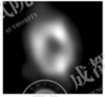  The first picture of the huge black hole at the heart of the Way was shown on Thursday, thanks to the Thursday, thanks to the efforts of astronomers（天文学家）from around the world, including17 from China. Shen Zhiqiang says that the future purpose of the Event Horizon Telescope（EHT）is to get video pictures of the black hole at the center of the Milky Way. | d  China’s healthcare    China has made progress in public health over the past years. In 1949, average life expectancy（平均寿命）was 35. It reached nearly 77 in 2019, much higher than the world average of 72. In 1949, there were just 3, 670 medical and health organizations in the whole country. The number increased to nearly 1 million at the end of 2018. Health insurance（保险）has also benefited over 95 percent of the population.

36. What did Luo do for the young people in the remote areas?
A. He improved their living conditions.
B. He gave them online English lessons.
C. He helped them choose dream universities.
37. What does Rachel want to know?
A. How Luban Lock works.
B. Why Luban created Luban Lock.
C. Whether Luban’s son was clever.
38. Who took the first picture of the black hole?
A. A foreign astronomer team.
B. A Chinese astronomer team.
C. An international astronomer team.
39. Why are the numbers given in Passage d?
A. To introduce the govermment’s plans.
B. To show China’s progress in healthcare.
C. To describe the present situation of China’s healthcare.
40. What’s the theme of the four passages?
A. East meets West. B. For a better future. C. Great Chinese, great China.
B
Most people agree that honesty is a good thing. But does Mother Nature agree? Animals can’t talk, but can they lie with their bodies and behavior? Animal experts may not call it lying, but they do agree that many animals behave dishonestly to fool other animals. Dishonesty often helps them survive（生存）.

Many kinds of birds are very successful at fooling other animals. A bird called the plover sometimes pretends （假装） to be hurt in order to protect its young. When an enemy gets close to its nest, the plover pretends to have a broken wing. The enemy follows the “hurt” adult, leaving the baby birds safe.

Another kind of bird, the scrub jay, buries （埋） its food so it always has something to eat. Scrub jays also steal food. They watch where others bury their food and steal it. But clever scrub jays seem to know when others are watching them. So they get back later, unbury the food, and bury it again somewhere else.
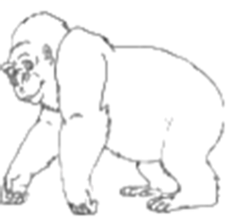
Chimpanzees can also be sneaky. After a fight, the losing chimpanzee will give its hand to the other. When the winning chimpanzee puts out its hand, too, the chimpanzees are friendly again. But an animal expert once saw a losing chimpanzee take the winner’s hand and start fighting again. When chimpanzees find food, it’s natural for them to cry out. Then other chimpanzees come running. But some clever chimpanzees learn to cry very softly when they find food. That way, other chimpanzees don’t hear them, and they don’t need to share the food.
41. Why does the plover pretend to be hurt?
A. To show its friendliness. B. To save its young. C. To catch the enemy.
42. What do clever scrub jays do with their food?
A. They bury the food deep. B. They watch the food. C. They bury the food twice.
43. What will the chimpanzee probably do after crying softly?
A. It will eat all the food it finds.
B. It will share the food with others.
C. It will fight again with the winner.
44. According to Paragraph 4, in which picture can we find a sneaky animal?
A. 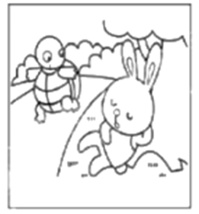 B. 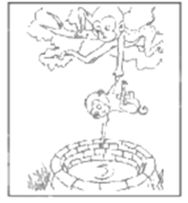 C. 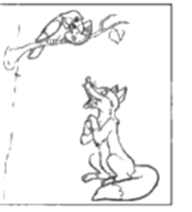
45. What is the best title of the passage?
A. Do animals lie? B. Honesty or dishonesty? C. How do animals protect lives?
B卷（共50分）
一、补全单词 根据首字母及句意写出完整单词。（共5小题；每小题1分，计5分）
46. Jiangnan, a famous area in China, has long been m_______ in many Chinese poems for its beautiful style.
47. The Chengdu Plain belongs to the country’s double-planting area. This means wheat（小麦）and rice are planted in the same f_______.
48. Animal r_______ have discovered the number of endangered animals in Yunnan Province is increasing.
49. School education offers chances for p_______ development to help each of us realize our dream.
50. China’s railway network has grown to c________ most cities and the government is looking to build on it further.
二、完成对话 在空格中填上适当的单词，使对话完整正确。一空一词（含缩写词）。（共10小题；每小题1分，计10分）
Bob, an exchange student from the UK, is at Li Ming’s home in Chengdu. They are talking about the photos on the wall.
B-Bob L-Li Ming
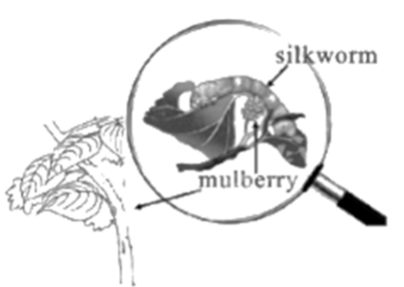
B: What are you picking in the photo?
L: Mulberries. Mulberries like these taste delicious.
B: Oh, really? Are mulberries ___51___ fruit in Chengdu?
L: Yes, there are a lot every May. You know Sichuan has a long history of silk culture. Silk from Chengdu became famous ___52___ as early as 2,000 years ago. I mean nearly all the people in the country knew it! And mulberry ___53___ are the main food for silkworms.
B: I see. Where did you pick the mulberries?
L: Inside an ecological（生态的）park in Chengdu. ___54___ like picking mulberries and feeding silkworms are hot in May.
B: Wow! The ecological park ___55___ like a great place. What else can you do in the park?
L: You can rent（租）a piece of land and grow crops or vegetables. Some experts will give you help if necessary. This way, you can learn more about ___56___.
B: That’s a good way to ___57___ the life on the farm. It may help you forget the pressure in life and feel ___58___.
L: That’s true. It has many ___59___. It also produces food for the city and makes the city greener.
B: Could you ___60___ me there this weekend? I can’t wait to visit the ecological park.
L: No problem.
三、短文填空 从下面方框中选出10个单词，将其正确形式填入短文，使短文意思正确通顺（每词限用一次）。（共10小题；每小题1分，计10分）
clear complete excite follow health interview luck shine silence ten touch well
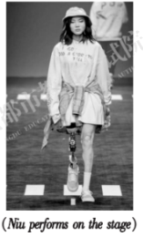
When the other models appeared on the stage, the audience cheered and clapped. Then it was Niu’s turn. The audience suddenly became ___61___. However, after four or five seconds, Niu ___62___ heard someone next to the stage say in admiration, “So cool!”
Niu Yu, 24, became a(n) ___63___ star at Shanghai Fashion Week for her confidence, even though she was wearing a prosthetic leg. When Niu was only 11, she ___64___ lost her right leg during the Wenchuan Earthquake.
Niu has won lots of praise. This gives those who have prejudice(偏见) against the disabled a hit on the nose.
“I ___65___ by something they said. They said the traditional view was that sports were for people with ___66___ legs, but sports should be a kind of spirit. Even though I have lost a leg, I still deeply love sports and will do so forever,” Niu said. Actually, Niu first drew the public's attention when she ___67___ a marathon—a 42-kilometer race in 2018, which was held in Wenchuan to mark the ___68___ anniversary(周年纪念) of the earthquake.
Now, Niu works as a photographer and has more than 850, 000 ___69___ on social platforms, such as Douyin. “I feel I have a social responsibility to bridge the disabled and the public. Showing my life to the public can allow them to ___70___ understand our group and can also tell other disabled people that our society is more tolerant(宽容) than they imagined,” she explained.
四、阅读表达（共10小题；计10分）
补全短文 根据短文内容，从短文后的A-F选项中，选出5个适当的选项补全短文。

Brainstorming is the practice of coming up with ideas or solutions. ___71___ But we do have some rules to follow for successful brainstorming.
Focus on quantity（数量）over quality. When it comes to brainstorming, the more ideas, the better. Don’t worry about the quality of your ideas for now. ___72___ Remember that your goal is to come up with as many ideas as possible. Even if none of them are perfect, you’ll still have many creative ideas to use for your final plan.
Encourage big or unusual ideas. ___73___ Although unusual ideas may not be immediately practical, just creating those ideas gives your brain training. It can also help to produce creative solutions that are hard to come up with.
___74___ Don’t say no to the ideas of others. You can put together the best parts of different ideas to create new, even better ones. Even if you’re not brainstorming as a group, you should still think about sharing your ideas with others and asking them for their advice.
You don’t have to regard yourself as a very creative person to come up with excellent ideas and solutions at once. ___75___ Even if you don’t find the perfect solution, just practicing it can help to improve your creativity. Put these tips together and you are sure to come up with some great ideas.
A. Share ideas with each other.
B. Brainstorming can help unlock ideas.
C. There’s no correct way to brainstorm.
D. Just say or write any idea that comes to mind.
E. You can practice brainstorming skills whenever you want to.
F. Don’t give up your ideas, no matter how strange they seem to be.
完成图表。根据短文内容，完成图表中所缺信息。
Environmental protection is one of the hottest topics nowadays. It was also something that ancient Chinese paid great attention to. In fact, the world’s earliest environmental protection idea, ministry（部门）and law were all born in China. How did the ancient Chinese protect the environment?
The world’s earliest idea of “managing state affairs（政事）through environmental protection”
Xunzi, a famous thinker in the Warring States Period, came up with the idea of “managing state affairs through environmental protection”. He wrote in his book that vegetation（植被）should be protected well by humans.
Guan Zhong, a government officer 400 years ahead of Xunzi, was also an environmental protection expert. He said “a king who cannot protect his vegetation is not doing a good job”.
The world’s earliest “environmental protection ministry”
Nine ministries set up by Shun, an ancient Chinese emperor, included “Yu”（虞）, an environmental protection ministry. The first “Yu” leader was Boyi, an environmental protection expert. He invented wells so people could drink clean water. He knew a lot about animals and also called for animal protection.
The world’s earliest “environmental protection law”
Over 4,000 years ago, Dayu, an ancient Chinese water-control expert and also an emperor, made a rule, not allowing people to cut down trees in March or catch fish in June, because it was the time when they grew quickly.
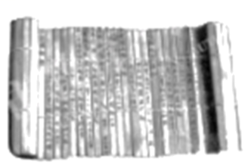
Almost 3,000 years ago, Tianlü, the first environmental protection law, appeared in Qin. It recorded many ancient environmental protection rules. Two of them were interesting: firstly, rivers should not be blocked （堵塞）; secondly, grass and trees should not be burned to be fertilizer（肥料） except for summer. The second one is inspiring even for today. It can help to keep air clean and fresh.
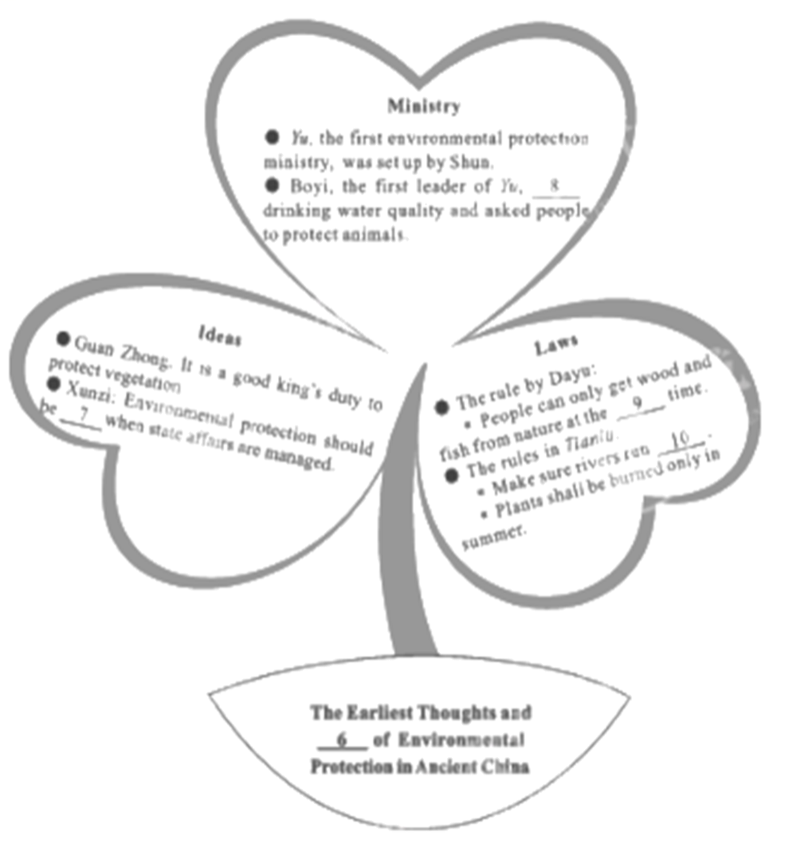
76. ___________
77. ___________
78. ___________
79. ___________
80. ___________
五、书面表达（计15分）
81. 越来越多的人将阅读作为一种生活习惯。假如你是李欣，你校校园电视台英语栏目正在征集以阅读为主题的视频，请根据以下图示撰写视频文稿。
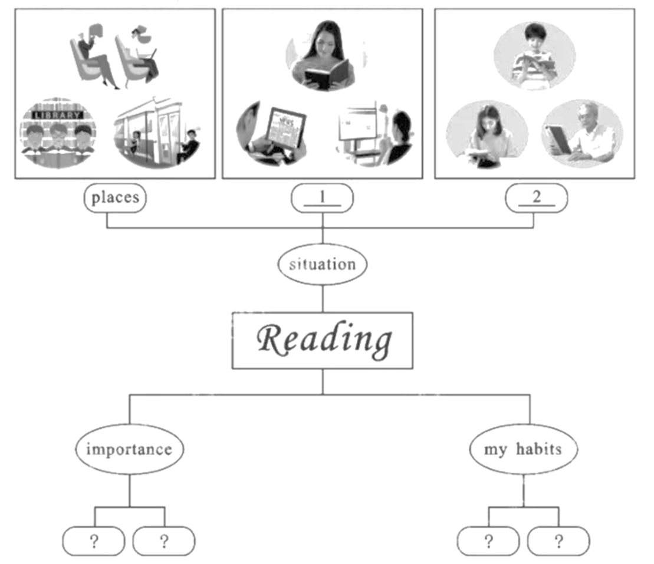
1. ___ways___ 2. ___family___
注意：
1. 请先在答题卡上填写图示中空格（一空一词）；
2. 须全面反映图文信息；
3. 文中不能出现真实姓名及学校名称；
4. 词数80—100，开头已给出，且不计入总词数。
Hello, everyone. I’m Li Xin. ____________________________________________________________________________________________________________________________________________________________________________________________________________________________________________________________________________________________________________________________________________________________________________________________________________________________________________________________________________________________________________________________________________________________________________________________________________________________________________________________

