徐州市2022年初中学业水平考试
英语试题
注意事项
1. 本试卷共8页，满分110分，考试时间100分钟。
2. 答题前，请将姓名、文化考试证号用0.5毫米黑色字迹签字笔填写在本试卷和答题卡的指定位置。
3. 答案全部涂、写在答题卡上，写在本试卷上无效。考试结束后，将本试卷和答题卡一并交回。
一、选择填空（共15小题；每小题1分，满分15分）
从下列各题所给的A、B、C、D四个选项中，选择最佳选项。
1. Which sign says “Turn left”?
A.  B.  C.  D. 
2. People usually ________ in the kitchen.
A. sleep B. chat C. cook D. study
3. Today is much ________ than yesterday. Nice!
A. cool B. cooler C. coolest D. the coolest
4. ________ is our duty to make our country better and stronger.
A. It B. This C. That D. One
5 —I love this T-shirt. ________ does it cost?
—50 yuan. Why not try it on?
A. How long B. How often C. How old D. How much
6. We need to guard ________ any possible danger around us.
A. for B. over C. with D. against
7. I have the habit of ________ the unknown words in the dictionary or on the Internet.
A. looking up B. looking for C. looking at D. looking after
8. Dad sometimes goes to the supermarket with us ________ he hates going shopping.
A. because B. so C. though D. if
9. —Daniel has gone to Beijing on business.
—Oh, I didn’t know. When ________?
A. has he left B. was he leaving C. did he leave D. will he leave
10. Why does John act so ________? Look, he’s speaking faster, his face becomes redder and you can almost see fire in his eyes.
A. happily B. angrily C. calmly D. sadly
11. —Can we play games here?
—Better not. If you ________, please go to the open space there.
A. must B. can C. may D. will
12. From my ________ on the top of the TV tower, I can have a perfect view of our city.
A. tradition B. condition C. position D. situation
13. I ________ by aliens on my way home the other day. Do you believe me?
A. have attacked B. was attacked C. was attacking D. am attacked
14. —Are you going to Helen’s birthday party tomorrow?
—________. I might have to work.
A. It depends B. Thank you C. Good idea D. With pleasure
15. Please read the poem on the right. Which word is the most suitable for ________?
A Spring Morning
By Meng Haoran
This spring morning in bed I’m lying,
Not to awake till birds are crying.
After one night of wind and ▲ ,
How many are the fallen flowers?

A. rains B. storms C. snows D. showers
二、完形填空（共15小题；每小题1分，满分15分）
阅读下面的短文，从短文后各题所给的A、B、C、D四个选项中，选择最佳选项。
“Mum, please! Can I keep a pet dog or a cat?” Andrew asked.
Mum said nothing, but the next day, she got home with a bright goldfish swimming around in a plastic bag.
“A fish. A ____16____ little fish. Not exactly my dream pet. It’s ____17____! Everyone has a pet dog,” Andrew complained. “Mum, I’ve got ____18____ against fish. They’re perfectly fine animals. But I want a pet that would do tricks and ____19____ me when I enter my room. I need a pet that would show me love, like a gentle bark or a miaow.____20____, I’ve got a dead-eyed fish!”
“It’s the only pet that you can keep,” Mum ____21____.
Andrew had no choice but to keep the goldfish. He put it in the tank and said “I will name it Dog.” “Dog!” Andrew shouted. Suddenly, the goldfish stopped eating and swam over from the other side of the ____22____. It looked at Andrew, right up to the glass next to him.
Andrew was ____23____. “Did it know its name was Dog? Was it coming to me when I called? ____24____. Fish aren’t that smart. Are they?” Andrew waited for Dog to swim away again and ____25____ eating. Then he shouted again, “Dog!” It stopped eating at once and ____26____ over to Andrew. Maybe Dog wasn’t a stupid fish, after all.
Andrew started to train Dog to do tricks. After two weeks, Dog could swim in the shape of eight. After one month of practice, Dog could get back a little plastic ball by swimming under it and ____27____ it up to the top of the tank. Then Andrew could drop the ball ____28____ into the water. Dog was playing go-and-bring!
Dog did more than the tricks. Whenever Andrew walked into the room, Dog would ____29____ swim up and give him a happy ____30____. Every time Andrew smiled down at Dog, he was pretty sure it smiled right back.
16. A. lovely B. stupid C. clever D. nervous
17. A. unlucky B. uncomfortable C. unimportant D. unfair
18. A. something B. anything C. everything D. nothing
19. A. greet B. respect C. protect D. lead
20. A. So B. Moreover C. Instead D. Otherwise
21. A. insisted B. added C. asked D. doubted
22. A. box B. cage C. tank D. bag
23. A. surprised B. unhappy C. excited D. scared
24. A. No problem B. No way C. No worry D. No hurry
25. A. forget B. avoid C. stop D. begin
26. A. ran B. swam C. walked D. jumped
27. A. pulling B. pushing C. taking D. turning
28. A. off B. away C. back D. out
29. A. never B. seldom C. sometimes D. always
30. A. bubble B. bark C. miaow D. touch
三、阅读理解（共15小题；每小题2分，满分30分）
阅读下面四则材料，从材料后各题所给的A、B、C、D四个选项中，选择最佳选项。
A
9:05 a.m.
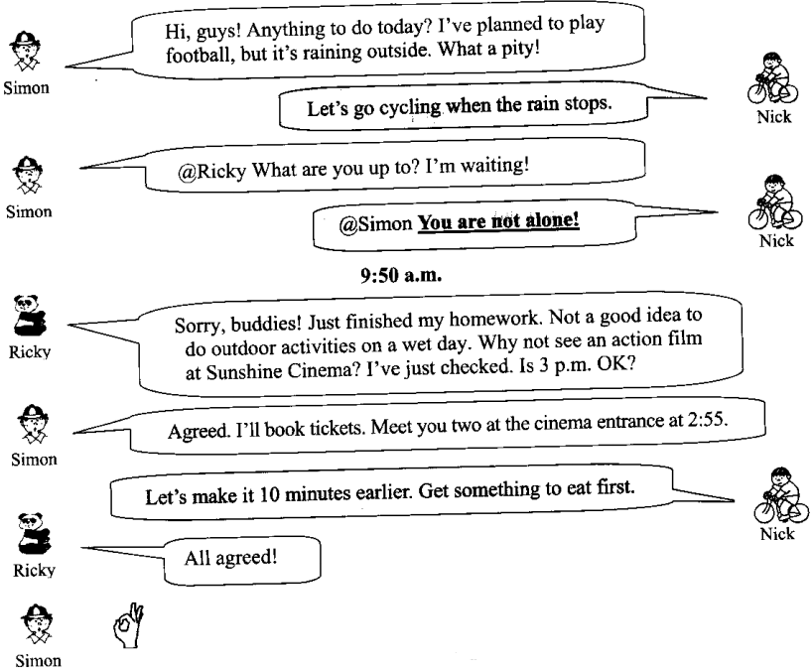
31. What’s the weather like when Simon, Nick and Ricky are chatting?
A. Sunny. B. Foggy. C. windy. D. Rainy.
32. What will they do this afternoon?
A. Play football. B. Go cycling. C. See a film. D. Go to the zoo.
33. What time will they meet?
A. At 2:45 p.m. B. At 2:55 p.m. C. At 3:00 p.m. D. At 3:05 p.m.
34. What docs Nick mean by saying “You are not alone!”?
A. I’m also a football fan. B. I’m also waiting.
C. I’m also doing my homework. D. I’m also booking tickets.
B
Making a deer out of paper without cutting or using glue sounds impossible. But for Du Jialei, paper can be folded (折) into anything. There is no limit to his imagination.
Du, 23, is a student from Shanghai University. He won third place at the ninth IOIO (国际折纸奥林匹克) in February this year. A total of 803 competitors from 59 countries and areas took part in this year’s event.
Du discovered his interest in folding paper in his childhood. After Du went to college in 2017, he had enough time to take the hobby seriously. He learned folding from online teachers and experts. Later he copied patterns from books. He spent almost three years improving his basic skills by making copies of other artists’ designs. Then he made his own creations.
For Du, folding paper develops his ability to pay attention to both the bigger picture and the details. He is creative as he has been challenging himself to make original (原创的) works.
35. What place did Du win at the ninth IOIO?
A. 1st place. B. 2nd place. C. 3rd place. D. 4th place.
36. Before making his own creations, Du did plenty of learning and ________ work.
A. designing B. cutting C. writing D. copying
37. What is the right order of Du’s experience?
① He took part in the ninth IOIO.
② He went to Shanghai University.
③ He discovered his interest in folding paper.
④ He worked hard to improve his basic skills in folding paper.
A. ②③④① B. ②④①③ C. ③②④① D. ③④②①
C
Flying cars: flying high and reaching for the sky!
Traffic jam is almost every driver’s headache. So it’s not surprising to see why the idea of turning cars into flying machines has been popular for years. The flying cars can be seen in a lot of science fiction novels and films. Now the idea may become a reality in the near future.
Basic information
● A flying car provides transport by both land and air.
● A few models of flying cars have already completed test flights.
Advantages
● Reducing road traffic jams.
● Travelling across greater distances much faster than common cars.
● Saving space on the ground for parks and other public spaces.
▲
● Building an engine that is powerful enough to lift and fly the car for a long time.
● Creating a strong lightweight body so that the flying car can be used in any weather.
● Designing sky “roads” to manage the flow of traffic in the air.
● Making new traffic rules in the sky.
38. How many advantages does the material tell us about flying cars?
A. Two. B. Three. C. Four. D. Five.
39. Which word is the most suitable for ▲ ?
A. Disadvantages. B. Possibilities. C. Contributions. D. Challenges.
40. What do we learn from the material?
A. People may drive flying cars in the near future.
B. So far no flying cars have completed test flights.
C. There are some rules against the use of flying cars.
D. Flying cars can be used on land, in water and in the air.
41. What’s the main purpose of the material?
A. To explain how to make flying cars. B. To introduce flying cars.
C. To show the importance of flying cars. D. To advertise for flying cars.
D
Peter loves baseball. Last summer he helped coach a school baseball team. When he first watched the team of 12-year-olds play baseball, his first impressions were not really positive.
One player often left as soon as they started losing. Another player paid too much attention to all their mistakes during the game. Other boys preferred to dig up the grass when they weren’t in the play. A lot of boys threw their baseball bats when they lost the catch.
While their baseball skills improved over time with more practice, there were still problems with their all-important character. The team had a long way to go. For example, some boys were hard on those who made mistakes. Instead of being supportive or encouraging, they blamed (责怪) each other.
Peter started one-on-one talks with each player to discuss things that he had noticed. Some were about skills like holding the bat up higher or opening their eyes when they were making a catch. But most were about staying positive and supporting each other.
Slowly things began to change. The boys began to take the duties for their play instead of blaming others for mistakes. They stayed optimistic even when losing. The team culture was improving.
Players began encouraging each other, high-fiving and supporting teammates. Peter was especially pleased to see some of the boys taking leadership roles and having their own one-on-one talks with their teammates.
Peter doesn’t think he made huge progress in teaching the boys how to throw, catch or hit better, but he was pleased that their conversations around character led to something positive. Although the team still lost games, the players had stronger characters. Next season, their characters will be tested again.
42. When did Peter begin to help coach a school baseball team?
A. Last spring. B. Last summer. C. Last autumn. D. Last winter.
43. Paragraph 2 mainly tells us that the players had problems with their ________.
A. baseball skills B. baseball bats C. characters D. training
44. What does the underlined word “optimistic” in Paragraph 5 mean?
A. 精益求精的 B. 吹毛求疵的 C. 悲观的 D. 乐观的
45. What can we infer from the passage?
A. Peter’s efforts for the team work.
B. The team will win the next season.
C. The coach of the team wants to leave.
D. They’ll be many fights among the boys.
四、词语运用（共15小题；每小题1分，满分15分)
A）
选用方框内的单词或词组填空，其中有一个单词或词组是多余的。
understand unless themselves steps turn out miss

46. Follow these small ________, and you can make a big difference to the Earth!
47. Victory won’t come to me ________ I go to it.
48. Not many people realize that helping others is helping ________.
49. Let’s begin where we stopped yesterday so that we won’t ________ any point.
50. “Barking dogs seldom bite.” It means that some things may seem dangerous, but they often ________ not to be dangerous.
B）
用括号中所给单词正确形式填空，使短文完整、通顺。
This time yesterday, Mr Zhang ____51____ (celebrate) his ____52____ (ninety) birthday at home. He said this to his family____53____ (member): “Most people change houses during their lifetime, but I ____54____ (live) in this house since I was born. I’ve got three children and all of them were born in this house too. Most of the time it has ____55____ (be) a happy place. The street is very different from when I was young. At that time, there were no cars and all the children used to play in the road. Some children still do, but it’s not the same—you’ve got to be very careful nowadays with the traffic. None of the people who live in the street now are as ____56____ (old) as I am—many of them have died; others have moved to another area. I ____57____ (not go) out much now and I’m getting a bit deaf. But none of this is important. I’ve got my children and my grandchildren, and they are everything to ____58____ (I).”
At the end of the party, on the dinner table, Mr Zhang’s daughter laid two big bowls of noodles which ____59____ (eat) up in a minute by the whole family.
“Happy birthday!” Everyone said ____60____ (cheer) to Mr Zhang.
五、任务型阅读（共10小题；61～65题每小题1分，66～70题每小题2分，满分15分）
A）
根据短文内容及首字母提示，写出所缺单词，使短文完整、通顺。
When people meet strangers, they often have small talks. These talks are a good way for people to s____61____ hello. The talks cover many topics, such as weather, films, sports, TV shows o____62____ the latest news. But we should always keep it in mind that p____63____ subjects about money, age, and weight should be avoided. Besides, it’s better to ask open-ended questions. If you ask, “Do you like our city?” They may say s____64____, “Yes”. If you ask, “What do you think of our city?” They will have more freedom in answering. This type of question also shows that you are interested in them. If you seem interested in w____65____ people are saying, they will feel more comfortable talking with you.
B）
阅读短文，回答短文后的五个问题。

Chinese traditional painting and dance are two important parts of the art world. But what about when they meet each other?
This year, a dance drama called Poetic Dance: The Journey of a Legendary Landscape Painting (《只此青绿》) was shown on CCTV’s Spring Festival Gala. It became popular overnight.
According to CCTV, this poetic dance got the idea from the 900-year-old Chinese painting A Panorama of Rivers and Mountains (《千里江山图》). Created by Song Dynasty painter Wang Ximeng at about 18, the painting is amazing in its sweeping size, rich coloration and expressive details. It shows a Chinese blue-green landscape: “mountains and groupings of endless rise and fall between cloudless sky and rippling water”.
A The dance shows the Chinese traditional beauty of the painting. The dancers each had a different hairstyle, which looked like a mountain rock. B The clothes that they wore were shades of green and blue, which is also poetic show of the mountains and rivers. C When the dancers swayed beautifully, the audience seemed to be looking at the moving mountains and rivers. D More than a thousand years later, green mountains and rivers still wow people as they did long ago.
In recent years, more and more modern shows highlight Chinese traditional culture and have received warm welcome, especially among young people. They show _________ Chinese culture and are proud of it.
注：每题答案不超过5个词。
66. What does the underlined word “they” refer to in Paragraph 1?
___________________________________________________
67. In A Panorama of Rivers and Mountains what colour is the Chinese landscape?
___________________________________________________
68. What does the dancers’ hairstyle look like?
____________________________________________________
69. In Paragraph 4, the sentence “Huge mountains and rivers are coming to life!” is missing. Where should we put it, A, B, C or D? ________
70. Please fill in the blank in the last paragraph.
____________________________________________________
六、书面表达（满分20分）
71. 你校在课后服务活动中，根据学生的需求开设了丰富多彩的课程（见下表）。你选修了其中的一门，收获颇丰。你校英文报正在组织题为“Me and my after-class course”的征文活动，请你写一篇短文投稿，内容包括：
1. 你选修的课程；
2. 你学习该课程的经历；
3. 你的收获及感受。
①运动（Sports） ②阅读（Reading） ③手工（DIY）
④绘画（Painting） ⑤声乐（Singing） ⑥……（自拟）
注意：
1. 词数90左右；
2. 短文中不得泄露个人信息；
3. 请按照如下格式在答题卡的相应位置作答。
Me and my after-class course
In my school, there are many kinds of after-class courses. I choose ____________________________________________________________________________________________________________________________________________________________________________________________________________________________________________________________________________________________________________________________________________________________________________________________________________________________________________________________________________________________________________________________________________________________________________________________________________________________________________________________________________________________________________________________________________________________________________________________________________________________________________________________

