2022年无锡市初中学业水平考试
英 语 试 题
本试题分两卷。第I卷（客观题）在第1至第6页，第II卷（主观题）在第7至第8页。考试时间为100分钟。试卷满分为100分。
注意事项：
1．答题前，考生务必用0.5毫米黑色墨水签字笔将自己的姓名、准考证号填写在答题卡的相应位置上，并认真核对条形码上的姓名、准考证号是否与本人的相符合。
2．答客观题必须用2B铅笔将答题卡上对应题目的正确选项涂黑。如需改动，用橡皮擦干净后，再选其他答案。答案不能答在试题卷上。
3．答主观题必须用0.5毫米黑色墨水签字笔作答，答案写在答题卡各题目指定区域内相应位置上。如需改动，先划掉原来的答案，然后再写上新的答案。不准使用铅笔和涂改液。不按以上要求作答的答案无效。
4．考生必须保持答题卡的整洁。考试结束后，将试题卷和答题卡一并交回。
第I卷（客观题 共50分）
一、单项选择 在A、B、C、D四个选项中，选出可以填入空白处的最佳选项，并在答题卡上将该项涂黑。（本大题共14小题，每小题1分，共14分）

1. Our English teacher came into the classroom ________ a smile on her face.
A. in B. over C. with D. against
2. — ________ did the online concert begin?
— You didn’t miss anything. It has just begun.
A. When B. Where C. What D. Why
3. Oh, she smiles! She nods! She understands! We’ve got ________ dog in the world.
A. a cleverer B. the cleverest C. a shyer D. the shyest
4. —Coffee or tea, Frank?
—Coffee, please. To get relaxed, ________ is better than a cup of coffee.
A. nothing B. anything C. something D. everything
5. We should learn some basic life skills since we ________ depend on ourselves some day.
A. can B. can’t C. must D. mustn’t
6. —Dad, what’s for dinner? It ________ nice!
—I’m cooking chicken soup.
A. tastes B. smells C. looks D. feels
7. The chief engineer announced that they ________ a space lab on the space station around the end of 2022.
A. have built B. had built C. will build D. would build
8. —Julie was playing the piano every time I saw her.
—You know ________.
A. every dog has its day B. many hands make light work
C. practice makes perfect D. the early bird catches the worm
9. You will not get the special gift ________ you finish all the tasks.
A. after B. because C. while D. unless
10. — There will be a robot on show in our school next week.
— Really? I wonder ________.
A. what it likes B. what it is like C. what does it like D. what is it like
11. — Cindy, can I look at your notebook? It looks special.
— Sorry. I usually write down something ________ in it.
A. perfect B. practical C. pleasant D. private
12. UNICEF, part of the United Nations, ________ in Europe in 1946 after World War II.
A. set up B. was set up C. took up D. was taken up
13. —Does the colour red represent good things in Chinese culture?
—Yes. But writing one’s name in red is not good, and we usually ________ it.
A. avoid B. advise C. allow D. accept
14. —How about going to the library this afternoon?
—________ Reading is my therapy.
A. Are you kidding? B. You got me there.
C. Don’t you know? D. You read my mind.
二、完形填空
先通读下面的短文，掌握其大意，然后在每小题所给的四个选项中，选出可以填入空白处的最佳选项，并在答题卡上将该项涂黑。（本大题共10小题，每小题1分，共10分）
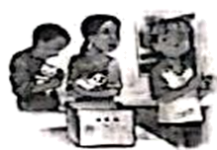
On the first morning of a new term, Jared remembered the things he didn’t like about school: Jessica, maths and reading aloud.
Jared ___15___ to stay at home, but his mom sent him anyway. He had to sit next to Jessica. At reading time, Mrs. Thomas asked Jared to read. Reading aloud always made Jared ___16___ . As he picked up the book, his hands shook. “He can’t read,” Jessica said. “I didn’t call on you, did I?” asked Mrs. Thomas. Jared made a ___17___ .
During the break time, Jessica whispered to him, “When Mom brings my cute kittens（小猫） to school for show-and-tell, don’t even think about ___18___ them.”
The four kittens arrived in a box covered with a piece of screen. Everyone except Jared held them. When Jared picked up his pen from the floor, he looked into the box, saying, “Stupid kittens.”
After show-and-tell, the children took out their maths books.
Then Philip said, “Hey, where are the kittens?” The box was ___19___ .
“Oh no!” Jessica cried and told Mrs. Thomas. “Jared said they were stupid.”
“I didn’t ___20___ it.” Jared’s face turned red.
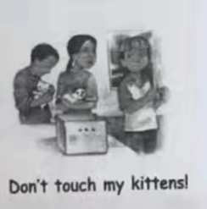
“Look at the radiator（散热器）!” Angela said. Tiny grey paws pushed out from under the radiator cover. Alex yelled, “Kitten!” But the kitten disappeared at once.
The bell rang, and the class went out for a break. When Jared passed the empty box, he saw kitten treats. He then had a(n) ___21___ . He threw the treats on the floor. A kitten came out. Jared waited until it was eating. Then another... Soon the other kittens were eating. Jared gently put them in the box. Mrs. Thomas put a book on the screen so they couldn’t run ___22___ again.
“Class, Jared helped the kittens out,” Mrs. Thomas announced. Everyone ___23___ .
“Thanks,” whispered Jessica. “You’re the greatest.”
Jared was so ____24____ that when he read, his hands didn’t shake. That day, Jared felt the new term might not be so bad.
15. A. agreed B. wanted C. managed D. happened
16. A. tired B. angry C. bored D. nervous
17. A. face B. joke C. mistake D. decision
18. A. taking B. touching C. catching D. carrying
19 A. stolen B. dirty C. broken D. empty
20. A. say B. make C. mean D. know
21. A. idea B. answer C. rest D. guess
22. A. away B. forward C. back D. upwards
23. A. doubted B. cheered C. regretted D. complained
24. A. brave B. stressed C. happy D. surprised
三、阅读理解
阅读下面的短文，然后根据短文内容，在每小题所给的四个选项中选出最佳选项，并在答题卡上将该项涂黑。（本大题共 13 小题，每小题 2 分，共 26 分）
A

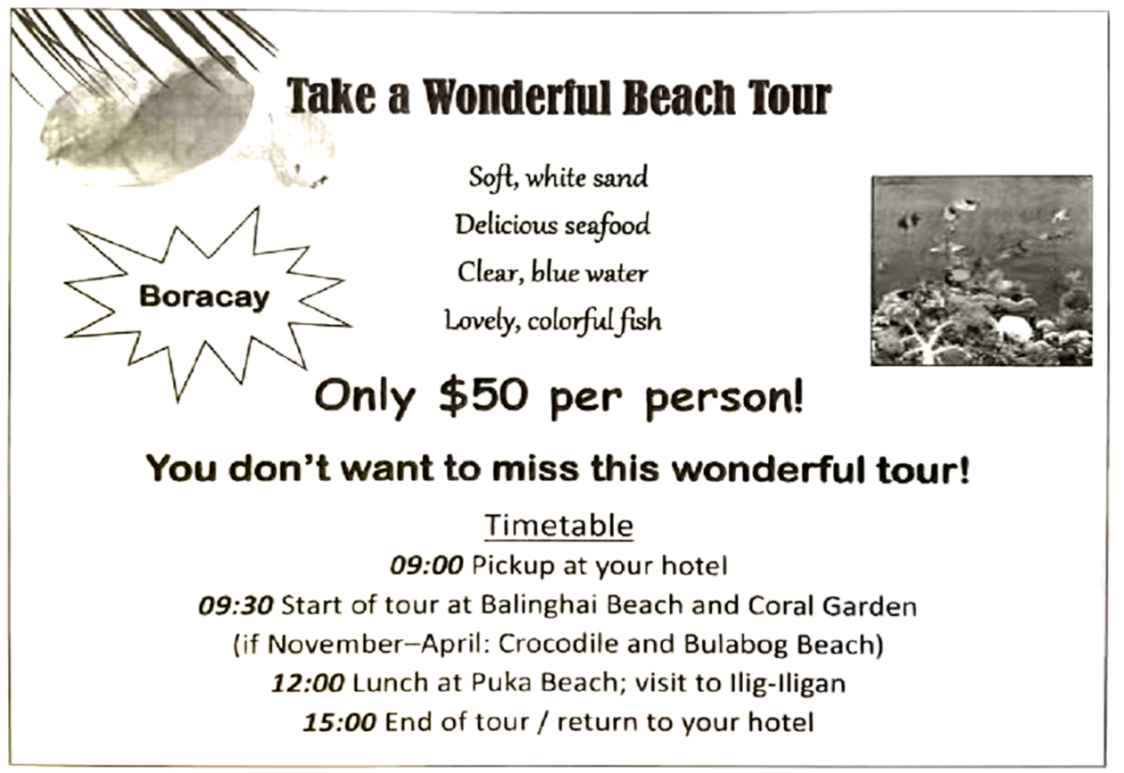
25. The picture above is _________.
A a poster B. a notice C. a story D. a report
26. If Bob takes the tour with his parents, they will pay _________.
A. $50 B. $100 C. $150 D. $200
27. On November 1st the tourists will start the tour at __________.
A. Balinghai Beach B. Coral Garden
C. Crocodile and Bulabog Beach D. Puka Beach
B
Studying is not always the most interesting task within your day, but it is a necessary one. Even though it is required, everyone has got bored at one time or another while studying. Although this is a common problem, here are some tips for you to keep boredom away while you are studying.
Find a suitable place to study.

Make sure you are in a place that is free of distraction (分心). Distractions will actually cause you to become more bored because you are reminded of the things you could be doing other than studying.
Make a ▲ plan.
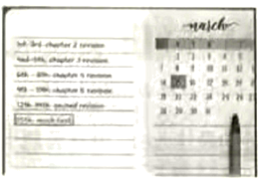
Plan first. List what you need to get completed and how long you need to complete it. If you know when you can go back to play sports or talk to your friends, you will be more likely to fix your attention on studies.
Mix up your topics.
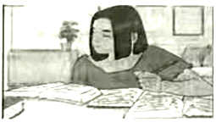
Change up the topics that you are studying. Mix up what you study every half an hour to an hour or so to avoid boredom. For example, study history for 45 minutes, maths for 45 minutes, and English for 45 minutes. Make sure you don’t spend all your time on one subject.
Take notes as you go.
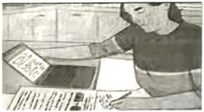
Take a notebook out and write down important notes while you are reading an article in a textbook. Not only will it help keep you engaged, you will also be learning more because you process the information once as you read it and then again as you synthesize the information to write down.
28. Which part of a magazine is the passage most probably taken from?
A. Study. B. Health. C. Science. D. Culture.
29. Which word is the most suitable for ▲ ?
A. trip B. time C. business D. lunch
30. The passage is mainly about ________.
A. how to learn different subjects B. how to study without getting bored
C. how to read an article in a text book D. how to choose a proper place to study
C
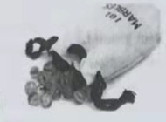
Lupe Medrano, a shy girl, was a straight-A student. Though Lupe had a sharp mind, she could not, no matter how much she tried, run as fast as the other girls. The truth was that Lupe was no good in sports.
“I’ll never be good at sports.” She felt angry one rainy day as she lay on her bed, looking at the shelf her father had made to hold her awards. “I wish I could win something, anything, even marble(弹珠).”
At the word “marbles”, she sat up. “That’s it. Maybe I could be good at playing marbles, and marbles is a sport.” She rushed out of her room and found the marbles in her brother’s room.
She practiced shooting softly at first. The marble rolled from her thumb(拇指) and clicked against the targeted(作为目标的) marble. But the target wouldn’t budge. She tried again and again, but the power from her thumb made the targeted marble roll only an inch or two.
She realized her thumb was weak and then decided to squeeze(捏) a rubber eraser one hundred times, hoping it would strengthen her thumb.
The weeks passed quickly. Lupe worked so hard that one day, while she was drying dishes, her mother asked why her thumb was swollen(肿胀的).
“It’s muscle,” Lupe explained, “I’ve been practicing for the marbles championship.”
“You, honey?” Her mother, Mrs. Medrano, knew Lupe was no good in sports.
“Yeah, I beat Alfonso, and he’s pretty good.”
When her father, Mr. Medrano, heard this, he was very happy and encouraged Lupe.
Practice, practice, practice. Lupe got better and better. Then the day of the championship came. She beat her first competitor easily, and won one marble, and then one after another. At last, Lupe was in the final to play against a girl in a baseball cap. The girl never even looked at Lupe.
“I don’t know, Dad. She looks tough.”
“You can do it,” her father encouraged. “Just think of the marbles, not the girl, and let your thumb do the work.”
It was a tough fight. But finally Lupe won the most marbles and became the winner!
“I did it!” Lupe said under her breath. She rose from her knees, which hurt from bending all day, and hugged her father.
Back home, in her own bedroom, she was happy. She had always won praise because of her brains, but winning in sports was a new experience. She thanked her tired thumb. “You did it, thumb. You made me champion.” As its reward, Lupe went to the bathroom, filled the bathroom sink with warm water, and let her thumb swim as it pleased. Then she climbed into bed and fell into her sweet dreams.
31. What does the underlined word “budge” mean in this story?
A Jump. B. Spin. C. Float. D. Move.
32. How did Lupe feel when she saw the girl in a baseball cap?
A. Sad. B. Ashamed. C. Curious. D. Worried.
33. Which is the best title for this story?
A. The Thumb. B. A Sharp Mind.
C. The Marbles. D. A New Experience.
D
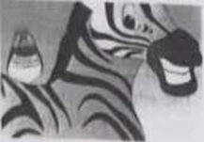
Have you ever watched a show about the wild? A shark (鲨鱼) eats a seal! Lions run down a gazelle! Is all nature like that? All about eating and blood? Or is that just what keeps our eyes glued to the TV screen? Let’s look at sonic living things who work with each other instead of ripping each other apart.
When a lion kills a gazelle, it wants to eat as much as it can and maybe share the rest with its family. There are some living things that will take small pieces of another living thing’s body. Parasitism is when one living thing gets its energy from another living thing, does not give anything back, and hurts the thing it’s taking things from.
Now let’s get a little nicer. Sometimes a living thing will live off the body of another living thing without hurting it. They do not steal anything. They do not bite. Commensalism is when two living things live together and one gets good things out of it while the other is not hurt by it. Have you seen a picture of a whale (鲸) with rocky white things stuck to its skin? Those are barnacles(藤壶). They attach themselves to the whale, so nothing will try to eat them and they can eat things that float by.
Now let’s get really nice. While sharks are biting and lions are fighting, are there any animals that just get along? Yes! Actually, there are many. Mutualism is when two living things work together and both get good things out of it. Bees and flowers are the most common example. Without flowers, bees could not make honey. Without bees, flowers could not make new seeds. It’s win-win for these two. There are lots of animals that get along. Birds will live on the backs of zebras and eat the ticks that are drinking the zebra’s blood. The bird gets food. The zebra gets its ticks taken away. In some of these cases, one animal could not live without the other.
We use the word “Symbiotic (共生的)” for all of these kinds of relationships. Sometimes it’s good for one and bad for the other. Sometimes it’s just good for one. Sometimes it’s even good for both. So, it is nice to know that there are some living things out there that are finding ways to live together. We could pay attention to the animals that do not always make it on TV.
34. The writer mentioned a TV show about the wild in Paragraph 1 to ________.
A tell a story B. solve a mystery
C. Introduce a subject D. discuss a programme
35. Which of the following best describes the relationship between bees and flowers?
A. Neighbours. B. Friends. C. Strangers. D. Partners.
36. How does the writer develop the passage?
A. By showing pictures. B. By giving examples.
C. By presenting reasons. D. By drawing conclusions.
37. What can we infer from the passage?
A. The world of living things remains to be explored.
B. More actions should be taken to protect living things.
C. TV programmes about living things require to be improved.
D. More money will be spent on documentaries about living things.
第II卷(主观题共50分)
四、词汇运用 (本大题共8小题，每小题1分，共8分)
(A)根据句意和汉语注释，在答题卡对应题号的横线上写出单词的正确形式。
38. Helen developed a _________ (持久的) friendship with her teacher.
39. The situation won’t be out of _________ (控制). The worst is behind us.
40. I hope the FIFA World Cup will be covered ________ (现场直播) as usual.
41. It’s necessary for us to learn how to ________ （处理）with the stress in our daily life.
(B)根据句意在答题卡对应题号的横线上，写出括号内所给单词的适当形式。
42. Jerry studied many languages ________ (simple) for pleasure.
43. For your own ________ (safe), you shouldn’t climb mountains alone.
44. Jim is no ________ (long) afraid of making new friends at school now.
45. My brother’s flight was _________ (cancel) because of the bad weather.
五、动词填空
用括号内所给动词的适当形式填空，并将答案写在答题卡对应题号的横线上。(本大题共8小题，每小题1分，共8分)
46. In the coming summer vacation, I __________ (attend) a DIY course.
47. — Lily, I have difficulty __________ (read) comic strips in English.
— Don’t worry. Let’s read some together.
48. Eric is a sports fan and always _________ (follow) the latest sports news.
49. Remember to wash hands often and be sure ________ (wear) masks correctly.
50 Fan Jinshi ________ (do) a lot to protect Dunhuang culture for many years.
51. —Why didn’t you reply to my Wechat?
—Sorry. I ________ (help) my neighbour look after her baby.
52. Su Yiming _________ (achieve) his dream in the 2022 Beijing Winter Olympics.
53. You ________ (expect) to be more organized in high school. So you can keep a diary.
六、阅读填空(本大题共5小题.每小题1分，共5分)
先通读下面的短文，然后根据短文内容，在文章后表格的空格内填入一个最恰当的单词，每个空格只能填一个单词。
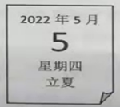
Beginning of Summer, one of the Chinese 24 solar terms, usually falls each year on a day between May 5 and 7 according to the calendar. For centuries, people of the Banshan neighbourhood in Hangzhou, Zhejiang hold a lot of events. Celebrations usually begin with parade made up of people dressed up in traditional Chinese clothing, Hanfu. After the parade, local people take part in some activities at the square.
Eating black rice: A few days before Beginning of Summer, people of Banshan begin busying themselves with cooking black rice. They mix rice and the juice of fresh-picked sea bilberry leaves. Black rice culture started from the Tang Dynasty (618-907). It is believed that children who eat black rice will not be bitten by insects and will be fit the whole summer.
Weighing people: Local people of Banshan developed the interesting tradition of weighing people on this day to check the changes in their bodyweight over the past year. People of all ages take part in the activity. Locals believe that people who weigh themselves on this day will not only have good luck, but also guard against weight loss during the coming summer.
Egg fights: Children are undoubtedly crazy about this game. With a boiled egg, each child tries to break the egg of their competitor. Whoever’s egg breaks first is the loser, and needs to eat the egg as a punishment. The champion in the game is awarded the title of “Egg King”.
Today these activities have given birth to a series of special customs in Banshan on Beginning of Summer.
Title: Traditions on Beginning of Summer: A Taste of Food and ____54____
Background information | » Beginning of Summer usually falls each year on a day between May 5 and 7.  » Local people in traditional Chinese clothing take part in some activities to ____55____ this day.
Special activities | » Eating black rice has a long ____56____. People believe eating it keeps children safe from the danger of insect biting.  » Weighing people on this day is ____57____ among people of different ages. By doing so, they believe they will have good luck and guard against weight loss in the coming summer.  » Egg fights is a game that children are crazy about. If a child ____58____ the game, he needs to eat the egg.

七、完成句子
按所给的汉语，用英语完成下列句子，并将答案写在答题卡对应题号的横线上。(本大题共6小题，每小题1.5分，共9分)
59. 我的生日要到了，妈妈给我做了很多动物形状的饼干。
My birthday is coming. Mum made many cookies _____________ animals for me.
60. 让我们吃惊的是，这位国际友人擅长烹制中餐。
__________________________, the foreign friend is good at cooking Chinese food.
61. 小汤姆一看到这幅剪纸作品就爱上了这种艺术形式。
Little Tom _____________________ the art form as soon as he saw the paper-cutting.
62. 人无完人，自我解嘲意味着接纳自己。
No one is perfect. _____________________ means accepting who you are.
63. 这位游客想知道这座博物馆投入使用多久了。
The visitor wants to know __________________________.
64. 宇航员在太空中进行的实验颇有价值，值得开展。
The experiments done in space by the astronauts are so valuable ____________________.
八、书面表达（本大题共20分）
65. 生命中总有一些值得我们感恩的人。最近，无锡教育电视台将举办题为“The Person I Want to Thank”的英语演讲比赛。假如你想感谢身边某位对你有影响的人(父/母亲、老师、 朋友……)，请根据以下流程图写一篇英文演讲稿参加比赛。

注意事项：
1. 演讲稿须根据流程图自拟，要求语句通顺、意思连贯、符合题意；
2. 流程图中括号部分为非限定性内容，仅供参考；
3. 词数在100个左右，演讲稿的首尾已在答题卡上给出，不计入总词数；
4. 演讲稿中不得使用真实的个人及学校信息；
5. 演讲稿必须写在答题卡指定的位置上。
_____________________________________________________________________________________________________________________________________________________________________________________________________________________________________________________________________________________________________________________________________________________________________________________________________________________________________________________________________________________________________________________________________________________________________________________________________________________________________________________________________________________________________________________________________________________________________________________________________________________________________________________

