泰州市二〇二二年初中学业水平考试
英语试题
（考试时间：120分钟 满分：120分）
请注意：1.本试卷分选择题和非选择题两部分。
2.所有试题的答案均填写在答题卡上，答案写在试卷上无效。
第一部分 选择题（共61分）
一、单项选择 从下列每题所给的选项中，选择一个最佳答案。（共10小题；每小题1分，满分10分）
1. 200 families won 2021 Jiangsu Most Beautiful Families Award this year, and 15 families from Taizhou were ________ them.
A. among B. between C. over D. on
2. ________ cultures such as Chinese knot, Chinese paper-cutting and Chinese opera are deeply loved by students.
A. Social B. Modern C. Traditional D. Natural
3. Schools should ________ students to form good working habits through labor(劳动) education.
A force B. encourage C. warn D. promise
4. —It is impossible to finish the difficult task in such a short time on my own ________ both of us work together.
—No problem. Let’s start!
A. if B. but C. because D. unless
5. COVID-19(新冠肺炎) ________ the world, and many people’s life changes a lot.
A. influenced B. is influencing C. is influenced D. was influenced
6. —________ is China Tiangong space station from us?
—About 400 kilometers above the earth.
A How much B. How often C. How far D. How long
7. Look at part of one page from an English-Chinese dictionary, which of the following words can be looked up on this page?
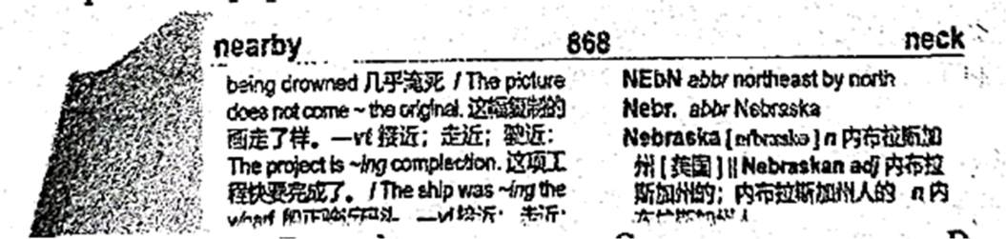
A. necessary B. modest C. navy D. need
8. The government is ________ elevators(电梯) in the old buildings of some communities so that people, especially the elderly can go up and down easily.
A. putting away B. putting out C. putting in D. putting through
9. —What a sunny day! Why not go camping with your friends?
—________
A. It’s my pleasure. B. You’d better not.
C. No, I don’t mind. D. That sounds great.
10. Read the Tang poem A spring morning on the right. Its theme is about ________.
A spring morning
Meng Haoran
This spring morning in bed I’m lying. Not wake up till I hear birds crying. After one night of wind and showers. How many are the fallen flowers!
A. history B. sights C. friendship D. festivals
二、完形填空阅读短文，从每题所给选项中选出可以填入空白处的最佳选项。（共15小题；每小题1分，满分15分）
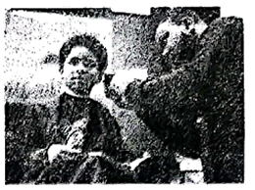
“Hey, how are you doing? I’m Courtney. What grade are you in? What’s your favourite book? Elephant and Piggy? Yeah, I got it.”
If you think you have walked into a library with a ____11____ like that, you are exactly wrong. ____12____, you’ve entered the workplace of Courtney Holmes, known as the Storybook Barber (理发师).
Two years ago, his small town held its first yearly Back to School Party, offering needy families a ____13____ to learn about free resources in the community. Holmes, a warm-hearted barber agreed to take part. Though he was very busy, he choose to donate his ____14____ to give free haircuts to needy kids so that they’d look tidy on that first chose to donate his day of school. Suddenly, a(n) ____15____ went through his mind, “The kids should go on getting their free ____16____ by having to read a book to me.”
The idea was so ____17____ that he continued it for the next two years. Kids aged 5-10 would grab a favourite book, sit in the barber chair, and ____18____ while Holmes snipped (剪). If they stuttered (结结巴巴) over a word, Holmes was there to ____19____.
After the haircut, they’d _____20_____ the books, from the characters and vocabulary to the themes — just like in school, only more fun. Holmes realized that not every _____21_____ had the time to read with their kids. He had a talk with his neighbour Mr. Smith, “You have four kids, and you are so _____22_____ that sitting down and listening to them read is the last thing you have time to do. Just bring in your kids and let them read to _____23_____.”
Holmes added, “I, too, _____24_____ the free snip-and-reads. Last month, there was a seven-year-old boy, Bob, who tried hard to read through his book, stuttering over words, and then I asked the boy to take the book home and practice. _____25_____ the kid came back a few days later, he read it with no problems. That inspires (鼓舞) me,” said Holmes.
11. A. surprise B. question C. greeting D. suggestion
12. A. As usual B. In fact C. In general D. Above all
13. A. job B. thought C. possibility D. chance
14. A. money B. books C. time D. hair
15. A. courage B. imagination C. story D. idea
16. A. haircut B. education C. books D. resource
17. A. important B. necessary C. popular D. interesting
18. A. read aloud B. have chats C. have fun D. think hard
19. A. stop B. beat C. help D. laugh
20. A. review B. read C. write D. create
21. A. barber B. neighbour C. teacher D. parent
22. A. happy B. busy C. worried D. energetic
23. A. mе B. you C. us D. them
24. A. know B. enjoy C. need D. join
25. A. Since B. When C. Before D. Until
三、阅读理解阅读下列短文，根据短文内容选择最佳答案。（共18小题；每小题2分，满分36分）
A
Store Guide
Here’s a list that shows what is on each floor of a department store.
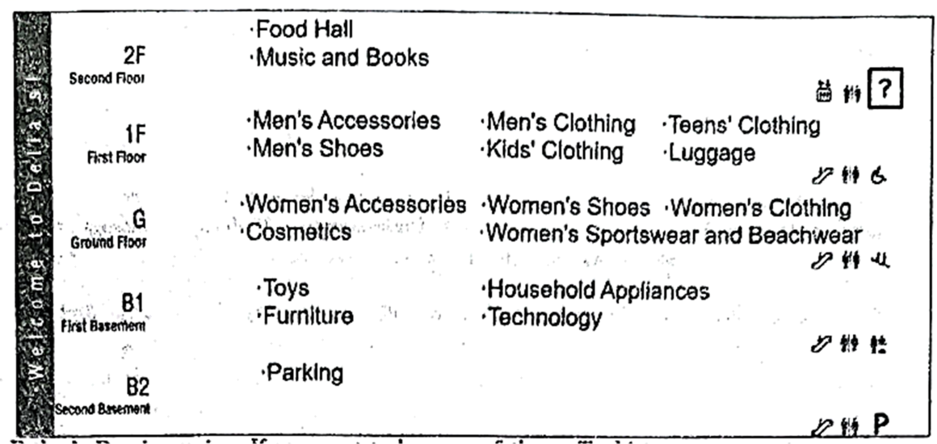
26. Father’s Day is coming. If you want to buy your father a T-shirt, you can go to ________.
A. Second Floor B. First Floor C. Ground Floor D. First Basement
27. On which floor can’t people do the shopping?
A. Second Floor. B. First Floor. C. First Basement. D. Second Basement.
28. If you start shopping on the second floor and finish in the second basement, what’s the most reasonable(合理的) order to get the things below?
a. trousers for kids b. a toy car c. a jazz CD d. a silk dress
A. c→a→d→b B. c→b→a→d C. a→c→b→d D. a→b→d→c
29. According to the information of 2F, which of the following icons is the most suitable for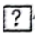?
A. 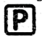 B. 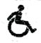 C.  D. 
B
Want to enjoy some exercise at home? Here are some online fitness live courses for you!
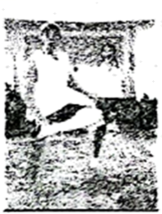 | LIU GENGHONG’S SHUTTLECOCK EXERCISE  Build strong bodies in a fantastic way!  Shuttlecock exercise does not require equipment(装备) and is perfect for people to perform at home. Liu Genghong helps you to keep going until the last minute, and you can burn your fat fast.  Time: 7 p.m.—8:30 p.m. on weekdays  9 a.m.—10:30 a.m. at weekends
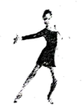 | LATIN DANCE WITH KAREN  Have fun and get fit!  Do you love dancing and parties? Well, Latin dance is for you—it mixes great music and dancing with hard exercise (burn 1, 000 calories an hour). Karen is an experienced Latin dance trainer and many people like her classes very much.  Time: 2 p.m.—4 p.m. on weekdays  9 a.m.—11 a.m. at weekends
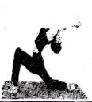 | YOGA WITH SARA  Exercise your body and mind!  Sara’s yoga classes are perfect for people who want to improve their strength and shape their bodies. Sara has trained in several different styles of yoga.  Time:3 p.m.—4 p.m. every Monday and Wednesday for beginners  4 p.m.—5 p.m. every Tuesday and Thursday for experienced learners
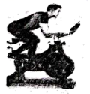 | JOHN’S SPIN CLASSES  Have a lot of fun on a bike!  Spin classes are a safe and effective way to work out—it doesn’t matter how old you are or how fit you are. John is an excellent spin trainer who’ll inspire you to do your best in every class.  Time: 7 p.m.—8 p.m. every day

30. If Mike is busy with his work and he only has free time after 5 p.m. at weekends, he can go to ________.
A. Latin Dance B. Shuttlecock exercise
C. Spin class D. Yoga class
31. If Susan likes dancing and doesn’t mind hard exercise, whose course can she take?
A. Liu Genghong’s. B. Karen’s. C. John’s. D. Sara’s.
32. Which of the following is TRUE according to the material?
A. Spin classes are only fit for young people.
B. Karen’s Latin dance classes are liked by few people.
C. Yoga classes on Tuesday are suitable for the beginners.
D. Shuttlecock exercise can help people lose weight quickly.
33. Where is the material probably taken from?
A. A tour guide. B. A sports website.
C. A news report. D. A fashion magazine.
C
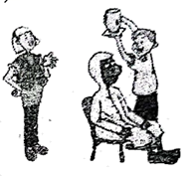
Daniel, Sandy and Simon are in the lab.
Simon: Let’s do an experiment I fill a jar(罐子) with water. I cover the top with a piece of cardboard(纸板) and hold it there. Then I turn the jar upside down and take my hand off the cardboard. Can you guess what will happen?
Daniel: I think the floor will get wet. We should do this experiment outside, Simon.
Sandy: I think the cardboard will hold the water.
Daniel: I don’t think so.
Sandy: You think the water will pour out, Daniel. I think the water will stay in the jar. Let’s do the experiment to test whose opinion is correct.
Simon: Good idea, Sandy. That is called the scientific method.
Sandy: I am so sure of my opinion that Simon can do the experiment over your head and I know you won’t get wet.
Daniel: Well, let’s try.
Simon: Are you ready, Daniel?
Daniel: No! Wait! (He puts on a raincoat and sits down.) Now I think I’m ready.
Sandy: Simon, take your hand off the cardboard.
Daniel: No! (Daniel closes his eyes tightly(紧紧地), and Simon takes his hand off the cardboard. The water stays in the jar.)
Sandy: See, Daniel!
Daniel: How is that possible?
Simon: The force(力) of the air keeps the water in the jar. It is strong enough to hold the water.
Daniel: Wow!
Simon: So what have we discovered?
Sandy: We have discovered the air pressure(压力) helps the cardboard hold the water in the jar.
Simon: Right. What do you conclude, Daniel?
Daniel: I conclude that air is stronger than I thought.
34. How does Daniel feel during the experiment?
A. Excited. B. Nervous. C. Tired. D. Unhappy.
35. What keeps the water in the jar according to the result of the experiment?
A. Simon’s hand. B. The water pressure.
C. The force of the air. D. The force of the jar.
36 Which of the following is the right order of the experiment according to the script?
① Put a piece of cardboard over the jar.
② Fill the glass jar with water,
③ Take the hand off the cardboard.
④ Turn the glass jar over quickly and hold the hand on the cardboard.
A. ②①④③ B. ①②④③ C. ①④③② D. ②③①④
37. The underlined word “that” refers to(指的是) ________.
A. Sandy’s guessing B. Daniel’s opinion
C. doing an experiment D. discussing with others
38. What does the script mainly tell us?
A. Teamwork can help solve problems.
B. Safety is important when doing experiments.
C. The air pressure is always strong enough to hold the water.
D. Correct conclusions can be got through doing experiments.
D
Ancient art doesn’t have to be boring. Technology in the 21st century can help to bring it to life by combining(融合) the best of the old and the new.
Along the River During the Qingming Festival
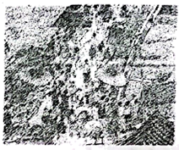
Walking into the China Pavilion at Expo 2010 in Shanghai, people were amazed by seeing a huge digital(数码的) painting. Scientists digitized(数码化) the famous painting Along the River During the Qingming Festisal by Chinese artist Zhang Zeduan.
The original(原先的) painting shows life during the Northern Song period and it includes many details of ancient Chinese customs, lifestyles and technology.
Farmers work in the fields, sailors move around their boats and people eat and do business in restaurants. Parts of the background are also animated(做成动画). You can see the wind blowing through the trees and across the water. These animations perfectly combine modern technology and ancient art.
Digital technology allows today’s artists to express their ideas in ways that ancient artists would not believe possible. Techniques such as animation and 3D digital projection(投影) make art come alive.
Dunhuang Cave Paintings
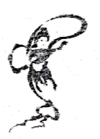
Dunhuang Caves, which are protected ancient treasures in the Gobi desert in Northwest China, are filled with paintings and sculptures with lasting value. This artwork was created over a period of around 1,000 years.
The good news is for art lovers who cannot travel and for the caves. Scientists have created a 360-degree, 3D digital projection of the caves, which makes the artwork come alive. There is also a function(功能) that lets viewers zoom in and enjoy the paintings and sculptures in greater detail.
Digitising ancient art allows us to explore the ancient practices. It also makes the whole world understand the art while protecting the original artworks for the future.
39. From the passage, we can know that ________.
A. both of the two artworks use 3D digital projection
B. ancient art allows people to explore the modern technology
C. people can’t go to Dunhuang to enjoy paintings and sculptures now
D. the digital painting, Along the River During the Qingming Festival was created by Zhang Zeduan
40. Which sentence may be the best to fill in the “________”?
A. In the digital painting, a lot of these details are animated.
B. In the digital painting, a lot of these scenes are well known.
C. In the digital painting, more details of the art can be enjoyed.
D. In the digital painting, many different styles of art can be seen.
41. The underlined phrase “zoom in” means ________ in Chinese.
A. 使(镜头)抬高 B. 使(镜头)拉近 C. 使(镜头)俯视 D. 使(镜头)远离
42. From the passage, we can infer(推断) that _________.
A. studying ancient art as much as possible is very necessary
B. good art must combine modern technology and ancient art
C. protecting the ancient artworks is more important than developing technology
D. more valuable ancient artworks will be protected better with technology in the future
43. Which of the following can be the best title of the passage?
A. Enjoying Ancient Art B. Protecting Modern Technology
C. Digitising Ancient Art D. Understanding Modern Technology
第二部分 非选择题（59分）
四、阅读表达阅读下面的短文，并根据短文后的要求答题。（共5小题；每小题2分，满分10分）
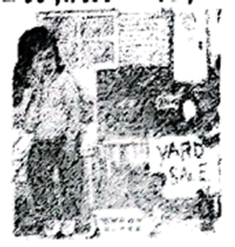
Flora and her dad are moving to a new house soon. Next week, workers will turn the yard of the old house into a car park. The yard is full of beautiful flowers grown by Flora and Dad.
“My poor flowers,” Flora complains in a low voice, looking at the bright purple blooms(花朵) sadly. She sits outside, selling things she doesn’t want to take to the new house. Beside her hangs a sign that says Yard Sale. Several of her neighbours come to have a look.
Dad comes out, holding some snacks in his hands. “Here’s a snack for everyone,” he says. Flora’s dad loves sharing things.
Occasionally(偶然地), Flora digs her heels(鞋后跟) deep into the grass. Then she feels the soft earth move under her heels, and she knows what she can do.
She whispers her plan to Dad. He nods with a smile. Flora takes out some flowerpots(花盆) happily and finds a tool to dig with. Carefully she digs up the flowers with some earth and puts them into the pots.
She lines up the pots near her sign. Now she is ready to be a generous person, just like her Dad.
“How much is a pot?” asks Ana from next door.
“Zero cents!” she smiles and says, “Pick any pot you like!”
回答下面5个问题，每题答案不超过8个词。
44. What will happen to the yard?
____________________________________________
45. Why does Flora feel sad at first?
____________________________________________
46. What is written on the sign?
____________________________________________
47. Where are the flowers in the pots from?
____________________________________________
48. What do you think of Flora’s Dad according to the passage?
____________________________________________
五、任务型阅读 （共10小题；每小题1分，满分10分）
阅读下面的短文，并根据所读内容在文章后表格中的空格里填入一个最恰当的单词，每个空格只填一个单词。
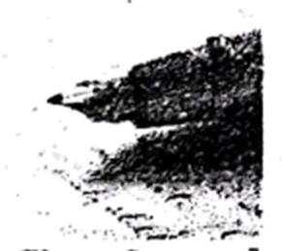
Have you ever compared your handwriting with your friends’ to see how different it is? Like fingerprints, no two people share the same handwriting. Your handwriting can actually say a lot about what kind of person you are. Try writing out a sentence: The quick brown fox jumps over the lazy dog. Then see what your handwriting says about you.
Size of your handwriting
Did you know that the size of your handwriting can represent the level of your self-respect and self-awareness(自我意识)? Large handwriting may show that you’re easy to get along with and you want to be noticed by others. On the other hand, small handwriting may mean that you’re shy and careful, and always pay attention to details. Medium-sized handwriting shows that you can get used to a new environment easily.
Spacing between words
Do you leave a large space between your words when you write? According to a study, the distance between two words can show how close or how far you feel towards others. If you write with wide spacing between your words, it may mean that you enjoy your freedom. On the other hand, people leaving narrow spacing between words may like staying with others.
Slant(倾斜) of the words
Did you know that the slant in your handwriting can tell how you treat people and things around you? Slanting to the right means you welcome or accept new ideas easily. And you consider your friends and family are more important than anything else. While slanting to the left may show that you think deeply about your own thoughts, feelings or behaviors. And you like to work behind the scenes better. If you write without slanting at all, you may be practical.
Although the handwriting analyses(分析) are not always true, we can read them for fun. What matters most is you should write carefully.
Introduction | Different people have different handwriting. Your handwriting can actually say a lot about your personal qualities.
Main body | ___49___ | The size of handwriting can stand for the level of self-respect and self-awareness you have.  Large  ● You are easygoing.  ● You want to make other people ___50___ you.  Small  ● You are shy and do things carefully.  ● You always pay attention to ___51___.  Medium-sized  ●It is ___52___ for you to get used to new environment
Main body | Spacing | The distance between two words can show how you feel towards ___53___.  Wide  ● ___54___ with wide spacing means you enjoy being free.  Narrow  ● You dislike being ___55___.
Main body | Slant | The slant of the words can show how you treat what’s around you.  Right  ● You are open to new ideas.  ● You think your friends and family are the ___56___important in your heart.  Left  ● You think twice before doing anything.  ● You ___57___ to work behind the scenes.  Straight  ● You may be practical.
Conclusion | ● You can know the ____58____ between your handwriting and personality. Though it is not always true, just write carefully.

六、词汇运用
用括号内所给词的适当形式填空（每空不限一词）。（共9小题；每小题1分，满分9分）
59. Beijing, the capital of China, is world’s ________ (one) city to host Olympic Games twice.
60. The film The Battle at Lake Changjin (《长津湖》) showed us many ________ (hero) in the War to Resist US Aggression and Aid Korea (抗美援朝战争).
61. With the ________ (develop) of the society, more and more people devote their energy to charity.
62. Audiobooks(有声读物) are so welcome that the number of the listeners is increasing ________ (rapid).
63. I spent one ________ (night) time making a video Mei Lanfang and His Hometown to take part in “Tell China’s Stories” competition.
64. Jiangsu automatic(自动化) test of listening and speaking _______ (hold) in April every year.
65. Our country has made laws ________ (protect) biodiversity(生物多样性) of the Yangtze River.
66. Students have ________ (little) homework than before because of the “double reduction” policy(“双减”政策).
67. Gu Ailing has a gift for ________ (ski) and won high praise in Beijing 2022 Olympic Winter Games.
七、短文填空 （共10小题；每小题1分，满分10分）
根据短文内容及首字母提示，补全空格内单词，使短文完整、通顺（请在答题卡上写出完整单词）。
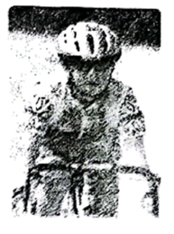
It was a beautiful fall day. I was out riding my bicycle. I guessed I rode over a hole in the road. All of a sudden, WHAM(砰)! I fell off my bicycle. My right side really h___68___!
My head hit the ground h___69___. I lay there for a few minutes. I tried to get up, b___70___ I failed! “There must be s___71___ wrong with me,” I thought. I felt so t___72___ that I had to still lie there. Then I saw b___73___ on my shoe. My hand and knee were bleeding.
As I lay there, I took off my helmet. There was a sharp rock sticking out of it. I looked at it in f___74___. Thank goodness I wore my helmet!
I shouted for help. At that time, a truck went by. The driver s___75___ his truck and came to help me. He put my bicycle in the back of his truck and drove me to the hospital.
When my mother got to the hospital, she gave me a big hug(拥抱). “I’m so glad you were wearing your helmet. The helmet saved your life,” she said. She knew I was c___76___ before and did not always wear my helmet. “Mum, it was not the helmet i___77___ that saved my life, but safety awareness did. I’ll ride my bicycle with great care later on!”
八、书面表达（满分20分）
78. 我们在变化中成长，成长让我们的人生充满意义。回首三年初中时光，我们在学习、思想、性格、生活等方面发生了很多变化。你所在学校公众号的英语写作栏目正在开展“我的成长”征文活动，请分享你初中三年中的成长故事，具体讲述其中一个变化。
要点如下：
1.变化是什么？
2.变化过程是什么？
3.你从中得到了什么启发？
要求：
1.必须含有所有要点，并适当拓展；
2.不得出现真实的人名、校名、地名等相关信息；
3.词数100左右。
________________________________________________________________________________________________________________________________________________________________________________________________________________________________________________________________________________________________________________________________________________________________________________________________________________________________________________________________________________________________________________________________________________________________________________________________________________________________________________________________________________________________________________________________________________________________________________________

