
海南省2022年初中学业水平考试
英语
(考试时间90分钟，满分120分)
第一部分 听力（共四大题，满分20分）
Ⅰ.听句子选图画（共5小题，每小题1分，满分5分）
看图听句子，选出与句子意思一致的图画。每个句子读一遍。
A. 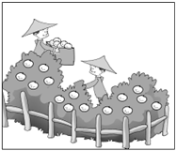B. 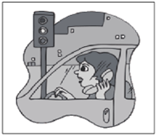C. 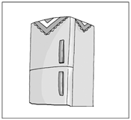D. 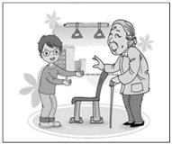 E. 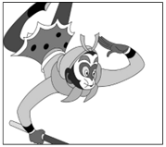
1. ________ 2. ________ 3. ________ 4. ________ 5. ________
Ⅱ.听句子选答语（共5小题，每小题1分，满分5分）
根据你所听到的句子，选出正确的答语。每个句子读两遍。
6. A. I’m Li Lei. B. I’m fine. C. I’m from Hainan.
7. A. It’s on the table. B. It’s sunny. C. It’s in September.
8. A. Well done. B. With pleasure. C. Don’t worry.
9. A. Here you are. B. All right. C. Enjoy yourself.
10. A. I agree with you. B. Sounds good. C. Sorry to hear that.
Ⅲ.对话理解（共5小题，每小题1分，满分5分）
根据你所听到的对话内容，选出能回答所提问题的最佳选项。每段对话读两遍。请听第一段对话，回答11和12小题。
11. Which sport does the girl enjoy?
A. Swimming. B. Running. C. Playing table tennis.
12. Where will they meet?
A. In the school. B. In the park. C. In the sports center.
请听第二段对话，回答13至15小题。
13. Why does the woman want to buy a TV set?
A. Because she has a new house.
B. Because the old one is broken.
C. Because her parents need one.
14. What does the woman think of the first TV set?
A. It’s popular. B. It’s cheap. C. It’s small.
15. When will the TV set be sent?
A. In the morning. B. In the afternoon. C. In the evening.
Ⅳ.短文理解（共5小题，每小题1分，满分5分）
根据你所听到的短文内容，选出最佳选项。短文读两遍。
16. The students had a trip to the Dashan Collection House ________.
A. by bike B. by bus C. on foot
17. When the students entered the house, they were interested in the old ________.
A. photos B. clocks C. stones
18. Many clocks were ________ of the second floor.
A. in the middle B. on the left C. on the right
19. Picture ________ can match the shape of the stone that the writer really loved.
A.  B. 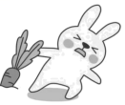 C. 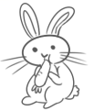
20. The students stayed in the house for ________ hour(s).
A. one B. two C. three
第二部分 语言知识运用（共两大题，满分30分）
Ⅴ.单项选择（共20小题，每小题1分，满分20分）
A)单词辨音。
找出划线部分与其他单词发音不同的选项。
1. A. June B. cut C. glue
2 A. awake B. relax C. jacket
3. A. meat B. weak C. bread
4. A. loudly B. mouse C. soup
5. A. circle B. pencil C. become
B)选择填空。从A、B、C三个选项中选出一个能填入空白处的最佳选项。
6. I got a dog yesterday as a birthday gift. ________ dog is very cute and I like it.
A. The B. / C. A
7. —What do you usually have ________ breakfast?
—Hainan noodles.
A. with B. for C. by
8. To keep ________ safe, you’d better not go out alone at night.
A. myself B. herself C. yourself
9. —How do you like this cup of Xinglong Coffee?
—It ________ really great. I’d like another cup.
A. looks B. feels C. tastes
10. The boy ________ be Tom. I saw him reading in the library just now.
A. shouldn’t B. can’t C. needn’t
11. According to the latest rules, everyone must have their temperature taken ________ they enter the school.
A. before B. though C. unless
12. —Mum, I can’t take care of Mary. She is crying all the time.
—Try to be ________, Jack. Your little sister is ill.
A. patient B. serious C. excited
13. We ________ each other since we met in the last summer camp.
A. won’t see B. haven’t seen C. didn’t see
14. —Lucy, I’m poor in English. Could you give me some advice?
—You can speak it as ________ as possible.
A. much B. more C. most
15. —Peter always remembers ________ the light off when he leaves the room.
—That’s great. It’s a good way to save energy.
A shut B. shutting C. to shut
16. — ________ beautiful poem Happy Rain on a Spring Night is!
—So it is! Du Fu showed his care for farmers in the poem.
A. How B. What a C. What
17. —It’s said that the Shenzhou-14 astronauts will say hello to us on Mid-Autumn Day.
—Wonderful! I’m ________ it.
A. getting along with B. staying away from C. looking forward to
18. Few students could understand the sentence until it ________ by Miss Chen.
A. explained B. was explained C. was explaining
19. —Have you decided ________ the children in the poor area?
—By sending them books and schoolbags.
A. how you will help B. how will you help C. when you will help
20. Look at the notice. It says ________.
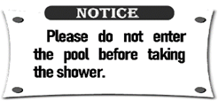
A. we can’t swim without a shower here
B. we can’t use the new shower
C. we can’t go to the pool
Ⅵ.完形填空（共10小题，每小题1分，满分10分）
阅读下面短文，掌握其大意，从每小题所给的A、B、C三个选项中选出最佳选项。
There was once a couple named Sue and John. Both of them were ___21___.
In the late autumn, John was badly ill and became bedridden (长期卧床的). After the doctor visited John several times, he told Sue, “His condition is quite ___22___. John seems to have lost all will to live. If he doesn’t want to live, medicines will not help him.”
Sue tried her best to ___23___ John. She sang and danced, she painted their favorite pictures, she told jokes, but John did not respond (回应).
“Five,” he said ___24___ one day, as he looked out of the window. When Sue asked what John meant, he explained slowly. “There are… only ___25___ leaves left on the tree now. When the last leaf falls, I... shall go with ___26___.” Upon hearing this, Sue couldn’t help crying. She went to their neighbor, Mr Smith, who was also an artist.
Mr Smith was sorry about John’s poor health. He ___27___ his friend to get better, then he painted a leaf.
Over the next few days, it rained heavily, but the last leaf on the tree held on firmly (坚固地). Every day, John would look ___28___ and see the same lone leaf on the tree.
Then, one day, the doctor came in and said John’s ___29___ was improving. John said to Sue, “I’ve realized that life is hard, but I shouldn’t give up. That leaf has stayed on that tree for so long. It has taught me to ___30___!”
The doctor smiled, so did Sue.
21. A. teachers B. artists C. doctors
22. A. terrible B. common C. simple
23. A. cheer up B. talk about C. listen to
24. A. angrily B. proudly C. quietly
25. A. four B. five C. six
26. A. it B. them C. you
27 A. taught B. wanted C. asked
28. A. up B. down C. out
29. A. condition B. ability C. level
30. A. draw B. wait C. live
第三部分 阅读理解（共两大题，满分35分）
Ⅶ.阅读理解（共15小题，每小题2分，满分30分）
阅读下列三篇语言材料，根据语言材料的内容，从每小题所给的A、B、C三个选项中选出能回答所提问题或完成所给句子的最佳选项。
A
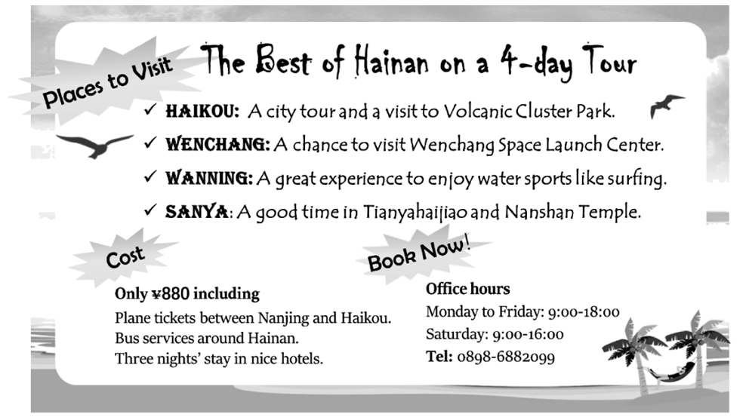
31. You will visit ________ on this tour of Hainan.
A. Haikou and Qionghai B. Wenchang and Wanning C. Qionghai and Sanya
32. During the trip you can enjoy ________.
A. surfing B. camping C. shopping
33. The cost includes the following EXCEPT ________.
A. free plane tickets B. fresh seafood C. nice hotels
34. What is the right time to book the trip on the phone?
A. 8: 30 am on Monday. B. 6: 30 pm on Friday. C. 3: 30 pm on Saturday.
35 Where is this reading material(材料) probably taken from?
A. A newspaper. B. A novel. C. A diary.
B
Yang Hongwei, 56, was born into a kite-making family in Weifang. When she was young, she often saw kites with bright colors and different shapes in her grandfather’s workshop.
“Every time I see these beautiful kites, my bad feelings go away,” said Yang.
Yang learned to make kites from her grandfather at the age of 16. After practicing the skill for 10 years, she started her own shop in 1992.
“Many places around the world have a tradition of flying kites,” Yang said. “But I think the cultural idea behind our kites is special.”
On Yang’s kites, people can see not only common pictures like butterflies and birds, but also some prints telling Chinese myths, legends and history. For example, she once made a kite with a phoenix(凤凰). On each side of the phoenix were 50 images(形象) of famous women from Chinese history. Each woman was different in look, clothes and makeup.
“It took me a lot of time,” Yang said, “but when I explain the stories of the kites to foreigners, I feel a great sense of achievement.”
In her free time, Yang travels to countries such as Germany, Australia, the United States and New Zealand. She tells the stories of Chinese kites and the traditional ways they are made. “It is an important job of mine.” She said.
36. Yang Hongwei saw some beautiful kites in her ________ workshop when she was young.
A. uncle’s B. father’s C. grandfather’s
37. Yang Hongwei started her own shop at the age of ________.
A. 16 B. 26 C. 56
38. The example of Yang’s kite with a phoenix is given to show ________.
A. how she makes kites B. why she likes kites C. what’s in her kites
39. From the passage we can know Yang Hongwei is ________.
A. creative B. humorous C. honest
40. Yang’s important job refers to(指) ________.
A. spreading Chinese culture B. traveling abroad C. selling more kites
C
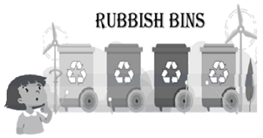
Do you ever find yourself standing in front of rubbish bins, not sure whether the piece of waste in your hand is recyclable or not? To solve this problem, four Hong Kong high school students have invented a smart rubbish bin that uses AI to sort(分类) the waste. The students named the bin Waste Collection Point.
Connected to a computer, the bin uses a camera to tell the kind of the waste it receives and sorts it into plastic, paper, glass, or other kinds. To make sure the bin can sort waste correctly, the team tested every product in the school shop and took at least500 pictures of each one. “To train the AI, we had to take many photos from different angles(角度), so it has a better rate of accuracy,” said one of the students who built the AI system.
The idea of the smart bin was born two years ago, when the students were in Grade Ten. At that time, people from the city crowded into their village because of the COVID-19. They left behind a lot of rubbish and caused more pollution.
“All the bins were full, and there was even rubbish on the mountain,” the students recalled, “Every weekend, we had to join the villagers in picking up the waste.”
The students decided to develop a special recycling bin that would encourage people to protect the environment. Although school ended at 2 pm, the team would continue to work on their invention until 6 or 7 pm at school. Even when their school was closed last year, they would still meet and work together online.
“Our bin is now in its third generation(代). Before graduation, we hope it can be widely used in the city.” The students said, “Then it will be easier than ever for people to recycle and protect our environment.”
41. According to the first paragraph we know the ________ of Waste Collection Point.
A. price B. size C. use
42. The underlined words “rate of accuracy” mean “________” in Chinese.
A. 精准度 B. 参与度 C. 知名度
43. This chart shows why Waste Collection Point was developed. Which is the missing part?
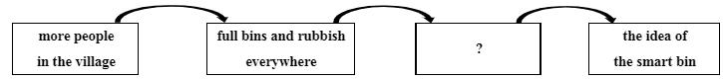
A. the hit of the COVID-19 B. villagers’ encouragement C. picking up rubbish around
44. This passage is mainly about ________.
A. four young inventors B. a new invention C. the rubbish problem
45. How is this passage organized(组织)? (P=Paragraph)
A. 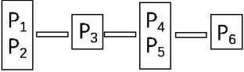 B. 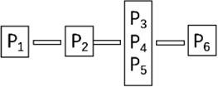 C. 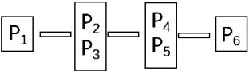
Ⅷ.情景对话（共5小题，每小题1分，满分5分）
根据对话内容，从选项中选出能填入空白处的最佳选项，其中有两项为多余选项。
Host: Hello, Ailing, welcome to our Sports Talk. Glad to see you.
Gu: Nice to see you, too.
Host: Ailing, you won three medals in Olympics at the age of 18. ___46___
Gu: Well, that’s because of my habit. ___47___
Host: Have you got any difficulties?
Gu: Of course! ___48___ However, I like challenges (挑战).
Host: ___49___ By the way, apart from sports, what else do you like?
Gu: I love fashionable clothes, so that’s why I am also a model.
Host: Wow, it seems that you are able to do everything well. ___50___
Gu: You’re welcome.
A. How brave you are!
B. Do you have any future plans?
C. I often fall over and get hurt during practice.
D. Could you share the secret of your success?
E. When did you compete for the first time?
F. Thanks again for your coming, Ailing.
G. Whatever I do, I will put 100% energy into it.
第四部分 书面表达（共三大题，满分35分）
Ⅸ.任务型读写（共5小题，每小题2分，满分10分）
阅读下面短文，按要求完成下列各题。
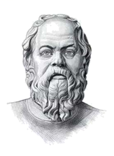
Socrates was famous in ancient Greece for his knowledge. One day, one of his friends went up to him and said, “I’ve just heard something about your friend, do you want to know?”
“Well,” Socrates said, “Before telling me anything, I’d like you to pass a test. It’s called the triple filter (三重筛选) test.”
“Triple filter?”
“That’s right,” Socrates continued, “Before you talk to me about my friend, it is a good idea to think about what you will say. The first filter is ________. Are you sure what you are going to tell me is true?”
“In fact, I just heard about it and…” the man said.
“All right,” Socrates said, “So you don’t really know whether it’s true or not. Now let’s try the second filter—goodness. Is what you are going to tell me good?”
“No, on the contrary (相反)…” the man replied.
“Okay,” Socrates continued, “The last filter is usefulness. Is what you are going to tell me useful to me?”
“No, not really.” The man said.
“Well,” Socrates ended, “If what you want to tell me is not true, good or even useful, why tell it to me at all?”
51. Why did the man go up to Socrates one day? (根据短文内容回答问题)
_________________________________________________
52. How many questions did Socrates ask the man? (根据短文内容回答问题)
_________________________________________________
53. According to the story what do you think of Socrates? (根据短文内容回答问题)
_________________________________________________
54. 根据短文内容，给下面的句子补充一个单词，使句子意思完整。
The first filter is ________.
55. 根据短文内容，完成句子。
This story teaches us ________________________________.
Ⅹ.词汇（共10小题，每小题1分，满分10分）
A)根据句意及词首字母或汉语提示，补全单词。
56. Hurry up! The movie will b________ in ten minutes.
57. Pandas are black and w________. They feed on bamboo.
58. Sam has lost his k________ to the door. He can’t get in now.
59. I have poor eyesight. I can’t see the blackboard ________ (清晰地).
60. The earth is a ________ (行星), which goes around the sun.
B)
选用方框内所给词的适当形式，完成短文。（每词限用一次）
be; I; number; polite; walk
One day, a little boy came into a shop. He ___61___ to the shop assistant(售货员) and said, “I’d like twelve exercise books of six cents each and nine pencils of ten cents each. How much are they?”
The shop assistant wrote these ___62___ down on a piece of paper and thought for a minute. Then she answered, “$1.62.”
“If I give you $10, how much money will I get back?”
“You will get $8.38 for change. Here you are. These ___63___ the things you want.”
“No, thanks. In fact, I don’t need to buy anything. This is ___64___ math homework.” The boy looked at the piece of paper and asked ___65___, “Can I take it away?”
Ⅺ.写作（满分15分）
66. 为创造美好的生活，青少年在成长的过程中应不断学习新的生活技能（如烹饪、种植、救护方法……)。请结合下列提示和自身的需求，以“Little Life Skills Are a Big Help”为题写一篇短文，在英语课堂上分享。
提示：
1. What life skill do you want to learn?
2. Why do you want to learn this skill?
3. How do you learn this skill?
要求：1.内容须涵盖所有要点；
2.语句通顺，意思连贯，语法正确，书写规范；
3.文中不得出现真实的人名、校名、地名；
4. 80词左右（文章开头已给出，不计入总词数）。
Little Life Skills Are a Big Help
Life skills are necessary for us teenagers. To live more healthily and happily, we are supposed to learn more new skills...
________________________________________________________________________________________________________________________________________________________________________________________________________________________________________________________________________________________________________________________________________________________________________________________________________________________________________________________________________________________________________________________________________________________________________________________________________________________________________________________________________________________________________________________________________________________________________________________

