2022年岳阳市初中学业水平考试试卷
英语
温馨提示：
1.本试卷共两部分，76小题，满分120分，考试时间90分钟；
2.本试卷分为试题卷和答题卡，所有答案必须填涂或填写在答题卡规定的答题区域内；
3.考试结束，考生不得将试题卷、答题卡、草稿纸带出考场。
Good Luck to all of you!
第一部分 听力部分(共三节，满分20分)
第一节 图片理解 从每小题所给的三幅图中选出与你所听到的对话内容相同或相近的图画，每段对话读两遍。
1. A. 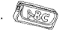 B.  C. 
2. A. 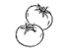 B. 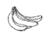 C. 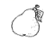
3. A. 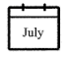 B. 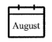 C. 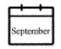
4. A.  B.  C. 
5. A. 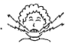 B. 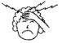 C. 
第二节 对话理解 根据你所听到的对话内容，选择最佳选项回答问题，每段对话读两遍。
听第6至第10段对话，回答第6~10小题。
6. What’s the woman’s first name?
A. Linda. B. White. C. Gina.
7. How much is the purple skirt?
A. $15. B. $40. C. $45.
8. What time will they go shopping this afternoon?
A. At 3:30. B. At 3:15. C. At 3:45.
9. What was Mike doing when the girl called him?
A. Watching TV. B. Taking a shower. C. Drinking coffee.
10. Who is Jenny’s sister?
A. The tall girl with curly hair.
B. The heavy girl with straight hair.
C. The short girl with blonde hair.
听下面一段对话，回答第11、12小题。
11 How far is it from Tom’s home to Animal Helpers?
A. 4 kilometers. B. 5 kilometers. C. 6 kilometers.
12. How does Tom go to Animal Helpers in Yueyang?
A. By bus. B. By bike. C. On foot.
听下面一段对话，回答第13~15小题。
13. Why is Kim angry with his grandfather?
A. Because grandfather read Kim’s diaries.
B. Because grandfather expected to look after Kim.
C Because grandfather shouted at Kim.
14. What will Kim do to solve the problem?
A. Talk with others. B. Keep a diary. C. Write his grandpa a letter.
15. How old is Kim’s grandfather?
A. 68. B. 70. C. 87.
第三节 短文理解 根据你所听到的短文内容，回答第16~20小题，短文读两遍。
16. What did they see along the way?
A. Flowers and trees. B. Pandas. C. Gifts.
17. How long did it take them to arrive at the top of Yun Mountain?
A. Half a day. B. Half an hour. C. An hour.
18. How many pandas were there in the zoo?
A. 2. B. 3. C. 4.
19. How did they feel about pandas?
A. Beautiful and lazy. B. Lovely and cute. C. Scary and ugly.
20. Whom did the writer buy the toy panda for?
A. The writer’s cousin. B. The writer’s sister. C. The writer’s classmate.
第二部分 笔试部分(共三节，满分100分)
第一节 知识运用（共两部分，20小题，21~40小题，每小题1分，共20分)
A) 单项填空 从A、B、C三个选项中选出一个最佳答案。
1. Gu Ailing is _______ excellent sports star who made a great success in the Beijing 2022 Winter Olympic Games.
A. a B. an C. the
2. Even if we are in Grade 9, it’s necessary for _______ to go to bed early and get up early.
A. we B. us C. our
3. So many young people regard _______ as the most delicious drink.
A. salad B. porridge C. milk shake
4. I will return it to the library _______ I finish reading Little Women.
A. no longer B. as soon as C. so that
5. With the development of 5G technology, our daily lives have become _______.
A. more and more convenient
B. the most convenient
C. convenienter and convenienter
6. The Monkey King is not a normal monkey, he can _______ himself _______ different animals and objects.
A. turn; off B. turn; up C. turn; into
7. Many students practice _______ in the morning because of the P.E. exam.
A. run B. running C. ran
8. The Communist Party of China’s 20th National Congress (中共二十大) _______ in autumn this year.
A. was held B. is held C. will be held
9. They wonder _______.
A. if robots will think like a human in 25 to 50 years
B. if will robots think like a human in 25 to 50 years
C. when robots will think like a human in 25 to 50 years
10. —Long time no see, Angela. How’s it going?
—_______, thank you.
A. It doesn’t matter B. The same to you C. Pretty good
B)完形填空 通读全文，掌握其大意，然后从各题所给的A、B、C三个选项中选出一个正确答案。

FIFA World Cup is one of the biggest sports events in the world. It ___11___ every 4 years. The first World Cup was in 1930. It has a history of over 90 years. During the World Cup, ___12___ fans watch the games and cheer for their favorite teams or players. We have known some famous football players from the football competitions, such as Beckham, Messi, and Figo. They have excited football fans for many years. The World Cup ___13___ the best chances for football players around the world. The winners can get not only ___14___ but also respect（尊重）.
The 2022 World Cup will start on November 21st and ___15___ on December 18th. The competition is going to last（持续）___16___ days. To avoid the high ___17___ in Qatar（卡塔尔）, the games will come in winter ___18___ summer. Gianni Infantino, FIFA’s president（国际足联主席）said, “This is a good decision, the ___19___ temperature in Qatar is up to 45℃. It’s too hot for players to compete.” The true spirit of the 2022 World Cup is “Where there is life, there is struggle（奋斗）.” It’s sure that every football player will try ____20____ best to achieve their goals.
If you have time, if you love soccer, why not come to Qatar to enjoy the exciting football event?
11. A. takes off B. takes a walk C. takes place
12. A. few B. little C. quite a few
13. A. has agreed B. has refused C. has provided
14. A. silence B. honor C. mistakes
15 A. end B. begin C. cross
16. A. 8 B. 18 C. 28
17. A. price B. heat C. speed
18. A. instead of B. in total C. in front of
19. A. deepest B. highest C. widest
20. A. their B. theirs C. them
第二节 阅读技能(共四部分，20小题，每小题2分，共40分)
A)选择答案 阅读下列材料，从A、B、C三个选项中，选择最佳选项回答问题或完成句子。
(Ⅰ)
APPs | Functions（功能） | Launch（推广）Time
Alipay  Alipay Network Technology CO., LTD | *Paying for bills（账单）  *Shopping online  *Booking（订购）tickets | In 2004
WeChat  Tencent Technology Company | *Chatting（交流）with others  *Sending red packets（包）  *Sharing locations  *Making voice or video calls | In 2011
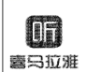 Himalaya  Shanghai Himalaya Technology CO., LTD | *Listening to many radio programs  *Listening to audio books（有声书籍） | In 2013

21. Alipay is used for ________.
A. listening to many programs B. paying for products C. chatting with others
22. When was WeChat put to use?
A. In 2004. B. In 2011. C. In 2013.
(II)
Spring Equinox  The 4th term  March 20th~April 5th | Grain in Ear  The 9th term  June 5th~June 20th | Beginning of Autumn  The 13th term  August 7th~ August22nd | Greater Cold  The 24th term  January 20th~ February 2nd
Everything begins to grow and flowers come out. Some birds fly back to the north. People always fly kites and go climbing. | It’s a long period of continuous（持续不断）rainy and cloudy weather. Farmers are busy sowing （播种）and working in the fields. | The leaves of trees start to fall, as the saying goes “one leaf falls, autumn arrives.” people can feel that the wind is getting cool. | It is snowy and cold. People wear thick clothes to keep warm. Children often make snowmen and do some winter sports like ice skating.

23. Spring Equinox is the best time to ________.
A. fly kites B. pick up leaves C. make snowmen
24. How’s the weather during Grain in Ear?
A. Sunny and hot. B. Rainy and cloudy. C. Snowy and cold.
25. Which solar term is the last one of all the solar terms?
A. Spring Equinox. B. Grain in Ear. C. Greater Cold.
B)判断正误
阅读下面的材料，判断下列句子是否符合短文内容。符合的填涂“T”，不符合的填涂“F”(T=True, F=False)

There are three characters on everyday stage. I’m the main character COVID-19 vaccine（新冠疫苗）, you are my partner nucleic acid test（核酸检测）. We have an enemy, his name is COVID-19（新型冠状病毒）.
Nowadays, COVID-19 is spreading around the world. He is very tiny but harmful, people can’t see him with their eyes. He can spread from one person to another easily and quickly. People are afraid of him because he can make them sick and have a fever. That’s why people stay at home and hide from him.
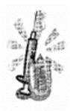
Then I’m coming, my name is vaccine, everyone needs me because there is no special medicine to treat COVID-19. I can help people to stay away from the virus（病毒）. People can get me for free, if they get me twice, they will have green health codes（健康码）with a needle（针）hat. Now people are supposed to get me a third time in the hospital. This can lower（降低）the risk of getting virus. With the third vaccine, people’s green health codes put on a shield（盾牌）, it’s also a passport to enter public places.
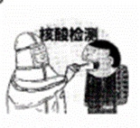
You are my best partner, nucleic acid test. People just need to stand there and open their mouths to take you. Doctors and nurses are working hard to check whether people have COVID-19 or not. They all think you are the most useful way.
So far, you and I have performed pretty well on this stage. Thanks to our strong country, we will pull together to make sure people can live a normal and safe life.
26. COVID-19 is so small that people can’t see him.
27 Getting vaccines isn’t helpful to stop COVID-19 from entering human body.
28. It costs people much money to get COVID-19 vaccines.
29. Nucleic acid test is the partner of COVID-19.
30. To check if they have COVID-19, people need to take nucleic acid tests.
C)补全短文
根据短文内容，从短文后的选项中选出能填入空白处的最佳选项。选项中有两项为多余选项。
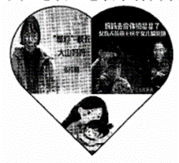
“A child with a mother is like a treasure.” ___31___
When you were a baby crying all night, your mom sang to you and stayed by your side. When you were tired, ___32___ When you fell and hurt yourself, she gave you a hug and lifted you up. When you didn’t get what you wanted, when you were sad, when...your mother was always there to help you. She is a mother who is common and wants nothing in return at all.
Among all the mothers, we are deeply moved by the two mothers. Wang Yaping is the first Chinese woman to live in the Tiangong station and the first female（女性）Chinese spacewalker（太空行走者）. She is also a 6-year-old girl’s mother. Before setting out, she promised to pick a star for her daughter. Six months later, Wang Yaping came back and told her little daughter, “Mom has returned after reaching for the stars.” ___33___ She is an inspiring（鼓舞人心的）and unusual mother. Zhang Guimei is the headmaster of Huaping Girls High School in Lijiang, she went out of her way to raise money so that she set up this school. ___34___ Over the past 13 years, she has sent 1,800 girls to university. Zhang Guimei’s effort and love have changed their lives. ___35___ she is a selfless（无私的）mother to these girls.
Mother plays an important role in our lives. All the mothers have one thing in common: Full love in their eyes, bright light in their hearts.
A. she gave you warm arms to sleep in.
B. She succeeded in achieving her promise.
C. However, Zhang Guimei raised money for her own child.
D. This song shows that mother means the whole world to her child.
E. Although she doesn’t have her own child,
F. This song brings friends closer together.
G It has offered free education to girls in the mountains.
D)阅读表达
阅读短文，根据短文内容，简要回答下列问题。
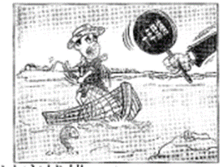
Recently, a father called Daming and his son Dongshun’s photos became hot all over China. In the photos, while they are working on the boat on Dongting Lake, lots of fish are jumping into the fish bin(鱼舱).
Dongting Lake is the second freshwater(淡水) lake in China, it’s home to nearly 400 kinds of fishes. But in the past, people threw litter and factories put waste water into the lake. Even worse, a large number of fish were caught by fishermen. Because of pollution and overfishing (过度捕捞), the Yangtze River was in great danger. For example, the Chinese paddlefish(中华白鲟) disappeared 2 years ago. Daming used to make a living by fishing near Dongting Lake. However, life was gradually becoming difficult for Daming and other fishermen. The more times they went to fish, the fewer fish they could get.
In January, 2020, the government called for a 10-year fishing ban(禁渔令), covering 332 conservation areas(保护区) in the Yangtze River. Dongshun has worked with his father as a lake ranger (巡湖员) for almost 3 years. This job helps him understand how important it is to protect Dongting Lake. “I think this job is meaningful.” he said, “As the wind is blowing gently, fish are swimming happily. What a beautiful scene! The fishing ban will lead Dongting Lake to a better future.”
36. Why was the Yangtze River in great danger in the past from the passage?
__________________________________________________________
37. How did Daming use to make a living?
__________________________________________________________
38. What did the government call for in January, 2020?
__________________________________________________________
39. What is Dongshun’s job now?
__________________________________________________________
40. Does Dongshun know the importance of protecting Dongting Lake?
__________________________________________________________
第三节 写作技能(共三部分，16小题。61~70小题，每小题1分；71~75小题，每小题2分；76小题20分，共40分)
A) 阅读填空
根据短文内容，在文中空格处填上一个恰当的词，使短文完整、通顺。
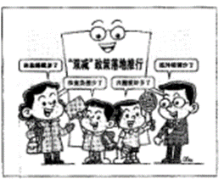
How does the tea plant grow? This term, some students got their answers in the school’s rooftop(屋顶) garden. Many schools have built small gardens on their teaching building’s rooftop. Some students planted tea plants there. While taking ___41___ of tea plants, they also did experiments to learn more about tea.
How to ___42___ egg soup and sandwiches? Some students learned to cook in an after-school cooking club. To parents’ ___43___, their kids could cook some simple dishes in a short time.
In the past, Chinese children were sometimes busier after school ___44___ they had to take so many after-school classes. Now, students join all kinds of clubs. Why do students have free time to ___45___ up their hobbies? Because China has introduced the “double reduction” policy(双减政策). It hopes to ease(减轻) students’ learning burden(负担) ___46___ reducing homework and after-school classes.
Students’ lives have changed a lot since the policy was carried out. On the one hand, their homework is clearly ___47___ than before, they aren’t encouraged to buy workbooks(练习册) any more. Teenagers have more chances to get knowledge from the real life. This is a much better way than just hitting the books. On the other hand, students spend more time ___48___ after-school clubs. They get lots of life skills from these colorful clubs and have enough time to relax and think for ___49___. It’s believed ___50___ the “double reduction” policy makes a difference to students’ lives.
B)翻译语篇
阅读下面的短文，将文中的划线部分译成汉语或英语。
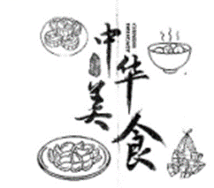
Different Chinese festivals have their own special foods. Dumplings, mooncakes, zongzi and sweet dumplings(汤圆) are the most popular.
※Zongzi 1. Zongzi is the typical food of the Dragon Boat Festival. On that day, people often make zongzi by hand. They put pork, red dates (红枣), beans into sticky rice(糯米). There are boat races in Miluo River every year. Some old people put zongzi in Miluo River to honor the ancient poet(诗人)—Qu Yuan.
※Mooncakes 2.月饼是满月的形状。On the Mid-Autumn Festival, the moon rises in the sky, mooncakes and fruits are laid out in the garden. All the family sit around a table, admire the bright and round moon, enjoy mooncakes, listen to the traditional folk stories and pray(祈祷) for family’s happiness and peace.
※Dumplings Dumplings are China’s traditional food and local snacks. They look like gold or silver ingots(锭). They can be boiled, steamed(蒸) and pan-fried(煎)。It’s a traditional custom that family members make and eat dumplings on the Spring Festival. People always hide a coin in one of the dumplings. 3.吃到有硬币的饺子的人是一个幸运儿。
※Sweet dumplings Sweet dumplings are a must-have on the Lantern Festival. We always make sweet dumplings good-looking, just like small balls which give us a big smile. We usually eat sweet dumplings and guess lantern riddles(谜语) on this festival. 4. Most of us like sweet dumplings because they remind people of many soft and sweet memories.
No matter how far away they are from home, the food is like a bridge between family members. The taste of food means the taste of home. 5. Chinese get a strong feeling, there is “no place like home.”
51. ________________________________
52. ________________________________
53. ________________________________
54. ________________________________
55. ________________________________
C)作文
56. 某英语网站开展关于“How to Improve Myself”的征稿活动，倡导同学们提升自我，努力成为“终生运动者，责任担当者，问题解决者，优雅生活者”，请根据以下图示内容积极投稿。
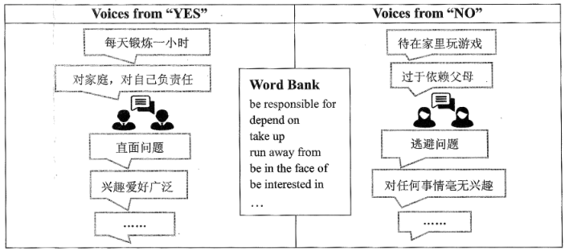
要求：
1.词数80~100；
2.请根据以上提示信息，结合实际情况叙述，可适当发挥；
3.文稿中不得出现真实的人名、校名；
4.字迹工整，语言流畅，表达正确，逻辑清晰。
How to Improve Myself
Life is really a long lesson, so I have to improve myself.
_______________________________________________________________________________
______________________________________________________________________________________________________________________________________________________________________________________________________________________________________________________________________________________________________________________________________________________________________________________________________________________________________________________________________________________

