2022年邵阳市初中学业水平考试试题卷
温馨提示:
1. 本学科试卷分试题卷和答题卡两部分，考试时间为90分钟，滿分120分;
2. 请你将姓名、准考证号等相关信息按要求填涂在答题卡上;
3. 请在签题卡上作答，答在本试題卷上无效。
第一部分 听力技能(两节，共20小題，满分20分)
A)反应 根据你所听到的内容，选择正确答语完成对话。每个句子读两遍。(共5小題，每小題1分)
1. A. Good idea. B. Thank you. C. No problem.
2. A. Tall. B. Yes. she is. C. Beautiful.
3. A. On Sunday. B. Twice a week. C. Three days.
4. A. Of course. you can. B. Well done. C. It’s easy.
5. A. Good luck. B. I think so. C. Moving.
B)理解根据你听到的対话或独白,选择最佳答案回答问題。每段对话读两遍。(共15小题，毎小题1分)
听下面的对话，回答第6至7小题。
6. What does the boy want to buy?
A. A sweater. B. A T-shirt. C. A coat.
7. How much is il?
A. 8 dollars. B. 9 dollars. C. 10 dollars.
听下面的对话，回答第8至9小題。
8. What is Peter doing?
A. Playing games. B. Reading a book. C. Doing homework.
9. What’s the relationship between the two speakers?
A. Father and son. B. Mother and son. C. Friends.
听下面的对话，回答第10至12小题。
10. What did Lisa do at Natural History Museum last weekend?
A. She worked as a guide. B. She gave a talk. C. She did some cleaning.
11 How many kinds of butterflies are there in the butterfly house?
A. Over 300. B. Over 200. C. Over 100.
12. Why did Paul feel a little tired?
A. Because he went hiking.
B. Because he helped his father work.
C. Because he stayed up late.
听下面的对话，回答第13至16小题。
13. How long has Jack been in Beijing?
A. One week. B. Two weeks. C. Three weeks.
14. Where does Jack come from?
A. America. B. Australia. C. Japan.
15. What does Jack think of the Terracotta Army in Xi’an?
A. Terrible. B. Ancient. C. Fantastic.
16. What’s Jack’s favorite Chinese food?
A. Beijing duck. B. Beijing noodles. C. Chinese jiaozi.
听下面一段独白，回答第17至20小題。独白读两遍。
17. How old is Lucy?
A. 13. B. 14. C. 15.
18. What sport does Lucy like best?
A. Tennis. B. Badminton. C. Volleyball.
19. How about Lucy’s eating habits?
A Bad. B. Good. C. Funny.
20. What happened to Lucy last night?
A. She had a toothache. B. She had a stomachache. C. She had a headache.
第二部分 知识运用(两节，共20小题，满分20分)
A)单项选择从A、B、C三个选项中选择最佳答案填空。(共10小題，每小题I分)
1. — Whose bike is this? Don’t put it here.
— Oh, it’s not mine. it’s ________.
A. her B. she C. hers
2. — Would you like some ________?
— Yes, madam.
A. egg B. juice C. milk teas
3. — ________ I use your iPad?
—Sorry, I’m using it now.
A. May B. Must C. Should
4. —This silk scarf looks nice.
—Yes, and it ________ in Thailand.
A. made B. makes C. was made
5. — A pandemic (疫情) broke out in Shaoyang last month.
— Yeah. ________ were so many doctors and nurses coming to help us.
A. They B. There C. Those
6. — Mike, why are you reading outside?
— I cannot enter the library ________ it opens.
A. because B. if C. until
7. —What kind of music do you like, Linda?
—I like music ________ I can dance to.
A. when B. that C. what
8. — Where’s Anna, dear?
— She ________ an online class in her room.
A. is taking B. takes C. will take
9. — Hou can I prevent COVID-19, Dad?
—________ healthy, you should always wear a mask and wash hands frequently.
A. Keep B. Keeping C. To keep
10. — Could you tell me ________ the Dragon-boat Festival, Jackson?
— I had a family get-together and ate delicious zongzi.
A. how you spent B. how did you spend C. when you spent
B) 完形填空 阅读短文，掌握其大意，从A、B、C三个选项中选择最佳答案填空。(共10小 每小题1分)
An unexpected thing happened in the ____11____ of my eleventh year. The home I had ____12____in was burned to the ground in the middle of the night. ____13____ , my mom, dad, grandma, brothers and I escaped(幸免于难). Yet, we had ____14____ but the night clothes we were wearing. I ____15____ the rest of the night with a friend of our family.
The next day, my mom brought me a few T-shirts ____16____ pair of jeans that another friend gave to her. My dad ____17____ to our broken home to see what he could find. The only things he could find were my mom’s rings.
To spend the summer, my dad rented us a big house on the same road ____18____ our old house had been. As we moved in, our kind friends and community continued to donate all they could to help us. Love was around us.
Looking back now I am ____19____ for all we went through that summer. It taught me so much about life, love and people. It showed me that when you have nothing left but ____20____ , for the first time you see that love is enough.
11. A. spring B. winter C. summer
12. A. grown up B. got up C. set up
13. A. Carefully B. Luckily C. Easily
14. A. anything B. something C. nothing
15. A. spent B. took C. decided
16. A. but B. and C. or
17. A. found B. moved C. returned
18. A. like B. as C. with
19. A. thankful B. surprised C. sorry
20. A. money B. friendship C. love
第三部分 阅读技能(四节，共20小题，满分40分)
A) (共5小题，每小题2分)
正误判断 阅读短文，根据短文内容判断所给句子正（T）误（F）。
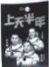
China’s Shenzhou XIII astronauts have completed their six-month stay in the Tiangong space station. They returned to Earth safely on April 16, 2022. They are Zhai Zhigang, Wang Yaping and Ye Guangfu.
“We thank all the Chinese people for their support and encouragement. Our thanks also go to our workmates who took part in the mission (任务) and worked with us all the time,” Zhai said to the reporter after he landed on the ground. “It is the power and strength of our country that built the high-flying space station. I am proud of our great motherland.”
Wang Yaping is the first Chinese woman to live in the Tiangong space station. She is also the first Chinese woman spacewalker. She told her little daughter happily, “Mom has returned after reaching for the stars.”
The three astronauts have set a new record for China’s longest spaceflight. They did more than 20 different scientific experiments and gave two live space classes. They also spent much time getting the station ready for its next visitors.
The success of the mission shows that China has mastered the key technologies of the space station. As the Tiangong space station is going to be completed at the end of this year, it will be a comfortable “home” for astronauts to further explore the space.
21. China’s Shenzhou XIII astronauts returned to Earth safely on March 16, 2022.
22. Zhai Zhigang thinks the success belongs to all the Chinese people.
23. From the space Wang Yaping got a real star for her daughter.
24. The three astronauts have set a new record for the world’s longest spaceflight.
25. From the passage, we can know that China’s space technology is getting more and more powerful.
B)阅读图表 阅读下面图表，从A、B、C三个选项中选出最佳答案回答问题或完成句子。(共5小题，每小题2分)
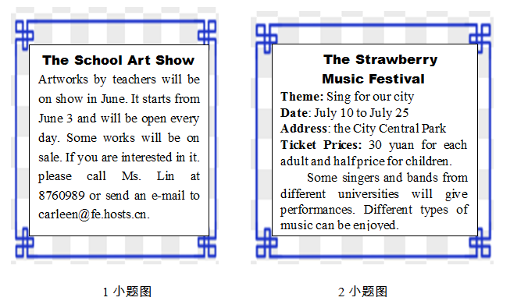
26. All the artworks shown at the School Art Show come from ________.
A. workers B. teachers C. artists
27. How much will they pay if Ms. Brown goes to the Strawberry Music festival with her two children?
A. 30 yuan. B. 45 yuan. C. 60 yuan.

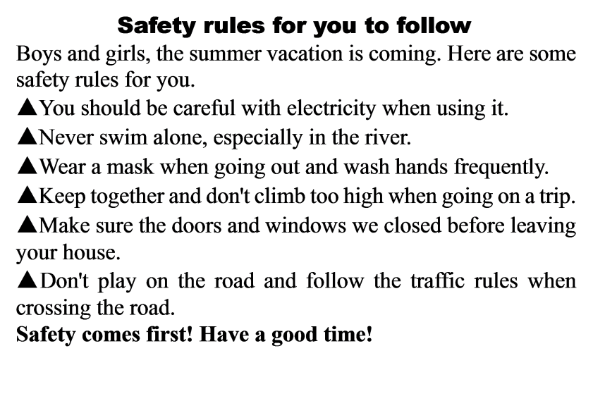

28. The passage is probably from ________.
A. a school notice B. a website C. a magazine
29. Which is NOT allowed for boys and girls according to the safety rules?
A. Keeping together when going on a trip.
B. Wearing masks when going out.
C. Swimming in the river.
30. What should you do when crossing the road?
A. Follow the traffic rules. B. Play on the road. C. Run across the road.
C)阅读选择 阅读短文，从A，B、C三个选项中选出最佳答案回答问题或完成句子。(共5小题，每小题2分)
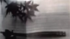
Chopsticks are a pair of small equal-length sticks, usually made of wood, used for eating Asian food. It is believed that the first chopsticks were developed in China. Chopsticks play an important role in Chinese food culture. Chinese chopsticks are usually 9 to 10 inches long. They are round on the eating end which means heaven (天), and the other end is square which means earth. The appearance of chopsticks said goodbye to those days when our Chinese ancestors had to use their hands to eat.
Besides, the use of chopsticks has also been a part of Chinese food culture. There are some taboos that you must pay great attention to when you use chopsticks. Firstly, don’t use them to hit your bowl or plate. Secondly, never use them to point at others. Thirdly, don’t put them in different food without taking something. Fourthly, don’t cross the chopsticks on the table. And lastly don’t leave your chopsticks standing in the rice. Chinese people do this only when they honour the dead.
Nowadays, chopsticks have many new usages. For example, you can buy a pair as a gift to your friends and relatives. In Chinese, it reads “kuaizi”, which means having sons soon, so a newly-married couple will be very happy to accept it as their wedding gift.
31. In which country are chopsticks mainly used?
A France. B. China. C. Australia.
32. What did our Chinese ancestors use to eat according to the passage?
A. Hands. B. Chopsticks. C. Spoons.
33. What does the underlined word “taboos” mean in Chinese?
A. 用途 B. 禁忌 C. 说明
34. Which of the following is TRUE from the passage?
A. The round end means earth, while the other square end means heaven.
B. You can use the chopsticks to point at others when you are angry.
C. Chopsticks can be used as gifts.
35. What does the passage mainly tell us?
A. The introduction of chopsticks.
B. The history of chopsticks.
C. The ways to use chopsticks.
D)信息摘录 (共5小题，每小题2分)
阅读短文，然后完成内容摘要。每空不超过三个单词。
There are many successful people in the world. If you want to succeed like them, the following rules of success are of great importance to you.
Speak less. Let your results speak for you. You don’t always need to tell everyone what you are doing, or what you’re planning to achieve. Let your results do the talking. People will notice and respect you more if they see your results before they hear your plans.
Listen more. You can not learn if you do not listen. You cannot grow if you do not learn. Listen with purpose. If you are serious about making your life great, you have to be devoted to (致力于) it.
Observe more. The closer you observe, the better your understanding and decisions will be. Pay close attention to those you admire. Pay close attention to what you want to master. Observe what works and what doesn’t work in your own life and make changes.
Finally, take action. Knowing is not enough and willing is not enough. We must do. If you want anything in life, it’s not coming to you while you sit on your hands. Get up, get out there and get it. Do whatever you can to achieve your great goals.
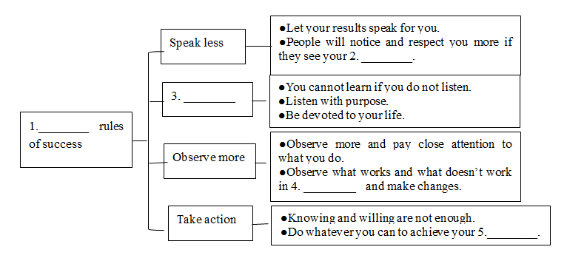
36. ________
37. ________
38. ________
39 ________
40. ________
第四部分 写作技能(四节，共16小题，满分40分)
A) 综合填空 (共5小題，每小題1分)
阅读下面短文，根据语境、中文、首字母或所给单词的提示，在空白处填入一个恰当的词，要求所填的词意义准确，形式正确，使短文意思完整，行文连贯。
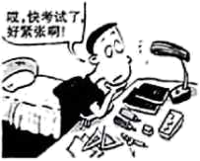
It is normal to feel a bit nervous about exams, especially if you’re u____41____ pressure from school or family. Exam stress can cause you to feel nervous. It might influence you. Here are some things you can do to reduce your exam pressure.
Firstly, let your trusted friends or family know if you are having ____42____ hard time. They can support you, encourage you and offer a listening ear. Keeping it a secret will only make things ____43____ (bad), so don’t be afraid to open up.
Secondly, tell your teachers about your worries and ask for help. They may have talked to lots of ____44____ (学生) who are going through similar things. So they can give you some helpful advice.
Thirdly, be kind to yourself. Think about all the things you have achieved so far. It can be helpful to write the things you like about yourself, and the things other people value about you, too. Treating yourself ____45____ (kind) is helpful.
If you follow these things above, I’m sure you will not be worried about exams anymore.
B) 补全对话 (共5小题, 每小題2分)
通读对话，根据上下文补全对话内容
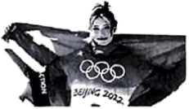
A: Hello, Lin Shan!
B: Hi, Wang Ling!
A: ____46____?
B: Yes, I did. I watched the Beijing Winter Olympics on TV last night.
A: Me, too. It’s really interesting. Did you see the skier Gu Ailing on TV?
B: Sure. She looks like a foreign girl, but she competes for our China. ____47____?
A: Because her mother is a Chinese, and she loves China, though she has an American father.
B: Wow! What a lovely girl! ____48____?
A: She won two gold medals in the Beijing Winter Olympic Games.
B: When was she born?
A:____49____.
B: Only 19 years old? She is still a student, isn’t she?
A: ____50____. She studies well, too.
B: Wow! She must be hard-working.
C) 英汉互译(共5小題, 每小題2分)
阅读下面短文，将文中画线的句子译成汉语或英语。
Now the children can read books for free in some villages in Indonesia. A moving library lends books to them in exchange for the waste. 1. They only need to collect waste. The special library was founded by Raden. 2.她经常给孩子们准备许多书。Each weekend, she uses the books to exchange for plastic bags, cups, bottles and other waste. 3. As soon as she arrives, the children will carry their waste to ask for books. Raden collects about 100kg waste each week and then sorts it out. Then she sends it for recycling or sells it. 4. Now the children are spending less time on online games but more time in reading. It’s a good way to help children develop their reading habits. It can also help them learn to care for the environment. Kevin is a 15-year-old reader and he always spends time looking for waste in his village. “When there is too much waste, our environment will become dirty. 5.这对我们的健康不好。That’s one of the reasons why I pick up waste in order to borrow books.” he said.
51. ________
52. ________
53. ________
54. ________
55. ________
D) 情景作文(共1小题，满分15分)
56. “双减”政策实施后的第一个暑假即将来临，假如你是Zhang Wei，你的英国笔友Tom来信询问你今年的暑期计划，请你给他写一封回信，内容要点如下：
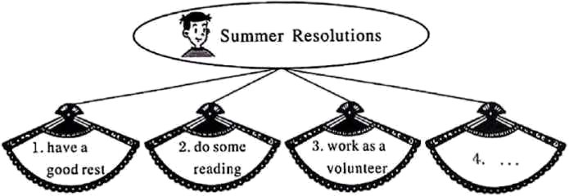
要求：1. 至少写四点暑期计划，可适当发挥；2.语言表达准确，语意通顺连贯；
3. 词数80左右。书信开头和结尾已给出，不计入总词数;
4. 请勿在文中出现其实的姓名、校名及地名。
Dear Tom,
How is everything going with you? In your letter, you asked me about my summer holiday resolutions. Now I’m writing to tell you some details.
Firstly,
________________________________________________________________________________________________________________________________________________________________________________________________________________________________________________________________________________________________________________________________________________________________________________________________________________________________________________________________________________________________________________________________________________________________________________________________________________________________________________________________________________________________________________
All in all, I hope I’ll spend a meaningful and colorful summer holiday.
Yours,
Zhang Wei

