2022年邵阳市初中学业水平考试试题卷
温馨提示:
1. 本学科试卷分试题卷和答题卡两部分，考试时间为90分钟，滿分120分;
2. 请你将姓名、准考证号等相关信息按要求填涂在答题卡上;
3. 请在签题卡上作答，答在本试題卷上无效。
第一部分 听力技能(两节，共20小題，满分20分)
A)反应 根据你所听到的内容，选择正确答语完成对话。每个句子读两遍。(共5小題，每小題1分)
1. A. Good idea. B. Thank you. C. No problem.
2. A. Tall. B. Yes. she is. C. Beautiful.
3. A. On Sunday. B. Twice a week. C. Three days.
4. A. Of course. you can. B. Well done. C. It’s easy.
5. A. Good luck. B. I think so. C. Moving.
B)理解根据你听到的対话或独白,选择最佳答案回答问題。每段对话读两遍。(共15小题，毎小题1分)
听下面的对话，回答第6至7小题。
6. What does the boy want to buy?
A. A sweater. B. A T-shirt. C. A coat.
7. How much is il?
A. 8 dollars. B. 9 dollars. C. 10 dollars.
听下面的对话，回答第8至9小題。
8. What is Peter doing?
A. Playing games. B. Reading a book. C. Doing homework.
9. What’s the relationship between the two speakers?
A. Father and son. B. Mother and son. C. Friends.
听下面的对话，回答第10至12小题。
10. What did Lisa do at Natural History Museum last weekend?
A. She worked as a guide. B. She gave a talk. C. She did some cleaning.
11. How many kinds of butterflies are there in the butterfly house?
A. Over 300. B. Over 200. C. Over 100.
12. Why did Paul feel a little tired?
A. Because he went hiking.
B. Because he helped his father work.
C. Because he stayed up late.
听下面的对话，回答第13至16小题。
13. How long has Jack been in Beijing?
A. One week. B. Two weeks. C. Three weeks.
14. Where does Jack come from?
A. America. B. Australia. C. Japan.
15. What does Jack think of the Terracotta Army in Xi’an?
A. Terrible. B. Ancient. C. Fantastic.
16. What’s Jack’s favorite Chinese food?
A. Beijing duck. B. Beijing noodles. C. Chinese jiaozi.
听下面一段独白，回答第17至20小題。独白读两遍。
17. How old is Lucy?
A. 13. B. 14. C. 15.
18. What sport does Lucy like best?
A. Tennis. B. Badminton. C. Volleyball.
19. How about Lucy’s eating habits?
A. Bad. B. Good. C. Funny.
20. What happened to Lucy last night?
A. She had a toothache. B. She had a stomachache. C. She had a headache.
第二部分 知识运用(两节，共20小题，满分20分)
A)单项选择从A、B、C三个选项中选择最佳答案填空。(共10小題，每小题I分)
1. — Whose bike is this? Don’t put it here.
— Oh, it’s not mine. it’s ________.
A. her B. she C. hers
【答案】C
【解析】
【详解】句意：——这是谁的自行车？不要把它放在这里。——哦，这不是我的。这是她的。
考查代词辨析。her她，她的；she她；hers她的，名词性物主代词。空处是表示“她的自行车”，空后没有名词，应用名词性物主代词，hers=her bike，故选C。
2. — Would you like some ________?
— Yes, madam.
A egg B. juice C. milk teas
【答案】B
【解析】
【详解】句意：——你想要些果汁吗？——是的，夫人。
考查名词辨析。egg鸡蛋；juice果汁；milk teas错误表达，奶茶是不可数名词，不可以加s。some修饰可数名词复数或不可数名词，只有B选项符合，故选B。
3. — ________ I use your iPad?
—Sorry, I’m using it now.
A. May B. Must C. Should
【答案】A
【解析】
【详解】句意：——我可以用一下你的平板电脑吗？——抱歉，我正在用。
考查动词辨析。May可以；Must必须；Should应该。根据“Sorry, I’m using it now.”可知，此处是拒绝对方的请求，表示请求，用may。故选A。
4. —This silk scarf looks nice.
—Yes, and it ________ in Thailand.
A. made B. makes C. was made
【答案】C
【解析】
【详解】句意：——这条丝巾看起来不错。——是的，它是在泰国制造的。
考查被动语态。主语it与动词make之间是被动关系，be made in“产自”，故选C。
5. — A pandemic (疫情) broke out in Shaoyang last month.
— Yeah. ________ were so many doctors and nurses coming to help us.
A. They B. There C. Those
【答案】B
【解析】
【详解】句意：——上个月，邵阳爆发了一场疫情。——是的。有很多医生和护士来帮助我们。
考查there be句型。分析句子可知，此处是there be句型，表示“有……”，主语是many doctors and nurses，故选B。
6. — Mike, why are you reading outside?
— I cannot enter the library ________ it opens.
A. because B. if C. until
【答案】C
【解析】
【详解】句意：——迈克，你为什么在外面看书？——直到图书馆开门我才能进入。
考查连词辨析。because因为；if如果；until直到。根据“I cannot enter the library...it opens.”可知在外面看书的原因是图书馆没开门，直到它开门时才能进入，not...until“直到……才”，故选C。
7. —What kind of music do you like, Linda?
—I like music ________ I can dance to.
A. when B. that C. what
【答案】B
【解析】
【详解】句意：——琳达，你喜欢什么样的音乐？——我喜欢我能跟着跳舞的音乐。
考查定语从句。when先行词时间，在从句中做状语；that先行词是人/物，在从句中作主语/宾语；what不引导定语从句。空前先行词“music”是物，需用that引导定语从句。故选B。
8. — Where’s Anna, dear?
— She ________ an online class in her room.
A. is taking B. takes C. will take
【答案】A
【解析】
【详解】句意：——安娜在哪里，亲爱的？——她正在她的房间里上在线课程。
考查动词时态。根据“Where’s Anna”可知，空处是强调此时此刻正在进行的动作，所以用现在进行时（am/is/are doing）。故选A。
9. — Hou can I prevent COVID-19, Dad?
—________ healthy, you should always wear a mask and wash hands frequently.
A. Keep B. Keeping C. To keep
【答案】C
【解析】
【详解】句意：爸爸，我该如何预防新冠病毒？——为了保持健康，你应该经常戴口罩，经常洗手。
考查非谓语动词。空处是动词不定式做目的状语。故选C。
10. — Could you tell me ________ the Dragon-boat Festival, Jackson?
— I had a family get-together and ate delicious zongzi.
A. how you spent B. how did you spend C. when you spent
【答案】A
【解析】
【详解】句意：——Jackson，你可以告诉我你如何度过端午节吗？——我有一个家庭聚会，吃美味的粽子。
考查宾语从句。此处是宾语从句，从句用陈述语序，排除B选项。根据答语“I had a family get-together and ate delicious zongzi”可知，此处询问度过节日的方式，用how引导宾语从句，故选A。
B) 完形填空 阅读短文，掌握其大意，从A、B、C三个选项中选择最佳答案填空。(共10小 每小题1分)
An unexpected thing happened in the ____11____ of my eleventh year. The home I had ____12____in was burned to the ground in the middle of the night. ____13____ , my mom, dad, grandma, brothers and I escaped(幸免于难). Yet, we had ____14____ but the night clothes we were wearing. I ____15____ the rest of the night with a friend of our family.
The next day, my mom brought me a few T-shirts ____16____ pair of jeans that another friend gave to her. My dad ____17____ to our broken home to see what he could find. The only things he could find were my mom’s rings.
To spend the summer, my dad rented us a big house on the same road ____18____ our old house had been. As we moved in, our kind friends and community continued to donate all they could to help us. Love was around us.
Looking back now I am ____19____ for all we went through that summer. It taught me so much about life, love and people. It showed me that when you have nothing left but ____20____ , for the first time you see that love is enough.
11. A. spring B. winter C. summer
12. A. grown up B. got up C. set up
13. A. Carefully B. Luckily C. Easily
14. A. anything B. something C. nothing
15. A. spent B. took C. decided
16. A. but B. and C. or
17. A. found B. moved C. returned
18. A. like B. as C. with
19. A. thankful B. surprised C. sorry
20. A. money B. friendship C. love
【答案】11. C 12. A 13. B 14. C 15. A 16. B 17. C 18. A 19. A 20. C
【解析】
【导语】本文主要讲述了作者11岁住的房子半夜被烧毁了，全家人逃了出来。朋友们在物质和精神上给了他们很大的帮助，使他们一家渡过了难关，重新开始新的生活。作者明白了只要身边有爱，生活就有希望。
【11题详解】
句意：在我十一岁的夏天，一件意想不到的事情发生了。
spring春天；winter冬天；summer夏天。根据下文“To spend the summer”可知是指夏天，故选C。
【12题详解】
句意：我成长的家在半夜被烧成了平地。
grown up长大；got up起床；set up建立。根据“The home”可知，此处指作者从小长大的地方，故选A。
【13题详解】
句意：幸运的是，我的妈妈，爸爸，奶奶，兄弟们和我都逃了出来。
Carefully仔细地；Luckily幸运地；Easily容易地。结合语境可知，发生了火灾，但是家人都没事，这是很幸运的，故选B。
【14题详解】
句意：然而，我们除了穿的睡衣，什么都没有。
anything任何事；something某事；nothing没有什么。根据“Yet, we had...but the night clothes we were wearing”可知作者一家人除了睡衣，什么都没有，故选C。
【15题详解】
句意：剩下的时间我和我们家的一个朋友一起过的。
spent花费，主语是人；took花费，主语一般是it；decided决定。根据“the rest of the night with a friend of our family.”可知是度过剩下的时间，主语是人，用spend，故选A。
【16题详解】
句意：第二天，妈妈给我带来了几件t恤和一条牛仔裤，这是另一个朋友送给她的。
but但是；and和；or或者。根据“T-shirts...pair of jeans”可知此处是表示并列，应用and，故选B。
【17题详解】
句意：我父亲回到我们破碎的家，想看看能找到什么。
found发现；moved移动；returned返回。根据“My dad...to our broken home”可知父亲是返回到被烧毁的家，故选C。
【18题详解】
句意：为了度过这个夏天，我爸爸在同一条路上给我们租了一所大房子，就像我们的老房子一样。
like像；as作为；with和。根据“To spend the summer, my dad rented us a big house on the same road...our old house had been”可知租的房子就像之前的老房子一样，故选A。
【19题详解】
句意：现在回想起来，我很感激那个夏天我们所经历的一切。
thankful感激的；surprised惊讶；sorry遗憾的。根据“It taught me so much about life, love and people”可知作者对此表示感谢，故选A。
【20题详解】
句意：它让我明白，当你除了爱一无所有时，你会第一次明白，有爱就足够了。
money钱；friendship友谊；love爱。根据“ love is enough.”可知是指爱，故选C。
第三部分 阅读技能(四节，共20小题，满分40分)
A) (共5小题，每小题2分)
正误判断 阅读短文，根据短文内容判断所给句子正（T）误（F）。
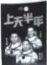
China’s Shenzhou XIII astronauts have completed their six-month stay in the Tiangong space station. They returned to Earth safely on April 16, 2022. They are Zhai Zhigang, Wang Yaping and Ye Guangfu.
“We thank all the Chinese people for their support and encouragement. Our thanks also go to our workmates who took part in the mission (任务) and worked with us all the time,” Zhai said to the reporter after he landed on the ground. “It is the power and strength of our country that built the high-flying space station. I am proud of our great motherland.”
Wang Yaping is the first Chinese woman to live in the Tiangong space station. She is also the first Chinese woman spacewalker. She told her little daughter happily, “Mom has returned after reaching for the stars.”
The three astronauts have set a new record for China’s longest spaceflight. They did more than 20 different scientific experiments and gave two live space classes. They also spent much time getting the station ready for its next visitors.
The success of the mission shows that China has mastered the key technologies of the space station. As the Tiangong space station is going to be completed at the end of this year, it will be a comfortable “home” for astronauts to further explore the space.
21. China’s Shenzhou XIII astronauts returned to Earth safely on March 16, 2022.
22. Zhai Zhigang thinks the success belongs to all the Chinese people.
23. From the space Wang Yaping got a real star for her daughter.
24. The three astronauts have set a new record for the world’s longest spaceflight.
25. From the passage, we can know that China’s space technology is getting more and more powerful.
【答案】21. F 22. T
23. F 24. F
25. T
【解析】
【导语】本文主要介绍了中国神舟十三号宇航员已经在天宫空间站完成了六个月的停留。他们于2022年4月16日安全返回地球。
【21题详解】
细节理解题。根据“They returned to Earth safely on April 16, 2022, They are Zhai Zhigang,Wang Yaping and Ye Guangfu.”可知他们于2022年4月16日安全返回地球，故选F。
【22题详解】
推理判断题。根据“We thank all the Chinese people for their support and encouragement. Our thanks also go to our workmates who took part in the mission (任务) and worked with us all the time”可知翟志刚认为成功属于全体中国人。故选T。
【23题详解】
细节理解题。根据“ She told her little daughter happily, “Mom has returned after reaching for the stars”结合常识可知星星是不可能被摘下来的，故选F。
【24题详解】
细节理解题。根据“The three astronauts have set a new record for China’s longest spaceflight.”可知这三名宇航员创造了中国最长太空飞行的新纪录，不是世界上，故选F。
【25题详解】
推理判断题。根据“The success of the mission shows that China has mastered the key technologies of the space station.”可知从文章中，我们可以知道中国的空间技术越来越强大。故选T。
B)阅读图表 阅读下面图表，从A、B、C三个选项中选出最佳答案回答问题或完成句子。(共5小题，每小题2分)
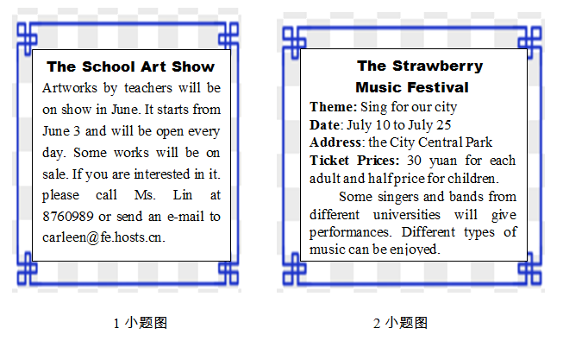
26. All the artworks shown at the School Art Show come from ________.
A. workers B. teachers C. artists
27. How much will they pay if Ms. Brown goes to the Strawberry Music festival with her two children?
A 30 yuan. B. 45 yuan. C. 60 yuan.
【答案】26. B 27. C
【解析】
【导语】本文主要介绍了学校艺术展和草莓音乐节的相关信息。
【26题详解】
细节理解题。根据“Artworks by teachers will be on show...”可知，作品都出自老师之手，故选B 。
【27题详解】
数字计算题。根据“Ticket Prices：30 yuan for each adults and half-prices for children”可知，成人是30元，儿童是半价，所以布朗太太和她的两个孩子一共要花60元，故选C。

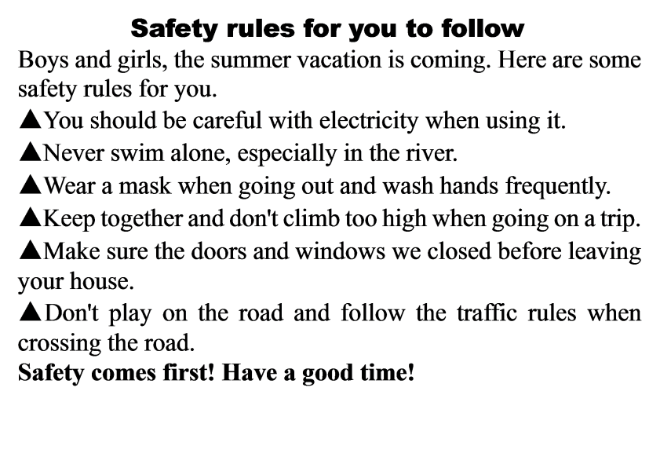

28. The passage is probably from ________.
A. a school notice B. a website C. a magazine
29 Which is NOT allowed for boys and girls according to the safety rules?
A. Keeping together when going on a trip.
B. Wearing masks when going out.
C. Swimming in the river.
30. What should you do when crossing the road?
A. Follow the traffic rules. B. Play on the road. C. Run across the road.
【答案】28. A 29. C 30. A
【解析】
【导语】本文主要介绍了一些暑假期间的安全守则。
【28题详解】
推理判断题。本文主要介绍了一些暑假期间的安全守则，针对的是学生，所以可能是一则学校的布告。故选A。
【29题详解】
细节理解题。根据文中提到的安全守则中“Never swim alone,especially in the river”可知，在河里游泳是不允许的。故选C。
【30题详解】
细节理解题。根据“Don’t play on the road and follow the traffic rules when crossing the road”可知，过马路时不要在马路上玩耍，要遵守交通规则。故选A。
C)阅读选择 阅读短文，从A，B、C三个选项中选出最佳答案回答问题或完成句子。(共5小题，每小题2分)

Chopsticks are a pair of small equal-length sticks, usually made of wood, used for eating Asian food. It is believed that the first chopsticks were developed in China. Chopsticks play an important role in Chinese food culture. Chinese chopsticks are usually 9 to 10 inches long. They are round on the eating end which means heaven (天), and the other end is square which means earth. The appearance of chopsticks said goodbye to those days when our Chinese ancestors had to use their hands to eat.
Besides, the use of chopsticks has also been a part of Chinese food culture. There are some taboos that you must pay great attention to when you use chopsticks. Firstly, don’t use them to hit your bowl or plate. Secondly, never use them to point at others. Thirdly, don’t put them in different food without taking something. Fourthly, don’t cross the chopsticks on the table. And lastly don’t leave your chopsticks standing in the rice. Chinese people do this only when they honour the dead.
Nowadays, chopsticks have many new usages. For example, you can buy a pair as a gift to your friends and relatives. In Chinese, it reads “kuaizi”, which means having sons soon, so a newly-married couple will be very happy to accept it as their wedding gift.
31. In which country are chopsticks mainly used?
A. France. B. China. C. Australia.
32. What did our Chinese ancestors use to eat according to the passage?
A. Hands. B. Chopsticks. C. Spoons.
33. What does the underlined word “taboos” mean in Chinese?
A. 用途 B. 禁忌 C. 说明
34. Which of the following is TRUE from the passage?
A. The round end means earth, while the other square end means heaven.
B. You can use the chopsticks to point at others when you are angry.
C. Chopsticks can be used as gifts.
35. What does the passage mainly tell us?
A. The introduction of chopsticks.
B. The history of chopsticks.
C. The ways to use chopsticks.
【答案】31. B 32. A 33. B 34. C 35. A
【解析】
【导语】本文主要介绍了筷子在中国饮食文化中扮演的重要角色。
【31题详解】
细节理解题。根据“ It is believed that the first chopsticks were developed in China. Chopsticks play an important role in Chinese food culture. ”可知，中国主要使用筷子。故选B。
【32题详解】
细节理解题。根据“The appearance of chopsticks said goodbye to those days when our Chinese ancestors had to use their hands to eat.”可知，筷子出现之前，中国的祖先是用手吃饭的，故选A。
【33题详解】
词义猜测题。根据“ Firstly, don’t use them to hit your bowl or plate. Secondly, never use them to point at others. Thirdly, don’t put them in different food without taking something. Fourthly, don’t cross the chopsticks on the table. And lastly don’t leave your chopsticks standing in the rice. Chinese people do this only when they honour the dead.”可知，这里是介绍使用筷子时需要注意的禁忌，所以划线单词表示“禁忌”。故选B。
【34题详解】
细节理解题。根据“For example, you can buy a pair as a gift to your friends and relatives.”可知，筷子可以作为礼物送人，故选C。
【35题详解】
主旨大意题。本文主要介绍了筷子在中国饮食文化中扮演的重要角色。故选A。
D)信息摘录 (共5小题，每小题2分)
阅读短文，然后完成内容摘要。每空不超过三个单词。
There are many successful people in the world. If you want to succeed like them, the following rules of success are of great importance to you.
Speak less. Let your results speak for you. You don’t always need to tell everyone what you are doing, or what you’re planning to achieve. Let your results do the talking. People will notice and respect you more if they see your results before they hear your plans.
Listen more. You can not learn if you do not listen. You cannot grow if you do not learn. Listen with purpose. If you are serious about making your life great, you have to be devoted to (致力于) it.
Observe more. The closer you observe, the better your understanding and decisions will be. Pay close attention to those you admire. Pay close attention to what you want to master. Observe what works and what doesn’t work in your own life and make changes.
Finally, take action. Knowing is not enough and willing is not enough. We must do. If you want anything in life, it’s not coming to you while you sit on your hands. Get up, get out there and get it. Do whatever you can to achieve your great goals.
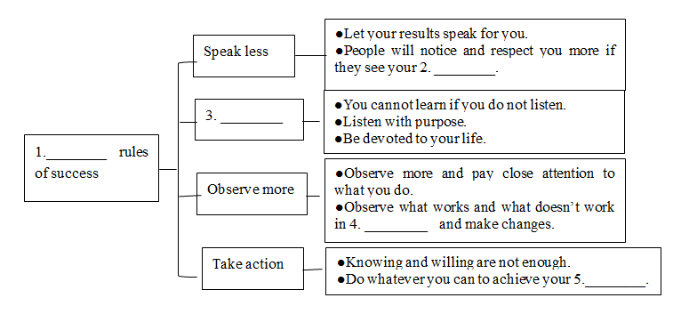
36. ________
37. ________
38. ________
39. ________
40. ________
【答案】36. Four##4
37. results
38. Listen more
39. your own life
40. goals
【解析】
【导语】本文介绍了成功的方法和策略。
【36题详解】
根据“Speak less”“Listen more”“Observe more”及“Finally, take action.”可知，介绍了四种成功的方法，故填Four/4。
【37题详解】
根据“People will notice and respect you more if they see your results before they hear your plans”可知，如果人们在听到你的计划之前看到你的成果，他们会更注意和尊重你，故填results。
【38题详解】
根据“Speak less”“Listen more”“Observe more”及“Finally, take action.”可知，第二个方法是“多听”，故填Listen more。
【39题详解】
根据“Observe what works and what doesn’t work in your own life and make changes”可知，观察在你自己的生活中什么可行，什么不可行，然后做出改变，故填your own life。
【40题详解】
根据“Do whatever you can to achieve your great goals”可知，尽你所能去实现你的伟大目标，故填goals。
第四部分 写作技能(四节，共16小题，满分40分)
A) 综合填空 (共5小題，每小題1分)
阅读下面短文，根据语境、中文、首字母或所给单词的提示，在空白处填入一个恰当的词，要求所填的词意义准确，形式正确，使短文意思完整，行文连贯。
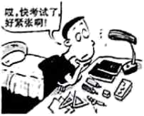
It is normal to feel a bit nervous about exams, especially if you’re u____41____ pressure from school or family. Exam stress can cause you to feel nervous. It might influence you. Here are some things you can do to reduce your exam pressure.
Firstly, let your trusted friends or family know if you are having ____42____ hard time. They can support you, encourage you and offer a listening ear. Keeping it a secret will only make things ____43____ (bad), so don’t be afraid to open up.
Secondly, tell your teachers about your worries and ask for help. They may have talked to lots of ____44____ (学生) who are going through similar things. So they can give you some helpful advice.
Thirdly, be kind to yourself. Think about all the things you have achieved so far. It can be helpful to write the things you like about yourself, and the things other people value about you, too. Treating yourself ____45____ (kind) is helpful.
If you follow these things above, I’m sure you will not be worried about exams anymore.
【答案】41. (u)nder
42. a 43. worse
44. students##pupils
45. kindly
【解析】
【导语】本文注意讲述了一些可以做的事情来减轻你的考试压力。
【41题详解】
句意：考试时感到有点紧张是正常的，尤其是当你面临来自学校或家庭的压力时。根据“you’re u...pressure from school or family”可知是处于压力下，under pressure“在压力下”，故填(u)nder。
【42题详解】
句意：首先，如果你遇到了困难，让你信任的朋友或家人知道。固定短语have a hard time“日子不好过”，故填a。
【43题详解】
句意：保守秘密只会让事情变得更糟所以不要害怕敞开心扉。根据“ Keeping it a secret will only make things...so don’t be afraid to open up.”可知句子暗含两者比较，应用形容词比较级，故填worse。
【44题详解】
句意：他们可能已经和许多有类似经历的学生谈过了。student和pupil都可以表示“学生”，可数名词，此处应用复数形式，故填students/pupils。
【45题详解】
句意：善待自己是有益的。kind是形容词，此处应用其副词形式修饰动词，故填kindly。
B) 补全对话 (共5小题, 每小題2分)
通读对话，根据上下文补全对话内容。
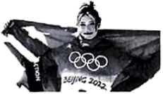
A: Hello, Lin Shan!
B: Hi Wang Ling!
A: ____46____?
B: Yes, I did. I watched the Beijing Winter Olympics on TV last night.
A: Me, too. It’s really interesting. Did you see the skier Gu Ailing on TV?
B: Sure. She looks like a foreign girl, but she competes for our China. ____47____?
A: Because her mother is a Chinese, and she loves China, though she has an American father.
B: Wow! What a lovely girl! ____48____?
A: She won two gold medals in the Beijing Winter Olympic Games.
B: When was she born?
A:____49____.
B: Only 19 years old? She is still a student, isn’t she?
A: ____50____. She studies well, too.
B: Wow! She must be hard-working.
【答案】46. Did you watch the Beijing Winter Olympics
47. Why 48. What did she win in the Beijing Winter Olympics
49. She was born in 2003
50. Yes, she is
【解析】
【导语】本文是A和B的对话，主要谈论了滑雪运动员谷爱凌的一些基本信息。
【46题详解】
根据“Yes, I did. I watched the Beijing Winter Olympics on TV last night.”可知，此处是问对方有没有看北京冬奥会。故填Did you watch the Beijing Winter Olympics。
【47题详解】
根据“She looks like a foreign girl, but she competes for our China.”以及“Because her mother is a Chinese...”可知，此处是问原因。故填Why。
【48题详解】
根据“She won two gold medals in the Beijing Winter Olympic Games.”可知，此处是问在北京冬奥会上谷爱凌赢得了什么奖牌。故填What did she win in the Beijing Winter Olympics。
【49题详解】
根据“When was she born?”以及“Only 19 years old?”可知，此处是回答谷爱凌什么时候出生，今年19岁，也就是2003年出生。故填She was born in 2003。
【50题详解】
根据“She is still a student, isn’t she?”以及“ She studies well, too.”可知，谷爱凌是学生，此处是作肯定回答。故填Yes, she is。
C) 英汉互译(共5小題, 每小題2分)
阅读下面短文，将文中画线的句子译成汉语或英语。
Now the children can read books for free in some villages in Indonesia. A moving library lends books to them in exchange for the waste. 1. They only need to collect waste. The special library was founded by Raden. 2.她经常给孩子们准备许多书。Each weekend, she uses the books to exchange for plastic bags, cups, bottles and other waste. 3. As soon as she arrives, the children will carry their waste to ask for books. Raden collects about 100kg waste each week and then sorts it out. Then she sends it for recycling or sells it. 4. Now the children are spending less time on online games but more time in reading. It’s a good way to help children develop their reading habits. It can also help them learn to care for the environment. Kevin is a 15-year-old reader and he always spends time looking for waste in his village. “When there is too much waste, our environment will become dirty. 5.这对我们的健康不好。That’s one of the reasons why I pick up waste in order to borrow books.” he said.
51. ________
52. ________
53. ________
54. ________
55. ________
【答案】51. 他们仅仅需要收集废物。
52. She often prepares lots of books for the kids.
53. 她一到，孩子们就会带着废物来换书籍。
54. 现在孩子们玩网络游戏的时间少了，但是阅读的时间更多了。
55. It’s bad for our health.
【解析】
【导语】本文主要讲述了在印度尼西亚的一个村庄里，孩子们用收集的废物来换书读。
【51题详解】
They“他们”；only“只、仅仅”；need“需要”；to collect waste“收集废物”。根据汉语表达习惯，故填：他们仅仅需要收集废物。
【52题详解】
根据汉语可知，时态是一般现在时，“她”she，作主语，谓语动词用三单形式；“经常”often；“给某人准备某物”prepare sth for sb；“孩子们”children；“许多书”lots of books。故填She often prepares lots of books for the kids.
【53题详解】
As soon as“一……就……”；she“她”；arrives“到达”；the children“孩子们”；will carry“就会带着”；their waste“他们的废物”；to ask for books“换书”。根据汉语表达习惯，故填：她一到，孩子们就会带着废物来换书籍。
【54题详解】
Now“现在”；the children“孩子们”；spending less time on online games“玩网络游戏时间少了”；but“但是”；more time in reading“阅读时间更多了”。根据汉语表达习惯，故填：现在孩子们玩网络游戏的时间少了，但是阅读的时间更多了。
【55题详解】
根据汉语可知，时态是一般现在时，“这”it作主语，谓语动词用三单形式；“对……不好”be bad for；“我们的健康”our health。故填It’s bad for our health.
D) 情景作文(共1小题，满分15分)
56. “双减”政策实施后的第一个暑假即将来临，假如你是Zhang Wei，你的英国笔友Tom来信询问你今年的暑期计划，请你给他写一封回信，内容要点如下：
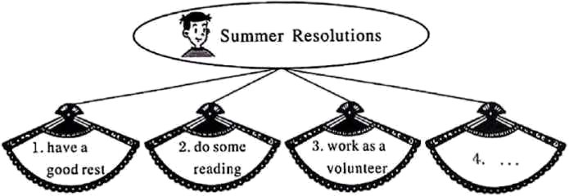
要求：1. 至少写四点暑期计划，可适当发挥；2.语言表达准确，语意通顺连贯；
3. 词数80左右。书信开头和结尾已给出，不计入总词数;
4. 请勿在文中出现其实的姓名、校名及地名。
Dear Tom,
How is everything going with you? In your letter, you asked me about my summer holiday resolutions. Now I’m writing to tell you some details.
Firstly,
________________________________________________________________________________________________________________________________________________________________________________________________________________________________________________________________________________________________________________________________________________________________________________________________________________________________________________________________________________________________________________________________________________________________________________________________________________________________________________________________________________________________________________
All in all, I hope I’ll spend a meaningful and colorful summer holiday.
Yours,
Zhang Wei
【答案】[例文]
Dear Tom,
How is everything going with you? In your letter, you asked me about my summer holiday resolutions. Now I’m writing to tell you some details.
Firstly, I want to have a good rest and relax myself. I will listen to some music or watch some TV. Secondly, I will read some books. I like reading very much. So I read a book every week to broaden my horizons. Thirdly, I will be a volunteer to help those in need. Finally, I will help my parents do some housework at home.
All in all, I hope I’ll spend a meaningful and colorful summer holiday.
Yours,
Zhang Wei
【解析】
【详解】1.题干解读：本文是一篇书信作文。根据要点提示，给英国笔友Tom回一封关于你今年的暑期计划的信。
2.写作指导：本文时态以一般将来时为主。人称以第一人称为主。写作时包含要点，且自己需要再加一点暑期计划，可使用过渡词Firstly，Secondly，Thirdly以及Finally使文章更通畅，最后确保语句通顺，无单词语法错误。

