2022年天水市初中毕业与升学学业考试（中考）
英语试卷
Ⅰ.单词辨音（共5小题；每小题1分，满分5分）
从A、B、C、D四个选项中，找出画线部分与其他三个单词画线部分读音不同的选项。
1. A. cut B. luck C. music D. hurry
2. A. ever B. he C. mess D. pen
3. A. forty B. morning C. horse D. word
4. A. who B. what C. why D. where
5. A. cake B. cent C. city D. cinema
Ⅱ.语法与情景对话（共20小题；每小题1分，满分20分）
阅读下列各题，从A、B、C、D四个选项中选择一个最佳答案。
6. I just bought a new shirt. ________ shirt was pretty expensive.
A. A B. An C. The D. /
7. The ________ rang and Pat answered it. It was his son calling from New York.
A. telephone B. doorbell C. clock D. bike
8. These are my cousins. ________ are both university students.
A. We B. You C. I D. They
9. We can see the toy bear ________ in the picture.
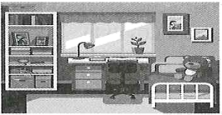
A in the box B. on the bed C. beside the shelf D. under the table
10. —This will be my ________ visit to the Great Wall. I’m really excited.
—Really? I can’t believe you’ve never been there yet. You arrived in Beijing almost a year ago!
A. first B. second C. third D. fourth
11. Let’s ________ the chicken and make some soup.
A. look at B. cut up C. put off D. knock against
12. — How’s the new restaurant?
— It’s ________. We waited a long time for the food to arrive.
A. wonderful B. exciting C. difficult D. awful
13. I haven’t got any apple juice, ________ I’ve got some orange juice. Would you like some?
A. but B. and C. or D. for
14 — ________ do you exercise?
— Every day.
A. How long B. Why C. What time D. How often
15. Linda spoke too quietly. I could ________ hear her at the back.
A. always B. ever C. hardly D. usually
16. — Shall we have an outdoor graduation party after the exam?
— ________ I think everyone will love it.
A. Good idea. B. No way. C. Enjoy yourself. D. The same to you.
17. Paper ________ in ancient China more than 2,000 years ago.
A. invented B. was invented C. invent D. is invented
18. I wonder ________ .
A. that April is the hottest month in Thailand B. do you know where I can buy some medicine
C. whether June is a good time to visit Gansu D. how can I improve my pronunciation
19. —I don’t think sixteen-year-olds should be allowed to smoke.
— ________ It’s bad for the teens’ health.
A. I agree. B. I hope so. C. I disagree. D. I hope not.
20. What can we know from this School Notice?
NOTICE: School Closed
starting Monday,
March 16 due COVID-19

A. School will start on Monday. B. School will be closed for a week.
C. We’ve succeeded in fighting against COVID-19. D. Students needn’t go to school on March 16.
21. — Hi, Mary. You look tired. ________
— I missed the school bus so I had to run to school this morning.
A. What happened? B. What a pain! C. You’re kidding. D. How about you?
22. We ________ a meeting. Come and join in.
A. were having B. are having C. had D. have been
23. —Kevin, what are you doing? Don’t you remember that the doctor warns you not to eat any candy?
—I’m so sorry! I totally forgot about that. I’m so used to eating candy every Halloween that I didn’t remember this year I wasn’t supposed to. ________
A. Practice makes perfect. B. When in Rome, do as the Romans do.
C. Old habits die hard. D. Time is money.
24. — Happy birthday to you, Mary.
— ________
A. Have a nice day. B. See you. C. The same to you. D. Thank you.
25. Which of the following sign will you probably see in a reading room of a library?
A.  B.  C. 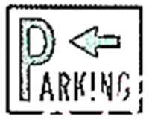 D. 
Ⅲ.完形填空（共10小题；每小题1.5分，满分15分）
阅读下面短文，从短文后各题所给的四个选项中选出能填入空白处的最佳答案。
阅读下面短文，从短文后各题所给的四个选项中选出能填入空白处的最佳答案。
It was the turkey that made it the worst Thanksgiving ever…well, it ___26___ did.
All the family—my grandparents, my parents, my aunt and uncle, my cousin, my sister and I— ___27___ the turkey. However, turkey is not the easiest thing to ___28___. It takes a lot of time to prepare and a lot of work to cook…and there are a lot of chances for things to go wrong.
My mum and dad bought a nice, big turkey a few days before Thanksgiving. ___29___ was proud of herself as she got it for a good price. ___30___ Thanksgiving, Mum got the turkey out of the fridge. Early the next morning, my sister and I helped her put some butter and salt on the turkey. After that, Mum put it in the oven. It looked like it would be delicious. My sister and I were ___31___.
But soon, we noticed something was wrong. The oven was ___32___. Dad checked it closely. ___33___ he said in a low voice, “it’s broken.”
Mum’s heart almost stopped She didn’t want her dinner to be a failure. We didn’t know ___34___. How were we going to feed everyone without the turkey? Mum looked worried.
Finally, Dad had an idea, and we all agreed with his suggestion to order ____35____ instead. After all, Thanksgiving is about giving thanks and spending time with your family.
That evening, we shared a delicious pizza. We had a great time, talking, eating and playing games. Thanksgiving without turkey can still be fun!
26. A. really B. nearly C. finally D. hardly
27. A. shared B. hated C. expected D. bought
28. A. cook B. eat C. buy D. raise
29. A. Grandma B. My aunt C. My sister D. Mum
30. A. The night before B. After C. On D. Two days before
31. A. worried B. excited C. nervous D. full
32. A. cooking well B. self cleaning C. not heating up D. not smoking
33. A. For B. Or C. But D. And
34. A. what to do B. how to do it C. where to buy it D. when to have it
35. A. pizza B. a turkey C. sandwiches D. chicken
Ⅳ.阅读理解（共15小题；每小题2分，满分30分）
A
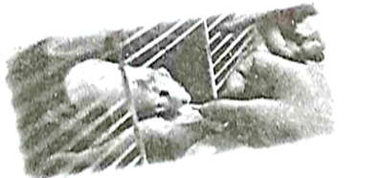
Dear Kimmy,
Guess what, we have a class pet! It’s a hamster. Miss Lee showed us how to take care of our new furry friend, Tobin. She explained that her own hamster had given birth to three pups and Tobin is one of them. Needless to say, we were delighted and promised to be responsible pet owners.
Well, till next time.
PS: It’s a picture of our new pet. Do you have a pet?
Your pen-pal,
Andrew
阅读以上书信，根据其内容判读下列句子正误。正确填（涂）A、错误填（涂）B。
36. It’s a letter from Kimmy to Andrew.
37. Andrew’s class pet is furry.
38. Miss Lee took Tobin to the class.
39. Tobin’s mother gave birth to four pups.
40. Andrew is sure that his pen-pal has a pet and loves animals.
B
Riddle 1  I carry a big bag every day.  There are letters and parcels in the bag.  I take them to people.  Who am I? | Riddle 2  I wear a uniform.  I catch thieves.  I make sure the neighbourhood is safe.  Who am I?
Riddle 3  I work on a bus.  I drive it around every day.  I take people to different places.  Who am I? | Riddle 4  I work in a shop.  Many children come to the shop.  They buy sweets and chocolate.  Who am I?
阅读以上四条谜语，根据其内容回答其后各个小题。
41. The underlined pronoun “them” in Riddle 1 refers to ________ .
A big bags B. letters and parcels C. people D. riddles
42. What is the answer of Riddle 2?
A. A teacher. B. An engineer. C. A waiter. D. A policeman.
43. Where does the person in Riddle 3 work?
A. On a bus. B. In a zoo. C. At an airport. D. On a farm.
44. The shop in Riddle 4 is probably a ________ .
A. book store B. fruit store C. fish market D. candy store
45. The riddles are about ________ .
A. children B. parents C. jobs D. places
C

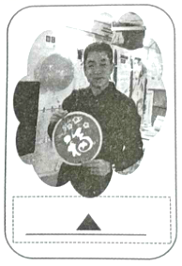
Life in Outer Space
Chinese taikonauts Zhai Zhigang, Wang Yaping and Ye Guangfu carried out the Shenzhou-13 spaceflight mission (任务) that started on Oct. 15, 2021. This mission lasts 6 months, which was also a national record. Zhai is the commander (指令长) who performed China’s first spacewalk in the Shenzhou-7 mission in 2008. Wang, who was in the Shenzhou-10 mission in 2013, is the first Chinese woman astronaut to visit China’s space station. Ye is a new comer to space.
The trio had carried out two spacewalks and completed more than 20 scientific tasks. Besides their tasks, they had also given two live lectures from the space station, showing the students their living and working areas at the Tianhe core module and several scientific experiments under zero-gravity conditions and answering real-time questions from students.
The trio also became the first Chinese to spend the nation’s most important festival — the Chinese Lunar New Year — in outer space.
They returned to Earth on April 16, 2022 and made Shenzhou-13 mission a great success.
阅读以上新闻稿，根据其内容回答其后各个小题。
46. How long was the mission that was carried out by the taikonauts?
A. 13 months. B. 10 months. C. 7 months. D. 6 months.
47. What does the underlined “ trio ” probably mean?
A. A group of two. B. A group of three. C. A group of four. D. A group of five.
48. Which paragraph tells us what the taikonauts had mainly done in this mission in space?
A. Paragraph 1. B. Paragraph 2. C. Paragraph 3. D. Paragraph 4.
49. What would be the most suitable to replace ________ in the picture?
A. Commander Zhai held a pair of couplets and wished the Chinese people good health.
B. Wang, with a red balloon in hand, wished children across the country healthy growth.
C. Ye held a sticker with the Chinese character “ fu, ” and wished the Chinese people a happy Lunar New Year.
D. The taikonauts have put up red lanterns, Chinese knots and paper-cut craft to celebrate the Chinese New Year.
50. Which of the following is NOT true?
A. All the three taikonauts had been to the space before. B. Zhai Zhigang is a commander.
C. The trio gave two live lectures from the space station. D. They returned to earth in mid-April.
Ⅴ.任务型完形填空（共10空；每空1分，满分10分）
用方框中所给单词或短语的适当形式填空，使短文通顺、正确、连贯，每个单词或短语限用一次。
can, I, be, five, miss, good, in, road, wait for, back
“What a great film!” says Dan.
Dan Parks and Sue Barrington are leaving the Odeon cinema in Oxford.
“I love Eddie Redmayne,” says Sue.
“Yes, he’s a ___51___ actor,” replies Dan.
He looks at his watch.
“It’s ___52___ o’clock already,” he says. “Time to get home.”
“Yes,” says Sue. “It’s beginning to get dark.”
They walk up the street and look for their bikes. There ___53___ a lot of bikes in Oxford. The city is flat and a lot of people cycle.
“There’s my bike,” says Dan. He looks for Sue’s, but he ___54___ see it.
“Where’s ___55___?” asks Sue. “It’s not here.”
Then they see her bike lock on the ground — ___56___ two bits.
“Oh no!” says Sue. “Bike thieves!”
Dan looks up and down the road. He sees a police car fifty metres away on the other side of the street.
“___57___ me,” he says to Sue, and runs across the street.
She watches him. He talks through the window of the police car and points ___58___ at her.
Then a policewoman gets out of the car and comes across the road with Dan.
“Hello,” says the policewoman to Sue. “I’m PC Jennings. Your friend tells me your bike is ___59___ . Now tell me about the bike.”
“Well, it’s blue,” begins Sue. “It’s a ____60____ bike. And it’s only a year old.”
Jennings writes everything in her notebook.
…
Ⅵ.任务型阅读理解（共5小题；每小题2分，满分10分）
阅读下面材料，并按要求完成1至5小题。
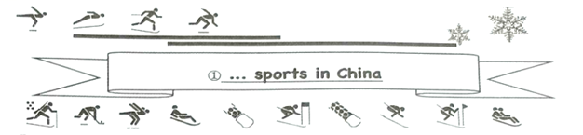
Beijing has become the first city ever to hold both Summer and Winter Olympic Games after winning the 2022 Winter Olympics bid with co-host city Zhangjiakou. That brings snow and ice sports into public spotlight. Unlike the hugely popular Summer Olympic events such as tennis and badminton, winter sports have limited fans in China.
②However, Beijing and Zhangjiakou’s success in holding the Winter Olympics has … Let’s take a look at the present and the future plans of the ice and snow sports.
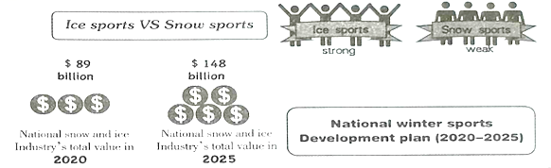
1、2题回答问题；3、4题补全内容；5题读用结合。
61. How many cities held the 2022 Winter Olympics?
_________________________________________________
62. What sport is more popular, ice sports or snow sports?
_________________________________________________
63. 根据材料内容，补全①处画线标题。
_________________________________________________
64. 根据以下所给单词提示，将材料②处画线句子补全，使上下文语义通顺、连贯、语法正确。（词数不限）make, more, interested, sports
_________________________________________________
65. 根据材料内容，完成以下折线图表（画出2020-2025的Development plan）。
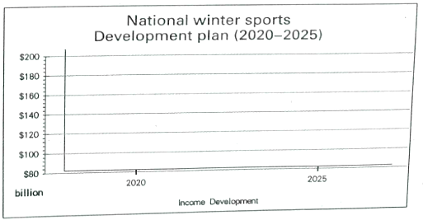
Ⅶ.口语交际（共5小题；每小题2分，满分10分）
阅读下面的对话，根据上下文，选择恰当的选项补全对话，使句意完整、符合逻辑。（其中有两项为多余选项）
A: What’s the matter, John?
B: I’m thinking about going somewhere nice after the exam with my parents. ___66___
A: Why don’t you go to Dunhuang? ___67___
B: We went there last summer. We also went to Mingsha Mountain, Crescent Spring and Yumen Pass.
A: ___68___ The beach city is a perfect place for the summer holidays.
B: It’s a lovely place, but it’s a bit far away from here. ___69___
A: Well, you’d better find some advice for a short trip in a travel guide.
B: ___70___ Thank you.
A: You’re welcome.
A. You can go to the Mogao Caves.
B. Do you have any ideas?
C. I don’t feel like it.
D. What about Qingdao?
E. That’s a good idea.
F. Why don’t you go skating?
G. We want a short trip.
Ⅷ.词汇考查（共15小题；每小题1分，满分15分）
A）根据句意，用括号内所给单词的适当形式填空。
71. I bought two ________ (notebook) yesterday.
72. There ________ (be) a lot of rain outside last night.
73. Young children should not be left by ________ (they).
74. Smile and greet others in a ________ (friend) way.
75. More and more young people enjoy ________ (read) poems.
76. Who can run ________ (fast) in your class?
77. I go to a chess club ________ (two) a week.
78. Sometimes brothers or sisters will ________ (agree) with each other and begin to argue.
79. ________ (make) sure you lock the door when you go out.
80. The teacher asked the students ________ (circle) the correct answer.
B）选出与句子画线部分意思相同或相近的选项。
81. He offered her a trip to Australia but she turned him down.
A. refused him B. looked at him C. hated him D. invited him
82. I waited a quarter of an hour and went home.
A. 10 minutes B. 15 minutes C. 30 minutes D. 45 minutes
83. I’ve completely forgotten her name. We haven’t seen each other for over 10 years.
A. partly B. kind of C. totally D. hardly
84. It’s rude not to say “Thank you” when you are given something.
A. simple B. kind C. open D. impolite
85. On the traditional Chinese calendar, Qingming, meaning clear and bright, is on the fourth or fifth day of April.
A. falls B. jumps C. walks D. runs
Ⅸ.按要求完成句子（共10小题；每空1分，满分20分）（每空限填一词）
A）句型转换。按括号内的要求转换下列句型。
86. Tom goes to school with his best friend every day. (对画线部分提问)
________ ________ Tom go to school with every day?
87. The dragon boat is very pretty. (改为感叹句)
________ ________ the dragon boat is!
88. The bees collect honey from the flowers. (改为被动语态)
Honey ________ ________ from the flowers by the bees.
89. Linda helps her mum with housework every day. (用at 10 o’clock yesterday morning 替换时间状语，改写句子)
Linda ________ _________ her mum with housework at 10 o’clock yesterday morning.
90. — Have Tom and Jerry seen this movie before? (补全否定回答)
— No, ________ ________.
B）根据所给汉语提示完成下列句子。
91. 他过去特别安静。
He ________ ________ be really quiet.
92. 甘肃是我国三个大熊猫自然憩息分布省之一。
Gansu Province is ________ ________ the three natural habitats of giant pandas.
93. 我们应该遵守交通法规。
We should always ________ the ________ signs and rules.
94. 我更喜欢自己创作音乐的歌手。
I ________ ________ that write their own music.
95. 我们齐心协力就能创造更加美好的未来。
Together, our actions can lead to a ________ ________.
Ⅹ.书面表达（满分15分）
96. 以“being lost”为主题，根据以下提示信息写一篇80词左右的短文。
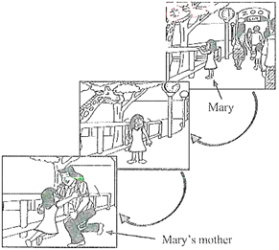
The pictures are provided to help you think about this topic.
Pay attention to the following points when you plan your composition
●Where was Mary?
●What was Mary doing?
●What happened to her?
●What did Mary feel when seeing her mother?
The following words may help you:
●crowded with visitors
●so interested in the animals
●no one around
●turn to …
要求：
1.条理清楚，行文连贯，可适当发挥；
2.文中不能出现其他人名和地名等信息；
3.在答题卡的相应位置作答。
____________________________________________________________________________________________________________________________________________________________________________________________________________________________________________________________________________________________________________________________________________________________________________________________________________________________________________________________________________________________________________________________________________________________________________________________________________________________________________________________________

