2022年毕节市初中毕业生升学考试
英语
考生注意：
1. 答题前，请务必将自己的姓名、准考证号填写在答题卡的规定位置。
2. 答题时，选择题使用2B铅笔在答题卡上填涂，非选择题使用黑色字迹的笔在答题卡规定区域内作答，在试卷上作答无效。
3. 本试题共8页，满分150分，考试时间120分钟。
第一部分 听力（30分）
I. 听句子。从下面各小题所给的A、B、C三幅图片中，选择与句子内容相符的图片。每个句子听两遍。（共5小题，每小题1分，满分5分）
1. A. 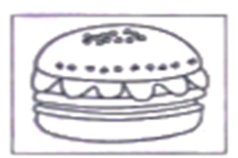 B. 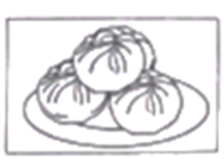 C. 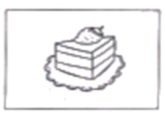
2. A. 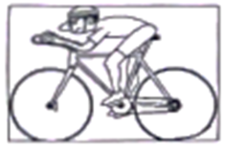 B.  C. 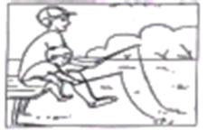
3. A. 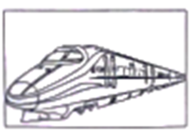 B. 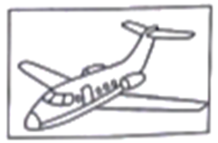 C. 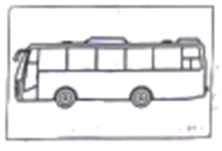
4. A. 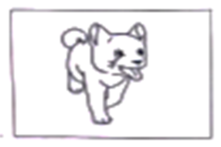 B. 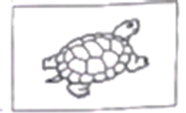 C. 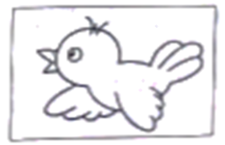
5. A.  B. 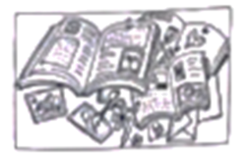 C. 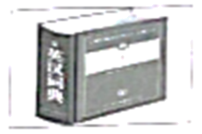
II. 听对话。根据对话内容，从下面各小题所给的A、 B、C三个选项中选出最佳选项。每段对话听两遍。（共10小题，满分15分）
（A）听下面5段对话，完成6至10小题。（每小题1分）
6. Where does the conversation take place?
A. At school. B. At home. C. At a breakfast shop.
7. What does the boy want to be when he grows up?
A. An actor. B. An engineer. C. An English teacher.
8. How is the fish at this restaurant?
A. The fish is nice. B. The fish isn't fresh. C. The fish is not cooked.
9. How much is the shirt today?
A. 120 yuan. B. 130 yuan. C. 150 yuan.
10. Why are many wild animals in danger?
A. Because they don't have safe places to live.
B. Because they don't have enough food to eat.
C. Because they have no water to drink.
（B）听下面1段对话，完成11至12小题。（每小题2分）
11. How will they go to the museum?
A. By underground B. By taxi. C. By car.
12. What time will they leave for the museum?
A. At 2：00 p.m. B. At 3：00 p.m. C. At 4：00 p.m.
（C）听下面1段对话，完成13至15小题。（每小题2分）
13. When did the 2022 Beijing Winter Olympic Games start?
A. On February 6, 2022. B. On February 5, 2022. C. On February 4, 2022.
14. What does the girl think of the games?
A. Fantastic. B. Happy. C. Famous.
15. Which game would the girl prefer watching?
A. She prefers skating. B. She prefers skiing. C. She prefers riding.
III. 听短文。按照所听内容从下面各小题所给的A、B、C三个选项中选出最佳选项。本段短文听三遍。（共5小题，每题2分，满分10分）
16. Where was the cat at mealtime?
A. She often went out to play. B. She often sat at table. C. She often slept under the table.
17. How did the cat eat food?
A. She ate from her dish. B. She ate with a knife and fork. C. She ate her master's food.
18. What happened to the cat at mealtime one day?
A. The cat was jumping and singing. B. The cat was ill. C. The cat was missing.
19. What did the master（主人）find in the cat's mouth when she jumped into her chair?
A. Two fish. B. Two mice. C. Two cats.
20. Why did she drop one into her master's dish?
A. Because she thought her master often shared his food with her.
B. Because she wanted to give him a surprise.
C. Because she wanted her master to give her more food.
第二部分 单项选择（10分）
从下列各小题所给的四个选项中，选出可以填入空白处的最佳选项。（共10小题，每小题1分）
1. Would you like to go to the open-air concert at school? It’ll start in ________ hour and ________ half.
A. an; an B. a; an C. an; a D. a; a
2. I began to teach ________ English when I was twenty-two years old.
A. they B. their C. theirs D. them
3. Students ________ play with fire in the classroom. It’s quite dangerous.
A. mustn’t B. must C. couldn’t D. could
4. The Forbidden City (紫禁城), the largest palace in the world, ________ more than 600 years ago.
A. built B. were built C. was built up D. was building
5. Neither Saturday nor Sunday________ OK because I will be quite busy these two days.
A. are B. is C. am D. be
6. —Could you tell me ________ pay the bills?
—You can pay your bills through Alipay（支付宝）online.
A. how much I’ll B. how many I’ll C. how can I D. how I can
7. ________ the weather improves, we’ll have to cancel the outdoor picnic.
A. Unless B. If C. Because D. When
8. Many people have lost their homes because of wars. It’s important for people ________ a peaceful world.
A. have B. had C. to have D. to be having
9. Making robots is one of ________ activities among students. Each of them has his own robot.
A. more popular B. the most popular C. more difficult D. the most difficult
10. —Please mind your head, sir.
—________
A. It doesn’t matter. B. OK! Thank you. C. Don’t mention. D. I’m afraid not.
第三部分 完形填空（15分）
阅读以下短文，从短文后各小题所给的四个选项中，选出可以填入空白处的最佳选项（共10小题，每小题1. 5分，满分15分）
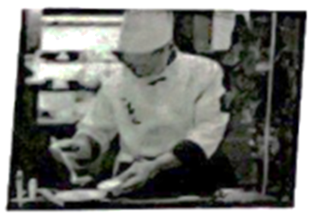
Mr. Zhang was a cook in Canada. He ___11___ in Guangzhou, and he learned to cook in Hong Kong. He moved to Canada for work when he was 26 years old. Everything was good till COVID-19（新冠病毒）broke out. Last year, he returned to China because the economy（经济）in Canada began ___12___ down. “I’m 50 now and I worry about my future there,” said Mr. Zhang. So he gave up his job and returned to China in September, 2021 and set up his own ___13___ named Hong Kong Restaurant in Guangzhou.
Mr. Zhang loves ___14___ and his restaurant offers everyone a taste of Hong Kong. When he was preparing for his restaurant, his friend who is the leader of a nursing home（疗养院）asked him if he would like to provide food ___15___ patients aged above 60 there. Mr. Zhang thought it was a good idea. “It is my pleasure to do this social work by ___16___ a government program.”
He uses his free time in the morning to prepare special ___17___ for these old people. He has to be careful because the food must be ___18___. The old patients enjoy the food ___19___.
Mr Zhang said, “The local government offers many preferential policies（优惠政策）for people from abroad and I want to hold the ___20___.” Doing such kind of work has brought Mr. Zhang a lot of happiness.
11. A. woke up B. grew up C. brought up D. set up
12. A. to slow B. to take C. to shut D. to throw
13. A. office B. restaurant C. factory D. shop
14. A. cooking B. eating C. drinking D. painting
15. A. on B. in C. for D. with
16 A. giving B. taking C. joining D. starting
17. A. bowls B. chairs C. meat D. meals
18. A. beautiful B. possible C. comfortable D. healthy
19. A. kindly B. sadly C. happily D. hurriedly
20. A. chance B. activity C. advice D. people
第四部分阅读理解（40分）
I. 阅读短文，根据短文内容从短文后各小题所给的四个选项中，选出最佳选项。（共15小题，每小题2分，共30分）
（A）
East Daily January 5, 2022, Wednesday
THEY NEED YOUR HELP

This is the chance for you to help those less lucky members. We suggest you give help to the following organizations.
Orphan（mL）House
Children’s toys, books and clothes are needed here. Also we are looking for friendly families who would like to take our children into their homes for a few hours as guests.
If possible, please phone Mrs. Liu at 88776655.
Street Food
In very cold weather, it is no fun being homeless and hungry. We give hot food to at least one hundred people every night. We need new cookers（炊具）. Please give us a hand.
If possible, please phone 88775566.
Youth Club
Have you got an unwanted chair or a CD player? We need them to work in our meeting room! Please call the secretary. Phone number: 88667755.
We’ll be happy to collect anything you can give us. Thank you!
Night Shelter（庇护所）
We offer a warm bed to anyone who has nowhere to go. Although a bed is not expensive, we do not have enough money to pay for enough beds. If you would like to support us some, please send money to us at 15, Landong Street Office. Phone number: 88557766.

21. The passage appeared in the newspaper in the season of ________.
A. spring B. summer C. autumn D. winter
22. The people who can offer a kind family to an orphan for a few hours may call ________.
A. 88667755 B. 88776655 C. 88775566 D. 88557766
23. To give hot food to so many homeless and hungry people every night, Street Food would like to have ________.
A. toys and books B. new cookers C. beds and chairs D. CD players
24. People can send their money to Night Shelter ________.
A. to buy enough beds B. to buy some hot food
C. to get toys and clothes D. to take unwanted things
25. Reading the passage, you might like to help these organizations which work for ________.
A. Mrs. Liu B. Landong Street Office
C. less lucky members D. the secretary of Youth Club
（B）
If you travel in New Zealand, you may find some very interesting things. It is called “New Zealand Four Strange Things”.
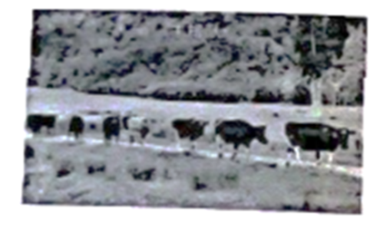 | Have you ever seen that cows are lined up? New Zealand is so large. It is impossible for people to milk cows by hand. So the farmers trained the leading cow to take the cows to the milking station twice a day. The leading cow has a sensor（传感器）on its head. When it is time for milking, the sensor warns the leading cow to take the lead.
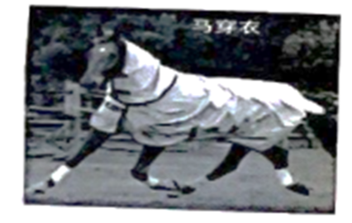 | Horses are mainly raised for viewing（观赏）and racing, so the coat color is very important. Wearing sunscreen（防晒）clothes on horses can avoid the harm from the sun. The clothes on horses are filled with weights that are the same weight of the rider. When the weights are replaced by the rider during the race, “________” just like the sportsman running with sandbags.
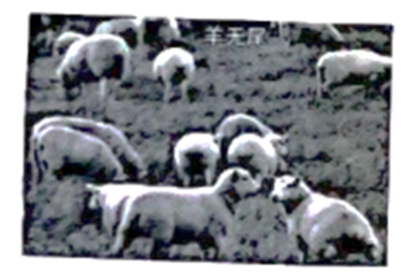 | Sheep in New Zealand used to have tails. Because they poop（排便）when they’re born, grass flies are interested in them. Grass flies lay their eggs in the tails of the baby sheep, causing illness and death. Then people tie their tails. As time passes, the sheep become tailless. This improves the survival rate（成活率）.
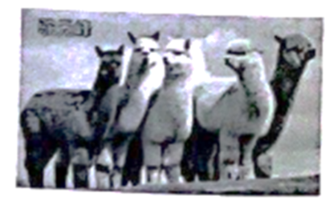 | New Zealand’s alpacas（羊驼）were introduced from South America. They are quite different from two-humped camels（双峰驼）. An alpaca weighs about 55 kg to 65 kg. Its shape is like a sheep. Only one grown-up male（雄性）alpaca can be found in each group. It is the leading one. Alpacas are gentle, clever and human.

26. Why do the cows in New Zealand stand in line?
A. Because the cows want to eat grass. B. Because the cows are ready for milking.
C. Because the cows used to do so. D. Because the leading cow asks them to do so.
27. Which of the following can be put in “________”?
A. the horses will be used to running with weights B. the horses can run faster than before
C the horses won’t be able to run D. the horses will not be used to running
28. How do people make sheep’s tails become tailless?
A. By cutting them. B. By tying them. C. By pulling them. D. By pushing them.
29 How much does an alpaca weigh?
A. About 30 kg to 40 kg. B. About 40 kg to 50 kg.
C. About 50 kg to 60 kg. D. About 55 kg to 65 kg.
30. Which is the best title for this article?
A. Travel in New Zealand B. Cows, Horses, Sheep and Alpacas
C. New Zealand Four Strange Things D. Animals in New Zealand
（C）
China has four satellite launch bases（卫星发射基地）. They are Jiuquan in Gansu, Xichang in Sichuan, Taiyuan in Shanxi and Wenchang in Hainan.
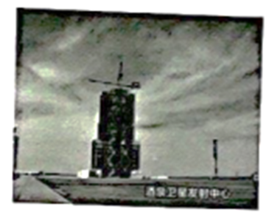
Jiuquan Satellite Launch Center which was founded（建立）in 1958 is one of the four famous satellite launch bases in China. The center has created eight proud firsts for China’s space industry. On April 21, 1970, China’s first man-made earth satellite was raised there. The Long March 2F rocket carrying the Shenzhou XII manned spacecraft blasted off（发射）from Jiuquan Satellite Launch Center in June, 2021.
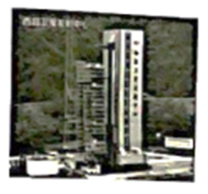
Xichang Satellite Launch Center, also known as Xichang Satellite City, was founded in 1970. After 37 years of development, the center has thousands of sets of excellent equipment（设备）. It is known as the “Oriental Houston（东方休斯顿）”.
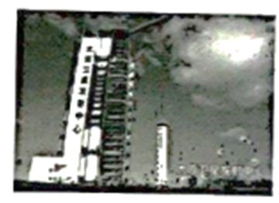
Taiyuan Satellite Launch Center was founded in 1967. The center has launched China’s first weather satellite “Fengyun-1”, making nine firsts in the history of China’s satellite launches.
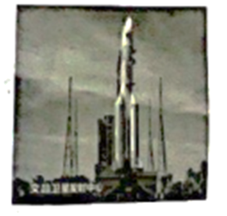
Wenchang Space Launch Center（founded in 2009）is now the fourth satellite launch center of China. Because it is only 19 degrees away from the equator（赤道）, more rocket loads（负载）are possible, making it the center of China’s space development in the future.
31. How many satellite launch bases are there in China according to the passage?
A. There are three. B. There are four. C. There are five. D. There are six.
32. What does the underlined words “manned spacecraft” mean in Chinese?
A. 载人飞船 B. 宇宙空间站 C. 航空航天器 D. 人造地球卫星
33. Which center is known as the “Oriental Houston”?
A. Jiuquan Satellite Launch Center. B. Xichang Satellite Launch Center.
C. Taiyuan Satellite Launch Center. D. Wenchang Space Launch Center.
34. Choose the order of the foundation（成立）time of the four centers according to the following:
①Jiuquan ②Xichang ③Taiyuan ④Wenchang
A. ①②③④ B. ③①④② C. ③④②① D. ①③②④
35. Which of the following is NOT right?
A. The center of Taiyuan has made nine firsts since 1967.
B. The Shenzhou XII manned spacecraft blasted off in June, 2021.
C. The center of Jiuquan has created eight proud firsts since 1968.
D. The center of Wenchang will be the center of China’s space development.
II. 阅读短文。根据短文内容，从所给的七个选项中，选出可以填入空白处的最佳选项。每个选项只能选一次，选项中有两项为多余选项。（共5小题，每小题2分，满分10分）
（A）
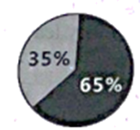
Do you know how people send messages to each other? Scientists say only 35% of our communication is done through spoken language. ___36___ It is natural for us to use our bodies to share our thoughts and feelings.
___37___ For example, smiling may be the easiest body language. People understand its meaning without thinking. ___38___ But the meaning of some body languages change from one culture to another. Most people move their heads up and down to mean “yes” and side to side to mean “no”. You may think that these have the same meanings everywhere. ___39___ In a country, people move their heads side to side to mean “yes”, and up and down to mean “no”.
As we have looked at some examples, there are many kinds of body languages and their meanings may change from one culture to another. ___40___ If we don't understand them, we may make a mistake and send a wrong signal（信号）. The best advice is to watch what other people do in their cultures and follow them.
A. Some of the ways of body language are the same all over the world.
B. Body language is the most important.
C. It is necessary for us to understand them.
D So it is good to smile when we meet people.
E. The other 65% is done through “body language”.
F. It is not polite to smile at people.
G. However, they have the opposite meanings.
第五部分 情景交际（10分）
根据对话内容，从选项中所给的五个选项中，选出可以填入空白处的最佳选项。每个选项只能选一次。
A: ___41___
B: Pretty good. ___42___
A: Who did you go with?
B: I went with my parents and my brother.
A: Did you go by bus or by car?
B: Neither. ___43___
A: How long did it take you to get there?
B: ___44___ It was much faster.
A: ___45___
B: It has changed a lot with the help of the government.
A: I’m glad to hear that.
A. We went by high speed train.
B. How was your weekend?
C. What do you think of your hometown?
D. I went back to my hometown to see my grandparents.
E. Only one hour.
第六部分 短文改错（15分）
阅读短文。判断标有题号每一行画线部分和有漏字符号（^）处是否有错误。如无，在该行右边横线上画一个“√”；如有（每行只有一个），则按下列情况改正）
画线部分为多余的词：把该词写在该行右边的横线上并画上斜线（\）。画线部分为错词：在该行右边横线上写出一个正确的词。有漏字符号（^）处缺一个词：在该行右边横线上写出所缺的词。
John is a 13-years-old schoolboy. He studies very hard at school and gets good ____46____
grades in all his subject. But he doesn’t like sports. Six months ago, he did not ____47____
feel good. He often had colds and felt sick to his stomach. His parents took him ____48____
to see a doctor. After asking him some questions and giving him a careful ____49____
examination, the doctor said which it was not serious and told John’s parents ____50____
^ to worry about it. Then the doctor told John to take more exercise and stop ____51____
eating fast food. From then on, John went to school by a bike every day instead ____52____
of taking the bus. At first, he felt tire and weak. But two weeks later, he got ____53____
fitter and started to enjoy it. Since he started ride a bike, he has not had a cold. ____54____
To his surprise, he has not had a stomachache since he stoped eating fast food. ____55____
第七部分 书面表达（30分）
书面表达分为A、B两部分，A部分10分，B部分20分。文中不能出现本人及所在学校、乡（镇）、县（区）的相关信息，凡抄袭试卷上原句的不给分。
A.
56. 下面是一篇未写完的短文，请认真阅读，为短文写一个30~40词的结尾，使短文连贯完整。
Family is the first school in one’s life. Family education is very important. In my family, my parents often…
_______________________________________________________________________________________________________________________________________________________________________________________________________________________________________________________________________________________________________________________________________________________________________________________________________________________________________________________________________________________________________________________________________________________________________________________________________________________________________________________________________________________________________________________________________________________________________________________
B.
57. 劳动课即将走进我们的课程中，你作为一名即将完成义务教育阶段学习任务的学生，请你为在校同学写一篇英文发言稿，谈谈你对新课程方案的看法和建议。词数80左右。
内容包括：
1. 初中学生的学习任务应该有哪些?（写2点）
2. 课程方案规定，初中学生能设计一日三餐食谱，独立制作午餐或晚餐中3—4道菜等。对此你有何想法?（2点）
3. 你对在校同学的倡议（2点）
作文要求：
1. 文章的开头已经给出，但不计入总词数；
2. 语句连贯，书写工整；不得出现单位或个人真实名称。
参考词汇：
课程方案： curriculum plan； 设计食谱design recipes；
A new subject will be carried out in school
The new change about the labor class in school has had a heated discussion online.
_______________________________________________________________________________________________________________________________________________________________________________________________________________________________________________________________________________________________________________________________________________________________________________________________________________________________________________________________________________________________________________________________________________________________________________________________________________________________________________________________________________________________________________________________________________________________________________________________________________________________________________________________________________________

