第Ⅰ卷 选择题
第一部分 完形填空（共两节，16小题；每小题1分，共16分）
第一节
阅读下面一篇短文，从短文前的选项中选出能填入空白处的最佳选项。选项中有一个为多余选项。
A. in B. how C. but D. enough E. some F. the G. and
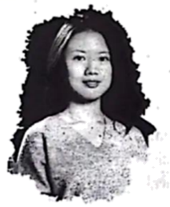
Born into a Yao family in Yizhang, Hunan, Jiang Mengnan’s world has been silent since she was 6 months old. At that time, ___1___ medicine damaged(损害) her hearing. But through her hard work, she did well at school and university. She started studying for a doctorate(博士学位) at Tsinghua University ___2___ 2018.
When Jiang was about one year old, her parents began showing her ___3___ to understand people by reading lips (嘴唇). It was really hard, but soon Jiang learned to “listen” and even speak. Jiang’s mother says she’ll never forget ___4___ day Jiang said “Mama” for the first time when she was 16 months old.
When she was old ___5___, Jiang went to a primary school instead of a special school for disabled children. She said it was difficult at first. During lessons, she had to copy down everything on the blackboard and study alone after class to keep up with her classmates. Jiang did quite well at school ___6___ made it all the way to Tsinghua University.
“I’m always thankful that my parents, teachers and friends never give me special attention, so I never thought I was different from anyone else,” Jiang said.
【答案】1. E 2. A
3. B 4. F
5. D 6. G
【解析】
【导语】本文是一篇记叙文，向我们介绍2021感动中国人物之一——江梦南。
【1题详解】
句意：当时，一些药物损害了她的听力。根据“At that time, ...medicine damaged(损害) her hearing.”可知，此处修饰medicine，some“一些”符合语境，故选E。
【2题详解】
句意：2018年，她开始在清华大学攻读博士学位。“2018”是年份，此前用时间介词in，in 2018“在2018年”，故选A。
【3题详解】
句意：当江梦南大约1岁的时候，她的父母开始教她如何通过读唇语来理解别人。根据“her parents began showing her...to understand people by reading lips”可知，父母教她如何读唇语，how“如何”符合语境，故选B。
4题详解】
句意：江梦南的妈妈说，她永远不会忘记江梦南16个月大时第一次说“妈妈”的那一天。根据“Jiang’s mother says she’ll never forget...day Jiang said “Mama” for the first time when she was 16 months old.”可知，此处特指那一天，用定冠词the，故选F。
【5题详解】
句意：当她足够大的时候，她去了一所小学，而不是一所残疾儿童的特殊学校。根据“When she was old..., Jiang went to a primary school instead of a special school for disabled children.”可知，当她够年龄了，去上了小学，enough“足够”，作old的后置定语，故选D。
【6题详解】
句意：江梦南在学校表现很好，并一路考入清华大学。前后构成并列关系，用and连接，故选G。
第二节 阅读下面一篇短文，从每题所给的A、B、C三个选项中选出能填入空白处的最佳选项。
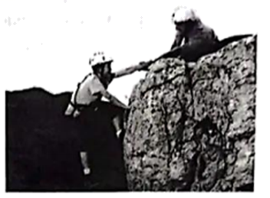
My dad has always spent his free time climbing mountains. He spends ages ___7___ his route (路线), checking the weather forecast and finding the best maps. He really likes a good ___8___. For example, he always chooses the most difficult way up the mountain. It means he feels he’s really ___9___ something.
As soon as I could walk, he started taking me with him sometimes. At first, he used to carry me on his shoulders. Later on, I had my own little boots (靴子) and I ____10____ him up the easiest slopes (斜坡). I can still remember how excited I was when we set off and how ____11____ I felt.
The first time I did a proper climb with him, I was about eight years old. As we came round the last bend to the summit (山顶), we ____12____ some other climbers standing there enjoying the view. They couldn’t believe my father had managed to get to the ____13____ with such a small child. In fact, we weren’t the only ones who managed to do so that day. When we were coming down, we met another family with two ____14____ girls, who must have been just behind us.
I’m now 15 and I belong to a local climbing club. Dad ____15____ hoped to pass on his love of climbing to me. It seems that he has. I already spend most of my weekends in the ____16____. Sometimes Dad comes too but now I’m the one out in front and he can’t always keep up with me!
7. A. planning B. describing C. explaining
8. A. partner B. challenge C. suggestion
9. A. lost B. missed C. achieved
10. A. pushed B. guided C. followed
11. A. tired B. happy C. lonely
12. A. saw B. recorded C. interviewed
13. A. top B. hole C. corner
14. A. wise B. young C. strong
15. A. never B. hardly C. always
16. A. forests B. markets C. mountains
【答案】7. A 8. B 9. C 10. C 11. B 12. A 13. A 14. B 15. C 16. C
【解析】
【导语】本文主要讲作者和父亲两人通过爬山表达作者的感情和爱意的故事。
【7题详解】
句意：他花了很长时间规划路线，查看天气预报，寻找最好的地图。
planning计划；describing描述；explaining解释。根据“...his route”可知，在爬山前要规划路线，故选A。
【8题详解】
句意：他真地很喜欢挑战。
partner搭档；challenge挑战；suggestion建议。根据“he always chooses the most difficult way up the mountain”可知，他总是选择上山最困难的路，所以是喜欢挑战，故选B。
【9题详解】
句意：这意味着他觉得自己真的取得了一些成就。
lost丢失；missed思念，错过；achieved实现。根据“It means he feels he’s really...something.”可知，取得了一些成就，故选C。
【10题详解】
句意：后来，我有了自己的小靴子，跟着他爬上了最容易的山坡。
pushed推；guided指导；followed跟随。根据“I...him up”可知，作者跟着爸爸，故选C。
【11题详解】
句意：我还记得我们出发的时候我是多么的兴奋和高兴。
tired累的；happy开心的；lonely孤独的。根据“I can still remember how excited I was when we set off and how...I felt.”可知，感到兴奋开心，故选B。
【12题详解】
句意：当我们绕过最后一个弯道到达山顶时，我们看到其他一些登山者站在那里欣赏风景。
saw看见；recorded记录；interviewed采访。根据“we...some other climbers standing there enjoying the view”可知，看到人们欣赏风景，故选A。
【13题详解】
句意：他们不敢相信我父亲带着这么小孩子能爬到山顶。
top顶部；hole洞；corner角落。根据前文“As we came round the last bend to the summit”可知，到达了山顶，故选A。
【14题详解】
句意：当我们下来的时候，我们遇到了另一家人，他们有两个小女孩，他们肯定就在我们后面。
wise明智的；young年轻的；strong强壮的。根据“In fact, we weren’t the only ones who managed to do so that day.”可知，另一家人也带着小孩子，所以指带着两个小女孩，故选B。
【15题详解】
句意：爸爸一直希望把他对爬山的热爱传递给我。
never从不；hardly几乎不；always总是。根据“Dad...hoped to pass on his love of climbing to me.”可知，爸爸一直希望把他对攀岩的热爱传递给我，故选C。
【16题详解】
句意：我周末大部分时间都在山里度过了。
forests森林；markets市场；mountains山。根据“It seems that he has. I already spend most of my weekends in the...”可知，父亲把对爬山的爱传递给我，我们也在山里度过了周末的大部分时间，故选C。
第二部分 阅读理解（共三节，22小题，含第Ⅱ卷第三节5小题；每小题2分，共44分）
第一节 阅读下面三个语篇，从每题所给的A、B、C三个选项中选出最佳选项。
A
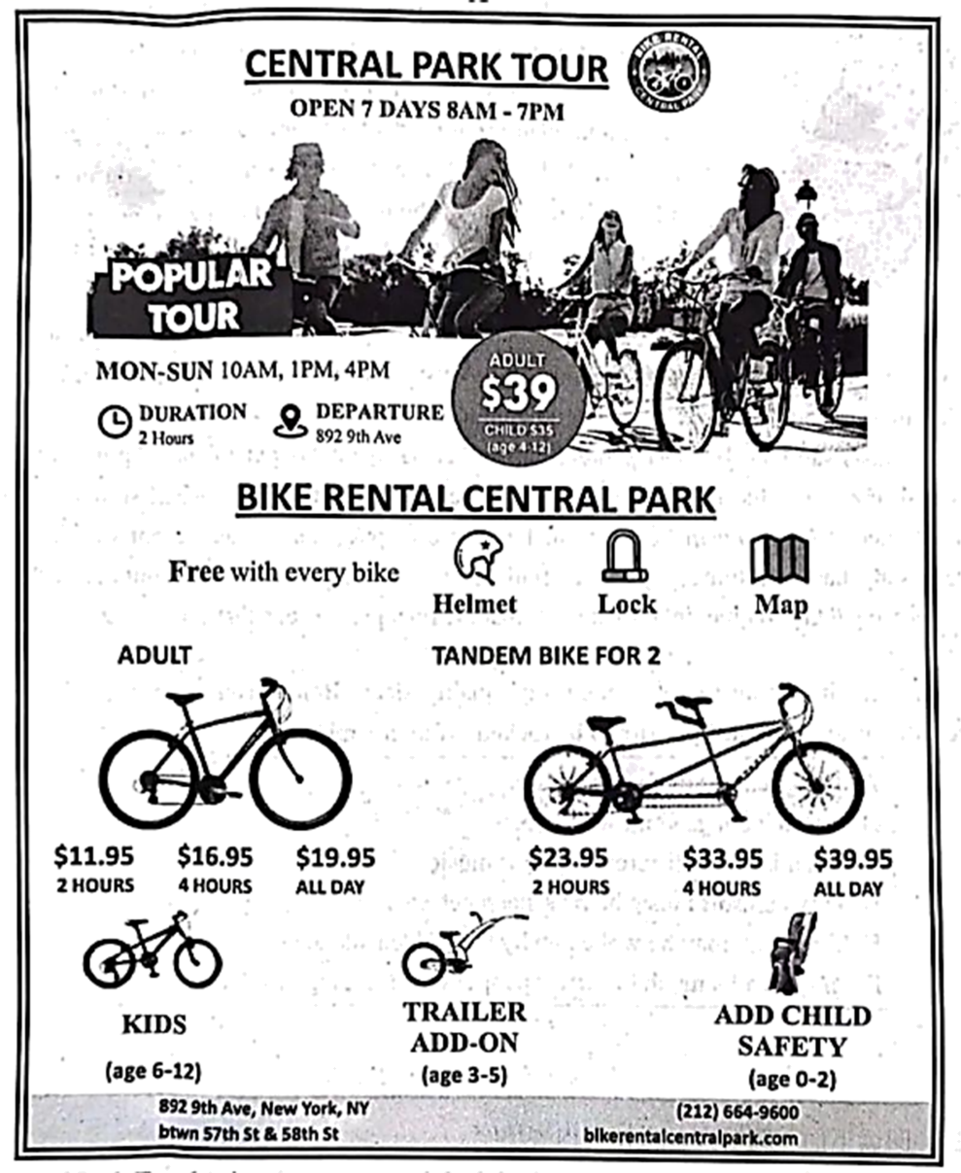
17. Central Park Tour begins at ________ o’clock in the morning every day.
A. six B. seven C. eight
18. How much should we pay for an adult bike for two hours?
A. $11.95. B. $16.95. C. $19.95.
19. A couple will need a ________ if they take their eight-month-old baby.
A. 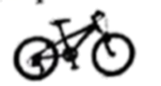 B. 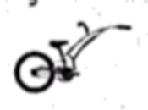 C. 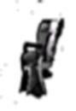
20. What is the text type of the reading material?
A. An ad. B. A poem. C. A speech.
【答案】17. C 18. A 19. C 20. A
【解析】
【导语】本文是一篇应用文。这个是中央公园观光团活动的宣传海报，介绍了活动的时间、参加对象、注意事项以及费用等相关内容。
【17题详解】
细节理解题。根据“OPEN 7 DAYS 8AM-7PM”可知中央公园观光团在每天上午8点开始。故选C。
【18题详解】
细节理解题。根据“$11.95 2 HOURS”可知每个成人要参加2个小时的活动需要支付11.95美元。故选A。
【19题详解】
细节理解题。根据“ADD CHILD SAFETY (age 0-2)”可知一对夫妇带上他们八个月大的婴儿需要选择C选项的车。故选C。
【20题详解】
推理判断题。这篇文章是中央公园观光团的活动宣传海报，也就是一个广告。故选A。
B
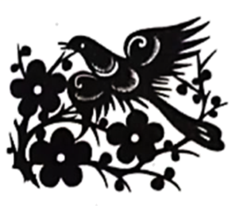
Paper cutting or tearing is a cultural tradition in China. For centuries, it has been passed down from one generation（一代人） to the next, especially from mothers to daughters. This beautiful art created by skillful artists is used to decorate（装饰） doors, ceilings, and beds in people’s homes, or at celebrations such as birthdays and weddings. At Chinese New Year, window flowers are glued to windows, creating beautiful patterns of light and shadow.
The two main techniques（技艺） used are cutting the paper using a knife or scissors, or tearing it by hand. If the paper is cut, the edges（边缘） are very smooth. Paper cutting can produce very fine and delicate work. This type of work is typical of southern China. If the paper is torn by hand, the edges are more simple and natural. Tearing is used more in northeast China. In addition, different parts of China have their own motifs or pictures. These motifs can express many stories, ideas and emotions.
It can be hard to hold on to traditions like these because young people don’t know much about traditional art. Often they prefer spending their time on newer pastimes. The experts are getting older. If young people don’t learn the traditions, they won’t be able to pass them down to their own children. But recently there is a change. There are more exhibitions of traditional art. Artists are going into schools to teach children how to do paper cutting. Children enjoy working together with artists and talking to them about the meaning of their art. In this way, they are becoming proud of their culture and traditions.
21. The underlined word “motifs” in Paragraph 2 is closest in meaning to ________ .
A. habits B. reasons C. subjects
22. What is the writer’s opinion on paper cutting or tearing?
A. It is easy to hold on to this form of art.
B. It will continue in China for future generations.
C. It is so expensive that only the rich can afford to learn it.
23. From the passage we know that ________ .
A. young people know traditional art very well
B. the edges are very smooth when the paper is cut
C. girls were not allowed to learn paper cutting in the past
24. What could be the best title for the passage?
A. Chinese Paper Art B. Great Changes in China C. Famous Chinese Artists
【答案】21. C 22. B 23. B 24. A
【解析】
【导语】本文是一篇说明文。短文介绍了中国传统的纸类艺术，如剪纸或撕纸，以及它们的发展趋势。
【21题详解】
词句猜测题。根据“These motifs can express many stories, ideas and emotions”可知这些主题可以表达许多故事、想法和情感。由此可知motifs指的是艺术作品的主题，可用subjects来表示。故选C。
【22题详解】
推理判断题。根据“If young people don’t learn the traditions, they won’t be able to pass them down to their own children. But recently there is a change.”可知如果年轻人不学习这些传统艺术的话，他们就不可能把这些流传给子孙后代，但最近有一些改变，说明作者认为这些技艺会在中国的后代中流传下来。故选B。
【23题详解】
细节理解题。根据“If the paper is cut, the edges（边缘） are very smooth”可知如果纸张被裁剪的话，它的边缘会非常的光滑。故选B。
【24题详解】
最佳标题题。根据“Paper cutting or tearing is a cultural tradition in China”可知全文在介绍中国的一种文化传统工艺，剪纸或撕纸。故选A。
C
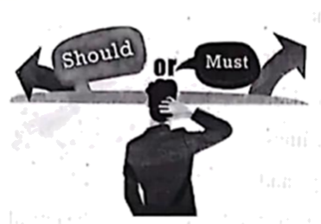
There are two paths (路) in life: Should and Must. We arrive at these crossroads over and over again. And each time, we get to choose.
Should is how others want us to show up in the world—what we should or shouldn’t do. When we choose Should, the risk is small.
Must is who we are, what we believe, and what we do when we are alone with our truest self. Must is why Van Gogh painted his whole life without ever receiving public recognition (认可). Must is why Reyna Marder Gentin started to write for the first time after 23 years of being a lawyer.
Choosing Must sounds fantastic, right? But Must is scary, hard, and a lot like jumping off a high building where you can’t see anything down below. How can we actually choose Must?
Ask yourself, “What is my Must?” If you don’t know the answer, write down your biggest, most impossible dreams! Don’t worry! It’s just the first step.
Now, think about what’s actually in your way. Is it your parents? Maybe they’re just worried that you haven’t thought it through. Try to make a practical(切实可行的) plan for what you want to do. Your parents may find it a good one. Is it money? Well, the best way to make money is to do what you love because it’s very likely that you will pay great attention to it. Choosing Must doesn’t mean we need to give up everything we already have. It’s about changing one small thing at a time.
If you believe that you have something special inside of you, it’s about time you gave Must a try—today.
25. What happens if we choose the path of “Should”?
A. We don’t need to take great risks.
B. We have to give up what we have.
C. We’ll have a clear picture of ourselves.
26. The writer develops his idea in Paragraph 3 by ________.
A. listing numbers B. asking questions C. giving examples
27. What should we do if we choose the path of “Must”?
A. Try to make a practical plan.
B. Turn to other people for help.
C. Change many things at a time.
28. The writer wrote this passage to ________.
A. take others’ advice B. be our truest self C. communicate with parents
【答案】25. A 26. C 27. A 28. B
【解析】
【导语】本文主要介绍生活中的每一次选择都有“应该”和“必须”两条路，告诉我们有的时候要做最真实的自己，给“必须”一试。
【25题详解】
细节理解题。根据“When we choose Should, the risk is small.”可知，当我们选择“应该”时，风险很小。故选A。
【26题详解】
细节理解题。分析第三段内容可知，作者以举例的方式来阐述观点，故选C。
【27题详解】
细节理解题。根据“Try to make a practical(切实可行的) plan for what you want to do.”可知，如果选择“必须”这条路，试着为你想做的事情制定一个切实可行的计划。故选A。
【28题详解】
主旨大意题。本文介绍生活中的每一次选择都有“应该”和“必须”两条路，告诉我们有的时候要做最真实的自己，给“必须”一试。故选B。
第二节 阅读下面一篇短文，从短文后的选项中选出能填入空白处的最佳选项。选项中有一个为多余选项。
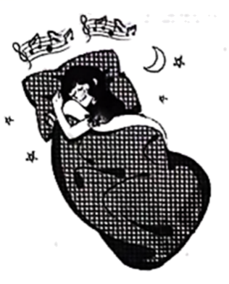
Do you have difficulty falling asleep at night? If so, here is a piece of advice for you: Listen to some soft music.
Scientists have found that soft music can help to improve sleep quality and quantity. It works for people of all ages. ____29____ Soft music can help us fall asleep faster, wake up less during the night and feel more rested in the morning. You may not notice the effects overnight, though. It could take as many as three weeks to see any improvements.
____30____ The reasons aren’t clear yet. It may have something to do with the relaxing effect of a good song. Music can have real physical effects, too. Soft music can lower our heart rate and slow down our breathing. ____31____
Scientists say that for most people, music that has 70 beats per minute (bpm) works best. Classical, jazz and folk music are usually more effective than other musical styles. ____32____ You may need to experiment(尝试) to make your own playlists. If you are not sure how many beats a song has in a minute, you can find out by entering its title into songbpm.com. And remember to get the volume right. Make sure that the final piece is one that slowly fades out(渐弱). ____33____
It is very important to get enough high-quality sleep. Before you go to bed tonight, play some soft music. Then, just prepare to be rocked off to dreamland!
A. This prepares us for sleep.
B. Familiar songs work well too.
C. Scientists like different kinds of music.
D. Why can soft music help us sleep better?
E. If not you may be woken up by the sudden silence.
F. And it works much better for people with sleeping problems.
【答案】29. F 30. D 31. A 32. B 33. E
【解析】
【导语】本文是一篇说明文，主要介绍轻音乐如何改善我们的睡眠。
【29题详解】
根据“Scientists have found that soft music can help to improve sleep quality and quantity. It works for people of all ages.”可知，科学家发现，轻柔的音乐有助于提高睡眠质量，它适用于所有年龄的人。选项F“它对有睡眠问题的人更有效。”符合语境，故选F。
【30题详解】
根据“The reasons aren’t clear yet.”可知，此处与轻音乐改善睡眠的原因相关，选项D“为什么轻柔的音乐能帮助我们睡得更好？”符合语境，故选D。
【31题详解】
根据“Soft music can lower our heart rate and slow down our breathing.”可知，轻柔的音乐可以降低我们的心率，减缓我们的呼吸。选项A“这为我们的睡眠做准备。”符合语境，故选A。
【32题详解】
根据“Classical, jazz and folk music are usually more effective than other musical styles.”可知，古典、爵士和民间音乐通常比其他音乐风格更有效。此处介绍哪种音乐有效，选项B“熟悉的歌曲也很管用。”符合语境，故选B。
【33题详解】
根据“Make sure that the final piece is one that slowly fades out (渐弱).”可知，确保最后部分是渐弱的，此处介绍为什么要减弱，选项E“如果不是的话，你可能会因为突然的寂静而醒过来。”符合语境，故选E。
第Ⅱ卷 非选择题
第三节
阅读下面一篇短文，根据其内容填空。
Wind power is a very clean source of energy. This is how wind power works. Wind makes windmills spin(旋转). When the windmills spin, they make electricity. Then we can use the electricity.
A lot of people think that wind power is new, but that’s not true. For thousands of years, people have used wind to sail boats and move water. We still do those things today, but these days we mostly use wind power to make electricity.
Wind power is a very popular source of energy. Most people think that we should use it more and more. First of all, it’s clean. Wind mills don’t pollute the environment at all. Second, we can use wind power forever. After all, we will always have wind. Also, wind power is cheap, and it’s getting even cheaper.
A lot of people don’t understand wind power very well. They believe that there are problems with wind power, but many of those problems are not real. For example, some people say that windmills are dangerous for birds. That used to be true, but it isn’t true anymore. Old windmills killed birds because they spun very fast. New windmills spin slowly, and they aren’t dangerous for birds.
However, there are real problems with windmills. One problem is that many people think windmills are very ugly. This is a problem for some people because windmills are often in very pretty areas. Also, wind doesn’t blow all the time, so we can’t use wind power all the time. Finally, windmills are noisy.
Wind power is becoming more and more common. Right now, more than 80 countries use wind power. About 2.5 percent of the world’s power comes from the wind. For some countries, that number is a lot higher. Wind power gives Denmark more than 25 percent of its electricity.
34. Wind power can be turned into __________ when windmills spin.
35. People have used wind to __________ and move water for a long time.
36. New windmills don’t __________ because they spin at a slow speed.
37. One of the real problems with windmills is that they __________.
38. This passage mainly introduces a kind of clean, __________ energy to us.
【答案】34. electricity
35. sail boats
36. kill birds
37. are very ugly/are noisy/make noise/look ugly
38. cheap and common
【解析】
【导语】本文是一篇说明文，主要介绍了风能如何产生的，它的优点和存在的问题。
【34题详解】
根据“Wind power is a very clean source of energy. This is how wind power works. Wind makes windmills spin(旋转). When the windmills spin, they make electricity.”可知，当风车旋转时，风能可以转化为电能。故填electricity。
【35题详解】
根据“For thousands of years, people have used wind to sail boats and move water.”可知，几千年来，人们一直用风来航行和移动水。故填sail boats。
【36题详解】
根据“New windmills spin slowly, and they aren’t dangerous for birds.”可知，新型风车不会杀死鸟类，因为它们旋转得很慢。故填kill birds。
【37题详解】
根据“One problem is that many people think windmills are very ugly...Finally, windmills are noisy.”可知，风车的真正问题之一是它们很丑、很吵，故填are very ugly/are noisy/make noise/look ugly。
【38题详解】
根据“Also, wind power is cheap, and it’s getting even cheaper.”和“Wind power is becoming more and more common.”可知，文章主要向我们介绍了一种清洁、廉价和常见的能源——风能。故填cheap and common。
第三部分 写作（共四节；第一、二、三节15分，第四节15分；共30分）
第一节 根据语境，用所给词的适当形式填空。（每小题1分，共5分）
39. Reading makes _______ (we) wiser and more learned.
【答案】us
【解析】
【详解】句意：读书使我们更有智慧，更有学问。此处在动词后作宾语，用宾格，故填us。
40. People eat eggs on their birthday in some _______ (place) of China.
【答案】places
【解析】
【详解】句意：在中国的某些地方人们在生日那天要吃鸡蛋。place是可数名词，some后接可数名词的复数形式，place的复数形式为places。故填places。
41. Huangguoshu Waterfall is _______ (wide) known to people from home and abroad.
【答案】widely
【解析】
【详解】句意：黄果树瀑布为国内外人们所熟知。此处在句中修饰形容词，用副词形式，表示“广泛地”，故填widely。
42. Doing exercise in a scientific way _______ (be) healthy for both our body and mind.
【答案】is
【解析】
【详解】句意：以科学的方式做运动对我们的身心都是健康的。时态是一般现在时，主语是“Doing exercise in a scientific way”，be动词用is。故填is。
43. Climbers’ spirit shows humans sometimes can be _______ (strong) than the forces of nature.
【答案】stronger
【解析】
【详解】句意：攀登者的精神表明，人类有时可以比大自然的力量更强大。根据“than”可知，此处用形容词比较级作表语。故填stronger。
第二节（每小题1分，共5分）
根据语境，选择恰当的短语完成下列各句。短语中有一个为多余短语。
at night look for take care of too much belongs to look up to

44. ____________ attention and pressure are harmful to a child’s development.
45. To ____________ the old and care for the young is a good Chinese tradition.
46. At the Night Safari in Singapore, a lot of animals only wake up ____________.
47. Many teenagers ____________ national heroes and dream to become like them.
48. President Xi said, “The future ____________ the young people and our hopes also rest with them.”
【答案】44. Too much
45. take care of
46. at night
47. look up to
48. belongs to
【解析】
【44题详解】
句意：过多的关注和压力对孩子的成长是有害的。根据“...attention and pressure are harmful to a child’s development.”和备选词可知，此处修饰不可数名词，too much“太多”符合语境，句首需大写首字母，故填Too much。
【45题详解】
句意：尊老爱幼是中国的优良传统。根据“To...the old and care for the young”和备选词可知，此处表示“尊老爱幼”，take care of“照顾”符合语境，用于不定式结构中，故填take care of。
【46题详解】
句意：在新加坡的夜间野生动物园，很多动物只在晚上醒来。根据“At the Night Safari in Singapore”和备选词可知，在新加坡的夜间野生动物园，所以是晚上醒来，at night“在晚上”符合语境，故填at night。
【47题详解】
句意：许多青少年崇拜民族英雄，并梦想成为他们那样的人。根据“Many teenagers...national heroes and dream to become like them.”和备选词可知，青少年崇拜民族英雄，look up to“尊敬，崇拜”，时态是一般现在时，主语是复数，动词用原形，故填look up to。
【48题详解】
句意：习主席说：“未来属于青年，希望寄托在青年身上。”此处在句中作谓语，根据“The future...the young people and our hopes also rest with them.”可知，未来属于青年，belong to“属于”符合语境，时态是一般现在时，主语是第三人称单数，动词用三单。故填belongs to。
第三节 根据中文意思，补全英语译文。（每小题1分，共5分；每空限填一词，缩写算一词）
49. 冰墩墩的设计是从5800多份作品中挑选出来的。
The design of Bing Dwendwen __________ from over 5,800 works.
【答案】was chosen
【解析】
【详解】choose“选择”，主语是动作的承受者，该动作发生在过去，用一般过去时的被动语态，主语是第三人称单数，be动词用was。故填was chosen。
50. 骑行能帮助我们节能而且不会污染空气。
Cycling can help us save energy and _______ _______ cause air pollution.
【答案】 ①. will##does##it##it ②. not##not##won’t##doesn’t
【解析】
【详解】根据汉语句意提示，“不会”可用will not+动词原形来表示；由can可知句子可用一般现在时，主语Cycling为动词名词，因此谓语动词应用其第三人称单数形式，“不会污染空气”可用does not+动词原形来表示；连词and也可连接两个并列的句子，因此可用代词it作主语，指代前文提到的“Cycling”，句子用一般将来时时，谓语动词应用won’t+动词原形；句子若用一般现在时，谓语动词应用助动词doesn’t+动词原形。故填will/does/it/it/；not/not/won’t/doesn’t。
51. 做往往比说更重要。
_______ something is usually more important than to say something.
【答案】To do
【解析】
【详解】根据汉语句意提示，“做”do something在句子作主语，且与“说”to say something进行比较，因此应用动词不定式to do，位于句首，首字母t要大写。故填To do。
52. 孔子是一位对中国教育有着深远影响的思想家。
Confucius is a thinker ____________ a far-reaching influence on Chinese education.
【答案】who has##who has had##that has##that has had
【解析】
【详解】此处是定语从句，先行词是人，可用who/that引导；结合句意可知，用一般现在时或现在完成时，have a/an influence on“有影响”。故填who/that has/has had。
53. 有许多像大数据一样无形的“桥”连接着贵州与世界。
________ many invisible bridges like Big Data connecting Guizhou and the world.
【答案】There are
【解析】
【详解】there be“有”，时态是一般现在时，主语是复数，be动词用are。故填There are。
第四节 书面表达（15分）
54. 劳动教育是青少年全面发展的重要组成部分。因此，青少年应该主动参加各类劳动，如社区服务、学校劳动和日常家务等。近期，育才中学围绕“劳动让我成长”这一主题开展了问卷调查。请你参考问卷内容或结合自身经历，以“Let’s Take Part in Labor Activities” 为题，写一篇不少于80词的短文。
要求如下：
1.请列举2~3项你经常参加的劳动；
2.重点谈谈你参加劳动的收获并提出建议；
3.文中不得出现真实个人信息。
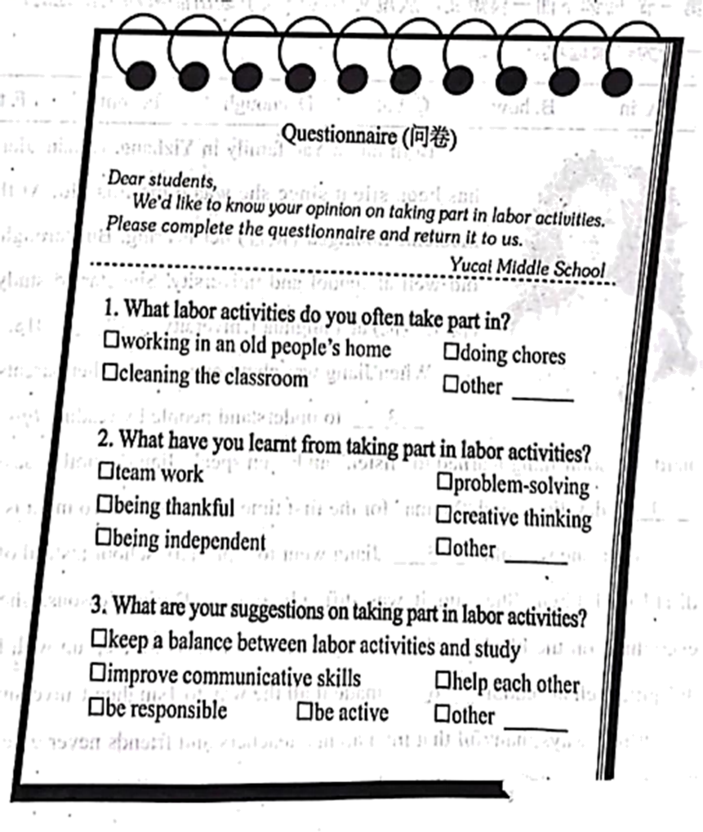
______________________________________________________________________________________________________________________________________________________________________________________________________________________________________________________________________________________________________________________________________________________________________________________________________________________________________________________________________________________________________________________________________________________________________________________________________________________________________________________________________________________________________________________________________________________________________________________
【答案】例文
Let’s Take Part in Labor Activities
Labor is the source of all happiness. Labor is one of the necessary conditions for students’ all-round development. And I think it is good to do housework.
Doing chores helps to develop children’s independence and teaches them how to look after themselves. I used to be lazy at home. Seeing this, my mother came up with an idea—I have to earn my pocket money by doing housework. It changed me a lot. For example, when I can’t work out a math problem, I prefer to sweep the floor or tidy up my room to clear my mind. Once my mother told me to buy some fruit. I quickly made a list, compared prices and bought fresh fruit. I now have a habit of managing money and I know it’s great of my mother to look after my family so well!
This is how I learn to do housework—it’s a skill that lasts a lifetime.
【解析】
【详解】1.题干解读：本文是一篇材料作文。要求以“Let’s Take Part in Labor Activities” 为题，结合提示内容进行写作，注意要点齐全，可适当发挥。
2.写作指导：写作时要以第一和第三人称来行文，时态用一般现在时。作文要分别介绍经常参加的劳动以及参加劳动的收获并提出建议。要保证语言连贯，无语法和拼写错误。

