青海省2022年初中学业水平考试
英 语
第 I 卷 听力及选择题
I. 听力测试（共四部分，计 20 分）
听句子，从 A、B、C 三个选项中选出与所听句子相对应的图片。每个句子仅读一遍。
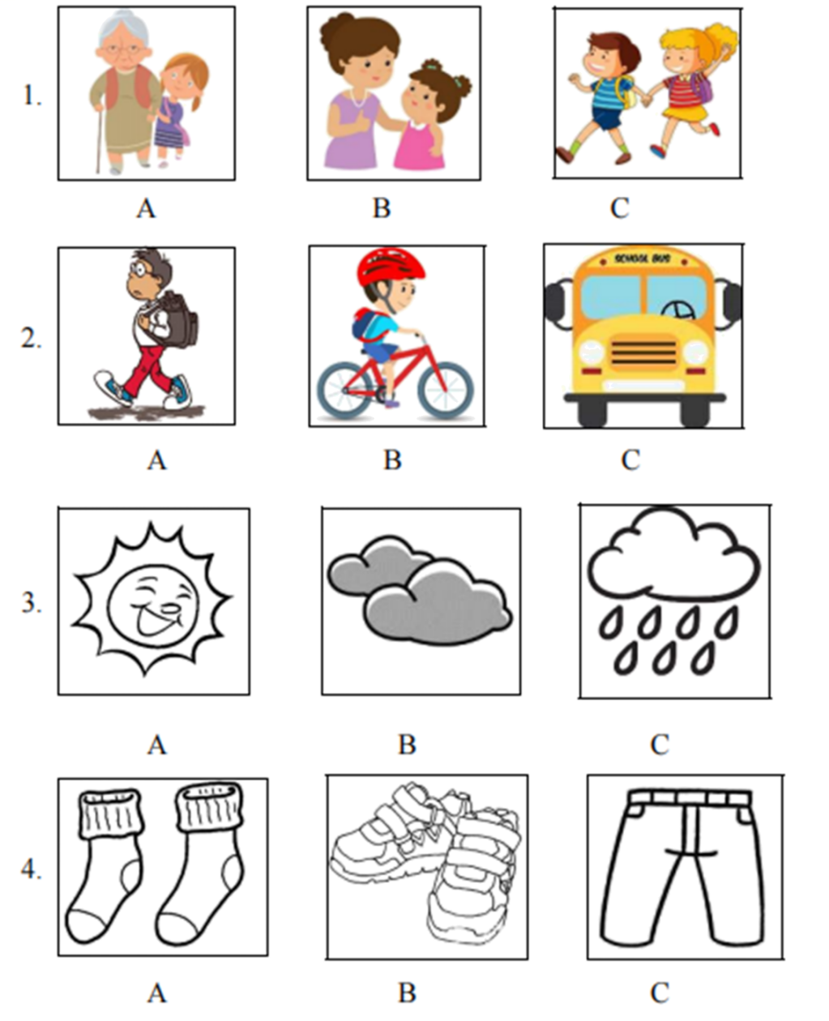
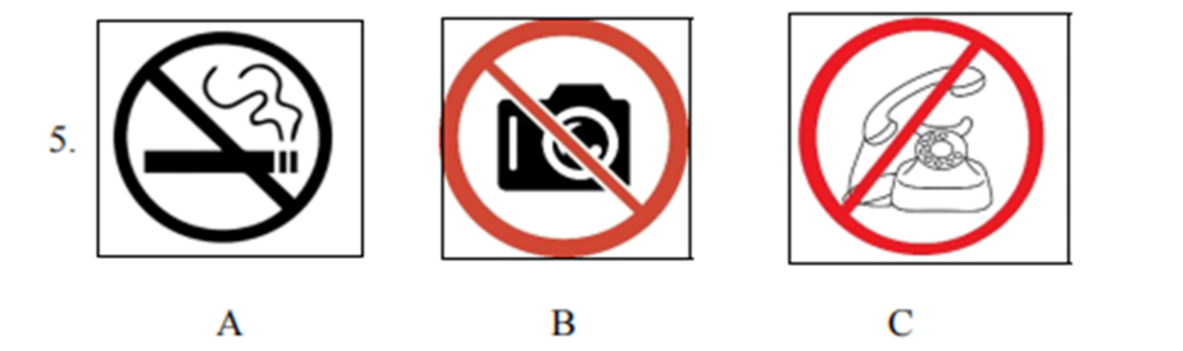
第二部分：听句子，选择最佳答语。每个句子仅读一遍。（每小题 1 分，共 5 分）
6. A. Yes, I am looking for a job.
B. I want to be a scientist.
C. I have a dream.
7. A. Thank you. B. You are welcome. C. What a pity!
8. A. It takes me 10 minutes. B. Once a week. C. I go to the movies by bus.
9. A. See you. B. It doesn’t matter. C. It’s my pleasure.
10. A. I am a doctor. B. I am sorry. C. I have a cold
第三部分：听下面五段对话和对话后的问题，选择正确答案。每段对话和问题读两遍。（每小题 1 分，共 5 分）
11. What club does the boy like?
A. English club. B. Swimming club. C. Art club.
12. Why does Tina stay up?
A. To prepare for the final exam.
B. To prepare for the English exam.
C. To prepare for the Chinese exam.
13. Where does the conversation probably take place?
A. In a library. B. At the man’s home. C. In a bookstore.
14. How will the speakers go to the Qinghai Lake?
A. In the man’s car. B. By bus. C. In the woman’s car.
15. According to the man, what will Chinese people do during the Spring Festival?
A. Enjoy dumplings. B. Wash clothes. C. Travel with family
听短文，根据短文内容，完成下面的表格，每空一词，短文读两遍。
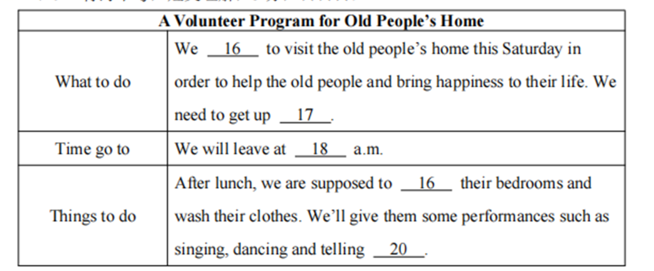
II. 单项选择（每小题 1 分，共 20 分）
从 A、B、C 三个选项中选出一个最佳答案填入空白处。
1. Gu Ailing is ________ excellent sports star. She achieved her dream in the 2022 Winter Olympic Games.
A. a B. an C. /
【答案】B
【解析】
【详解】句意：谷爱凌是一位优秀的体育明星。她在2022年冬奥会上实现了自己的梦想。
考查冠词用法。此处表示“一位体育明星”，表泛指，且excellent是以元音音素开头的，故选B。
2. When you are enjoying yourself on the beach, wear a pair of sunglasses to ________ your eyes.
A. keep B. protect C. treat
【答案】B
【解析】
【详解】句意：当你在海滩上玩得很开心的时候，戴上一副太阳镜来保护你的眼睛。
考查动词辨析。keep保持；protect保护；treat对待。根据“wear a pair of sunglasses to …your eyes”可知，戴太阳镜的目的是为了保护眼睛，故选B。
3. Chinese people were so excited ________ the Shenzhou-13 was successfully launched into space.
A. when B. why C. how
【答案】A
【解析】
【详解】句意：当神舟十三号成功发射进入太空时，中国人非常兴奋。
考查从属连词辨析和when引导时间状语从句。when当……时；why为什么；how如何。根据“Chinese people were so excited...the Shenzhou-13 was successfully launched into space.”可知，当神舟十三号成功发射进入太空时，人们很兴奋，用when引导时间状语从句。故选A。
4. If you make a promise, you must ________ it.
A. break B. have C. keep
【答案】C
【解析】
【详解】句意：如果你许下了诺言，就必须遵守它。
考查动词辨析。break打破；have有；keep保持。根据“If you make a promise, you must … it”可知，此处指要遵守承诺，keep a promise表示“遵守诺言”，故选C。
5. —Excuse me, could you please tell me where the nearest restroom is?
—Go ________ the hallway and turn left, it’s across ________ the teachers’ office.
A. along; from B. to; of C. down; to
【答案】A
【解析】
【详解】句意：——打扰一下，你能告诉我最近的洗手间在哪里吗？——沿着走廊走，然后左转，它就在教师办公室的对面。
考查介词辨析。along沿着；from从；to到；of……的；down向下。go along“沿着……走”，across from“在……对面”。故选A。
6. —Remember to ________ the lights when you leave the classroom.
—OK, no problem, Mr. Smith.
A. turn on B. turn up C. turn off
【答案】C
【解析】
【详解】句意：——当你离开教室时要记得关灯。——好的，没问题，史密斯老师。
考查动词短语辨析。turn on打开；turn up出现；turn off关闭。根据“Remember to…the lights when you leave the classroom”可知，离开教室要关灯，故选C。
7. —You did a great job, Joe!
—Thanks. I think you can do it even ________.
A. better B. best C. well
【答案】A
【解析】
【详解】句意：——你做得很好，乔！——谢谢。我觉得你可以做得更好。
考查副词比较级。“even”修饰比较级，better“更好”符合语境，故选A。
8. Our school held the graduation ceremony last Friday. All the parents ________ to cheer us up.
A. are invited B. were invited C. will be invited
【答案】B
【解析】
【详解】句意：我们学校上周五举行了毕业典礼。所有的家长都被邀请来给我们打气。
考查一般过去时的被动语态。根据“last Friday”可知，时态是一般过去时，主语是动作的承受者，所以用一般过去时的被动语态。故选B。
9. Paper cutting is one of the Chinese traditional ________.
A. arts B. sports C. subjects
【答案】A
【解析】
【详解】句意：剪纸是中国传统艺术之一。
考查名词辨析。arts艺术；sports运动；subjects科目。根据“Paper cutting is one of the Chinese traditional...”可知，剪纸是一门传统艺术，故选A。
10. —Hurry up! The plane ________ in one and a half hours.
—Don’t worry. I will drive you to the airport immediately.
A. will take off B. takes off C. took off
【答案】A
【解析】
【详解】句意：——快点！飞机将在一个半小时后起飞。——不要担心。我马上开车送你去机场。
考查一般将来时。根据“in one and a half hours.”可知，时态是一般将来时，故选A。
11. Wang Yaping becomes ________ female taikonaut to work in China’s space station.
A. one B. first C. the first
【答案】C
【解析】
【详解】句意：王亚平成为首位在中国空间站工作的女宇航员。
考查序数词的用法。此处作定语修饰“female taikonaut”，用序数词，序数词前加定冠词the。故选C。
12. —Look! Mr. Li is playing basketball with his students.
—It ________ be him. He has gone to Xi’an.
A. mustn’t B. can’t C. shouldn’t
【答案】B
【解析】
【详解】句意：——看！李老师正在跟他的学生们打篮球。——不可能是他。他去西安了。
考查情态动词辨析。mustn’t禁止；can’t不可能；shouldn’t不应该。根据“He has gone to Xi’an”可知，此处表示否定推测，所以应填can’t，故选B。
13. —The doctors are busy ________ how to deal with this disease these days.
—So they are. They’re really hard-working.
A. discuss B. to discuss C. discussing
【答案】C
【解析】
【详解】句意：——这些天医生们正忙着讨论如何治疗这种病。——确实如此。他们真的很努力。
考查非谓语动词。be busy doing sth“忙于做某事”，因此填动名词，故选C。
14. —Do you like the song Jian Hun on Douyin?
—Yes, I like the songs ________ I can dance to.
A. that B. who C. what
【答案】A
【解析】
【详解】句意：——你喜欢抖音上的歌曲《剑魂》吗？——是的，我喜欢能跟着跳舞的歌。
考查定语从句。此处是定语从句，先行词songs是指物，在从句中作宾语，用that引导定语从句，故选A。
15. —________ is it from your home to school?
—It’s 8 kilometers.
A. How long B. How far C. How often
【答案】B
【解析】
【详解】句意：——从你家到学校有多远？——8公里。
考查特殊疑问句。How long多长；How far多远；How often多久一次。根据答语“It’s 8 kilometers.”可知，对距离进行提问，故选B。
16. —Have you watched the movie named The Battle at Lake Changjin?
—Yes, I was moved to tears. ________!
A. What a touching movie
B. What touching a movie
C. How a touching movie
【答案】A
【解析】
【详解】句意：——你看过电影《长津湖》吗？——看过，我感动得热泪盈眶。多么感人的电影啊！
考查感叹句。此处强调的中心词是可数名词单数movie，用“What+a/an+adj+可数名词单数(+主谓)！”结构，故选A。
17. People in Qinghai are working hard. That’s why Qinghai is developing so ________.
A. regularly B. rapidly C. suddenly
【答案】B
【解析】
【详解】句意：青海人民正在努力工作。这就是青海发展如此迅速的原因。
考查副词辨析。regularly有规律地；rapidly迅速地；suddenly突然。根据“People in Qinghai are working hard. That’s why Qinghai is developing so...”可知，人民努力工作，所以发展迅速，故选B。
18. What ________ you ________ when I called you yesterday afternoon? You neither answered nor called me back.
A. are; doing B. will; do C. were; doing
【答案】C
【解析】
【详解】句意：昨天下午我给你打电话时你在干什么？你既不接也不回电话。
考查过去进行时。根据“What...you...when I called you yesterday afternoon?”可知，此处强调在过去的时间点正在发生的动作，用过去进行时。故选C。
19. —President Xi has spoken highly of the environment protection in Qinghai Province. As a teenager, I wonder ________.
—We should throw rubbish in the bins and keep public places clean.
A. how we can protect the environment
B. why we can protect the environment
C. how can we protect the environment
【答案】A
【解析】
【详解】句意：——习主席高度评价了青海省的环境保护工作。作为一个青少年，我想知道我们怎样才能保护环境。——我们应该把垃圾扔进垃圾箱，保持公共场所清洁。
考查宾语从句。此处是宾语从句，从句用陈述语序，排除C选项。根据答语“We should throw rubbish in the bins and keep public places clean”可知，想知道保护环境的方法，用how引导宾语从句，故选A。
20. —I think keeping one-meter distance is very important when we stand in line.
—________.
A. I totally agree B. It doesn’t matter C. Nothing much
【答案】A
【解析】
【详解】句意：——我认为当我们排队时保持一米的距离是非常重要的。——我完全同意。
考查情景交际。I totally agree我完全同意；It doesn’t matter没关系；Nothing much没什么事。根据“I think keeping one-meter distance is very important when we stand in line”可知，此处应是对对方的观点表示同意还是不同意，故选A。
III. 完形填空（共 10 小题，计 10 分）
阅读短文，从 A、B、C、D 四个选项中选出一个最佳选项，使短文完整、通顺。
One day, I came home after school and threw my gym bag and volleyball down at the floor. I had tried out for the school volleyball team, but I didn’t ____21____. I felt terrible. My mother tried to cheer me up, ____22____ nothing she did worked.
Finally, my mother sent me to visit my uncle ____23____ lived around the corner. “Are you still feeling bad?” my uncle asked. I guess my mother had told my uncle ____24____ my disappointment (失望). He ____25____ give me some good advice. He said, “Tommy, I’m ____26____ you for trying out for the volleyball team although you failed. You know what I do? Every year, I make a promise to ____27____ to try one new thing like a new sport, a new hobby or a new friend each year. Trying new things helps you grow as a person.”
One day, when I was walking by a school, I saw some kids ____28____ baseball. I thought about what my uncle had said, so I got close to the kids. It took some courage, but soon I was playing with them and having fun. From then on, I played with them every week.
A year ____29____, I became a happy player on our school baseball team. And I found this happiness because I tried ____30____ new.
21. A. make it B. put it C. find it D. lose it
22. A. and B. but C. because D. so
23. A. which B. whom C. who D. what
24. A. with B. to C. of D. about
25. A. felt lucky to B. decided to C. happened to D. refused to
26. A. strict with B. angry with C. proud of D. good to
27. A. myself B. himself C. herself D. yourself
28. A. play B. to play C. playing D. played
29. A. late B. later C. early D. earlier
30. A. anything B. everything C. nothing D. something
【答案】21. A 22. B 23. C 24. D 25. B 26. C 27. A 28. C 29. B 30. D
【解析】
【导语】本文是一篇记叙文，讲述作者参加校排球队选拔失败后，通过尝试新的运动，重新找到了快乐。
【21题详解】
句意：我曾参加学校排球队的选拔，但没有成功。
make it成功；put it放它；find it发现它；lose it失去它。根据“I felt terrible.”可知，感觉很糟糕，所以没有成功，故选A。
【22题详解】
句意：我母亲试图使我振作起来，但她所做一切都不起作用。
and和；but但是；because因为；so因此。前后构成转折关系，用but连接，故选B。
【23题详解】
句意：最后，我妈妈送我去拜访住在街角的叔叔。
which哪一个；whom谁（宾格）；who谁；what什么。此处是定语从句，先行词是人“my uncle”，引导词在从句中作主语，故选C。
【24题详解】
句意：我猜我妈妈把我的失望告诉了叔叔。
with和；to到；of……的；about关于。此处是tell sb about sth短语，意为“告诉某人关于某事”，故选D。
【25题详解】
句意：他决定给我一些好的建议。
felt lucky to感到幸运；decided to决定；happened to发生；refused to拒绝。根据“He...give me some good advice.”和后文内容可知，叔叔决定给我一些好的建议，故选B。
【26题详解】
句意：汤米，尽管你失败了，但我为你参加排球队的选拔感到骄傲。
strict with严厉；angry with生气；proud of骄傲；good to对……好。根据“I’m...you for trying out for the volleyball team although you failed”可知，叔叔在鼓励我，所以是为我骄傲，故选C。
【27题详解】
句意：每年，我都对自己承诺，每年尝试一件新事情，比如一项新的运动，一个新的爱好或一个新的朋友。
myself我自己；himself他自己；herself她自己；yourself你自己。根据“I make a promise to...”可知，主语是I，所以用myself，故选A。
【28题详解】
句意：一天，当我路过一所学校时，我看到一些孩子在打棒球。
play动词原形；to play动词不定式；playing动名词/现在分词；played动词过去式。根据“when I was walking by a school, I saw some kids...baseball”可知，此处是see sb doing sth短语，意为“看见某人正在做某事”，故选C。
【29题详解】
句意：一年后，我成为了学校棒球队的一名快乐的球员。
late晚；later更晚；early早；earlier更早。根据“A year..., I became a happy player on our school baseball team.”可知，一年后，成为了棒球队的队员，故选B。
【30题详解】
句意：我找到了这种快乐，因为我尝试了新的东西。
anything任何事；everything每件事；nothing无事；something某事。根据“And I found this happiness because I tried...new.”可知，因为尝试了新的事物，所以找到了快乐，故选D。
IV. 阅读理解（共三节，共 15 小题，计 30 分）
A
Famous Places around the World
The best time to visit...
China
China is a huge country so it depends on where you go. The best time to visit is autumn. During that time, temperatures are pleasant wherever you are. If you don’t like the heat, don’t come in summer. In Beijing, in summer, the average temperature is up to 30 degrees centigrade.
Greece
The best time to visit Greece is April to June. If you like snow, then go to the northwest of the country in winter. It’s great for skiing. If you just want to sit on a beach and see the sunshine every day, then August is the perfect month. But, be careful! Temperatures are really high. In the southeast of Greece, it might be 30-35 degrees centigrade.
Mexico
The weather in Mexico is hot, wet and sticky for most of the year, except in Mexico City. February to April is the best time to visit. It can get very stormy at the end of August. From time to time, there are hurricanes and tornados.
South Africa
South Africa has a pleasant climate, with lovely warm sunny days most of the year. The summer is from November to February, and the weather is really hot at this time. In August, it’s winter and the weather is usually warm, except at night. South Africa has the world’s highest daily hours of sunshine.
根据短文内容，选择最佳答案。
31. When South Africa is in summer, Beijing is in ________.
A. spring B. autumn C. winter D. summer
32. What’s the weather like in Mexico?
A. Hot and wet. B. Hot and dry. C. Windy and cool. D. Humid and cold.
33. If you are interested in skiing, you can visit ________.
A. China B. Mexico C. Greece D. South Africa
34. In ________, the daily sunshine lasts for the longest time.
A. Greece B. South Africa C. China D. Mexico
35. In which part of a magazine can we read this passage?
A. Business. B. Advertisement. C. Sports. D. Travel.
【答案】31. C 32. A 33. C 34. B 35. D
【解析】
【导语】本文主要介绍游览几个国家的最佳时间。
【31题详解】
推理判断题。根据“The summer is from November to February, and the weather is really hot at this time.”可知，南非的夏天是从11月到2月，与中国北京的季节相反，所以此时北京是冬天，故选C。
【32题详解】
细节理解题。根据“The weather in Mexico is hot, wet and sticky for most of the year”可知，墨西哥的天气一年中大部分时间都是炎热、潮湿和粘稠的。故选A。
【33题详解】
细节理解题。根据“Greece...It’s great for skiing.”可知，希腊适合滑雪，故选C。
34题详解】
细节理解题。根据“South Africa has the world’s highest daily hours of sunshine.”可知，南非是世界上每天日照时间最长的国家。故选B。
【35题详解】
推理判断题。本文主要介绍游览几个国家的最佳时间，推测可能在杂志的旅游版块看到这篇文章，故选D。
B
Zhou Jiangtao passed away at only 17 years old. He got bone cancer when he was 13. Four days before his death, he asked to donate his organs (器官). “I know the pain of suffering from disease and the helplessness of having no cure ... I’ve seen so much sadness and regret and want to offer help.” On the day he “left”, two patients who had been waiting for cornea transplants (角膜移植) were told they would get donations.
It has been 12 years since China started national test program for human organ donation. According to the China Organ Donation Administrative Center, about 300,000 people across China are waiting for organ transplants, but only 20,000 receive transplants each year.
In recent years, organ donation and transplantation have gotten more public support in China. “As of April 2 this year, more than 4.62 million people had signed up (登记) for organ donation,” said the center. As many as 75 people can get help from a single donor.
In China, there are some traditional thoughts about the bodies of dead people. For example, many believe the body is a gift from one’s parents. So, ________. But many others don’t think so. They think donating organs is a way to help others, which makes life more valuable than oneself.
More facts ●Rare organ: heart (must be from a donor under age 45)
●How to keep organs: using ice and a cooler
●How long can an organ survive outside the body?
Heart: 4—6 hours
Lung (肺): 4—6 hours
Liver (肝): 12—15 hours
Kidney (肾): 36—48 hours
Skin (皮肤): up to five years.
根据短文内容，选择最佳答案。
36. How long has Zhou Jiangtao been suffering from bone cancer?
A. For about 4 years. B. For about 13 years.
C. For about 17 years. D. For about 12 years.
37. In Paragraph 3, the underlined word “donor” means __________.
A. 接受者 B. 监护人 C. 组织者 D. 捐献者
38. According to the passage, a 48-year-old man can donate the following organs, EXCEPT ________.
A. lung B. heart C. liver D. skin
39. Choose the best sentence to put in ________ in Paragraph 4.
A. they think dead bodies must be kept complete
B. they are willing to donate their organs
C. they are pleased to donate their organs
D. they are encouraged to donate their organs
40. Which organ can survive for the longest time outside the body?
A. Heart. B. Kidney. C. Skin. D. Liver.
【答案】36. A 37. D 38. B 39. A 40. C
【解析】
【导语】本文从周江涛去世后捐献器官来引出关于器官捐赠情况，并详细地介绍了各种器官捐献的要求。
【36题详解】
细节理解题。根据“Zhou Jiangtao passed away at only 17 years old. He got bone cancer when he was 13”可知，13岁时得了骨癌，17岁去世，患骨癌四年，故选A。
【37题详解】
词义猜测题。根据“As of April 2 this year, more than 4.62 million people had signed up (登记) for organ donation”可知，此处介绍了捐赠者的人数，结合“As many as 75 people can get help from a single donor”可知，此处介绍从捐赠者中得到帮助的概率，所以划线单词表示“捐赠者”，故选D。
【38题详解】
细节理解题。根据“Rare organ: heart (must be from a donor under age 45)”可知，45岁以下的人可以捐赠心脏，所以48岁的人不可以捐赠心脏，故选B。
【39题详解】
推理判断题。根据“For example, many believe the body is a gift from one’s parents”可知，许多人认为身体是来自父母的礼物，所以认为人去世之后要有一个完整的身体，故选A。
【40题详解】
细节理解题。根据“How long can an organ survive outside the body”对应的内容“Skin (皮肤): up to five years.”可知，皮肤保存的时间最久，可以最多到5年，故选C。
C
Culture Flying High
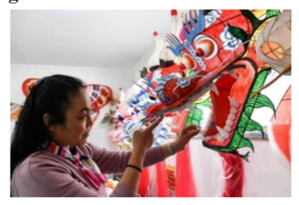
Known as the birthplace of kites, Weifang in Shandong Province has a long history of making kites.
Weifang kite-making dates back to 2,000 years ago. At first, they were often used by the army for measuring distance and communication purposes. During the Ming Dynasty(1368—1644), kites started to be popular among ordinary people as entertainment. Weifang kite-making was included in the national-level intangible cultural heritage lists(国家级非物质文化遗产名录) in 2006. Since 1984, the International Kite Festival has been held in Weifang every year.
Yang Hongwei, 56, is an inheritor(继承人) of the Weifang kite-making art, born into a kite-making family. “Every time I see the beautiful kites, my boredom and negative feelings go away,” said Yang.
Having a special connection with kites, Yang learned the art from her grandfather at the age of 16. After practicing the skills for 10 years, she started her own shop in 1992. On Yang’s kites, people can see not only common patterns like butterflies and birds, but also some paintings telling Chinese legends and history.
Though the idea was cool, the process was not easy. “It’s really hard work,” Yang added, “but when I explain the stories on the kites to foreign customers, I feel a sense of great achievement.”
In her space time, she also travels to different countries including Germany, Australia, the US and New Zealand to tell people about Chinese stories seen on kites and the traditional ways of making kites. “I’m an inheritor of the culture. It is also an important job of mine to spread the heritage around the world and onto the next generation,” she said.
根据短文内容，选择最佳答案。
41. When did kites start to be popular as entertainment?
A. During Ming Dynasty. B. 2000 years ago.
C. In 2006. D. In 1984.
42. Paragraph 2 mainly tells us ________.
A. the birthplace of kites B. the purposes of kites
C. the styles of kites D. the development of kites
43. The underlined word “negative” is similar to ________.
A. positive B. terrible C. personal D. joyful
44. According to the passage, what can we know about Yang Hongwei?
A. She traveled all over the world.
B. She started her own shop at the age of 16.
C. She tried her best to spread Chinese culture of kite to the world.
D. She was the only inheritor of the Weifang kite-making art.
45. The passage is written to ________.
A. tell the history of kites
B. teach us how to make a kite
C. introduce an inheritor of Weifang kite-making art
D. describe patterns of kites
【答案】41. A 42. D 43. B 44. C 45. C
【解析】
【导语】本文是一篇说明文，介绍风筝的起源以及潍坊风筝制作艺术传承人杨红卫的经历，以及她为传播中华文化做出的努力。
【41题详解】
细节理解题。根据“During the Ming Dynasty(1368—1644), kites started to be popular among ordinary people as entertainment.”可知，在明朝(1368-1644)，风筝开始在普通人中流行作为娱乐。故选A。
【42题详解】
段落大意题。分析第二段内容可知，本段主要介绍潍坊风筝制作的发展史，故选D。
【43题详解】
词句猜测题。分析“Every time I see the beautiful kites, my boredom and negative feelings go away”可知，每当我看到美丽的风筝，我的无聊和负面情绪就消失了。此处negative的意思是“负面的，消极的”。故选B。
【44题详解】
推理判断题。根据“It is also an important job of mine to spread the heritage around the world and onto the next generation”可知，杨红卫表示将这些遗产传播到世界各地，并传给下一代，也是她的一项重要工作。由此推知，她会尽她最大的努力向世界传播中国的风筝文化，故选C。
【45题详解】
主旨大意题。本文主要介绍风筝的起源以及潍坊风筝制作艺术传承人杨红卫的经历，以及她为传播中华文化做出的努力。选项C“介绍一位潍坊风筝制作艺术传承人”符合主题，故选C。
IV. 补全对话（共 5 小题，计 40 分）
根据对话内容，选出能填入空白处的最佳选项。（其中两个选项为多余选项）
Linda: Hi, Jim! What are you doing?
Jim: Hi, Linda! ____46____
Linda: What are you looking for on the Internet?
Jim: I’m searching for some information about Sanjiangyuan National Park.
Linda: Sanjiangyuan National Park? ____47____
Jim: Really? Please tell me something about it.
Linda: Sure. It is located in Qinghai Province and it’s a top national park in China.
Jim: Wow! ____48____
Linda: Yes, it is known as the “water tower of China”.
Jim: Amazing! I have just learned that Sanjiangyaun is home to the headwaters of the Yangtze, Yellow and Lancang rivers.
Linda: Exactly right. ____49____
Jim: What animals are there in this park?
Linda: Tibetan antelope, snow leopard, and Tibetan wild donkey. ____50____
Jim: How precious the animals are! I hope one day I can go there and see them.
A. I’m shopping on the Internet now.
B. Anything else?
C. I’m surfing on the Internet now.
D. I want to go there.
E. They have lived there for generations.
F. And there are also many wild animals in the park.
G. I have been there recently.
【答案】46. C 47. G 48. B 49. F 50. E
【解析】
【导语】本文是Linda和Jim讨论有关三江源国家公园相关信息的一则对话。
【46题详解】
根据“What are you doing”可知，此处介绍自己正在做的事情。结合“What are you looking for on the Internet”可知，自己正在上网，C选项“我现在正在上网”符合，故选C。
【47题详解】
根据“Really? Please tell me something about it”可知，自己知道这个地方，所以对方想了解有关它的情况，G选项“我最近去过那”符合，故选G。
【48题详解】
根据“Yes, it is known as the ‘water tower of China’”可知，此处应是一个问句，B选项“还有其他的吗”符合，故选B。
【49题详解】
根据“What animals are there in this park”可知，此处提到了“动物”，F选项“公园里也有很多野生动物”符合，故选F。
【50题详解】
根据“Tibetan antelope, snow leopard, and Tibetan wild donke”可知，此处介绍与这些动物有关的情况，E选项“它们世世代代都住在那里”符合，故选E。
第 II 卷（非选择题）
VI. 词汇运用（每空 1 分，共 5 分）
用方框中所给词的适当形式填空，使短文完整、通顺。
two get quick confuse suggest
You have been learning English for several years. Do you feel stressed and ____51____ when you are learning English? If yes, here are some ____52____ to help you.
How about ____53____ a pen fiend? You can send each other messages. It’s an effective way to improve your English and enjoy yourself.
Why don’t you get together with other English learners and set up some kind of “English Speaking Club”? You can talk to each other about your life and your worries.
It’s a wise idea to read English newspapers once or ____54____ a week. Get your notebook out and write down some words you don’t know. You’ll ____55____ build up your vocabulary.
Learning is a lifelong journey, so learn wisely and learn well.
【答案】51 confused
52. suggestions
53. getting
54. twice 55. quickly
【解析】
【导语】本文主要介绍了学习英语的方法和建议。
【51题详解】
句意：当你学习英语时，你是否感到压力和困惑？根据“Do you feel stressed and”及备选词可知，询问是否会感到困惑，confused“感到困惑的”，修饰人，故填confused。
【52题详解】
句意：如果是，这里有一些建议可以帮助你。根据“here are some … to help you”及下文的介绍可知，提供了一些学习英语的建议，suggestion“建议”，可数名词，根据“some”可知，此空应填可数名词的复数形式，故填suggestions。
【53题详解】
句意：找个笔友怎么样？根据“a pen fiend”及备选词可知，此处建议找一个笔友，get“得到”符合，about是介词，后接动名词，故填getting。
【54题详解】
句意：每周读一两次英文报纸是个聪明的主意。根据“once or … a week”可知，此处表示频率，twice“两次”符合，故填twice。
【55题详解】
句意：你的词汇量会很快增加。此空修饰动词短语“build up”，应填quick的副词quickly“快速地”，故填quickly。
VII. 阅读表达（每空 1 分，共 10 分）
根据短文内容，用符合语义及语法规则的词填空，每空一词。
Now we are in the Year of the Tiger. In Chinese culture, tigers are named the king of all animals. They symbolize power, energy, protection and generosity. Tigers and fearless creatures, so that’s why in China you can see images of tigers on the walls of temples and houses to get rid of disasters and danger. Tigers have an important cultural meaning not in China, but across Asia.
Instead of tigers, lions are seen as the king of all animals in the West. That’s why brave warriors are given the name “the lion”. But in the West, tigers are also powerful animals. In English, if you want someone who feels nervous to take it easy, you can say to them, “easy tiger”.
Tigers are endangered species now. We can only hope that in the Year of the Tiger more people can learn about tigers and help protect their habitats (栖息地) from destruction (破坏).
56. A tiger is ________ ________ of power, energy, protection and generosity.
57. In China, you can see images of tigers on the walls of temples and houses because people think they can help them ________ ________ from disasters and danger.
58. In the West, brave warriors are given the name “the lion” because people ________ lions ________ the king of all animals.
59. When people say “easy tiger” to you, it means they want you to ________ ________.
60. We hope more people can get to know tigers and help ________ their habitats ________ being destroyed.
【答案】56. ①. a ②. symbol
57. ①. keep ②. away
58. ①. regard ②. as
59. ①. calm ②. down
60. ①. prevent ②. from
【解析】
【导语】本文是一篇说明文，介绍了中国的“虎”文化。
【56题详解】
根据“They symbolize power, energy, protection and generosity.”可知，老虎象征着力量、能量、保护和慷慨。a symbol of“……的象征”，故填a；symbol。
【57题详解】
根据“Tigers and fearless creatures, so that’s why in China you can see images of tigers on the walls of temples and houses to get rid of disasters and danger.”可知，老虎是一种无所畏惧的动物，所以这就是为什么在中国，你可以在寺庙和房子的墙上看到老虎的形象，以驱除灾难和危险。get rid of“摆脱，除去”可替换为keep away from“远离”，故填keep；away。
【58题详解】
根据“Instead of tigers, lions are seen as the king of all animals in the West.”可知，在西方，狮子被视为动物之王，而不是老虎。regard...as...“把……视为……”，故填regard；as。
【59题详解】
根据“In English, if you want someone who feels nervous to take it easy, you can say to them, ‘easy tiger’.”可知，在英语中，如果你想让一个感到紧张的人放松，你可以对他说“easy tiger”。calm down“放松”符合语境，故填calm；down。
【60题详解】
根据“We can only hope that in the Year of the Tiger more people can learn about tigers and help protect their habitats from destruction.”可知，我们只希望在虎年，更多的人能了解老虎，帮助保护它们的栖息地。prevent...from...“阻止”符合语境。故填prevent；from。
VIII. 书面表达（计 15 分）
61. 当今，中国正迅速发展，在各方面都取得了令人瞩目的成就。请你以“China in Ten Years”为题，畅想并描述十年后的祖国。
要求：（1）内容积极向上，完整连贯；
（2）逻辑清晰，表达准确，书写规范；
（3）文中不得出现姓名、校名和地名；
（4）词数：80—100（文章开头已给出，不计入总词数）。
China in Ten Years
Nowadays, our country is developing fast. It has made great achievements in
many fields. What will China be like in ten years? _____________________________________________________________________________________________________________________________________________________________________________________________________________________________________________________________________________________________________________________________________________________________________________________________________________________________________________________________________________________________________________________________________________________________________________________________________________________________________________________________________________________________________________________________________________________________________________________________________________________________________________________________________
【答案】例文
China in Ten Years
Nowadays, our country is developing fast. It has made great achievements in many fields. What will China be like in ten years?
I imagine my life in ten years will be wonderful. I will live in Shanghai. The neighborhood which I lived in will be very comfortable. There will be many trees and flowers around my house. A lot of subways will be built in my city. It will be very convenient for me to go out. As for my job, I will be a doctor. I will help people in need. Maybe I’ll go to a famous university for further study. My parents will be too old to take care of themselves. So taking good care of them will be my duty. I will make money to support my parents because they gave me so much when I was young.
In a word, my life in ten years will be better than it is now. I will try my best to make it possible to have a better life!
【解析】
【详解】[总体分析]
①题材：本文是一篇记叙文，为话题作文；
②时态：时态为“一般将来时”；
③提示：写作要点已给出，考生应注意不要遗漏，适当增加细节完整表述内容。
[写作步骤]
第一步，引出本文主题，畅想中国未来十年是什么样子；
第二步，从生活，工作，交通等方面畅想未来。
[亮点词汇]
①a lot of 许多
②as for 至于
③take care of 照顾
[高分句型]
①The neighborhood which I lived in will be very comfortable.（which引导定语从句）
②There will be many trees and flowers around my house（there be句型）

