2023年内蒙古通辽市初中毕业生学业考试试卷
英 语
注意事项：
1. 本试卷共12页, 8道大题, 满分为120分, 考试时间为120分钟。
2. 根据网上阅卷需要, 本试卷中的所有试题均要求在答题卡上作答, 答在本试卷上的答案
无效。
听力部分( 共 3 0 分 )
一、听句子, 选择图片。(每小题1分, 共5分)
第一节听句子, 从每小题A、B、C选项中选择最佳图片。(每个句子读一遍)
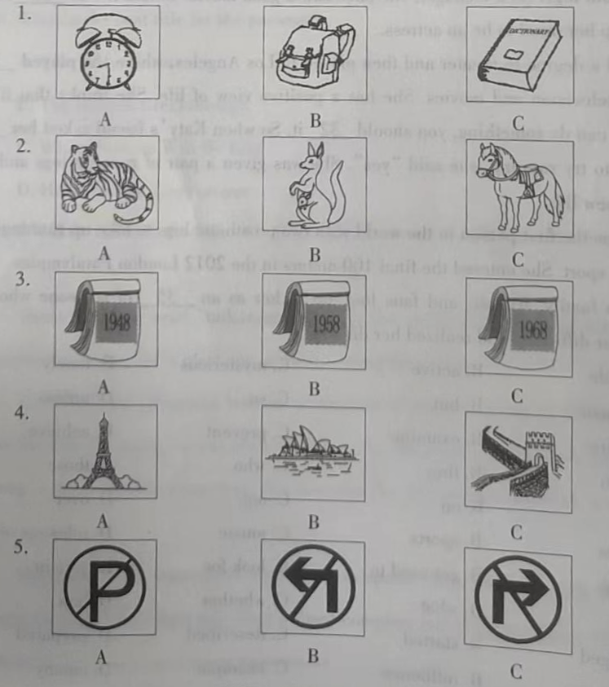
二、听句子、对话和短文。(每小题1分, 共15分
第二节听句子, 从每小题A、B、C选项中选择能对句子做出适当反应的答语。(每个句子读两遍)
6. A. Yes, please. B. No, I wouldn’t. C. You’re welcome.
7. A. I’m fine. B. Let me help you. C. The same to you.
8. A. I agree with you. B. Have a good time. C. See you.
9. A. Good luck. B. Good job. C. Good idea.
10. A. That’s right. B. Take it easy. C. With pleasure.
第三节听对话, 从每小题A、B、C选项中选择能回答所给问题的最佳选项。(每段对话读两遍)
所下面一段对话, 回答第11至12小题。
11. What is Tony’s hobby?
A. Skating. B. Cycling C. Swimming.
12 How does Tony like playing basketball?
A. He doesn’t mind it. B. He loves it very much. C. He doesn’t like it at all.
听下面一段对话, 回答第13至15小题。
13. How did Mr. Brown come to the city?
A. By bus. B. By plane. C. By train.
14. Is there an airport in the city?
A. Yes, there is. B. No, there isn’t. C. We don’t know.
15. How soon will Mr. Brown leave the city?
A. In 5 days. B. In 6 days. C. In 7 days.
第四节听短文, 根据所给问题选择最佳选项。(短文读两遍)
16. Who is the report for?
A. Officers. B. Students. C. Parents.
17. What is the topic of the report?
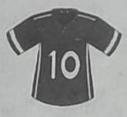
A. Safety. B. Study. C. Sports.
18. What time will the talk begin?
A. At 3:00 p. m B. At 4:00 p. m. C. At 5:00 p.m.
19. Which activity is mentioned?
A. Discussion B. Watching films. C. Questions and answers.
20. It isn’t allowed to ____________ during the report.
A. take photos B. have a talk C. wear masks
三、听短文, 填表格。(每小题2分, 共10分)
第五节 听短文, 根据短文内容填写表格, 每空一词。(短文读两遍)
How to 21________ Their English
Who | What | How
Mark | Spoken English | To go to the English corner 22__________ a week.
Betty | 23___________ | To read out loud while watching 24______________.
Jack | Writing skills | To 25 ______ words and expressions and use them in his diary
笔试部分 (共90分)
四、完形填空。(完成26~35小题, 每小题1分, 共10分)
阅读下面短文，掌握其大意，然后从A、B、C、D四个选项中选择最佳选项。
Katy Sullivan is an actress, an athlete, and a person who also refuses to accept the words “no” or “I can’t”.
She was born without the lower half of her legs and has worn prosthetic (假体的) ones all her life. She grew up in Alabama, the US and had a(n) ____1____ childhood. She kept up with her sisters and brothers at the gym and the swimming pool. She feels lucky ____2____ her family treated her in just the same way as the other members.
When a person is born without legs, there are plenty of things that are difficult to do. But Katy believed she could ____3____ anything. So she chose two jobs ____4____ were difficult even with both legs. As a teenager, she once saw a good movie. Before it was ____5____, Katy had made up her mind to be an actress.
She did a degree in theater and then moved to Los Angeles, where she played ____6____ in theater, television and movies. She has a positive view of life. She thinks that if you believe you can do something, you should ____7____ it. So when Katy’s friend asked her ____8____ she’d like to try running, she said “yes”. She was given a pair of running legs and she ____9____ her new life.
Katy was the first person in the world with two prosthetic legs to take up running as a competitive sport. She entered the final 100 meters in the 2012 London Paralympics.
Katy’s family, friends, and fans look up to her as an ____10____ of someone who has overcome her difficulty and realized her dreams.
1. A. terrible B. active C. mysterious D. lonely
2. A. because B. but C. so D. unless
3. A. require B. examine C. prevent D. achieve
4. A. which B. they C. who D. those
5. A. up B. on C. out D. over
6. A. games B. sports C. music D. roles
7. A. go for B. get used to C. look for D. give in
8. A. that B. what C. whether D. how
9. A. changed B. started C. described D. prepared
10. A. explorer B. influence C. example D. enemy
五、阅读理解。(完成36~50小题, 每小题2分, 共30分)
阅读短文, 从每小题所给的A、B、C、D四个选项中, 选择最佳选项。
A
Hey soccer fans. . .
Wouldn’t you like to show your support by wearing a replica(复制品) of your favorite player’s jersey(运动衫)?
If you order now, you can be wearing your jersey for the opening game in August. But hurry. It will take you 7 to 10 days to get your jersey after you place an order. The order ends on July 31.
Price:
Number | Price | Handling(运费)
1 | $39 each | $6
2 to 5 | $35 each | $3
over 5 | $30 each | $0
Just choose your favorite team and player’s name, and tell us your size (S. M. L. XL). Don’t hesitate or your team’s jersey may be sold out!
Order now by phone (0327654952) or online at our website (www.anyfan.com).

11. If Peter orders a jersey on July 3, he may receive it on ________.
A. July 3 B. July 6 C. July 8 D. July 12
12. How much should Mr. Green pay if he buys 5 jerseys?
A. $150. B. $175. C. $178. D. $207.
13 What does the underlined word “hesitate” mean?
A. 犹豫不决 B. 深谋远虑 C. 精打细算 D. 循规蹈矩
14. How many ways of ordering the jersey are there in the passage?
A. One. B. Two. C. Three. D. Four.
15. The passage is probably from a ________.
A. diary B. newspaper C. textbook D. storybook
B
Narrator: There once was a pretty princess whose favorite toy was a golden ball. One day the princess tossed the ball too high, and it landed in the well. As the princess cried over her lost treasure, she heard someone ask a question.
Frog: Why are you so sad, pretty princess?
Narrator: The princess looked around and saw only a frog.
Princess: My favorite golden ball fell into the well.
Frog: I can retrieve it for you, but first, you must agree to one condition. You must promise to take me home and be my friend.
Narrator: The princess didn’t want to be friends with a frog, but she promised anyway. When the frog brought her the ball, the princess snatched it from him and hurried home.
Frog: What a selfish princess! I’m certain that she has forgotten her promise. I’ll just hop over to the castle to remind her.
Narrator: The frog hop-hop-hopped through the grass and knocked on the heavy door of the castle.
Princess: What are you doing here, you bumbling frog?
Frog: Dear princess. I am here to remind you of the promise you made.
Narrator: The princess slammed the door in the frog’s face with a big BANG.
King: I heard a door slam. What’s happening? If you made a promise, you must honor it.
Narrator: The princess was angry but obeyed her father. So, the king, the princess, and the frog enjoyed dinner together. It was mutton stew, the cook’s specially.
Frog: I was hungry, but now I’m full. Thank you for dinner. Kindly show me to my bed now.
Narrator: The princess did as she was asked, but the frog looked sad.
Frog: You have welcomed me into your home, but I can tell that you don’t want to be my friend.
Narrator: The princess’s face went red, for what the frog said was true. She bent down to kiss the frog, but ended up kissing a prince.
Frog: I am a prince who was turned into a frog, and your kiss turned me back. Thank you, dear friend.
Narrator: The prince and princess were wonderful friends from that day on and lived happily ever after.
16. The reading material above is ________.
A. a play B. a poem C. a survey D. an interview
17. What’s the meaning of the underlined word “retrieve”?
A. put away B. bring back C. carry away D. cut down
18. Why did the frog hop over to the castle?
A. To ask the king for help.
B. To enjoy dinner with his friend.
C. To give the ball to the princess.
D. To remind the princess of her promise.
19. What is the right order of what the princess did in the story?
① She went back to the castle.
② She bent down to kiss the frog.
③ She got help from the frog and made a promise.
④ She obeyed her father and ate the meal with the guest.
A. ①③②④ B. ②④③① C. ③①④② D. ③④①②
20. What can we learn from the story?
A. We shouldn’t be afraid of making friends.
B. It’s a pleasure to see friends from far away.
C. We should ask for help when we are in trouble.
D. Once you make a promise, you must keep it.
C
Have you ever imagined what life will be like in the future? Here are some surprising statements from an international group of forty scientists. They said that in the near future, our lives would change beyond our wildest dreams.
Firstly, humans can grow body parts themselves. Dr. Ellen Heber-Katz is one of the forty scientists. He says, “People will think it common that sick organs (器官) can be repaired. It’s just like the way we repair a car.” Damaged parts will be taken away. Scientists could use human cells (细胞) to grow new organs. New technologies like this will also help people to live longer. Within forty years, most people will be able to live to be one hundred years old.
Secondly the scientists have thought that a machine will be invented to “read” the minds of animals. In the future, we will be able to “talk” to animals. Scientists say that humans may first “talk” with mammals (哺乳动物) and then other vertebrates (脊椎动物) such as fish.
Our houses might also change beyond our imagination. Dr. Susan Greenfield says that when you enter the living room, sensors (传感器) will know you. They will turn on the lights. If you talk to the lights, they will change to the color of your choice.
But what would be the biggest breakthrough (突破) over the next forty years? A number of scientists believe it would be the discovery of aliens. NASA scientist Chris Mckay says, “We may find aliens in space and talk with them.” He believes marks of alien life may even be found here on Earth.
What an amazing world it will be! Does life in the future sound cool to you? Let’s wait and see what will really happen then!
21. Which of the following is mentioned in the passage?
A. Scientists can use human cells to kill damaged parts of human bodies.
B. All people will be able to live to be one hundred years old in forty years.
C. In the future, humans may be able to communicate with dogs and aliens.
D. The sensors will turn off the lights after you leave the living room in the future.
22. Which scientist believes we will find aliens?
A. Chris Langdon. B. Ellen Heber-Katz. C. Susan Greenfield. D. Chris Mckay.
23. Which of the following best shows the structure of the passage?
(①=Paragraph 1, ②=Paragraph 2. ...)
A. 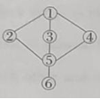 B. 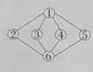 C. 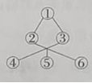 D. 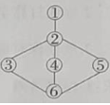
24. The writer wrote the passage in a tone (语气) of ________.
A. fear B. respect C. regret D. surprise
25. What is the best title for the passage?
A. Life in the Future
B. The Biggest Breakthrough
C. What Humans Will Be Like
D. How We Can Live Longer
六、读写综合。(完成51~65小题。51~55每小题2分, 56~65每小题1分, 共20分)
A
These days the word “taikonaut” is hot in the world. It is a special name for Chinese astronauts. Today, let’s meet one of them—Deng Qingming.
In1998, Deng Qingming became a member of the first group of Chinese astronauts. For the next 25 years, he was always ready to fly. He waited and waited. At the age of 56, Deng’s dream finally came true. Not long ago, he joined Shenzhou-15’s team and went into space.
Shenzhou-15’s team spent six months in space. After they met with Shenzhon-14’s team, they took over their job. They helped complete the Tiangong Space Station, do some science experiments and go on spacewalks.
The journey to his dream took a very long time. Deng once felt sad and hurt, but he never gave up. He worked hard all the time and finally his dream came true. The trip to space was not only exciting for Deng, but also for his family and friends. His daughter, who also works for China’s Space Program, said with pride, “My father is a hero!”
根据短文内容，请用完整句子回答下列问题。
26. When did Deng Qingming become an astronaut?
________________________________________
27. How old was Deng Oingming when he flew to space?
________________________________________
28. How long did Deng Qingming stay in space?
________________________________________
29. What does Deng’s daughter think of him?
________________________________________
30. What do you think made Deng’s dream come true?
________________________________________
B
阅读下面短文，根据语境、音标或所给单词的提示，在每个空格内填入一个恰当的词，使短文意思完整、行文连贯。
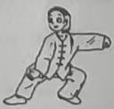
As Chinese, I’m sure you know something about tai chi. It’s a kind of sport and one of the symbols of Chinese culture.
Tai chi is common in China. If you walk through a park, you might see people doing these slow and ____31____ (beauty) actions. They are doing tai chi, ____32____ ancient art called wushu. Doing tai chi is good for our health and helps us ____33____ / rɪˈlæks / and free ourselves from pressure. It can make us walk and move freely. Tai chi also mixes slow actions and deep breaths ____34____ (perfect).
But tai chi is more than a kind of sport. It shows ____35____ we see the world as well. The world is full of yin and yang, such as dark and light, soft and hard, full and empty etc.

Tai chi sets up good relationships ____36____ yin and yang, while they aren’t opposite. Just like the picture on the right, a white circle is in the black area and a black circle is in the white area. After a dark night, the sun will rise. Leaves fall in autumn but grow in spring. Everything keeps changing. Yin and yang depend on each other and make ____37____ (different) to each other. That is why humans can get on well with nature and people can use softness to beat hardness. Tai chi makes full use of yin and yang.
In China, tai chi has been practiced for about 600 years. At present, more people are ____38____ (encourage) to join in tai chi and pass it on. ____39____ (million) of people in more than 150 countries practice tai chi. It is ____40____ (get) more and more popular in the world.
七、完成句子。(完成66~70小题, 每小题2分, 每空1分, 共10分)
根据所给中文意思完成句子, 每空一词。
41. 十分钟不够我算出这道数学题。
Ten minutes ________ ________ for me to work out the math problem.
42. 王老师使我们能在他课堂上通过有趣的方式轻松地学习物理。
Mr. Wang makes ________ ________ for us to learn physics easily and in an interesting way in his class.
43. 怀特一家来中国已经两年了。
It has ________ two years ________ the Whites came to China.
44. 你为别人倒茶时，要倒七分满。
When you serve the tea to somebody, you should ________ the cup 70% full ________ the tea.
45. 追随着父母的脚步，西尼·麦克劳克林在很小的时候就开始跑步了。
________ ________ her parents’ footsteps, Sydney McLaughlin-Levrone started running at an early age.
八、书面表达。(共20分)
46. 勤劳是中华民族的优秀传统美德，青少年要继承并发扬这一传统美德。请结合下列提示及自身实际，以“Doing Housework”为题，写一篇80词左右的短文。
提示：
1. 请列举你经常做的家务活；
2. 你还打算学做什么家务及原因；
3. 谈谈你对做家务的看法。
要求：
1. 思路清晰，语句通顺，书写规范。
2. 文中不得出现与考生本人相关的校名和姓名等真实信息。
Doing Housework
______________________________________________________________________________________________________________________________________________________________________________________________________________________________________________________________________________________________________________________________________________________________________________________________________________________________________________________________________________________________________________________________________________________________________________________________________________

