2023成都中考真题
英 语
A 卷 (共100分)
第一部分 听力 (共30小题；计30分)
一、听句子，根据所听到的内容选择正确答语。每小题念两遍。(共5小题；每小题1分，计5分)
1. A. Come on. B. Good morning. C. I’m fine.
2. A. Sounds great! B. Congratulations! C. Good luck!
3. A.You’re right. B. The same to you C. I hope not.
4. A. I agree. B. Don’t worry. C. You’re welcome.
5. A. It depends. B. Yes here you are. C. Never mind.
二 、听句子，选择与所听句子内容相符的图片。每小题念两遍。(共5小题；每小题1分，计5分)
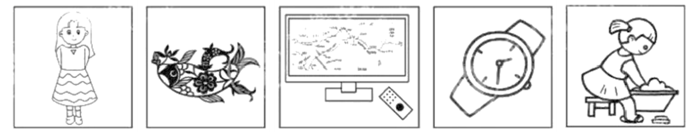
三、听对话，根据对话内容及问题选择正确答案。每小题念两遍。(共10小题；每小题1分，计10分)
11. A. A hotel. B. A cinema C. A bank.
12. A. Cloudy. B. Rainy C. Sunny.
13. A. An actress. B. An engineer C. A reporter.
14. A. At a restaurant B. At a clothes store C. At a museum.
15. A He’s calling. B. He’s traveling C. He’s reading.
16. A. Tony’s. B. Mary’s. C. Andy’s.
17. A. By car. B. By bus. C. By bike.
18. A. Father and daughter. B. Doctor and patient C. Teacher and student.
19. A. Their hobbies. B. Favorite subjects C. School clubs.
20. A. He got on a wrong train. B. He bought a wrong ticket. C. He got off at a wrong station.
四、听短文，根据短文内容选择正确答案。短文念两遍。(共5小题；每小题1分，计5分)
21. Where will they meet after visiting Chengdu Research Base?
A. At the south gate. B. At the east gate. C. At the west gate.
22. What time will they leave Wuhou Temple?
A. 1:30 p.m. B. 2:30 p.m. C. 4:00 p.m.
23. Which is the right order of the activities?
① going shopping ② seeing pandas ③ drinking tea
A. ②①③ B. ②③① C. ③②①
24. What are mentioned by the speaker?
A. Food and history. B. Food and performance. C. History and performance.
25. What is the speaker’s purpose?
A. To tell about the travel plan.
B. To wish the tourists a good trip.
C. To introduce some places of interest.
五、听短文，根据短文内容完成图表中所缺信息。短文念三遍。(共5小题；每小题1分，计5分)
The International Day of Families
Date | On 26 every year.
Beginning | It was set by the 27 in 1993.
Purposes | · To know the importance of family.  · To realize the 28 and work together for a better world.
Ways of 29 | · Staying with your family.  · Reflecting on the meaning of family to you.  · Building a good relationship with 30 .
第二部分 基础知识运用 (共30小题；计40分)
六、选择填空 (共15小题；计20分)
A. 从以下各题的A、B、C三个选项中选择最佳选项。(共10小题；每小题1分，计10分)
1. The 31st Summer Universiade (大运会) is ________ big event for Chengdu.
A. a B. an C. the
2. —Gina, have you seen my textbook?
—Oh, sorry. I took ________ by mistake.
A. mine B. yours C. hers
3. Deng Qingming, an astronaut of Shenzhou 15, achieved his dream ________ many years’ hard work.
A. without B. in C. through
4. Your answer ________ be right, but I’m going to check to make sure.
A. can’t B. might C. must
5. The book of Songs is the ________ collection of poems in China and the beginning of China’s poetry tradition.
A. early B. earlier C. earliest
6. ________ you treat others with your heart, you will get friendship in return.
A If B. Until C. Unless
7. He showed me the photos ________ he took at his graduation ceremony.
A. that B. who C. what
8. I am sorry I didn’t answer your phone because I ________ the piano at that time.
A. played B. was playing C. am playing
9. —Do you know ________ the Dragon Boat Festival is this year?
—Sorry, I don’t know the exact date.
A. how B. why C. when
10 A great number of beautiful flowers ________ on the second ring road in Chengdu these days.
A. plant B. are planted C. are planting
补全对话根据对话内容，选出适当的选项补全对话。
A: Hi, Jill. ____11____
B: A Little Prince, a classic novel. Have you heard of it?
A: Yes. ____12____
B: Oh, it’s so fantastic that I couldn’t put it down.
A: Wow! ____13____
B: Hmm ... A story between a pilot and the little prince from another planet.
A: Sounds interesting!
B: Yeah. It also satisfies the taste of both kids and adults. ____14____
A: Oh, I can’t wait to read it. Can you lend it to me?
B: Sure. ____15____
A. What is it about?
B. I’m almost done.
C. What are you reading?
D. It’s well worth reading.
E. But I haven’t read it yet.
七、完形填空阅读下面两篇短文，根据短文内容，从A、B、C 三个选项中选出可以填入空白处的最佳选项。 (共15小题；计20分。 A 篇每小题2分，计10分；B 篇每小题1分，计10分)
A
An e-mail from a man named Ben came in to Steve’s restaurant.
“Dear sir, my mom loves your pancake so much. Every time she visits Richmond, your restaurant is her must-go place,” he wrote. “____16____, she is seriously ill in Boston. Could you give me the recipe (食谱) so that I can make it for her?”
Steve, the owner of the restaurant, replied with another ____17____, “I’d like to meet you in Boston and make it ____18____ for her.”
Steve drove over 500 miles and reached Ben’s house. Ben’s mom was so ____19____ to see Steve.
“Why did you drive all the way up here to ____20____ for me?” She was so happy and touched.
“Because you’re an amazing and sweet lady!”
16. A. Suddenly B. Unluckily C. Finally
17. A. result B. example C. suggestion
18. A. fresh B. new C. healthy
19. A. interested B. surprised C. disappointed
20. A. speak B. try C. cook
B
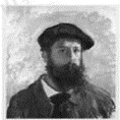
Claude Monet brought sunshine into painting.
He was one of the first artists to work ___21___. That may sound ___22___ to us today. But before 1870, most artists did all their paintings in rooms. They used models dressed up as Greek gods or heroes from history. They painted with dark colors so their pictures would look more ___23___ .
However, Monet and his artist friends ___24___ the rules. They took their paints and brushes to paint lakes, flowers and woods in the open air. They wanted to show ___25___ sunlight made water and boats look at different times during the day. If they painted people, they always painted common people. They used ___26___ colors and painted quickly.
For years, Monet had ___27___ in making money. Sometimes he could not pay the rent (租金); sometimes his family had no heat; sometimes they went hungry. ___28___, Monet would not give up.
Today, he is one of the most famous artists ever. Paintings by Monet sell for millions of dollars and ___29___ in museums around the world. We’re all lucky that Monet never ____30____.
21. A. inside B. outdoors C. everywhere
22. A. usual B. special C. strange
23. A. funny B. lively C. serious
24. A. supported B. broke C. followed
25. A. when B. why C. how
26. A. bright B. dark C. peaceful
27. A. fun B. trouble C. success
28. A. Still B. Also C. Besides
29. A. stand B. stick C. hang
30. A. kept B. stopped C. avoided
第三部分 阅读理解 (共15小题；计30分)
阅读下面短文，根据短文内容判断句子正误。正确的涂“A”，错误的涂“B”。
A Survey on Sports in Chengdu
by Class 1, Grade 9
Q: What are Chengdu people’s favorite sports?
Walking is No. 1 favorite. Another four most popular sports are running, ping-pong, swimming and badminton. Greenways and parks near their homes are green gifts for Chengduers to do sports conveniently.
Q: Do Chengdu people do sports just to lose weight?
Not really. Physical shape doesn’t matter that much. The chart on the right shows the reasons for exercise.
Q: Do Chengdu people use much technology when doing sports?
Yes. Technology, such as smart watches, sports apps or smart gyms, is used to record exercise habits, provide suggestions, give reports on health and even remind people to do sports.
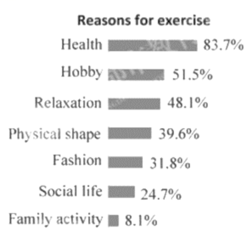
31. The top three popular sports in Chengdu are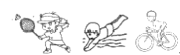 .
32. Places for sports are easy to find in Chengdu.
33. The chart shows that about a quarter of Chengduers exercise to spend time with family.
34. We can learn that hobby is more important than fashion for Chengduers to do sports.
35. Technology is smart but hardly used in daily exercise.
九、阅读下面两篇短文，根据短文内容选择最佳选项。(共10小题；每小题2分，计20分)
A
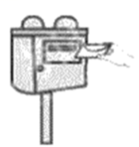
Host: As we know, the British have been sending cards since the 19th century. They spend about 1,700,000,000 pounds on cards every year. However, the number of people sending cards and letters is falling. More than 30 percent of UK children have never sent or received a handwritten letter. Should the tradition of sending cards and letters be stopped?
Group A:  We live in a fast-developing world and using snail mail is unnecessary. Making paper uses lots of energy and some cards are hard to recycle. It’s bad for environment. What’s more, cards are expensive to buy and so is posting. Nowadays, we usually use our phones and computers because they are quick, easy and free. Traditional cards and letters are out of date. They are not young people’s cup of tea. It’s no surprise that most of them end up as litter. | Group B:  The tradition has been around for hundreds of years and should stay. Sending a handwritten letter or carefully chosen card shows that you care. Phone messages and emails are quick and easy, but they seem to carry less feeling. Sending letters is good for children because it is a chance to practice writing skills. Also, it’s fun! Receiving post makes you feel special and it’s important if someone lives far away or is lonely—just imagine a birthday without cards!

36. What’s the discussion mainly about?
A. When the British send cards and letters.
B. Whether the British should keep the tradition.
C. Why the British like sending cards and letters.
37. Who thinks it’s necessary to keep the tradition?
A. The host. B. Group A. C. Group B.
38. Which picture can show the meaning of the underlined word snail?
A. 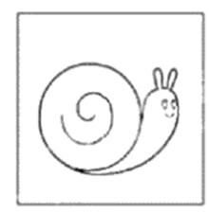 B. 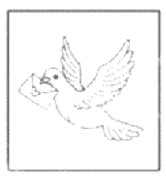 C. 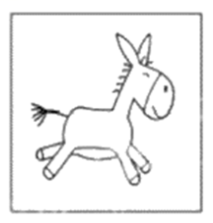
39. What does Group A think of sending cards?
A. Free but slow. B. Fast but expensive. C. Wasteful and expensive.
40. Which of the following facts directly caused the discussion?
A. People have different opinions.
B. Fewer British people send cards and letters.
C. The British spend too much money on cards and letters.
B
a. Locals Care for Natural World
Grasslands and lakes in Sanjiangyuan have taken on a new look and many wild animals have come back. On January 24, 2003, China set up Sanjiangyuan National Nature Reserve to protect the area and the wildlife. Local people joined in the project, picking up waste and protecting the animals.
b. China Successfully Grows Rice in Space
How to grow food in space if humans live there one day? For nearly 40 years, China has developed over 260 new types of seeds (种子) in space. Recently growing rice at Tiangong Space Station makes a big step forward. It can also solve food problems on Earth.
c. Doctors Sent to West Africa
Doctors are flying to an island off the coast of West Africa after a new flu broke out. They will test different medicines to find a way to deal with it. To get things better, they will also offer medical care and help train local nurses there.
d ________
A strong earthquake hit Turkey on February 6. More than 8,000 international rescuers (救援人员) around the world went to help, including the Blue Sky Rescue Team from China. They helped save lives and rebuild homes.
e. Scientists Fight against Plastic Pollution
A natural material, fungi (真菌), used to break down a type of plastic called polypropylene turned out to be useful. Scientists at the University of Sydney found that after 90 days, between 25% and 27% of polypropylene broke down and after 140 days, polypropylene became completely safe.

41. Which passages are about environmental protection?
A. a, b B. a, e C. b, e
42. When did China probably begin to develop seeds in space?
A. In the 1980s. B. In the 1990s. C. In the 2000s.
43. What does the underlined word it in Passage c refer to?
A. An island. B. A new flu. C. Medical care.
44. Which is the best title for ________?
A. Turkey Calling for Help
B. The World Saving Lives in Quake
C. Terrible Situation Faced by Turkey
45 What’s the theme shared by all the passages?
A. Challenges and Chances. B. Responsibility and Success. C. Problems and Efforts.
B卷 (共50分)
一、补全单词根据首字母及句意写出完整单词。 (共5小题；每小题1分，计5分)
46. Some desert plants grow d________ into the earth to get water.
47. Humor is a type of language art, which brings a lot of p________ and laughter to our daily life.
48. In Beijing, people’s act of k________ makes me feel warm even in the place far from home.
49. Jiuzhaigou is one of the most popular places in China and the number of the visitors keeps r________.
50. Wu Yuren, a 73-year-old professor from Tongji University, e________ difficult physics knowledge in a simple way on Douyin to help children develop interest in science.
完成对话 在空格中填上适当的单词，使对话完整正确。 一空一词(含缩写词)。
A: You look worried. What’s the matter?
B: I’ll have a ping-pong match against Mike tomorrow. I think I’ll ____51____ it because he is much better than me.
A: Don’t worry too much. Let’s play a game. Look, is this glass of milk half-full or half-empty?
B: Half-empty. What’s the ____52____ of it?
A: This game is used to test people’s opinions. The ____53____ opinions show people treat life in two different ways. I guess you don’t often believe things will turn out well.
B: No, I don’t. When I face challenges, I always feel nervous about what lies ____54____.
A: Perhaps you don’t have a good ____55____ of challenges. Why don’t you think positively? I mean, look at the bright side.
B: But how?
A: If Mike beats you, don’t be sad. Think about his strengths and your weaknesses, ____56____. And then learn from him.
B: Maybe you’re right. I need to be ____57____ worried, but I don’t know why I can’t help worrying.
A: Well, worrying ____58____ is not always bad. It warns you of risks, just like a fire alarm. However, the trouble is that sometimes it goes off ____59____ there isn’t a huge danger.
B: I see. So a half-full glass of milk means thinking positively. The game teaches me to ____60____ the way I think. I’ll learn to do it. Thanks.
A: Hope things work out.
短文填空从下面方框中选出10个单词，将其正确形式填入短文，使短文意思正确通顺 (每词限用一次)。
actual advantage chance child difficult
difference few hear many possible silence tell
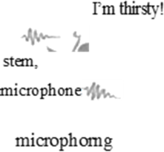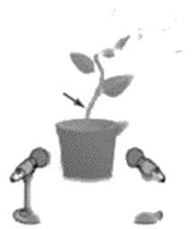
Do you believe a rose plant says “I want some water” or a tree shouts “My arms hurt”? Maybe you will say this could only happen in some ___61___ stories.
In fact, plants are not always ___62___. A recent study has found plants shout when they are in need of water or having their stems cut. “Even in a quiet field, there are___63___ some sounds that carry information. However, the pitch (音高) is too high for people ___64___,” said Lilach Hadany, a professor from Tel Aviv University.
The researchers used microphones to record some tomato plants and found that stressed plants send out ___65___ sounds than unstressed plants. “When tomatoes are not stressed at all, they are very quiet,” Professor Hadany said. They also trained a machine in ___66___ the differences between thirsty plants and cut plants. The result shows that when the causes of stress change, they shout ___67___. After the team recorded many kinds of other plants, they found that many plants like corn, wheat and grape plants send out sounds when they are under stress, too.
“There is a ___68___ that a lot of communication is happening,” Professor Hadany said. “Because other plants can probably hear the call of the stressed plants.”
Sound recordings of plants could bring humans lots of ___69___, especially in farming. For example, people will make sure whether corn is getting enough water or where water is needed most without much ___70___.
四、阅读表达 (共10小题；计10分)
补全短文根据短文内容，从短文后的A～F 选项中，选出5个适当的选项补全短文。
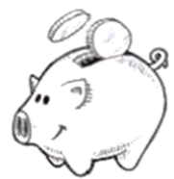
Money may not buy happiness, but it helps. Many teenagers want to learn how to manage money before going out into the world. ___71___ This idea is raised by Dr. Mara Harvey, a money expert. The following are some of her tips.
Learn to make money. Ask parents or neighbors if you can do chores to make pocket money. These could include washing a car or taking the dog for a walk. ___72___ In this way, you can also improve your communication skills, which will help when you have a grown-up job, too.
Help your money grow. Money can’t grow if it’s sitting inside a piggy bank. Put your money in the bank and you can get interest (利息) . ___73___ One day you may feel surprised at how much money you have.
Make a plan. If you have a big event, such as a holiday coming up, it might mean you will need to spend more of your pocket money. Try making a plan for spending and saving. ___74___ Then it will help you take control of your money.
___75___ Figure out how much you can reasonably spend each month. Spend your money on what you truly need. Then try to cut down on spending. For example, rather than eating out, you can choose to cook at home.
A. Spend your money wisely.
B. Be smart with your money.
C. Set a goal of saving money.
D. Save your money in the long run.
E. Agree on the value of different jobs before you start.
F. Write down how much money you have and what you are spending.
完成图表根据短文内容，完成图表中所缺信息。
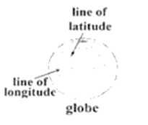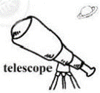
Maps mark seas, countries, cities and our homes, and guide us through the world. To know them better, let’s take a look at how maps have changed over the centuries.
Many ancient countries used maps. One of the first is thought to have been drawn on the wall in Lascaux, France, around 16,500 years ago. Hidden among the drawings of birds and bulls (公牛) is a map of the stars. The Babylonian Map of the World is the oldest known earthly map, which shows Babylon and its neighboring towns on the stone.
Claudius Ptolemy made maps go global. Born in Egypt around 100 AD, he was the first person to try to make a world map. With the help of math, Ptolemy marked around 10,000 locations from Britain to Asia and Africa.
Perhaps the most commonly used world map is the Mercator Projection. It was introduced in 1569 by Gerardus Mercator. An important part of maps is the imaginary lines of longitude, latitude and the equator.
Mercator took the globe and made it flat (平的), but to do this he had to make the areas further north and south larger, while the areas nearer the middle stay about the right size. The reason for this is that the Earth is like a ball, but a map is flat. It is easy to find places, but some people said it was unfair because places including Canada, the UK and Europe appeared much bigger than they really were.
In the 19th and 20th centuries, modern technology allowed map makers to produce maps showing locations exactly. Today, many people view maps on their phones. Researchers are working to map the floor of the oceans and to locate every tree on Earth. Scientists are also trying to map the past by using the James Webb Space Telescope (JWST). This invention will collect light from stars and may find the secrets about the beginning of the universe (宇宙).
The History of Maps
Maps provide us with information of ___76___.
Ancient maps
* One of the first maps is a map of ___77___ around 16,500 years ago.
* The oldest earthly map is the Babylonian Map of the World.
Maps go global
* The first world map was drawn by using ___78___.
* The imaginary lines introduced to the Mercator Projection made it most commonly used, but it still needed ___79___.
Maps and ___80___
* Maps can be used on the phone.
* Maps can help us know more about the oceans, the land and the universe through JWST.

81. 你校英文报就“网络安全”这一话题征稿。请根据以下图示，以“Stay Safe Online”为题投稿。
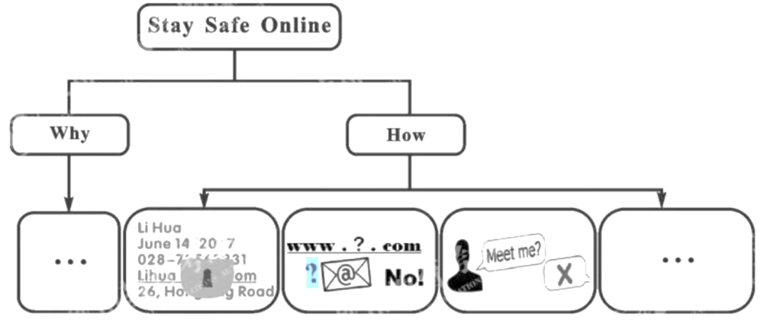
注意：
1. 请先在答题卡上填写图示中空格 (一空一词)；
2. 须全面反映图文信息；
3. 文中不能出现真实姓名及学校名称；
4. 词数80左右。
____________________________________________________________________________________________________________________________________________________________________________________________________________________________________________________________________________________________________________________________________________________________________________________________________________________________________________________________________________________________________________________________________________________________________________________________________________________________________________________________________________________________________________________________________________________________________________________________________________________________________________________________________________________________________________________________________________________________________

