威海市2023年初中学业考试
英语
注意事项：
1.本试卷共8页，共80分。考试时间90分钟。考试结束后，将本试卷和答题卡一并交回。
2.答题前，考生务必用0.5毫米黑色签字笔将自己的姓名、考生号、座号填写在答题卡和试卷规定的位置上。
3.需要涂卡的小题，选出答案后，用2B铅笔把答题卡上对应题目的答案标号涂黑；如需改动，用橡皮擦干净后，再选涂其他答案标号，答案选在试卷上无效。
4.非选择题必须用0.5毫米黑色签字笔作答，答案必须写在答题卡指定区域内相应的位置，写在试卷一的答案无效：如需改动，先划掉原来的答案，然后再写上新的答案；不能使用涂改液、胶带纸、修正带，不按以上要求作答的答案无效。
一、阅读理解（五篇短文，共25小题，计30分。1-20小题，每题1分；21-25小题，每题2分。）
阅读A、B、C篇，从文后每小题A、B、C选项中选择最佳答案。请将答案编号涂卡。
A
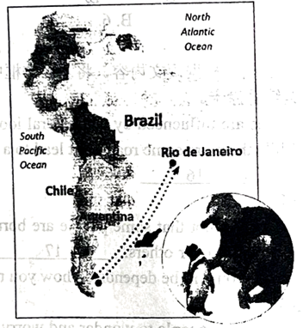
Penguin(企鹅) Swims 5, 000 Miles Every Year
Joao, 71, lives on an island near Rio de Janeiro, Brazil. He has retired(退休), but still works as a part-time fisherman. One day, about five years ago, when he was fishing, he found a tiny, sick penguin on the beach near his home. The penguin’s feathers(羽毛) were covered in oil. The poor bird was dying. Joao felt sorry for the sick, little bird, and so he took him back to his home. He cleaned him and fed him fish, and he gave him the name Din dim. The penguin soon became strong and healthy again.
After a week or two, Joao went down to the coast and tried to put Din dim back into the water. The penguin didn’t want to go. He stayed with Joao, getting bigger and bigger—beautiful new feathers grew on his back. Eight months passed. Joao was very happy because he was enjoying the company of his new friend. Then suddenly, one day in February, Din dim disappeared. Joao was sad to lose him, but hoped that the bird just wanted to return to his penguin family. Four more months passed, Joao was walking sadly home from the beach, when suddenly he heard a familiar (熟悉的) “honking” sound—Din dim was back.
Every year since then, Din dim spends eight months with Joao and then disappears for four months. Where does he go? It is thought that he swims 2, 500 miles to the coast of Argentina or Chile to start a penguin family and then swims 2, 500 miles to Joao. That’s 5, 000 miles a year to be with the man who saved his life.
1 What was the penguin like when Joao first met him?
A. He was tiny and sick.
B. He was strong and healthy.
C. He had clean and beautiful feathers.
2. When the penguin became healthy after a week or two what did he do?
A. He still stayed with Joao.
B. He returned to his penguin family.
C. He walked sadly on the beach every day.
3. How might Joao feel when he suddenly heard a familiar sound?
A. Sorry and sad. B. Surprised and sad. C. Surprised and happy.
4. Which is the right order according to the passage?
a. The penguin was found. b. The penguin was hurt.
c. The penguin was back. d. The penguin disappeared.
A. d c b a B. b a d c C. a b d c
5. Why does the penguin swim to Brazil every year?
A. To star this penguin family.
B. To look for more delicious food.
C. To visit the man who saved his life.
B
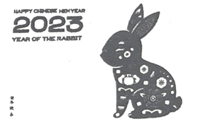
In Chinese culture, twelve different animals are used to stand for the Chinese birth years. 2023 is the Chinese Year of the Rabbit. At the beginning of 2023, rabbits have been used for artistic themes around the world. As a cultural image(文化意象), rabbits have been in different forms of art worldwide, including stamps, colorful lights and exhibitions.
The worldwide popularity of the Chinese Rabbit might have something to do with Western culture. For people in Europe, rabbits mean new life and prosperity(繁荣) as they can give birth to many young ones. So the image of a rabbit is easily accepted by people in the West.
Through the Chinese Year of the Rabbit, people from other counties can get a closer look into Chinese culture. On January 21, an exhibition was held in a museum in the US to celebrate the Year of the Rabbit 16 excellent Chinese artworks on rabbits were on show. It showed visitors that rabbits have been a popular artistic theme in China since ancient times. The museum has also explained the meaning behind rabbits in China to visitors. People could also learn about the stories of the rabbit and the moon in China.
Images of the 12 Chinese animals are fun to everyone. They can help with communication between different cultures.
6. Why do Western people accept the Chinese Rabbit easily?
A. Because it’s one of the 12 Chinese animals.
B. Because it has connection with Western culture.
C. Because it is used to stand for the Chinese Year of the Rabbit.
7. In Paragraph 3, what does “It” refer to(指代)?
A. The exhibition. B. The museum. C. The rabbit.
8. In Paragaph 3, why does the writer introduce the exhibition held in the US?
A. To invite people to visit the exhibition.
B. To show the popularity of the Chinese Rabbit.
C. To tell the stories of the rabbit and the moon in China.
9. What’s the passage mainly talking about?
A. An exhibition on rabbits in the US.
B. The culture of the Chinese Rabbit.
C. Images of the 12 Chinese animals.
10. Where may we read this passage?
A. In a guide book. B. In a text book. C. In a magazine.
C
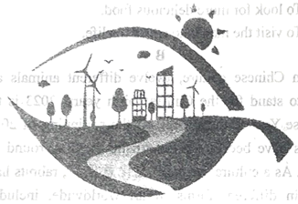
Green Energy for Today and Tomorrow
Did you know that most of the energy we use comes from the sun? For example, the sun helps plants to grow. Plants that grew millions of years ago turned into coal, oil, and natural gas (天然气). We call these fossil fuels (化石燃料).
However, fossil fuels make pollution. This is bad for the Earth. Fossil fuels are also nonrenewable. Some day they will be gone. So, scientists want people to use green energy. Why is green energy important? First, it is clean. It doesn’t hurt the Earth. Next, it is renewable. It won’t run out. Green energy gives us almost 25% of the electricity we use today.
What are the main sources (来源) of green energy?
Water Power
Water power uses moving water in rivers and dams (堤坝). Moving water has energy. Water power makes 16.6% of the electricity we use.
Wind Power
Is wind power new? No, it isn’t. People used wind power many years ago. Wind power makes 4% of the electricity we use.
Solar Power
Soar power comes from sunlight. The sun shines on solar panels (太阳能板) and electricity is made. Solar power is now as cheap as some fossil fuels. It makes 15% of the electricity we use
Biomass (生物质能)
Biomass is energy that we get from plants around us. For example, deadwood or grass is burned in power stations. This makes electricity. Biomass is green energy because we plant new trees or crops (庄稼) after we use it. Biomass makes 2% of the electricity we use.
New Green Energy
Ocean rise and fall each day. This moving water can make electricity. We call it tide power. There is also heat under the Earth’s surface. Scientists can use this heat for energy, which is called heat power. We may find other sources of green energy in the future.
Some day, green energy could make 100% of the electricity we use. That’s good news for the Earth!
11. How do we get most of the electricity nowadays?
A. Through fossil fuels. B. Through green energy. C. Through other kinds of energy.
12. In Paragraph 2, what’s the meaning of the word “nonrenewable” ?
A. 可回收的 B. 不可更新的 C. 不可再生的
13 Why do scientists suggest using green energy?
A. Because it is as cheap as fossil fuels.
B. Because it is clean and won’t be used up.
C. Because it is the main source of electricity now.
14. Where can we get biomass?
A. From natural gas. B. From new trees. C. From dead plants.
15. How many kinds of green energy are mentioned in the passage?
A. 4. B. 6. C. 7.
D
根据短文内容，将下面的句子还原到文章当中，使短文内容完整。请将答案编号涂卡。
Our lives are influenced by our general look on life, experiences, and how we choose to see things. While there are some roads that lead to a happy life, other roads lead to a life controlled by many things. _____16_____
Tip 1
There’s no doubt that some people are born with a silver spoon in their mouths. They have certain advantages over others._____17_____Yes, you might have to work harder. But what kind of person you will be depends on how you regard your weakness and make it work for you.
Tip 2
It’s natural for people to wonder and worry about opinions of others. But sometimes we lose ourselves when we spend too much time worrying about how other people see us. _____18_____As long as you are happy, healthy, and not hurting anyone, you’re living a good life.
Tip 3
We all have at least some unhappiness from things that have happened in our past. No matter how much we want to change what happened, we can’t. _____19_____ It’s a waste of time, and it’s a waste of energy. Whatever has happened, you need to learn to let it go. See it as a lesson and move forward. When you can manage to do it, you will feel much relaxed.
Tip 4
A large number of people never really try or achieve much in their life. That is because they are too afraid of failing. _____20_____ Try to change how you look at failure. Then you’ll realize that never starting or giving up are the only ways you can fail. Don’t live a life full of regret because of fear.
A. Don’t try to please everyone all the time.
B. So there’s no need to let the past control the present.
C. Here are some tips for you to avoid being controlled.
D. If you’re too afraid to start, here is no chance to succeed.
E. However, where you came from should never control where you’re going.
E
研读报刊“畅所欲言”专栏，结合文中信息回答问题并表达观点。请将答案填写到答题卡指定位置。
OPINION | A.I.
In each Opinion section of the The New York Times for Kids: China, we visit a different Chinese school and invite kids to express their opinions on a certain topic(话题). In March, we went to Shenzhen Bay School to record students’ opinions on how humans and A.I.(人工智能) get along.
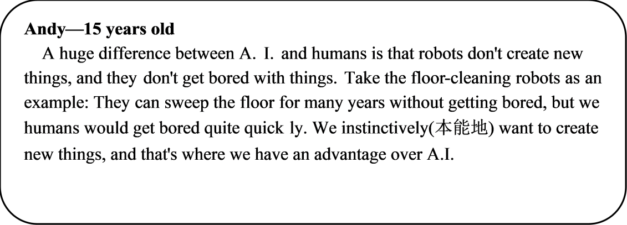
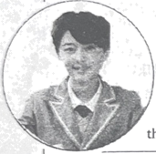
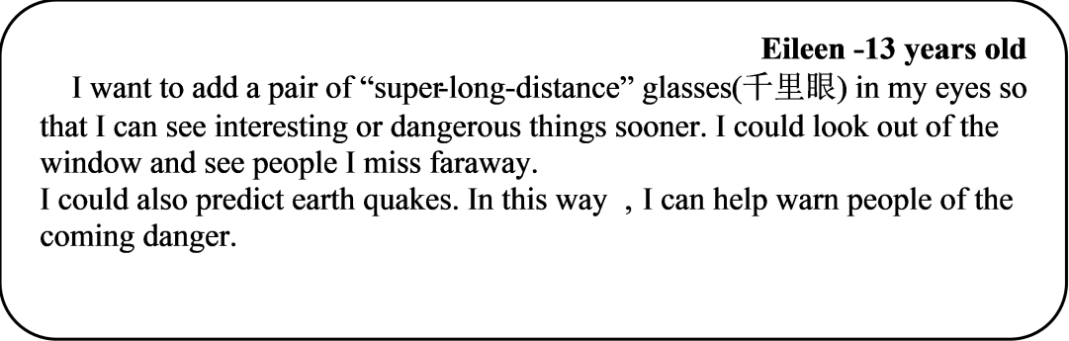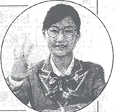
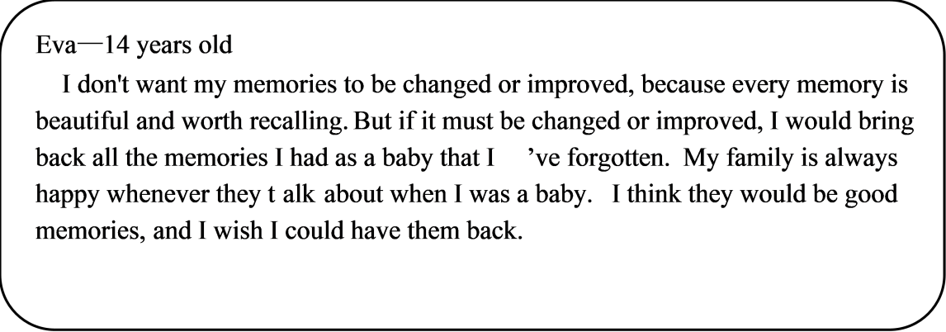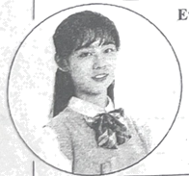
1—4小题，每小题答案不超过8个词；5小题，不限词数。
21. What’s the topic of the Opinion section in March?
______________________________________________
22. According to Andy, what can humans do better than A. I.?
______________________________________________
23. Why does Eileen want to predict earthquakes?
______________________________________________
24. From Eva’s opinion, what ability does A.I. have?
______________________________________________
25. In your opinion, what else could A.I. possibly do for us?
______________________________________________
二、单词拼写（共8小题，计8分）
根据句意和音标提示以适当形式填写单词。请将答案填写在答题卡指定位置。
26. Beijing Opera is our ________ /'væljuəbl/ art treasure.
27. Do you know the story of Cao Chong ________ /weɪz/ the Elephant?
28. What ________ /smu:ð/ and beautiful music he played with Erhu!
29. Many foreigners find it interesting to use ________ /'tʃɒpstɪks/ to eat.
30. Tea was ________ /'treɪdɪd/ to European countries through the Silk Road.
31. Journey to the West was ________ /'rɪrtn/ by Wu Cheng’en in Ming Dynasty.
32. Many Chinese poets praised the beauty of ________ /'ɔ:təm/ in their poems.
33. Chinese traditional ________ /'medsn/ has a great influence in Western countries.
三、动词填空（共8小题，计8分）
用括号里所给动词的适当形式填空。请将答案填写在答题卡指定位置。
I went to a restaurant for lunch with my Granddad yesterday, and when the starters came, I got out my phone and began to take some photos of them. My Granddad was very surprised, and he laughed at me. “Food is for eating!” he said, “And why ____34____ you _______ (take) photos of it?” Then I was surprised. Didn’t he know why?
All my friends always take photos of food in restaurants when they go out to eat, and the photos ____35____ (share) on social media(社交媒体). When we’re deciding which restaurant to go to, we look at photos people post on social media. Before I go to a restaurant, I also look at photos on social media ____36____ (see) the food on the menu. So, when I ____37____ (arrive) at the restaurant, I know what I want to eat.
Yesterday, my Granddad ____38____ (choose) mushroom(蘑菇) soup for his starter because he likes soup, and I ordered fruit salad because it looked delicious in a photo I saw on my phone. Both dishes were very good.
“Granddad! We ____39____ (finish) our starters. Now! Look at the menu for the main course (主菜).” He couldn’t ____40____ (decide) between a fish dish and a beef dish. “Would you like to see some photos of them?” I asked. He laughed again. “OK!” he said. I got out my phone again, found the photos and gave him the phone. He decided the beef because it came with rice and carrots.
After the meal, I asked Granddad, “____41____ you _______ (use) photos on social media to choose your food next time you eat out?” “Maybe” he sad, “if I’m with one of my grandchildren!”
四、完成句子（共6小题，计12分）
请将答案填写在答题卡指定位置。
Judy向她的朋友介绍威海图书馆，请根据情境完成句子。
42. 我听说你想找个安静的地方学习。
______________________________________________
43. 市中心有一家非常现代的图书馆。
______________________________________________
44. 它每周二到周日对公众开放。
______________________________________________
45. 如今它已成为威海最受欢迎的地方之一。
______________________________________________
46. 昨天上午我到那儿的时候，很多人在看书。
______________________________________________
47. 如果你有兴趣，周末我可以陪你一起去。
______________________________________________
五、短文填空（共10小题，计10分）请将答案编号涂卡。
根据短文内容，选择适当的短语填空，使短文意思完整。每个选项仅使用一次。
A. want a change B. safer place C. a better life D. move abroad E. with my friends
F. with children G. the warm weather H. more space I. without my father J. pack their belongings
Moving from Here to There...
Do you know someone who moved to your city or town? Maybe they came from a rural（乡村的）area, or from another city. Perhaps they came from another country.
Every day, people ____48____ and move to new places. Why do people move? Let’s look at three important reasons.
Jobs
People move to find jobs and ____49____. Sometimes, people move from rural areas to urban（城市）areas to get a job. In 1990, about a quarter of the people in China lived in cities. Today, over half of the Chinese people live in cities.
People ____50____ to find a better way of life, too. For example, immigrants（移民）from Europe moved to Brazil in the 1950s to work in factories.
Li Lin: Last year my father moved to the city of Chengdu to find work. My mother and I stayed in our small town. I felt lonely ____51____. Now we all live together in an apartment in Chengdu. I’m in a good school, and I really like my new friends.
Services
When another city has good services, people want to move there. A city with good services may also be a cleaner and ____52____ to live in.
Sometimes people move from a city to areas called suburbs（郊区）. Suburbs are near the outside of a city. Suburbs have ____53____ for schools, hospitals, clinics, shopping malls, and zoos. Families ____54____ like to live in suburbs.
Mark: When I was three, my parents sold their flat in central London and bought a house in the suburbs. My dad has to drive further to work now, but I can walk to school. There’s lots of space to play football ____55____ here.
New Experiences
Finally, people move when they ____56____ in their lives, or to find new experiences. Older people often move to places with better weather. If students want to learn about other places, they sometimes go to universities in other countries.
Tiago: My grandparents moved to Portugal when I was five. They visit us here in Stockholm in summer, but in winter they stay in Portugal. They love _____57_____ there.
As you can see, people move for many reasons. Maybe someday, you, or someone you know, will move, too!
六、书面表达（共1小题，计12分）
58. 请将答案填写在答题卡指定位置。
为倡导广大青少年积极参与体育运动，在运动中增强体质，享受乐趣，收获健康，某报刊英语专栏以“Together for a Healthy Future”为题向中学生开展征文活动。请结合自身实际，从以下两种情况中任选其一，用英文写一篇短文投稿。
情况 | 要点
1.经常运动 | 你的运动习惯、经历、运动对你的影响，……
2.不常运动 | 不常运动的原因、你对运动的看法、今后的打算，……
注意：
1.词数100左右，首句已给出，不计入总词数；
2.内容需涵盖所选情况的要点，可适当发挥；
3.文中不能出现真实的人名、校名等信息；
4.以下表达仅供参考：
improve health增强体质 build up confidence树立信心
Together for a Healthy Future
As we all know, doing sports can make us strong and healthy.
_____________________________________________________________________________________________________________________________________________________________________________________________________________________________________________________________________________________________________________________________________________________________________________________________________________________________________________________________________________________________________________________________________________________________________________________________________________________________________________________________________________________________________________________________________________________________________________________________________________________________________________________________________________________________________________________________________________________________________________________________________________________________________________________________________________________________________________________________________________________________________________________________________________________________________

