
威海市2023年初中学业考试
英语
注意事项：
1.本试卷共8页，共80分。考试时间90分钟。考试结束后，将本试卷和答题卡一并交回。
2.答题前，考生务必用0.5毫米黑色签字笔将自己的姓名、考生号、座号填写在答题卡和试卷规定的位置上。
3.需要涂卡的小题，选出答案后，用2B铅笔把答题卡上对应题目的答案标号涂黑；如需改动，用橡皮擦干净后，再选涂其他答案标号，答案选在试卷上无效。
4.非选择题必须用0.5毫米黑色签字笔作答，答案必须写在答题卡指定区域内相应的位置，写在试卷一的答案无效：如需改动，先划掉原来的答案，然后再写上新的答案；不能使用涂改液、胶带纸、修正带，不按以上要求作答的答案无效。
一、阅读理解（五篇短文，共25小题，计30分。1-20小题，每题1分；21-25小题，每题2分。）
阅读A、B、C篇，从文后每小题A、B、C选项中选择最佳答案。请将答案编号涂卡。
A
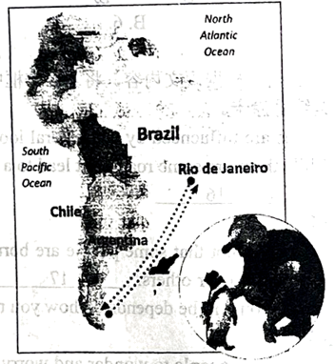
Penguin(企鹅) Swims 5 000 Miles Every Year
Joao, 71, lives on an island near Rio de Janeiro, Brazil. He has retired(退休), but still works as a part-time fisherman. One day, about five years ago, when he was fishing, he found a tiny, sick penguin on the beach near his home. The penguin’s feathers(羽毛) were covered in oil. The poor bird was dying. Joao felt sorry for the sick, little bird, and so he took him back to his home. He cleaned him and fed him fish, and he gave him the name Din dim. The penguin soon became strong and healthy again.
After a week or two, Joao went down to the coast and tried to put Din dim back into the water. The penguin didn’t want to go. He stayed with Joao, getting bigger and bigger—beautiful new feathers grew on his back. Eight months passed. Joao was very happy because he was enjoying the company of his new friend. Then suddenly, one day in February, Din dim disappeared. Joao was sad to lose him, but hoped that the bird just wanted to return to his penguin family. Four more months passed, Joao was walking sadly home from the beach, when suddenly he heard a familiar (熟悉的) “honking” sound—Din dim was back.
Every year since then, Din dim spends eight months with Joao and then disappears for four months. Where does he go? It is thought that he swims 2, 500 miles to the coast of Argentina or Chile to start a penguin family and then swims 2, 500 miles to Joao. That’s 5, 000 miles a year to be with the man who saved his life.
1. What was the penguin like when Joao first met him?
A. He was tiny and sick.
B. He was strong and healthy.
C. He had clean and beautiful feathers.
2. When the penguin became healthy after a week or two, what did he do?
A. He still stayed with Joao.
B He returned to his penguin family.
C. He walked sadly on the beach every day.
3. How might Joao feel when he suddenly heard a familiar sound?
A. Sorry and sad. B. Surprised and sad. C. Surprised and happy.
4. Which is the right order according to the passage?
a. The penguin was found. b. The penguin was hurt.
c. The penguin was back. d. The penguin disappeared.
A. d c b a B. b a d c C. a b d c
5. Why does the penguin swim to Brazil every year?
A. To star this penguin family.
B. To look for more delicious food.
C. To visit the man who saved his life.
【答案】1. A 2. A 3. C 4. B 5. C
【解析】
【导语】本文主要讲述了住在巴西里约热内卢附近的一个岛上的Joao救了一只企鹅的故事。
【1题详解】
细节理解题。根据“The penguin’s feathers(羽毛) were covered in oil. The poor bird was dying. Joao felt sorry for the sick, little bird, and so he took him back to his home.”可知当时这只企鹅又小又病。故选A。
【2题详解】
细节理解题。根据“After a week or two, Joao went down to the coast and tried to put Din dim back into the water. The penguin didn’t want to go. He stayed with Joao”可知当企鹅在一两个星期后恢复健康时，他仍然和Joao在一起。故选A。
【3题详解】
推理判断题。根据“Then suddenly, one day in February, Din dim disappeared. Joao was sad to lose him”可知当Joao发现Din dim消失了，他很伤心，所以四个多月过去了，当他听到一声熟悉的声音时，他很激动，也很开心，故选C。
【4题详解】
细节理解题。根据“One day, about five years ago, when he was fishing, he found a tiny, sick penguin on the beach near his home.”可知企鹅受伤了排在第一位，企鹅被Joao发现排在第二位；根据“Then suddenly, one day in February, Din dim disappeared...Four more months passed, Joao was walking sadly home from the beach, when suddenly he heard a familiar (熟悉的) ‘honking’ sound—Din dim was back.”可知企鹅不见了排在第三位，企鹅回来了排在第四位。故选B。
【5题详解】
细节理解题。根据“That’s 5, 000 miles a year to be with the man who saved his life.”可知企鹅是为了去看望救了他一命的人。故选C。
B
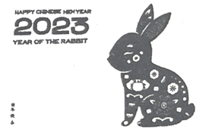
In Chinese culture, twelve different animals are used to stand for the Chinese birth years. 2023 is the Chinese Year of the Rabbit. At the beginning of 2023, rabbits have been used for artistic themes around the world. As a cultural image(文化意象), rabbits have been in different forms of art worldwide, including stamps, colorful lights and exhibitions.
The worldwide popularity of the Chinese Rabbit might have something to do with Western culture. For people in Europe, rabbits mean new life and prosperity(繁荣) as they can give birth to many young ones. So the image of a rabbit is easily accepted by people in the West.
Through the Chinese Year of the Rabbit, people from other counties can get a closer look into Chinese culture. On January 21, an exhibition was held in a museum in the US to celebrate the Year of the Rabbit 16 excellent Chinese artworks on rabbits were on show. It showed visitors that rabbits have been a popular artistic theme in China since ancient times. The museum has also explained the meaning behind rabbits in China to visitors. People could also learn about the stories of the rabbit and the moon in China.
Images of the 12 Chinese animals are fun to everyone. They can help with communication between different cultures.
6. Why do Western people accept the Chinese Rabbit easily?
A. Because it’s one of the 12 Chinese animals.
B. Because it has connection with Western culture.
C. Because it is used to stand for the Chinese Year of the Rabbit.
7. In Paragraph 3, what does “It” refer to(指代)?
A. The exhibition. B. The museum. C. The rabbit.
8. In Paragaph 3, why does the writer introduce the exhibition held in the US?
A. To invite people to visit the exhibition.
B. To show the popularity of the Chinese Rabbit.
C. To tell the stories of the rabbit and the moon in China.
9 What’s the passage mainly talking about?
A. An exhibition on rabbits in the US.
B. The culture of the Chinese Rabbit.
C. Images of the 12 Chinese animals.
10. Where may we read this passage?
A. In a guide book. B. In a text book. C. In a magazine.
【答案】6. B 7. A 8. B 9. B 10. C
【解析】
【导语】本文介绍了中国生肖属相“兔”的文化意义在世界各地的艺术展览中得到了展示，并探讨了兔子在中国文化中的重要象征意义。
【6题详解】
细节理解题。根据“The worldwide popularity of the Chinese Rabbit might have something to do with Western culture. For people in Europe, rabbits mean new life and prosperity(繁荣) as they can give birth to many young ones. So the image of a rabbit is easily accepted by people in the West.(中国兔子在世界范围内的流行可能与西方文化有关。对欧洲人来说，兔子意味着新的生活和繁荣，因为它们可以生很多小兔子。所以兔子的形象很容易被西方人接受。)”可知西方人易于接受中国兔子，是因为兔子在西方文化中也有美好的寓意，即兔子在中西方文化中有联系。故选B。
【7题详解】
词句猜测题。根据“On January 21, an exhibition was held in a museum in the US to celebrate the Year of the Rabbit 16 excellent Chinese artworks on rabbits were on show. It showed visitors that rabbits have been a popular artistic theme in China...”可知美国博物馆举办的一场展览，向游客展示了兔子自古以来就是中国流行的艺术主题。划线部分“It”指前文“an exhibition”。故选A。
【8题详解】
细节理解题。根据“Through the Chinese Year of the Rabbit, people from other counties can get a closer look into Chinese culture...People could also learn about the stories of the rabbit and the moon in China.”可知第三段介绍在美国博物馆举办的展览，是为了显示中国兔子的受欢迎程度。故选B。
【9题详解】
主旨大意题。通读全文可知本文介绍了中国生肖属相“兔”，以及兔子在中国文化中的重要象征意义。故选B。
【10题详解】
推理判断题。本文介绍了中国生肖属相“兔”的文化意义在世界各地的艺术展览中得到了展示，并探讨了兔子在中国文化中的重要象征意义，最有可能会在杂志上看到文章。故选C。
C

Green Energy for Today and Tomorrow
Did you know that most of the energy we use comes from the sun? For example, the sun helps plants to grow. Plants that grew millions of years ago turned into coal, oil, and natural gas (天然气). We call these fossil fuels (化石燃料).
However, fossil fuels make pollution. This is bad for the Earth. Fossil fuels are also nonrenewable. Some day they will be gone. So, scientists want people to use green energy. Why is green energy important? First, it is clean. It doesn’t hurt the Earth. Next, it is renewable. It won’t run out. Green energy gives us almost 25% of the electricity we use today.
What are the main sources (来源) of green energy?
Water Power
Water power uses moving water in rivers and dams (堤坝). Moving water has energy. Water power makes 16.6% of the electricity we use.
Wind Power
Is wind power new? No, it isn’t. People used wind power many years ago. Wind power makes 4% of the electricity we use.
Solar Power
Soar power comes from sunlight. The sun shines on solar panels (太阳能板), and electricity is made. Solar power is now as cheap as some fossil fuels. It makes 15% of the electricity we use
Biomass (生物质能)
Biomass is energy that we get from plants around us. For example, deadwood or grass is burned in power stations. This makes electricity. Biomass is green energy because we plant new trees or crops (庄稼) after we use it. Biomass makes 2% of the electricity we use.
New Green Energy
Ocean rise and fall each day. This moving water can make electricity. We call it tide power. There is also heat under the Earth’s surface. Scientists can use this heat for energy, which is called heat power. We may find other sources of green energy in the future.
Some day, green energy could make 100% of the electricity we use. That’s good news for the Earth!
11. How do we get most of the electricity nowadays?
A. Through fossil fuels. B. Through green energy. C. Through other kinds of energy.
12. In Paragraph 2, what’s the meaning of the word “nonrenewable” ?
A. 可回收的 B. 不可更新的 C. 不可再生的
13. Why do scientists suggest using green energy?
A. Because it is as cheap as fossil fuels.
B. Because it is clean and won’t be used up.
C. Because it is the main source of electricity now.
14. Where can we get biomass?
A. From natural gas. B. From new trees. C. From dead plants.
15. How many kinds of green energy are mentioned in the passage?
A. 4. B. 6. C. 7.
【答案】11. A 12. C 13. B 14. C 15. B
【解析】
【导语】本文主要介绍了过去和现在使用的能源，并详细说明了绿色能源。
【11题详解】
细节理解题。根据“Did you know that most of the energy we use comes from the sun?...We call these fossil fuels.”可知现在我们获得的大部分电力来自化石燃料。故选A。
【12题详解】
词句猜测题。根据“Fossil fuels are also nonrenewable. Some day they will be gone.”以及“Next, it is renewable. It won’t run out.”可知绿色能源不会用完，与化石燃料不一样，化石燃料总有一天会消失，因此化石燃料是“不可再生的”。故选C。
【13题详解】
细节理解题。根据“So, scientists want people to use green energy. Why is green energy important? First, it is clean. It doesn’t hurt the; Earth. Next, it is renewable. It won’t run out. Green energy gives us almost 25% of the electricity we use today.”可知绿色能源是很干净的，也是可再生的。故选B。
【14题详解】
细节理解题。根据“Biomass is energy that we get from plants around us. For example, deadwood or grass is burned in power stations.(生物质能是我们从周围的植物中获取的能量。例如，发电厂燃烧枯木或枯草。)”可知可以从枯死植物中获得生物质能。故选C。
【15题详解】
细节理解题。根据“What are the main sources of green energy?...Water Power...Wind Power...Solar Power...Biomass...Ocean rise and fall each day. This moving water can make electricity. We call it tide power...Scientists can use this heat for energy, which is called heat power.”可知文中共介绍了6种绿色能源。故选B。
D
根据短文内容，将下面的句子还原到文章当中，使短文内容完整。请将答案编号涂卡。
Our lives are influenced by our general look on life, experiences, and how we choose to see things. While there are some roads that lead to a happy life, other roads lead to a life controlled by many things. _____16_____
Tip 1
There’s no doubt that some people are born with a silver spoon in their mouths. They have certain advantages over others._____17_____Yes, you might have to work harder. But what kind of person you will be depends on how you regard your weakness and make it work for you.
Tip 2
It’s natural for people to wonder and worry about opinions of others. But sometimes we lose ourselves when we spend too much time worrying about how other people see us. _____18_____As long as you are happy, healthy, and not hurting anyone, you’re living a good life.
Tip 3
We all have at least some unhappiness from things that have happened in our past. No matter how much we want to change what happened, we can’t. _____19_____ It’s a waste of time, and it’s a waste of energy. Whatever has happened, you need to learn to let it go. See it as a lesson and move forward. When you can manage to do it, you will feel much relaxed.
Tip 4
A large number of people never really try or achieve much in their life. That is because they are too afraid of failing. _____20_____ Try to change how you look at failure. Then you’ll realize that never starting or giving up are the only ways you can fail. Don’t live a life full of regret because of fear.
A. Don’t try to please everyone all the time.
B. So there’s no need to let the past control the present.
C. Here are some tips for you to avoid being controlled.
D. If you’re too afraid to start, here is no chance to succeed.
E. However, where you came from should never control where you’re going.
【答案】16. C 17. E 18. A 19. B 20. D
【解析】
【导语】本文提出了一些建议让人们避免被控制。
【16题详解】
根据“While there are some roads that lead to a happy life, other roads lead to a life controlled by many things”及下文的内容可知，提出一些避免被控制的建议，C选项“这里有一些建议可以帮助你避免被控制”符合，故选C。
【17题详解】
根据“There’s no doubt that some people are born with a silver spoon in their mouths. They have certain advantages over others.”可知，此处提到了与每个人出身情况有关的内容，E选项“然而，你从哪里来永远不应该控制你要去哪里”符合，故选E。
【18题详解】
根据“But sometimes we lose ourselves when we spend too much time worrying about how other people see us”及“As long as you are happy, healthy, and not hurting anyone, you’re living a good life”可知，太在乎别人对自己的看法，所以此处建议不要去取悦每个人，A选项“不要总是试图取悦每个人”符合，故选A。
【19题详解】
根据“Whatever has happened, you need to learn to let it go. See it as a lesson and move forward”可知，要向前看，不要被过去发生的事情所控制，B选项“所以没有必要让过去控制现在”符合，故选B。
【20题详解】
根据“That is because they are too afraid of failing. ”可知，此处提到了害怕失败相关的内容，D选项“如果你太害怕开始，就没有成功的机会”符合，故选D。
E
研读报刊“畅所欲言”专栏，结合文中信息回答问题并表达观点。请将答案填写到答题卡指定位置。
OPINION | A.I.
In each Opinion section of the The New York Times for Kids: China, we visit a different Chinese school and invite kids to express their opinions on a certain topic(话题). In March, we went to Shenzhen Bay School to record students’ opinions on how humans and A.I.(人工智能) get along.
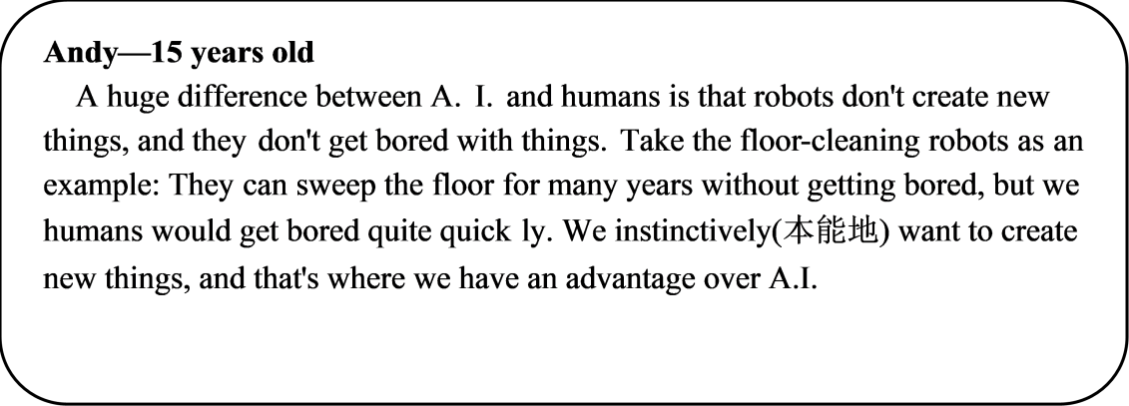
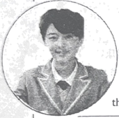
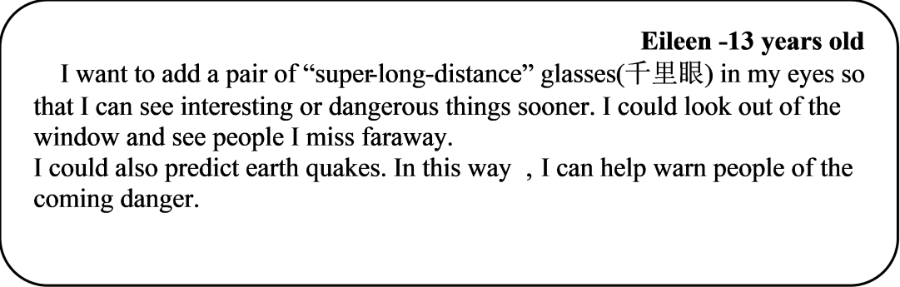
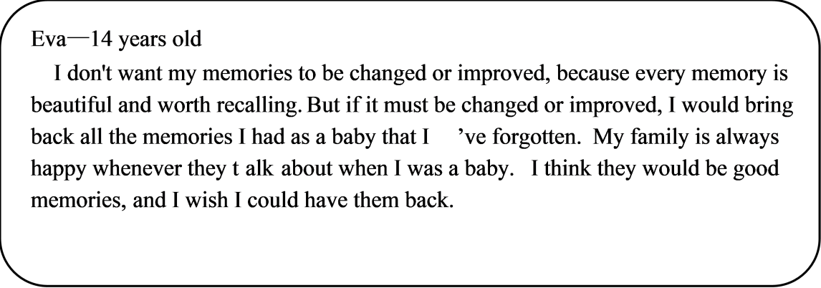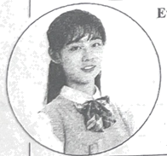
1—4小题，每小题答案不超过8个词；5小题，不限词数。
21. What’s the topic of the Opinion section in March?
______________________________________________
22. According to Andy, what can humans do better than A. I.?
______________________________________________
23. Why does Eileen want to predict earthquakes?
______________________________________________
24. From Eva’s opinion, what ability does A.I. have?
______________________________________________
25. In your opinion, what else could A.I. possibly do for us?
______________________________________________
【答案】21. How humans and A.I. get along.
22. Create new things.
23. To warn people of the coming danger.
24. Change/Improve/Bring back memories.
25. A.I. can help us control machines to do the hard work.
【解析】
【导语】本文主要介绍了学生们对人类和人工智能相处的看法。
【21题详解】
根据“In March, we went to Shenzhen Bay School to record students’ opinions on how humans and A.I.(人工智能) get along.”可知主题是关于人类和人工智能是如何相处的。故填How humans and A.I. get along.
【22题详解】
根据“A huge difference between A. I. and humans is that robots don’t create new things”可知安迪认为人类能比人工智能做得更好的在于人类可以创造新事物。故填Create new things.
【23题详解】
根据“I could also predict earth quakes. In this way, I can help warn people of the coming danger.”可知是为了警告人们即将到来的危险。故填To warn people of the coming danger.
【24题详解】
根据“I don’t want my memories to be changed or improved, because every memory is beautiful and worth recalling. But if it must be changed or improved, I would bring back all the memories I had as a baby that I’ve forgotten.”可知人工智能可以改变/改善/唤起记忆。故填Change/Improve/Bring back memories.
【25题详解】
开放性作答，结合文章，言之有理即可。参考答案为A.I. can help us control machines to do the hard work.
二、单词拼写（共8小题，计8分）
根据句意和音标提示以适当形式填写单词。请将答案填写在答题卡指定位置。
26. Beijing Opera is our ________ /'væljuəbl/ art treasure.
【答案】valuable
【解析】
【详解】句意：京剧是我们宝贵的艺术财富。根据所给音标可知，空处应填valuable“宝贵的”，故填valuable。
27. Do you know the story of Cao Chong ________ /weɪz/ the Elephant?
【答案】Weighs
【解析】
【详解】句意：你知道曹冲称象的故事吗？根据所给音标和题干可知，此处应填weighs“称重”，结合“Elephant”可知，首字母需要大写。故填Weighs。
28. What ________ /smu:ð/ and beautiful music he played with Erhu!
【答案】smooth
【解析】
【详解】句意：他用二胡演奏出的音乐多么流畅优美啊！根据所给音标可知，空处应填形容词smooth“流畅的”，故填smooth。
29. Many foreigners find it interesting to use ________ /'tʃɒpstɪks/ to eat.
【答案】chopsticks
【解析】
【详解】句意：许多外国人觉得用筷子吃饭很有趣。根据音标“/'tʃɒpstɪks/”可知，此处单词为chopsticks，意为“筷子”。故填chopsticks。
30. Tea was ________ /'treɪdɪd/ to European countries through the Silk Road.
【答案】traded
【解析】
【详解】句意：茶叶通过丝绸之路贸易到欧洲国家。根据音标“/'treɪdɪd/”可知，此处单词为traded，意为“交易”。故填traded。
31. Journey to the West was ________ /'rɪrtn/ by Wu Cheng’en in Ming Dynasty.
【答案】written
【解析】
【详解】句意：《西游记》是明代吴承恩写的。根据所给音标可知，空处应填written“写”。故填written。
32. Many Chinese poets praised the beauty of ________ /'ɔ:təm/ in their poems.
【答案】autumn
【解析】
【详解】句意：许多中国诗人在他们的诗中赞美秋天的美丽。根据所给音标可知，空处应填名词autumn“秋天”。故填autumn。
33. Chinese traditional ________ /'medsn/ has a great influence in Western countries.
【答案】medicine
【解析】
【详解】句意：中医在西方国家有很大的影响。根据所给音标可知，空处应填名词medicine“医学”。故填medicine。
三、动词填空（共8小题，计8分）
用括号里所给动词的适当形式填空。请将答案填写在答题卡指定位置。
I went to a restaurant for lunch with my Granddad yesterday, and when the starters came, I got out my phone and began to take some photos of them. My Granddad was very surprised, and he laughed at me. “Food is for eating!” he said, “And why ____34____ you _______ (take) photos of it?” Then I was surprised. Didn’t he know why?
All my friends always take photos of food in restaurants when they go out to eat, and the photos ____35____ (share) on social media(社交媒体). When we’re deciding which restaurant to go to, we look at photos people post on social media. Before I go to a restaurant, I also look at photos on social media ____36____ (see) the food on the menu. So, when I ____37____ (arrive) at the restaurant, I know what I want to eat.
Yesterday, my Granddad ____38____ (choose) mushroom(蘑菇) soup for his starter because he likes soup, and I ordered fruit salad because it looked delicious in a photo I saw on my phone. Both dishes were very good.
“Granddad! We ____39____ (finish) our starters. Now! Look at the menu for the main course (主菜).” He couldn’t ____40____ (decide) between a fish dish and a beef dish. “Would you like to see some photos of them?” I asked. He laughed again. “OK!” he said. I got out my phone again, found the photos and gave him the phone. He decided the beef because it came with rice and carrots.
After the meal, I asked Granddad, “____41____ you _______ (use) photos on social media to choose your food next time you eat out?” “Maybe” he sad, “if I’m with one of my grandchildren!”
【答案】34. are##did；taking##take
35. are shared##will be shared
36. to see 37. arrive
38. chose 39. have finished
40. decide 41. Will；use
【解析】
【导语】本文主要叙述作者和爷爷去餐厅吃饭的故事，作者饭前拍照发社交媒体，爷爷对此不太理解，但爷孙俩还是按照别人发过的照片挑选了菜品。
【34题详解】
句意：你为什么要给它拍照？根据语境可知，此处可以是爷爷在问作者正在做的事情，用现在进行时；另一方面，也可以是作者拍完了照，爷爷问作者刚才为什么拍照，用一般过去时。主语是you，现在进行时be动词用are；一般过去时里助动词用did，后加动词原形，故填are/did；taking/take。
【35题详解】
句意：我所有的朋友出去吃饭的时候都会给餐馆里的食物拍照，并把照片分享到社交媒体上。根据“All my friends always take photos of food in restaurants when they go out to eat,”可知此处的时态可以是一般现在时，表示经常性的动作。另一方面，可以说是先拍照，然后再分享，可以用一般将来时。主语和动词share之间是被动关系，应用一般现在时的被动语态：am/is/are done，或一般将来时的被动语态：will be done。主语是复数，be动词用are。故填are shared/will be shared。
【36题详解】
句意：在我去餐厅之前，我也会在社交媒体上看照片，看看菜单上的食物。see是动词，此处应用动词不定式作目的状语，故填to see。
【37题详解】
句意：所以，当我到达餐厅时，我知道我想吃什么。根据“I know what I want to eat.”可知本句是一般现在时，主语是I，动词用原形，故填arrive。
【38题详解】
句意：昨天，我爷爷选了蘑菇汤作为他的开胃菜，因为他喜欢汤。根据“Yesterday”可知句子是一般过去时，动词用过去式，故填chose。
【39题详解】
句意：我们已经吃完了开胃菜。根据“Now! Look at the menu for the main course (主菜).”可说明开胃菜已经吃完了，所以可以看主菜了，应用现在完成时，主语是we，助动词用have，故填have finished。
【40题详解】
句意：他决定不了是吃鱼还是吃牛肉。decide是动词，空前有情态动词，动词用原形，故填decide。
【41题详解】
句意：你会用社交媒体上的照片来选择食物吗？根据“next time you eat out?”可知本句是一般将来时：will do。故填Will；use。
四、完成句子（共6小题，计12分）
请将答案填写在答题卡指定位置。
Judy向她的朋友介绍威海图书馆，请根据情境完成句子。
42. 我听说你想找个安静的地方学习。
______________________________________________
【答案】I heard you wanted (to find) a quiet place/somewhere quiet to study.
【解析】
【详解】I“我”；hear“听说”；you“你”；want to do“想要做”；find“找到”；a quiet place/somewhere quiet“一个安静的地方”；study“学习”，动词，此处应用动词不定式作定语。根据语境可知句子应用一般过去时，动词用过去式。故填I heard you wanted (to find) a quiet place/somewhere quiet to study.
43. 市中心有一家非常现代的图书馆。
______________________________________________
【答案】There is a very modern library in the city center/centre/in the center/centre of the city.
【解析】
【详解】there be“有”；a very modern library“一家非常现代的图书馆”，作主语，be动词用is；in the city center/centre或in the center/centre of the city“在市中心”。故填There is a very modern library in the city center/centre/in the center/centre of the city.
44. 它每周二到周日对公众开放。
______________________________________________
【答案】It is open/opens to the public from Tuesday to Sunday every week.
【解析】
【详解】it“它”；此处表示“开放”，可以应用be open to（形容词）或open to（动词）；the public表示“公众”；from...to...“从……到……”；Tuesday“周二”；Sunday“周日”。every week“每周”，时间状语位于句尾。故填It is open/opens to the public from Tuesday to Sunday every week.
45. 如今它已成为威海最受欢迎的地方之一。
______________________________________________
【答案】These days/Now it is/has been/has become one of the most popular places in Weihai.
【解析】
【详解】these days和now都可以表示“如今”；it is/has been/has become在此处可以表示“它已经成为……”；one of the+形容词最高级+名词复数，表示“……最……之一……”；most popular“最受欢迎的”；place“地方”；in Weihai“在威海”。故填These days/Now it is/has been/has become one of the most popular places in Weihai.
46. 昨天上午我到那儿的时候，很多人在看书。
______________________________________________
【答案】When I got there yesterday morning, many people were reading books./When I arrived there yesterday morning, there were many people reading books.
【解析】
【详解】when“当……时候”，引导时间状语从句；I“我”；get/arrive there“到达那里”；yesterday morning“昨天早上”，是一般过去时的时间状语，动词用过去式；表示“很多人在看书”可以用many people were reading books或there were many people reading books，前者是过去进行时结构，后者是there be句型，reading是现在分词作定语。故填When I got there yesterday morning, many people were reading books./When I arrived there yesterday morning, there were many people reading books.
47. 如果你有兴趣，周末我可以陪你一起去。
______________________________________________
【答案】If you have interest (in it), I will/can go with you on weekends/on the weekend.
【解析】
【详解】if“如果”，引导条件状语从句，遵循“主将从现”原则。you“你”；have interest (in it)“有兴趣”；I“我”；can“能够”；go with you“和你一起去”；on weekends/on the weekend“周末”。故填If you have interest (in it), I will/can go with you on weekends/on the weekend.
五、短文填空（共10小题，计10分）请将答案编号涂卡。
根据短文内容，选择适当的短语填空，使短文意思完整。每个选项仅使用一次。
A. want a change B. safer place C. a better life D. move abroad E. with my friends
F. with children G. the warm weather H. more space I. without my father J. pack their belongings
Moving from Here to There...
Do you know someone who moved to your city or town? Maybe they came from a rural（乡村的）area, or from another city. Perhaps they came from another country.
Every day, people ____48____ and move to new places. Why do people move? Let’s look at three important reasons.
Jobs
People move to find jobs and ____49____. Sometimes, people move from rural areas to urban（城市的）areas to get a job. In 1990, about a quarter of the people in China lived in cities. Today, over half of the Chinese people live in cities.
People ____50____ to find a better way of life, too. For example, immigrants（移民）from Europe moved to Brazil in the 1950s to work in factories.
Li Lin: Last year my father moved to the city of Chengdu to find work. My mother and I stayed in our small town. I felt lonely ____51____. Now we all live together in an apartment in Chengdu. I’m in a good school, and I really like my new friends.
Services
When another city has good services, people want to move there. A city with good services may also be a cleaner and ____52____ to live in.
Sometimes people move from a city to areas called suburbs（郊区）. Suburbs are near the outside of a city. Suburbs have ____53____ for schools, hospitals, clinics, shopping malls, and zoos. Families ____54____ like to live in suburbs.
Mark: When I was three, my parents sold their flat in central London and bought a house in the suburbs. My dad has to drive further to work now, but I can walk to school. There’s lots of space to play football ____55____ here.
New Experiences
Finally, people move when they ____56____ in their lives, or to find new experiences. Older people often move to places with better weather. If students want to learn about other places, they sometimes go to universities in other countries.
Tiago: My grandparents moved to Portugal when I was five. They visit us here in Stockholm in summer, but in winter they stay in Portugal. They love _____57_____ there.
As you can see, people move for many reasons. Maybe someday, you, or someone you know, will move, too!
【答案】48. J 49. C
50. D 51. I
52. B 53. H
54. F 55. E
56. A 57. G
【解析】
【导语】本文介绍了人们到处移居的几个原因。
【48题详解】
句意：每天，人们收拾行装，搬到新的地方。根据“move to new places”可知，搬去新地方要收拾行装，备选词汇pack their belongings“收拾行装”符合语境。故填J。
【49题详解】
句意：人们为了找工作和更好的生活而搬家。根据“find jobs”可知此处应用备选词汇a better life表示搬家为了“更好的生活”，符合语境。故填C。
【50题详解】
句意：人们移居国外也是为了找到更好的生活方式。根据“immigrants（移民）from Europe moved to Brazil in the 1950s”可知此处应用备选词汇move abroad表示“移居国外”，符合语境。故填D。
【51题详解】
句意：爸爸不在身边，我感到很孤单。根据“Li Lin: Last year my father moved to the city of Chengdu to find work.”可知，爸爸去成都找工作，说明爸爸不在身边，备选词汇without my father“爸爸不在身边”符合语境。故填I。
【52题详解】
句意：一个拥有良好服务的城市也可能是一个更清洁、更安全的居住场所。根据“cleaner”可知备选词汇safer place“更安全的地方”符合语境。故填B。
【53题详解】
句意：郊区有更多的空间供学校、医院、诊所、购物中心和动物园使用。根据“for schools, hospitals, clinics, shopping malls, and zoos”可知学校、医院、诊所、购物中心和动物园需要更多空间，备选词汇more space“更多空间”符合语境。故填H。
【54题详解】
句意：有孩子的家庭喜欢住在郊区。根据“like to live in suburbs”可知备选词汇with children“有孩子的”符合语境。故填F。
【55题详解】
句意：这里有很多空间可以和我的朋友们一起踢足球。根据“play football”可知此处备选词汇with my friends“和我的朋友们一起”符合语境。故填E。
【56题详解】
句意：最后，当人们想要改变自己的生活或寻找新的体验时，他们就会搬家。根据“or to find new experiences”可知，备选词汇want a change“想要改变”符合语境。故填A。
【57题详解】
句意：他们喜欢那里的天气。根据上一句“They visit us here in Stockholm in summer, but in winter they stay in Portugal.”可知谈到了天气，备选词汇the warm weather“暖和的天气”符合语境。故填G。
六、书面表达（共1小题，计12分）
58. 请将答案填写在答题卡指定位置。
为倡导广大青少年积极参与体育运动，在运动中增强体质，享受乐趣，收获健康，某报刊英语专栏以“Together for a Healthy Future”为题向中学生开展征文活动。请结合自身实际，从以下两种情况中任选其一，用英文写一篇短文投稿。
情况 | 要点
1.经常运动 | 你运动习惯、经历、运动对你的影响，……
2.不常运动 | 不常运动的原因、你对运动的看法、今后的打算，……
注意：
1.词数100左右，首句已给出，不计入总词数；
2.内容需涵盖所选情况的要点，可适当发挥；
3.文中不能出现真实的人名、校名等信息；
4.以下表达仅供参考：
improve health增强体质 build up confidence树立信心
Together for a Healthy Future
As we all know doing sports can make us strong and healthy.
_____________________________________________________________________________________________________________________________________________________________________________________________________________________________________________________________________________________________________________________________________________________________________________________________________________________________________________________________________________________________________________________________________________________________________________________________________________________________________________________________________________________________________________________________________________________________________________________________________________________________________________________________________________________________________________________________________________________________________________________________________________________________________________________________________________________________________________________________________________________________________________________________________________________________________
【答案】例文
Version 1
Together for a Healthy Future
As we all know, doing sports can make us strong and healthy. Besides P.E. classes, I usually play badminton with my parents on weekends. During the summer holiday, I also get up early in the morning to run along the beach or climb the mountains.
Last term, one of my friends invited me to join his basketball team. To be honest, I was not good at playing basketball at that time. But he told me not to be worried and taught me how to play in person. Gradually, I got much pleasure from this exiting sport. We took part in my life.
As you can see, doing sports has influenced me a lot. Firstly it greatly improved my physical health. Secondly, I have made a lot of new friends who share the same interest with me. Most importantly, it has built up my confidence. It encourage me to face difficulties.
Thanks to sports, my life has been so colorful and meaningful. Let’s exercise together for a healthy future!
Version 2
Together for a Healthy Future
As we all know, doing sports can make us strong and healthy. As students, we are often told by parents or teachers to do exercise regularly.
Many of my friends love sports, but I seldom exercise. To be honest, I’m not quite good at it. Sports like running or playing basketball are difficult for me. Also, I don’t have much free time to exercise. The only time when I do play sports is in P.E. classes. After PE. classes, I just feel too tired to do other things. That why I don’t want to do it.
Although I don’t like it, there is no doubt that doing sports plays an important part in our life. Not only can it improve our heath but also it is a good way to build up our confidence. So maybe it’s time for me to change.
For the coming vacation, it is necessary to make some plans about doing exercise. I’m considering looking for a partner to play sports with. Perhaps badminton or ping-pong will be a good choice.
As the saying goes, “Health is the basis of all”. Just stop being lazy and step out side!
【解析】
【详解】[总体分析]
① 题材：本文是一篇记叙文，为材料作文；
② 时态：时态为“一般现在时”和“一般过去时”；
③ 提示：根据所给提示完成写作，不能遗漏信息，可适当发挥。
[写作步骤]
第一步，从所给的两种情况选出一种（情况1）；
第二步，具体阐述你的运动习惯、经历；
第三步，最后表达运动对你的影响。
[亮点词汇]
① as we all know众所周知
② invite sb to do sth邀请某人做某事
③ in person亲自
④ take part in参加
[高分句型]
①As you can see, doing sports has influenced me a lot.（动名词作主语）
②I have made a lot of new friends who share the same interest with me.（who引导的定语从句）

