2023年广东省初中学业水平考试
英 语
本试卷共10页，81小题，满分120分。考试用时90分钟。
注意事项：
1. 答卷前，考生务必用黑色字迹的钢笔或签字笔将自己的准考证号、姓名、考场号和座位号填写在答题卡上。用2B铅笔在“考场号”和“座位号”栏相应位置填涂自己的考场号和座位号。将条形码粘贴在答题卡“条形码粘贴处”。
2. 作答选择题时，选出每小题答案后，用2B铅笔把答题卡上对应题目选项的答案信息点涂黑；如需改动，用橡皮擦干净后，再选涂其他答案，答案不能答在试卷上。
3. 非选择题必须用黑色字迹的钢笔或签字笔作答，答案必须写在答题卡各题目指定区域内相应位置上；如需改动，先划掉原来的答案，然后再写上新的答案；不准使用铅笔和涂改液。不按以上要求作答的答案无效。
4. 考生必须保持答题卡的整洁。考试结束后，将试卷和答题卡一并交回。
一、听说应用（本大题共30小题，每小题1分，共30分；A、B、C、D部分为听力理解，E部分为情景对话）
A. 听句子（本题共5小题，每小题1分，共5分）
请根据所听内容，选择符合题意的图画回答问题，并将答题卡上对应题目所选的选项涂黑。每个句子听两遍。
1. What is the boy doing?
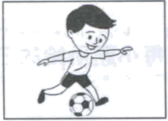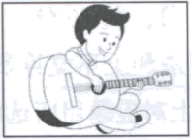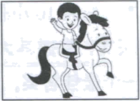
A B C
2 What’s the time now?
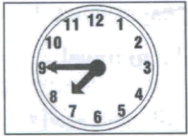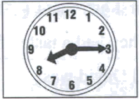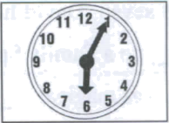
A B C
3. Who is Tom?
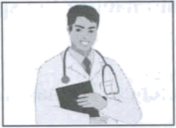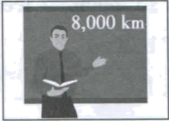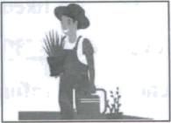
A B C
4. Where is the teapot?
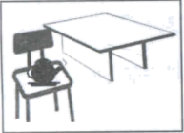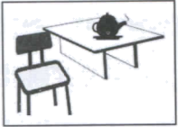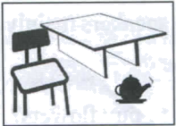
A B C
5. How tall was Mary last year?
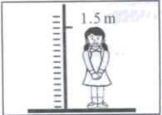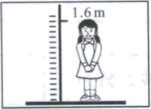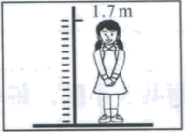
A B C
B. 听对话（本题共10小题，每小题1分，共10分）
请根据每段对话的内容回答问题，从每小题所给的三个选项中选出一个最佳答案，并将答题卡上对应题目所选的选项涂黑。每段对话听两遍。
听第一段对话，回答第6小题。
6 How will John go to the museum tomorrow?
A. By bike. B. By bus. C. By car.
听第二段对话，回答第7小题
7. Which subject does Sam like best?
A. English. B. History. C. Geography.
听第三段对话，回答第8小题。
8. Why does Mandy like singing?
A. Because it makes her brave.
B. Because it makes her relaxed.
C. Because it makes her popular
听第四段对话，回答第9小题。
9. What does the woman order?
A. Lemon juice. B. Green tea. C. Apple juice.
听第五段对话，回答第10小题。
10. Where will Lisa go for holiday?
A. To the beach. B. To the lakeside. C. To the mountains.
听第六段对话，回答第11～12小题。
11. What is the relationship between the two speakers?
A. Husband and wife. B. Brother and sister. C. Mother and son.
12. What housework will the boy do today?
A. Tidying up his bedroom. B. Washing his clothes. C. Setting the table.
听第七段对话，回答第13～15小题。
13. What are the speakers mainly talking about?
A. Gifts. B. Food. C. Gardening.
14. Who decides to buy flowers?
A. Ben. B. Kelly. C. Tony.
15. What may the boy prepare at last?
A. Books. B. Plants. C. Chocolates.
C. 听短文（本题共5小题，每小题1分，共5分）
请根据所听内容，从每小题所给的三个选项中选出一个最佳答案，并将答题卡上对应题目所选的选项涂黑。短文听两遍。
16. How did Frank’s class feel when they got to the zoo?
A. Tired. B. Happy. C. Surprised.
17. What animals did Frank go to see first?
A. Bears. B. Tigers. C. Monkeys.
18. How was the weather when Frank was taking photos?
A. Rainy B. Sunny. C. Snowy.
19. What was Frank’s trouble?
A. He fell down. B. He got lost. C. He lost his camera.
20. Who helped Frank?
A. A visitor. B. A classmate C. A zookeeper.
D. 听填信息（本题共5小题，每小题1分，共5分）
你将听到一则烹饪比赛的通知。请根据所听内容填写下面的信息卡，并将答案写在答题卡对应题目的答题位置上。短文听两遍。
A Cooking Competition
Date Place: next 21 in the school dining hall
Things provided: vegetables, 22 , meat and other necessary things
Scoring standards: ● how good the dishes look, smell and taste
● how 23 the dishes are
Prize: a(n) 24 cooking lesson at a top restaurant
Reason to join in: to show your 25 and creativity
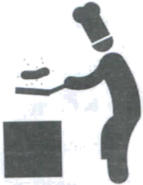
E. 情景对话（本题共5小题，每小题1分，共5分）
请通读下面对话，根据对话内容，从选项中选出能填入空白处的最佳选项，并将答题卡上对应题目所选的选项涂黑。选项中有一项为多余选项。
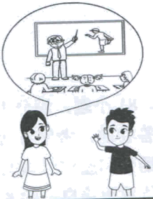
Jim: Hi, Sue. How’s your acting class going?
Sue: The teacher is great, but I’m not learning much.
Jim: ____1____
Sue: I can’t act as well as other students.
Jim: Hmm. Maybe you need more practice.
Sue: But I’ve already spent a lot of time on it. I just can’t do it well. ____2____
Jim: Well, before you give up, I suggest you ask the teacher for help.
Sue: ____3____
Jim: I see. Why not leave him a note to tell him about your problem?
Sue: ____4____ I’ll give it a try. Thanks a lot.
Jim: ____5____
A. But I’m afraid he is too busy these days.
B. I’m thinking of giving up.
C. You’re welcome.
D. Enjoy yourself.
E. Sounds good.
F. How’s that?

二、语法选择（本大题共10小题，每小题1分，共10分）
请通读下面短文，掌握其大意，根据语法和上下文连贯的要求，从每小题所给的三个选项中选出一个最佳答案，并将答题卡上对应题目所选的选项涂黑。
David is a 15-year-old boy and he is crazy about space. He always wonders how space stations work. For him, a space camp is ____6____ than any other camp in the world.
At the age of seven, David had ____7____ first astronaut (宇航员) training experience. He and his parents ____8____ to a Family Space Camp. They had a taste of what it was like to travel ____9____ space. Everything was magical. ____10____ excited David was!
David has been to many space camps over the last eight years. Last month, he went to ____11____ new space camp. It had a lot of fun training programs, ____12____ he enjoyed all of them. There he was often asked ____13____ he liked space camps so much. “I feel like a real astronaut in the space camp, and I don’t even need ____14____ the earth,” he said.
These experiences have influenced his life. Now David ____15____ space science. He has made up his mind to be a space engineer in the future.
6. A. great B. greater C. the greatest
7. A. he B. him C. his
8. A. invited B. are invited C. were invited
9. A. on B. in C. for
10. A. How B. What C. What an
11. A. a B. an C. the
12. A. or B. but C. and
13. A. why B. when C. where
14. A. leave B. leaving C. to leave
15. A. study B. is studying C. was studying
三、完形填空（本大题共10小题，每小题1分，共10分）
请通读下面短文，掌握其大意，从每小题所给的四个选项中选出一个最佳答案，并将答题卡上对应题目所选的选项涂黑。
Little Dora always wanted a sister. So when Mum told her she would have one in six months, she felt very ____16____. But Dora had to be away for some time. She had promised to stay with her grandparents till autumn came.
“How can I make ____17____ go faster? I can’t wait to see the ____18____.” Dora said to herself while she was sitting in her grandparents’ yard one day. She had a good ____19____ when she saw the apple tree in the yard. She decided to ____20____ a picture of the tree each day. As Grandpa said, by the time she saw red apples on the tree, she would have a sister!
Dora’s first picture was a tree full of green leaves. Day by day, the weather got cooler. The leaves slowly ____21____ their colour and tiny apples appeared among them.
____22____, Dora drew her last picture of the tree. It had a lot of red apples. Now it was time to return home. When she entered the house, Mum and Dad were ____23____ her on the sofa. Each of them was ____24____ a baby in their arms.
“Now you have a sister and a brother!” Dad said. “Wow, I’m the ____25____ sister in the world!” Dora said happily. “Look! Their faces are as round as red apples. They are so cute.”
16 A. rich B. afraid C. nervous D. cheerful
17. A. air B. time C. light D. water
18. A. yard B. tree C. baby D. apple
19. A. job B. idea C. life D. trip
20. A. buy B. take C. draw D. borrow
21. A. shared B. found C. passed D. changed
22. A. Finally B. Really C. Usually D. Suddenly
23. A. waiting for B. laughing at C. looking after D. learning from
24. A. hiding B. training C. walking D. holding
25. A. funniest B. smallest C. luckiest D. prettiest
四、阅读理解（本大题共15小题，每小题2分，共30分）
请阅读A、B两篇短文，从每小题所给的四个选项中选出能回答所提问题或完成所给句子的最佳答案，并将答题卡上对应题目所选的选项涂黑。
A
When it’s hot outside and we have to go out, surely we want to keep cool. We can put on hats, wear light clothing, or stay at a cool place. However, nothing can beat a good fan. Now I’ll show you how to make a good DIY (Do It Yourself) paper fan.
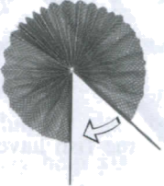
What to prepare
Please prepare two pieces of paper. All paper will work, but your DIY fan can be used for a long time with quality (优质的) paper.
Then get glue, two sticks, etc.
How to make a DIY fan
The first step is to draw pictures on the paper. Just draw anything you like. The next step is to fold up (折叠) the paper. Then glue the two pieces of folded paper together. After that, paint the sticks. The final step is to glue the sticks onto the folded paper. And everything is done.
If you look at your watch, you will be surprised: it takes less than 15 minutes to make a good paper fan. Then you can fold it up and drop it in your bag. When you are out in the heat next time, just take it out and enjoy the gentle wind.

26. Which is the best way to keep cool according to paragraph 1?
A. Putting on hats. B. Using a good fan.
C. Wearing light clothing. D. Staying at a cool place.
27. Why is quality paper a good choice to make a fan?
A. It is light. B. It is colorful.
C. It lasts long. D. It looks beautiful.
28. What is the second step of making a paper fan?
A. Painting the sticks.
B. Drawing pictures on the paper.
C. Folding up the paper.
D. Gluing the sticks onto the folded paper.
29. From the last paragraph, we can tell that making a paper fan is ________.
A. quick B. difficult C. boring D. strange
30. What is the purpose of this passage?
A. To sell paper fans. B. To show how to save time.
C. To share a fun story. D. To teach how to make paper fans.
B
Some animals can easily find their way home after a long journey. How do they make it? Scientific research shows that they are born with certain unusual abilities for direction.
A certain kind of ants, for example, can count their steps to avoid getting lost. They can go as far as 110 metres and bring food home. These ants live in the open desert (沙漠), so they have nothing to guide them along the way. It’s like someone walking six kilometres through a dark forest.
Some fish have an unbelievable sense of smell. They can smell even a single drop of their home water in a large sea area. Some sea birds have a similar ability. They are able to make a smell map of their flying area.
Some animals can sense the earth’s magnetic field (磁场), while humans can’t. This magnetic field guides a certain kind of fish when they swim a long way to a place and then back. How can this kind of fish do that? It is still a mystery. Scientists have no good answers yet.
However, animals with such unusual abilities still have difficulty dealing with environmental changes caused by human activities. For example, many birds depend on stars for direction, but they get lost easily at night when city lights are kept on all night. To solve this problem, we can simply turn off some lights at night. Clearly, one small act of humans may mean a lot to animals.
31. Where is this passage most probably from?
A. A storybook. B. An art magazine.
C. A guidebook. D. A science magazine.
32 How can a certain kind of ants find their way?
A. By imagining the way. B. By counting their steps.
C. By bringing food together D. By walking through a forest.
33. What does the underlined word “mystery” in paragraph 4 probably mean?
A. Secret. B. Choice. C. Reason. D. Feeling.
34. What are people advised to do according to the last paragraph?
A. To help animals. B. To travel at night.
C. To keep city lights on. D. To develop unusual abilities.
35. Which can be the best title for the passage?
A. Birds’ Sense of Light B. Fish’s Sense of Smell
C. Animals’ Sense of Direction D. Animals’ Sense of Magnetic Field
C
配对阅读。左栏是五位学生的困惑，右栏是七则建议，请将困惑和建议进行匹配，并将答题卡上对应题目所选的选项涂黑。
___36___ My mum didn’t agree to buy another model racing car for me. She said it would be a waste of money. I am angry with her.  ___37___ I want a pair of basketball shoes for my training. But I don’t want to ask my parents for money.  ___38___ I get as much pocket money as my sister each month. But my money runs out much more quickly than hers.  ___39___ I think I can spend all my lucky money. But my father doesn’t allow me to.  ___40___ My mum wants me to do the weekly shopping for our family. But I don’t know how to spend money wisely. | A. You can make a shopping list first. And you may go to different supermarkets to compare prices before you make a decision.  B. You should understand your mum. A model car is not a must. Parents know more about the value of money as they work hard to support the family.  C. Write down your daily spending of the pocket money in a notebook. This may help you avoid unnecessary spending.  D. You can learn numbers first. For example, you can count coins and banknotes with your parents.  E. Maybe you can have a yard sale to get money for your shoes. There must be things you don’t need any more like old toys or magazines.  F. I agree with your father. You can keep part of your lucky money in a bank instead of using it up. This can help you save money for the future.  G. You can invite someone working in a bank to your club to give a talk. In this way, you can know more about how banks work.

请从方框内选择适当的词并用其正确形式填空，使文章完整连贯。注意每空一词，每词仅用一次，有两词为多余项。请将答案写在答题卡对应题目的答题位置上。
it either be because what else by invent clean popular habit hundred
There is a small thing we use every day. We usually put ____41____ in the bathroom. Without it, we might have tooth problems. Can you guess ____42____ it is? Yes, it’s the toothbrush. But do you know anything about its history?
According to some research, before toothbrushes appeared, the ancient Chinese people ____43____ their teeth with some small tree branches (树枝). About 800 years ago, people made a kind of brushes with pig hair and bamboo. It might ____44____ the world’s earliest form of toothbrushes. As time went ____45____, the forms of toothbrushes changed. For example, people chose horse-tail hair instead of pig hair ____46____ pig hair was too hard. Imagine that you travel back to ____47____ of years ago and brush your teeth comfortably. It sounds fantastic, doesn’t it?
Around the 15th century, the Chinese toothbrush found its way into Europe. It became ____48____ among local people soon. The ____49____ of toothbrushes was not as famous as that of paper-making, but it was very useful in daily life. Today we have a good ____50____ of brushing teeth. We should thank the ancient Chinese for it.
六、读写综合（本大题分为A、B两部分，共25分）
A. 回答问题（本题共5小题，每小题2分，共10分）
请阅读下面短文，根据所提供的信息，回答5个问题。要求所写答案语法正确、语义完整切题，并将答案写在答题卡对应题目的答题位置上。
Dreams may make you smart This was discovered by scientists who do research on dreams.
What is a dream exactly? Scientists explain that during sleep time your brain reviews your experiences in the day. It tries to connect your new experiences with the old memories (记忆). As your brain connects things, it turns them into a story, and then you get a dream.
Dreams may help you deal with worries and fears. What has happened during the day may be painful. While you are sleeping, however, the brain will replay the painful memories in a safe dream space. There the bad memories become less painful. And you will feel better after waking up.
Dreams also seem to be able to help you learn. This idea is supported by a study. So scientists advise you not to stay up all night studying, especially when an exam is coming. They say a sweet dream might help you get higher marks.
Dreams may make you more creative, too. It was reported that a famous songwriter came up with his best song in a dream, and wrote it down as soon as he woke up. However, dreams alone can’t bring about creativity. In fact, the songwriter spent a lot of time thinking about the song before the dream. In a word, hard work matters more for creativity, though dreams also have a role to play.
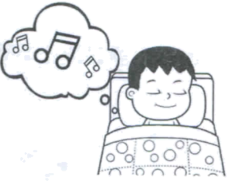

51. Who discovered that dreams may make you smart?
_______________________________________________________________________________________________
52. When does the brain review your experiences in the day?
_______________________________________________________________________________________________
53. Where does the brain replay the painful memories?
_______________________________________________________________________________________________
54. What might help you get higher marks according to the passage?
_______________________________________________________________________________________________
55. Which matters more for creativity, hard work or dreams?
_______________________________________________________________________________________________
B. 书面表达
请根据要求完成短文写作，并将写作内容写在答题卡对应题目的答题位置上。
56. 假设你叫李明，你打算向某学生英文网站投稿，分享你做过的一个有趣的梦。请你根据以下思维导图内容提示用英文写一篇短文。
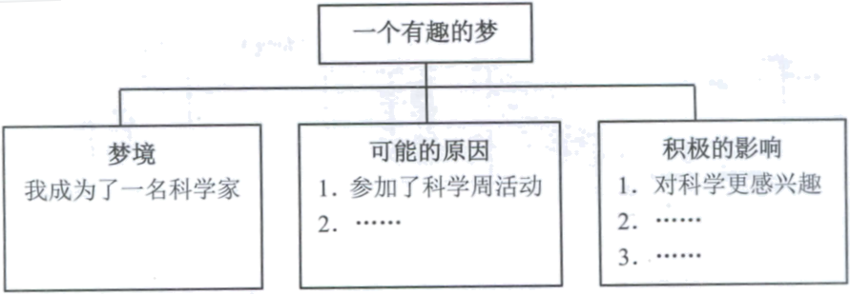
注意：
（1）可在思维导图内容提示的基础上适当拓展信息。
（2）不能照抄原文：不得在作文中出现真实校名、地名和考生的真实姓名。
（3）语句连贯，词数80左右。作文的标题和开头已经给出，不计入总词数，也不必抄写在答题卡上。
An Interesting Dream
By Li Ming
I have an interesting dream to share with you. _________________________________________________________________________________________________________________________________________________________________________________________________________________________________________________________________________________________________________________________________________________________________________________________________________________________________________________________________________________________________________________________________________________________________________________________________________________________________________________________________________________________

