扬州市2023年初中毕业、升学统一考试英语试题
说明：
1. 本试卷共8页，包含选择题（第1题～第45题，共45题）、非选择题（第46题～第76题，共31题）两部分。满分120分，考试时间为100分钟。考试结束后，请将本试卷和答题卡一并交回。
2. 答题前，考生务必将本人的姓名、准考证号填写在答题卡相应的位置上，同时务必在试卷的装订线内将本人的姓名、准考证号、毕业学校填写好，在试卷第4页的右下角填写好座位号。
3. 所有的试题都必须在专用的“答题卡”上作答，选择题用2B铅笔作答、非选择题在指定位置用0.5毫米黑色水笔作答。在试卷或草稿纸上答题无效。
一、单项选择（共15小题；每小题1分，计15分）
在下列各题A、B、C、D四个选项中选择一个能填入题干空白处的最佳答案。
1. Yangzhou is ________ city full of ________ history, culture and mouthwatering food.
A. the; a B. a; a C. the; the D. a; /
2. The children have painted since ________ could first pick up a brush.
A. they B. them C. their D. themselves
3. Slow cooking seems to hold the taste of the meat much ________.
A. good B. well C. better D. best
4. Everyone will have to get out of their houses ________ meet their neighbours.
A. and B. but C. or D. so
5. I ________ China for three months and this is the first time I’ve tried on hanfu.
A. have gone to B. have been to C. have arrived in D. have been in
6. Science is my favourite subject, so I have prepared ________ the STEAM Club.
A. join B. joining C. to join D. to joining
7 Paper cut-outs of “double happiness” are often ________ in the married couple’s home to bring good wishes.
A. put back B. put up C. put on D. put off
8. —What places of interest are there in Yangzhou?
—I recommend the Slender West Lake. A boat tour is a wonderful ________!
A. movement B. attraction C. experience D. research
9. We need to tell people to just do one small thing well ________ 100 things poorly.
A. as well as B. instead of C. according to D. because of
10. While everyone ________ the comics page, I picked up a copy to see what was so funny.
A is laughing at B. laughed at C. laughs at D. was laughing at
11. —I like your teapot. It has a very funny but interesting shape.
—Thank you. It’s a work of art, but it is also ________ for tea making.
A. natural B. practical C. equal D. general
12. Sand turns to glass when it ________ by lightning.
A. hits B. is hit C. is hitting D. will be hit
13. We don’t ________ much from the kids because they can’t understand the value of this work.
A. express B. excuse C. expect D. explain
14. —I’m wondering ________ at a low price.
—You can book one through our official APP.
A. how I can buy the air ticket B. how can I buy the air ticket
C. when I can buy the air ticket D. when can I buy the air ticket
15. —I’ve made little progress in my maths, Li Ming. I’m really worried.
—________, Liu Mei. It takes time.
A. Sounds good B. Don’t mention it
C. That’s a good idea D. Don’t worry
二、完形填空（共15小题；每小题1分，计15分）
阅读下面短文，从文后各题所给的A、B、C、D四个选项中选出一个最佳答案。
Jack sat alone on the bus ride home from school. All his friends were ____16____ their class projects excitedly, but Jack remained silent. How could they understand his feelings when their parents would help them? His parents worked all the time.
When the bus stopped, he raced home, ____17____ his schoolbag on the floor, and walked straight to his bedroom.
“Jack?” Grandpa’s ____18____ called out. “Was that you?”
Jack stopped ____19____ he closed his bedroom door. “Yes, Grandpa, it’s me.”
Grandpa Higgins came from the kitchen carrying a sandwich. “You don’t sound okay,” he said as he took a ____20____.
Should Jack tell Grandpa the truth? What could it hurt? He quickly ____21____ they should do a class project for the weekend and together they would build something with an adult. The students needed to make a ____22____ to explain how their projects had gone.
Grandpa listened quietly. “____23____ are you so unhappy?”
Jack felt his ____24____ and anger rising inside him. “Because I don’t have anyone to help me.” He sounded so sad and so angry.
Grandpa raised his eyebrows ____25____. “What am I?” he asked gently.
Jack froze. “You’d build a project with me, Grandpa?”
“Sure, I would,” Grandpa said. “Just let me finish this sandwich.”
Jack’s heart seemed so ____26____ that he thought it would float away. He rushed to the schoolbag and ____27____ his assignment paper. Then, they studied the assignment and made a list of ideas. Finally, they ____28____ to build a cardboard robot from old biscuit and noodle boxes. They used glue, staples, and tape. Grandpa helped a lot and he ____29____ found a box of eyeball stickers.
When they finished, Jack looked at their misshapen (奇形怪状的) robot. He couldn’t stop smiling. “I think it’s the best ____30____ I have ever built. Now I have to write my report,” Jack said, hugging Grandpa. “Thank you, Grandpa. I had a lot of fun.”
16. A. discussing B. building C. reporting D. improving
17. A. dropped B. hung C. stuck D. hid
18. A. pronunciation B. voice C. noise D. sound
19. A. if B. until C. before D. though
20. A. break B. bite C. ride D. drink
21. A. recommended B. considered C. confirmed D. explained
22. A. change B. report C. robot D. choice
23. A. How B. Where C. Why D. What
24. A. sadness B. envy C. joy D. excitement
25. A. in luck B. in fear C. in anger D. in surprise
26. A. heavy B. big C. light D. empty
27. A. took out B. put away C. handed in D. cut off
28. A. promised B. forgot C. refused D. decided
29. A. just B. even C. still D. ever
30. A. room B. table C. schoolbag D. robot
三、阅读理解（共15小题；每小题2分，计30分）
A
阅读下列内容, 从每小题所给的A、B、C、D四个选项中选出一个最佳答案。
China has made great achievements in biodiversity protection. Building a national park system is one of the greatest jobs that China has done so far. In October 2021, China’s first five national parks were designated (认定). They are home to nearly 30% of the earth’s key wildlife species (物种) found in China, covering a protected land area of 230,000 square kilometers. This table will inform you of the first five national parks—China’s treasures in nature.
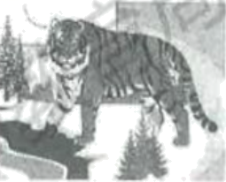  Northeast China Tiger and  Leopard National Park | Locations: Heilongjiang and Jilin provinces  Landscapes: Mountains, hills, and valleys  Representative species: Siberian tiger, Amur leopard (豹)  Progress: Increasing population of protected animal species from the year of 2015 to 2022 — Siberian tigers: 27→50; Amur leopards: 42→60
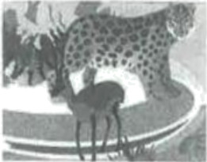  Sanjiangyuan National Park | Locations: Qinghai Province and Xizang Autonomous Region  Landscapes: Glaciers, snow-capped mountains, high-altitude wetlands, deserts, alpine grasslands  Representative species: Snow leopard, Tibetan antelope  Progress: At present, the vegetation coverage of the grassland in the park has been over 60%, which is nearly 5% higher than that in 2015.
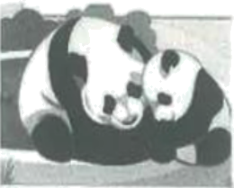  Giant Panda National Park | Locations: Sichuan, Shaanxi and Gansu provinces  Landscapes: Mountains, basins  Representative species: Giant panda, red panda  Progress: It is protecting over 70% of the wild giant panda population in the country. The population of protective animals in the park — Giant pandas 50⁺; Sichuan takins 1,300⁺
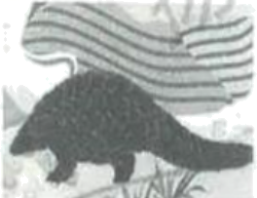  Wuyishan National Park | Locations: Fujian and Jiangxi provinces  Landscapes: Mountains  Representative species: Chinese pangolin, Cabot’s tragopan  Progress: Through reasonable development of 10% of its area, the park has holds its biodiversity conservation in 90% of its area under protection.
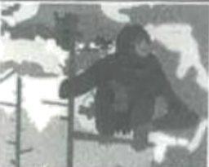  Hainan Tropical Rainforest  National Park | Locations: Hainan Province  Landscapes: Mountains  Representative species: Hainan black crested gibbon  Progress: The population of Hainan’s black crested gibbon in the wild — 1970s: 2 groups of 7 individuals (个体); At present: 5 groups of 36 individuals

31. What does the passage mainly tell us?
A. When China’s first five national parks were discovered.
B. Some general information of China’s first five national park!
C. What challenges China’s first five national parks are facing.
D. Some actions to protect the wildlife species in these parks.
32. According to the passage, which park has the most types of landscapes?
A. Wuyishan National Park.
B. Giant Panda National Park.
C. Sanjiangyuan National Park.
D. Northeast China Tiger and Leopard National Park.
33. According to the passage, which of the following is TRUE about the progress of the parks?
A. 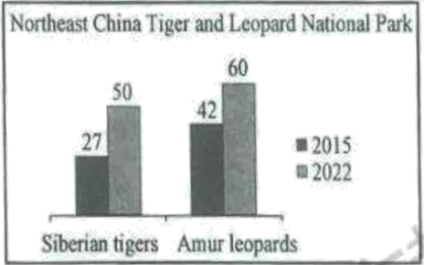 B. 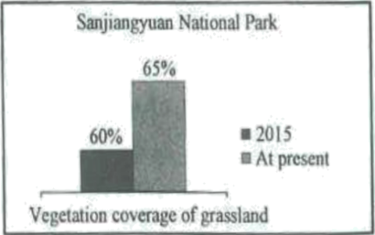
C. 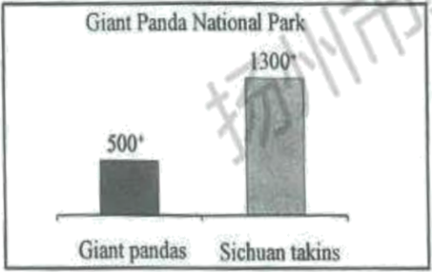 D. 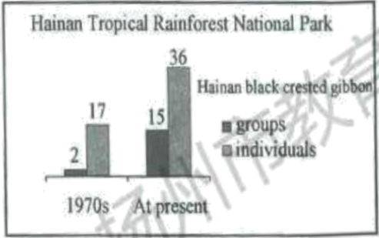
B
What would happen if you tried to blow a soap (肥皂) bubble in below-freezing weather? Would it freeze and fall to the ground? Would you have to hit it with a stone to break it? These questions came into my mind one cold winter day. It was too cold to play in the snow, but it was a perfect time to experiment with blowing frozen bubbles.
To blow frozen bubbles, I had to wait until the air outside was very cold. For this activity, that meant 10 degrees below 0 Fahrenheit or colder. I didn’t have the bubble things that come in a bottle, so I used dish-washing soap. Adding a drop of glycerin made the soap work even better. I chose a place out of the wind, and blew bubbles the same way I always do. I watched to see what would happen. Here’s what I learned.
If the temperature is low enough, the skin of the bubble frosts (结霜) over, becoming cloudy instead of clear. And what about those rainbow swirls (漩涡状物体) that you see in soap bubbles? The rainbow colors stay even (均匀的) when the bubbles frost, but they don’t spin anymore. The bubbles still float in the air. They don’t fall to the ground any faster than they would on a warm summer day.
When these frozen bubbles break, they don’t turn into tiny drops of soap as summer bubbles do. They turn into shiny rainbow pieces and fly slowly to the ground. Sometimes a frozen bubble will roll across the snow without breaking. If it breaks, it may leave a strong bubble skin on the ground. Leave the bubble alone and it may stay there for a long time.
Sometimes I could catch a bubble and hold it until the heat of my hand made it pop.
I learned one other thing about blowing frozen bubbles. It’s so much fun. I want to try it again next year!
34. How does the writer begin the passage?
A. By comparing two types of bubbles.
B. By describing the freezing cold weather.
C. By asking some questions about the subject.
D. By presenting the tools needed to do the experiment.
35. What is this passage mainly about?
A. Making soap that can work even better.
B. Making bubbles that will stay longer.
C. Inventing a new kind of soap that makes clearer bubbles.
D. Finding out what happens to bubbles in freezing temperatures.
36. According to the passage, what will happen if you blow frozen soap bubbles?
A. Cold enough, the skin of the bubbles will stay clear.
B. When the bubbles frost, the rainbow colors will spin faster.
C. A frozen bubble may roll across the snow without breaking.
D. When these frozen bubbles break, they turn into tiny drops of soap.
37. What is the best title for the passage?
A. A science club B. Broken bubbles
C. A happy child D. Frozen bubbles
C
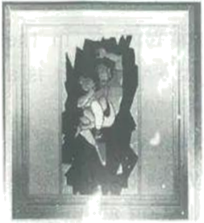
That night, July 11, 2022, Nick Bostic was driving down the streets of Lafayette, Indiana, when he found a two-story house was on fire.
Flames (火焰) were climbing up the front porch. Without pausing for a moment to think about the danger, Bostic stopped his car and ran from the back door into the burning building, which belongs to the Barrett family.
Bostic had just started climbing the stairs when he looked up and saw four faces appear from a room at the top of the stairs and look down at him, their eyes wide. “Your house is on fire, you need to go!” Bostic yelled.
Bostic hurried the four girls into the fresh air. “Anybody else in there?” Bostic asked.
“Kaylani is in there! We can’t find her!” Seionna, the eldest of the girls, screamed referring to her six-year-old sister. Without hesitating, Bostic ran back inside.
By now, the whole side of the house was in flames. Bostic went upstairs. He searched every bedroom. No kid. The smoke was thick now. He lifted his T-shirt, trying to cover his mouth and nose when he heard the sound of crying, from the dark smoke below.
Bostic felt about in the blackness and heat, moving downstairs toward the sound. Then suddenly Kaylani was in front of him. Bostic quickly lifted the girl into his arms. Where is the front door?! Bostic remembered seeing a window on the side of the house where the fire hadn’t reached.
Bostic climbed back up, made it to the room and broke the glass, Kaylani still in his arms.
Bostic and Kaylani looked down at the open grassy space. The girl said, “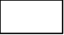” He was thinking the exact same thing.
But they had little choice. The flames were inching ever closer. Holding Kaylani tightly in one arm, Bostic ran forward and threw himself out of the window. He managed to land on the other shoulder. Kaylani was almost unhurt.
Days passed. Bostic woke up from first-degree burns to his leg and arm, He felt like he’d just done what anyone would have done in that situation. But outside the hospital, the story of Nick Bostic was already spreading. He was a hero—the pizza man who had run into a burning building not once, but twice.
38. What does the underlined word “hesitating” mean in Paragraph 5?
A. 交谈 B. 犹豫 C. 埋怨 D. 期待
39. Which of the following is the correct order of the story?
a. Bostic looked for the door with Kaylani in his arms.
b. Bostic led the four girls out into the fresh air.
c. Bostic went upstairs to search every bedroom for Kaylani.
d. Bostic jumped out of the window holding Kaylani tightly in one arm.
e. Bostic followed the sound of crying to the dark smoke below.
A. cbade B. bcead C. ceabd D. baedc
40. Which sentence should go in the empty box in Paragraph 3 from the bottom?
A. I want my sisters!
B. Wow, we’ll be heroes!
C. I can’t thank you too much.
D. I don’t want to jump out the window.
41. The picture in the passage is helpful because it shows ________.
A. when Kaylani was found
B. how brave Kaylani and Bostic were
C. what the two-story house on fire was like
D how the hero saved Kaylani at the very moment
D
The scientific method is used for simple experiments that students may do in the classroom or very difficult experiments that scientists are doing all over the world. It is a way of thinking that helps you to avoid drawing incorrect conclusions.
There are usually four steps in the scientific method, including observation (观察), hypothesis (假设), experiment, and conclusion. The steps may not always be completed in the same order, but the first step is usually observation and asking a question about your observation. For example, you had a sick stomach, and ate a candy bar. An hour later, you observed that you felt much better. Here, you can ask a question, such as, “What makes a sick stomach feel better?”
The second step is to state a possible answer to the question, or a hypothesis, such as “” A good hypothesis includes three things: The explanation for the observations, it is able to be tested, and it will usually predict new outcomes or conclusions.
The third step is the experiment, to test the hypothesis. An experiment is a test which will either challenge or support the hypothesis. The hypothesis will then be true or false.
The final step is to think about what happened when you tested the hypothesis and draw a conclusion. The conclusion will either clearly support the hypothesis or it will not. If the results support the hypothesis, a conclusion can be written and you can share it with the rest of the world. If it does not support the hypothesis, you may choose to change the hypothesis or write a new one based on what was learned during the experiment.
42. Which sentence best expresses the main idea of the passage?
A. How do the four basic steps in the scientific method work?
B. What makes a good hypothesis based on the observation?
C. The conclusion will always clearly support the hypothesis.
D. Learning the scientific method may help students succeed in science.
43. Which sentence should go in the empty box in Paragraph 3?
A A candy bar makes a sick stomach feel better.
B. It was the medicine you took an hour earlier that made you feel better.
C. Eat a candy bar again, and see what happens to your sick stomach.
D. Ask people if eating a candy bar has made a sick stomach feel better.
44. What does the underlined word “it” in the last paragraph refer to (指的是)?
A. The hypothesis. B. The conclusion.
C. The question. D. The observation.
45. Which of the following sentences about the experiment is TRUE?
A. An experiment is a test to always support the hypothesis.
B. An experiment does not have to be part of the scientific method.
C. An experiment is a test to either challenge or support a hypothesis.
D. An experiment is only used when scientists are trying to prove a hypothesis.
四、词汇运用（共10小题；每小题1分，计10分）
根据句子意思，用括号中所给汉语提示或英语单词的适当形式填空。在答题卡标有题号的横线上，写出空缺处所填单词的正确形式。（每空一词）
46. Follow these tips, and you can enjoy your summer ________. (safe)
47. Chinese Language Day ________ on April 20th of every year, the same day with Guyu. (fall)
48. It seems that families are ________ more and more time together. (spend)
49. We students now use ________ throwaway products than before. (few)
50. The artists are ________ to tell good Chinese stories in their favorite art forms. (encourage)
51. In these ________, each plant has its own story to tell. (花园)
52. My uncle lives in a town ________ kilometers from Yangzhou. (十五)
53. Since he had no musical ________, he made music with common objects. (乐器)
54. She’s not a ________ mother with rules for every little thing. (严格)
55. No matter how times change, the ________ of Lei Feng will always be relevant. (精神)
五、阅读表达（共5小题；每小题2分，计10分）
阅读短文，回答下面5个问题。（每题答案不超过10个词）
Roberta woke up early the next morning. Then she woke up Phyllis and Peter. “We’re in the new house. There are no servants here. We must help Mother now,” whispered Roberta.
Carefully the three children lit the fire and filled a kettle (水壶) with water. They hung the kettle above the fire.
“Mother isn’t awake yet. Let’s go outside and sit on that flat stone,” said Roberta. “Perhaps we will see a train go by.”
When Mother came out at eight o’clock, Roberta, Peter and Phyllis were all fast asleep in the sunshine. They had put the kettle on the fire at five o’clock: three hours ago. All the water had boiled away (烧干). Now there was a hole in the bottom of the kettle. The fire had gone out.
“Never mind,” laughed Mother. “We can boil some water in a pan. And I’ve found the dinner.”
She led them into the kitchen and pointed to a door.
“Last night, I thought this was a cupboard. It was so dark. But look,” she said.
Mother opened the door and the children saw a little room with a table in the middle. On it there was roast beef, bread and butter, cheese and an apple pie.
“Apple pie for breakfast,” cried Peter. “What fun!”
It was a wonderful breakfast. Everyone was very hungry.
“It feels like dinner because we were up so early,” said Peter, as he passed his plate for more apple pie.
When the children had finished, they helped Mother put everything away in the right place.
Then Mother said “I’m tired. I’m going to lie down for a while. Go out to play but please be careful.”
Roberta, Peter and Phyllis looked at each other. They were all thinking the same thing.
“Let’s go down to the railway,” cried Roberta.
“Listen!” said Phyllis. “I think I can hear a train.”
Peter asked, “Do you think it’s going to London?”
“Father is in London,” replied Roberta. “Let’s go to the station and find out.”
—Taken from The Railway Children
56. When did the children get up?
____________________________________________________________
57. What happened to the kettle when the water boiled away?
____________________________________________________________
58. How did the children like the breakfast?
____________________________________________________________
59. What is “the same thing” they were thinking?
____________________________________________________________
60. What are the children like in your eyes? Why do you think so?
_____________________________________________________________
六、缺词填空（共10空；每空1分，计10分）
根据短文内容和首字母提示，在下文空格处填入适当的词使短文完整。在答题卡标有题号的横线上，完整地写出空缺处各单词的正确形式。（每空一词）
Peter Pan wishes Wendy, John and Michael, especially Wendy, would stay in Neverland forever, but finally the Darling children decide to fly back home and grow up.
“Quick, Tink,” Peter whispers. “S____61____ the window. Then when Wendy comes back, she will think her mother doesn’t love her anymore, and she will return to Neverland with me.”
Mrs. Darling is playing the piano. Peter didn’t know the tune, Home, Sweet Home, b____62____ he knows it’s saying, “Come back, Wendy, Wendy, Wendy.” Peter looks through the door and sees two big tears in Mrs. Darling’s eyes.
“She loves Wendy,” he thinks. “But I love Wendy, too. We c____63____ both have her.”
He looks at Mrs. Darling again. The two tears are still sitting on her e____64____.
“Oh, all right,” he says at last, sadly. Then he opens the window.
When Wendy, John, and Michael arrive, they find the window o____65____ for them. They all get into bed to surprise their mother.
When Mrs. Darling goes back to the children’s room, they are all in their beds. They wait for her to say something, but she says n____66____. She thinks she is dreaming. She sits by the fire.
The children are so w____67____. Why isn’t their mother happy to see them again? All three of them jump out of bed, run to her and shout, “Mother!” She realizes she is not d____68____ anymore. Mr. Darling and Nana come in. They are all so happy. Peter w____69____ them from the window but he is looking at something he will never have.
Many years pass. When Peter visits Wendy again, she has g ____70____ up and has a daughter of her own. Peter is still a boy who can’t grow up.
—Taken from Peter Pan
七、书面表达（计30分）
A. 句子翻译（共5小题；每小题2分，计10分）
将下列句子译成英语，并将所译句子写在答题卡标有题号的横线上。
71. 你们的教学楼有几层？
_______________________________________________________________
72. 有些人相信颜色会影响人们的心情。
_______________________________________________________________
73. 我认为和朋友们分享兴趣爱好很重要。
_______________________________________________________________
74. 在你使用新洗衣机前，最好读一下说明书。
_______________________________________________________________
75. 我们和祖父母住在一起，这样可以很好地照顾他们。
_______________________________________________________________
B. 写作（计20分）
76. 为丰富校园生活，弘扬中华优秀传统文化，近期你校校报英语专栏举行了Getting close to traditional Chinese culture征文活动，请根据表格中的内容提示写一篇英语短文，向此专栏投稿，介绍中国传统手工艺（handicraft）风筝的历史、特征及其文化重要性，并分享你的看法。
Kites
History | Mozi, in the Warring States period
Characteristics | materials for making kites:…  shapes of kites:…
Cultural importance | kites:  ● a traditional Chinese handicraft  ● …  kite flying:  ● a popular outdoor activity…  ● the World Kite Capital: Weifang, Shandong Province…
Your ideas | …
要求：(1) 表达清楚，语法正确，上下文连贯；
(2) 必须包括提示中的所有信息，并按要求适当发挥；
(3) 词数：100词左右（开头已给出，不计入总词数）；
(4) 不得使用真实姓名、校名和地名等。
Kites
Kites have a history of about 2,300 years in China. _______________________________________________________________________________________________________________________________________________________________________________________________________________________________________________________________________________________________________________________________________________________________________________________________________________________________________________________________________________________________________________________________________________________________________________________________________________________________________________________________________________________________________________________________________________________________________________________________________________________________________________________________________________________

