2023年河南省普通高中招生考试试卷
英 语
注意事项：
1. 本试卷共10页，六个大题，满分120分，考试时间100分钟。
2. 本试卷上不要答题，请按答题卡上注意事项的要求直接把答案填写在答题卡上，答在试卷上的答案无效。
一、听力理解（20小题，每小题1分，共20分）
第一节 听下面5段对话。每段对话后有一个小题，从题中所给的A、B、C三个选项中选出最佳答案。每段对话读两遍。
1. Which club will the boy join?
A. A music club. B. A painting club. C. A chess club.
2. What will the weather be like this afternoon?
A. Sunny. B. Cloudy. C. Windy.
3. What’s the possible relationship between the two speakers?
A. Father and daughter. B. Doctor and patient. C. Waiter and customer.
4. Who likes jiaozi best?
A. The man. B. The woman. C. Their friend
5. What happened to Kevin?
A. He lost the game. B. He left the team. C. He hurt his arm.
第二节 听下面几段对话或独白。每段对话或独白后有几个小题，从题中所给的A、B、C三个选项中选出最佳答案。每段对话或独白读两遍。
听下面一段对话，回答第6至第7两个小题。
6. When will the girl give a speech?
A. Next Monday. B. Next Wednesday. C. Next Friday.
7. What is the girl going to talk about?
A. Environmental protection. B. Language learning. C. Traditional culture.
听下面一段对话，回答第8至第9两个小题。
8. Where is the bookstore?
A. On Zhongshan Road. B. On Renmin Road. C. On Huayuan Road.
9. How will the man get to the bookstore?
A. By car. B. By bus. C. By bike.
听下面一段独白，回答第10至第12三个小题。
10. Who will be invited to the speaker’s school?
A. A fireman. B. A policeman. C. A sportsman.
11 How long will the talk last?
A. One hour. B. Two hours. C. Three hours.
12. Where will the students go after the talk?
A. To the school hall. B. To the classroom. C. To the playground.
听下面一段对话，回答第13至第15三个小题。
13. What is the boy’s name in the story?
A. Bob. B. John. C. Scott.
14. What do the speakers think of the boy in the story?
A. Brave. B. Honest. C. Cute
15. Where will the two speakers meet?
A. At the bus stop. B. At the school gate. C. At the street corner.
第三节 听下面一篇短文。按照你所听内容的先后顺序将下列图片排序。短文读两遍。
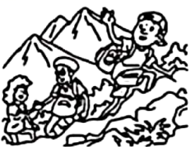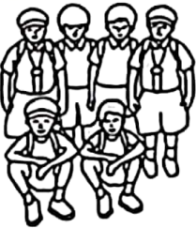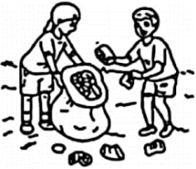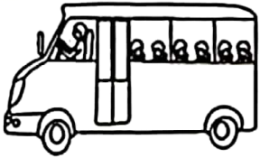
A B C D E
16._________ 17._________ 18._________ 19._________ 20._________
二、阅读理解（20小题，每小题2分，共40分）
阅读下面四篇语言材料，然后按文后要求做题。
A
Kew Gardens
Enjoy yourselves in a wonderland of science with over 50,000 living plants and different kinds of educational events or interesting activities. Here is some useful information about planning a school visit to Kew Gardens.
Educational session (时段) prices
You can plan a self-led visit or book one of our educational sessions. Students will take part in the educational sessions in groups of 15. Prices are different according to different situations.
● 45-minute session: £35/group ● 90-minute session: £70/group
● Half day (one session): £80/group ●Full day (two sessions): £160/group
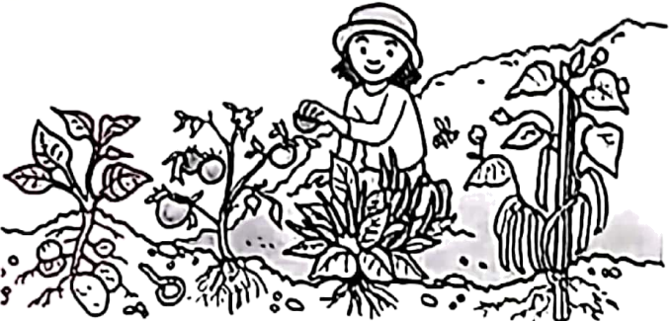
Health and safety
Required teacher-student ratios (比例):
● Key Stage 1: 1:5
● Key Stage 2: 1:8
● Key Stage 3: 1:10
● Key Stage 4: 1:12
If you need help, please contact (联系) the Kew staff members (工作人员). You can also call 0202 332 3333 for direct and quick support. Please do not call 999.
Timings
The Kew Gardens opens at 10 am. Your visit may take three to five hours. The closing time changes throughout the year. But the earliest is 3:30 pm. We have a fixed schedule for educational sessions, which is from 10:30 am to 2:20 pm.
根据材料内容选择最佳答案。
1. How much should a group of 15 students pay for a 90-minute session?
A. £35. B. £70. C. £80. D. £160.
2. How many teachers are needed if 40 children (Key Stage 2) visit Kew Gardens?
A. 3. B. 4. C. 5. D. 6.
3. What should you do if you need help according to the text?
A. Call 999 right away. B. Call your parents at once.
C. Turn to your teachers. D. Ask staff members for help.
4. Which of the following is a proper time to take part in the educational sessions?
A. 9:30 am. B. 11:30 am. C. 3:30 pm. D. 4:30 pm.
5. What is the main purpose of the text?
A. To list the reasons for visiting Kew Gardens.
B. To introduce different plants in Kew Gardens.
C. To compare different activities in Kew Gardens.
D. To give information about visiting Kew Gardens.
B
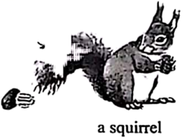
Plunk! I dropped another pecan (山核桃) into my basket. Then a gentle autumn wind blew some more off the tree. I ran to pick them up. Whew! Pecan picking was hard. My basket was only half full.
I was visiting my grandpa’s farm in Kansas, and Grandpa sent me into the woods to pick up pecans for us to enjoy later. I wasn’t about to let him down.
Then something caught my eye: a squirrel picked up a pecan, climbed up a tree and disappeared into a large hole. A moment later, the squirrel climbed down to the ground to pick another pecan. Once again, he took the pecan back to his secret hiding place inside the hollow (洞) of the tree.
Not so secret anymore I thought. I ran over to the tree and found the hollow was filled with sweet pecans. They were right there for the taking. This was my chance. Handful by handful, I took all the pecans from the hollow. Now the basket was full!
I was so proud of myself. I couldn’t wait to show Grandpa all of the pecans I’d collected.
“Look, Grandpa,” I shouted, “look at all of the pecans I found!”
Grandpa took a look at my basket. “Well, well, how did you find so many, Jimmy?” I told him how I’d followed the squirrel and taken the pecans from his hiding place. Grandpa congratulated me on finding out something about the squirrel’s habits. Then he did something that surprised me. He handed the basket back to me and put his arm gently around my shoulders.
“That squirrel worked very hard to collect his winter food,” he said. “Now that all of his pecans are gone, don’t you think that little squirrel will be very hungry when it gets cold?”
“I didn’t think about that,” I said.
“I know,” Grandpa said. “But a good man should never take advantage of someone else’s hard work, even the squirrel’s.”
Suddenly I felt as hollow as that old tree. The image (形象) of that hungry squirrel wouldn’t leave my mind. There was only one thing I could do.
…
根据材料内容选择最佳答案。
6. Why did the writer go to the woods at the beginning of the story?
A. To pick up pecans. B. To catch little animals.
C. To feed the squirrels. D. To look for his grandpa.
7. The writer was proud of himself because ________.
A. he was praised by his grandpa
B. he found out his grandpa’s secret
C. he helped the squirrel in the hollow
D. he filled his basket with so many pecans
8. Which of the following can best describe Grandpa?
A. Kind and wise. B. Caring and humorous.
C. Shy and friendly. D. Patient and hard-working.
9. What is the possible ending to the story?
A The writer sent the pecans to his neighbors.
B. The writer put all the pecans back into the hole.
C. The writer hid the pecans in his grandpa’s house.
D. The writer enjoyed all the pecans with his family.
10. What is the best title for the text?
A. An unusual tree B. The stolen pecans
C. A smart squirrel D. The magic basket
C
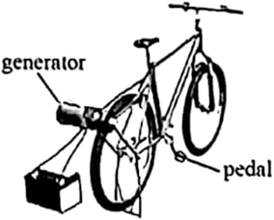
Energy is the ability to do work. Solar energy comes from the Sun. There is also energy that comes from wind and water.
But do you know that energy can come from people, too? When you pedal a bike, you produce energy. You use your legs to push the pedals. Your energy is transferred (转移) to the bike. That makes the bike move.
Now imagine riding your bike to create enough power to run a computer. Some students at one school did just that! They jumped on bikes connected to generators (发电机) and pedaled in place. Soon they were producing electricity. This energy is needed to run their computers.
Here is how bicycle-powered energy works. When a student pedals the bike, the back wheel spins. The wheel spins the generator. The generator produces electricity. As long as a student pedals the bicycle, electricity moves through the generator. The electricity can be used right away. This energy can also be stored and used later.
People use bicycle-powered energy to run small devices (设备) such as small televisions and fans. They often use less than 100 watts per hour. However, it would be a mistake to use pedal power to run a fridge. This large machine often uses more than 700 watts per hour. The electricity for these machines comes from power lines overhead or underground.
Pedal power can be seen in schools, gyms, and homes. What a fun way to provide electricity!
根据材料内容选择最佳答案。
11. How does the writer lead into the topic “bicycle-powered energy” in Paragraph 2?
A. By asking a question. B. By telling a joke.
C. By using an old saying. D. By making a survey.
12. What does the underlined word “spins” mean in the text?
A. Falls down suddenly. B. Breaks up completely.
C. Moves up and down slowly. D. Turns round and round quickly.
13. What is Paragraph 5 mainly about?
A. The future of new energy. B. The forms of world’s energy.
C. Using bicycle-powered energy. D. Producing bicycle-powered energy.
14. What do we know about bicycle-powered energy?
A. It can’t be seen in schools. B. It comes from wind and water.
C. It can be stored and used later. D. It’s from power lines overhead.
15. In which unit of a textbook can the text be found?
A. Unit 1 Friends Forever B. Unit 2 Dream of the Stars
C. Unit 3 The Value of Money D. Unit 4 The World of Science
D
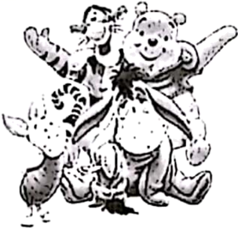
Have you heard of Oliver Twist or Peter Pan? These are just some of the characters (角色) that have been created by British writers.
Geoffrey Chaucer was a famous poet in the 1300s. He wrote poetic short stories about people travelling to Canterbury. ____16____
Probably the most famous British writer was William Shakespeare. In the late 1500s and early 1600s, Shakespeare wrote plays that became famous all over the world. ____17____ Some of his plays were comedies, such as Twelfth Night, others were tragedies (悲剧), such as King Lear.
____18____ Early stories were often printed a chapter (章节) at a time in a newspaper. People would have to get the newspaper every week to read the whole story. One of the most famous stories, Oliver Twist, was written by Charles Dickens at that time.
____19____ Maybe you have heard of some of them. Robert Louis Stevenson wrote the adventure novel Treasure Island. J. M. Barrie wrote Peter Pan and Lewis Carroll wrote Alice’s Adventures in Wonderland. Do you know a teddy bear called Winnie the Pooh? ____20____ And it is still one of children’s favorite characters.
There are so many famous characters in British plays, novels and poetry. What other characters do you know?
根据材料内容，从下而五个选项中选出能填入文中空缺处的最佳选项，使文章意思通顺、内容完整。
A. It was created by A. A. Milne.
B. They are still very popular today.
C. British people love reading stories.
D. The stories are called The Canterbury Tales.
E. There are many children’s books by British writers.
三、完形填空（15小题，每小题1分，共15分）
先通读短文，掌握其大意，然后从A、B、C、D四个选项中选出一个可以填入相应空白处的最佳答案。
It was a rainy, windy October afternoon. Garth stood outside his house with a wide smile. This was ____21____ weather for testing his new invention—Umbrella Hat. He could hardly wait to see whether it could keep the rain off. He carefully ____22____ the hat on his head and started walking ____23____ along the street. It worked!
Suddenly, three boys in his neighborhood appeared and ____24____ him. Todd, the biggest one, pulled his Umbrella Hat off his head.
“What’s THIS?” he asked.
“It’s an Umbrella Hat. You can wear it on rainy days and…” Garth said.
The boys ____25____, “Will anyone wear that stupid thing?” Todd threw the hat onto the ground and they ran off.
Garth picked up his Umbrella Hat from the ground in tears. “Maybe Todd was ____26____ …in reality, who would ever need his invention?” He lowered his head and thought to himself.
Suddenly he ____27____ and saw a lady looking at him. “I was just leaving my house ____28____ I saw you and those boys. Are you okay?”
Then she saw the ____29____ Umbrella Hat and asked, “Er… what’s that?”
“It’s my Umbrella Hat. I thought of it and made it myself…” answered Garth.
“What a creative _____30_____ you have! Don’t ever let stupid boys put you down! Keep inventing and one day you will _____31_____ something really great!” said the lady.
“And you have given me a wonderful _____32_____,” she continued, “I have a gadget (小器具) shop—Gadgets4U—and I’d like to hold a _____33_____ to find the best young gadget inventor in our town. I will display (展示) three best inventions in my shop. I’m sure you will have a(n) _____34_____ of winning a prize.”
Garth was very _____35_____. Gadgets4U was one of his favorite places and the thought of having his invention displayed in that wonderful place was too exciting for words. He suddenly felt much better and could already feel lots of new ideas coming out, waiting to spring into life!
21. A. cold B. perfect C. strange D. changeable
22. A. raised B. placed C. dropped D. repaired
23. A. heavily B. madly C. thankfully D. purposefully
24. A. guided B. praised C. stopped D. refused
25. A. replied B. laughed C. wondered D. greeted
26. A. right B. angry C. polite D. silly
27. A. came up B. gave up C. looked up D. showed up
28. A. when B. until C. if D. after
29. A. ugly B. old C. broken D. tiny
30. A. mind B. habit C. game D. tool
31. A. show B. meet C. plan D. create
32. A. skill B. gift C. idea D. job
33. A. party B. meeting C. conversation D. competition
34. A. choice B. chance C. excuse D. experience
35. A. surprised B. bored C. relaxed D. worried
四、语篇填空（15小题，每小题1分，共15分）
第一节
阅读短文，从方框中选择适当的词并用其正确形式填空，使短文通顺、意思完整。每空限填一词，每词限用一次。
final I decide hard what work driver in year young
Hi, David,
How are you doing? Do you remember we once talked about ____36____ jobs and careers (职业) we might do in the future? I’m finding it very difficult to make up ____37____ mind.
My parents tell me I’m too ____38____ to be expected to know about my future. They say I can choose whatever I want to do in the end if I keep ____39____ hard at school. I’m not sure if I agree with them. I feel as if I’m the only person ____40____ my class who hasn’t got a career in mind! It’s a big decision to make, but even so it’s much ____41____ than I thought.
Sometimes I think I’d like to go into medicine. My teacher thinks Chinese medicine will be greatly developed over the next few ____42____. That sounds really interesting!
Then again, I’d also love to be a racing ____43____. That’s a very interesting field too! When I’ve ____44____ made my choice, I’ll let you know! Have you ____45____ what you want to do? Do let me know if you have!
Li Hua
第二节
阅读短文，根据语篇要求填空，使短文通顺、意思完整。每空限填一词。
Comments (评论) about the Museum of Chinese Characters (文字)
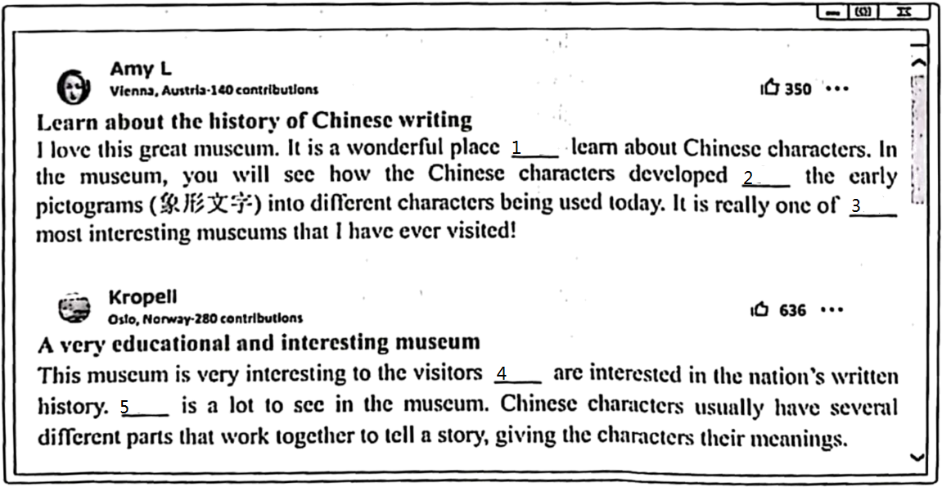
46. _______
47. _______
48. _______
49 _______
50. _______

五、补全对话（5小题，每小题2分，共10分）
根据下面的对话情景，在每个空白处填上一个适当的句子，使对话的意思连贯、完整。
A: Hey, Leilei! Have you got any plans for the weekend?
B: Not yet. ____51____?
A: I heard the Science and Technology Center is a great place to visit _____52_____?
B: I am sorry, but I have been there already.
A: What a pity! When did you go there?
B: ____53____. I went with my family.
A: Did you enjoy yourselves?
B: Yes, we had a great time there.
A: _____54_____?
B: We watched a video about how Shenzhou-16 was sent into space successfully.
A: What else did you do?
B: _____55_____.
A: Cool! I will ask my sister to go with me this weekend.
B: Have a good time!
六、书面表达（20分）
56. 为了丰富学校大课间活动内容，学校校刊英语专栏以“最美大课间，强健青少年”为主题面向学生进行征文。请你根据写作要求，用英语写一篇短文，向专栏投稿。
写作要求：1) 介绍学校目前30分钟大课间的活动内容，并简单谈谈你的感受；
2) 你对大课间活动内容有什么更好的建议，请写出理由；
3) 文中不得出现考生的真实姓名和学校名称；
4) 词数100左右（开头已给出，不计入总词数）。
参考词汇：shuttlecock exercises 毽子操；badminton 羽毛球；rope skipping 跳绳
The colorful activities during the 30-minute break help make teenagers healthier and stronger.
________________________________________________________________________________________________________________________________________________________________________________________________________________________________________________________________________________________________________________________________________________________________________________________________________________________________________________________________________________________________________________________________________________________________________________________________________________________________________________________________________________________________________________________________________________________________________________________________________________________________________________________________________________________

