2023年河南省普通高中招生考试试卷
英 语
注意事项：
1. 本试卷共10页，六个大题，满分120分，考试时间100分钟。
2. 本试卷上不要答题，请按答题卡上注意事项的要求直接把答案填写在答题卡上，答在试卷上的答案无效。
一、听力理解（20小题，每小题1分，共20分）
第一节 听下面5段对话。每段对话后有一个小题，从题中所给的A、B、C三个选项中选出最佳答案。每段对话读两遍。
1. Which club will the boy join?
A. A music club. B. A painting club. C. A chess club.
2. What will the weather be like this afternoon?
A. Sunny. B. Cloudy. C. Windy.
3. What’s the possible relationship between the two speakers?
A. Father and daughter. B. Doctor and patient. C. Waiter and customer.
4. Who likes jiaozi best?
A The man. B. The woman. C. Their friend
5. What happened to Kevin?
A. He lost the game. B. He left the team. C. He hurt his arm.
第二节 听下面几段对话或独白。每段对话或独白后有几个小题，从题中所给的A、B、C三个选项中选出最佳答案。每段对话或独白读两遍。
听下面一段对话，回答第6至第7两个小题。
6. When will the girl give a speech?
A. Next Monday. B. Next Wednesday. C. Next Friday.
7. What is the girl going to talk about?
A. Environmental protection. B. Language learning. C. Traditional culture.
听下面一段对话，回答第8至第9两个小题。
8. Where is the bookstore?
A. On Zhongshan Road. B. On Renmin Road. C. On Huayuan Road.
9. How will the man get to the bookstore?
A. By car. B. By bus. C. By bike.
听下面一段独白，回答第10至第12三个小题。
10. Who will be invited to the speaker’s school?
A. A fireman. B. A policeman. C. A sportsman.
11. How long will the talk last?
A. One hour. B. Two hours. C. Three hours.
12. Where will the students go after the talk?
A. To the school hall. B. To the classroom. C. To the playground.
听下面一段对话，回答第13至第15三个小题。
13. What is the boy’s name in the story?
A. Bob. B. John. C. Scott.
14. What do the speakers think of the boy in the story?
A. Brave. B. Honest. C. Cute
15. Where will the two speakers meet?
A. At the bus stop. B. At the school gate. C. At the street corner.
第三节 听下面一篇短文。按照你所听内容的先后顺序将下列图片排序。短文读两遍。
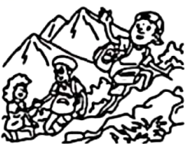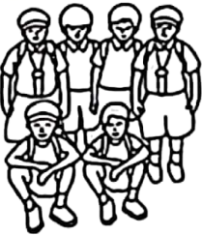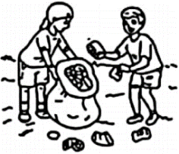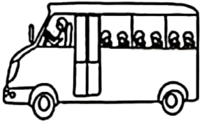
A B C D E
16._________ 17._________ 18._________ 19._________ 20._________
二、阅读理解（20小题，每小题2分，共40分）
阅读下面四篇语言材料，然后按文后要求做题。
A
Kew Gardens
Enjoy yourselves in a wonderland of science with over 50,000 living plants and different kinds of educational events or interesting activities. Here is some useful information about planning a school visit to Kew Gardens.
Educational session (时段) prices
You can plan a self-led visit or book one of our educational sessions. Students will take part in the educational sessions in groups of 15. Prices are different according to different situations.
● 45-minute session: £35/group ● 90-minute session: £70/group
● Half day (one session): £80/group ●Full day (two sessions): £160/group
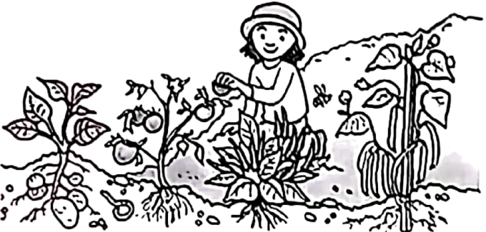
Health and safety
Required teacher-student ratios (比例):
● Key Stage 1: 1:5
● Key Stage 2: 1:8
● Key Stage 3: 1:10
● Key Stage 4: 1:12
If you need help, please contact (联系) the Kew staff members (工作人员). You can also call 0202 332 3333 for direct and quick support. Please do not call 999.
Timings
The Kew Gardens opens at 10 am. Your visit may take three to five hours. The closing time changes throughout the year. But the earliest is 3:30 pm. We have a fixed schedule for educational sessions, which is from 10:30 am to 2:20 pm.
根据材料内容选择最佳答案。
1. How much should a group of 15 students pay for a 90-minute session?
A. £35. B. £70. C. £80. D. £160.
2 How many teachers are needed if 40 children (Key Stage 2) visit Kew Gardens?
A. 3. B. 4. C. 5. D. 6.
3. What should you do if you need help according to the text?
A. Call 999 right away. B. Call your parents at once.
C. Turn to your teachers. D. Ask staff members for help.
4. Which of the following is a proper time to take part in the educational sessions?
A. 9:30 am. B. 11:30 am. C. 3:30 pm. D. 4:30 pm.
5. What is the main purpose of the text?
A. To list the reasons for visiting Kew Gardens.
B. To introduce different plants in Kew Gardens.
C. To compare different activities in Kew Gardens.
D. To give information about visiting Kew Gardens.
【答案】1. B 2. C 3. D 4. B 5. D
【解析】
【导语】本文主要介绍了去邱园参观的相关信息。
【1题详解】
细节理解题。根据“90-minute session: £70/group”可知90分钟课程一组需要70磅。故选B。
【2题详解】
细节理解题。根据“Key Stage 2: 1:8”可知老师和学生的比例是1:8，所以40个孩子需要5名老师。故选C。
【3题详解】
细节理解题。根据“If you need help, please contact (联系) the Kew staff members”可知如果你需要帮助，可以联系工作人员。故选D。
【4题详解】
细节理解题。根据“We have a fixed schedule for educational sessions, which is from 10:30 am to 2:20 pm.”可知教育课程时间是从上午10点半到下午2点半。故选B。
【5题详解】
主旨大意题。本文主要介绍了去邱园参观的相关信息。故选D。
B
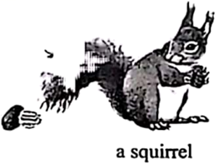
Plunk! I dropped another pecan (山核桃) into my basket. Then a gentle autumn wind blew some more off the tree. I ran to pick them up. Whew! Pecan picking was hard. My basket was only half full.
I was visiting my grandpa’s farm in Kansas, and Grandpa sent me into the woods to pick up pecans for us to enjoy later. I wasn’t about to let him down.
Then something caught my eye: a squirrel picked up a pecan, climbed up a tree and disappeared into a large hole. A moment later, the squirrel climbed down to the ground to pick another pecan. Once again, he took the pecan back to his secret hiding place inside the hollow (洞) of the tree.
Not so secret anymore, I thought. I ran over to the tree and found the hollow was filled with sweet pecans. They were right there for the taking. This was my chance. Handful by handful, I took all the pecans from the hollow. Now the basket was full!
I was so proud of myself. I couldn’t wait to show Grandpa all of the pecans I’d collected.
“Look, Grandpa,” I shouted, “look at all of the pecans I found!”
Grandpa took a look at my basket. “Well, well, how did you find so many, Jimmy?” I told him how I’d followed the squirrel and taken the pecans from his hiding place. Grandpa congratulated me on finding out something about the squirrel’s habits. Then he did something that surprised me. He handed the basket back to me and put his arm gently around my shoulders.
“That squirrel worked very hard to collect his winter food” he said. “Now that all of his pecans are gone, don’t you think that little squirrel will be very hungry when it gets cold?”
“I didn’t think about that,” I said.
“I know,” Grandpa said. “But a good man should never take advantage of someone else’s hard work, even the squirrel’s.”
Suddenly I felt as hollow as that old tree. The image (形象) of that hungry squirrel wouldn’t leave my mind. There was only one thing I could do.
…
根据材料内容选择最佳答案。
6. Why did the writer go to the woods at the beginning of the story?
A. To pick up pecans. B. To catch little animals.
C. To feed the squirrels. D. To look for his grandpa.
7. The writer was proud of himself because ________.
A. he was praised by his grandpa
B. he found out his grandpa’s secret
C. he helped the squirrel in the hollow
D. he filled his basket with so many pecans
8. Which of the following can best describe Grandpa?
A. Kind and wise. B. Caring and humorous.
C. Shy and friendly. D. Patient and hard-working.
9. What is the possible ending to the story?
A. The writer sent the pecans to his neighbors.
B. The writer put all the pecans back into the hole.
C. The writer hid the pecans in his grandpa’s house.
D. The writer enjoyed all the pecans with his family.
10. What is the best title for the text?
A. An unusual tree B. The stolen pecans
C. A smart squirrel D. The magic basket
【答案】6. A 7. D 8. A 9. B 10. B
【解析】
【导语】本文讲述了作者把松鼠树洞里的山核桃据为己有，带回家给爷爷看，爷爷告诉他：一个好人不应该窃取别人的劳动成果。
【6题详解】
细节理解题。根据“Grandpa sent me into the woods to pick up pecans”可知，作者去树林里摘山核桃。故选A。
【7题详解】
细节理解题。根据“Now the basket was full! I was so proud of myself. I couldn’t wait to show Grandpa all of the pecans I’d collected.”可知，作者自豪是因为他在篮子里装满了山核桃。故选D。
【8题详解】
推理判断题。根据“He handed the basket back to me and put his arm gently around my shoulders.”和爷爷说的话“Now that all of his pecans are gone, don’t you think that little squirrel will be very hungry when it gets cold?”，“But a good man should never take advantage of someone else’s hard work, even the squirrel’s.”可知，爷爷没有责备作者，而是耐心地告诉他不应该窃取别人的劳动成果，拿走松鼠的食物，冬天它会挨饿。由此可知，爷爷是善良并且有智慧的。故选A。
【9题详解】
推理判断题。根据最后一段“Suddenly I felt as hollow as that old tree. The image (形象) of that hungry squirrel wouldn’t leave my mind. There was only one thing I could do.”可知，作者明白了自己做的事情会伤害那只松鼠，所以他接下来会把山核桃送回松鼠的树洞中。故选B。
【10题详解】
最佳标题题。文章通过讲述作者拿走松鼠山核桃的故事告诉我们：一个好人不应该窃取别人的劳动成果。B项“偷来的山核桃”适合做标题。故选B。
C
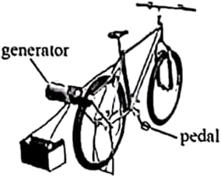
Energy is the ability to do work. Solar energy comes from the Sun. There is also energy that comes from wind and water.
But do you know that energy can come from people, too? When you pedal a bike, you produce energy. You use your legs to push the pedals. Your energy is transferred (转移) to the bike. That makes the bike move.
Now imagine riding your bike to create enough power to run a computer. Some students at one school did just that! They jumped on bikes connected to generators (发电机) and pedaled in place. Soon they were producing electricity. This energy is needed to run their computers.
Here is how bicycle-powered energy works. When a student pedals the bike, the back wheel spins. The wheel spins the generator. The generator produces electricity. As long as a student pedals the bicycle, electricity moves through the generator. The electricity can be used right away. This energy can also be stored and used later.
People use bicycle-powered energy to run small devices (设备) such as small televisions and fans. They often use less than 100 watts per hour. However, it would be a mistake to use pedal power to run a fridge. This large machine often uses more than 700 watts per hour. The electricity for these machines comes from power lines overhead or underground.
Pedal power can be seen in schools, gyms, and homes. What a fun way to provide electricity!
根据材料内容选择最佳答案。
11. How does the writer lead into the topic “bicycle-powered energy” in Paragraph 2?
A. By asking a question. B. By telling a joke.
C. By using an old saying. D. By making a survey.
12. What does the underlined word “spins” mean in the text?
A. Falls down suddenly. B. Breaks up completely.
C. Moves up and down slowly. D. Turns round and round quickly.
13. What is Paragraph 5 mainly about?
A. The future of new energy. B. The forms of world’s energy.
C. Using bicycle-powered energy. D. Producing bicycle-powered energy.
14. What do we know about bicycle-powered energy?
A. It can’t be seen in schools. B. It comes from wind and water.
C. It can be stored and used later. D. It’s from power lines overhead.
15. In which unit of a textbook can the text be found?
A. Unit 1 Friends Forever B. Unit 2 Dream of the Stars
C. Unit 3 The Value of Money D. Unit 4 The World of Science
【答案】11. A 12. D 13. C 14. C 15. D
【解析】
【导语】本文主要讲述了“自行车动力能源”相关知识。
【11题详解】
细节理解题。根据“But do you know that energy can come from people, too? When you pedal a bike, you produce energy. You use your legs to push the pedals. Your energy is transferred (转移) to the bike.”可知，作者是通过问问题来引出“自行车动力能源”的，故选A。
【12题详解】
词义猜测题。根据“When a student pedals the bike, the back wheel spins.”可及常识可知，当踩自行车时，后轮会转动，所以划线单词表示“转动”，D项符合，故选D。
【13题详解】
段落大意题。根据“People use bicycle-powered energy to run small devices (设备) such as small televisions and fans. ”可知，本段主要讲的是“自行车动力能源”的使用，故选C。
【14题详解】
细节理解题。根据“This energy can also be stored and used later.”可知，这种能源可以储存起来以后使用，故选C。
【15题详解】
推理判断题。本文主要讲述了“自行车动力能源”相关知识，与科学相关，故选D。
D
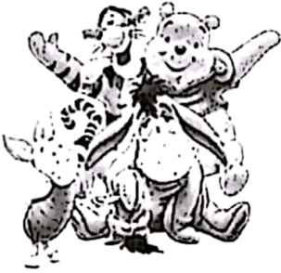
Have you heard of Oliver Twist or Peter Pan? These are just some of the characters (角色) that have been created by British writers.
Geoffrey Chaucer was a famous poet in the 1300s. He wrote poetic short stories about people travelling to Canterbury. ____16____
Probably the most famous British writer was William Shakespeare. In the late 1500s and early 1600s, Shakespeare wrote plays that became famous all over the world. ____17____ Some of his plays were comedies, such as Twelfth Night, others were tragedies (悲剧), such as King Lear.
____18____ Early stories were often printed a chapter (章节) at a time in a newspaper. People would have to get the newspaper every week to read the whole story. One of the most famous stories Oliver Twist, was written by Charles Dickens at that time.
____19____ Maybe you have heard of some of them. Robert Louis Stevenson wrote the adventure novel Treasure Island. J. M. Barrie wrote Peter Pan and Lewis Carroll wrote Alice’s Adventures in Wonderland. Do you know a teddy bear called Winnie the Pooh? ____20____ And it is still one of children’s favorite characters.
There are so many famous characters in British plays, novels and poetry. What other characters do you know?
根据材料内容，从下而五个选项中选出能填入文中空缺处的最佳选项，使文章意思通顺、内容完整。
A. It was created by A. A. Milne.
B. They are still very popular today.
C. British people love reading stories.
D. The stories are called The Canterbury Tales.
E. There are many children’s books by British writers.
【答案】16. D 17. B 18. C 19. E 20. A
【解析】
【导语】本文主要介绍了英国的戏剧、小说和诗歌以及其中的著名人物。
【16题详解】
根据“He wrote poetic short stories about people travelling to Canterbury”可知他写了一些关于去坎特伯雷旅行的人的富有诗意的短篇小说，选项D“这些故事被称为《坎特伯雷故事》”符合语境。故选D。
【17题详解】
根据“Shakespeare wrote plays that became famous all over the world”可知莎士比亚的戏剧非常有名，选项B“它们现在仍然很受欢迎”符合语境。故选B。
【18题详解】
根据“...People would have to get the newspaper every week to read the whole story”可知英国人喜欢读故事，选项C“英国人爱读故事”符合语境。故选C。
【19题详解】
根据“Maybe you have heard of some of them. Robert Louis Stevenson wrote the adventure novel...”可知此处介绍了儿童故事，选项E“有许多英国作家写的儿童读物”符合语境。故选E。
【20题详解】
根据“Do you know a teddy bear called Winnie the Pooh”可知此处介绍这个角色相关的信息，选项A“它是由A.A.米尔恩创造的”符合语境。故选A。
三、完形填空（15小题，每小题1分，共15分）
先通读短文，掌握其大意，然后从A、B、C、D四个选项中选出一个可以填入相应空白处的最佳答案。
It was a rainy, windy October afternoon. Garth stood outside his house with a wide smile. This was ____21____ weather for testing his new invention—Umbrella Hat. He could hardly wait to see whether it could keep the rain off. He carefully ____22____ the hat on his head and started walking ____23____ along the street. It worked!
Suddenly, three boys in his neighborhood appeared and ____24____ him. Todd, the biggest one, pulled his Umbrella Hat off his head.
“What’s THIS?” he asked.
“It’s an Umbrella Hat. You can wear it on rainy days and…” Garth said.
The boys ____25____, “Will anyone wear that stupid thing?” Todd threw the hat onto the ground and they ran off.
Garth picked up his Umbrella Hat from the ground in tears. “Maybe Todd was ____26____ …in reality, who would ever need his invention?” He lowered his head and thought to himself.
Suddenly he ____27____ and saw a lady looking at him. “I was just leaving my house ____28____ I saw you and those boys. Are you okay?”
Then she saw the ____29____ Umbrella Hat and asked, “Er… what’s that?”
“It’s my Umbrella Hat. I thought of it and made it myself…” answered Garth.
“What a creative _____30_____ you have! Don’t ever let stupid boys put you down! Keep inventing and one day you will _____31_____ something really great!” said the lady.
“And you have given me a wonderful _____32_____,” she continued, “I have a gadget (小器具) shop—Gadgets4U—and I’d like to hold a _____33_____ to find the best young gadget inventor in our town. I will display (展示) three best inventions in my shop. I’m sure you will have a(n) _____34_____ of winning a prize.”
Garth was very _____35_____. Gadgets4U was one of his favorite places and the thought of having his invention displayed in that wonderful place was too exciting for words. He suddenly felt much better and could already feel lots of new ideas coming out, waiting to spring into life!
21. A. cold B. perfect C. strange D. changeable
22. A. raised B. placed C. dropped D. repaired
23. A. heavily B. madly C. thankfully D. purposefully
24. A. guided B. praised C. stopped D. refused
25. A. replied B. laughed C. wondered D. greeted
26. A. right B. angry C. polite D. silly
27. A. came up B. gave up C. looked up D. showed up
28. A. when B. until C. if D. after
29. A. ugly B. old C. broken D. tiny
30. A. mind B. habit C. game D. tool
31. A. show B. meet C. plan D. create
32. A. skill B. gift C. idea D. job
33. A. party B. meeting C. conversation D. competition
34. A. choice B. chance C. excuse D. experience
35. A. surprised B. bored C. relaxed D. worried
【答案】21. B 22. B 23. D 24. C 25. B 26. A 27. C 28. A 29. C 30. A 31. D 32. C 33. D 34. B 35. A
【解析】
【导语】本文主要介绍了Garth发明了一个雨伞帽，但是三个男孩嘲笑他的发明，他感到很沮丧，但是一个女士鼓励了他，他又重新燃气了希望。
【21题详解】
句意：这是测试他的新发明雨伞帽的最佳天气。
cold冷的；perfect完美的；strange奇怪的；changeable多变的。根据“It was a rainy”可知下雨的天气测试雨伞帽是完美的。故选B。
【22题详解】
句意：他小心翼翼地把帽子戴在头上，开始有目的地沿着街道走。
raised提高；placed放置；dropped掉落；repaired修理。根据“the hat on his head”可知是把帽子放在头上。故选B。
【23题详解】
句意：他小心翼翼地把帽子戴在头上，开始有目的地沿着街道走。
heavily重重地；madly生气地；thankfully感激地；purposefully有意地。根据“along the street”可知他带着雨伞帽在雨中行走是为了测试，所以是有目的的。故选D。
【24题详解】
句意：突然，他附近的三个男孩出现并拦住了他。
guided指导；praised表扬；stopped阻止，阻拦；refused拒绝。根据“three boys in his neighborhood appeared and”可知是拦住他和他说话。故选C。
【25题详解】
句意：男孩们笑着说：“有人会戴那个愚蠢的东西吗？”
replied回答；laughed笑；wondered想知道；greeted打招呼。根据“Will anyone wear that stupid thing”可知这些男孩笑他的发明很愚蠢。故选B。
【26题详解】
句意：也许Todd是对的。
right正确的；angry生气的；polite礼貌的；silly愚蠢的。根据“who would ever need his invention”可知他现在也认为Todd也许是对的。故选A。
【27题详解】
句意：突然，他抬起头来，看到一位女士在看着他。
came up走上前；gave up放弃；looked up向上看；showed up现身。根据“saw a lady looking at him”可知是抬起头看到了一位女士。故选C。
【28题详解】
句意：我刚离开家，就看到你和那些男孩。
when当……时候；until直到；if如果；after在……后。根据“I was just leaving my house...I saw you...”可知是当看到他们的时候。故选A。
【29题详解】
句意：然后她看到那顶破伞帽。
ugly丑陋的；old老的；broken破的；tiny小的。根据“Todd threw the hat onto the ground”可知Todd把雨伞帽从他头上拿下来，摔到了地上，所以这个帽子坏了。故选C。
【30题详解】
句意：你真有创造力！
mind思想；habit习惯；game游戏；tool工具。根据“What a creative...”可知是大脑很有创造力。故选A。
【31题详解】
句意：继续发明，总有一天你会创造出真正伟大的东西！
show展示；meet遇见；plan计划；create创造。根据“Keep inventing and one day you will”可知是继续发明，会创造出好东西。故选D。
【32题详解】
句意：你给了我一个绝妙的主意。
skill技能；gift礼物；idea想法；job工作。根据“And you have given me a wonderful...”以及下文的描述“ I’d like to hold a...to find the best young gadget inventor in our town. I will display (展示) three best inventions in my shop.”可知，他给了那位女士一个好的想法。故选C。
【33题详解】
句意：我想举办一场比赛，寻找我们镇上最优秀的年轻小工具发明者。
party聚会；meeting会议；conversation交谈；competition比赛。根据“find the best young gadget inventor in our town”可知要找到最优秀的发明者，所以要举办比赛。故选D。
【34题详解】
句意：我相信你会有机会获奖的。
choice选择；chance机会；excuse借口；experience经历。根据“of winning a prize”可知是有机会获奖。故选B。
【35题详解】
句意：Garth非常吃惊。
surprised吃惊的；bored无聊的；relaxed放松的；worried担心的。根据“Gadgets4U was one of his favorite places”可知这个地方是他最喜欢的地方之一，所以当他听到这个店的老板说他有机会获奖时，他感到很惊讶。故选A。
四、语篇填空（15小题，每小题1分，共15分）
第一节
阅读短文，从方框中选择适当的词并用其正确形式填空，使短文通顺、意思完整。每空限填一词，每词限用一次。
final I decide hard what work driver in year young
Hi, David,
How are you doing? Do you remember we once talked about ____36____ jobs and careers (职业) we might do in the future? I’m finding it very difficult to make up ____37____ mind.
My parents tell me I’m too ____38____ to be expected to know about my future. They say I can choose whatever I want to do in the end if I keep ____39____ hard at school. I’m not sure if I agree with them. I feel as if I’m the only person ____40____ my class who hasn’t got a career in mind! It’s a big decision to make, but even so it’s much ____41____ than I thought.
Sometimes I think I’d like to go into medicine. My teacher thinks Chinese medicine will be greatly developed over the next few ____42____. That sounds really interesting!
Then again, I’d also love to be a racing ____43____. That’s a very interesting field too! When I’ve ____44____ made my choice, I’ll let you know! Have you ____45____ what you want to do? Do let me know if you have!
Li Hua
【答案】36. what
37. my 38. young
39. working
40. in 41. harder
42. years 43. driver
44. finally
45. decided
【解析】
【导语】本文主要讲述了作者谈论自己的未来职业。
【36题详解】
句意：你还记得我们曾经谈论过我们未来可能做什么工作和职业吗？根据“talked about… jobs and careers we might do in the future”及备选词可知，这里指谈论未来可能做什么工作，所以用特殊疑问词what，故填what。
37题详解】
句意：我发现很难下定决心。make up one’s mind意为“下定决心”，所以此处用人称代词I的形容词性物主代词my，故填my。
【38题详解】
句意：我父母告诉我，我太小了，不能指望我知道自己的未来。“be+too+形容词+to do”意为“太……而不能……”，根据“to be expected to know about my future”及备选词可知，是指年纪太小了，young意为“年轻的”，故填young。
【39题详解】
句意：他们说，如果我在学校继续努力，我最终可以选择我想做的任何事情。根据“keep…hard at school”即备选词可知，这里指继续努力，work hard意为“努力学习”，因为keep doing意为“继续做某事”，故填working。
【40题详解】
句意：我觉得我是班上唯一一个没有想过职业的人！根据“the only person…my class”可知，这里指班上唯一一个，in my class意为“在我班上”，故填in。
【41题详解】
句意：这是一个重大的决定，但即便如此，它也比我想象的要困难得多。根据“much…than I thought”及备选词可知，这里指比想象的要困难得多，hard意为“困难的”，much后跟比较级形式，故填harder。
【42题详解】
句意：我的老师认为在接下来的几年里，中医将会得到很大的发展。根据“over the next few…”可知，这里指在接下来的几年里，few后跟名词复数，故填years。
【43题详解】
句意：其次，我也很想成为一名赛车手。根据“be a racing…”及备选词可知，这里指成为一名赛车手，racing driver意为“赛车手”，不定冠词a后跟单数形式，故填driver。
【44题详解】
句意：当我最终做出选择时，我会告诉你的！根据“I’ll let you know”及备选词可知，这里指最终做出选择时，此处修饰动词应用副词形式，final意为“最后的”，是形容词，其副词为finally，故填finally。
【45题详解】
句意：你决定要做什么了吗？根据“what you want to do”及备选词可知，这里指决定要做什么，decide意为“决定”，该句为现在完成时，助动词have后跟过去分词decided，故填decided。
第二节
阅读短文，根据语篇要求填空，使短文通顺、意思完整。每空限填一词。
Comments (评论) about the Museum of Chinese Characters (文字)
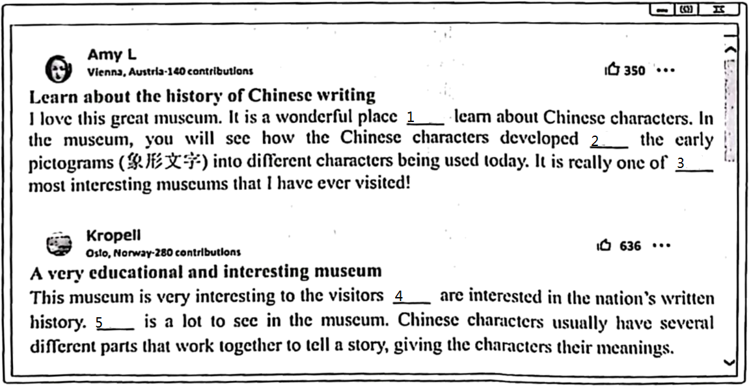
46. _______
47. _______
48. _______
49. _______
50. _______
【答案】46. to 47. from
48. the 49. that##who
50. There
【解析】
【导语】本文主要介绍了几个人对于中国文字博物馆的评价。
【46题详解】
句意：这是一个学习汉字的好地方。根据“a wonderful place...learn about...”可知此处用动词不定式作定语。故填to。
【47题详解】
句意：在博物馆里，你会看到汉字是如何从早期的象形文字发展成今天使用的不同文字的。根据“developed...the early pictograms into different characters being used today”可知是从早期的象形文字发展到今天使用的汉字，from“从”。故填from。
【48题详解】
句意：这真的是我参观过的最有趣的博物馆之一。空格后是最高级，最高级常与定冠词the连用。故填the。
【49题详解】
句意：这个博物馆对那些对这些国家的文字历史感兴趣的游客来说非常有趣。此处是定语从句，先行词是人，关系词在从句中作主语，用that/who引导定语从句。故填that/who。
【50题详解】
句意：博物馆里有很多东西可看。根据“is a lot to see in the museum”可知，此处表示“有”，结构为there be。故填There。

五、补全对话（5小题，每小题2分，共10分）
根据下面的对话情景，在每个空白处填上一个适当的句子，使对话的意思连贯、完整。
A: Hey, Leilei! Have you got any plans for the weekend?
B: Not yet. ____51____?
A: I heard the Science and Technology Center is a great place to visit. _____52_____?
B: I am sorry, but I have been there already.
A: What a pity! When did you go there?
B: ____53____. I went with my family.
A: Did you enjoy yourselves?
B: Yes, we had a great time there.
A: _____54_____?
B: We watched a video about how Shenzhou-16 was sent into space successfully.
A: What else did you do?
B: _____55_____.
A: Cool! I will ask my sister to go with me this weekend.
B: Have a good time!
【答案】51. Do you have any suggestions/advice/ideas/opinions/plans/Do you have any plans for the weekend/How/What about you/What’s your plan/idea/opinion/suggestion/advice...
52. Do you want to go (there) with me/Would you like to go (there) with me/How/What about going there together/Shall we go (there) together/Why not go there with me...
53. Last Saturday/Three days ago/Yesterday/I went there last Saturday/yesterday/...
54. What did you do (there)...
55. We (also) watched a robot show/We (also) talked to a smart robot/We (also) took some photos/We (also) bought some souvenirs...
【解析】
【导语】本文两人主要谈论了Leilei去科技中心的事情。
【51题详解】
根据“Have you got any plans for the weekend”以及“Not yet”可知此处询问对方有没有什么计划/建议等，也可问“你呢”。故填Do you have any suggestions/advice/ideas/opinions/plans/Do you have any plans for the weekend/How/What about you/What’s your plan/idea/opinion/suggestion/advice...
【52题详解】
根据“I am sorry, but I have been there already”可知此处询问对方想不想和自己一起去，故填Do you want to go (there) with me/Would you like to go (there) with me/How/What about going there together/Shall we go (there) together/Why not go there with me...
【53题详解】
根据“When did you go there”可知此处回答一个过去的时间，合理即可。故填Last Saturday/Three days ago/Yesterday/I went there last Saturday/yesterday/...
【54题详解】
根据“We watched a video about how Shenzhou-16 was sent into space successfully.”可知此处询问对方在那里做了什么。故填What did you do (there)...
【55题详解】
根据“What else did you do”可知此处回答自己在那里做的事情，符合语境即可。故填We (also) watched a robot show/We (also) talked to a smart robot/We (also) took some photos/We (also) bought some souvenirs...
六、书面表达（20分）
56. 为了丰富学校大课间活动内容，学校校刊英语专栏以“最美大课间，强健青少年”为主题面向学生进行征文。请你根据写作要求，用英语写一篇短文，向专栏投稿。
写作要求：1) 介绍学校目前30分钟大课间的活动内容，并简单谈谈你的感受；
2) 你对大课间活动内容有什么更好的建议，请写出理由；
3) 文中不得出现考生的真实姓名和学校名称；
4) 词数100左右（开头已给出，不计入总词数）。
参考词汇：shuttlecock exercises 毽子操；badminton 羽毛球；rope skipping 跳绳
The colorful activities during the 30-minute break help make teenagers healthier and stronger.
________________________________________________________________________________________________________________________________________________________________________________________________________________________________________________________________________________________________________________________________________________________________________________________________________________________________________________________________________________________________________________________________________________________________________________________________________________________________________________________________________________________________________________________________________________________________________________________________________________________________________________________________________________________
【答案】例文
The colorful activities during the 30-minute break help make teenagers healthier and stronger.
In our school, we usually do running during the 30-minute break. When the bell rings, students walk out of the classroom to the playground. Then we are lined up and run together. I think it is quite boring. In my opinion, we need different kinds of activities at break, such as shuttlecock exercises, rope skipping and so on. Through these activities, we can really relax ourselves and experience the joy of sports. Also, we will be more energetic in class.
Different kinds of activities at break time will surely benefit us a lot. I really hope our school can organize more of them to ensure the overall development of us students.
【解析】
【详解】[总体分析]
①题材：本文是一篇材料作文；
②时态：时态为“一般现在时”；
③提示：根据题干中的提示内容进行写作，适当增加细节。
[写作步骤]
第一步，引出话题；
第二步，介绍学校目前30分钟大课间的活动内容，并简单谈谈你的感受；
第三步，介绍你对大课间活动内容有什么更好的建议，请写出理由。
[亮点词汇]
①walk out of走出
②in my opinion依我来看
③different kinds of不同种类的
[高分句型]
①When the bell rings, students walk out of the classroom to the playground.(when引导的时间状语从句)
②I really hope our school can organize more of them to ensure the overall development of us students.(宾语从句)

