浙江省湖州市2023年初中学业水平考试
英 语
（满分100分，考试时间100分钟）
卷Ⅰ
一、听力（本题有15小题，其中1—10小题每题1分，11—15小题每题2分，共20分）
第一节 听下面五段对话，每段对话后有1个小题，请从题中所给的A、B、C三个选项中选择正确的选项。每段对话仅读一遍。
1. How will the speakers go home?
A. By car. B. By bus. C. By bike.
2. Where is Linda from?
A. Germany. B. Russia. C. France.
3. What’s wrong with Mom?
A. She’s hungry. B. She’s lonely. C. She’s angry.
4. Where does the conversation probably take place?
A. In a bookstore. B. In a clothes store. C. In a restaurant.
5. What does the woman think of parties?
A. She loves them. B. She doesn’t mind them. C. She can’t stand them.
第二节 听下面两段较长对话，每段对话后有2至3个小题，请从题中所给的A、B、C三个选项中选择正确的选项。每段对话读两遍。
听下面一段较长对话，回答第6、7小题。
6. What’s Nancy’s favorite subject?
A Math. B. Science. C. Geography.
7. Who might be talking with Nancy now?
A. Her classmate. B. Her teacher. C. Her father.
听下面一段较长对话，回答第8—10小题。
8. What are the speakers mainly talking about?
A. Watching football games.
B. Doing reading projects.
C. Visiting famous players.
9. Who will go with them?
A. Tony. B. Eric. C. Michael.
10 What time will they meet?
A. At 6:30 p.m. B. At 7:00 p.m. C. At 7:30 p.m.
第三节 听下面一段独白，独白后有5个小题，请从题中所给的A、B、C三个选项中选择正确的选项。独白读两遍。
11. When did Andy’s family move to the countryside?
A. 2 years ago. B. 6 years ago. C. 12 years ago.
12. How did Andy feel about moving to the countryside at first?
A. Excited. B. Unhappy. C. Tired.
13. What does Andy’s dad do?
A. A writer. B. A farmer. C. An artist.
14. How many children are there in Andy’s family?
A. Two. B. Three. C. Four.
15. Why does Andy agree with his parents now?
A. He can enjoy the freedom.
B. He can go shopping easily.
C. He can often go to the cinema.
二、完形填空（本题有15小题，每小题1分，共15分）
阅读下面短文，理解其大意，然后从各题所给的A、B、C、D四个选项中选出最佳选项。
Ella loved her new life in Alaska, except for one thing—Grandma wasn’t happy.
Before they moved here, Ella lived with Dad and Grandma in Kansas. Every day Ella and Grandma cooked, gardened or sewed (缝纫) together.
Then Dad got a job in Alaska and would take ____1____ with him. Grandma thought Alaska wasn’t a good place for a child. She wanted Ella to stay ____2____ Dad didn’t agree. Finally Grandma decided to go, too. Ella was overjoyed. She couldn’t ____3____ living anywhere without Grandma.
By autumn, they were in Alaska. Ella had never had so much ____4____. She made some friends and rode in the snowfall. Grandma, however, didn’t share Ella’s joy. She didn’t like the cold and ____5____ stayed at home. She often said she ____6____ the garden of sunflowers back in Kansas.
Ella was ____7____ and wished to make Grandma happy. She went to her new friend Laura for ____8____. Laura’s mom Helen suggested, “We can make your grandma a sunflower quilt that will be cheery and warm.” “Good idea!” Ella said.
Ella then secretly ____9____ some brightest cloth from Grandma’s bag and sewed the sunflower quilt every afternoon in Laura’s house. It was slow going but enjoyable. She wanted to give Grandma a ____10____.
But Grandma seemed sadder and sadder, always talking about the ____11____ and friends in Kansas. One night Ella heard Grandma ____12____. She decided to take Grandma to Laura’s house the next day.
When Grandma saw the quilt they were making for ____13____ these days, she was moved to tears. She ____14____ and helped with the sewing. They chatted and laughed. Ella hadn’t heard Grandma sound so ____15____ since they left Kansas.
Maybe what Grandma really needed was staying together, Ella thought.
1. A. Ella B. Helen C. Grandma D. Laura
2. A. or B. so C. and D. but
3 A. avoid B. suggest C. imagine D. forget
4. A. homework B. sleep C. trouble D. excitement
5. A. mostly B. once C. still D. seldom
6. A. missed B. found C. sold D. entered
7. A. bored B. worried C. relaxed D. interested
8. A. gifts B. flowers C. courage D. advice
9. A. received B. chose C. borrowed D. made
10. A. task B. prize C. surprise D. choice
11. A. school B. library C. garden D. hotel
12. A. crying B. singing C. reading D. coughing
13. A. him B. her C. us D. them
14. A. hung out B. went away C. showed up D. sat down
15. A. serious B. cheerful C. polite D. strange
三、阅读理解（本题有13小题，每小题2分，共26分）
阅读下面短文，从各题所给的A、B、C、D四个选项中选出最佳选项。
A
 THE SCHOOL PL AY
Calling all students for auditions(试演)!
Critters on Ice!

is about animals and ice skates.
The writer and director is our
drama teacher, Ms Ann Core.

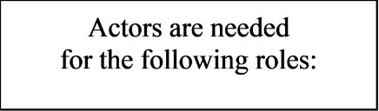
Flora, the fast snail
Richard, the slow rabbit

Tim,the smart ox

James,
the serious goose

Not an actor?
We also need:
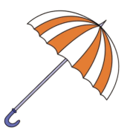Set Design: Someone to
draw fun winter backgrounds.
He or she must also find things
such as umnbrellas, gloves, and ice
skates to use in the play.

Light: Someone to make the
actors “shine” on stage. Green
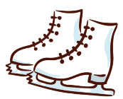and blue lighits follow
each animal.
Sound: Someone to make sure every
word is heard.

Auditions are
on Friday, February 27, at 3:30
in the gym.
Hot cocoa will be served.

16. What is the name of the play?
A. Not an Actor? B. Critters on Ice!
C. The School Play D. Flora, Richard, Tim and James
17. If you do Set Design, you are expected to ________.
A. call the students for auditions
B. prepare the fun backgrounds
C. make the lights follow each animal
D. make sure every word is heard
18. The text is probably ________.
A. a poster B. a speech C. a report D. a poem
B
Scientists believe the Earth is 4.6 billion years old. However, the mountains, valleys (山谷), hills, rivers, deserts and forests we see today are much younger than that. For example, Mount Qomolangma is about 60 million years old and the Amazon rainforest is only 10 million years old. The youngest sea in the world is the Baltic Sea, at about 15000 years old.
The Earth is always changing because of volcanoes (火山), earthquakes and of course, wind and rain. Some of these changes are very slow and others are quick. Water and ice can make very great changes to the planet. For example, glaciers rivers of ice can cut through mountains and make lakes and deep valleys. Many volcanoes are under the oceans and sometimes they become new islands. This is happening in the South Pacific, near Tonga.
It’s normal for our planet to change, but at the moment, scientists think it’s changing faster than usual. Some deserts are growing and many forests are getting smaller. The weather is getting wetter in some places and drier in others, and there are more big storms. According to the research, the sea level will continue to rise in the next hundred years. As a result, many cities will possibly be covered by water and much of the most productive farming areas will be lost. Some island countries are likely to disappear on the map of the world.
These changes will bring great harm to the planet. However, they can be beneficial to some people. For example, as the Arctic is getting warmer, some people in Greenland now own businesses and sell vegetables they grow on their land. That wasn’t possible in the far north 50 years ago. Farmers in Greenland like the warm weather and hope it will continue.
19. How does the writer describe the changes of the Earth in Paragraph 2?
A. By using sayings. B. By giving examples.
C. By telling stories. D. By listing numbers.
20. From Paragraph 3, we can mainly learn about ________.
A. the age of the Earth B. problems for the planet
C. the life of the farmers D. influences on the mountains
21. The underlined word “beneficial” in Paragraph 4 is the closest in meaning to “________”.
A. harmful B. normal C. helpful D. uncomfortable
C
①Chinese calligraphy (书法) was once considered an important part of the school curriculum (课程). However, for many reasons, some people think it’s less important to teach this art form at school now. In this article, I will look at both the pros and cons of learning Chinese calligraphy at school.
②One reason why Chinese calligraphy should be learned at school is that it is an important form of culture expression. Clearly, it is not just about practicing handwriting. It is also about connecting with a traditional Chinese art form. When students learn this art in class, they will become more interested in the works of famous Chinese artists.
③Another reason is that it may help students to develop patience. At the times of high technology, students are getting less patient for traditional classroom learning. By introducing Chinese calligraphy into the classroom, students’ patience can be improved because they have to practice focusing on each brush movement.
④From the above, it can be seen that there are clear advantages. However, others think there are some disadvantages. The first one is that it has little to do with students’ life. Living in a modern age, pens and paper will lose their importance by and by. So, wouldn’t it be a backward (倒退的) step if students were asked to spend their valuable time at school learning Chinese calligraphy?
⑤The second argument against learning Chinese calligraphy at school is that it takes a long time to master. The time at school is better spent on more important subjects. After all, learning Chinese calligraphy can always be done as an after-school activity if students are really interested in it.
⑥In my opinion, the advantages far outweigh the disadvantages. This special art form is one of China’s national treasures. It also helps to enrich students’ life and improve their sense of beauty. So without doubt, it is worth being included in the school curriculum.
22. Which of the following is the structure of the passage?
A. 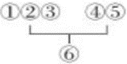 B. 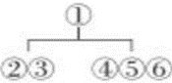 C. 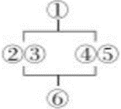 D. 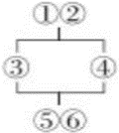
23. What can we learn from the passage?
A. High technology can help students become more patient.
B. Students should spend more time on after-school activities.
C. Learning Chinese calligraphy gets more popular in the modern age.
D. Students may like art works better after learning Chinese calligraphy.
24. What does the writer probably think of learning Chinese calligraphy?
A. Important and necessary. B. Valuable but backward.
C. Popular and interesting. D. Meaningful but boring.
D
Jackson was walking home from school one afternoon when his untied shoelaces (鞋带) caught his foot. He almost fell. He put down his backpack and tied them.
Eva and Dave were riding down the other side of the street. Suddenly, Dave stopped and pointed.
“Whoa! Did you see that?” he asked. “Jackson just totally fell down there!”
“Oh, no! Is he okay?” asked Eva.
“It looks like he hurt his knee.”
Just as they were still talking about this, Mandy caught up with them. “What are you guys talking about?” she asked.
“Jackson just fell and hurt his knee,” said Eva.
“Was he bleeding (流血)?” asked Mandy.
The story began to spread. Within an hour, Kevin heard the whole story. “Jackson got hit by a car on his way home. There was blood everywhere, and he was sent to hospital.
That night Oliver got more information. “ ▲ He doesn’t even remember anything about the accident! He won’t be at school for at least four weeks.”
The next morning, everybody at school was talking about Jackson.
“Lucky Jackson,” Maya said. “He gets to miss so much school.”
“The poor guy can’t even move, and you think he’s lucky?” said Kathy.
Bob shook his head sadly, “He was so good at soccer—what if he can never play again?”
“Maybe we should send him a card or visit him in the hospital,” suggested Bill.
“Will he even remember us?” asked Gina.
“I can’t believe he lost his memory!” Lisa cried.
Just then, Jackson came around the corner and walked over to Gina and Lisa. “Hey guys, what’s going on?” he asked.
Everyone stopped talking and stared at him.
25. What was Jackson doing when he almost fell?
A. Tying his shoelaces. B. Riding his bike home.
C. Walking in the street. D. Putting down his backpack.
26. Which of the following is the best to fill in the “ ▲ ” in the passage?
A. Jackson fell down and hurt his knee.
B. Jackson got hit by a car and kept bleeding.
C. Jackson got caught by his shoelaces and fell.
D Jackson broke his leg and his head was hurt.
27. From the last sentence of the passage, we can infer that everyone was ________.
A. shocked B. scared C. upset D. disappointed
28. The best title for the passage can probably be ________.
A. A Funny Friend B. He Said, She Said
C. A Terrible Accident D. He Hurt, She Cared
卷Ⅱ
说明：本卷共四大题，25小题，满分39分。
四、任务型阅读（本题有4小题，每小题1分，共4分）
假设你是某视频网站的博主Grace，正在回复网友提出的有关短视频拍摄的问题，请根据“5 tips for making online videos”，补全1-4题的信息，每空一词。
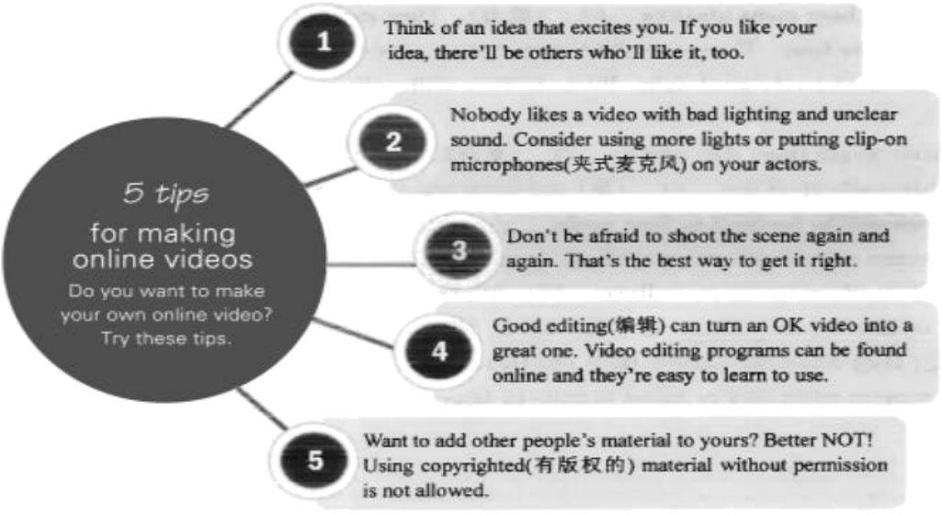
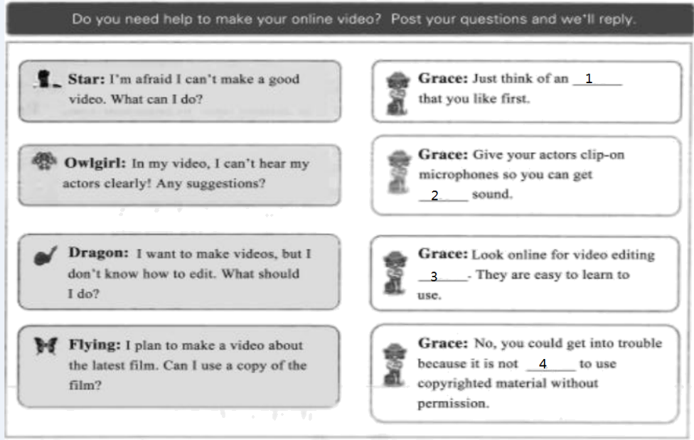
____29____ ____30____ ____31____ ____32____
五、单词拼写（本题有10小题，每小题1分，共10分）
根据短文内容和所给中文提示，在空白处写出单词的正确形式。每空限填一词。
With big, soft ears and round eyes, rabbits are some of the cutest animals around. They even ____33____ (跳跃) and turn around in the air when they are happy. It’s such a lovely action. Besides, rabbits are interesting animals to study.
Rabbits have many amazing ____34____ (能力). They can run at the ____35____ (速度) of 30 kilometers per hour. Their ears allow them to hear sounds from up to 2.8 kilometers away. They also have a very good sight. With all these skills, they can often run away from ____36____ (危险).
Some might think that rabbits ____37____ (更喜欢) carrots, but that’s not true. Their food is mostly made up of dry ____38____ (草) and fresh vegetables. Carrots are ____39____ (富有的) in sugar and will be harmful to their teeth.
Rabbits are usually active in the early morning and late afternoon. That’s when you’ll possibly see them eating or walking ____40____ (安静地) and freely in fields or woods. In the wild, rabbits live in ____41____ (地下的) holes. Often, groups of rabbits in one area ____42____ (掘，挖) their holes and connect them together. They dislike being lonely. As pets, they are much happier when they’re raised in pairs or larger groups.
六、语法填空（本题有10小题，每小题1分，共10分）
阅读下面的短文，在空白处填入一个适当的词，或填入括号中所给单词的正确形式。
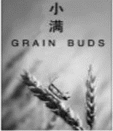
The traditional Chinese calendar divides the year into 24 solar terms (节气). Thousands of years ago, they ____43____ (create) to help with farming, but the solar term culture is still very ____44____ (use) today to people’s life. Grain Buds is ____45____ eighth solar term of a year. It means that the seeds from the grain are becoming full but are not ripe. This year Grain Buds falls ____46____ May 21st, and lasts 16 days. Here are some things you may not know about Grain Buds.
A good season for eating fish
A saying about rain during this time says, “A heavy rainfall makes the river full. “Because of a lot of rain, rivers are full of water and a great number of fish. You can’t miss the chance ____47____ (enjoy) them. Also, it is such a golden season for ____48____ (fisherman)!
Suggestions on health
Wet and hot days ____49____ (be) common in this season. It may make you get skin illnesses easily. It is necessary to take more exercise. Walking, jogging and practicing tai chi are popular.
A key period for flower caring
It is a good period for flowers to grow ____50____ (rapid). Caring for your garden becomes even ____51____ (important) than any other time. ____52____ you take good care of them, your plants will be healthier.
七、书面表达（本题15分）
53. 幸福可以是偶得礼物时的欣喜，可以是帮助他人时的愉悦……你觉得幸福是什么呢？请你写一篇英语短文向学校英语报投稿，分享你的经历，谈谈你对幸福的理解。
参考词汇（仅供选择使用）：achieve，share，have fun，be thankful to
注意：（1）词数：80—100；短文首句已给出，不计入总词数；
（2）文中不得出现真实姓名、学校等信息。
Happiness is everywhere around us. _______________________________________________________________________________________________________________________________________________________________________________________________________________________________________________________________________________________________________________________________________________________________________________________________________________________________________________________________________________________________________________________________________________________________________________________________________________________________________________________________________________________________________________________________________________________________________________________________________________________________________________________________________________________

