浙江省湖州市2023年初中学业水平考试
英 语
（满分100分，考试时间100分钟）
卷Ⅰ
一、听力（本题有15小题，其中1—10小题每题1分，11—15小题每题2分，共20分）
第一节 听下面五段对话，每段对话后有1个小题，请从题中所给的A、B、C三个选项中选择正确的选项。每段对话仅读一遍。
1 How will the speakers go home?
A. By car. B. By bus. C. By bike.
2. Where is Linda from?
A. Germany. B. Russia. C. France.
3. What’s wrong with Mom?
A. She’s hungry. B. She’s lonely. C. She’s angry.
4. Where does the conversation probably take place?
A. In a bookstore. B. In a clothes store. C. In a restaurant.
5. What does the woman think of parties?
A. She loves them. B. She doesn’t mind them. C. She can’t stand them.
第二节 听下面两段较长对话，每段对话后有2至3个小题，请从题中所给的A、B、C三个选项中选择正确的选项。每段对话读两遍。
听下面一段较长对话，回答第6、7小题。
6. What’s Nancy’s favorite subject?
A. Math. B. Science. C. Geography.
7. Who might be talking with Nancy now?
A. Her classmate. B. Her teacher. C. Her father.
听下面一段较长对话，回答第8—10小题。
8. What are the speakers mainly talking about?
A. Watching football games.
B. Doing reading projects.
C. Visiting famous players.
9. Who will go with them?
A. Tony. B. Eric. C. Michael.
10. What time will they meet?
A. At 6:30 p.m. B. At 7:00 p.m. C. At 7:30 p.m.
第三节 听下面一段独白，独白后有5个小题，请从题中所给的A、B、C三个选项中选择正确的选项。独白读两遍。
11. When did Andy’s family move to the countryside?
A. 2 years ago. B. 6 years ago. C. 12 years ago.
12. How did Andy feel about moving to the countryside at first?
A. Excited. B. Unhappy. C. Tired.
13. What does Andy’s dad do?
A. A writer. B. A farmer. C. An artist.
14. How many children are there in Andy’s family?
A. Two. B. Three. C. Four.
15. Why does Andy agree with his parents now?
A. He can enjoy the freedom.
B. He can go shopping easily.
C. He can often go to the cinema.
二、完形填空（本题有15小题，每小题1分，共15分）
阅读下面短文，理解其大意，然后从各题所给的A、B、C、D四个选项中选出最佳选项。
Ella loved her new life in Alaska, except for one thing—Grandma wasn’t happy.
Before they moved here, Ella lived with Dad and Grandma in Kansas. Every day Ella and Grandma cooked, gardened or sewed (缝纫) together.
Then Dad got a job in Alaska and would take ____1____ with him. Grandma thought Alaska wasn’t a good place for a child. She wanted Ella to stay ____2____ Dad didn’t agree. Finally Grandma decided to go, too. Ella was overjoyed. She couldn’t ____3____ living anywhere without Grandma.
By autumn, they were in Alaska. Ella had never had so much ____4____. She made some friends and rode in the snowfall. Grandma, however, didn’t share Ella’s joy. She didn’t like the cold and ____5____ stayed at home. She often said she ____6____ the garden of sunflowers back in Kansas.
Ella was ____7____ and wished to make Grandma happy. She went to her new friend Laura for ____8____. Laura’s mom Helen suggested, “We can make your grandma a sunflower quilt that will be cheery and warm.” “Good idea!” Ella said.
Ella then secretly ____9____ some brightest cloth from Grandma’s bag and sewed the sunflower quilt every afternoon in Laura’s house. It was slow going but enjoyable. She wanted to give Grandma a ____10____.
But Grandma seemed sadder and sadder, always talking about the ____11____ and friends in Kansas. One night Ella heard Grandma ____12____. She decided to take Grandma to Laura’s house the next day.
When Grandma saw the quilt they were making for ____13____ these days, she was moved to tears. She ____14____ and helped with the sewing. They chatted and laughed. Ella hadn’t heard Grandma sound so ____15____ since they left Kansas.
Maybe what Grandma really needed was staying together, Ella thought.
1. A. Ella B. Helen C. Grandma D. Laura
2. A. or B. so C. and D. but
3. A. avoid B. suggest C. imagine D. forget
4. A. homework B. sleep C. trouble D. excitement
5. A. mostly B. once C. still D. seldom
6. A. missed B. found C. sold D. entered
7. A. bored B. worried C. relaxed D. interested
8. A. gifts B. flowers C. courage D. advice
9. A. received B. chose C. borrowed D. made
10. A. task B. prize C. surprise D. choice
11. A. school B. library C. garden D. hotel
12. A. crying B. singing C. reading D. coughing
13. A. him B. her C. us D. them
14. A. hung out B. went away C. showed up D. sat down
15. A. serious B. cheerful C. polite D. strange
【答案】1. A 2. D 3. C 4. D 5. A 6. A 7. B 8. D 9. B 10. C 11. C 12. A 13. B 14. D 15. B
【解析】
【导语】本文主要讲述了艾拉为了缓解奶奶的思乡之情，在朋友的帮助下给奶奶做了一床向日葵被子的故事。
【1题详解】
句意：后来爸爸在阿拉斯加找到了一份工作，带着艾拉一起去了。
Ella艾拉；Helen海伦；Grandma祖母；Laura劳拉。根据“Grandma thought Alaska wasn’t a good place for a child.”可知，爸爸想带着艾拉去，故选A。
【2题详解】
句意：她想让艾拉留下，但爸爸不同意。
or或者；so因此；and和；but但是。空格前后是转折关系，故选D。
【3题详解】
句意：她无法想象没有奶奶的生活。
avoid避免；suggest建议；imagine想象；forget忘记。根据“Before they moved here, Ella lived with Dad and Grandma in Kansas. ”可知，之前艾拉一直跟奶奶一起生活，所以她无法想象没有奶奶的生活，故选C。
【4题详解】
句意：艾拉从来没有这么兴奋过。
homework作业；sleep睡觉；trouble问题；excitement兴奋。根据“Grandma, however, didn’t share Ella’s joy.”可知，她很兴奋，故选D。
【5题详解】
句意：她不喜欢寒冷，大部分时间都待在家里。
mostly主要地；once曾经；still仍然；seldom很少。根据“She didn’t like the cold”可知，不喜欢寒冷，所以大部分时间都待在家里，故选A。
【6题详解】
句意：她经常说，她想念堪萨斯州的向日葵花园。
missed想念；found发现；sold售卖；entered进入。根据前文描述可知，奶奶不喜欢这里的生活，所以想念堪萨斯州的向日葵花园，故选A。
【7题详解】
句意：艾拉很担心，希望能让奶奶高兴。
bored无聊的；worried担心的；relaxed放松的；interested有趣的。根据“wished to make Grandma happy”可知，看到奶奶的不适应，艾拉很担心，故选B。
【8题详解】
句意：她向她的新朋友劳拉寻求建议。
gifts礼物；flowers花；courage勇气；advice建议。根据“wished to make Grandma happy”及“She went to her new friend Laura for”可知，她想让奶奶开心，所以向朋友寻求建议，故选D。
【9题详解】
句意：然后艾拉偷偷地从奶奶的包挑了一些颜色最鲜艳的布，每天下午在劳拉家缝制向日葵被子。
received接受；chose选择；borrowed借入；made制造。根据“some brightest cloth from Grandma’s bag”可知，从奶奶的包里挑了一些颜色最鲜艳的布，故选B。
【10题详解】
句意：她想给奶奶一个惊喜。
task任务；prize奖品；surprise惊喜；choice选择。根据“Ella then secretly…some brightest cloth from Grandma’s bag and sewed the sunflower quilt every afternoon in Laura’s house”可知，艾拉悄悄地做这个事，是为了给奶奶一个惊喜，故选C。
【11题详解】
句意：但是奶奶似乎越来越悲伤，总是在谈论堪萨斯的花园和朋友。
school学校；library图书馆；garden花园；hotel酒店。根据“She often said she… the garden of sunflowers back in Kansas.”可知，奶奶怀念堪萨斯州的向日葵花园，所以经常谈论起它，故选C。
【12题详解】
句意：一天晚上，艾拉听到奶奶在哭。
crying哭；singing唱歌；reading阅读；coughing咳嗽。根据“ She decided to take Grandma to Laura’s house the next day.”可知，决定第二天就带奶奶看她准备的惊喜，所以此处应是“看到奶奶又在想念堪萨斯州的东西，奶奶哭了”符合语境，故选A。
【13题详解】
句意：当奶奶看到这些天她们为她做的被子时，她感动得流下了眼泪。
him他；her她；us我们；them她们。根据“We can make your grandma a sunflower quilt that will be cheery and warm”可知，被子是给奶奶做的，故选B。
【14题详解】
句意：她坐下来帮忙缝被子。
hung out闲逛；went away离开；showed up出现；sat down坐下。根据“helped with the sewing”可知，坐下来帮着缝被子，故选D。
【15题详解】
句意：自从他们离开堪萨斯以来，艾拉还没有听过奶奶这么高兴的声音。
serious严肃的；cheerful欢快的；polite礼貌的；strange奇怪的。根据“They chatted and laughed”可知，自从离开堪萨斯，从来没看到奶奶这么高兴，故选B。
三、阅读理解（本题有13小题，每小题2分，共26分）
阅读下面短文，从各题所给的A、B、C、D四个选项中选出最佳选项。
A
 THE SCHOOL PL AY
Calling all students for auditions(试演)!
Critters on Ice!

is about animals and ice skates.
The writer and director is our
drama teacher, Ms Ann Core.

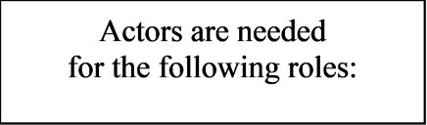
Flora, the fast snail
Richard, the slow rabbit

Tim,the smart ox

James,
the serious goose

Not an actor?
We also need:
Set Design: Someone to
draw fun winter backgrounds.
He or she must also find things
such as umnbrellas, gloves, and ice
skates to use in the play.

Light: Someone to make the
actors “shine” on stage. Green
and blue lighits follow
each animal.
Sound: Someone to make sure every
word is heard.

Auditions are
on Friday, February 27, at 3:30
in the gym.
Hot cocoa will be served.

16. What is the name of the play?
A. Not an Actor? B. Critters on Ice!
C. The School Play D. Flora, Richard, Tim and James
17. If you do Set Design, you are expected to ________.
A. call the students for auditions
B. prepare the fun backgrounds
C. make the lights follow each animal
D. make sure every word is heard
18. The text is probably ________.
A. a poster B. a speech C. a report D. a poem
【答案】16. B 17. B 18. A
【解析】
【导语】本文是学校话剧招聘试演的一则广告信息。
【16题详解】
细节理解题。根据“Critters on Ice”可知，这个话剧的名字是《Critters on Ice》，故选B。
【17题详解】
细节理解题。根据“Set Design: Someone to draw fun winter backgrounds”可知，需要准备有趣的背景，故选B。
【18题详解】
推理判断题。通读全文可知，本文是学校话剧招聘试演的一则广告信息，故选A。
B
Scientists believe the Earth is 4.6 billion years old. However, the mountains, valleys (山谷), hills, rivers, deserts and forests we see today are much younger than that. For example, Mount Qomolangma is about 60 million years old and the Amazon rainforest is only 10 million years old. The youngest sea in the world is the Baltic Sea, at about 15000 years old.
The Earth is always changing because of volcanoes (火山), earthquakes and of course, wind and rain. Some of these changes are very slow and others are quick. Water and ice can make very great changes to the planet. For example, glaciers rivers of ice can cut through mountains and make lakes and deep valleys. Many volcanoes are under the oceans and sometimes they become new islands. This is happening in the South Pacific, near Tonga.
It’s normal for our planet to change, but at the moment, scientists think it’s changing faster than usual. Some deserts are growing and many forests are getting smaller. The weather is getting wetter in some places and drier in others, and there are more big storms. According to the research, the sea level will continue to rise in the next hundred years. As a result, many cities will possibly be covered by water and much of the most productive farming areas will be lost. Some island countries are likely to disappear on the map of the world.
These changes will bring great harm to the planet. However, they can be beneficial to some people. For example, as the Arctic is getting warmer, some people in Greenland now own businesses and sell vegetables they grow on their land. That wasn’t possible in the far north 50 years ago. Farmers in Greenland like the warm weather and hope it will continue.
19. How does the writer describe the changes of the Earth in Paragraph 2?
A. By using sayings. B. By giving examples.
C. By telling stories. D. By listing numbers.
20. From Paragraph 3, we can mainly learn about ________.
A. the age of the Earth B. problems for the planet
C. the life of the farmers D. influences on the mountains
21. The underlined word “beneficial” in Paragraph 4 is the closest in meaning to “________”.
A. harmful B. normal C. helpful D. uncomfortable
【答案】19. B 20. B 21. C
【解析】
【导语】本文主要讲述了地球因为各种原因总是在变化，详细地介绍了这些变化好处和坏处。
【19题详解】
推理判断题。根据“For example, glaciers rivers of ice can cut through mountains and make lakes and deep valleys…”可知，通过举例子的方式来描述地球的变化，故选B。
【20题详解】
推理判断题。根据“The weather is getting wetter in some places and drier in others, and there are more big storms…As a result, many cities will possibly be covered by water and much of the most productive farming areas will be lost. Some island countries are likely to disappear on the map of the world”可知，第三段主要介绍了这些变化所带来的问题，故选B。
【21题详解】
词义猜测题。根据“These changes will bring great harm to the planet.”以及“However, they can be beneficial to some people.”可知，这些变化会带来危害，However表示转折，划线句子应说也可以带来好处，也就是给一些朋友带来帮助，故选C。
C
①Chinese calligraphy (书法) was once considered an important part of the school curriculum (课程). However, for many reasons, some people think it’s less important to teach this art form at school now. In this article, I will look at both the pros and cons of learning Chinese calligraphy at school.
②One reason why Chinese calligraphy should be learned at school is that it is an important form of culture expression. Clearly, it is not just about practicing handwriting. It is also about connecting with a traditional Chinese art form. When students learn this art in class, they will become more interested in the works of famous Chinese artists.
③Another reason is that it may help students to develop patience. At the times of high technology, students are getting less patient for traditional classroom learning. By introducing Chinese calligraphy into the classroom, students’ patience can be improved because they have to practice focusing on each brush movement.
④From the above, it can be seen that there are clear advantages. However, others think there are some disadvantages. The first one is that it has little to do with students’ life. Living in a modern age, pens and paper will lose their importance by and by. So, wouldn’t it be a backward (倒退的) step if students were asked to spend their valuable time at school learning Chinese calligraphy?
⑤The second argument against learning Chinese calligraphy at school is that it takes a long time to master. The time at school is better spent on more important subjects. After all, learning Chinese calligraphy can always be done as an after-school activity if students are really interested in it.
⑥In my opinion, the advantages far outweigh the disadvantages. This special art form is one of China’s national treasures. It also helps to enrich students’ life and improve their sense of beauty. So without doubt, it is worth being included in the school curriculum.
22. Which of the following is the structure of the passage?
A. 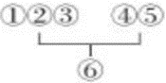 B. 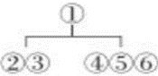 C. 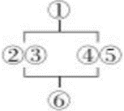 D. 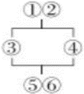
23. What can we learn from the passage?
A. High technology can help students become more patient.
B. Students should spend more time on after-school activities.
C. Learning Chinese calligraphy gets more popular in the modern age.
D. Students may like art works better after learning Chinese calligraphy.
24. What does the writer probably think of learning Chinese calligraphy?
A. Important and necessary. B. Valuable but backward.
C. Popular and interesting. D. Meaningful but boring.
【答案】22. C 23. D 24. A
【解析】
【导语】本文主要介绍了在学校学习中国书法的利弊。
【22题详解】
篇章结构题。通读全文可知，第一段引出本文主题；第二段和第三段主要分析了在学校学习书法的原因，第四段和第五段介绍了学习书法的弊端；最后一段作者发表了自己的看法。故选C。
【23题详解】
推理判断题。根据“When students learn this art in class, they will become more interested in the works of famous Chinese artists.”可知，学习中国书法后，学生可能会更喜欢艺术作品。故选D。
【24题详解】
推理判断题。根据“This special art form is one of China’s national treasures. It also helps to enrich students’ life and improve their sense of beauty. So without doubt, it is worth being included in the school curriculum”可知，作者认为这种特殊的艺术形式是中国的国宝之一。这也有助于丰富学生的生活，提高他们的美感。因此，毫无疑问，它值得被纳入学校课程，由此可知作者认为它既重要也是很有必要。故选A。
D
Jackson was walking home from school one afternoon when his untied shoelaces (鞋带) caught his foot. He almost fell. He put down his backpack and tied them.
Eva and Dave were riding down the other side of the street. Suddenly, Dave stopped and pointed.
“Whoa! Did you see that?” he asked. “Jackson just totally fell down there!”
“Oh, no! Is he okay?” asked Eva.
“It looks like he hurt his knee.”
Just as they were still talking about this, Mandy caught up with them. “What are you guys talking about?” she asked.
“Jackson just fell and hurt his knee,” said Eva.
“Was he bleeding (流血)?” asked Mandy.
The story began to spread. Within an hour, Kevin heard the whole story. “Jackson got hit by a car on his way home. There was blood everywhere, and he was sent to hospital.
That night, Oliver got more information. “ ▲ He doesn’t even remember anything about the accident! He won’t be at school for at least four weeks.”
The next morning, everybody at school was talking about Jackson.
“Lucky Jackson,” Maya said. “He gets to miss so much school.”
“The poor guy can’t even move, and you think he’s lucky?” said Kathy.
Bob shook his head sadly, “He was so good at soccer—what if he can never play again?”
“Maybe we should send him a card or visit him in the hospital,” suggested Bill.
“Will he even remember us?” asked Gina.
“I can’t believe he lost his memory!” Lisa cried.
Just then, Jackson came around the corner and walked over to Gina and Lisa. “Hey guys, what’s going on?” he asked.
Everyone stopped talking and stared at him.
25. What was Jackson doing when he almost fell?
A. Tying his shoelaces. B. Riding his bike home.
C. Walking in the street. D. Putting down his backpack.
26. Which of the following is the best to fill in the “ ▲ ” in the passage?
A. Jackson fell down and hurt his knee.
B. Jackson got hit by a car and kept bleeding.
C. Jackson got caught by his shoelaces and fell.
D. Jackson broke his leg and his head was hurt.
27. From the last sentence of the passage, we can infer that everyone was ________.
A. shocked B. scared C. upset D. disappointed
28. The best title for the passage can probably be ________.
A. A Funny Friend B. He Said, She Said
C. A Terrible Accident D. He Hurt, She Cared
【答案】25. C 26. D 27. A 28. B
【解析】
【导语】本文主要讲述了Jackson在放学回家的路上，因为鞋带没有系好差点摔倒，被好心的朋友们误解成被车撞伤送医院，结果他们都很担心。但事实上，Jackson并没有受伤，当大家看到他的时候都感到十分惊讶。
【25题详解】
细节理解题。根据“Jackson was walking home from school one afternoon when his untied shoelaces (鞋带) caught his foot. He almost fell.”可知，在街上走路的时候差点摔倒，故选C。
【26题详解】
推理判断题。根据“He doesn’t even remember anything about the accident!”可知，脑袋受伤了所以几乎记不得任何东西，D选项“Jackson摔断了腿，头部也受了伤”符合，故选D。
【27题详解】
推理判断题。根据“Everyone stopped talking and stared at him.”可知，大家都传Jackson被车撞，失忆了，当Jackson出现在大家面前的时候，每个人停止讨论盯着他，都感到很惊讶，故选A。
【28题详解】
最佳标题题。通读全文可知，本文由Jackson差点摔倒而引发一系列的谣言，每个人都有不一样的说法，所以B选项“他说，她说”符合本文标题，故选B。
卷Ⅱ
说明：本卷共四大题，25小题，满分39分。
四、任务型阅读（本题有4小题，每小题1分，共4分）
假设你是某视频网站的博主Grace，正在回复网友提出的有关短视频拍摄的问题，请根据“5 tips for making online videos”，补全1-4题的信息，每空一词。
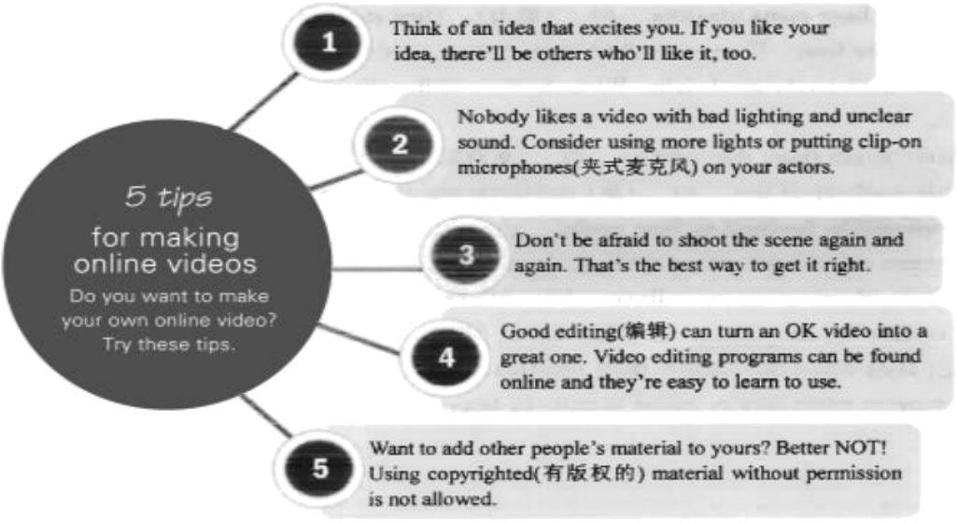
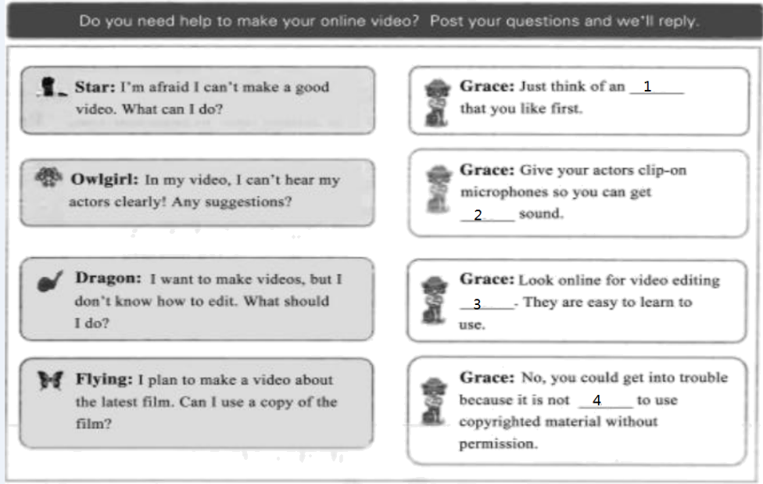
____29____ ____30____ ____31____ ____32____
【答案】29. idea
30. clear 31. programs
32. allowed
【解析】
【导语】本文主要介绍了制作在线视频的5个技巧。
【29题详解】
根据“Think of an idea that excites you”可知，想一个让你兴奋的想法，故填idea。
【30题详解】
根据“Nobody likes a video with bad lighting and unclear sound. Consider using more lights or putting clip-on microphones on your actors”可知，没有人喜欢光线不好、声音不清晰的视频，考虑使用更多的灯光或夹式麦克风，这样就能得到清晰的声音，故填clear。
【31题详解】
根据“Video editing programs can be found online and they’re easy to learn”可知，在网上寻找视频编辑程序，故填programs。
【32题详解】
根据“Using copyrighted material without permission is not allowed”可知，未经允许不得使用受版权保护的材料，故填allowed。
五、单词拼写（本题有10小题，每小题1分，共10分）
根据短文内容和所给中文提示，在空白处写出单词的正确形式。每空限填一词。
With big, soft ears and round eyes, rabbits are some of the cutest animals around. They even ____33____ (跳跃) and turn around in the air when they are happy. It’s such a lovely action. Besides, rabbits are interesting animals to study.
Rabbits have many amazing ____34____ (能力). They can run at the ____35____ (速度) of 30 kilometers per hour. Their ears allow them to hear sounds from up to 2.8 kilometers away. They also have a very good sight. With all these skills, they can often run away from ____36____ (危险).
Some might think that rabbits ____37____ (更喜欢) carrots, but that’s not true. Their food is mostly made up of dry ____38____ (草) and fresh vegetables. Carrots are ____39____ (富有的) in sugar and will be harmful to their teeth.
Rabbits are usually active in the early morning and late afternoon. That’s when you’ll possibly see them eating or walking ____40____ (安静地) and freely in fields or woods. In the wild, rabbits live in ____41____ (地下的) holes. Often, groups of rabbits in one area ____42____ (掘，挖) their holes and connect them together. They dislike being lonely. As pets, they are much happier when they’re raised in pairs or larger groups.
【答案】33. jump
34. abilities
35. speed 36. danger
37. prefer 38. grass
39. rich 40. quietly
41. underground
42. dig
【解析】
【导语】本文主要介绍了兔子的情况，包括它们的能力，喜欢吃的食物以及活动情况。
【33题详解】
句意：当它们高兴的时候，它们甚至会在空中跳跃和转身。jump“跳跃”，此空与turn构成并列关系，此空应填动词原形，故填jump。
【34题详解】
句意：兔子有许多惊人的能力。ability“能力”，根据many可知，此空应填复数形式，故填abilities。
【35题详解】
句意：它们能以每小时30公里的速度奔跑。speed“速度”，at the speed of“以……的速度”，故填speed。
【36题详解】
句意：有了这些技能，它们通常可以逃离危险。danger“危险”，不可数名词，故填danger。
【37题详解】
句意：有些人可能认为兔子更喜欢胡萝卜，但事实并非如此。prefer“更喜欢”，此句是一般现在时，主语是复数形式，动词用原形，故填prefer。
【38题详解】
句意：它们的食物主要是干草和新鲜蔬菜。grass“草”，不可数名词，故填grass。
【39题详解】
句意：胡萝卜富含糖，对牙齿有害。rich“富有的”，形容词作表语，故填rich。
40题详解】
句意：那时候你可能会看到它们在田野或树林里安静、自由地吃东西或散步。quietly“安静地”，副词修饰动词，故填quietly。
【41题详解】
句意：在野外，兔子住在地下洞里。underground“地下的”，形容词作定语，故填underground。
【42题详解】
句意：通常，一群兔子在一个地方挖洞，然后把它们连在一起。dig“挖”，此空与connect是并列关系，此空应填动词原形，故填dig。
六、语法填空（本题有10小题，每小题1分，共10分）
阅读下面的短文，在空白处填入一个适当的词，或填入括号中所给单词的正确形式。
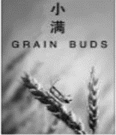
The traditional Chinese calendar divides the year into 24 solar terms (节气). Thousands of years ago, they ____43____ (create) to help with farming, but the solar term culture is still very ____44____ (use) today to people’s life. Grain Buds is ____45____ eighth solar term of a year. It means that the seeds from the grain are becoming full but are not ripe. This year Grain Buds falls ____46____ May 21st, and lasts 16 days. Here are some things you may not know about Grain Buds.
A good season for eating fish
A saying about rain during this time says, “A heavy rainfall makes the river full. “Because of a lot of rain, rivers are full of water and a great number of fish. You can’t miss the chance ____47____ (enjoy) them. Also, it is such a golden season for ____48____ (fisherman)!
Suggestions on health
Wet and hot days ____49____ (be) common in this season. It may make you get skin illnesses easily. It is necessary to take more exercise. Walking, jogging and practicing tai chi are popular.
A key period for flower caring
It is a good period for flowers to grow ____50____ (rapid). Caring for your garden becomes even ____51____ (important) than any other time. ____52____ you take good care of them, your plants will be healthier.
【答案】43. were created
44. useful 45. the
46. on 47. to enjoy
48. fishermen
49. are 50. rapidly
51. more important
52. If
【解析】
【导语】本文介绍了小满这个节气。
【43题详解】
句意：几千年前，人们创造节气是为了帮助农业，但是节气文化在今天对人们的生活仍然非常有用。they指代“24 solar terms”，与动词create之间是被动关系，结合“Thousands of years ago”可知，此处用一般过去时被动语态，根据they可知，助动词用were，故填were created。
【44题详解】
句意：几千年前，人们创造节气是为了帮助农业，但是节气文化在今天对人们的生活仍然非常有用。is后接形容词作表语，useful“有用的”，故填useful。
45题详解】
句意：小满是一年中的第八个节气。序数词eighth前要加the，故填the。
【46题详解】
句意：今年的小满落在5月21日，持续16天。“May 21st”是具体的一天，时间介词用on，故填on。
【47题详解】
句意：你不能错过享受它们的机会。此空作名词chance的定语，应填动词不定式，故填to enjoy。
【48题详解】
句意：此外，这也是渔民的黄金季节。fisherman“渔民”，可数名词，此空应填复数形式表示泛指，故填fishermen。
【49题详解】
句意：潮湿和炎热的天气在这个季节很常见。此句是一般现在时，and连接并列主语，be动词用are，故填are。
【50题详解】
句意：这是花卉快速生长的好时期。此空修饰动词grow，应该填副词rapidly“迅速地”，故填rapidly。
【51题详解】
句意：照料你的花园变得比任何时候都更重要。根据than可知，此空应填比较级，故填more important。
【52题详解】
句意：如果你好好照顾它们，你的植物会更健康。“you take good care of them”是“your plants will be healthier”的肯定条件，用if引导条件状语从句，故填if。
七、书面表达（本题15分）
53. 幸福可以是偶得礼物时的欣喜，可以是帮助他人时的愉悦……你觉得幸福是什么呢？请你写一篇英语短文向学校英语报投稿，分享你的经历，谈谈你对幸福的理解。
参考词汇（仅供选择使用）：achieve，share，have fun，be thankful to
注意：（1）词数：80—100；短文首句已给出，不计入总词数；
（2）文中不得出现真实姓名、学校等信息。
Happiness is everywhere around us. _______________________________________________________________________________________________________________________________________________________________________________________________________________________________________________________________________________________________________________________________________________________________________________________________________________________________________________________________________________________________________________________________________________________________________________________________________________________________________________________________________________________________________________________________________________________________________________________________________________________________________________________________________________________
【答案】例文
Happiness is everywhere around us. When asked what happiness is, many people will give the answer like making a lot of money because money and fame bring people the great sense of satisfaction. But, in my eyes, staying with my families really makes me happy for the simple and sincere love among us can last forever throughout our life.
In the sixth grade of primary school, I had a high fever and had to be hospitalized for two weeks. My father sent me delicious food made by my mother and talked with me every day. My little sister Lucy often called me and cared about my health. When I was awake at night, I found my father sleeping on the chair beside my bed, and I suddenly thought that staying with families was the biggest happiness and I was the happiest person in the world.
【解析】
【详解】[总体分析]
①题材：本文一篇记叙文，为材料作文；
②时态：时态为“一般现在时和一般过去时”；
③提示：写作要点已给出，考生应注意不要遗漏，适当增加细节完整表述内容。
[写作步骤]
第一步，讲述对幸福的理解；
第二步，讲述一件让自己感觉幸福的经历。
[亮点词汇]
①the sense of……的感觉
②have to不得不
③care about关心
[高分句型]
①When asked what happiness is, many people will give the answer like making a lot of money because money and fame bring people the great sense of satisfaction.（when引导时间状语从句）

