2023年十堰市初中毕业生学业水平考试
英语试题
注意事项：
1.本卷共有8页，81小题，满分120分，考试时限120分钟。
2.答题前，考生先将自己的姓名、准考证号填写在试卷和答题卡相定的位置，并认真核对条形码上的准考证号和姓名，在答题卡规定的位置贴好条形码。
3.选择题必须使用2B铅笔在指定位置填涂；非选择题必须使用0.5毫米黑色墨水签字笔答题，不得使用铅笔或圆珠笔等笔做答。要求字体工整，笔迹清楚。请按照题目序号在答题卡对应的各题目的答题区域内作答，超出答题卡区域的答案和在试卷、草稿纸上答题无效。
4.考生必须保持答题卡的整洁，考试结束后，将试卷和答题卡一并上交。
第一部分 听力理解（共两节，满分25分）
第一节：听小对话，按要求做答。（每小题1分，满分5分）
请听5段小对话及对话后的问题，选择能正确回答所提问题的图画选项。每段对话及对话后的问题仅读一遍。
1. A. 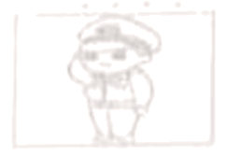 B. 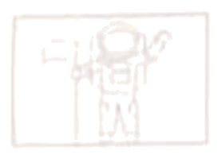 C. 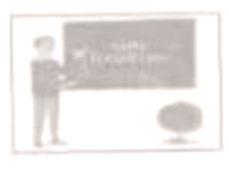
2. A. 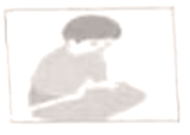 B. 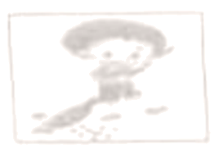 C. 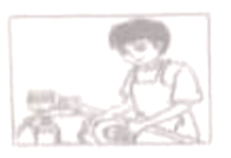
3. A. 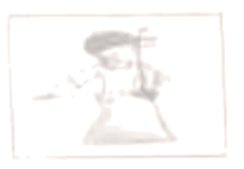 B. 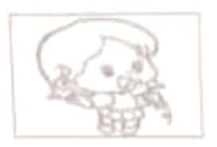 C. 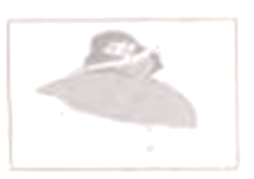
4. A. 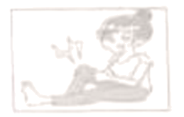 B. 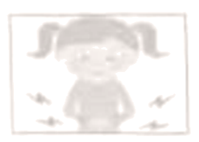 C. 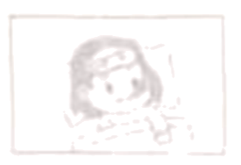
5. A. 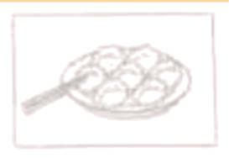 B. 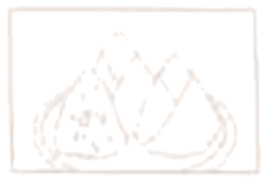 C. 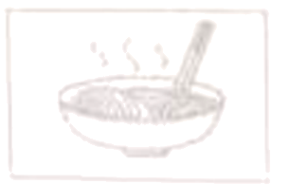
第二节：听大对话或独白，按要求做答。（每小题1分，满分20分）
请听6段大对话或独白，每段对话或独白后有几个小题，请按要求做答。每段对话或独白均读两遍。
听第6段材料，回答第6、7小题。
6. How often does Jack exercise?
A. Once a week. B. Twice a week. C. Three times a week.
7. What will the woman do tomorrow?
A. Take exercise. B. Go shopping. C. See a film.
听第7段材料，回答第8、9小题。
8. What does the boy have to wear on school days?
A. Sports shoes. B. Jeans. C. School uniforms.
9. What does he think of these school rules?
A. Strange. B. Necessary. C. Boring.
听第8段材料，回答第10~12小题。
10. What does Bob want to buy?
A. A shirt. B. A T-shirt. C. A jacket.
11. What color does Bob like best?
A. Red. B. Blue. C. White.
12. Who will Lily buy a gift for?
A. Her father. B. Her mother. C. Her brother.
听第9段材料，回答第13~15小题。
13. Where will Lucy go this weekend?
A. The city park. B. The old people’s home. C. The animal hospital.
14. How many people will go there?
A. 4. B. 5 C. 6.
15. What time will they meet in the morning?
A. At 6:00. B. At 7:00. C. At 8:00.
听第10段材料，回答第16~20小题。
16. Where will they get on the bus tomorrow?
A. At the hotel. B. At the parking lot. C. At the restaurant.
17. How many tourists will take the second bus?
A. Fifty. B. Thirty. C. Twenty
18. How long will it take them to get to Mount Emei?
A. Two hours. B. Three hours. C. Four hours.
19. What’s the weather like in the night?
A. Cold. B. Warm. C. Hot
20. Who may be the speaker of this passage?
A. A teacher. B. A farmer. C. A tour guide.
听第11段材料，完成表中21~25小题的信息记录。（每空一词）
How to become a ________ person?
Some advice | *Be nice to people. Give help to people in ________
Some advice | *Help strangers .Someday a stranger could give you a ________ when you need help.
Some advice | *Write thank-you notes to ________ your thanks.
Some advice | *Don’t leave after dinner. You can help the host by ________ the table.
第二部分 基础知识运用（共两节，满分25分）
第一节：单项选择。（每小题1分，满分10分）
从所给的A、B、C、D四个选项中，选出可以填入空白处的最佳选项。
1. —Do you know Journey to the West?
—Yes. It’s ________ interesting book. I like it very much.
A. a B. an C. the D. /
2. —________ my surprise, the restaurant is a actually very nice.
—The service is also great.
A. In B. At C. On D. To
3. —How did you fix up the machine, dad?
—It’s easy. I just followed the ________.
A. instructions B. inventions C. interviews D. influences
4. —As far as I know, the high-speed railway from Shiyan to Xi’an will be finished soon.
—Yeah. It will be more ________ for us to travel to Xi’an.
A. dangerous B. difficult C. convenient D. traditional
5. —The air in our city becomes fresher and fresher.
—I think so. To cut down air pollution, many factories ________ new energy cars.
A. produce B. throw C. cancel D. divide
6. My friend promised to come to my birthday party. However, he didn’t ________ in the end.
A. give up B. cut up C. show up D. pick up
7. Mr. Smith ________ at the Natural History Museum for more than 10 years so he knows a lot about insects.
A. is working B. has worked C. was working D. will work
8. —I want to know ________.
—Friendly and honest people.
A. when you will meet your friends
B. how you make your friends happy
C. where you spend weekends with friends
D. what kind of people you want to make friends with
9. I will remember the important people ________ helped and supported me in my life.
A. which B. whose C. whom D. who
10. —Some of my classmates like soap operas. What about you?
—Oh. ________. They are too boring!
A. I love them B. I’m not sure C. I can’t stand them D. It’s hard to say
第二节：完形填空。（每小题1分，满分15分）
通读下面短文，掌握其大意，然后从所给的A、B、C、D四个选项中选出一个可以填入短文空白处的最佳选项。
Many stories happened at the Children’s Medical Care Center. These stories deeply touched us. We saw a lot of children without hair ___11___ they got special treatment (治疗). We played with them and ___12___ pictures with them. They had great pains, ___13___ they were very friendly. It was much ___14___ to talk with them than we had expected.
One day, a girl wanted to teach us ___15___ to fold paper. She taught us ___16___ great patience (耐心) and explained each step slowly and ___17___. Though we could do that well, we still pretended (假装) to know ___18___ about it. We followed her step by step and did as she told us. Finally, when we ___19___ our work perfectly, she gave each of us a big hug. We could see the ___20___ and happiness on her face. Her father was so ___21___ to us that his eyes were full of tears. Until then, we knew that the girl would ___22___ an operation (手术) the next day.
It was really a valuable ___23___ to all of us. We began to ___24___ the ways to deal with the difficulties in life. When we ___25___ our “troubles” with those kids, ours seem not worth mentioning at all.
11. A. before B. because C. unless D. if
12. A. drew B. broke C. deleted D. covered
13. A. and B. or C. but D. so
14. A. easier B. harder C. wiser D. deeper
15. A. where B. when C. what D. how
16. A. without B. by C. with D. for
17. A. suddenly B. heavily C. widely D. clearly
18. A. something B. nothing C. everything D. anything
19. A. continued B. completed C. competed D. communicated
20. A. pride B. fear C. courage D. sadness
21. A. sorry B. harmful C. humorous D. thankful
22. A. receive B. disagree C. promise D. improve
23. A. reason B. research C. experience D. risk
24. A. give out B. put off C. turn down D. think about
25. A. provide B. compare C. share D. part
第三部分 阅读理解（共四节，满分40分）
第一节：阅读短文，根据其内容，选择最佳选项。（每小题2分，满分10分）
Mike, Germany
I stayed with my host family for three weeks in China. It was unforgettable for me. I was lucky enough to study some Chinese culture. I visited Mount Wudang and learned a lot about Tai Chi. I even visited a famous traditional Chinese medicine hospital. Now I have a better understanding of Chinese culture.
Lisa, Australia
I spent five weeks with my host family. My host mother is an excellent Chinese teacher. She is really friendly and warm-hearted. With her help my Chinese has improved a lot. And now I can talk with my Chinese friends freely. I like sharing my feelings with them.
Judy, Italy
I lived in China for half a month. My host mother is a wonderful cook. She often makes different kinds of Chinese dishes, such as gongbao chicken and mapo tofu. They are tasty and I like them very much. I am able to make dumplings now. I plan to make them for my family when I return to my hometown.
Nancy, Canada
Recently I took part in a program to study Chinese. I lived with a host family in China for 6 weeks. My host sister is a really hard-working student. It was amazing to see how well she did in English. She set a good example to me. We often exchanged opinions about study. And our friendship has become closer.

26. Where does Nancy come from?
A. Australia. B. Germany. C. Canada. D. Italy.
27. Who stayed in China for the shortest time?
A. Lisa. B. Judy. C. Mike. D. Nancy.
28. What does Lisa think of her host mother?
A Hard-working. B. Amazing. C. Unforgettable. D. Warm-hearted.
29. Which of the following is TRUE according to the passage?
A. Mike can make dumplings.
B. Judy’s host mother is a cook.
C. Nancy’s English has improved a lot.
D. Lisa dislikes to share feelings with her Chinese friends.
30. We can read this passage from a magazine about ________.
A. life experience B. science fiction C. sports news D. safety education
第二节：阅读短文，根据其内容，选择最佳选项。（每小题2分，满分10分）
I have an 11-year-old son named Peter. I knew that playing sports would be good to our son. He would get some exercise, learn about teamwork and learn some physical skills. We continually encouraged him to have a try, but after a while it was clear that he didn’t like team sports, and there was nothing we could do to change it.
We decided not to push him to take part in sports, even though most of his friends did sports. As time went by, we gradually realized that we had made the right decision. Don’t misunderstand (误解) me. I have nothing against sports. Now my son isn’t interested in sports, but I’m not pushing him to do sports. Here are the reasons:
I want him to know I accept him unconditionally. I don’t even want Peter to feel that I will love him only if he behaves in a certain way or takes part in some activities. Whether he succeeds or fails he will always be my son, and that will never change.
I want him to form his own path (道路) in life. His path doesn’t have to be the same as mine. In fact, we both have similar interests in several areas like music, computers and Star Wars, but we’re also different in many ways. Peter needs to be free to go his own path.
I want him to know that I don’t judge (判断) my worth by his achievements. Every father will feel proud of his son if he can make great achievements. So most parents always push them so hard. Sometimes we have seen ourselves indirectly through our own sons. Their achievements remind us of our wonderful days in the past. We must make sure we don’t want to make up for (弥补) our own regrets by pushing our sons to climb higher and go further than we did.
31. The advantages of doing sports don’t include ________.
A. getting some exercise B. getting some exam skills
C. learning about teamwork D. learning some physical skills
32. What was the writer’s final decision?
A. Our son must master a kind of sport.
B. He should do the same thing as his friends.
C. We didn’t push him to do sports he disliked.
D. We would push him to find what he was good at.
33. What does the underlined word “unconditionally” mean?
A. 慎重地 B. 无条件地 C. 不耐烦地 D. 犹豫地
34. How many reasons does the father give for not pushing his son to take part in sports?
A. Two. B. Three. C. Four. D. Five.
35. Which sentence can best describe the father in this passage?
A. He is a wise and open-minded father.
B. He doesn’t care about his son’s future.
C. He is brave and knows when to give up.
D. He is rich enough to support the whole family.
第三节：阅读短文，根据其内容，选择最佳选项。（每小题2分，满分10分）
Everybody knows that protecting the environment today will prepare for a better tomorrow. Kids can also be taught to do their bit for helping the environment.
A large number of people just have the water running when they are washing faces or brushing teeth. ___36___ Another thing kids can do is taking a shorter shower.
Video games use a lot of energy. Encourage kids to go out to play in the fresh air or finish their homework instead of playing these video games. ___37___
Teach kids to turn off lights when they are not in use. ___38___ Since kids are not told about environmental problems, they do not know they are wasting electricity.
___39___ Try not to use paper cups and plates whenever possible. Cutting down on use of paper wherever possible will help to save more trees. Use recycled paper.
Kids must be educated about saving the environment at a young age. ___40___ And we can together make a great effort to have a cleaner and greener earth.
A. In this way, kids can save energy.
B. Ask your kids to try to save paper.
C. If kids can also play a role in helping to save the earth, it will be great.
D. Kids should be taught to turn off the tap when they do the same things.
E. Most of the time, kids will leave the lights on when they leave the classroom.
第四节：阅读短文，根据其内容，完成下列任务。（每小题2分，满分10分）
Pound was a famous professor of Law College of Harvard. Although he was 80, he still worked eight hours every day no matter what the weather was like.
His workmate once said, “Though he was old, he kept on walking from his house to the office. It would take him an hour to do so, but he insisted (坚持) because it made him get a sense of success. I admired him. He not only made great achievements in his field, but also came up with creative teaching methods to inspire students.”
One day, a student got out of the professor’s office with a lot of books. He complained (抱怨), “He always answers my questions with just a yes or ①______. At the same time, he always gives me too many books and advises me to read them again and again. I have to spend plenty of time ②______ the answers on my own.”
By accident, the professor knew what the student complained about. He explained to him patiently. “This is the method I have learnt—the harder you work independently, the better solutions you will get. If you can make full use of the books, you will probably become a good lawyer.” He believed “Teaching people to fish is better than giving them fish”.
Ten years later, the student became a well-known lawyer. When he returned to Law College of Harvard, he met the professor again. He thanked the professor. Besides, he gave away many books to Harvard.
41. 请根据短文内容，分别写出①、②处所缺单词。（每空限填一词）
①______ ②______
42. 阅读短文，从短文中找出与下面句子意思相近的句子。
If you can put the books to good use, perhaps you will be a good lawyer.
___________________________
43. 请把上文中划线的句子翻译成汉语。
___________________________
44. How old was the professor ten years later?
___________________________
45. What did the student do when he met the professor again in the last paragraph?
___________________________
第四部分 语言综合运用（共三节，满分30分）
第一节：选词填空。（每小题1分，满分5分）
选择单词或词组，用其适当的形式填空，使句子意思正确、通顺、（每词限用一次，其中两词多余）
him; successfully; argue with; country; nearly; agree with; overcome

46. I quite ______ you. Let’s take action now.
47. Even though my brother is young, he can take good care of ______.
48. There is no doubt that China is one of the oldest ______ in the world.
49. Jimmy ______ all the difficulties and got to the top of the mountain.
50. The C919, China’s self-developed large passenger plane ______ finished its first flight from Shanghai to Beijing on May 28th.
第二节：补全句子。（每小题2分，满分10分）
根据汉语提示补全英语句子，使句子意思正确、通顺。每空词数不限。
51. 朋友不在于多，只要他们好。
You don’t need a lot of friends ________ they are good.
52. 对游客们来说，旅行时拍照很常见。
It’s common that tourists often ________ when they travel.
53. 多吃蔬菜和水果有助于人们保持健康。
Eating more vegetables and fruits helps people ________.
54. 很多父母在几天前受邀去观看他们孩子的表演。
Many parents ________ their kids’ performances a few days ago.
55. 做完试卷后，请仔细检查你的试卷以避免犯错。
Please check your paper carefully to ________ after finishing it.
第三节，初级写作。（满分15分）
56. 三年的初中生活，你一定有许多收获，也会有一些不足。展望未来，你肯定有许多美好的期待。假如你被邀请在班会上发言，请你根据以下表格信息，写一篇发言稿。
 | 提示内容 | 提示词
回顾过去 | 1.性格上的改变  2.学习上的成就  3.反思不足 | 1. outgoing, get on with  2. learn from, make progress  3. waste time, not understand
展望未来 | 未来的期望 | come true
要求：
1.发言稿需涵盖表格中所有内容，可适当发挥；
2.行文连贯，条理清楚，语句通顺，语法正确，书写规范；
3.文中不可出现真实人名和校名等相关信息：
4.词数80-100，开头已给出，不计入总词数
Dear students,
How time flies! Looking back at these past three years, I have improved a lot. ________________________________________________________________________________________________________________________________________________________________________________________________________________________________________________________________________________________________________________________________________________________________________________________________________________________________________________________________________________________________________________________________________________________________________________________________________________________________________________________________________________________________________________________________________________________________________________________________________________________________________________________________________________________________________________________________________________________________________
Good luck!

