2023年武汉市初中毕业生学业考试
英语试卷
亲爱的同学：
在你答题前，请认真阅读下面的注意事项。
1.本试卷由第Ⅰ卷（选择题）和第II卷（非选择题）组成。全卷共10页，七大题，满分120分，考试用时120分钟。
2.答题前，请将你的姓名、准考证号填写在“答题卡”相应位置，并在“答题卡”背面左上角填写姓名和座位号。将条形码横贴在答题卡第1页右上“贴条形码区”。
3.答第Ⅰ卷（选择题）时，选出每小题答案后，用2B铅笔把“答题卡”上对应题目的答案标号涂黑。如需改动，用橡皮擦干净后，再选涂其他答案。答在“试卷”上无效。
4.答第Ⅱ卷（非选择题）时，答案用0.5毫米黑色笔迹签字笔书写在“答题卡”上。答在“试卷”上无效。
5.认真阅读答题卡上的注意事项。
预祝你取得优异成绩!
第Ⅰ卷（选择题 共85分）
第一部分 听力部分
一、听力测试（共三节）
第一节（共4小题，每小题1分，满分4分）
听下面4个问题。每个问题后有三个答语，从题中所给的A、B、C三个选项中选出最佳选项。听完每个问题后，你都有5秒钟的时间来作答和阅读下一小题。每个问题仅读一遍。
1. A. I think so. B. Toby. C. Pretty nice.
2. A. In 2023. B. At 7:00. C. For two years.
3. A. An astronaut. B. In the newspaper. C. Great.
4. A. Kind. B. Reading. C. At school.
第二节（共8小题，每小题1分，满分8分）
听下面8段对话。每段对话后有一个小题，从题中所给的A、B、C三个选项中选出最佳选项。听完每段对话后，你都有10秒钟的时间来作答有关小题和阅读下一小题。每段对话仅读一遍。
5. What will the weather be like tomorrow?
A. Cloudy. B. Rainy. C. Sunny.
6. How did Nick go to school today?
A. By car. B. By bike. C. By bus.
7. What kind of sandwich does the man want?
A. Chicken. B. Beef. C. Egg.
8. How many times has the man been to Xi’ an?
A. Once. B. Twice. C. Three times.
9. What’s the lesson mainly about?
A. Nature. B. Safety. C. Invention.
10. What would the woman probably say to the man next?
A. How much is it? B. Can I try it on? C. Could it be cheaper?
11. Which scene is talked about?
A.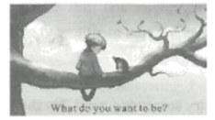 B.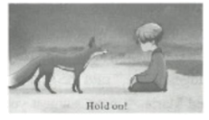 C.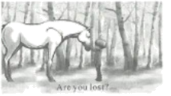
12. What can we know about the woman?
A. She complains to the man.
B. She sees things differently.
C. She is good at singing.
第三节（共13小题，每小题1分，满分13分）
听下面4段对话或独白。每段对话或独白后有几个小题，从题中所给的A、B、C三个选项中选出最佳选项。听每段对话或独白前，你将有时间阅读各个小题，每小题5秒钟；听完后，各小题将给出5秒钟的作答时间，每段对话或独白读两遍。
听下面一段对话，回答13至15三个小题。
13. Why does the boy interview the girl?
A. For his homework. B. For a news report. C. For cancer research.
14. What’s Cathy’s biggest plan for the future?
A. To take photos. B. To be a good doctor. C. To join in fashion shows.
15. What’s the probable relationship between the two speakers?
A. Doctor and patient. B. Teacher and student. C. Brother and sister.
听下面一段对话，回答16至18三个小题
16. What does the man exercise for?
A. Losing weight. B. Relaxing himself. C. Making friends.
17. Which sport does the woman like best?
A. Swimming. B. Running. C. Bike riding.
18. When are they going to start exercise together?
A. Right now. B. Tomorrow. C. This weekend.
听下面一段对话，回答19至22四个小题。
19. Where did Sofia go last night?
A. A teahouse. B. A theater. C. A bookstore.
20. What did Sofia do there?
A. She made tea. B. She admired an opera. C. She performed a play.
21. When did Sofia leave there?
A. At 7：00 p. m. B. At 8：00 p. m. C. At 9：00 p. m.
22. Which is true about the two speakers?
A. They’re interested in Beijing Opera.
B. They don’t know Chinese writers.
C. They went on a trip last night.
听下面一段独白，回答23至25三个小题。
23. What did Jacob do when he was three?
A. He started a charity.
B. He drew a map perfectly.
C. He studied at a college.
24. What is the book he’s writing about?
A. Health. B. Math. C. Basketball.
25. Which words can best describe Jacob?
A. Talented and warm-hearted.
B. Quiet and open-minded.
C. Funny and well-educated.
第二部分 笔试部分
二、选择填空（共15小题，每小题1分，满分15分）
从题中所给的A、B、C、D四个选项中，选出可以填入空白处的最佳选项。
1. —Do you understand what I mean?
—________. I’m a bit lost.
A. Very much B. I hope not C. Not really D. It’s nothing
2. —Mom, can I talk to you about my job offer, please?
—________.
A. Go ahead B. I see C. Much better D. Never mind
3. —What the headmaster said at the graduation must have stuck in the minds of many students.
—________. It was very inspiring.
A. I agree B. Thank you C. All right D. My pleasure
4. —The car will not start. What can I do?
—Don’t worry. Tom and I ________ it a push.
A. give B. gave C. have given D. will give
5. Jessica ________ every night before her Chinese test and got good results.
A. studies B. studied C. has studied D. will study
6. —Who will talk about the development of American country music next week?
—I suggest Brad. He ________ in Nashville, the home of country music, since he was a child.
A. lives B. lived C. has lived D. will live
7. Please bring Ms. Steen to the welcome party ________ telling her so that she can be surprised.
A. about B. from C. without D. for
8. —Peter was picked out to be on the school volleyball team.
—His height gives him a big ________.
A. situation B. challenge C. achievement D. advantage
9. — There are many celebrations in the coming Dragon Boat Festival.
— Sounds very interesting. I don’t want to miss ________.
A. it B. any C. none D. one
10. —Mary is ________ about what she eats. She never has junk food.
—A good habit.
A. careful B. angry C. nervous D. relaxed
11. — The hair product is being ________ at present.
— You mean if it’s up to the standard, it will be put on the market soon.
A. used B. tested C. shown D. sold
12. —Excuse me, but we ________ wait in line to get on the subway.
—I’m sorry.
A. might B. would C. could D. should
13. — Sally ________ into the role of our group leader.
— Really? I’m expecting fresh air and new ideas from her.
A. ran B. broke C. stepped D. looked
14. —Hard to believe. Luke won the school speech contest!
—He used to be shy, but his friends’ support ________ his confidence.
A. took away B. made up C. put away D. built up
15. This famous saying “When I walk along with two others, they may serve me as my teachers” tells us ________.
A. how should we treat people B. who we can learn from
C. what did we say in public D. why we need teachers
三、完形填空（共15小题，每小题1分，满分15分）
阅读下面短文，从短文后各题所给的A、B、C、D四个选项中，选出可以填入空白处的最佳选项。
Katie said goodbye to her parents at the front door of their candy shop as they drove off for a vacation, and Katie ___16___ she’d be able to run it with Aunt Maria’s help. Aunt Maria didn’t have any experience on business, but she is always called “___17___”.
As Maria blew into the store, she said, “All right, Katie my love, let’s get this party started.”
Katie took her aunt over to where the family made their own candy, such as fresh fudge (软糖). Aunt Maria ___18___ a piece of chocolate fudge. “Hmm,” she said. “It’s good, but not ___19___. We can add something to make that basic taste exciting.”
Before Katie could ___20___ what Maria meant, the woman had gone to the kitchen. Katie heard her walking around, opening drawers and the fridge. Then she came back with her hands full of things. She ___21___ them on the work surface with a happy tune(小调).
“Brussels sprouts(甘蓝)?” Katie gave her aunt a ___22___ look. She couldn’t be serious! But she was. The woman’s hands were busy ___23___ the green vegetables and then adding those small pieces into the fudge. Katie’s eyes grew wide as she watched her aunt mix them together.
Katie ___24___ as the bell over the front door rang, announcing some ____25____. Three boys came in. “I’ll have strawberry fudge, please,” said the first boy.
“Oh, how ____26____,” laughed Maria. “I must suggest you try something new! Try this!” She offered the boys the Brussels sprout fudge. “It’s free! ____27____!”
Surprised, but too polite to ____28____, the boys left with the fudge.
“There go our customers. They will tell everyone how strange our candy is, and nobody will want to shop here!” Katie said to herself. She didn’t know what to do. Her parents were going to be ____29____.
The sound of the bell woke her up from her ____30____. The boys were back! But this time there was a crowd of kids coming into the store with them.
“Give me two pieces of Brussels sprout fudge, please.”
16. A. promised B. remembered C. pretended D. checked
17. A. friendly B. creative C. honest D. lucky
18. A. noticed B. bought C. made D. tried
19. A. soft B. sweet C. smooth D. special
20 A. believe B. change C. question D. explain
21. A. stuck B. left C. spread D. swept
22. A. strange B. fresh C. black D. hungry
23. A. washing B. weighing C. cutting D. cooking
24. A. moved on B. looked up C. broke down D. came over
25. A. clerks B. policemen C. customers D. businessmen
26. A. expensive B. cheap C. funny D. boring
27. A. Stay B. Enjoy C. Go D. Help
28. A. accept B. argue C. eat D. order
29. A. mad B. calm C. relaxed D. silent
30. A. mistakes B. memories C. plans D. thoughts
四、阅读理解（共15小题，每小题2分，满分30分）
阅读下面三篇材料，从每题所给的A、B、C、D四个选项中，选出最佳选项。
A
Dinosaur (恐龙) Prints Discovered  A diner eating in a restaurant’s outdoor yard, in Sichuan Province, has discovered dinosaur footprints on the ground. After using a 3D scanner (扫描仪), scientists made sure that the footprints are 100 million years old. They belonged to two dinosaurs with long necks and tails. | 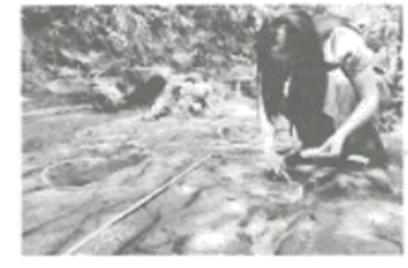
________________  Marley and Bob say they became interested in archaeology (考古学) from studying history at school going to museums and watching Human Histories! They also go to the Young Archaeologists’ Club and they do digs at archaeological sites (地点) and carefully research their finds. “You never know what you might discover, and it is a fascinating way to uncover old remains on a real dig. It makes me really happy,” says Bob. | 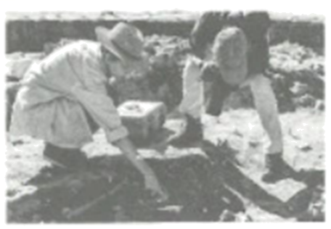
Students Find Ancient Mural  A group of student archaeologists have unearthed a 1,000-year-old mural (wall painting). The 30-meter mural shows mysterious scenes, which could reflect what the life was like in ancient Peru. Professor Luis says, “The discovery is the most exciting and important find of recent years.” | 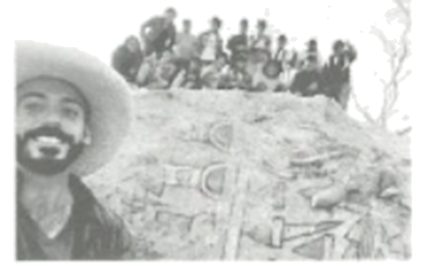

31. In which section of the newspaper can we read the news?
A. BUSINESS. B. TRAVEL. C. HISTORY. D. ART.
32. Those dinosaur prints were found ________.
A. through a scanner B. by scientists
C. millions of years ago D. during a meal
33. The best heading for the second piece of news would be ________.
A. Come to Our Club B. Dig and Discover the World
C. Find Out Your Hobby D. Study Human Histories
34. Professor Luis finds the mural very valuable mainly because ________.
A. it’s connected to ancient society B. it shows the birth of the mural
C. it’s the world’s earliest wall painting D. it has a very large size
35. All the news above ________.
A. reports new archaeological finds
B. tells ancestors’ stories
C describes the history events
D. says hello to the past
B
Bert won a national prize called Young Heroes for his “green” project. This public-spirited young person was now a university student. His love for insects grew deeper and he was protecting them for the future.
_________. When he was around 4 or 5, he always loved to watch different insects, especially beautiful swallowtails(凤蝶). One interesting fact he learned about swallowtails was that their bright colors warned hungry animals that they tasted bad. And it was also fun to watch how they came into being. But the reason he really fell in love with them was that they were very accessible. For example, if you wanted to attract (吸引) swallowtails, you planted some zinnias, a kind of bright flowers.
Bert started a zinnia garden at his house, where he raised a large number of swallowtails over the years. With the world’s swallowtail population falling, Bert wanted people to realize that if insects like swallowtails disappeared, so would all the others above them on the food chain. To make the fact clear and easy to understand for other students, he also created a zinnia garden at his junior high school.
Part of the joy for Bert was watching the younger students get excited when running after swallowtails. “Whenever a swallowtail lands on them, the young students will soon fall in love with these cute insects. They develop a new appreciation for them,” he said.
Bert put his efforts into the environmental educational project and made it take flight.
36. After Bert was honored with Young Heroes, _________.
A. he often gave speeches in public
B. he set up his “green” project
C. he became interested in swallowtails
D. he went on protecting insects
37. Which of the following can be put in _________?
A. Bert saved many swallowtails
B. Bert had a dull childhood
C. Bert found his love early in life
D. Bert made a hard decision
38. The underlined word “accessible” in paragraph 2 means “_________”.
A. dangerous to feed B. easy to get close to
C. hard to raise D. safe to reach
39. The main reason for Bert to create a zinnia garden at school was _________.
A. to watch students have fun
B. to make his school more beautiful
C. to stop swallowtails from disappearing
D. to help kids learn about swallowtails
40. What would be the best title for the passage?
A. A Bright Flower B. A Flying Project C. A Green Garden D. A Warning Action
C
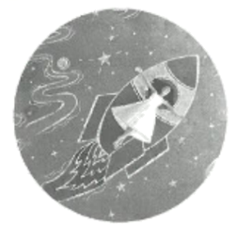
When the famous scientist Albert Einstein was 16 years old, he imagined himself riding alongside a beam (束) of light. He used this picture in mind to help him when working out the “theory of relativity(相对论)”. “Imagination is more important than knowledge,” said Einstein.
Daydreaming, called “thought experiments” by Einstein, can make you have wild imaginings, like flying around in space. It lets your mind walk slowly around ideas, memories and experiences that aren’t happening right now. It means thinking ahead to a holiday or remembering how much you enjoyed a birthday party. According to China’s health authorities(权威机构), daydreaming for a while each day can improve your health and creativity.
Disappearing into a daydream lets your mind escape when things are difficult. It helps you deal with worries and fears. For example, imagining how you’re going to speak up in class is like practicing the scene in your head, which can make you feel calmer. Daydreaming also inspires creativity and lets you find new worlds where there are no limits (限制) to what you can do or who you are. Guo Qiang, an expert in thoughts and feelings, thinks we should all make time to daydream. “Thinking for pleasure can be a powerful tool to shape our feelings,” he said.
However, try not to let your mind be absent when you need to focus (聚焦) in class or cross the road. Instead, find a time when you don’t have to focus on anything, like going for a walk or brushing your teeth. Guo suggests you can start by focusing on a happy memory or imagining a future success, like scoring a goal in the World Cup.
To encourage creativity, think about interesting ideas and see where your mind takes you. Research shows that people often come up with more solutions to problems after they’ve taken a break. So next time you’re stuck with homework, stop for a moment and see where your daydreams take you.
41. Which writing skill is used in paragraph 1?
A. Giving an example. B. Raising a question. C. Listing numbers. D. Comparing facts.
42. Daydreaming can make people _________.
A. fly around B. walk slowly C. think freely D. be absent-minded
43 Guo Qiang first suggests _________.
A. escaping from the hard time B. looking for new worlds
C. finding time to imagine D. focusing on success
44. What is mentioned in paragraph 4?
A. The steps to daydream.
B. The things to daydream of.
C. The reasons for daydreaming.
D. The meanings of daydreaming.
45. Daydreaming is talked about _________.
A. to remind people to have a mind break
B. to suggest living at the moment
C. to find solutions to homework problems
D. to show a science research result
第Ⅱ卷(非选择题 共35分)
五、词与短语填空（共5小题，每小题2分，满分10分）
仔细阅读下面五个句子，然后用下面方框中所给的单词或短语填空，使每个句子在结构、句义和逻辑上正确。（提示：方框中有两个单词或短语是多余的。）
dress up/business/clever/protect/strong/take off/hold

46. The ancient emperors built the Great Wall to _________ their country.
47. I get such a _________ feeling of satisfaction when I see the animals get better.
48. Hometowns are the places that _________ all the best memories in childhood.
49. In many countries, you should _________ your gloves before shaking hands.
50. Li Xin set up a _________ to make beautiful art works by using materials from old cars.
六、综合填空（共10小题，每小题1分，满分10分）
阅读下面短文，根据上下文、所给首字母或括号内单词等提示，在空白处填入适当的单词。每个空只能填一个单词。
Traditional Chinese Medicine (TCM) is used to help people keep the balance of yin and yang. But have you ever imagined that one day you can learn herb (药草) planting and TCM courses at school?
A primary school in Nanjing has just ___51___ (open) a herb farm. More than 30 herbs are planted. Students there are g___52___by doctors from a TCM hospital to tell different herbs and learn plant development, medicinal value as well as ___53___ (grow) herbs. The hospital has also donated over 100 cartoon books about TCM to help draw children’s a___54___ in herbal medicine.
Another middle school has i___55___ TCM courses to students of all grades. These courses c___56___ a basic knowledge of herbs, herb planting and cooking with herbs. They give students a deeper understanding of TCM, bringing out their sense of p___57___ in Chinese traditions and the country’s rich culture.
Also in Shanghai, Tongji University has provided foreign students ___58___ some chances to plant different kinds of herbs ___59___ (wide) used in Chinese medicine and cooking. By taking care of the plants, foreign students can get first-hand experience of making herbal medicine from start to finish, and spread TCM culture to their o____60____ countries.
The herb planting courses at schools and universities across China get students close to TCM and help pass on the tradition.
七、书面表达（共1大题，满分15分）
61. 你的英语老师布置了一项体验式作业，希望你和家人假期时去一次公园，然后写一篇英文短文，向同学们介绍公园离你家有多远，能在公园内体验的活动项目及公园周边生活设施。请你根据以下内容提示完成短文。
内容提示：
How far is it from your home to the park?
What activities can you do in the park?
Is there a restaurant, a library or something else near the park? How is it?
Something more about the park.
注意：文中不得透露个人真实姓名和学校；词数60—80；标题和开头已给出，不计入总词数。
Come to Happy Park!
Happy Park is a public park in our hometown. _______________________________________________________________________________________________________________________________________________________________________________________________________________________________________________________________________________________________________________________________________________________________________________________________________________________________________________________________________________________________________________________________________________________________________________________________________________________________________________________________________________________________________________________________________________________________________________________________________________________________________________________________________________________

