2023年邵阳市初中学业水平考试试题卷
英语
温馨提示:
第一部分 听力技能 (两节, 共20小题, 满分20分)
A) 反应根据你所听到的内容, 选择正确答语完成对话。每个句子读两遍。(共5小题每小题1分)
1. A. Good morning! B. Good afternoon! C. Good night!
2. A. Yes, I can. B. Thank you. C. Yes. I am.
3. A. No way. B. I don’t know. C. Yes, please.
4. A. English. B. It’s Monday. C. It’s an orange.
5. A. I have a cold. B. Miss Wang. C. A cat.
B) 理解根据你听到的对话或独白, 选择最佳答案回答问题。每段对话读两遍。(共15小题, 每小题1 分)
听下面的对话, 回答第6 至7小题。
6. How old is Cindy?
A. 13. B. 14. C. 15.
7. Where will Cindy have her birthday party?
A. At her house. B. At school. C. At the park.
听下面的对话, 回答第8至9小题。
8 What is Amy doing?
A. Drawing. B. Watching TV. C. Sleeping.
9. Who are listening to a CD?
A. Dave and Mary. B. John and Amy. C. Bob and Jenny.
听下面的对话, 回答第10至12小题。
10. What’s Molly good at?
A. Art. B. Music. C. Football
11. What’s Rick’s dad?
A A football player. B. A teacher. C. A dentist.
12. How many kids are there in Rick’s family?
A. Three. B. Four. C. Five.
听下面的对话, 回答第13至16小题。
13. Why do they have to make dinner by themselves?
A. Because Mom is busy B. Because Mom is ill. C. Because Mom isn’t at home.
14. What is Bill’s plan?
A. To make fruit salad. B. To make rice noodles. C. To make chicken soup.
15. How much yogurt do they need?
A. One cup. B. Two cups. C. Three cups.
16. What are on the shopping list?
A. Ice-cream and milk. B. Orange juice and eggs. C. Bananas and pears.
听下面一段独白, 回答第17 至20 小题。独白读两遍。
17. What does Alan’s mother ask him to buy?
A. Bread. B. Milk. C. Honey.
18. Where is the birthday card?
A. In the kitchen. B. In the bedroom. C. In the living room.
19. What’s on the table in Alan’s mother’s bedroom?
A. Some money B. A hamburger. C. A card.
20. What time will Alan call his father?
A. At about 4:00 p.m. B. At about 5:00 p.m. C. At about 6:00 p.m.
第二部分知识运用 (两节, 共20 小题, 满分20 分)
A) 单项选择从A、B、C三个选项中选择最佳答案填空。(共10小题, 每小题1分)
1. —Hi, Wang Li, who is Miss Deng?
—Miss Deng is ________ nice teacher and she is very popular in our school.
A. a B. an C. /
2. —What animals did you see on the farm, Tom?
—I saw some ________.
A. rabbit B. ducks C. sheeps
3. —Is Lucy in the classroom?
—Yeah. She is still there watching Mr. Li ________.
A. to draw B. drawing C. draws
4. —I can’t find my shoes. Where are they, Mom?
—Oh, one is under the bed, ________ is behind the door.
A. the other B. others C. another
5. —Ben, who is the boy in blue in the picture?
—It’s my brother. The picture ________ five years ago.
A. take B. is taken C. was taken
6. —Is that Tom?
—No, that is Peter. Tom has ________ hair than Peter.
A. long B. longer C. the longest
7. —Hello, this is Lily speaking. Could I speak to Mr. Liu?
—Sorry, he ________ Changsha.
A. has been to B. will go to C. has gone to
8. —What are you going to do this weekend?
—I’m not sure. I ________ go shopping.
A. must B. should C. may
9. —I’ve found a new pen, but I don’t know ________.
—It must be Lucy’s. She is looking for her pen.
A. whose is it B. whose it is C. who it is
10. —What do you think of the movie Wandering Earth Ⅱ (《流浪地球2》)?
—________. I have watched it three times.
A. I really enjoy it B. It’s terrible C. I can’t stand it
B) 完形填空阅读短文, 掌握其大意, 从A、B、C三个选项中选择最佳答案填空。(共10小题, 每小题1分)
One day, a crow (乌鸦) saw a swan (天鹅) on the beach. The crow laughed at him and said, “Can you ___11___ as fast as I do? Do you have as many flying skills as I do? ___12___ stupid you are!”
Hearing this, the swan thought the crow needed to be taught a lesson. He had an idea.
He asked the crow. “Do you dare to ___13___ with me? The competition will take place in ___14___ stages (阶段). In the first stage, you can show your flying skills, and I will do the same. In the second stage, you should copy what I will do.”
The crow said proudly, “It’s too easy!”
The competition started. ___15___ the crow showed different ways of flying. But the swan could do nothing. Next, the second stage began. The swan flew to the ___16___. The crow followed him. “Is this all you can do?” the crow asked. The swan just flew silently. He flew slowly, but didn’t stop. After flying a long distance (距离), the crow was so ___17___ that he could hardly fly and almost fell into the sea.
Seeing this, the swan said to the crow. “You have flying skills, ___18___ I have good endurance (耐力). Everyone has his own strong and weak points. One should never think that he is perfect while others are all good for nothing.” After the crow ___19___ the swan’s words, his ____20____ turned red and hung his head. He regretted having laughed at the swan.
11. A. run B. jump C. fly
12. A. What B. How C. What a
13. A. compete B. talk C. argue
14. A. one B. two C. three
15. A. In the end B. At last C. At first
16. A. road B. mountain C. sea
17. A. tired B. strong C. successful
18. A. or B. and C. but
19. A. heard B. watched C. saw
20. A. hand B. face C. leg
第三部分 阅读技能 (四节, 共20小题, 满分40分)
A) 正误判断 (共5小题, 每小题2分)
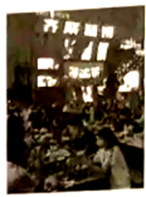
Zibo is in the middle of Shandong Province. In late February, some college students went to try the barbecue (烧烤) when they attended a job fair in the city. They took videos of themselves enjoying the food and posted onto social media. Zibo’s special barbecue has gone viral (走红) quickly. As a result, “college students going to Zibo for barbecue” and “taking a high-speed train to taste Zibo barbecue” have become hot topics on Chinese social media.
Xu Jiayue, a student from Shandong Transport Vocational College, came to Zibo to try the barbecue on Tuesday. “We use the stoves (火炉) to cook the meat, which gives us a feeling of achievement. We can eat the meat at a perfect temperature, so the food tastes delicious.” she said.
A total of 27,065 visitors arrived on March 4, setting a record for daily passengers arriving at the railway station in the past three years. Now, more and more people start to pour into Zibo to try its famous barbecue.
阅读短文，根据短文内容判断所给句子正 (T) 误 (F)。
21. In late February, some teachers tried the barbecue when they attended a job fair in Zibo.
22. Zibo has gone viral on Chinese social media for its special barbecue.
23. Xu Jiayue came to Zibo to try the barbecue on Friday.
24. The number of passengers arriving at the railway station on March 4 has set a record in the past three years.
25. Because of barbecue, Zibo has become a popular city.

B) 阅读图表阅读下面图表, 从A、B、C三个选项中选出最佳答案回答问题或完成句子。(共5 小题, 每小题2分)
A
Rubbish from a family in China
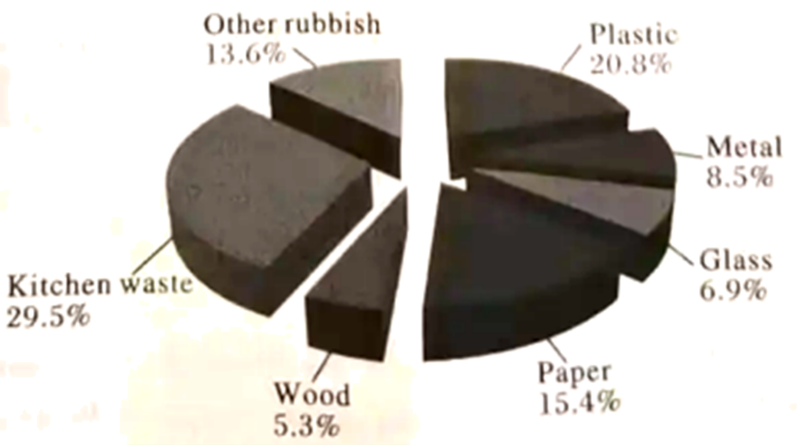
26 What kind of rubbish does the Chinese family produce most?
A. Wood. B. Plastic. C. Kitchen waste.
27. What percent of rubbish is paper?
A. 5.3%. B. 15.4%. C. 20.8%.
B
The 19th Asian Games Hangzhou will be held on September 23, 2023. Would you like to own the mascot (吉祥物) of the 19th Asian Games? If you order now, you can have your mascot before the opening ceremony. It will take you 4 to 6 days to get your mascot after you place an order. The order ends on September 17.
Price:
Number | Price | Handling (运费)
1 to 5 | ¥60 each | ¥10
over 5 | ¥50 each | ¥0
Order now online at our website (www. asianmascot. com).
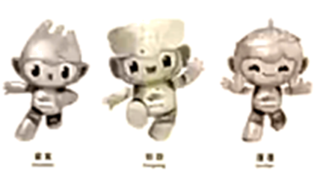

28. If Li Hua orders a mascot on September 5, he may receive it on ________.
A. September 10 B. September 17 C. September 23
29. We can order the mascot by ________.
A. making a phone call
B. visiting the website www.asianmascot.com
C. sending an email
30. How much should Alice pay if she buys 6 mascots?
A. ¥300. B. ¥360. C. ¥370.
C) 阅读选择阅读短文, 从A、B、C三个选项中选出最佳答案回答问题或完成句子。(共5小题, 每小题2分)
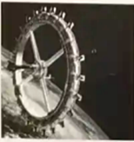
Are you dreaming of future travels to space? Your dream will come true soon.
It’s reported that people will have an “out-of-the-world” experience by staying at a hotel high above the earth in 2027.
The hotel is called Voyager Space Station (VSS). It is like a Ferris wheel (摩天轮). There will be rooms, restaurants, bars, gyms, reading rooms and scientific research laboratories. It’s eco-friendly (环保的) by getting power from the sun. It will have rooms for up to 400 people, including scientists, astronauts, and even some people to live there for a long time. You’ll pay 5 million dollars for each 3-day stay.
The hotel will serve traditional “space food”—like freeze dried ice cream. You’re going to have the top chefs making really good food. You can go on spacewalks to enjoy the beauty of the earth and space. You can enjoy 32 sunrises and sunsets each day.
“The building of the VSS will start in 2026 and welcome its first visitors in 2027. It will be the world’s first space hotel. We’re trying to make people realize that this golden age of space travel is just around the corner. It’s coming fast.” scientists say.
31. The Voyager Space Station (VSS) is ________.
A. a space hotel B. a space laboratory C. a kind of space food
32. If you pay 10 million dollars, you can stay at the Voyager Space Station for ________.
A. 3 days B. 6 days C. 9 days
33. The underlined word “chefs” in the passage means “________” in Chinese.
A. 设计师 B. 航天员 C. 厨师
34. Which of the following is NOT true?
A. The Voyager Space Station can get power from the sun.
B. People can enjoy 32 sunrises and sunsets each day at the Voyager Space Station.
C. The building of the Voyager Space Station (VSS) will start in 2027.
35. What’s the best title for the passage?
A. The world’s first space hotel B. The top chefs C. The beauty of the earth and space
D) 信息摘录 (共5小题, 每小题2分)
Do you know about traditional Chinese art? There are many different kinds of traditional Chinese art and each different part of China has its own special kinds of traditional art.
Huaguxi
Huguxi originated (起源) in Hunan Province. Some other provinces, like Hubei, Anhui, Henan, also have Huaguxi.
People could watch Huaguxi as early as the Qing Dynasty. There were only two roles in the early Huaguxi: chou and dan, and both roles were played by men. Now Huaguxi has more roles and women can play in Huaguxi.
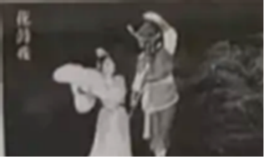
Face-changing
Face-changing, or bian lian in Chinese, is an important part of Sichuan Opera (Chuan Ju). It started about 300 years ago. It is one of the greatest treasures in traditional Chinese culture. Performers wear colored costumes and move to quick, dramatic music. They also wear colored masks and change from one mask to another with a movement of the head, or wave of the hand.
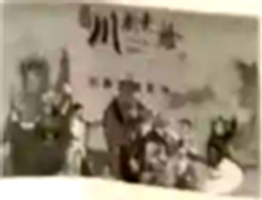
Crosstalk
Crosstalk, or xiangsheng in Chinese, is very popular in China. Many Chinese people like crosstalk because it makes them happy. Crosstalk is like a talk show. It makes people laugh with jokes or funny questions and answers.
Crosstalk first came out in North China. There are three forms of crosstalk: Dankou Crosstalk, Duikou Crosstalk and Qunkou Crosstalk.

阅读短文, 然后完成内容摘要。每空不超过三个单词。
Traditional Chinese art | Huaguxi | It originated in ____36____.  The early Huaguxi had two roles and only ____37____ could play in Huaguxi.
Traditional Chinese art | Face-changing | It is one of ____38____ in traditional Chinese culture.  Performers wear colored masks and change from one mask to another.
Traditional Chinese art | Crosstalk | It makes people ____39____ with jokes or funny questions and answers.  It has ____40____: Dankou Crosstalk, Duikou Crosstalk and Qunkou Crosstalk.

第四部分 写作技能 (四节, 共16小题, 满分40分)
A) 综合填空 (共5小题, 每小题1分)
阅读下面短文，根据语境、中文、首字母或所给单词的提示，在空白处填入一个恰当的词，要求所填的词意义准确、形式正确、使短文意思完整，行文连贯。
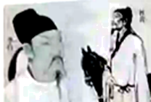
Li Bai was a great poet in the Tang Dynasty. He loved nature, especially big mountains and rivers. When he was 24 years old, he ____41____ (leave) home and traveled to Chengdu and Mount Emei, and then down the Yangtze River.
Li Bai wrote lots of poems about the beautiful mountains. He also wrote a lot about the ____42____ (月亮). These poems are loved by many Chinese people, f____43____ example Thoughts on a Tranquil Night (《静夜思》).
In his forties, Li Bai met another great poet, Du Fu, in Luoyang. They two became close friends. They traveled together for some time, visited other poets and had a great time. Li Bai gave Du Fu a lot of inspiration in the art of poetry. But ____44____ (they) poems were different. Li Bai’s poems were ____45____ (usual) about nature, while Du Fu wrote many poems to express the feelings of the ordinary people. They will always be remembered.
B) 补全对话 (共5小题, 每小题2分)
通读对话，根据上下文补全对话内容。
A: Hi, Li Hua. Junior high school life has come to an end. What are you going to do during this summer vacation?
B: _______46_______.
A: Sounds great. Longhui is a good place to visit in summer.
B: _______47_______?
A: It’s about 60 kilometers away from Shaoyang. _______48_______?
B: By car. My father will drive our family there.
A: That’s cool. By the way, why do you want to travel to Longhui?
B: Because I like the song Good morning, Longhui very much.
A: _______49_______?
B: I like it because it is full of positive energy and makes me feel relaxed and happy.
A: I agree. Wish you a good summer vacation.
B: _______50_______
C) 英汉互译 (共5小题, 每小题2分)
阅读下面短文，将文中画线的句子译成汉语或英语。
What do you like to do in your free time? 1. Different people have different answers. For the 3-grader Chen Yunxi, it’s rock climbing.
Chen is from Shenzhen. She is tall and thin, and has long black hair. 2. 像许多其他女孩一样，她最喜欢的颜色是粉色。But her hobby is very different—it’s rock climbing.
3. She started rock climbing when she was only four years old. She loves it so much that she trains very hard. Last November, 8-year-old Chen successfully finished the wild rock climbing route “CHINA CLIMB” in Yangshuo, Guangxi. That makes her the youngest climber in China to finish the 5.14A level climbing route.
4. 她有一个梦想。She wants to take part in the Olympics. She thinks that the happiest thing in the world is just to fight for her dream. 5. She says she will train hard to make her dream come true.
51. ____________________________________________
52 ____________________________________________
53. ____________________________________________
54. ____________________________________________
55. ____________________________________________
D) 情景作文 (共1小题, 满分15分)
56. 当前，全国儿童青少年近视率居高不下，习近平总书记对此高度重视并作出重要批示，教育部也于2023年3月30日印发了《2023年全国综合防控儿童青少年近视重点工作计划》。对于儿童青少年近视问题，你有何看法和建议。请你根据下面的提示，写一篇短文，告诉大家如何保护视力。
要求：
1. 包含提示中的所有要点，语言表达准确，语句通顺，可适当发挥；
2. 词数80左右，开头和结尾已给出，不计入总词数；
3. 请勿在文中出现真实的姓名、校名及地名。
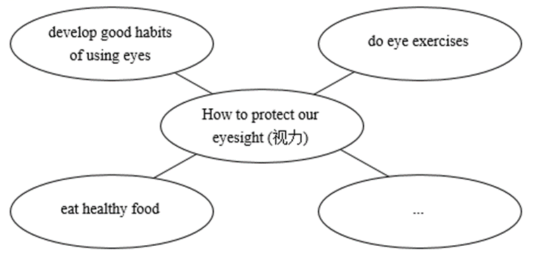
As we all know, eyes are very important to us. However, many students have poor eyesight. In order to protect our eyesight, we should follow these suggestions.
________________________________________________________________________________________________________________________________________________________________________________________________________________________________________________________________________________________________________________________________________________________________________________________________________________________________________________________________________________________________________________________________________________________________________________________________________________________________________________________________________________________________________________________________________________________________________________________
In a word, let’s take action to say goodbye to thick glasses.

