2023年邵阳市初中学业水平考试试题卷
英语
温馨提示:
第一部分 听力技能 (两节, 共20小题, 满分20分)
A) 反应根据你所听到的内容, 选择正确答语完成对话。每个句子读两遍。(共5小题每小题1分)
1. A. Good morning! B. Good afternoon! C. Good night!
2. A. Yes, I can. B. Thank you. C. Yes. I am.
3. A. No way. B. I don’t know. C. Yes, please.
4. A. English. B. It’s Monday. C. It’s an orange.
5. A. I have a cold. B. Miss Wang. C. A cat.
B) 理解根据你听到的对话或独白, 选择最佳答案回答问题。每段对话读两遍。(共15小题, 每小题1 分)
听下面的对话, 回答第6 至7小题。
6. How old is Cindy?
A. 13. B. 14. C. 15.
7. Where will Cindy have her birthday party?
A. At her house. B. At school. C. At the park.
听下面的对话, 回答第8至9小题。
8. What is Amy doing?
A. Drawing. B. Watching TV. C. Sleeping.
9. Who are listening to a CD?
A. Dave and Mary. B. John and Amy. C. Bob and Jenny.
听下面的对话, 回答第10至12小题。
10. What’s Molly good at?
A. Art. B. Music. C. Football
11. What’s Rick’s dad?
A. A football player. B. A teacher. C. A dentist.
12. How many kids are there in Rick’s family?
A. Three. B. Four. C. Five.
听下面的对话, 回答第13至16小题。
13. Why do they have to make dinner by themselves?
A. Because Mom is busy B. Because Mom is ill. C. Because Mom isn’t at home.
14. What is Bill’s plan?
A. To make fruit salad. B. To make rice noodles. C. To make chicken soup.
15. How much yogurt do they need?
A. One cup. B. Two cups. C. Three cups.
16. What are on the shopping list?
A. Ice-cream and milk. B. Orange juice and eggs. C. Bananas and pears.
听下面一段独白, 回答第17 至20 小题。独白读两遍。
17. What does Alan’s mother ask him to buy?
A. Bread. B. Milk. C. Honey.
18. Where is the birthday card?
A. In the kitchen. B. In the bedroom. C. In the living room.
19. What’s on the table in Alan’s mother’s bedroom?
A. Some money B. A hamburger. C. A card.
20. What time will Alan call his father?
A. At about 4:00 p.m. B. At about 5:00 p.m. C. At about 6:00 p.m.
第二部分知识运用 (两节, 共20 小题, 满分20 分)
A) 单项选择从A、B、C三个选项中选择最佳答案填空。(共10小题, 每小题1分)
1. —Hi, Wang Li, who is Miss Deng?
—Miss Deng is ________ nice teacher and she is very popular in our school.
A. a B. an C. /
【答案】A
【解析】
【详解】句意：——嗨，王丽，谁是邓小姐？——邓小姐是个好老师，在我们学校很受欢迎。
考查冠词。此处泛指“一个好老师”，nice以辅音音素开头，用不定冠词a。故选A。
2. —What animals did you see on the farm, Tom?
—I saw some ________.
A. rabbit B. ducks C. sheeps
【答案】B
【解析】
【详解】句意：——你在农场看到了什么动物，汤姆？——我看见一些鸭子。
考查名词的用法。rabbit兔子，名词单数；ducks鸭子，名词复数；sheeps表述错误。some修饰可数名词复数或不可数名词，故选B。
3. —Is Lucy in the classroom?
—Yeah. She is still there watching Mr. Li ________.
A. to draw B. drawing C. draws
【答案】B
【解析】
【详解】句意：——露西在教室里吗？——是的。她还在那儿看李老师画画。
考查非谓语动词。watch sb do sth看某人做某事（全过程或经常性）；watch sb doing sth看某人正在做某事。根据“She is still there watching Mr. Li...”可知，是正在进行的动作，故选B。
4. —I can’t find my shoes. Where are they, Mom?
—Oh one is under the bed, ________ is behind the door.
A. the other B. others C. another
【答案】A
【解析】
【详解】句意：——我找不到我的鞋子了。他们在哪里，妈妈？——噢，一只在床底下，另一只在门后面。
考查代词辨析。the other两者中的另一个；others其他人/物；another三者及以上的另一个。根据“one is under the bed, ...is behind the door”可知，此处是one...the other...结构，意为“一个……另一个……”。故选A。
5. —Ben, who is the boy in blue in the picture?
—It’s my brother. The picture ________ five years ago.
A. take B. is taken C. was taken
【答案】C
【解析】
【详解】句意：——Ben，照片上穿蓝衣服的男孩是谁？——这是我哥哥。这张照片是五年前拍的。
考查一般过去时的被动语态。本句主语是动作的承受者，结合时间状语“five years ago”可知，应使用一般过去时的被动语态。故选C。
6. —Is that Tom?
—No, that is Peter. Tom has ________ hair than Peter.
A. long B. longer C. the longest
【答案】B
【解析】
【详解】句意：——那是汤姆吗？——不，那是彼得。汤姆的头发比彼得的长。
考查形容词比较级。根据“than Peter”可知，应使用比较级，故选B。
7. —Hello, this is Lily speaking. Could I speak to Mr. Liu?
—Sorry, he ________ Changsha.
A. has been to B. will go to C. has gone to
【答案】C
【解析】
【详解】句意：——你好，我是莉莉。我可以和刘先生讲话吗？——对不起，他去长沙了。
考查has gone to的用法。has been to曾去过；will go to将会去；has gone to已经去了。根据“Sorry, he...Changsha.”可知，不能跟刘先生讲话，因为他去了长沙还没回来，故选C。
8. —What are you going to do this weekend?
—I’m not sure. I ________ go shopping.
A. must B. should C. may
【答案】C
【解析】
【详解】句意：——这个周末你打算做什么？——我不确定。我可能会去购物。
考查动词辨析。must必须；should应该；may可能。根据“I’m not sure.”可知，不确定，所以是不太肯定的推测，故选C。
9. —I’ve found a new pen, but I don’t know ________.
—It must be Lucy’s. She is looking for her pen.
A. whose is it B. whose it is C. who it is
【答案】B
【解析】
【详解】句意：——我找到了一支新钢笔，但我不知道它是谁的。——一定是露西的。她正在找她的钢笔。
考查宾语从句。此处是宾语从句，需用陈述语序，排除A；结合“It must be Lucy’s.”可知，询问是谁的笔，故选B。
10. —What do you think of the movie Wandering Earth Ⅱ (《流浪地球2》)?
—________. I have watched it three times.
A. I really enjoy it B. It’s terrible C. I can’t stand it
【答案】A
【解析】
【详解】句意：——你觉得电影《流浪地球Ⅱ》怎么样？——我真的很喜欢。我看了三遍。
考查情景交际。I really enjoy it我真的很喜欢；It’s terrible太糟糕了；I can’t stand it我受不了。根据“I have watched it three times.”可知，此处是肯定的评价，故选A。
B) 完形填空阅读短文, 掌握其大意, 从A、B、C三个选项中选择最佳答案填空。(共10小题, 每小题1分)
One day, a crow (乌鸦) saw a swan (天鹅) on the beach. The crow laughed at him and said, “Can you ___11___ as fast as I do? Do you have as many flying skills as I do? ___12___ stupid you are!”
Hearing this, the swan thought the crow needed to be taught a lesson. He had an idea.
He asked the crow. “Do you dare to ___13___ with me? The competition will take place in ___14___ stages (阶段). In the first stage, you can show your flying skills, and I will do the same. In the second stage, you should copy what I will do.”
The crow said proudly, “It’s too easy!”
The competition started. ___15___ the crow showed different ways of flying. But the swan could do nothing. Next, the second stage began. The swan flew to the ___16___. The crow followed him. “Is this all you can do?” the crow asked. The swan just flew silently. He flew slowly, but didn’t stop. After flying a long distance (距离), the crow was so ___17___ that he could hardly fly and almost fell into the sea.
Seeing this, the swan said to the crow. “You have flying skills, ___18___ I have good endurance (耐力). Everyone has his own strong and weak points. One should never think that he is perfect while others are all good for nothing.” After the crow ___19___ the swan’s words, his ____20____ turned red and hung his head. He regretted having laughed at the swan.
11. A. run B. jump C. fly
12. A. What B. How C. What a
13. A. compete B. talk C. argue
14. A. one B. two C. three
15. A. In the end B. At last C. At first
16. A. road B. mountain C. sea
17. A. tired B. strong C. successful
18. A. or B. and C. but
19. A. heard B. watched C. saw
20. A. hand B. face C. leg
【答案】11. C 12. B 13. A 14. B 15. C 16. C 17. A 18. C 19. A 20. B
【解析】
【导语】本文主要讲述了一只乌鸦嘲笑一只天鹅，天鹅通过一场比赛给了乌鸦一个教训。作者用这个故事告诉我们：不要拿自己的优点来嘲笑别人的缺点。
【11题详解】
句意：你能飞得和我一样快吗？
run跑；jump跳；fly飞。根据“Do you have as many flying skills as I do?”可知，二人要比飞行，故选C。
【12题详解】
句意：你真笨！
What强调的中心词是可数名词复数或不可数名词；How强调的中心词是形容词/副词；What a强调的中心词是可数名词单数。本句强调的中心词是形容词“stupid”，故选B。
【13题详解】
句意：你敢和我比赛吗？
compete比赛；talk谈论；argue争论。根据“The competition”可知，二人要比赛，故选A。
【14题详解】
句意：比赛将分两个阶段进行。
one一；two二；three三。根据“In the first stage, ... In the second stage, ...”可知，比赛分为两个阶段，故选B。
【15题详解】
句意：起初，乌鸦展示了不同的飞行方式。
In the end最后；At last最后；At first起初。根据“... the crow showed different ways of flying.”可知，起初乌鸦展示了不同的飞行方式。故选C。
【16题详解】
句意：天鹅飞向大海。
road道路；mountain山；sea海。根据“almost fell into the sea”可知，飞向大海，故选C。
【17题详解】
句意：飞了很长一段距离后，乌鸦累得几乎飞不起来了，差点掉进海里。
tired累的；strong强壮的；successful成功的。根据“the crow was so...that he could hardly fly and almost fell into the sea”可知，乌鸦很累，差点掉进海里，故选A。
【18题详解】
句意：你有飞行技术，但我有很好的耐力。
or或者；and和；but但是。分析“You have flying skills, ...I have good endurance (耐力).”可知，前后构成转折关系，用but连接，故选C。
【19题详解】
句意：乌鸦听了天鹅的话，脸变红了，低下了头。
heard听到；watched观看；saw看见。根据“the swan’s words”可知，听了天鹅的话，故选A。
【20题详解】
句意：乌鸦听了天鹅的话，脸变红了，低下了头。
hand手；face脸；leg腿。根据“his...turned red and hung his head”可知，乌鸦很羞愧，所以脸红了。故选B。
第三部分 阅读技能 (四节, 共20小题, 满分40分)
A) 正误判断 (共5小题, 每小题2分)
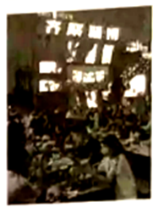
Zibo is in the middle of Shandong Province. In late February, some college students went to try the barbecue (烧烤) when they attended a job fair in the city. They took videos of themselves enjoying the food and posted onto social media. Zibo’s special barbecue has gone viral (走红) quickly. As a result, “college students going to Zibo for barbecue” and “taking a high-speed train to taste Zibo barbecue” have become hot topics on Chinese social media.
Xu Jiayue, a student from Shandong Transport Vocational College, came to Zibo to try the barbecue on Tuesday. “We use the stoves (火炉) to cook the meat, which gives us a feeling of achievement. We can eat the meat at a perfect temperature, so the food tastes delicious.” she said.
A total of 27,065 visitors arrived on March 4, setting a record for daily passengers arriving at the railway station in the past three years. Now, more and more people start to pour into Zibo to try its famous barbecue.
阅读短文，根据短文内容判断所给句子正 (T) 误 (F)。
21. In late February, some teachers tried the barbecue when they attended a job fair in Zibo.
22. Zibo has gone viral on Chinese social media for its special barbecue.
23. Xu Jiayue came to Zibo to try the barbecue on Friday.
24. The number of passengers arriving at the railway station on March 4 has set a record in the past three years.
25. Because of barbecue, Zibo has become a popular city.
【答案】21. F 22. T 23. F 24. T 25. T
【解析】
【导语】本文主要介绍了走红全国的淄博烧烤。
【21题详解】
细节理解题。根据“In late February, some college students went to try the barbecue (烧烤) when they attended a job fair in the city.”可知，2月下旬，一些大学生在参加该市的一个招聘会时去尝试烧烤，而不是一些老师尝试的。故选F。
【22题详解】
细节理解题。根据“They took videos of themselves enjoying the food and posted onto social media. Zibo’s special barbecue has gone viral (走红) quickly.”可知，他们拍下自己享受美食的视频，并发布到社交媒体上。淄博的特色烧烤迅速走红。故选T。
【23题详解】
细节理解题。根据“Xu Jiayue, a student from Shandong Transport Vocational College, came to Zibo to try the barbecue on Tuesday.”可知，周二，来自山东交通职业学院的学生许佳悦来到淄博尝试烧烤，而不是周五，故选F。
【24题详解】
细节理解题。根据“A total of 27,065 visitors arrived on March 4, setting a record for daily passengers arriving at the railway station in the past three years.”可知，3月4日，共有27065名游客抵达火车站，创下了过去三年来每天到达火车站的旅客人数的记录。故选T。
【25题详解】
推理判断题。根据“Now, more and more people start to pour into Zibo to try its famous barbecue.”可知，现在，越来越多的人开始涌入淄博品尝其著名的烧烤。所以“因为烧烤，淄博已经成为一个受欢迎的城市”表述正确，故选T。

B) 阅读图表阅读下面图表, 从A、B、C三个选项中选出最佳答案回答问题或完成句子。(共5 小题, 每小题2分)
A
Rubbish from a family in China
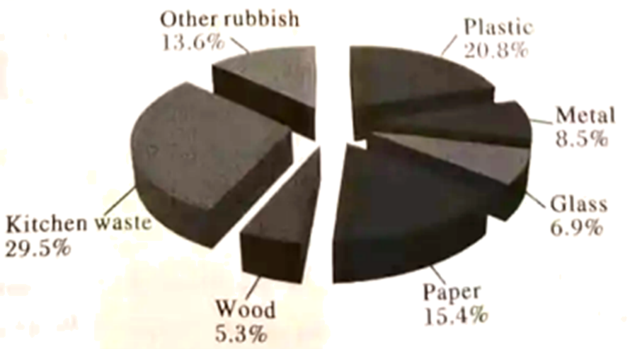
26. What kind of rubbish does the Chinese family produce most?
A. Wood. B. Plastic. C. Kitchen waste.
27. What percent of rubbish is paper?
A. 5.3%. B. 15.4%. C. 20.8%.
【答案】26. C 27. B
【解析】
【导语】本文以图表的形式介绍来自中国一个家庭的垃圾。
【26题详解】
细节理解题。根据图片内容可知，占比最多的垃圾是厨房垃圾，故选C。
【27题详解】
细节理解题。根据图片内容可知，废纸占垃圾的百分比是15.4%，故选B。
B
The 19th Asian Games Hangzhou will be held on September 23, 2023. Would you like to own the mascot (吉祥物) of the 19th Asian Games? If you order now, you can have your mascot before the opening ceremony. It will take you 4 to 6 days to get your mascot after you place an order. The order ends on September 17.
Price:
Number | Price | Handling (运费)
1 to 5 | ¥60 each | ¥10
over 5 | ¥50 each | ¥0
Order now online at our website (www. asianmascot. com).
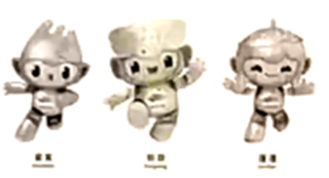

28. If Li Hua orders a mascot on September 5, he may receive it on ________.
A. September 10 B. September 17 C. September 23
29. We can order the mascot by ________.
A. making a phone call
B. visiting the website www.asianmascot.com
C. sending an email
30. How much should Alice pay if she buys 6 mascots?
A. ¥300. B. ¥360. C. ¥370.
【答案】28. A 29. B 30. A
【解析】
【导语】本文介绍第19届亚运会吉祥物的价格和订购方式。
【28题详解】
细节理解题。根据“It will take you 4 to 6 days to get your mascot after you place an order.”可知，在您下订单后，您需要4到6天的时间才能收到您的吉祥物。故选A。
【29题详解】
细节理解题。根据“Order now online at our website (www. asianmascot. com).”可知，可以在网站www. asianmascot. com上预订吉祥物，故选B。
【30题详解】
细节理解题。根据“over 5 ¥50 each ¥0”可知，预订6个吉祥物要付300元，故选A。
C) 阅读选择阅读短文, 从A、B、C三个选项中选出最佳答案回答问题或完成句子。(共5小题, 每小题2分)
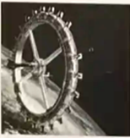
Are you dreaming of future travels to space? Your dream will come true soon.
It’s reported that people will have an “out-of-the-world” experience by staying at a hotel high above the earth in 2027.
The hotel is called Voyager Space Station (VSS). It is like a Ferris wheel (摩天轮). There will be rooms, restaurants, bars, gyms, reading rooms and scientific research laboratories. It’s eco-friendly (环保的) by getting power from the sun. It will have rooms for up to 400 people, including scientists, astronauts, and even some people to live there for a long time. You’ll pay 5 million dollars for each 3-day stay.
The hotel will serve traditional “space food”—like freeze dried ice cream. You’re going to have the top chefs making really good food. You can go on spacewalks to enjoy the beauty of the earth and space. You can enjoy 32 sunrises and sunsets each day.
“The building of the VSS will start in 2026 and welcome its first visitors in 2027. It will be the world’s first space hotel. We’re trying to make people realize that this golden age of space travel is just around the corner. It’s coming fast.” scientists say.
31. The Voyager Space Station (VSS) is ________.
A. a space hotel B. a space laboratory C. a kind of space food
32. If you pay 10 million dollars, you can stay at the Voyager Space Station for ________.
A. 3 days B. 6 days C. 9 days
33. The underlined word “chefs” in the passage means “________” in Chinese.
A. 设计师 B. 航天员 C. 厨师
34. Which of the following is NOT true?
A. The Voyager Space Station can get power from the sun.
B. People can enjoy 32 sunrises and sunsets each day at the Voyager Space Station.
C. The building of the Voyager Space Station (VSS) will start in 2027.
35. What’s the best title for the passage?
A. The world’s first space hotel B. The top chefs C. The beauty of the earth and space
【答案】31. A 32. B 33. C 34. C 35. A
【解析】
【导语】本文是一篇说明文，主要介绍旅行者空间站酒店VSS。
【31题详解】
细节理解题。根据“The hotel is called Voyager Space Station (VSS).”可知，这家酒店被称为旅行者空间站(VSS)。故选A。
【32题详解】
细节理解题。根据“You’ll pay 5 million dollars for each 3-day stay.”可知，每住三天，你要付500万美元。所以1000万美元可以住6天，故选B。
【33题详解】
词句猜测题。根据“You’re going to have the top chefs making really good food.”可知，你将有顶级厨师做真正美味的食物。此处chef的意思是“厨师”，故选C。
【34题详解】
细节理解题。根据“The building of the VSS will start in 2026 and welcome its first visitors in 2027.”可知，VSS将于2026年开始建设，2027年迎来第一批游客。故选C。
【35题详解】
最佳标题题。本文主要介绍旅行者空间站酒店VSS，故选A。
D) 信息摘录 (共5小题, 每小题2分)
Do you know about traditional Chinese art? There are many different kinds of traditional Chinese art and each different part of China has its own special kinds of traditional art
Huaguxi
Huguxi originated (起源) in Hunan Province. Some other provinces, like Hubei, Anhui, Henan, also have Huaguxi.
People could watch Huaguxi as early as the Qing Dynasty. There were only two roles in the early Huaguxi: chou and dan, and both roles were played by men. Now Huaguxi has more roles and women can play in Huaguxi.
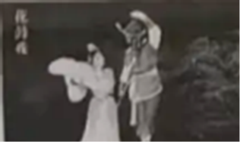
Face-changing
Face-changing, or bian lian in Chinese, is an important part of Sichuan Opera (Chuan Ju). It started about 300 years ago. It is one of the greatest treasures in traditional Chinese culture. Performers wear colored costumes and move to quick, dramatic music. They also wear colored masks and change from one mask to another with a movement of the head, or wave of the hand.
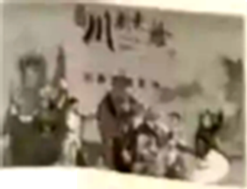
Crosstalk
Crosstalk, or xiangsheng in Chinese, is very popular in China. Many Chinese people like crosstalk because it makes them happy. Crosstalk is like a talk show. It makes people laugh with jokes or funny questions and answers.
Crosstalk first came out in North China. There are three forms of crosstalk: Dankou Crosstalk, Duikou Crosstalk and Qunkou Crosstalk.

阅读短文, 然后完成内容摘要。每空不超过三个单词。
Traditional Chinese art | Huaguxi | It originated in ____36____.  The early Huaguxi had two roles and only ____37____ could play in Huaguxi.
Traditional Chinese art | Face-changing | It is one of ____38____ in traditional Chinese culture.  Performers wear colored masks and change from one mask to another.
Traditional Chinese art | Crosstalk | It makes people ____39____ with jokes or funny questions and answers.  It has ____40____: Dankou Crosstalk, Duikou Crosstalk and Qunkou Crosstalk.

【答案】36. Hunan Province
37. men 38. the greatest treasures
39. laugh 40. three forms
【解析】
【导语】本文主要介绍了中国的传统艺术。
【36题详解】
根据“Huguxi originated (起源) in Hunan Province”可知花鼓戏起源于湖南省。故填Hunan Province。
【37题详解】
根据“There were only two roles in the early Huaguxi: chou and dan, and both roles were played by men”可知早期的花鼓戏只有两个角色：丑和旦，而且这两个角色都是由男人扮演的。故填men。
【38题详解】
根据“It is one of the greatest treasures in traditional Chinese culture”可知变脸是中国传统文化中最伟大的宝藏之一。故填the greatest treasures。
【39题详解】
根据“It makes people laugh with jokes or funny questions and answers.”可知相声通过笑话或有趣的问答让人们开怀大笑。故填laugh。
【40题详解】
根据“There are three forms of crosstalk: Dankou Crosstalk, Duikou Crosstalk and. Qunkou Crosstalk.”可知相声有三种形式：单口相声、对口相声和群口相声。故填three forms。
第四部分 写作技能 (四节, 共16小题, 满分40分)
A) 综合填空 (共5小题, 每小题1分)
阅读下面短文，根据语境、中文、首字母或所给单词的提示，在空白处填入一个恰当的词，要求所填的词意义准确、形式正确、使短文意思完整，行文连贯。
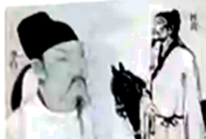
Li Bai was a great poet in the Tang Dynasty. He loved nature, especially big mountains and rivers. When he was 24 years old, he ____41____ (leave) home and traveled to Chengdu and Mount Emei, and then down the Yangtze River.
Li Bai wrote lots of poems about the beautiful mountains. He also wrote a lot about the ____42____ (月亮). These poems are loved by many Chinese people, f____43____ example Thoughts on a Tranquil Night (《静夜思》).
In his forties, Li Bai met another great poet, Du Fu, in Luoyang. They two became close friends. They traveled together for some time, visited other poets and had a great time. Li Bai gave Du Fu a lot of inspiration in the art of poetry. But ____44____ (they) poems were different. Li Bai’s poems were ____45____ (usual) about nature, while Du Fu wrote many poems to express the feelings of the ordinary people. They will always be remembered.
【答案】41. left
42. moon 43. (f)or
44. their 45. usually
【解析】
【导语】本文主要向我们介绍著名的诗人李白，以及李白和杜甫诗歌风格的差异。
【41题详解】
句意：24岁时，他离开家，到成都和峨眉山旅行，然后沿江而下。本句时态是一般过去时，动词用过去式，故填left。
【42题详解】
句意：他还写了很多关于月亮的文章。moon“月亮”，在介词后作宾语，故填moon。
【43题详解】
句意：这些诗歌受到许多中国人的喜爱，例如《静夜思》。for example“例如”，固定短语，故填(f)or。
【44题详解】
句意：但是他们的诗是不同的。此处作定语修饰“poems”，用形容词性物主代词形式，故填their。
【45题详解】
句意：李白的诗通常是关于自然的，而杜甫写了很多诗来表达普通人的感情。此处在句中作状语，用副词形式，故填usually。
B) 补全对话 (共5小题, 每小题2分)
通读对话，根据上下文补全对话内容。
A: Hi, Li Hua. Junior high school life has come to an end. What are you going to do during this summer vacation?
B: _______46_______.
A: Sounds great. Longhui is a good place to visit in summer.
B: _______47_______?
A: It’s about 60 kilometers away from Shaoyang. _______48_______?
B: By car. My father will drive our family there.
A: That’s cool. By the way, why do you want to travel to Longhui?
B: Because I like the song Good morning, Longhui very much.
A: _______49_______?
B: I like it because it is full of positive energy and makes me feel relaxed and happy.
A: I agree. Wish you a good summer vacation.
B: _______50_______.
【答案】46. I am going to visit Longhui
47. How far is it from Shaoyang
48. How will you get there
49. Why do you like it
50. Thank you
【解析】
【导语】本文是二人谈论暑假去哪里，怎么去以及为什么去等内容。
【46题详解】
根据“What are you going to do during this summer vacation?”和“Sounds great. Longhui is a good place to visit in summer.”可知，B打算去隆回度假，故填I am going to visit Longhui。
【47题详解】
根据“It’s about 60 kilometers away from Shaoyang.”可知，询问隆回离邵阳有多远，故填How far is it from Shaoyang。
【48题详解】
根据“By car. My father will drive our family there.”可知，询问要怎么去隆回，故填How will you get there。
【49题详解】
根据“I like it because it is full of positive energy and makes me feel relaxed and happy.”可知，此处询问为什么喜欢前文提到的歌曲，故填Why do you like it。
【50题详解】
根据“Wish you a good summer vacation.”可知，对于对方的祝愿应表示感谢，故填Thank you。
C) 英汉互译 (共5小题, 每小题2分)
阅读下面短文，将文中画线的句子译成汉语或英语。
What do you like to do in your free time? 1. Different people have different answers. For the 3-grader Chen Yunxi it’s rock climbing.
Chen is from Shenzhen. She is tall and thin, and has long black hair. 2. 像许多其他女孩一样，她最喜欢的颜色是粉色。But her hobby is very different—it’s rock climbing.
3. She started rock climbing when she was only four years old. She loves it so much that she trains very hard. Last November, 8-year-old Chen successfully finished the wild rock climbing route “CHINA CLIMB” in Yangshuo, Guangxi. That makes her the youngest climber in China to finish the 5.14A level climbing route.
4. 她有一个梦想。She wants to take part in the Olympics. She thinks that the happiest thing in the world is just to fight for her dream. 5. She says she will train hard to make her dream come true.
51. ____________________________________________
52. ____________________________________________
53. ____________________________________________
54. ____________________________________________
55. ____________________________________________
【答案】51. 不同的人有不同的答案。
52. Like many other girls, her favorite color is pink.
53. 她四岁时就开始攀岩了。
54. She has a dream.
55. 她说，她将努力训练，使她的梦想成真。
【解析】
【导语】本文是一篇记叙文，介绍Chen Yunxi的梦想。
【51题详解】
Different people不同的人，have有，different answers不同的答案。故填：不同的人有不同的答案。
【52题详解】
像许多其他女孩一样like many other girls，她最喜欢的颜色her favorite color，是粉色is pink。故填Like many other girls, her favorite color is pink.
【53题详解】
She她，started rock climbing开始攀岩，when she was only four years old当她四岁时。故填：她四岁时就开始攀岩了。
【54题详解】
她she，有一个梦想has a dream。故填She has a dream.
【55题详解】
She says她说，she will train hard她将努力训练，to make her dream come true使她的梦想成真。故填：她说，她将努力训练，使她的梦想成真。
D) 情景作文 (共1小题, 满分15分)
56. 当前，全国儿童青少年近视率居高不下，习近平总书记对此高度重视并作出重要批示，教育部也于2023年3月30日印发了《2023年全国综合防控儿童青少年近视重点工作计划》。对于儿童青少年近视问题，你有何看法和建议。请你根据下面的提示，写一篇短文，告诉大家如何保护视力。
要求：
1. 包含提示中的所有要点，语言表达准确，语句通顺，可适当发挥；
2. 词数80左右，开头和结尾已给出，不计入总词数；
3. 请勿在文中出现真实的姓名、校名及地名。
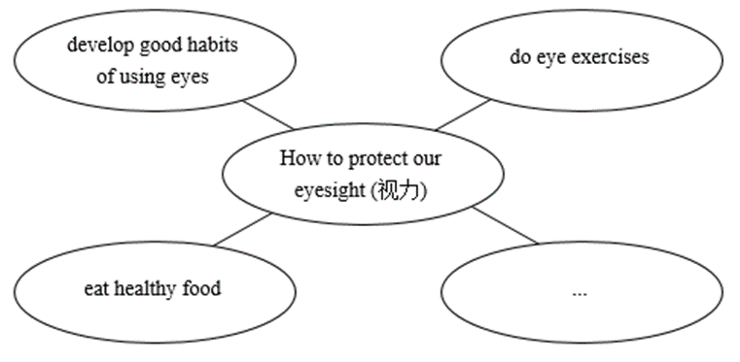
As we all know, eyes are very important to us. However, many students have poor eyesight. In order to protect our eyesight, we should follow these suggestions.
________________________________________________________________________________________________________________________________________________________________________________________________________________________________________________________________________________________________________________________________________________________________________________________________________________________________________________________________________________________________________________________________________________________________________________________________________________________________________________________________________________________________________________________________________________________________________________________
In a word, let’s take action to say goodbye to thick glasses.
【答案】例文
As we all know, eyes are very important to us. However, many students have poor eyesight. In order to protect our eyesight, we should follow these suggestions.
In my opinion, it’s important to have good eyesight. We should develop good habits of using our eyes. For example, we’d better take a break after reading for 45minutes. We can do eye exercises and do more sports. They are helpful to protect our eyesight. Eating healthy food is also good for protecting our eyesight. I hope we protect our eyes well so that we can see the colorful world.
In a word, let’s take action to say goodbye to thick glasses.
【解析】
详解】[总体分析]
①题材：本文是一篇材料作文；
②时态：时态为“一般现在时”；
③提示：写作要点已给出，要求根据提示内容呼吁人们保护视力，适当添加细节，并突出写作重点。
[写作步骤]
第一步，表明写作意图，引出对下文建议的介绍；
第二步，具体阐述写作内容，介绍如何保护视力；
第三步，书写结语。
[亮点词汇]
①In my opinion在我看来
②take a break休息一下
③be good for有益于
[高分句型]
①In my opinion, it’s important to have good eyesight.（It固定句型）
②I hope we protect our eyes well so that we can see the colorful world.（省略that宾语从句和so that引导的目的状语从句）

