2023年天水市初中毕业与升学学业考试（中考）
英语试卷

考生注意: 本试卷含听力，满分为150分，考试时间为120分钟、所有试题均在答题卡上作答，否则无效。
听力部分
Ⅰ.听力理解（分4小节，共20小题；每小题1分，满分20分）
第一节: 听句子，选择与所听内容相符的图片。每个句子读两遍。
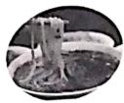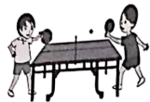
A B C D E
1. ________ 2.________3.________ 4.________ 5. ________
第二节: 听句子，选择恰当的应答语。每个句子读两遍。
6. A. Sounds good. B. Never mind. C. Thanks.
7. A. Math. B. Red. C. Monkeys.
8. A. Go ahead. B. OK, I will. C. You're welcome.
9. A. In English. B. To the park. C. On foot.
10. A. Sorry to hear that. B. Have fun. C. Happy birthday.
第三节: 听对话及问题，选择能回答所提问题的最佳答案。每段对话读两遍。
11. Who’s Cindy's best friend?
A. Peter. B. Helen. C. Bob.
12. Why will David go to Lanzhou?
A. To take an exam. B. To study there. C. To visit his friends.
13. Where does this conversation probably take place?
A. In a supermarket. B. In a bank. C. At home.
14. What's wrong with the boy?
A. He didn't get enough sleep.
B. He broke his leg.
C. He lost his keys.
15. How does Bob learn English?
A. By watching English movies.
B. By reading aloud.
C. By asking teachers for help.
第四节: 听短文，根据其内容选择能回答下列问题的最佳答案。短文读两遍。
16. How many people are there in the girl’s family?
A. 3. B. 4. C. 6.
17. What table manners are mentioned(提及) ?
A. Let the old eat first.
B. Don't eat with your hands
C. Don't talk with your mouth full.
18. What should the girl do first when she comes in the room?
A. Wash her hands. B. Take off the shoes. C. Change here clothes.
19. When could the girl hang out with friends?
A. On Tuesday. B. On Friday. C. On Saturday.
20. How does the girl like her family rules?
A. They are wonderful. B. They're terrible. C. Some of them are too strict.
笔试部分
Ⅱ.语法与情景对话（共20小题；每小题1分，满分20分）
阅读下列各题，从A、B.CD四个选项中选择一个最佳答案。
1. There are 60 minutes in ________ hour.
A. a B. an C. the D. /
【答案】B
【解析】
【详解】句意：一小时有六十分钟。
考查冠词。此处是表示泛指，且hour是以元音音素开头，应用an，故选B。
2. Put ________ first and be careful while riding on the road!
A. interest B. money C. knowledge D. safety
【答案】D
【解析】
【详解】句意：把安全放在第一位，在路上骑行时要小心！
考查名词辨析。interest兴趣；money钱；knowledge知识；safety安全。根据“be careful while riding on the road”可知路上骑车时要小心，要把安全放第一位。故选D。
3. —What’s thirty and ten?
—It’s ________.
A. forty B. fifty C. seventy D. eighty
【答案】A
【解析】
【详解】句意：——三十加十是多少？——四十。
考查数字运算。forty四十；fifty五十；seventy七十；eighty八十。根据“What’s thirty and ten”以及常识可知三十加十是四十。故选A。
4. That’s ________. That’s the man I was talking about.
A. me B. her C. him D. it
【答案】C
【解析】
【详解】句意：就是他。那就是我说的那个人。
考查代词辨析。me我；her她；him他；it它。根据“That’s the man I was talking about.”可知此处指男性，且表示“他”，需用代词him。故选C。
5. The cat in Picture ________ is on the box.
A. 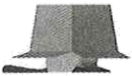 B. 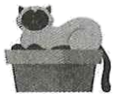 C. 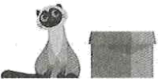 D. 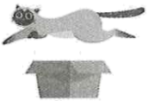
【答案】B
【解析】
【详解】句意：图片B中的猫在盒子上。
考查方位介词。图片A的猫在盒子里面；图片B在盒子上面且接触；图片C在盒子旁边；图片D在盒子上方且不接触，用over。on the box“在盒子上且接触”。故选B。
6. Let’s wait ________ the rain stops.
A. so B. while C. since D. until
【答案】D
【解析】
【详解】句意：让我们等雨停。
考查连词辨析。so因此；while然而；since自从；until直到……。根据“Let’s wait … the rain stops.”可知，此处指等着直到雨停，用until引导时间状语从句。故选D。
7. There ________ a big tree behind the shop. You can see many birds in it.
A. is B. are C. was D. were
【答案】A
【解析】
【详解】句意：商店后面有一棵大树。你可以在里面看到许多鸟。
考查时态和主谓一致。根据“There ... a big tree behind the shop.”可知陈述客观事实，用一般现在时，主语“a big tree”是单数，be动词用is。故选A。
8. —________ do you exercise?
—Every day
A. How many B. How old C. How much D. How often
【答案】D
【解析】
【详解】句意：——你多久锻炼一次？——每天。
考查疑问词辨析。How many多少，询问复数名词数量；How old多大年纪；How much多少，询问价格；How often多久一次，询问频率。根据“Every day.”可知，询问的是频率。故选D。
9. I ________ at 6 a. m. so I can leave for school at 7 a. m..
A. get up B. put up C. take after D. get on
【答案】A
【解析】
【详解】句意：我早上6点起床，所以我可以早上7点去上学。
考查动词短语。get up起床；put up张贴；take after长得像；get on上车。根据“at 6 a. m.”可知是早上六点起床。故选A。
10. I opened the door and all my friends shouted “Happy Birthday!” I had no idea they were coming. I was so ________.
A. interested B. surprised C. interesting D. surprising
【答案】B
【解析】
【详解】句意：我打开门，所有的朋友都喊道：“生日快乐！”我不知道他们要来。我很惊讶。
考查形容词辨析。interested感兴趣的；surprised感到惊讶的；interesting令人有趣的；surprising令人惊讶的。根据“I had no idea they were coming”可知不知道他们要来，所以很惊讶，修饰人，应用surprised，故选B。
11. ________ trying and do your best.
A. Keep B. Keeping C. To keep D. Kept
【答案】A
【解析】
【详解】句意：继续努力，尽你最大的努力。
考查祈使句。根据“and do your best”可知句子是祈使句，以动词原形开头。故选A。
12. I haven’t got time to wait. If you want to come with me, get dressed ________.
A. carefully B. loudly C. quickly D. heavily
【答案】C
【解析】
【详解】句意：我没时间等了。如果你想和我一起去，快点穿好衣服。
考查副词辨析。carefully认真地；loudly大声地；quickly快速地；heavily重地。根据“I haven’t got time to wait.”可知没时间等待，说明希望对方快点穿好衣服。故选C。
13. —I ________ find my keys.
—Have you checked in your jacket pockets?
A. mustn’t B. shouldn’t C. can’t D. wouldn’t
【答案】C
【解析】
【详解】句意：——我找不到我的钥匙了。——你检查过你的夹克口袋了吗？
考查情态动词。mustn’t禁止；shouldn’t不应该；can’t不能；wouldn’t将不。根据“Have you checked in your jacket pockets?”可知是自己不能找到钥匙，应用can’t。故选C。
14. —________ do you learn these words by heart?
—By using them in different ways.
A. When B. How C. Why D. Where
【答案】B
【解析】
【详解】句意：——你是怎么把这些单词背下来的？——通过以不同的方式使用它们。
考查特殊疑问句。when什么时候；how如何；why为什么；where哪里。根据“By using them...”可知此处询问方式，疑问词用how。故选B。
15. —Do you know ________?
—Yes, there’s one here. It’s in the store.
A. whom he is talking with B. when I can get to the hotel
C. how to use the machine D. if there’s a restroom around here
【答案】D
【解析】
【详解】句意：——你知道这附近有没有洗手间吗？——是的，这儿有一个。它在商店里。
考查宾语从句。whom he is talking with他正在和谁说话；when I can get to the hotel我什么时候能到达酒店；how to use the machine如何使用这台机器；if there’s a restroom around here这附近有没有洗手间。根据“Yes, there’s one here. It’s in the store.”可知此处询问是否有某物，D项符合语境。故选D。
16. If you heat ice, it ________ into water.
A. turns B. turned C. was turning D. has turned
【答案】A
【解析】
【详解】句意：如果你加热冰，它就会变成水。
考查动词时态。if引导的条件状语从句，遵循“主将从现”原则，但是主句是客观事实，还是用一般现在时。故选A。
17. That was the best meal I’ve ________.
A. ever been to B. ever chatted with C. ever read D. eaten in a long time
【答案】D
【解析】
【详解】句意：这是我很长时间以来吃过的最好的一顿饭。
考查动词辨析和短语。have been to去过；have chatted with和……聊天；have read已阅读；have eaten in a long time在很长一段时间吃过的。根据“the best meal”可知是指吃饭，故选D。
18. Which of the following is TRUE according to the right picture?
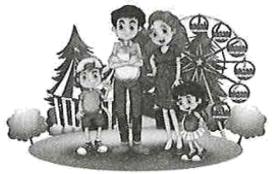
A. They are possibly in the kitchen of their house.
B. It seems that nobody is happy
C. They are probably a family.
D. The girl is taller than the boy.
【答案】C
【解析】
【详解】句意：根据右图，以下哪一项是正确的？
考查常识。根据常识可知，他们四个人在游乐场，两个成人两个孩子，由此可推知他们可能是一家人。故选C。
19. —Home is always the warmest place.
—________ East or west, home is the best.
A. I don’t think so. B. I’m afraid not.
C. I couldn’t agree more. D. I hope not.
【答案】C
【解析】
【详解】句意：——家永远是最温暖的地方。——我完全同意。金窝银窝，不如自己的草窝。
考查情景交际。I don’t think so我不这么想；I’m afraid not恐怕不行；I couldn’t agree more我完全同意；I hope not我希望不会。根据“East or west, home is the best.”可知是认同对方观点。故选C。
20. Which of the following shows that you can put your waste there?
A.  B. 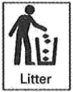 C. 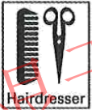 D. 
【答案】B
【解析】
【详解】句意：以下哪项表明你可以把废物放在那里？
考查常识和名词辨析。telephone手机；litter垃圾；hairdresser理发师；smoking allowed允许吸烟。根据常识可知，废物应放在垃圾桶内，B选项符合。故选B。
Ⅲ.完形填空（共10小题；每小题1.5分，满分15分）
阅读下面短文，从短文后各题所给的四个选项中选出能填入空白处的最佳答案。

Emily loved reading. She used to be very shy. She ___21___ talking to others. So she turned to ___22___. In 2019, her dad got sick. It was very serious. Books became an even bigger comfort for ___23___.
Emily’s dad got better. And she came up with a plan to ___24___ others.
Emily started a book drive in her hometown. She ___25___ books. She took them to ___26___ being cared for in hospitals. ___27___, she has collected more than 10,000 books.
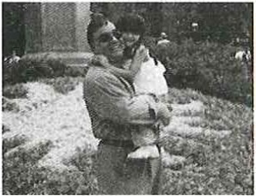
Emily and her father are very close. When her father learned of her plans for the book drive, he wasn’t surprised. “She was always interested in books,” he says. “___28___ she always wanted to do things for the neighborhood.” Emily runs the book drive herself, but she gets some help from her ___29___. “We do the driving,” her dad says.
Emily still runs the book drive. The memory of meeting the children she helps sticks with her. “It was the ____30____ day of my life,” she says. “I realized I wanted to do this type of work forever.”
21. A. was afraid of B. was interested in C. was good at D. was sorry for
22. A. music B. sports C. books D. stamps
23. A. me B. her C. him D. it
24. A. teach B. save C. move D. help
25. A. wrote B. collected C. read D. bought
26. A. kids B. men C. women D. newborns
27. A. In short B. Hardly ever C. So far D. On time
28. A. So B. Or C. But D. And
29. A. parents B. friends C. teachers D. neighbors
30. A. saddest B. best C. shortest D. strangest
【答案】21. A 22. C 23. B 24. D 25. B 26. A 27. C 28. D 29. A 30. B
【解析】
【导语】本文讲述了一位害羞的女孩发起了一场读书运动，帮助了他人也成长了自己。
【21题详解】
句意：她害怕和别人说话。
was afraid of害怕；was interested in对……感兴趣；was good at擅长……；was sorry for对……很抱歉。根据“She used to be very shy.”可知害怕，所以害怕和人说话。故选A。
【22题详解】
句意：于是她转向书本。
music音乐；sports运动；books书；stamps邮票根据“Books became an even bigger comfort”和“She was always interested in books,”可知Emily转向了书本。故选C。
【23题详解】
句意：书籍成了她更大的安慰。
me我；her她；him他；it它。根据“Books became an even bigger comfort for”可知书成了Emily的安慰，女性用代词her。故选B。
【24题详解】
句意：她想出了一个帮助别人的计划。
teach教；save节约；move移动；help帮助。根据“she always wanted to do things for the neighborhood.”可知是帮助他人的计划。故选D。
【25题详解】
句意：她收集书籍。
wrote写；collected收集；read阅读；bought买。根据“she has collected more than 10,000 books.”可知是收集书籍。故选B。
【26题详解】
句意：她把它们带给医院里的孩子们。
kids孩子们；men男人；women女人；newborns新生儿。根据“She took them to...being cared for in hospitals.”和“The memory of meeting the children she helps sticks with her.”可知是帮助孩子们。故选A。
【27题详解】
句意：到目前为止，她已经收集了1万多本书。
In short总而言之；Hardly ever几乎不；So far至今为止；On time准时。根据“she has collected more than 10,000 books.”可知本句是现在完成时，So far是其标志词。故选C。
【28题详解】
句意：她总是想为社区做点事。
So因此；Or或者；But但是；And和。根据“she always wanted to do things for the neighborhood.”可知此处是递进关系，需用and连接。故选D。
【29题详解】
句意：艾米丽自己负责募捐活动，但她也从父母那里得到了一些帮助。
parents父母；friends朋友；teachers老师；neighbors邻居。根据“‘We do the driving,’ her dad says.”可知是从父母那里得到了帮助。故选A。
【30题详解】
句意：“这是我一生中最美好的一天，”她说。
saddest最悲伤的；best最好的；shortest最短的；strangest最奇怪的。根据“I realized I wanted to do this type of work forever.”可知此处需填入褒义词，best符合语境。故选B。
Ⅳ.阅读理解(共15小题；每小题2分，满分30分)
A
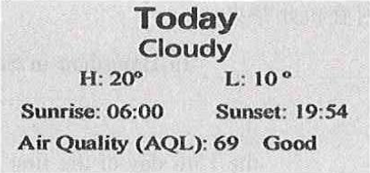
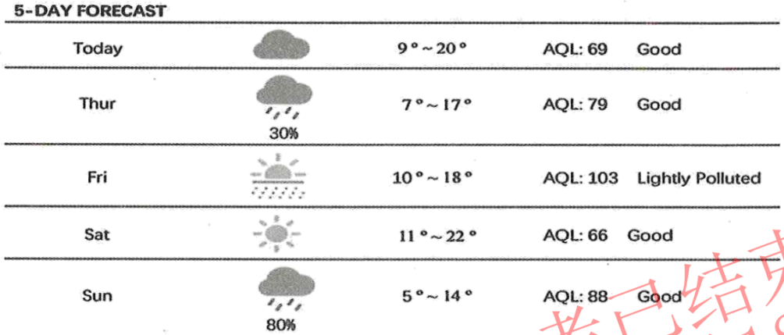
阅读以上天气预报，根据其内容判读下列句子正误。正确填（涂）A、错误填（涂）B。
31. The sun rises at 6 o’clock in the morning on Wednesday.
32. It may be rainy on Thursday.
33. Friday would be the best day for an outdoor soccer game.
34. Saturday will be sunny.
35. The night of Sunday will be the warmest.
【答案】31 A 32. A
33. B 34. A
35. B
【解析】
【导语】本文是一则天气预报。
【31题详解】
推理判断题。根据“sunrise：06:00”和“Thur”，可知，明天礼拜四，那么今天是礼拜三，早晨6点日出。故答案为A。
【32题详解】
细节理解题。根据图表可知，礼拜四可能会下雨。故答案为A。
【33题详解】
细节理解题。根据图表可知，礼拜六是晴天，会是户外足球运动的最佳选择，礼拜五可能会有阵雨，不是最佳选择。故答案为B。
【34题详解】
细节理解题。根据图表可知，礼拜六是晴天。故答案为A。
【35题详解】
细节理解题。根据图表可知，周日最低温度是五度，不是最温暖的。故答案为B。
B
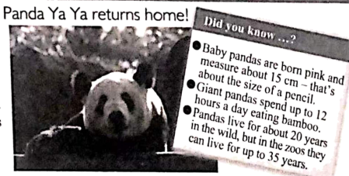
Ya Ya the giant panda has just arrived in Shanghai, east China on Thursday after 20 years of stay at the Memphis Zoo in the U.S. The flight was around 15.5 hours. Both Chinese and American vets are with Ya Ya.
Ya Ya was born at Beijing Zoo on August 3, 2000. She arrived at Memphis Zoo in April, 2003. YaYa has become a bridge of friendship between Chinese and foreign people. She will spend a month in Shanghai before returning to her birthplace, Beijing Zoo.
We do hope all pandas that are in foreign countries can be healthy and happy.
阅读以上材料，根据其内容回答其后各个小题。
36. Ya Ya had lived in U.S. for ________ years.
A. 5 B. 10 C. 15 D. 20
37. Ya Ya was born in ________.
A. Beijing B. Chengdu C. Shanghai D. Guangzhou
38. What color are new-born pandas?
A. Black and white. B. Pink. C. Yellow. D. Gray.
39. Which of the following is TRUE according to the passage?
A. Ya Ya is still a young panda now.
B. Shanghai Zoo is Ya Ya’s final home.
C. Ya Ya had a short flight coming back home.
D. Ya Ya helps foreigners know more about China.
40. This passage is ________.
A. a piece of news B. an ad C. a diary D. a letter
【答案】36. D 37. A 38. B 39. D 40. A
【解析】
【导语】本文是一则新闻，主要介绍了大熊猫“丫丫”返回中国以及熊猫的基本信息。
【36题详解】
细节理解题。根据“after 20 years of stay at the Memphis Zoo in the U.S.”可知大熊猫“丫丫”在美国待了20年。故选D。
【37题详解】
细节理解题。根据“Ya Ya was born at Beijing Zoo on August 3, 2000.”可知“丫丫”出生在北京。故选A。
【38题详解】
细节理解题。根据图片中内容“Baby pandas are born pink...”可知熊猫宝宝出生时是粉红色的。故选B。
【39题详解】
细节理解题。根据“YaYa has become a bridge of friendship between Chinese and foreign people. (丫丫已经成为中外人民友谊的桥梁。)”可知“丫丫”帮助外国人更多地了解中国。故选D。
【40题详解】
细节理解题。根据标题“Daily News”可知，最有可能新闻上看到本篇文章。故选A。
C
Pencils and Pens
No one knows who invented pencils or when it happened. A Swiss described a pencil in a book in 1565. He said it was a piece of wood with lead inside it. (Lead is a very heavy, soft, dark gray metal.) Pencils weren’t popular, and people continued to write with pens. They used bird feathers as pens.  Then, in 1795, someone started making pencils from graphite (石墨), and they became very popular. One pencil can write 50,000 English words or make a line 55 kilometers long.  People wrote with feather pens and then used pens with metal points. They had to dip (蘸) the point into ink after every few letters. Next, someone invented a fountain pen that could hold ink inside it. A fountain pen can write several pages before you have to fill it again.  Two Hungarian brothers, Ladislao and Georg Biro, invented the ballpoint pen. English pilots liked the pens. They couldn’t write with fountain pens in airplanes because the ink leaked out. Later, a French company called Bic bought the Biros’ company.  Some people call ballpoint pens “Bics.” Australians call them “Biros.” Whatever we call them, we use them every day. | 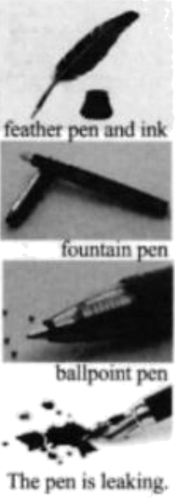
阅读以上材料，根据其内容回答其后各个小题。
41. A ________ described a pencil in 1565.
A. Canadian B. German C. Swiss D. Japanese
42. The first pens were ________.
A. feathers B. stone C. graphite D. wooden
43. One pencil can write ________ English words.
A. 1,795 B. 50,000 C. 55 D. 1,943
44. Which of the following is NOT true?
A. A fountain pen can hold ink inside it.
B. Ballpoint pen are good for writing in airplanes.
C. Fountain pens may leak ink.
D. Biros’ company bought Bic.
45. What’s the main idea of this passage?
A. We use pens and pencils every day.
B. There were many kinds of pens before ballpoint pens.
C. Pens and pencils are very useful inventions.
D. Pens were invented earlier than pencils.
【答案】41. C 42. A 43. B 44. D 45. C
【解析】
【导语】本文主要介绍了钢笔和铅笔的发展历史。
【41题详解】
细节理解题。根据“A Swiss described a pencil in a book in 1565”可知，一位瑞士人在1565年的一本书中描述了铅笔，故选C。
【42题详解】
细节理解题。根据“They used bird feathers as pens”可知，最早是用鸟的羽毛作笔，故选A。
【43题详解】
细节理解题。根据“One pencil can write 50,000 English words or make a line 55 kilometers long”可知，一支铅笔可以写5万个英语单词，故选B。
【44题详解】
推理判断题。根据“Later, a French company called Bic bought the Biros’ company.”可知，一家名为Bic的法国公司收购了Biros的公司，D表述错误，故选D。
【45题详解】
主旨大意题。通读全文可知，本文主要介绍了钢笔和铅笔这两种发明的发展历史，故选C。
V.任务型完形填空（共10空；每空1分，满分10分）
用方框中所给单词或短语的适当形式填空，使短文通顺、正确、连贯，每个单词或短语限用一次。
friend, or, silly, look up, you, a little, in, what, sometimes, have
Dear Li Ming,
How are you? My name is Mary. I’ve been looking forward to ___46___ a pen pal for a long time now. I hope we can become great ___47___!
Ever since I got your name and address from my teacher, Mrs. Brown, I have been thinking about ___48___ to write. First, I thought of telling ___49___ what it’s like to go to school here in London. But then, I thought you could ___50___ London on the internet and read about it yourself. And then I had the idea to tell you about my family, but I realized that the story of my little brother losing a tooth ___51___ the time we got a new kitten might be kind of boring. After that, I thought about asking you questions about what it’s like to live ___52___ Gansu, but I was afraid you might think my questions were ___53___.
I guess I can tell you ___54___ about myself. In fact, you’ve probably already learned one thing about me. I ____55____ have a hard time making up my mind! I hope you will write me back anyway.
Sincerely,
Mary

【答案】46. having
47. friends
48. what 49. you
50. look up
51. or 52. in
53. silly 54. a little
55. sometimes
【解析】
【导语】本文是玛丽写给李明的信，希望和对方成为笔友，并介绍自己的一些事情。
【46题详解】
句意：我盼望有一个笔友已经很久了。此空位于look forward to，应用动名词作宾语，结合选词可知have“有”的动名词having符合语境，故填having。
【47题详解】
句意：我希望我们能成为好朋友！根据“pen pal”可知希望对方和成为朋友，friend“朋友”，可数名词，此处应用复数，故填friends。
【48题详解】
句意：自从我从我的老师布朗夫人那里得到你的名字和地址后，我就一直在考虑写些什么。此处应该是“疑问词+动词不定式”的结构，结合选词可知what“什么”符合，故填what。
【49题详解】
句意：首先，我想告诉你在伦敦上学是什么感觉。根据“First, I thought of telling...what it’s like ”可知是告诉对方，应用第二人称you，故填you。
【50题详解】
句意：但后来，我觉得你可以在网上查一下伦敦，自己读一下。根据“I thought you could...London on the internet and read about it”可知是指上网查询一下伦敦，look up“查阅”，动词短语，could后加动词原形，故填look up。
【51题详解】
句意：然后我想告诉你我的家庭，但我意识到我弟弟掉牙的故事或者我们养了一只新小猫的故事可能有点无聊。根据“I realized that the story of my little brother losing a tooth...the time we got a new kitten might be kind of boring.”结合选词可知，两句话之间是选择关系，应用or“或者”，故填or。
【52题详解】
句意：在那之后，我想问你在甘肃生活是什么样的，但我担心你会认为我的问题很傻。根据“ what it’s like to live...Gansu”可知此处是固定短语live in“居住”，故填in。
【53题详解】
句意：在那之后，我想问你在甘肃生活是什么样的，但我担心你会认为我的问题很傻。此空应填形容词作表语，结合选词silly“愚蠢的”符合语境，故填silly。
【54题详解】
句意：我想我可以介绍一下我自己。根据“I guess I can tell you...about myself.”结合选项可知a little“一点”符合语境，故填a little。
【55题详解】
句意：我有时很难下定决心！此空应填作状语的词，结合选词可知sometime“有时候”符合语境，故填sometimes。
Ⅵ.任务型阅读理解（共5小题；每小题2分，满分10分）
阅读下面材料，并按要求完成1至5小题。
Fan Jinshi: Daughter of Dunhuang
The Mogao Grottoes are a very special place in China, which stand in Dunhuang, Gansu province. The Mogao Grottoes are thousands of years old and were listed as a world cultural heritage (遗产) by UNESCO in 1987.
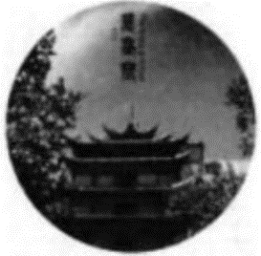
Many people, including archaeologists (考古学家) and researchers, work hard to take care of the Mogao Grottoes and learn more about them. Fan Jinshi is one of them.
Fan was born in Beijing on July 9, 1938. Her father was a graduate of Tsinghua University and had a strong interest in Chinese classical art and culture.
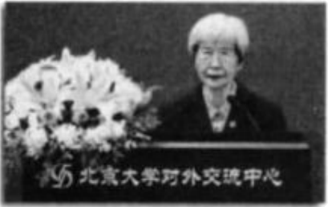
Influenced by her father, Fan liked visiting museums when she was in middle school. With the great love of Chinese culture, she studied in the archaeology department in Peking University and graduated in 1963. Then she started working at Dunhuang and has worked there ever since. She spends almost 60 years taking care of Dunhuang. People call her the “Daughter of Dunhuang.”
On May 4, 2023, “Daughter of Dunhuang” Fan Jinshi returned to Peking University and brought back 10 million RMB donations to set up the Fan Jinshi Education Fund (基金) to support the research of Dunhuang Studies at Peking University.
“Money made should be spent in the right way. People cannot only think of themselves,” she said. “Hopefully the setting of the Fund can help Dunhuang studies at the university, so it can raise cultural confidence and strength.”
阅读短文，根据其内容完成以下任务。
任务一：回答问题。
56. Who influenced Fan Jinshi to be interested in Chinese culture and decide to study archaeology?
_____________________________________________________________
57. Why do people call Fan Jinshi “Daughter of Dunhuang”?
_____________________________________________________________
任务二：列举一条有关the Mogao Grottoes的事实性信息（fact）。（用英语列举）
58. ______________________________________________________
任务三：根据短文最后一段补全下面句子。
59. Fan Jinshi hopes the Fund will _____________________________
任务四：填写以下信息卡中所缺的内容
60. __________上填写一词）
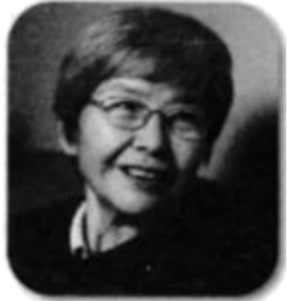 | Name: Fan Jinshi  Birthday: July 9, 1938  Country: China  Profession: Archaeologists  Workplace: the Mogao Grottoes  Education Background: graduated from Peking University in 1963  Personality: knowledgeable and (个性) 5 _________

【答案】56. Her father.
57. Because she spends almost 60 years taking care of Dunhuang.
58. The Mogao Grottoes stand in Dunhuang, Gansu Province.
59. help Dunhuang studies at the university.
60. helpful
【解析】
【导语】本文主要讲述了被誉为“敦煌女儿”的樊锦诗在保护莫高窟上所付出的努力和所做的贡献。
【56题详解】
根据“Influenced by her father, Fan liked visiting museums when she was in middle school.”可知，是受她爸爸的影响，故填Her father.
【57题详解】
根据“She spends almost 60 years taking care of Dunhuang. People call her the ‘Daughter of Dunhuang.’”可知，因为她花了近60年的时间来照顾敦煌，故填Because she spends almost 60 years taking care of Dunhuang.
【58题详解】
根据“The Mogao Grottoes are a very special place in China, which stand in Dunhuang, Gansu province.”可知，莫高窟位于甘肃敦煌，这是有关莫高窟的事实性信息，故填The Mogao Grottoes stand in Dunhuang, Gansu Province.
【59题详解】
根据“Hopefully the setting of the Fund can help Dunhuang studies at the university”可知，希望基金的设立能对敦煌大学的研究有所帮助，故填help Dunhuang studies at the university.
【60题详解】
根据“Fan Jinshi returned to Peking University and brought back 10 million RMB donations to set up the Fan Jinshi Education Fund (基金) to support the research of Dunhuang Studies at Peking University.”可知，带回了1000万元的捐款，成立了教育基金，支持北京大学的敦煌研究，由此可见她是有帮助的，故填helpful。

Ⅶ.口语交际（共5小题；每小题2分，满分10分）
阅读下面的对话，根据上下文，选择恰当的选项补全对话，使句意完整、符合逻辑。（其中有两项为多余选项）
(Li Ming is talking with an exchange student Tom. A is for Li Ming; B is for Tom.)
A: Hello, where are you from?
B: I’m from the United States.
A: Welcome to Gansu! Do you like it here?
B: I like it a lot here. ___61___ Are you a local here?
A: ___62___ I’m very proud of my hometown. There are many mountains and rivers in Gansu.
B: Really? I would love to see them. ___63___
A: Of course! We have many famous places of interest here, such as the Mogao Grottoes in Dunhuang, the Jiayuguan Great Wall, the Yellow River Stone Forest and so on. You can go there and enjoy the beauty of Gansu.
B: ___64___ I heard the food here is also very delicious, can you introduce me to some?
A: Of course! We have many local food, such as beef noodles, black bean soup, niangpizi, etc. ___65___
B: Thanks a lot.
A: You’re welcome. I am happy to share you something about my hometown.
A. Where is Gansu?
B. Yes, I was born and raised here.
C. No, I am from China.
D. Gansu is a very beautiful place.
E. You can go to local restaurants and taste them.
F. Can you tell me some places of interest?
G. Thank you very much for your advice.
【答案】61. D 62. B 63. F 64. G 65. E
【解析】
【导语】本文是一则对话，谈论内容主要关于甘肃的风景名胜和当地美食。
【61题详解】
根据“Welcome to Gansu! Do you like it here?”以及“I like it a lot here.”可知此处介绍自己喜欢甘肃，选项D“甘肃是一个非常美丽的地方。”符合语境，故选D。
【62题详解】
根据“Are you a local here?”以及“I’m very proud of my hometown.”可知自己是甘肃的当地人，选项B“是的，我在这里出生和长大。”符合语境，故选B。
【63题详解】
根据“Really? I would love to see them.”以及“We have many famous places of interest here,”可知是问对方甘肃的风景名胜，选项F“你能告诉我一些名胜古迹吗？”符合语境，故选F。
【64题详解】
根据“You can go there and enjoy the beauty of Gansu.”以及对方介绍了很多关于甘肃的内容，可知应该要表示感谢，选项G“非常感谢你的建议。”符合语境，故选G。
【65题详解】
根据“We have many local food, such as beef noodles, black bean soup, niangpizi, etc.”可知此处是介绍食物，选项E“你可以去当地的餐馆品尝。”符合语境，故选E。
Ⅷ.词汇考查（共10小题；每小题1分，满分10分）
根据句意，用括号内所给单词的适当形式填空。
66. Frank has more than 500 __________ (stamp).
【答案】stamps
【解析】
【详解】句意：弗兰克有500多张邮票。数词500后加可数名词复数stamps“邮票”。故填stamps。
67. It’s not my book. It’s __________ (her).
【答案】hers
【解析】
【详解】句意：这不是我的书。这是她的。根据“It’s not my book. It’s...”可知这是这本书是她的，空格后无名词，此处用名词性物主代词hers“她的”。故填hers。
68. Let me __________ (tell) you about my favorite book.
【答案】tell
【解析】
【详解】句意：让我告诉你我最喜欢的书。tell“告诉”，let sb. do sth.“让某人做某事”。故填tell。
69. Peter is __________ (young) than his sister May.
【答案】younger
【解析】
【详解】句意：彼得比他妹妹梅小。根据“than”可知此处用形容词的比较级younger“更年轻”。故填younger。
70. When mom came home, Danny __________ (play) the piano in the living room.
【答案】was playing
【解析】
【详解】句意：妈妈回家时，丹尼正在客厅弹钢琴。根据“When mom came home”可知丹尼当时正在客厅里弹钢琴，此处是含有when的过去进行时，主语是第三人称单数，be动词用was，故填was playing。
71. My teacher always offers us help __________ (patient).
【答案】patiently
【解析】
【详解】句意： 我的老师总是耐心地帮助我们。patient“耐心的”，此处修饰动词offers，应用副词patiently“耐心地”。故填patiently。
72. Our home is the __________ (three) from the end on the left.
【答案】third
【解析】
【详解】句意：我们的家在左边倒数第三个。根据“Our home is the...”可知是第三个，此处用序数词third“第三”。故填third。
73. You’re expected ______ (shake) hands when meeting people for the first time in China.
【答案】to shake
【解析】
【详解】句意：当你第一次在中国与人见面时，你应该握手。be expected to do sth“被期望做某事”，shake hands“握手”。故填to shake。
74. I __________ (learn) English ever since I was in Grade 3.
【答案】have learned
【解析】
【详解】句意：我从三年级就开始学英语了。此句为since引导的时间状语，用现在完成时“have/has+过去分词”表示过去发生的动作，持续到现在，也许还要继续下去，主语为I，助动词用have。故填have learned。
75. ChatGPT, an AI chatbot, was __________ (develop) by OpenAI and met the public in November, 2022.
【答案】developed
【解析】
【详解】句意：ChatGPT是由OpenAI开发的人工智能聊天机器人，于2022年11月与公众见面。develop“开发”，动词，和主语之间是被动关系，动词用过去分词，故填developed。
Ⅸ.根据所给汉语提示完成句子。（共5小题；每空1分，满分10分）（每空限填一词）
76. 我们将一起努力实现梦想。
We’ll work together to make our dreams __________ __________.
【答案】 ①. come ②. true
【解析】
【详解】根据中英文对照可知，空处应填come true表示“实现”，此处应用不带to的不定式作宾语补足语。故填come；true。
77. 每日练习对学习英语来说很重要。
It’s __________ to __________ English every day.
【答案】 ①. important ②. practice##practise
【解析】
【详解】重要的：important；练习：practice/practise，动词不定式符号to后加动词原形。故填important；practice/practise。
78. 第19届亚运会将于2023年9月在杭州举办。
The 19th Asian Games will __________ __________ in Hangzhou in September, 2023.
【答案】 ①. be ②. held
【解析】
【详解】根据中英文对照可知，hold表示“举办”，动词，和主语之间是被动关系，结合will可知应用一般将来时的被动语态will be done。故填be；held。
79. 元宵节在农历正月十五。
The Lantern Festival __________ __________ the 15th day of the first lunar month.
【答案】 ①. is##falls ②. on
【解析】
【详解】句子陈述一般事实，用一般现在时，on后接具体的时间，谓语动词可为be动词或fall，主语the Lantern Festival“元宵节”为第三人称单数，谓语动词用三单。故填is/falls；on。
80. “林业英雄”郭万刚在过去的四十年里在腾格里沙漠上建起了一道绿色屏障。
Guo Wangang, the forestry hero, __________ __________ a green belt in the Tengger Desert over the past 40 years.
【答案】 ①. has ②. built
【解析】
【详解】建立：build，根据“over the past 40 years”可知句子用现在完成时have/has done，主语是Guo Wangang，助动词用has。故填has；built。
X.书面表达（满分15分）
81. 假设你是李辉。你校英语报“Protect the Environment”专栏面向全校学生征集主题海报及宣传稿，需要用英语向大家宣讲环保的意义及作为中学生怎样保护环境。请你根据以下海报提示，以Save the Earth: Let’s Do Our Part!为题，用英语给专栏写一篇稿件。
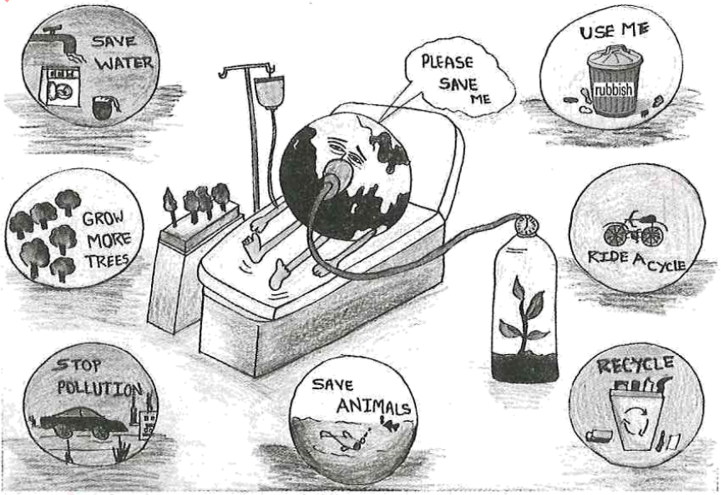
要求：1. 包括提示中所有的写作要点；
2. 条理清楚，行文连贯，可适当发挥；
3. 稿件中不能出现真实的人名和地名等信息；
4. 词数：80左右。题目和开头已给出，不计入总词数。（不用抄写在答题卡书面表达作答区域。）
Save the Earth: Let’s Do Our Part!
The earth is the only home for everyone on it. It’s crying for our help now. _____________________________
_______________________________________________________________________________________________
_______________________________________________________________________________________________
_______________________________________________________________________________________________
_______________________________________________________________________________________________
_______________________________________________________________________________________________
【答案】例文
Save the Earth: Let’s Do Our Part!
The earth is the only home for everyone on it. It’s crying for our help now. As middle school students, we have the power to make a difference and help save the earth!
To protect the earth, we can start by saving water, planting more trees, and reducing pollution. We can also save animals and recycle whenever possible.
We can also choose to ride a bike instead of driving a car to help stop pollution, and make sure to always throw trash in the proper bins. By doing our part, we can make a positive impact on the environment and create a better future for ourselves and generations to come.
【解析】
【详解】[总体分析]
①题材：本文是一篇说明文，为看图作文；
②时态：时态为“一般现在时”；
③提示：根据所给提示完成写作，不能遗漏信息，以第一人称为主。
[写作步骤]
第一步，承接开头，呼吁大家保护地球；
第二步，具体阐述作为中学生怎样保护环境；
第三步，最后宣讲环保的意义。
[亮点词汇]
①make a difference很有影响
②instead of代替
③make a positive impact on对……产生积极影响
[高分句型]
①To protect the earth, we can start by saving water, planting more trees, and reducing pollution.（动词不定式作目的状语）
②By doing our part, we can make a positive impact on the environment and create a better future for ourselves and generations to come.（动名词作宾语）

