贵州省2023年初中学业水平考试（中考）试题卷
英语（其他市、州卷）
同学你好! 答题前请认真阅读以下内容:
1. 全卷共8页, 五个部分, 满分150分, 考试时间为120分钟, 考试形式为闭卷。
2. 请在答题卡指定位置作答, 在试题卷上答题视为无效。
3. 选择题均为单项选择, 多选不得分。
第一部分听力（共五节, 30个小题; 每小题1分, 满分30分）
第一节听对话, 选择相应的图片。（读一遍）
1 A.  B. 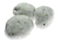 C. 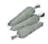
2. A.  B. 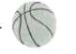 C. 
3. A.  B.  C. 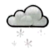
4. A. 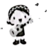 B. 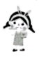 C. 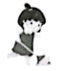
5. A.  B.  C. 
6. A.  B. 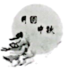 C. 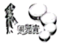
第二节听句子, 选择最佳应答。（读一遍）
7. A. Yes, I will. B. Yes, I did. C. Yes, I can.
8. A. Once a week. B. Two days ago. C. In five days.
9. A. Never mind. B. Sounds good! C. Here you are.
10. A. It's on Friday. B. It's relaxing. C. It's crowded.
11. A. What a pity! B. It doesn't matter C. You're welcome.
12. A. I'm looking for a hat. B. They're nine dollars. C. The prices are good.
第三节听对话, 选择最佳选项完成句子。（读两遍）
13. Lily's purple dress is made of___________.
A. silk B. cotton C. plastic
14. The topic of the conversation is___________.
A. food safety B. Internet safety C. traffic safety
15. Shelly listed___________ ways to help protect the environment.
A. two B. three C. four
16. The telephone was invented in___________.
A. 1867 B. 1876 C. 1885
17. Dale is going to___________ after class.
A. look after his sister B. go to the library C. watch a documentary
18. Tom___________ in an old people's home last month.
A. shared his stories B. wrote a song C. played the erhu
第四节听对话, 根据对话内容及问题, 选择最佳选项。（读两遍）
听下面一段对话, 回答第 19、20题。
19. What will Mike do on Saturday afternoon?
A. Take a tennis class. B. See a film. C. Tidy his room.
20. When will Mike and Julia meet on Sunday?
A. At 9:30. B. At 9:45. C. At 10:00.
听下面一段对话, 回答第21、22题。
21. How many times has Ms. Smart been to Miao Villages?
A. Twice. B. Three times. C. Four times.
22. What's the probable relationship between Ms. Smart and Tony?
A. Director and actress. B. Tourist and guide. C. Teacher and student.
听下面一段对话, 回答第23、24题。
23. What are Mary's favorite snacks?
A. Ice creams. B. Candies. C. Biscuits.
24. Where are the two speakers?
A. At the museum. B. At the bank. C. At the dentist's.
第五节 听短文, 完成表中所缺信息, 每空仅填一词。（读三遍）
Xu Fengean-An Excellent 25.________ Pilot
Personal information | Age: twenty-four years old
Personal information | Hometown: Jinhua, Zhejiang
Personal information | Hobbies: 26._______and writing  Talents: sports, especially running
Experience | joined the army in 27.________  28.________ in the PLA Aviation School
Achievement | can perform a solo flight  has grown into a 29.________ pilot
Motto | "Just hold on a little 30._______ , and I'll make it."
第二部分 完形（共两节, 满分20分）
第一节（共5个小题; 每小题1分, 满分5分）
阅读下面短文，从框内6个选项中选出能分别填入5个小题空白处的最佳选项。
A. if B. in C. activities D. this E. so F. different
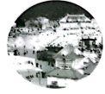
Every year, on January 5th, the city of Harbin in northeast China changes into a winter wonderland. Tourists from all around the world come to visit ___1___ wonderful ice and snow festival.
The festival started in 1963 and began as a winter party. The festival often lasts for one month. However, ___2___ the weather stays cold and dry, it will go on for a few more days. Temperatures are usually very cold. They can go down to -17℃.
Ice sculptors(雕塑家) use ___3___ tools to carve the hard ice and snow. These sculptors display their works ___4___ two main areas. “Sun Island” has huge snow sculptures of people and animals. “Ice and Snow World” has sculptures of buildings. At night, these buildings light up with brightly-colored lights.
Visitors can do a lot of other ___5___, such as skiing and ice sliding. They can also go swimming in the icy waters of the Songhua River.
第二节（共10个小题; 每小题1.5分, 满分15分）
阅读下面短文，从短文后各题所给的A、B、C三个选项中，选出可以填入各题空白处的最佳选项。
A gentleman needed a young man to help him in his office, so he put an advertisement in a newspaper. Nearly fifty people applied for the job. He in a short time ___6___ one and sent the rest away.
“I should like to know,” said a friend, “why did you ___7___ that young man, who didn’t bring a recommendation(推荐信) with him?”
“You are mistaken,” said the gentleman. “He had a great many.”
“He wiped his feet at the door and ___8___ the door after him, showing that he was tidy and orderly.”
“He gave up his seat immediately to that old man, indicating that he was ___9___ and thoughtful.”
“He took off his cap when he came in and answered my questions without delay(延迟) showing that he was polite and a ___10___ thinker.”
“He lifted up the book which I had purposely laid on the floor, and ___11___ it on the table, while all the rest stepped over it, or kicked it aside, showing that he was careful.”
“And he waited ___12___ for his turn instead of pushing the others aside, indicating that he was modest(谦逊的).”
“When I talked with him, I noticed that his ___13___ was carefully washed, his hair in nice order, and his teeth as white as milk. When he wrote his ___14___, I observed that his fingernails were clean.”
“Don’t you call these ___15___ letters of recommendation? I do and what I can tell about by using my eyes for ten minutes is worth more than all the fine letters he can bring to me.”
6. A. missed B. chose C. described
7. A. thank B. interview C. prefer
8. A. closed B. repaired C. painted
9. A. honest B. calm C. kind
10. A. quick B. careful C. friendly
11. A. covered B. placed C. weighed
12. A. worriedly B. excitedly C. quietly
13. A. shirt B. bike C. umbrella
14. A. name B. diary C. score
15. A. opinions B. qualities C. feelings
第三部分阅读（共三节, 满分50分）
第一节（共12个小题; 每小题2.5分, 满分30分）
阅读下面三个语篇, 从每题所给的A、B、C三个选项中, 选出各题的最佳选项。
A
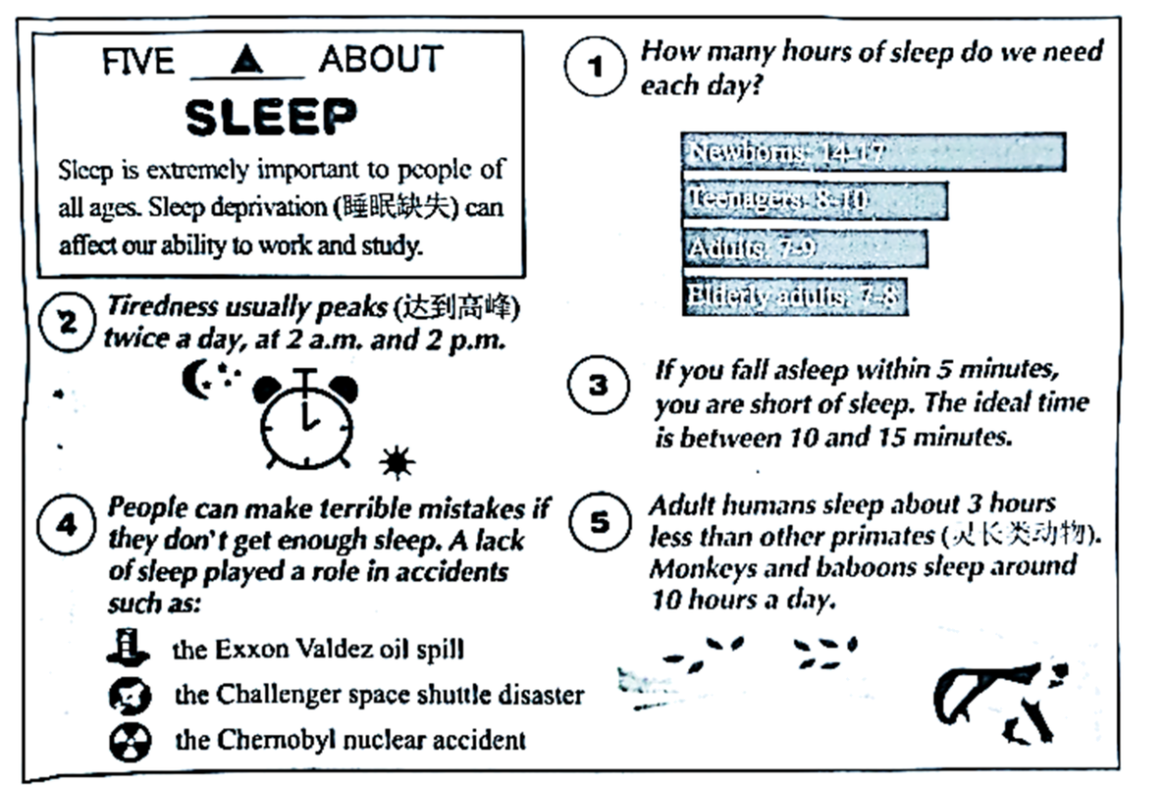
16. How long do teenagers need to sleep at least every day?
A. Seven hours. B. Eight hours. C. Nine hours.
17. What time do people feel the sleepiest during a day?
A.  B. 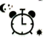 C. 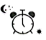
18. The writer proves a lack of sleep plays a role in accidents by ________.
A. asking questions B. listing numbers C. giving examples
19. Which of the following can be put in ▲ ?
A. SUGGESTIONS B. FACTS C. PROBLEMS
B
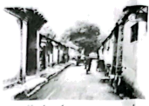
The old lanes(巷子) of the Beijing hutongs, many were there hundreds of years ago during the Ming and Qing dynasties. They keep not only the traditional culture but also the way of life in the past. People can go shopping, eat delicious food, and watch the street life by visiting the Beijing hutongs. What’s more, it’s a good way to learn more about the daily life of people in Beijing.
A hutong is a lane formed by traditional courtyard compounds(筑有围墙的院子) on both sides. The compounds are called siheyuan, meaning “four joined-together courtyard.”
The hutongs have interesting names, which tell their origin(起源), location, or history. They are in these gray lanes where kids talk and play.
One of China’s most famous writers, Laoshe, was born in siheyuan in the west of the city. The memories of his childhood in hutongs were so important to him that even after he had been away from Beijing for more than 20 years, he still clearly remembered them and wrote them into a novel called Four Generations under One Roof.
Now, Beijing still has about 400,000 siheyuan for people to live in. However, most hutongs are in great danger because more and more new buildings have been built. So, we should try our best to protect hutongs, the treasure of traditional culture.
20. What can we learn about the Beijing hutongs?
A. They have a short history.
B. They are far from siheyuan.
C. They have interesting names.
21. The writer would most probably talk about _________ after Paragraph 5.
A. how we can know the Beijing hutongs better
B. what we can do to protect the Beijing hutongs
C. why many new buildings were built in Beijing
22. What could be the best title for the text?
A. Laoshe—A Well-known Chinese Writer
B. Beijing Hutongs—The Treasure of China
C. Siheyuan—A Picture of the Qing Dynasty
23. We may read this text from the section of _________ in a newspaper.
A. Culture Window B. Famous People C. Eating Customs
C
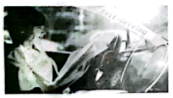
Could you imagine being in a car driven by a computer, not a human? Recently, China has made a big step toward self-driving technology. Since August 2022, driverless taxis can run on roads in Wuhan, Chongqing and Shenzhen.
Why do we develop self-driving cars?
Self-driving cars bring us many benefits. They use computers to sense the things around them and make better use of space. This means fewer traffic jams and better parking of cars. For disabled or blind people, self-driving cars can also help them get around more easily.
According to official statistics, each year, more than 1.35 million people are killed on roads around the world, and more are injured. It’s reported that self-driving cars could reduce road accidents by 90 percent and save governments a lot of money. The main cause of car accidents is human error(错误). By using computers, self-driving cars don’t make poor decisions or lose focus like humans do.
But self-driving cars aren’t perfect. If something unexpected on the road happens, self-driving cars can’t react(反应) as fast as a human driver could. Also, during weather events like heavy snow, self-driving cars wouldn’t see the lines on the road easily. It might lead to an accident. The car’s computer system would be broken by someone, causing it to crash or change its direction.
It’s clear that there is still a long way to go to make self-driving cars a common and safe sight(景象) on our roads. And China is taking the lead in making this happen, said China Daily.
24. What does the underlined word “They” in Paragraph 3 refer to?
A. Disabled people. B. Self-driving cars. C. Taxi drivers.
25. What do we know about self-driving cars?
A. They cannot make good use of space.
B. They always react faster than humans.
C. They do not lose focus like humans do.
26. We can infer(推断) that China ________ in self-driving technology.
A. will make greater progress
B. aided many other countries
C. is going to cut its total costs
27. The writer writes the text to ________.
A. encourage more people to buy self-driving cars
B. tell people several advantages of self-driving cars
C. introduce the present situation of self-driving cars
第二节（共5个小题;每小题2分,满分10分）
根据短文内容，从6个选项中选出能分别填入5个小题空白处的最佳选项。
Do you know what your IQ is? You can find out by taking a test. But what about your EQ（情商）? ___28___
EQ is a measure of your ability to recognize（辨别）and manage your emotions, as well as the emotions of others, according to Psychology Today.
Simply put, having a high EQ means that you’re a “people” person. You know yourself very well and you can easily understand others. ___29___ They are the ability to recognize your own emotions; the ability to use those emotions to solve problems; and the ability to manage emotions, such as by calming yourself down when you' re feeling nervous.
Does it seem obvious to you that having a high EQ can be a good thing? ___30___ They show great social skills, especially when they take up jobs that need them to deal with strangers often. According to MindTools, an online resource for career skill-building, many companies are now using EQ tests when interviewing new staff.
___31___ For example, when two friends have an argument, people with a high EQ can “read” the other person’s emotions and know when and how to stop the argument, perhaps by ending it in a humorous way.
If you feel like you have a low EQ, don’t worry. ___32___ A good way is using positive thinking to help you get out of failures. By doing so, you can improve your EQ gradually.
A It’s possible to improve it.
B. Do you know what EQ is?
C. A low EQ will make us get into trouble.
D. Many experts divide EQ into three skills.
E. People with a high EQ perform much better at work.
F. Having a high EQ can help you in everyday life as well.
第三节（共5个小题; 每小题2分, 满分10分）
阅读下面短文，根据其内容填空和回答问题。
WRITING SYSTEMS
Topic overview  There are two main kinds of writing systems.  ·alphabets(字母表)  ·pictures  Basic information  Alphabet writing systems  Some writing systems use alphabets. Alphabet writing systems use letters to tell you what sounds to make. Arabic and English both use an alphabet. There are 26 letters in the English alphabet and 28 letters in the Arabic alphabet. The first alphabet started in the Middle East 3,000 years ago. The English and Arabic alphabets both come from this alphabet.  Picture or symbol writing systems  Some writing systems use pictures or symbols to show the meaning of words. Picture writing started 5,000 years ago in the Middle East. Modern Chinese also uses a picture writing system today. Japanese uses some of the symbols from the Chinese picture system. For example, the Chinese word for fish is “yu” and the Japanese word is “sakana”, but both languages write it in the same way. There are thousands of symbols in picture writing systems -you have to learn 4,000 symbols to read Chinese. | Writing systems and change  Languages sometimes change their writing systems. Before 1423, the Korean language used the Chinese picture system. In 1423, the Koreans invented their own alphabet system. Now Korean uses an alphabet system. Turkey also changed its writing system. Before 1928, Turkish used the Arabic alphabet. Today it uses an alphabet like English, but with some extra symbols, like “ş” and “ç”.  Do you use symbols?  Today, in many languages, we use symbols to explain what we mean. For example, many people use symbols likeandwhen they write text messages or emails. These symbols show how we feel. They are called emoticons(表情符号) because they tell people about our emotions.  See also:  Ancient civilizations: Middle East, China  Languages: Arabic, Chinese, English, Japanese, Korean,  Turkish  writing system: the way of writing a language  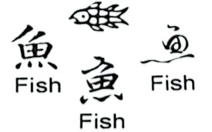
  ·First writing system: 3,000 BCE
  (Before Common Era)
  ·First alphabet system: 2000-1,000 BCE
  ·Chinese writing system: from 1,000 BCE

33. The records show that the ___________ was invented in 3,000 BCE. (答案不超过3个单词)
34. Both the first alphabet and the picture writing started in ___________. (答案不超过3个单词)
35. Some of the Japanese symbols ___________ the Chinese picture system. (答案不超过3个单词)
36. Korean changed its writing systems ___________ years earlier than Turkish. (答案不超过3个单词)
37. Do you like using emoticons such asand? Why or why not? (须用完整句子回答。)
_________________________________________________________________________
第四部分语言运用（共两节, 满分25分）
第一节（共5个小题; 每小题2分, 满分10分）
根据中文意思, 补全英语译文。（每空限填一词, 缩写算一词）
38. 《山行》是一首多么美的诗啊！
________ ________ beautiful poem Going up the Hill is!
39. 向他人学习并自我提升对我们极其重要。
________ ________ others and improving ourselves is essential for us.
40. 梵净山因其令人叹为观止的风光吸引大量的游客。
Mount Fanjing attracts ________ ________ tourists for its amazing scenery.
41. 事虽难，做则必成。
Difficult as the task is, ________ ________ get the job done if we keep working at it.
42. 中国科学家屠呦呦发现了一种治疗疟疾的有效药物。
Tu Youyou is the Chinese scientist ________ ________ an effective drug against malaria.
第二节（共10个小题; 每小题1.5分, 满分15分）
阅读下面短文，在各题空白处填入1个适当的单词或括号内单词的正确形式。
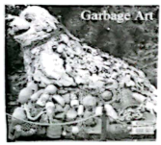
Each year, billions of pounds of garbage end up in the oceans. Sometimes people throw away water ___43___ (bottle) or other plastic. They do not recycle their garbage. People may not know that wind ___44___ rain can move garbage from land to sea. Plastic takes a very long time to break down. It can remain in the oceans ___45___ hundreds of years. Plastic pieces are very ___46___ (danger) to sea animals.
One group, Washed Ashore, came up with a new idea ___47___ (tell) people about the problems in the oceans. First, they take the garbage from ___48___ beach. Then, they clean and sort it. ___49___ (final), they work with the plastic pieces to make huge works of art. The artwork is mostly of sea creatures (生物).
Washed Ashore has ___50___ (create) more than seventy of these works of art. Some of ___51___ (they) are now traveling in a show all over the world. Each piece shows the effects of trash.
In one show, people learn how plastic fools fish and other sea animals. They think the plastic ___52___ (be) food, eat it, and get very sick or even die.
This would not happen if people used less plastic and did not litter. The plastic would not end up in the ocean.
第五部分 写作（满分25分）
53. 请结合下图内容及提示，以“My__________ Family Memory”为题，根据写作要求，写一篇不少于80词的短文。
describe the memory  What happened?  When did it happen?  Who was in the memory? | 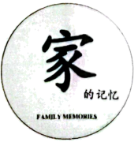 | express your feelings or opinions  What do you think of it?  Why do you think so?
写作要求：
1. 结合实际，用适当的形容词补全标题。
2. 短文须包含图中所有信息，并适当拓展
3. 文中不能出现真实的人名和校名。
_________________________________________________________________________________________________________________________________________________________________________________________________________________________________________________________________________________________________________________________________________________________________________________________________________________________________________________________________________________________________________________________________________________________________________________________________________________________________________________________________________________________

