沈阳市2023年初中学业水平考试
英语试题
试卷满分100分，考试时间100分钟。
注意事项：
1.答题前，考生须用0.5mm黑色字迹的签字笔在本试题卷规定位置填写自己的姓名、准考证号；
2.考生须在答题卡上作答，不能在本试题卷上作答，答在本试题卷上无效；
3.考试结束，将本试题卷和答题卡一并交回；
4.本试题卷包括七道大题，59道小题，1道阅读与表达试题，共8页。如缺页、印刷不清，考生须声明。
第一部分 选择题（三大题；共38分）
一、单项填空（共10小题，每小题0.5分；满分5分）
从A、B、C、D中选出可以填入空白处的最佳选项。
1. The spirit of Lei Feng always encourages us to give ________ hand to others.
A. a B. an C. the D. 不填
2. Betty is crazy about music. Her dream is to be a ________.
A. scientist B. painter C. musician D. writer
3. Three Shenzhou XV heroes successfully came back to the Earth ________ June 4, 2023.
A. at B. on C. in D. until
4. Don’t ride your bike too fast, or you may hurt ________.
A. myself B. yourself C. himself D. itself
5. The delicious food and ________ waiters made us happy with the restaurant.
A. slow B. tired C. awful D. polite
6. “Post-2000s” (00 后) have begun to amaze the world ________ they are very young.
A. though B. if C. unless D. before
7. When autumn comes, leaves start to ________ from the trees.
A. grow B. fall C. appear D. come
8. After this exam, you ________ a wonderful holiday next month. Take it easy!
A. have B. have had C. had D. will have
9. —Could you tell me ________?
—By underground.
A. where is Shenyang Imperial Palace
B. where Shenyang Imperial Palace is
C. how I can get to Shenyang Imperial Palace
D. how can I get to Shenyang Imperial Palace
10. —Wow! I have won a free ticket to the Film Park.
—________. You are so lucky!
A. That’s great B. Never mind C. You’re welcome D. Don’t worry
二、完形填空（共15小题，每小题1分；满分15分）
阅读短文，掌握其大意，然后从A、B、C、D中选出可以填入空白处的最佳选项。
A boy guarded the barrels (木桶) in his father’s winery (葡萄酒厂). Every morning, his father gave him a ____11____ of brushing the barrels and putting them in order, but the wind blew the barrels here and there overnight.
The boy was so ____12____ that he wrote a letter to the wind, “Please don’t blow down my barrels.” After seeing that, his father asked the boy with a smile, “Can the wind read your ____13____?” The little boy said, “I don’t know. I have no ____14____ but to make this request (请求).”
The next morning, when the little boy ran to ____15____ the barrels, he found that the barrels were blown here and there again. The little boy felt very unhappy and cried. His father came and said ____16____, “Son, don’t be sad. We may have no way to deal with the ____17____, but we may have ways for you, so we can have our own ways to ____18____ the wind.” Then the little boy ____19____ his tears and thought over and over. Finally, he thought of an idea. He filled the ____20____ barrels with water. After that, he went home worriedly.
The third morning, the little boy ____21____ his clothes in a hurry and ran out. He was ____22____ to find the barrels were placed in good order. The little boy smiled happily and told his father, “It’s a very ____23____ way, that is, to make the barrels heavier.” The little boy’s father smiled and ____24____ his head.
We can’t change many things in the world, but we can change ourselves. To add you the ____25____ is the only way not to be knocked over.
11. A. promise B. task C. warning D. method
12. A. cheerful B. shy C. satisfied D. angry
13. A. letter B. notice C. story D. poster
14. A. time B. purpose C. choice D. doubt
15. A. paint B. blow C. check D. repair
16. A. strictly B. kindly C. wildly D. nervously
17. A. wind B. brush C. factory D. cloud
18. A. invite B. accept C. encourage D. beat
19. A. believed B. dried C. collected D. tasted
20. A. empty B. full C. useless D. special
21. A. took off B. put on C. paid for D. sold out
22. A. worried B. interested C. excited D. bored
23. A. simple B. foolish C. strange D. dangerous
24. A. controlled B. nodded C. hid D. covered
25. A. water B. clothes C. height D. weight
三、阅读理解（共12小题，每小题1.5分；满分18分）
阅读短文，然后根据其内容从A、B、C、D中选出最佳选项。
A
Have you ever heard of Hainan Tropical Rainforest National Park? It is our own “Amazon”. If you travel there, what can you enjoy?
Animals
The park is home to Hainan gibbons (长臂猿). They look like monkeys, but have no tails. They eat fruits and leaves from over 130 kinds of plants. In the 1980s, there were fewer than 10 gibbons in the park. In 2022, there were 36 because people protected their homes and planted trees. | 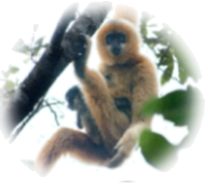
Plants
The park is a “live museum” of plants. It is also the home to 133 kinds of national key protected plants. Cycas hainanensis (海南苏铁) is an example. It has big, feather-like leaves. It grows slowly, but can live as long as 200 years. It probably won’t grow flowers or fruits in North China. But in Hainan, cycas hainanensis over 10 years old blossom (开花) and bear fruits almost every year. | 
Culture
Miao and Li people have lived in the park for generations (世代). Their houses look like upside-down boats. They are built above the ground to keep away animals. Li people make clothes from bark (树皮). Their history of tree bark clothing dates back to about 10,000 years ago. Some people still use bark clothing nowadays. | 

26 What was the population of Hainan gibbons in the 1980s?
A. Less than 10. B. More than 30. C. Nearly 130. D. Only 133.
27. What can we know about cycas hainanensis from the text?
A. It can grow very quickly. B. It never grows flowers.
C. It can live up to 200 years. D. It has very small leaves.
28. What is tree bark used to do by Li people?
A. To avoid animals. B. To build houses. C. To produce boats. D. To make clothes.
29. In which part of a magazine can we probably find the text?
A. Art. B. Travel. C. Health. D. Sports.
B

Both my wife and I are running lovers. I usually run on the track in my neighbourhood. Most people walk on the track, so I am faster than them. My speed seems amazing to the walkers and I often pass by them twenty or more times around the track. This makes me feel proud.
One day, a short man came. He didn’t look like much of a runner. I saw him get out of the car and warm up before running when I passed by two walkers. He started running a few metres ahead of me. He was fast but I sped up and managed to catch up with him. I had someone to compete with. But after a lap (圈), I fell behind him and had great difficulty in breathing. After two laps, my foot began to hurt, so I had to slow down and began to run at my usual speed. This time I could breathe again without sounding like I had a lung disease (肺病) and the pain in my foot went away. In a very short time, he was far ahead. He was too fast for me to follow.
That day, I learnt several lessons. In life, there will always be those slower and faster. Some have natural talent (天赋), and some have trained harder. Don’t judge (判断) the capacity of a person by how he or she looks.
The point is that we each have our own speed. When we are trying to keep up, we often end up hurting ourselves and being out of breath. Slow down or speed up, but run your race to your best. Don’t run fast when you should be running slowly. Don’t run at all when you should be walking. Don’t walk when you should be running.
30. What was the author’s first impression of the short man?
A. He was an amazing runner. B. He was an experienced driver.
C. He wasn’t good at running. D. He was too proud of himself.
31. What happened to the author when he slowed down?
A. His breath became much heavier. B. His foot didn’t hurt any more.
C. He sounded like having an illness. D. He started to have a pain in his foot.
32. What does the underlined word “capacity” probably mean?
A. age B. job C. attitude D. ability
33. Which can be the best title for the text?
A. The slower, the healthier B. The faster, the better
C. Keep fit through running D. Enjoy your own speed
C
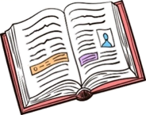
The 20th National Congress of the Communist Party of China points out the importance of reading and calls on people to read more books, so shared bookhouses have appeared in many places. Reading has become a trend in our country.
A reading campaign (行动) took place in Shenyang in April, 2023. Many people took part in it. Li Hong, a girl from a junior high school, said, “My mother and I took part in the campaign because both of us like reading. Books are our necessary furniture in our house. I know a lot about Chinese classic (经典的) works. Reading makes my life colourful and will change my dream into reality (现实).”
Reading is one thing, but knowing how to read and what to read is another.
There are mainly three kinds of reading: recreational reading study-type reading and survey reading. Recreational reading can bring you much fun. You can read at a relaxed speed. Study-type reading usually needs you to read the text very carefully to understand the ideas and details. Survey reading is a way of reading fast to get the main idea or find the information you need.
What kind of books should you read? Emerson, a great writer and thinker, had three rules: never read a book that is not a year old; never read any but famous books; never read a book you don’t like.
Good books can lift you to a higher plane (境界). Whatever you read, read with interest, with the whole mind. Try to be a best reader. If you are getting the most out of a book, you will do things more confidently. Reading is rewarding (有益的)!
34. What can we infer (推断) about Li Hong from the second paragraph?
A. There is no other furniture in her house but books.
B. Her mother teaches Chinese in a junior high school.
C. She has probably read the book Journey to the West.
D. She has changed her dream because of the campaign.
35. Which of the following probably belongs to survey reading?
A. Learning a long poem at a relaxed speed.
B. Reading a novel carefully to write a report.
C. Enjoying interesting comic strips as you like.
D. Searching newspapers quickly for something.
36 What kind of books should we read according to Emerson?
A. Books that are well known. B. Books that cost a lot of money.
C. Books that are about rules. D. Books that come out within a year.
37. What is the purpose of writing this text?
A. To introduce a reading campaign. B. To advise us to build bookhouses.
C. To encourage people to read books. D. To tell us about some classic works.
第二部分 非选择题（四大题；共62分）
四、回答问题（共5小题，每小题2分；满分10分）
阅读图文，然后根据内容回答所提问题。
Justin has just ordered some food from the Corner Cafe. Here is his order form.
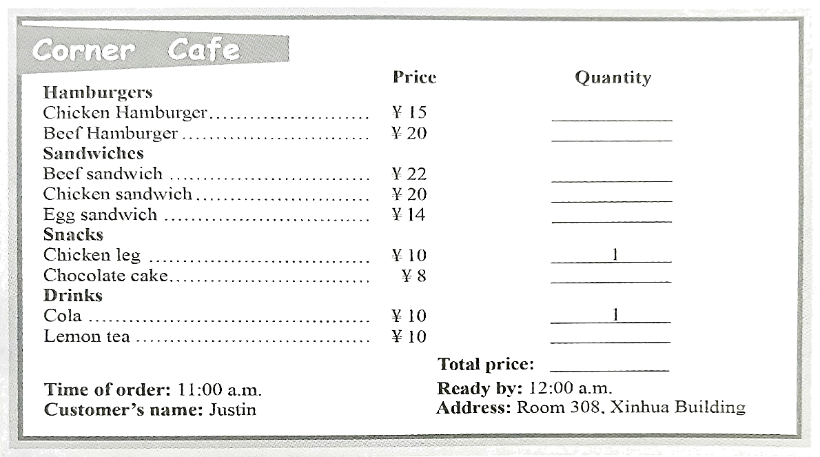
38. What is the name of the restaurant?
____________________________________________
39. Which sandwich is the most expensive?
____________________________________________
40. How much should the customer pay in total?
____________________________________________
41. By what time will the order be ready?
____________________________________________
42 Who placed the order above?
____________________________________________
五、阅读填空（共7小题，每小题1分；满分7分）
阅读短文，然后用短文括号中所给词的适当形式填空。
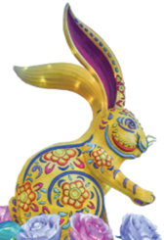
In China, people often talk about “Shuxiang”, especially during the Spring Festival. Images (形象) of the 12 Chinese “Shuxiang” animals are fun for everyone. The rabbit is in the ____43____ (four) place.
The rabbit is a symbol (象征) of kindness and a love of beauty in Chinese culture. People born in the Year of Rabbit are usually ____44____ (peace) and quick-minded. Although they are sometimes shy, they have a strong mind and will try their best ____45____ (make) their dreams come true. It is said that rabbit people are much ____46____ (wise) than other people and love taking part in artistic activities.
2023 is a “rabbit year”. Rabbits become more popular. You can see ____47____ (they) across the world. As a cultural image, the rabbit has been in different forms of art, including ____48____ (stamp), colourful lights and so on. Through the rabbit, people from other countries can get a closer look into Chinese culture. In January, 2023, an exhibition (展览) about rabbits ____49____ (hold) in the US.
六、综合阅读（共10小题，每小题2分；满分20分）
阅读短文，然后按要求完成第50-59小题。
A
Here is some information about three organizations. They provide funds (基金) to help children, women and animals in need.
CCTF
CCTF is short for the China Children and Teenagers’ Fund. One of the CCTF’s special activities is the Spring Bud Project. In 1989, 4.8 million children in the country, aged from seven to fourteen, (A) were unable to attend school. 83% of them were girls. As a result of this, the CCTF started the Spring Bud Project to help them. (B) From then on, the project started to help them go back to school. | 
UNICEF
UNICEF is the “United Nations Children’s Fund”. A lot of children suffered during World War II. It was started in 1946 to help those children. (C) 今天它仍然很重要. It offers help to children and women in over 190 countries. It helps them get proper food, clean water and (D) everyday health supplies (供给品). | 
WWF
The World Wide Fund for Nature (WWF) was set up in 1961. It uses a panda as its logo. The WWF is (E) ________ environmental organization. Now many animals become endangered (F) ________ people kill them and destroy their homes. The WWF aims to build a future where people live in harmony (和谐) with nature. | 

50. 写出文中画线部分(A)和(D)的同义词或近义词：________；________
51. 将文中画线部分(B)改写为：________ then, the project has helped them ________ to school.
52. 将文中画线部分(C)译成英语：________
53. 在文中(E)和(F)的空白处填入适当的单词：________；________
54. 从文中找出两个基金会的简称：________；________
B
In the coastal city of Laguna in Brazil, there is a special fishing team. (A) ________ is made up of fishermen and dolphins (海豚)! They cooperate (合作) to catch fish.
Mauricio Cantor from Oregon State University, US, studied this relationship. As he told Science News Explores, (B) they started to work as a team more than 100 years ago.
“The dolphins are really good at finding fish in dirty water and driving them to the coast,” Cantor said. “The fishermen are really good at catching the fish with their nets.” Once the fish are caught in the nets, dolphins can move in and get some for themselves. ①
Cantor’s study described how fishermen and dolphins give cues (信号) to each other during fishing. When dolphins find fish, they drive them to the coast. After that, they arch (拱起) their backs in front of the fishermen to tell them to get nets ready. ② Fishermen may wait for a long time (C) 如果他们失去最好的机会. Therefore, they should be well-trained to understand the cues from dolphins.
The study found that fishermen are 17 times more likely (可能的) to catch fish by working with dolphins. ③ At the same time, cooperative dolphins have 13 % higher survival rates (生存率) (D) ________ other dolphins.
Human-animal partnerships have been uncommon throughout history. But they give us an idea of how positive our human cooperation can be with nature.
55. 在文中(A)和(D)的空白处填入适当的单词：________；________
56. 将文中画线部分(B)改写为：they started to work ________ more than a ________ ago.
57. 将文中画线部分(C)译成英语：________
58. 将 “Fishermen will then throw the nets right away.” 填入文中，①②③三处中最佳的位置是：________
59. 从文中找出海豚擅长做的两件事：________；________
七、阅读与表达（共两小节，A节5分，B节20分；满分25分）
A
阅读短文，然后根据其内容从方框中选出可以填入空白处的短语。
cheerful person full of fun gives up solve problems with grey hair
We all have trusted elders (长辈) around us. They take good care of us and help us ___60___.
My grandma is a short woman ____61____. She is always busy with housework. She is a very good cook. Her dishes are probably the best in the world! She looks after my family. She is really kind and patient.
Mr. Li is my maths teacher. He is tall and thin. His classes are always ____62____. He uses lots of games in his teaching. He is strict about our studies, but he always encourages us and gives us support.
Uncle Zhang is my neighbour. He is an engineer. He never ___63___ when he meets difficult problems. He is a ____64____. After work, he likes to play table tennis with me in the neighbourhood. He is the best neighbour I have ever had.
B)
65. 为了传承和弘扬中华民族的优良家风，学校英文社团开展主题为“孝亲敬长”的英语征文比赛。假定你是李华，请你写一篇征文参加比赛。内容包括：
1.尊重的对象和原因；
2.具体做法；
3.发出号召
【注意】
1.词数 80-100，开头和结尾已为你写好，不计入总词数；
2.短文须包括所给内容信息，可以适当增加细节，以使行文连贯；
3.作文中不要出现考生和相关人物的真实校名和姓名。
Show respect for elders
Showing respect for elders is one of the family traditions that Chinese people have kept for thousands of years.
__________________________________________________________________________________________________________________________________________________________________________________________________________________________________________________________________________________________________________________________________________________________________________________________________________________________________________________________________________________________________________________________________________________________________________________________________________________________________________________________________________________

