
2023年盘锦市初中学业水平考试
英语试卷
（本试卷共65道题试卷满分100分考试时间90分钟）
注意：请在答题卡规定答题区域内作答，答在本试卷上无效。
第Ⅰ卷 选择题（共44分）
一、单项选择（每小题1分，共10分）
从各题的四个选项中选出一个最佳选项，并将其代表字母涂在答题卡的相应位置。
1 The travellers set out for the airport ________ 7 o’clock in the morning.
A. on B. to C. at D. of
2. When our bread maker broke, the Taylors lent us ________.
A. they B. them C. their D. theirs
3. The race is only two days away, ________ Alice practices day and night.
A. as B. but C. so D. or
4. Tina lost her pet dog. She ________ be worried about it.
A. need B. must C. can’t D. shouldn’t
5. The cheers filled the air. ________ an exciting basketball game!
A. What B. Why C. Who D. How
6. The class was over, but I still had ________ questions to ask.
A. a little B. little C. a few D. few
7. Mary ________ as a volunteer at a reading program since 2 years ago.
A. worked B. has worked C. is working D. will work
8. It is reported that 6G technology ________ widely in a short time.
A. used B. will use C. is used D. will be used
9. —Good morning, madam! ________ beef do you want?
—Two kilos, please.
A. How much B. How many C. How often D. How far
10. Class Three did a survey on the ways to relax. The pie chart tells us that __________.
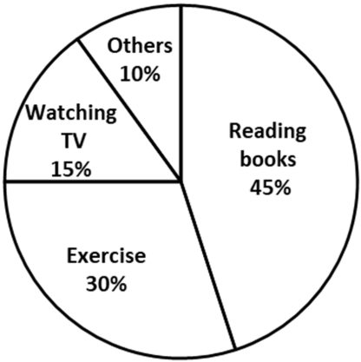
A. 15% of the students prefer to exercise
B. reading books is the most popular way to relax
C. students who like watching TV take up 10%
D. most students choose other ways to get relaxed
二、完形填空（每空1分，共10分）
根据短文内容，从各题的四个选项中选择一个最佳选项，并将其代表字母涂在答题卡的相应位置。
On a hot and wet summer day, Nura and her dad found a place to cool off at the city museum. Suddenly the lights went out, leaving the room completely ____11____.
“Dad what’s going on?” Nura called out loudly.
“Don’t worry. The lights might come back on soon.” Dad said ____12____ to comfort (安慰) Nura. In a moment, a worker waved the flashlight at them and said, “Excuse me, sir. There is a power cut (停电) across the city. We have to ____13____ the museum. I will walk you to the gate.”
Nura and her dad stopped at their favorite shop for ice cream. The shop owner refused when Nura’s dad tried to ____14____. “Forget about it,” he said, “It will all be soup soon, anyway!”
After Nura and her dad arrived home, they found the neighbors ____15____ their apartments. Everyone shared ice water, talking and laughing about the hot weather.
“I can’t ____16____ the heat in my room.” Mrs. Fong said, fanning herself with a newspaper.
A woman who lived downstairs was standing in the doorway. “If the power doesn’t come on soon, I’ll have to ____17____ all the food,” she said.
“The meat in the ____18____ will go bad without power,” said Nura’s dad. “Let’s take out the grill (烤架) to cook it.”
“I’ll see what I have,” the woman in the doorway said. “I’ll make sure to bring enough for everyone.”
As they had their ____19____, night fell over the city. The air was thick and hot, but Nura didn’t mind anymore. She had enjoyed ____20____ ice cream, and she had shared a meal with her neighbors. She smiled to herself and continued to watch the stars.
11. A. cold B. crowded C. dark D. empty
12. A. peacefully B. weakly C. fairly D. strangely
13. A. open B. close C. tidy D. visit
14. A. spend B. cost C. pay D. afford
15. A. along B. inside C. above D. outside
16. A. stand B. suggest C. raise D. create
17. A. take off B. throw away C. look through D. cut up
18. A. market B. bowl C. glass D. fridge
19. A. breakfast B. drink C. lunch D. dinner
20. A. smooth B. fresh C. free D. cheap
三、阅读理解（每小题1.5分，共24分）
根据短文内容，从各题的四个选项中选择一个最佳选项，并将其代表字母涂在答题卡的相应位置。
Passage 1
Some designers (设计师) are trying to build a new type of house. The picture below shows some information about the house.
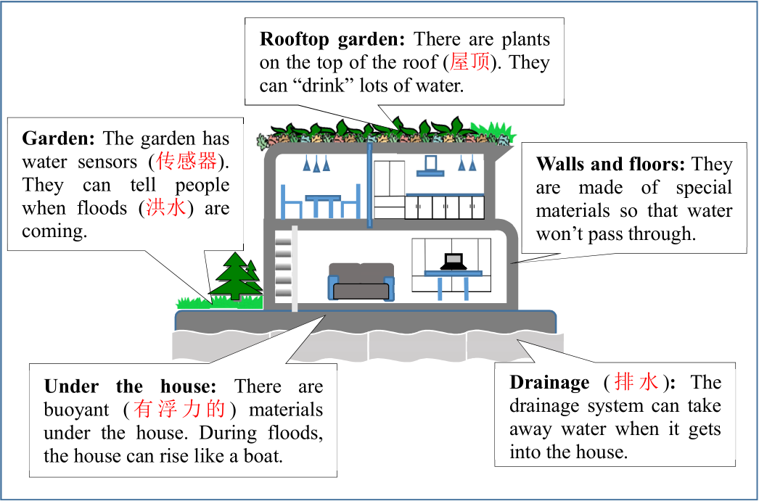
21. According to the passage, the plants on the rooftop can __________.
A. keep the house cool B. take in water
C. make the house beautiful D. prevent water passing through
22. The water sensors __________ can warn people about floods.
A. in the garden B. in the walls
C. under the floor D. on the top of the roof
23. During floods, __________ can make the house rise like a boat.
A. the floors of the house B. the plants on the rooftop
C. the buoyant materials under the house D. the drainage system
24. The designers build the special house to __________.
A. move it easily B. fight against snowstorms
C. reuse the waste D. keep safe during floods
Passage 2
I dreamed of becoming an artist when I was a little girl. My mom knew this and she gave me some crayons. They quickly became my treasure.
Unfortunately, my little sister Emily also loved them. For three days, she would ask to play with my crayons. One day before she got up, I kept my crayons in my room. Then I went to school, thinking that she wouldn’t enter my room.
When I got home, I couldn’t find my crayons. My rainbow-colored treasures were missing!
I searched the house for Emily, and found her in the basement (地下室). She was drawing something with my crayons. I shouted at her, grabbed (抢夺) the crayons and ran back up to my room, shutting the door with a loud noise. I sat there for at least half an hour.
Later, I heard Emily’s footsteps coming up the stairs. I noticed a folded piece of paper being pushed under the door.
Once it reached my side of the door, I picked it up. As I read the words on the cover, my anger disappeared. Tears began to well up in my eyes. On the paper were the words “Best Sister”. Inside was a picture Emily had drawn of herself, which was a birthday gift for me.
My sister used my crayons to make something special for me. I realized that I had owned the greatest treasure in the world.
I opened the door, reached out to Emily and gave her a big hug.
25. The writer’s mother gave her some crayons to __________.
A. celebrate her birthday B. encourage her to be an artist
C. use in her art class D. draw a picture for her sister
26. The writer __________ in order that her sister couldn’t get them.
A. locked the crayons in her mother’s room B. took the crayons to school
C. left the crayons in her room D. hid the crayons in the basement
27. What happened after the writer found her sister drawing with her crayons?
A. She gave the crayons to her sister.
B. She told her mother to punish her sister.
C. She became angry and shut herself in her room.
D. She shouted at her sister and ran out of her house.
28. What does the underlined phrase “the greatest treasure” refer to (指代)?
A. The crayons. B. The dream in the childhood.
C. The writer’s picture. D. Love between family members.
Passage 3
Chocolate is made from the seeds (种子) of cocoa trees (可可树). The seeds come in football-shaped pods (豆荚). A pod is about 15 to 30 centimeters long, 8 to 10 centimeters wide. When you break a pod, you’ll find 20 to 60 seeds.
You take out these seeds, cover them up in banana leaves and leave them for about a week. This process is called fermentation (发酵). It is similar to the process of making yogurt. After the fermentation, you dry them, clean them, heat them and break them. Then you get something with a smell of chocolate. It is heated and separated into cocoa butter. When you mix it with milk or sometimes vegetable oil, and sugar, you get different kinds of chocolate.
Chocolate is not a good choice if you want to lose weight, but it is a good source (来源) of vitamins and minerals (矿物质). You should be careful not to eat too much because it may cause some people to have a headache. It can also cause skin problems in some people.
But recent surveys have found that chocolate helps people improve the ability to understand or remember things. It is also said that chocolate helps many people sleep better. We might have to wait for more research but we all know that we love chocolate!
29. After reading the first paragraph, we know that __________.
A. the seeds come in the tree leaves B. the shape of a pod is like a football
C. a seed is about 15 to 30 cm long D. there is only one seed in a pod
30. In the fermentation process, the seeds are __________.
A. kept for about a week B. covered up in cocoa tree leaves
C mixed with yogurt D. dried and cleaned at first
31. Chocolate is good for health because __________.
A. it can solve skin problems
B. it helps people to lose weight
C. it provides people with vitamins and minerals
D. it makes people who have a headache feel better
32. Which might be the best title (题目) for the passage?
A. How to make chocolate B. Facts about chocolate
C. A healthy food—chocolate D. Say no to chocolate
Passage 4
根据短文内容，将下面的选项填入空白处，使短文意思完整、连贯。(每个选项限用一次)
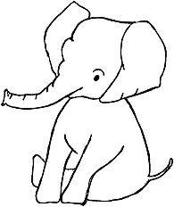
Elephants are the largest of all land animals. However, there are not many of them left in the world. Today, the earth is home to three kinds of elephants, the African bush elephant, the African forest elephant and the Asian elephant. World Elephant Day falls on August 12 each year. _____33_____
In Yunnan, China, a monitoring (监控) system keeps an eye on elephants with the help of cameras and drones (无人机). Elephant observers (观察员) are also important. _____34_____ They also pay attention to the animals’ health. When an elephant gets hurt, elephant doctors will come to help.
_____35_____ Sometimes, they visit villages and eat corn, rice and fruit. Although people can get money from the government for their losses, it’s still a big problem. In recent years, China set up many “elephant canteens (食堂)” in different places. There, people plant food that elephants love to eat.
Thanks to China’s hard work, the number of elephants in China rose up to about 300 by the end of 2021. _____36_____ Chinese government is now building a national park for elephants. China has made a great home for these big friends!
A. In the past 10 years, the number has been increasing.
B. They follow elephants in cars and tell people where elephants are.
C. The Asian elephants eat 400 kinds of food!
D. It calls on people to care more about elephants.
第Ⅱ卷 非选择题（共56分）
四、词语运用（每小题1分，共16分）
根据句子意思，用括号中单词的正确形式填空，并将答案写在答题卡的相应位置。
37. Spiders are insects with eight ________ (foot).
38. Mark is ________ (smart) than his cousin, but less hard-working.
39. Alexander Bell was the ________ (invent) of the telephone.
40. As we all know, smoking is ________ to our health. (harm)
41. Every time Aron climbed a mountain, he felt proud of ________ (him).
42. If Kate ________ (finish) her homework, her parents will allow her to hang out with friends.
根据短文内容，用方框中所给单词填空，使短文意思完整、连贯。（每个单词限用一次，有两个多余的单词)
never clothes praise thousands always protect
though grow because everywhere beauty rainy
Ancient Chinese people loved planting trees. ___43___ they didn’t have a special day like the Tree-Planting Day, the tradition of planting trees has been there for a long time.
Back then, it was always warm and ___44___ around the Qingming Festival. The trees were easy to ___45___ in spring. The ancients formed the tradition of planting trees around the Qingming Festival.
There are ___46___ of kinds of trees. However, mulberry trees (桑树) and fruit trees used to be especially popular in ancient times. Silkworms (蚕) took mulberry leaves as their food. Silk was produced from the cocoons of the silkworms, and then made into soft and beautiful ___47___ for noble and rich people.
The taste for ___48___ of the ancient people reached a high level. They planted trees to beautify their neighborhood and ___49___ the environment as well.
Bai Juyi, a great poet in the Tang Dynasty, loved planting trees. ___50___ he went, he would plant trees in places where he worked.
Dong Feng, a doctor in the Three Kingdoms Period, ___51___ accepted money from his patients. Instead, he asked them to plant apricot trees (杏树) on a hill. Gradually, a forest of apricot trees appeared on the hill. That is why we ____52____ a doctor who has noble ethics (高尚品格) and excellent skills with the words “warmth in an apricot forest”.
五、任务型阅读（每小题2分，共10分）
根据短文内容，回答短文后所提出的问题。
Matt, a seven-year-old boy, was interested after seeing the wooden box on the sidewalk. His friend Lisa told him that it was called “Little Library”. People built boxes and put books in them. Other people would take books to read and add books they had already read.
The idea excited Matt and he decided to make his own so that kids could trade books. But Lisa worried that kids might not see it. Matt wanted to have a try, anyway. Lisa agreed and went for tools, while Matt ran to collect books.
With the help of Matt’s father, they built a wooden box. They put a door on it and placed their small library in front of the yard. Matt put two books in the box and said, “Now I just have to wait.”
Matt ran out three times that day to check. But each time, his books were untouched. The next days, Matt kept checking the box, but his books were still there.
“No kids saw it, and no one wants to trade books,” Matt said in a low voice.
The next two days, Matt gave up checking the box. Lisa noticed his low spirits and encouraged him to take a look in case someone decided to trade.
They went to the box and Lisa opened the small door. There lied two new books and Matt’s books were gone! There was a card in the box, too. “Dear friend, thanks for your books, and I hope you like mine,” it said.
53. Who was Lisa?
__________________________
54. What did Matt do when Lisa went for tools?
__________________________
55. Where did Matt put his wooden box?
__________________________
56. How did Matt feel when he found that no one noticed his box?
__________________________
57. Some kids think “Little Library” is a great idea. Do you agree with them? Write down one of your reasons.
__________________________
六、完成句子（局部翻译每小题1分，整句翻译每小题2分，共10分）
根据所给中文完成句子翻译，并将答案写在答题卡的相应位置。
58. 老年人喜欢下象棋消遣
The elderly like to _______________ for fun.
59. 昨天这个时候吉米正在修理自行车。
Jimmy _______________ this time yesterday.
60. 上学期海伦参加了一些艺术俱乐部的活动。
Helen _______________ some activities at the art club last term.
61. 玲玲在公共场合表现得特别好，为他人树立了榜样。
Lingling behaved so well _______________ that she set an example for others.
62. 你听过乡村音乐吗？
__________________________
63. 我想知道今晚电影什么时候开始。
__________________________
64. 由于天气不好，上周日聚会被推迟了。
__________________________
七、书面表达(20分)
65. 根据要求完成作文，并写在答题卡的相应位置。
假如你是李华，你的朋友Peter来中国旅游，回国前他想给家人买一件代表中国文化的礼物。他通过邮件询问你的意见，请你用英文回复。
提示：
(1)建议买什么；
(2)介绍这个礼物；
(3)给出推荐理由。
要求：
(1)内容包含以上信息，80词左右（开头结尾已给出，不计入总词数）；
(2)语言准确，行文连贯，层次清晰，书写规范；
(3)文中不得出现真实姓名、校名和地名。
Dear Peter,
Glad to hear from you. It’s easy to choose a gift which stands for Chinese culture.
______________________________________________________________________________________________________________________________________________________________________________________________________________________________________________________________________________________________________________________________________________________________________________________________________________________________________________________________________________________________________________________________________________________________________________________________________________________________________________________________________________________________________________________________________________________
I hope my advice is helpful. Best wishes!
Yours,
Li Hua


