重庆市2023年初中学业水平暨高中招生考试
英语试题（A卷）
（全卷共九个大题满分：150分 考试时间：120分钟）
注意事项：
1.试题的答案书写在答题卡上，不得在试卷上直接作答。
2.作答前认真阅读答题卡上的注意事项。
3.考试结束，由监考人员将试题和答题卡一并收回。
第Ⅰ卷（共95分）
Ⅰ、听力测试。（共30分）
第一节（每小题1.5分，共9分）
听一遍。根据你所听到的句子，从A、B、C三个选项中选出最恰当的答语，并把答题卡上对应题目的答案标号涂黑。
1. A. I'm fine. B. Good morning. C. You're welcome.
2. A. It's sunny. B. That’s all right. C. It's boring.
3. A. Hurry up. B. Of course. C. Don't worry.
4. A. Good luck. B. Never mind C. Good idea.
5. A. Spring. B. Monday. C. June.
6. A. Have fun. B. I'm sorry. C. Thank you.
第二节（每小题1.5分，共9分）
听一遍。根据你所听到的对话和问题，从Ａ、B、C三个选项中选出正确答案，并把答题卡上对应题目的答案标号涂黑。
7. A. /sʌn/. B. /fɑ:(r)/. C. /tɔ:(r)/.
8. A. 10 yuan. B. 50 yuan. C.100 yuan.
9. A. Humorous. B. Beautiful. C. Helpful.
10 A. Chemistry B. Physics. C. Math.
11. A. Because he was ill. B. Because he got up late. C. Because he forgot the time.
12. A.  B.  C. 
第三节（每小题1.5分，共6分）
听两遍。根据你所听到的长对话，从A、B、C三个选项中选出正确答案，并把答题卡上对应题目的答案标号涂黑。
听第一段材料，回答第13和14小题。
13. How will the man get to the bank?
A. By bus. B. By bike. C. On foot.
14. What's the relationship between the speakers?
A. Friends. B. Strangers. C. Husband and wife.
听第二段材料，回答第15和16小题。
15. What's the name of the man?
A. Collin James. B. Celine Mates. C. Collin Gates.
16. When will the man see the doctor?
A. At 9:00 a.m. B. At 2:00 p.m. C. At 4:00 p.m.
第四节（每小题1.5分，共6分）
听两遍。根据你所听到的短文内容，从A、B、C三个选项中选出正确答案，并把答题卡上对应题目的答案标号涂黑。
17. How often does the speaker run?
A. Twice a week. B. Three times a week. C. Four times a week.
18. Which could be a better place for running?
A. A playground. B. A busy street. C. A mountain road.
19. How many suggestions did the speaker give?
A. Two. B. Three. C. Four.
20. What did the speaker mainly talk about?
A. How to keep your running speed.
B. Where to buy good running shoes.
C. How to avoid getting hurt in running.
Ⅱ.语法选择。（每小题1分，共10分）
根据短文内容，从A、B、C三个选项中选出一个语法正确的答案，并把答题卡上对应题目的答案标号涂黑。
Dear Lucy,
First I’d like to say that I love your name. When my teacher asked us to choose ___1___ pen pal, I chose a girl named Lucy. I think the name seems very friendly. I have a happy family. My father ___2___ in a factory two years ago, and now he is a successful businessman. Mom is a teacher. She ___3___ English for eighteen years. She takes care of us very well. My father always says ___4___ my mom is the best cook in the world. I have a sister. She is ____5____ than me. She thinks she knows more than I do, so she can always tell me what ___6___. It really drives me mad.
I live in Chongqing. It ___7___ the Mountain City. It is a “hot” city, too. It is famous for its hotpot and ___8___. And it is really hot in summer here. The people here are kind and hardworking. Every year many people come to have a visit. Welcome ___9___ Chongqing. If you come, I’ll be glad to be ____10____ guide.
I hope you can write back soon.
Your pen pal，
Isabel
1. A. a B. an C. the
2. A. work B. works C. worked
3. A. is teaching B. will teach C. has taught
4. A. that B. if C. how
5. A. old B. older C. oldest
6. A. do B. doing C. to do
7. A. calls B. is calling C. is called
8. A. noodle B. noodles C. noodles’
9. A. to B. at C. in
10. A. you B. your C. yours
Ⅲ.完形填空。（每小题1.5分，共15分）
根据短文内容，从A、B、C、D四个选项中选出一个能填入相应空格内的最佳答案，并把答题卡上对应题目的答案标号涂黑。
Siene is a firefighter in the USA. It isn’t easy to become a firefighter there. Many people try, but a lot of them ___11___. Also, in the past firefighting was always a job for men. Now there are women firefighters.
When Siene was five years old, it was her dream to become a ___12___. Forty years later, she was the ___13___ woman to pass a six-week course at the WFPA(女子消防预备学院). The WFP A trains women in the skills they need to be firefighters. In fact, Siene now trains firefighters there ___14___.
Starting the course doesn’t mean you’ll become a firefighter. The course is very ___15___, so not everyone finishes the training. They are trained like being in the army—Can you hold a heavy piece of wood for four minutes? How many exercises can you do? Can you lift a 12-meter ladder(梯子)?
You also need other ___16___. Can you lead a team? Are you a skillful driver? Can you use technology? There are so many more that are a part of firefighting these days. Of course, no one can do them all, but more skills ___17___ help.
However, you must wait for a chance to work as a firefighter even ___18___ passing your course. It seems that lots of women aren’t ready to do that. In one year, 50 women got trained, ___19___ only three of them are now firefighters. Learning the skills is not enough to become a firefighter. Like Siene, you also need to ____20____ your dream.
11. A. succeed B. pass C. fail D. fight
12. A. policewoman B. firefighter C. scientist D. doctor
13. A. oldest B. tallest C. kindest D. busiest
14. A. myself B. yourself C. himself D. herself
15. A. interesting B. easy C. important D. difficult
16. A. ideas B. methods C. skills D. rules
17. A. recently B. certainly C. hardly D. nearly
18. A. after B. during C. before D. in
19. A. but B. or C. because D. though
20. A. give up B. stick to C. talk about D. worry about
Ⅳ.阅读理解。（41-43小题，每小题1分，44-59小题，每小题2分，共35分）
阅读下列材料，从A、B、C、D四个选项中选出最佳答案，并把答题卡上对应题目的答案标号涂黑。
A
Do you love yogurt? Homemade yogurt tastes delicious, and making yogurt is easy and fun. Let’s have a try!
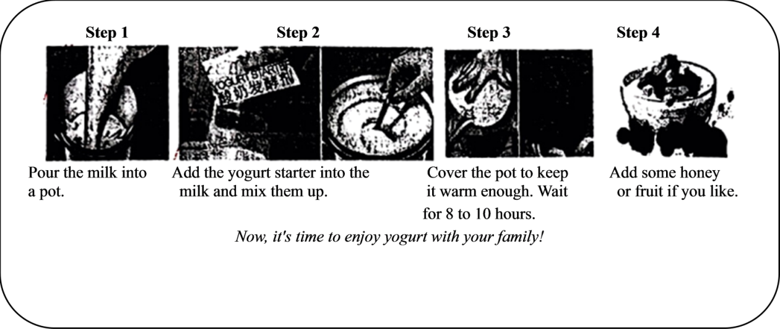
21. What does the writer think of making yogurt?
A. Difficult and boring. B. Easy and fun.
C. Difficult but fun. D. Easy but boring.
22. What is the first step to make yogurt?
A. Pour the milk into a pot. B. Mix the milk and yogurt starter.
C. Add some honey or fruit. D. Cover the pot to keep it warm.
23. How long will you wait before the yogurt is ready?
A. 4 hours. B. 6 hours. C. 9 hours. D. 12 hours.
B
Squirrels(松鼠) are cute and interesting animals that can be found in many parts of the world. They are known for their long tails, big teeth, and the ability to climb trees.
They can jump up to 6 meters in height, and they can run up to 32 kilometers every hour.
Squirrels have soft bodies. Their eyes are high on their small heads and a replaced on each side so they can see wide and far without having to turn around. This often helps them get out of danger.
Squirrels have four big teeth in the front of their mouth that keep growing all through their lives. They are known for their love of nuts(坚果), and they can eat as much food as their body weight each week. They will often keep nuts in the ground for the long winter months. Many people think that squirrels only eat nuts, but this isn’t true. They also like to eat plants, fruits, eggs, small animals and even young snakes.
One funny thing is that squirrels are good at planting trees. They hide the fruits of oak trees, but often forget where they put them. In the end, the forgotten fruits become big trees.
24. How high can squirrels jump?
A. 6 meters. B. 6 kilometers. C. 32 meters. D. 32 kilometers.
25. What do squirrels have?
A. Short tails. B. Big teeth. C. Cold bodies. D. Big heads.
26. Why do squirrels keep nuts in the ground?
A To eat in winter. B. To plant trees. C. To lose some weight. D. To have fun.
27. In which part of a magazine can you probably read this passage?
A. Art. B. Sports. C. Animals. D. History.
C
The Chinese pingfeng (folding screen) is an ancient invention and traditional Chinese furniture (家具). Its earliest common use dates from the Han Dynasty. The term pingfeng means protection from wind, showing its purpose at the very beginning.
As time passes, it has been made into different sizes with colourful paintings. On screens usually appears a dragon. It’s a symbol of light, growth and life-giving water. It also stands for nobility and power. The peacock, a beautiful bird, can be seen on screens, too. It’s a symbol of everlasting life. Beautiful flowers, which mean wealth and good luck, are also chosen as a popular design of the pingfeng. All the designs carry people’s beautiful wishes.
Behind the pingfeng lies an interesting story. In the past the unmarried daughter of a rich family was not supposed to see or be seen by men except her father, brothers or very close male cousins. When an admirer paid a visit however, she might take a secret look at him from a screen behind which she would be completely hidden. Her father would discuss poems with the young man and ask him to create one. If the daughter and her father were satisfied with the young man’s poem and his looks, she might agree to take him as a husband.
Today the pingfeng is back in fashion for its beauty and its practical (实际的) use as furniture. Acting as a moving wall or divider, it can be the perfect match (相配) for modern sofas and walls, which adds style to them.
The pingfeng is more than beautiful furniture.
28. What was the pingfeng used for at the very beginning?
A. Protecting people from wind. B. Dividing a room.
C. Making a room beautiful. D. Hiding a person.
29. Which design is a symbol of wealth and good luck?
A. The dragon. B. The peacock. C. The water. D. The flowers.
30. How does the writer develop his idea in Paragraph 2?
A. By telling a story. B. By giving examples.
C. By comparing differences. D. By explaining the result.
31. What is the best title for the passage?
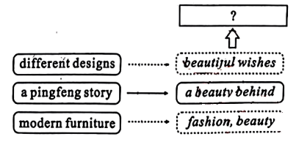
A. The Practical Use of the Pingfeng
B. A Beautiful Story of the Pingfeng
C. Old Pingfeng in Modem Homes
D. The Hidden Beauty of the Pingfeng
D
Prince Caspian’s parents died. He lived with his uncle, Miraz, the King of Narnia and his aunt. Though he had wonderful toys, he liked best the last hour of the day when the toys had all been put away and Nurse would tell him stories.
He didn’t care much for his uncle and aunt, but about twice a week his uncle would ask him to come and have a walk together.
One day, while they were doing this, the King said, “Well, boy, we must soon teach you to ride and use a sword. You know we have no children, so it looks as if you might have to be King when I’m gone. How shall you like that, eh?”
“I don’t know, Uncle,” said Caspian. “What do you wish?” asked the King. “I wish-I wish—I wish I could have lived in the Old Days,” said Caspian.
Up till now the King had been talking in a tiresome way, which made it quite clear that he wasn’t really interested in what they were saying, but he suddenly gave Caspian a sharp(锐利的) look.
“Eh? What’s that?” he said. “What old days?”
“Oh, don’t you know, Uncle?” said Caspian. “Once there was a White Witch(女巫) and she made herself Queen of the whole country. And she made it so that it was always winter. And then two boys and two girls came from somewhere and killed the Witch and they were made Kings and Queens of Narnia. And so they ruled for a long time and everyone had a lovely time, and it was all because of Aslan.”
“Who’s she?” said the King. If Caspian had been a little older, the tone(语气) of his uncle’s voice would have warned him it would be wiser to shut up. But he talked on...
32. What was Caspian’s favourite hour during a day?
A. When he played with wonderful toys.
B. When his uncle had a walk with him.
C. When he learned to ride a horse.
D. When Nurse told him stories.
33. What does the underlined word “tiresome” in Paragraph 5 mean?
A. Fantastic. B. Boring. C. Funny. D. Wrong.
34. What can we infer from the passage?
A. Caspian didn’t live with his uncle and his aunt.
B. Caspian wasn’t satisfied with his present life.
C. Caspian thought this uncle was a great king.
D. Caspian had an enjoyable walk with his uncle.
35. How did the King feel at the end of the story?
A. Proud. B. Worried. C. Angry. D. Calm.
E
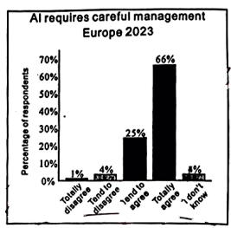
Diagram(图表) or Survey Result
①AI (artificial intelligence人工智能) and machine learning refer to the ability of machines to learn and act intelligently. It means they can make decisions, finish tasks, and even tell the possible future results based on what they learn from data(数据).
②AI and machine learning already play a bigger role in everyday life than you might imagine. Health care, banking, video games, every search on the Internet you make..., all are driven by AI.
③AI is going to change almost every field of modem life. Stephen Hawking said, “Success in creating AI would be the biggest event in human history.” And Hawking added at once, “Unluckily, it might also be the last, unless we learn how to avoid the risks.”
④ ▲ , especially when you consider some countries are racing to develop AI-enabled autonomous weapons(人工智能自主武器). It is also going to change and take the place of many human jobs. The same worries also come from the public. According to the survey result from Centre for the Governance of AI, 91% of the people (tend to and totally) agree that “AI is a technology that requires careful management” in Europe.
⑤But rather than agreeing with an idea of a helpless future where all human jobs are given over to robots, some people believe AI will make on working lives better. It will improve the work of humans, and new jobs will appear to take the place of the old ones.
⑥What’s more, machines become more intelligent and they are able to finish more human tasks. Things which only belong to humans lie creativity and critical(批判性的) thinking, will become even more valuable in the future.
⑦Like it or not, AI is here. Maybe changing ourselves and managing it well are the best way out. Just as Benjamin Franklin once said, “When you’re finished changing, you’re finished.”
36. Which paragraph does the diagram mainly support?
A. ② B. ③ C. ④ D. ⑤
37. Which sentence can be put in the ▲ ?
A. As we know, there are possible huge risks for society and human life
B. Also, you can find AI serving our daily life in every possible field
C. Without doubt, AI is a fantastic technology to lead us into the future
D. Humans ate surely more creative and better at many things than AI
38. What’s the purpose of writing the passage?
A. To warn us that AI will take humans’ place.
B. To show us that there are a lot of uses of AI.
C. To tell us that many people are worried about AI.
D. To suggest we prepare for the changes brought by AI.
39. Which of the following shows the structure of this passage?
A. 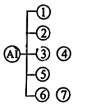 B. 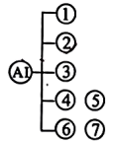 C. 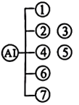 D. 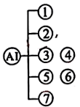
Ⅴ.口语应用。（每小题1分，共5分）
阅读下面对话，从7个选项中选择5个恰当的句子完成此对话，并把答题卡上对应题目的答案标号涂黑。
Rubbish Bins
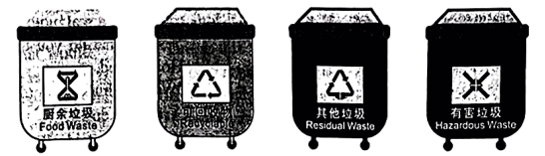
A: Tom, could you help me?
B: Fine. ____40____
A: Take out the rubbish, please.
B: No problem. ____41____
A: To the rubbish bins around the street corner.
B: OK. I’ll go at once!
A: ____42____
B: How many bins are there?
A: ____43____
B: But how can I know which is the right one?
A: It’s easy to tell. They have different colours and signs.
B: ____44____
A. OK. I see.
B. There are four.
C. You can do many things.
D. But where should I take it?
E. What do you want me to do?
F. What colour is the rubbish bin?
G. Don’t forget to put it in the right bin.
第Ⅱ卷（共55分）
Ⅵ.任务型阅读。（65-67小题，每小题2分，68小题3分，共9分）
阅读下文并回答问题
①A Teacher’s Diary
April 14
I put Sharla Tony, and Lee together to make a volcano(火山). I knew they weren’t good friends, and I encouraged all my students to learn to work together.
Something blew up! One looked mad, one looked sad, and one was nearly in tears. They didn’t agree with each other. Oh, dear!
I calmed them down. But they couldn’t agree on even the base for the volcano, and Tony didn’t want to touch the paste(浆糊).
I wondered if I had made a big mistake. Maybe this was one group who couldn’t work together.
②A Student’s Diary
April 16
Yesterday, Mrs. Holt made us stay behind so we could finish planning our volcano. Anyway, we finally moved ahead with our project.
I was making my side smooth. Tony just watched (unfair). I told Lee to smooth out her side, too. “No, Sharla, it should look like a real mountain,” she said just as if she were the boss. The whole thing went downhill. The day ended with no progress.
③The Show Time
The last workday for the project came.
“Is there a problem?” Mrs. Holt knew well there was a problem. She wanted them to put it in their own words, though.
“Well, I think the volcano should be smooth.” Sharla began.
“And,” jumped in Lee, “it should look rocky, like a real mountain.”
“I see. What do you think, Tony?” Mrs. Holt waited.
“Well, I think it would have lava(岩浆) running down.”
“Hey, a great idea!” cut in Sharla, “The lava would be smooth. Right Mrs. Holt?”
Sharla continued. “The other side without lava would look rocky. Right?”
Tony caught on. “So one side can be smooth, and the other rocky. Come on, you guys, let’s go finish!”
It was the show time.________

45. Did the students agree with each other at first?
________________________________________________________________
46. Who wrote the student’s diary?
________________________________________________________________
47. What could the students learn about working together after the project?
________________________________________________________________
48. What happened next? Finish the ending. (about 30 words)
________________________________________________________________
Ⅶ.完成句子。（每空1分，共10分）
根据所给提示，完成句子。每空一词，含缩略词。
49. Tim is reading Journey to the West.（改为否定句）
Tim ________ ________ Journey to the West.
50. The students planted trees in the park last week.（对划线部分提问）
__________ __________ the students plant trees last week?
51. Panda Ya Ya returned to China on April 27, 2023.（改为同义句）
Panda Ya Ya ________ ________ to China on April 27, 2023.
52. 加入社团是一个很好的交友方式。（完成译句）
Joining a club is a good way to ________ ________.
53. 书读得越多，你懂得就越多。（完成译句）
The ________ books you read, the ________ you’ll know.
Ⅷ.短文填空。（每空2分，共16分）
根据下面短文内容及部分首字母提示，在短文的空格处填上一个最恰当的词，使短文完整、通顺。请将完整的单词填写在答题卡上对应的位置。
After exercising the first thing that you want to do is to drink up a glass of cold water. When the water travels down your throat, you will ____54____ so good. However, you are often told not to do so. Is drinking ____55____ water really unhealthy?
Cold water is said to slow down a person’s digestion(消化). Having cold water or a cold drink makes your body’s temperature l____56____. Cold water causes your blood vessels (血管) to become narrower (更狭窄的). So, the body needs to burn energy to bring your ____57____ back to normal. At the same time, less energy is used for digestion.
Think of your digestive system as a burning pot. If someone suddenly poured cold water into this pot what would ____58____? Doing this would be dangerous. Similarly, when you drink cold water while eating, it is ____59____ adding water to a burning pot. Of course, it isn’t that bad, but it is a good way to explain why drinking cold water during meals maybe a bad idea. ____60____ you cannot control your urge(冲动) to do so, drinking water at room temperature is a better choice.
Traditional Chinese medicine suggests trying to avoid drinking cold water. And modern studies in Europe point out drinking cold water causes headaches. Scientists are doing more research on this. Maybe in the future t____61____ can give us more helpful information.
Ⅸ.书面表达。（满分20分）
62. “孝亲敬长”是中华民族的传统美德，家中老人尤其需要陪伴与关爱。校英语广播站正开展“孝敬祖辈，点滴做起”的好点子征集活动。请推荐一至两个切实可行的点子并讲述理由，以号召更多人孝敬祖辈，传承美德。
要求：
1.80—120词；
2.文中不能出现自己的姓名和所在学校的名称。
参考信息：
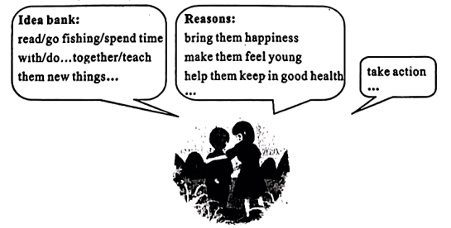
Hello, everyone. Caring for the older persons is the Chinese traditional virtue(美德).
_______________________________________________________________________________________________________________________________________________________________________________________________________________________________________________________________________________________________________________________________________________________________________________________________________________________________________________________________________________________________________________________________________________________________________________________________________________________________________________________________________________________________________________________________________________________________________________________________________________________________________________________________________________________

