青海省2023年初中学业水平考试
英语
（满分120分，考试时间120分钟）
第I卷(听力及选择题)
I.听力测试（共四部分，共20小题，每小题1分，满分20分）
第一部分：听句子，从A、B、C三个选项中选出与所听句子相对应的图片。每个句子仅读一遍。
1. A.  B.  C. 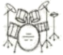
2. A.  B.  C. 
3. A.  B.  C. 
4. A. 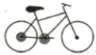 B.  C. 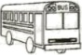
5. A.  B. 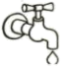 C. 
第二部分：听句子，选择最佳答语。每个句子读两遍。
6. A. Thank you, Dad. B. No problem, Dad. C. Sounds good, Dad.
7. A. Thanks a lot. B. Take it easy. C. Nice to meet you, too.
8. A. I'm sorry. B. Never mind. C. No, I can't.
9. A. Help yourself. B. Sounds good. C. Good luck.
10. A. Yes, I am. B. Yes, I agree. C. I'm afraid so.
第三部分：听对话，选择最佳答案。每段对话读两遍。
11. Where did Bob go during the summer holiday?
A. The Great Wall. B. The Summer Palace. C. Tian'anmen Square.
12. What does Emma think of the picture Along the River During the Qingming Festival(《清明上河图》）?
A. Interesting. B. Long. C. Wonderful.
13. Which book is the woman going to buy?
A. Journey to the West. B. Hou Yi Shoots the Suns. C. Yu Gong Moves the Mountains.
14. How many times has the man been to Cannes Film Festival(夏纳电影节）?
A. Once. B. Twice. C. Three times.
15. What does Tony do to relax himself?
A. Play sports with friends. B. Read books. C. Listen to music.
第四部分：听短文，根据短文内容填空。短文读两遍。（每空仅填一词）
My Friends in China
Helen | I am from the United Kingdom. But now I am in China and I have made some nice friends here. They always 16.________ me to learn Chinese.
At school | ● I'm very busy but I am feeling 17.________ every day.  ●There are 18.________classes in the morning and 3 classes in the afternoon.  ●My favorite subject is history because it is interesting and I like stories in different dynasties(朝代）like the Tang and Song Dynasty.
After school | ●They always teach me to play19.________ because I don’t play it in the UK and it is too difficult for me.  ●They often invite me to 20.________ homes for dinner.
II.单项选择（共10小题，每小题1分，满分10分）
从A、B、C三个选项中选出一个最佳答案填入空白处。
1. —________ did you stay in Huangyuan during their Lantern Festival?
—For six days.
A. How long B. How often C. How soon
【答案】A
【解析】
【详解】句意：——元宵节期间你在湟源待了多久？——6天。
考查疑问词组。How long多久；How often多久一次；How soon多久以后。根据“For six days.”可知对“for+时间段”提问，用How long。故选A。
2. To _______ surprise, local villagers are successful in planting strawberries without soil in Hainan.
A. we B. our C. us
【答案】B
【解析】
【详解】句意：让我们惊讶的是，当地村民在海南成功地种植了无土草莓。
考查代词辨析。we我们，主格；our我们的，物主代词；us我们，宾格。to one’s surprise“令某人惊讶的是”，所以此处用形容词性物主代词，故选B。
3. We are deeply _________ by the story of Mu Shengzhong, whose team started building road in Haixi in the 1950s.
A. hurt B. moved C. troubled
【答案】B
【解析】
【详解】句意：我们被慕生忠的故事深深打动，他的团队在20世纪50年代开始在海西修路。
考查动词辨析。hurt受伤；moved感动；troubled麻烦。根据“whose team started building road in Haixi in the 1950s”可知在海西修路，故事令人感动。故选B。
4. —More and more wild animals have been found as the natural environment improved in Guoluo.
—_________ exciting it is!
A. What B. How a C. How
【答案】C
【解析】
【详解】句意：——随着果洛自然环境的改善，野生动物越来越多。——多么令人兴奋啊！
考查感叹句。本句强调的中心词是形容词“exciting”，用“How+adj+主谓！”句型表示，故选C。
5. A taxi driver prevented (阻止) an _________ when he saw a car with serious problems travelling across Huangnan.
A. accident B. interview C. advertisement
【答案】A
【解析】
【详解】句意：一位出租车司机在看到一辆有严重问题的汽车穿过黄南时，阻止了一场事故。
考查名词辨析。accident事故；interview采访；advertisement广告。根据“when he saw a car with serious problems travelling across Huangnan”可知看到的汽车有严重问题，应是阻止了一场事故的发生。故选A。
6. The four pandas in Chongqing Zoo were born on the same day _______ 2019.
A on B. at C. in
【答案】C
【解析】
【详解】句意：重庆动物园的四只大熊猫于2019年同一天出生。
考查时间介词。on后接具体某一天等；at后接具体时刻等；in后接具体年月等。根据“2019”可知此处是在2019年，用介词in。故选C。
7. Thanks to the help of the government, farmers in China are ________ a happier and richer life.
A. living B. changing C. planting
【答案】A
【解析】
【详解】句意：由于政府的帮助，中国农民过上了更加幸福和富裕的生活。
考查动词辨析。living（以某种方式）生活，过日子；changing改变；planting种植。根据“farmers in China are ... a happier and richer life”可知是过着更加幸福和富裕的生活。故选A。
8. “We made our dreams come true through ________ work,” Chinese astronaut Liu Yang shared her stories on China’s Space Day.
A. hard B. lazy C. easy
【答案】A
【解析】
【详解】句意：“我们通过努力工作实现了我们的梦想，”中国宇航员刘洋在中国航天日分享了她的故事。
考查形容词辨析。hard努力的；lazy懒惰的；easy容易的。根据“We made our dreams come true through ... work”可知是通过努力工作实现了梦想。故选A。
9. According to the World Happiness Report 2023, Finland (芬兰) is the world’s happiest country. People ________ more time with families and friends there.
A. cost B. spend C. pay
【答案】B
【解析】
【详解】句意：根据《2023年世界幸福报告》，芬兰是世界上最幸福的国家。人们花更多的时间与家人和朋友在一起。
考查动词辨析。cost花费，主语是物；spend花费，主语是人；pay支付，主语是人。根据“People ... more time with families and friends there.”可知此处指花费时间和家人、朋友在一起，主语是人，用spend。故选B。
10. A best friend is a person _________ is always there when you need him or her. As the saying goes, “A friend in need is a friend indeed.”
A. whom B. whose C. who
【答案】C
【解析】
【详解】句意：最好的朋友是当你需要他或她时总是在那里的人。俗话说：“患难见真情。”
考查定语从句关系词。根据“a person ... is always there when you need him or her”可知此处是定语从句，先行词指人且在从句中作主语，用who引导定语从句。故选C。
III.完形填空（共15小题，每小题1分，满分15分）
阅读短文，从A、B、C三个选项中选出一个最佳答案，使短文完整、通顺。
It was a sunny day. Jenny and her mother went to a park. When they ____11____ to the park, Jenny wanted to ride the roller coaster(过山车）.
But it seemed that ____12____ people were already waiting in the line. ____13____, a boy cut in line(插队). “Hey, you! You must ____14____ the rules in public. Would you please get in the line?” Jenny shouted ____15____ the boy angrily. The boy’s face turned red at once. “I’m sorry,” the boy lowered his head and went to the back of the line.
After that, Jenny and her mother went around to take photos. There ____16____ different kinds of flowers in the park like tulips and sunflowers. Then Jenny saw a sea of roses, which are her favorite. When she was going to ____17____ some red roses, her mother stopped her, “Honey, the roses are beautiful, ____18____ we shouldn’t pick them because other people want to enjoy them, too.” Jenny was ashamed, “Mum, I agree with ____19____ you said. I won’t do it again.” “Honey, I am ____20____ you,” her mother nodded with a big smile on her face.
On that night, Jenny wrote in her diary, “What ____21____ interesting day! However, thinking back on the ____22____ I had today, I feel sorry for what I did in the park. I should have asked the boy politely to wait in line instead of ____23____loudly and angrily. Also, it is wrong to pick flowers in the park. I realize it is much ____24____ said than done. When we ask others to follow the rules, we need to remind(提醒) ____25____ not to break the rules, either.”
11. A. arrived B. got C. left
12. A. hundreds of B. a hundred of C. hundred of
13. A. Suddenly B. Happily C. Luckily
14. A. make B. break C. follow
15. A. at B. with C. for
16. A. were B. was C. had
17. A. water B. pick C. buy
18. A. unless B. though C. but
19. A. how B. why C. what
20. A. proud of B. worried about C. angry with
21. A. a B. an C. the
22. A. dream B. experience C. chance
23. A. smiling B. laughing C. shouting
24. A. easy B. easier C. easiest
25. A. yourselves B. themselves C. ourselves
【答案】11. B 12. A 13. A 14. C 15. A 16. A 17. B 18. C 19. C 20. A 21. B 22. B 23. C 24. B 25. C
【解析】
【导语】本文主要讲述了Jenny和妈妈去公园的所见所闻，晚上回到家时，Jenny在日记中记录了今天的经历，并感叹自己的行为是否妥当。
【11题详解】
句意：当他们到达公园时，珍妮想坐过山车。
arrived到达；got得到；left离开。get to“到达”，固定搭配，故选B。
【12题详解】
句意：但似乎已经有数百人在排队等候了。
hundreds of数以百计的；a hundred of表达错误；hundred of表达错误。表示概数用数词的复数形式+of，hundreds of“数百的”，故选A。
【13题详解】
句意：突然，一个男孩插队。
Suddenly突然；Happily开心地；Luckily幸运地。根据“a boy cut in line”可知，男孩插队是突然发生，故选A。
【14题详解】
句意：在公共场合你必须遵守规则。
make制造；break打破；follow跟随。根据“the rules in public”及“Would you please get in the line”可知，要遵守排队的规则，故选C。
15题详解】
句意：珍妮生气地对那个男孩大喊。
at在；with带有；for为了。shout at“朝……喊”，固定搭配，故选A。
【16题详解】
句意：公园里有不同种类的花，像郁金香和向日葵。
were是；was 是；had有。主语“flowers”是复数形式，用there were表示“有”，故选A。
【17题详解】
句意：当她要摘一些红玫瑰时，她妈妈阻止了她。
water浇水；pick摘；buy买。根据“we shouldn’t pick them”可知，Jenny想要摘花，故选B。
【18题详解】
句意：但我们不应该摘它们，因为其他人也想欣赏它们。
unless除非；though尽管；but但是。“we shouldn’t pick them because other people want to enjoy them, too.”与前文是转折关系，故选C。
【19题详解】
句意：妈妈，我同意你说的。
how怎样；why为什么；what什么。空格作said的宾语，应填what，故选C。
【20题详解】
句意：亲爱的，我以你为傲。
proud of以……为傲；worried about担心；angry with生气。根据“Mum, I agree …you said. I won’t do it again.”可知，听到Jenny这样说，妈妈以她为傲，故选A。
【21题详解】
句意：多么有趣的一天！
a一个，用于辅音音素前；an一个，用于元音音素前；the这个/那个。what+a/an+形容词+单数名词+主谓，是感叹句的结构，interesting是以元音音素开头的，故选B。
【22题详解】
句意：然而，回想起今天的经历，我为我在公园里所做的感到抱歉。
dream梦想；experience经历；chance机会。根据“thinking back on the … I had today”可知，此处指回想今天的经历，故选B。
【23题详解】
句意：我应该有礼貌地让那个男孩排队，而不是生气地大声喊叫。
smiling微笑；laughing笑；shouting呼喊。根据“Jenny shouted … the boy angrily.”及“I should have asked the boy politely to wait in line instead of …loudly and angrily”可知，认为自己不应该朝那个男孩大喊大叫，故选C。
【24题详解】
句意：我知道说起来容易做起来难。
easy容易的；easier更容易的；easiest最容易的。根据than可知，此空应填比较级，故选B。
【25题详解】
句意：当我们要求别人遵守规则时，我们也需要提醒自己不要违反规则。
yourselves你们自己；themselves他们自己；ourselves我们自己。根据we可知，此空应填反身代词ourselves，故选C。
Ⅳ.阅读理解（共15小题，每小题2分，满分30分）
阅读下面三篇材料，从每题所给的A、B、C、D四个选项中，选出最佳答案。
A
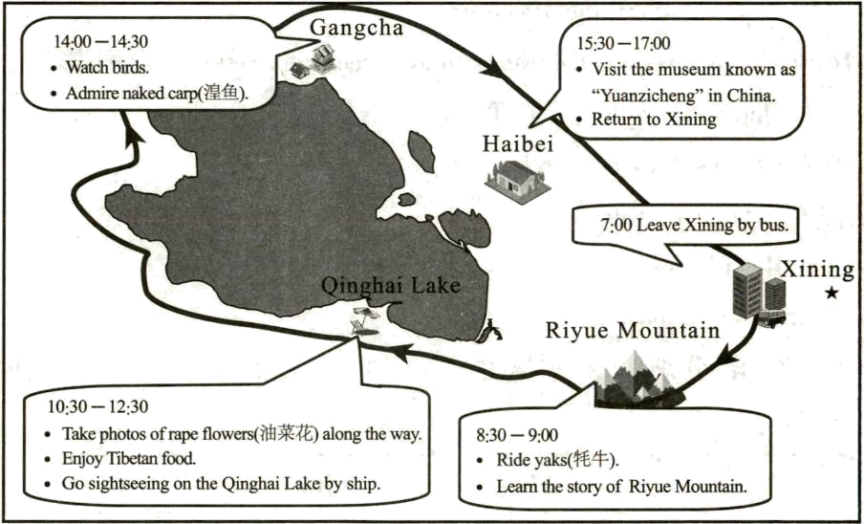
26. How long does it take us from Xining to Riyue Mountain?
A. 0.5 hour. B. 1 hour. C. 1.5 hours. D. 2.5 hours.
27. Where can we ride your yaks?
A. In Xining. B. At Riyue Mountain.
C. On the Qinghai Lake. D. In Gangcha.
28. What time can we go sightseeing on the Qinghai Lake by ship?
A. 9:00. B. 11:00. C. 14:00. D. 17:00.
29. What can we do in Gangcha?
A. Learn the story of Riyue Mountain. B. Enjoy Tibetan food.
C. Watch birds. D. Visit the museum.
30. Where is the text probably from?
A. Travel magazine. B. Science magazine.
C. Sports magazine. D. Health magazine.
【答案】26. C 27. B 28. B 29. C 30. A
【解析】
【导语】本文是一篇应用文，介绍青海湖的旅行计划。
【26题详解】
推理判断题。根据“7:00”和“8:30”可知，从西宁到日月山需要1.5小时，故选C。
【27题详解】
细节理解题。根据“Riyue Mountain”中的“Ride yaks”可知，可以在日月山骑牦牛，故选B。
【28题详解】
细节理解题。根据“10:30—12:30”下的“Go sightseeing on the Qinghai Lake by ship.”可知，我们可以在10:30—12:30坐船去青海湖观光，结合选项，故选B。
【29题详解】
细节理解题。根据“14:00—14:30”下的“Watch birds. Admire naked carp(湟鱼).”可知，可以在刚察观鸟和欣赏湟鱼，故选C。
【30题详解】
推理判断题。本文介绍青海湖的旅行计划，所以推测可能在旅游杂志上看到这篇文章，故选A。
B
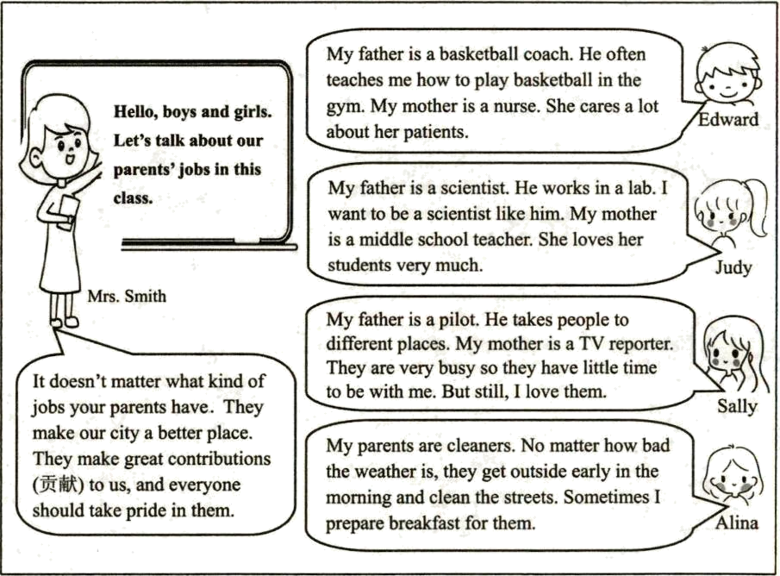
31. Where does the conversation probably take place?
A. In the street. B. In a hotel. C. In a bank. D. In a classroom.
32. How many kinds of jobs are mentioned?
A. 4. B. 6. C. 7. D. 10.
33. What does Judy’s father do?
A. A basketball coach. B. A scientist.
C. A pilot. D. A cleaner.
34. Why do Sally’s parents have little time to be with her?
A. Because they have different jobs. B. Because they are very busy.
C Because Sally loves her parents. D. Because Sally’s parents are nice people.
35. Mrs. Smith wants to tell the students ________.
A. different jobs have different values (价值)
B. we need to help our parents
C. different people have different jobs
D. we can only learn from our parents
【答案】31. D 32. C 33. B 34. B 35. A
【解析】
【导语】本文是史密斯老师让同学们谈论父母的工作，并告诉学生们不管做什么工作，都有自己的价值。
【31题详解】
推理判断题。根据“Hello, boys and girls. Let’s talk about our parents’ jobs in this class.”可知，该段话应该发生在教室里，故选D。
【32题详解】
细节理解题。根据“basketball coach, nurse, scientist, middle school teacher, pilot, TV reporter, cleaner”可知，共提到了7种工作，故选C。
【33题详解】
细节理解题。根据“My father is a scientist.”可知，朱迪的父亲是一位科学家，故选B。
【34题详解】
细节理解题。根据“They are very busy so they have little time to be with me.”可知，莎莉的父母很忙，所以很少有时间和她在一起。故选B。
【35题详解】
推理判断题。根据“It doesn’t matter what kind of jobs your parents have. They make our city a better place. They make great contributions (贡献) to us, and everyone should take pride in them.”可知，不管你父母的工作是什么。他们让我们的城市变得更美好。他们为我们做出了巨大的贡献，每个人都应该为他们感到骄傲。所以史密斯老师想让学生们知道不同的工作有不同的价值。故选A。
C
What will travel be like in 2070? Maybe travel will become smarter and easier by that time. Here are some amazing predictions about traveling that might happen in 2070.
At the airport
You will use “heartbeat passport(护照)” at the airport. And passport checks will not be used any more. Because everyone’s heartbeat is different and it can tell you who you are and where you will go. Also, it provides more personal information.
On the airplane
Airplane seats could fit a person’s body shape, size and even temperature. There will be no screens on the airplane. With a futuristic device(未来设备), you can watch many kinds of movies on the airplane right before your eyes.
In the hotel
3D print technology will develop surprisingly fast. It can print almost everything like clothes and food. Therefore, when you get to the hotel, suitcase will not be needed any more.
During the trip
The trip will become interesting and colorful. Many kinds of services will be provided during the trip. If you want to see what happened in the Ming Dynasty or the first Olympic Games, you can just wear a special headset or glasses.
36. What will travel be like in 2070 according to the passage?
A. Smarter and easier. B. More expensive.
C. More difficult. D. Much cheaper.
37. What does the underlined word “predictions” in Paragraph 1 probably mean?
A. 因素 B. 条件 C. 重点 D. 预测
38. You will use _________ at the airport instead of passport checks.
A. heartbeat passport B. personal information
C. personal body shape D. 3D print technology
39. 3D print technology can _________.
A. help us to check passports
B. provide many kinds of movies
C. print almost everything like clothes and food
D. take us to see the first Olympic Games
40. What is the best title of the passage?
A. Heartbeat Passport B. A Futuristic Device
C. 3D Print Technology D. Travel in 2070
【答案】36. A 37. D 38. A 39. C 40. D
【解析】
【导语】本文是关于2070年可能发生的旅行的一些惊人预测。
【36题详解】
细节理解题。根据“Maybe travel will become smarter and easier by that time.”可知，也许到那时旅行会变得更智能、更容易。故选A。
【37题详解】
词句猜测题。分析“Here are some amazing predictions about traveling that might happen in 2070.”可知，以下是关于2070年可能发生的旅行的一些惊人预测。所以此处predictions的意思“预测”，故选D。
【38题详解】
细节理解题。根据“You will use ‘heartbeat passport(护照)’ at the airport. And passport checks will not be used any more.”可知，你将在机场使用“心跳护照”，护照检查也将不再使用。故选A。
【39题详解】
细节理解题。根据“3D print technology will develop surprisingly fast. It can print almost everything like clothes and food.”可知，3D打印技术将以惊人的速度发展。它几乎可以打印任何东西，比如衣服和食物。故选C。
【40题详解】
最佳标题题。本文是关于2070年可能发生的旅行的一些惊人预测，选项D“2070年的旅行”符合主题，故选D。
V.补全对话（共5小题，每小题2分，满分10分）
根据对话内容，从选项中选出能填入空白处的最佳答案。
Judy: Hi, Sam! What are you doing?
Sam: ____41____ Have you heard about it before?
Judy: ____42____ What is it about?
Sam: ChatGPT is a smart AI chatbot(聊天机器人) made by a US company.
Judy: Sounds interesting. ____43____
Sam: It can do a lot of things, like answering questions, writing emails and chatting with you.
Judy: ____44____
Sam: Yes, you can. But you’d better use it as a learning tool, not to cheat on your homework.
Judy: Why?
Sam: ____45____ Then we will lose the ability to think and learn.
Judy: I totally agree with you.
A. No, I haven’t.
B. Can I use it for my homework?
C. Because if we do so, we won’t need to use our brains.
D. What can it do?
E. I’m reading an article about ChatGPT.
【答案】41. E 42. A 43. D 44. B 45. C
【解析】
【导语】本文是二人谈论关于ChatGPT的利弊。
【41题详解】
根据“What are you doing?”可知，此处应该介绍自己在做什么，选项E“我正在读一篇关于ChatGPT的文章。”符合语境，故选E。
【42题详解】
根据“Have you heard about it before?”可知，此处应回答之前是否听说过，选项A“不，我没有。”符合语境，故选A。
【43题详解】
根据“It can do a lot of things, like answering questions, writing emails and chatting with you.”可知，此处询问ChatGPT能做什么，选项D“它能做什么？”符合语境，故选D。
【44题详解】
根据“Yes, you can.”可知，此处是一个以“Can...?”开头的一般疑问句，选项B“我可以用它做作业吗？”符合语境，故选B。
【45题详解】
根据“Why?”可知，此处应该回答原因，选项C“因为如果我们这样做，我们就不需要用大脑了。”符合语境，故选C。
第Ⅱ卷（非选择题）
VI.语篇填空（共10小题，每小题1分，满分10分）
阅读下面短文，在空白处填入一个恰当的单词或用括号内所给单词的适当形式填空。
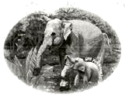
In February, there was a video about Asian elephants in Yunnan, in which two ____46____ (elephant) were fighting for food. By ____47____ end of 2022, the number of wild Asian elephants ____48____ (be) more than 300.
They started to visit villages. ____49____ did they do so? Because they needed more space and food. But this brought losses for the farmers.
Sometimes, the elephants were scared and ____50____ (hurt) people. So the local government is ____51____ (think) of some smart ways to get along with the cute but naughty animals.
◆ If the elephants eat farmers’ plants, farmers can get some money from the government.
If the elephants get too close to people, fences (栅栏) can be built near villages and schools to protect people.
◆ If you see some elephants, stay ____52____ least 300 meters away from them. Also, you should leave the place ____53____ (quick).
◆ If you are in a place with elephants, don’t ____54____ (wear) bright-colored clothes. Such clothes could make elephants ____55____ (angry).

【答案】46. elephants
47. the 48. was
49. Why 50. hurt
51. thinking
52. at 53. quickly
54. wear 55. angry
【解析】
【导语】本文向我们介绍亚洲象的相关内容，并告诉我们遇到大象应该怎么做。
【46题详解】
句意：今年2月，有一个关于云南亚洲象的视频，两头大象在争夺食物。two修饰可数名词复数，故填elephants。
【47题详解】
句意：到2022年底，野生亚洲象的数量超过了300头。by the end of...“到……为止”，故填the。
【48题详解】
句意：到2022年底，野生亚洲象的数量超过了300头。本句主语中心词是“the number of”，强调整体数量，时态是一般过去时，故填was。
【49题详解】
句意：他们为什么这样做呢？根据“Because they needed more space and food.”可知，此处在回答原因，用Why提问，故填Why。
【50题详解】
句意：有时，大象会受到惊吓，伤害人类。根据“were”可知，时态是一般过去时，动词用过去式，hurt的过去式还是hurt。故填hurt。
【51题详解】
句意：因此，当地政府正在考虑一些聪明的方法来与这些可爱但淘气的动物相处。根据“So the local government is...of some smart ways to get along with the cute but naughty animals.”可知，动作正在发生，时态是现在进行时，动词用现在分词形式，故填thinking。
【52题详解】
句意：如果你看到一些大象，要离它们至少300米远。根据“If you see some elephants, stay...least 300 meters away from them.”可知，此处at least短语，意为“至少”，故填at。
【53题详解】
句意：还有，你应该尽快离开这个地方。此处在句中修饰动词，用副词形式，故填quickly。
【54题详解】
句意：如果你在有大象的地方，不要穿颜色鲜艳的衣服。助动词don’t后用动词原形，故填wear。
【55题详解】
句意：这样的衣服会让大象生气。make...+adj“使……”，故填angry。
VII.阅读表达（共5小题，每小题2分，满分10分）
根据短文内容，用符合语义及语法规则的词填空，每空一词。
About 80% of the land animals make homes in the forest. But their homes are disappearing(消失) all over the world. In the last 10,000years, we’ve lost 30% of all trees that were once on the earth. That’s bad news for animals because cutting down trees destroys(破坏) the homes of animals that live in the forests. What’s worse, some pollutions caused by human activities like water pollution and air pollution are bringing further losses to the forests. Therefore, as good friends of animals, it is necessary for us to take some actions to protect their homes-forests.
Dos
●Plant more trees by taking part in the volunteering, projects and activities.
●Take extra plastic bags along and pick up litter on your walk to keep the forest clean.
●Put out campfires before moving on when you go camping to avoid wildfires in the forest.
Don’ts
●Don’t cut down trees for disposable chopsticks(一次性筷子).
●Don’t take rocks, flowers and leaves from the forest floor which might provide homes for small animals.
●Don’t destroy the animals’ homes and habitats.
Huge and beautiful forests where a great variety of animals make homes are ready for us to explore. Whenever you have a chance to get close to nature, make wise choices and take the advice mentioned above to protect homes for our dearest friends.
56. For animals, it is bad news to _______ ________ trees.
57. Human activities like water pollution and _______ ________ are bringing further losses to the forests.
58. _______ ________ campfires before moving on to avoid wildfires in the forest.
59. Try to use less disposable _________ to protect more _________ from being cut down.
60. _________ you get close to nature please make choices _________ and take the advice above to protect homes for our dearest friends.
【答案】56. ①. cut##chop ②. down
57. ①. air/land/soil/light/nuclear/industrial/waste ②. pollution
58. ①. Put ②. out
59. ①. chopsticks ②. trees##forests##bamboos
60. ①. Whenever/When/If/While/As/Once ②. wisely/cleverly/smartly/correctly/rightly/carefully
【解析】
【导语】本文主要介绍我们在保护森林方面应该做和不应该做的事。
【56题详解】
根据“That’s bad news for animals because cutting down trees destroys(破坏) the homes of animals that live in the forests.”可知，这对动物来说是个坏消息，因为砍伐树木破坏了生活在森林里的动物的家园。cut/chop down“砍倒”符合语境，故填cut/chop；down。
【57题详解】
根据“What’s worse, some pollutions caused by human activities like water pollution and air pollution are bringing further losses to the forests.”可知，一些由人类活动造成的污染，如水污染和空气污染，正在给森林带来进一步的损失。污染行为有很多，故填air/land/soil/light/nuclear/industrial/waste；pollution。
【58题详解】
根据“Put out campfires before moving on when you go camping to avoid wildfires in the forest.”可知，当你去露营时，在继续前进之前扑灭营火，以避免森林里的野火。故填Put；out。
【59题详解】
根据“Don’t cut down trees for disposable chopsticks(一次性筷子).”可知，不要为了一次性筷子而砍伐树木。除树木外，也不要砍伐森林、竹子等。故填chopsticks；trees/forests/bamboos。
【60题详解】
根据“Whenever you have a chance to get close to nature, make wise choices and take the advice mentioned above to protect homes for our dearest friends.”可知，每当你有机会亲近大自然时，做出明智的选择，并采取上述建议，为我们最亲爱的朋友保护家园。故填Whenever/When/If/While/As/Once；wisely/cleverly/smartly/correctly/rightly/carefully。
Ⅵ.书面表达（满分15分）
61. 积极健康、乐观向上的生活是我们共同追求的目标。通过正确合理的自我管理和自我提升，我们都能遇见更好的自己。请参考右图信息，以“How to become a better person”为主题，写一篇英语短文。
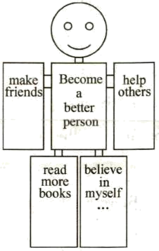
写作要求：
(1)语句通顺，逻辑清晰，书写规范；
(2)词数60—80左右；
(3)文中不能出现真实姓名和校名等信息。
_______________________________________________________________________________________________________________________________________________________________________________________________________________________________________________________________________________________________________________________________________________________________________________________________________________________________________________________________________________________________________________________________________________________________________________________________________________________________________________________________________________________________________________________________________________________________________________________________________________________________________________________________________________________
【答案】例文
Everyone wants to become a better person, so do I. I think the following suggestions can help me.
Firstly, making more friends will help me. It will not only offer me opportunities to learn from them, but it will also give me more chances to help others. Secondly, it is important for me to read more books. Because reading can help me open my eyes to the world and enrich my knowledge.
Action speaks louder than words. I will try my best to become a better person
【解析】
【详解】[总体分析]
①题材：本文是一篇材料作文；
②时态：时态为“一般现在时”；
③提示：写作要点已给出，要求以“How to become a better person”为主题，结合图示内容进行写作，适当添加细节，并突出写作重点。
[写作步骤]
第一步，表明写作意图，引出下文的建议；
第二步，具体介绍如何成为一个更好的人；
第三步，书写结语，表达决心。
[亮点词汇]
①learn from向……学习
②open my eyes to the world打开我的眼睛看世界
③enrich my knowledge丰富我的知识
[高分句型]
①It will not only offer me opportunities to learn from them, but it will also give me more chances to help others.（not only...but also...）
②Action speaks louder than words.（习语）

