西宁市城区2023年初中学业水平暨高中招生考试
英语试卷
考生注意:
1.本试卷满分120分，考试时间120分钟。
2.本试卷为试题卷，不允许作为答题卷使用，答题部分请在答题卡上作答，否则无效。
3.答题前，考生务必将自己的姓名、准考证号、考点、考场、座位号写在答题卡上，同时填写在试卷上。
4.选择题用2B铅笔把答题卡上对应题目的答案标号涂黑(如需改动，用橡皮擦干净后，再选涂其他答案标号)。非选择题用0.5毫米的黑色签字笔答在答题卡相应位置，字体工整，笔迹清楚。
第Ⅰ卷 共70分
一、听力理解(20小题，每小题1分，共20分)
第一节 听对话，根据对话内容和所给问题，选择正确图片。(读一遍)
1. Where is Lily’ s pencil box?
A. 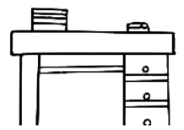 B. 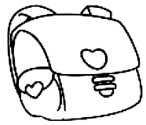 C. 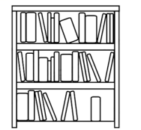
2. Which animal did the girl feed on the farm?
A. 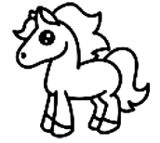 B.  C. 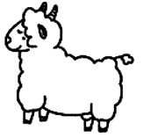
3. What does the man want to have?
A.  B.  C. 
4. How will the girl give Ben a big surprise?
A. 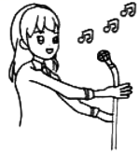 B. 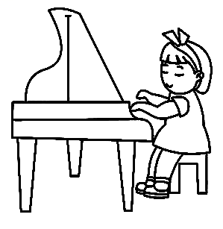 C. 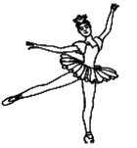
5. What was the boy doing when the rainstorm came?
A. 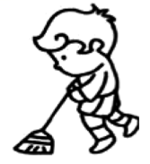 B. 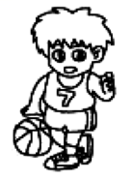 C. 
第二节 听对话，根据对话内容和所给问题，选择正确答案。(读两遍)
6. When would the woman like to visit Qinghai?
A. In June. B. In July. C. In August.
7. Which is Sam’ s dream job?
A. An astronaut. B. A scientist. C. A pilot.
8. What will John buy for his mom?
A Cakes. B. Milk. C. Eggs.
9. How old is the man’ s son?
A. 4 years old. B. 6 years old. C. 8 years old.
10. Whose cell phone is in the Lost and Found?
A. Alan’ s. B. Tina’ s. C. Jim’ s.
第三节 听长对话，根据对话内容和所给问题，选择正确答案。(读两遍)
听第一段对话，回答11至12小题。
11. How often should the man take the medicine?
A. Once a day. B. Twice a day. C. Three times a day.
12. What’ s the relationship between the two speakers?
A. Doctor and patient. B. Waiter and customer. C. Driver and passenger.
听第二段对话，回答13至15小题。
13. What is mum doing?
A. She is making zongzi. B. She is eating zongzi. C. She is drawing zongzi.
14. Who is mentioned in the dialogue?
A. A famous singer. B. A famous poet. C. A famous cook.
15. What else do the speakers plan to do during the festival?
A. Watch a dragon boat race.
B. Organize a dragon boat race.
C. Take part in a dragon boat race.
第四节 听短文，完成信息记录表，每空一词。(读两遍)
Father
Meaning | “Father” is a word that stands for power, duty and ________.
Actions | He teaches you how to________ a bike and how to face difficulties.  He is always there to give a helping hand and offer________.  As we grow ________, fathers are not so strong as we were young in our eyes.
Wishes | I hope time can fly ________!  My father can keep young and stay with us forever!
二、完形填空(10小题，每小题1分，共10分)
Can you sing the song Lonely Warrior(孤勇者)? The song is very popular ____1____ many people. Almost ____2____ likes it. The writer of the lyrics is Tang Tian. She ____3____ ill at the age of twenty-nine. Her illness was ____4____ serious that she might die soon. But to our ____5____, she beat it. Then she wrote down ____6____ story and named it Lonely Warrior. This song is really ____7____. We can get strength(力量) from it. It also encourages people ____8____ problems bravely. Teachers use the song to guide their ____9____. Doctors ____10____ their patients with it. It works very well.
Let’s sing and feel it together, “Who said that a hero is the one who stands in the light? …”
1. A. of B. from C. at D. with
2. A. no one B. everyone C. nobody D. someone
3. A. is B. are C. was D. were
4. A. so B. such C. so a D. such a
5 A. pity B. shame C. pain D. surprise
6. A. his B. her C. my D. your
7. A. careful B. harmful C. powerful D. awful
8. A. to solve B. solve C. solving D. to solving
9. A. workers B. actors C. farmers D. students
10. A. fix up B. cheer up C. turn up D. look up
三、阅读理解(20小题，31—45题，每小题2分;46—50题，每小题1分，共35分)
A
Chinese President Xi Jinping visited a school in Beijing on May 31st to celebrate Children’s Day, which falls on June 1st. He said, “Children are the future of a country and the hope of a nation.” Here is some information about Children’s Day in some countries.
China
Time: June 1st
Activity: Children get a one-day holiday and have parties with friends happily
Brazil(巴西)
Time: August 15th
Activity: Children go to hospitals to have a health check.
Japan
Time: March 3rd—for girls
May 5th—for boys
November 15th—for children who are 3, 5 and 7 years old
Activity: Children wear traditional Japanese clothes to celebrate their festivals.
Sweden(瑞典)
Time: August 7th is Boys’ Day. December 13th is Girls’ Day.
Activity: Boys join in some funny activities. Girls try to do something good to help others.

11. In ________ children have a one-day holiday on Children’s Day.
A. China B. Brazil C. Japan D. Sweden
12. Children in Brazil spend Children’s Day on ________.
A. December 13th B. August 15th C. June 1st D. March 3rd
13. How many Children’s Days are there in Japan in a year?
A. One. B. Two. C. Three. D. Four.
14. Girls in Sweden ________ on Children’s Day.
A. wear traditional clothes B. have a health check
C. have parties with friends D. do some good things for others
15. What can we learn from the passage?
A. Children are the future and the hope of a country.
B. Sweden has the most Children’s Days of the four countries.
C. The passage is only about Children’s Day in Asian countries.
D. Children around the world spend Children’s Day on the same day.
B
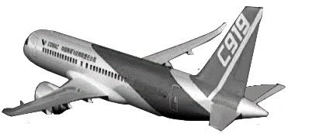
The C919 is an important kind of plane in China. 130 lucky people experienced its first business flight(飞行) from Shanghai to Beijing on May 28th, 2023. The body of this plane is painted “全球首架” in Chinese and “THE WORLD’ S FIRST C919” in English. There are 156 seats in the economy class(经济舱) and 8 seats in the first class(头等舱). Twenty big screens are in it, too. The seats are the most comfortable and the screens are the clearest. Passengers can enjoy different kinds of delicious foods. They can also lie down easily and have a good rest because it is very spacious.
The first successful business flight of the C919 makes a big difference to China. We have made great progress in Chinese civil transportation.
16. Where did the C919 take off on its first business flight?
A. In Shanghai. B. In Beijing. C. In Chengdu. D. In Chongqing.
17. How many seats are there in the plane in total?
A. 130. B. 148. C. 156. D. 164.
18. What can NOT passengers experience in the C919?
A. Comfortable seats. B. Clear screens.
C. Different kinds of foods. D. Exciting activities.
19. What does the underlined word “spacious” mean in Chinese?
A. 明亮的 B. 狭窄的 C. 宽敞的 D. 拥挤的
20. Where may this passage come from?
A. A storybook. B. A newspaper. C. A dictionary. D. A novel.
C
①Holly had a cousin called Rosie. Holly’s family was very poor but Rosie’s was very rich. Holly had short curly hair. Rosie’s hair was long and beautiful. Holly looked common while Rosie was pretty. Rosie always laughed at her. Holly was very sad and hated everything about herself, though her parents looked after her very well. She wanted to become Rosie.
②Finally, Holly became herself with the help of the old woman. She felt very happy, even if she was not rich or beautiful. She thought, “I needn’t admire others. The things that I have are the best.”
③After eating an old woman’s cake, Holly really became Rosie. Her house was large and bright. She wore expensive clothes and had much money. However, her parents were too busy to care about her. On her birthday, no one stayed with her because her parents were away on business and her friends were not available. She felt much lonelier and sadder than before. She missed her family so much. Holly wanted to be herself again.
(From I Want To Be You)
21. Which is the right order of the passage?
A. ②①③ B. ①②③ C. ①③② D. ③②①
22. Who helped Holly become Rosie?
A. Her cousin. B. An old woman. C. Her friends. D. Rosie.
23. What did NOT Holly have after she became Rosie?
A. A big house. B. Expensive clothes. C. Much money. D. Parents’ care.
24. Holly hated everything about herself because _________.
A. she was poor and looked common B. all the people laughed at her
C. no one cared about her in her family D. she couldn’t afford the old woman’s cakes
25. Which of the following is TRUE?
A. Everyone must admire others.
B. Rosie wanted to become Holly.
C. Rosie had short curly hair and looked pretty.
D. At last Holly found the things that she had were the best.
D
Hi, boys and girls! You’ll finish your junior high school and have a new beginning. Are you ready for the future? ____26____
First, make a plan. ____27____ Senior high school is quite different. So you’d better plan your time wisely.
____28____ Everybody is special in the world. You should know what you are good at and make efforts. If so, you will be able to build up confidence.
Then, be kind. ____29____, they will show kindness to you.
Finally, smile often. A pleasant smile is the best language. What will you do when someone smiles at you? ___30___
A. Second, be confident.
B. Here are some suggestions.
C. A good plan is half the success.
D. If you are kind to others
E. It’s polite to return a sweet smile.
四、口语表达(10小题，每小题1分，共10分)
A.七选五，补对话。
 | Amazing! So many people go to the city of Zibo for barbecue(烧烤)!
 | Yes, Zibo barbecue has been popular for months.
 | Is it as delicious as roast mutton in Qinghai? ____31____
 | Yes, I have. I like Qinghai roast mutton better. But Zibo barbecue gets more attention.
 | ____32____
 | Because of a promise between Zibo and some college students during COVID-19
 | Oh, just for this reason?
 | ____33____ Besides, friendly people in Zibo try their best to welcome tourists and make them feel at home. Tourists can enjoy special food, free parking lots, convenient traffic and the best service.
 | ____34____
 | So it is! It also sets a good example to us.
 | Yeah! If we learn from them, ____35____

A. Why?
B. Help yourself!
C. Of course not.
D. Have you tasted it?
E. What a warm city it is!
F. Have a good time on weekends.
G. Qinghai will be better and better.
第Ⅱ卷 共50分
B.填一词，补对话。(两小题首字母已给出，请将完整的单词填写在答题卡上。)
 | Lingling, look at the sign by the riverside.
 | N____36____ swimming!
 | Yes, many kids swim here in summer. It’s dangerous.
 | So it’s quite necessary to ____37____ kids not to swim in the river.
 | You’re right. And they should know what to do ____38____ someone falls into the water.
 | What should they do? Could they jump into the river to save people?
 | Never! Kids must know ____39____ to keep themselves safe. They should call 110 or find some adults for help.
 | Right! Safety comes first. They’d better swim in a swimming p____40____.
 | I couldn’t agree more.

综合填空，每空1词，限用一次，有三处请用括号内词的正确形式填空
hardly a woman we
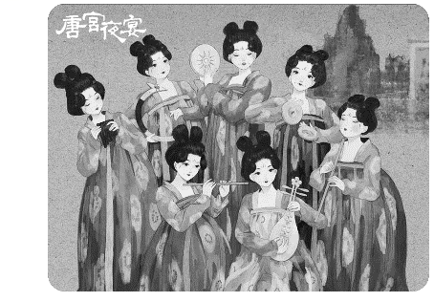
Have you heard of the show Tang Gong Ye Yan? You may know it if you are ____41____ (interesting) in traditional Chinese culture. It is a dance about the Tang Dynasty. We were surprised when the show was first ____42____ (play) on TV. Fourteen ____43____ dancers wore Tang clothes and gave a lively performance. They worked ____44____ to show the best dance to the world. Their dance was very classical and looked like ____45____ artwork. People might feel like ____46____ (travel) to 1,300 years ago while they were watching it. It made ____47____ know more about the Tang Dynasty in a new way. “The show is very wonderful. I enjoy it a lot,” one man said.
六、阅读表达(5小题，每小题2分，共10分)
Do you know the project — Ning-Ning Cooperation(宁宁合作) ? The first “Ning” means Nanjing and the second one is Xining. It is set up to help Xining in education, medical care and so on. Nanjing is a city which lies to the southeast of Xining. It’s about 2000 kilometers away from Xining. Although it is far, moving stories never stop happening.
A girl named Feifei got serious heart problems. The doctor said she was in great danger. It was impossible to save her because of the high sea level (海拔) in Xining. Her family got into the dark when the bad news came. Luckily, they got great help from Nanjing Children’ s Hospital. The excellent doctors tried their best to save the girl. ①They gave her successful treatment(治疗). The responsible nurses also took good care of her. Soon Feifei got better. What’s more, the whole treatment was free. Feifei’s family needn’t pay for it because of this project.
②What a(an) ________ and ________ project it is! Thumb up(点赞) for our country, for Nanjing and for the project!
48. 请在文中找出与 “ All her families were heartbroken when hearing the terrible news.” 意义相近的句子。
________________________________________
49. 请根据文意，找出①句中下划线单词所指代的内容。
________________________________________
50. 请根据文意，判断右图中“Nanjing”方位是否正确，正确填T，错误填F。
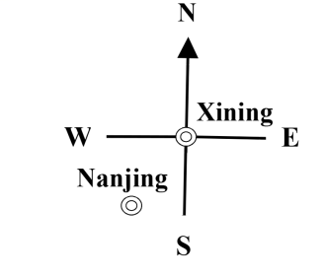
________________________________________
51. 请根据文意，在②句空白处填入合适的单词，使句意完整，符合逻辑，每空一词。
What a(an) __________ and __________ project it is!
52. 请根据文意，为本文拟一个标题(不超过五个词)。
________________________________________
七、完成短文(4小题，每小题2分，每空1分，共8分，每空1词)
Plogging(拾荒慢跑)
Plogging — a new sports activity appears in many countries. Runners ____53____ ____54____ (过去常常) do some running alone, but now they run in groups. ____55____ ____56____ (数以千计的) people have been in the activity so far. They try to ____57____ ____58____ (捡起) the rubbish while running. They can not only keep healthy, but also protect the environment. People also take up some good habits by doing this. So ____59____ ____60____ (为什么不) join them?
八、书面表达(2部分，A部分5分，B部分15分，共20分)
A.连词成文(共5分)
61. 用下列五个词或其适当形式确立主题、自拟题目，写一篇标题精准、主题鲜明、立意新颖、文意完整、至少五句话的短文，并用下划线标记所使用的五个词。
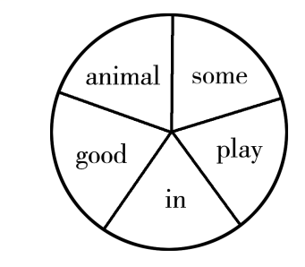
__________________
__________________________________________________________________________________________________________________________________________________________________________________________________________________________________________________________________________________________________________________________________________________________________________________________________________________________________________________________________________________________________________________________________________________________________________________________________________________________________________________________________________________________________________________________________________________________________________________________________
B.文段表达(共15分)
62. 为提高自理能力，适应未来发展，青少年应学会做日常家务，培养必备生活技能，如烹饪、洗衣、种花、打扫、整理等。请以“Doing Chores Makes Me Better” 为题写一篇80词左右的英语短文，文中不得出现真实校名和姓名。
要点提示：1.你会做哪些家务？2.你想学哪些家务？为什么？3.对你有何帮助和意义？
Doing Chores Makes Me Better
___________________________________________________________________________________________________________________________________________________________________________________________________________________________________________________________________________________________________________________________________________________________________________________________________________________________________________________________________________________________________________________________________________________________________________________________________________________________________________________________________________________________________________


