二O二三年齐齐哈尔市初中学业考试
英语试卷
考生注意:
1.考试时间120分钟
2.全卷共六道大题，总分120分
3.使用答题卡的考生，请将答案填写在答题卡的指定位置
第一部分 语言知识运用（共计55分）
Ⅰ.单项选择（每小题1分，共10分）
从每小题所给的A、B、C三个选项中，选出一个能填入空白处的最佳选项。
1. Tracy, ________ exchange student from Norway, is ________ university student in Heilongjing now.
A. a, an B. an, the C. an, a
2. Chinese scientists have made great ________ in space technology recently.
A information B. progress C. knowledge
3. Teachers often say that teenagers should learn to look after ________.
A. ourselves B. yourselves C. themselves
4. — This will be my ________ visit to the Sun Island. I’m really excited.
— Really? I can’t believe it. You’ve been in Harbin for a year.
A first B. second C. third
5. Bills is ________ all the other runners. It seems that he will be the winner.
A. next to B. far from C. ahead of
6. Remember this, kids. The harder you work, the ________ you will be.
A. worse B. luckier C. easier
7 We should often review our notes after class to avoid ________ the same mistakes.
A. making B. getting C. wasting
8. — Why do the elephants in Thailand have to ________?
— Because humans there catch them for their ivory to make money.
A. protect B. be protected C. are protected
9. When you are in trouble, a friend who ________ from you is not a true one.
A. takes away B. gives away C. runs away
10. — Excuse me, could you tell me ________?
— You can take the No. 28 bus there. It’s about 20 minutes’ ride.
A. how far Huaxing Middle School is
B. how can I get to Huaxing Middle School
C. how long it takes to get to Huaxing Middle School
Ⅱ.完形填空（每小题1分，共15分）
阅读短文，从每小题所给的A、B、C三个选项中，选出一个能填入空白处的最佳选项。
It seems that on every street corner in the world, there is a fast-food restaurant. People everywhere are ____11____, so they do not want to wait for their food. Around the world, $240 billion a year ____12____ on fast food. Yet, ____13____ fast food has become quite popular, there are many myths(荒诞的说法) ____14____ it
The first myth is that fast food is a recent ____15____. This is not true. More than 2, 000 years ____16____, the people of Rome lined up in the street to buy quick meals at small stands. One type of their most popular fast food ____17____ a lot like a modem hamburger. All through history, people have always eaten fast food.
The second myth is that all fast food is ____18____. While many modern fast-food restaurants are American, some very traditional Chinese food is nearly fast food. This ____19____ mantou, noodles and Chinese dumplings. ____20____, one of the most popular fast food chains(连锁店) in the US is a Chinese food chain, Panda Express. ____21____ has more than 1, 600 restaurants in America.
Finally, many people think that fast food is always bad for them. This is true of a lot of fast food. However, nearly every fast-food restaurant has some healthy food on its ____22____, and some fast-food restaurants ____23____ make healthy food. The problem is not fast food, ____24____ the choices we make. We can choose ____25____ healthy food, even at fast food restaurants.
11. A. tired B. busy C. lazy
12. A. is spent B. is paid C. is put
13. A. so that B. even though C. as soon as
14. A. for B. from C. about
15. A. invention B. tradition C. prediction
16. A. ago B. later C. before
17. A. sounded B. smelt C. looked
18. A. British B. Chinese C. American
19. A. means B. includes C. has
20. A. In fact B. At first C. So far
21. A. One B. This C. It
22. A. table B. menu C. plate
23. A. only B. never C. also
24. A. and B. because C. but
25. A. to cook B. to refuse C. to eat
Ⅲ.短文改错（每小题1分，找出错误和改正错误各0.5分，共10分）
阅读短文，从原文的每一行中找出一处错误并改正，不加词，不删词。
（例如: My mother often go shopping on weekends. go-goes）
Two boy students were asked to meet their teacher in the end of a forest. There ____26____
were two paths(小径). One was short and easy, and the others was full of fallen ____27____
trees. One student chooses the easy one. He felt he was clever as he walked through ____28____
without difficulty. He finished first and took proud in himself. The second student ____29____
decided to spend time jumping over every fallen tree in his path. After arrive at the ____30____
finishing line, she felt tired and regretted choosing that path. The teacher nodded ____31____
and smiled at all of them. He asked them to get a prize by a river in three days. ____32____
While the students arrived, they were surprised to hear that they needed to ____33____
jump over the river. It was a little meters wide. The teacher said, “Everything that ____34____
you have done until now will be prepared good for this moment. This jump will ____35____
lead you to greatness.” At last the second student made it!
Ⅳ.交际运用（共20分）
根据对话内容，从A到F选项中，选出能填入空白处的最佳选项，每个选项只使用一次，选项中有一项为多余项。
A: Hi, Linda. What are you reading?
B: The Adventure of Tom Sawyer: ____36____
A: Oh, I know he is a famous writer. ____37____
B: It’s about a little boy called Tom Sawyer and his friends who took lots of risks.
A: Really? I can’t imagine! What’s Tom Sawyer like?
B: ____38____
A: Is the story interesting?
B: Sure I enjoy it so much that I can’t stop reading.
A: ____39____ But we need to have a rest after an hour or so, such as looking out of the window to relax our eyes.
B: Yes, I agree. ____40____
A. Do you know the writer’s name?
B. I like reading, too.
C. What’s it about?
D. Thanks for your advice.
E. It was written by Mark Twain.
F. He is clever enough to overcome many difficulties.
结合本题所设置的情境，在每个空白处填入适当的内容完成下列对话。
（A: Ann B: Betty C: Sales clerk）
A: Hi, Betty. Long time no see. ____41____?
B: Pretty good. How about you?
A: Great! Where are you going?
B: Summer vacation is coming. I’m going shopping for my study tour. ____42____?
A: Sure, I’d love to.
B: Terrific! Let’s go.
（The two girls are in the shopping mall）
C: ____43____?
B: I’d like a pair of sports shoes.
C: What about this pair? They’re the latest design and at a good price.
B: ____44____?
C: Of course.
A: You look cool in the shoes, Betty!
B: Haha, I think so. ____45____?
C: 150 yuan.
B: I’ll take them. Here is the money.
第二部分 阅读理解（共计50分）
V.阅读理解（A、B、D每小题1分，C、E、F每小题2分）
（A）
阅读下面文字，从A到F选项中为每个段落选出一个最适合标题。
Cat-Cow, Crow, Downward-facing dog and Pigeon: these names might sound like animals but they are actually yoga (瑜伽) poses (姿势). Learning how to move your body into these poses takes practice, but your life quality (质量) is likely to improve.
46. Join me now. Practicing yoga can give you inside peace and strengthen your body. There are lot of chances to learn yoga.
47. Take 10 minutes a day to move your body and notice how your breath can have an influence on how you feel.
48. Take your time with each pose and remember not to rush. Each pose has steps to follow safely.
49. Keep practicing poses that you find difficult. With time and patience you will be able to do them.
50. Have a good time and enjoy it. That might mean playing music while doing yoga, or practicing outside in a park.
A. Keep going
B. One step at a time
C. Have fun
D. Get started
E. Feel changes
F. Enjoy music
（B）
Before the discovery of DNA information in the 1980s, fingerprint(指纹) science was the easiest way to solve serious crimes. It’s believed that each one of us has our own fingerprints. But did you know that our fingerprints could show a lot about us?
According to the expert, fingerprints can show lifestyle and environment, eating habits, possible medical problems and even the job of a person.
So how can we work all this out from just a simple fingerprint?
Well, a fingerprint is formed when a finger touches a surface. Most fingerprints can’t be seen to the eye and require a chemical development process in order to make them shown.
Besides, its use could be much wider. For example, it may be helpful in the future to doctors treating their patients. A fingerprint exam may also tell a doctor whether a patient is properly taking medicine. In the treatment of some of the most serious illnesses, taking proper medicine is important.
In the future, finger print science can be used by the police and help doctors keep us in the best possible health.
根据文章内容，判断句子正（T）、误（F）。
51. People didn’t discover DNA information until the 1980s.
52. Fingerprints can show a person’s both looks and lifestyle according to the passage.
53. People can easily see all the fingerprints without the help of technology.
54. Doctors can know about patients just through a finger print exam.
55. In the future, fingerprint science can still make a difference in our life.
（C）
Hello, boys and girls! Nice to see you again in our art club. Today we are going to learn about a new art form. It was created by an American artist Haring. He is good at different kinds of scrawling(涂鸦). Now let’s make some Haring sports scenes. Please follow the instructions. If you have any questions, let me know.
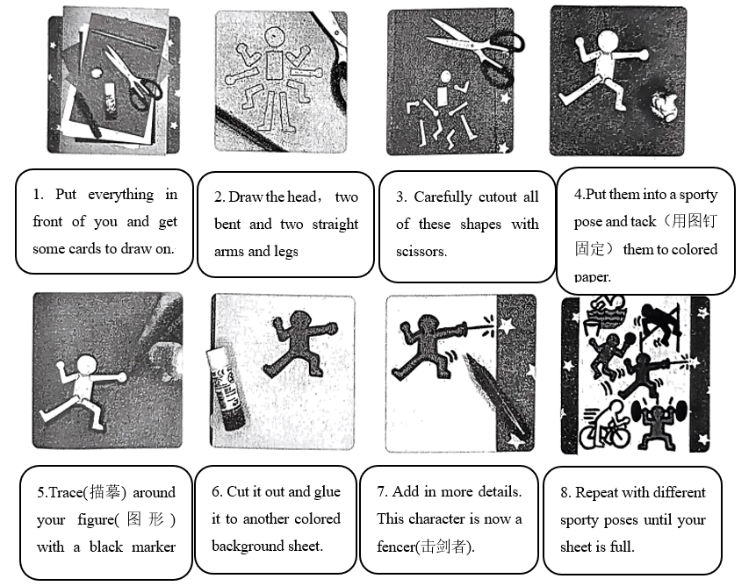
阅读以上信息，从每小题所给的A、B、C三个选项中选出一个最佳选项。
56. First of all, we should ________.
A. repeat with different poses B. get everything ready C. draw the head
57. There are ________ steps to make a Haring sports figure before adding in more details.
A. six B. seven C. eight
58. We don’t need ________ during the first four steps.
A. scissors B. tacks C. glue
59. We can use a marker pen to ________.
A. cutout the figure B. trace the figure C. glue the figure
60. In this period of the art club activities, you probably make some ________ poses.
A. running B. thinking C. singing
（D）
阅读短文，根据首字母或所给词的适当形式填空，使文章语义通顺。
Do you know China’s Teeth Care Day? It falls on S____61____ 20th every year. It began in 1989. Its aim is to take good care of ____62____ (people) teeth.
There are thirty-eight students in Wang Bin’s class, and eleven of ____63____ (they) have tooth problems which bring them a lot of trouble.
Mao Kang said, “I had three bad teeth. Each tooth c____64____ me four hundred yuan, and I had to see the dentist five times.”
Liu Jian said, “Something is wrong with my front teeth. I don’t like to open my mouth. My classmates say my teeth look like an old woman’s. I’m sad to hear that. And I can’t speak ____65____ (clear) now.”
Do you have good teeth, my friend? If you want to take care of your teeth, please follow the f____66____ suggestions below:
◆Brush your teeth at ____67____ (little) once a day. If you can, brush them after every meal.
◆Brush all your teeth, and do not just brush the front o____68____.
◆Brush your teeth slowly and carefully. Spend four minutes or more each time.
◆Do not use your teeth a____69____ tools to open bottles. It’s very easy to hurt your teeth to do such jobs.
◆Eating and drinking are also important to your teeth. Eat lots of fruits and vegetables and drink water.
Try not ____70____ (drink) Coke or other drinks.
（E）
Farming has always been a countryside thing. But now, farms are coming to the balconies(阳台) of city flats.
According to a recent report, sales of vegetable seeds(种子) on the Internet in the first quarter of 2022 doubled compared with the same period in 2021. Of these buyers, most were born after 1995.
Zhang Chao from Anhui Province is one young “city farmer”. The senior high school student said his love for planting was formed in primary school, when he lived with his grandpa in the countryside. He learned to grow vegetables from his grandpa, who has been a farmer for life. Though farming takes hard work, Zhang said he felt excited when he saw seeds turn into plants.
Now Zhang still keeps up his hobby with a balcony garden. He grows strawberries and carrots. “Growing fruits and vegetables not only brings delicious food, but it also reminds me of the happy times with my grandpa.” said Zhang.
Unlike Zhang, Fang Minke from Shenzhen thinks that planting a garden is a good way to relax and develop patience.
The 16-year-old girl sometimes felt stressed. To deal with this, she started planting vegetables on her balcony in 2021. Most of the seeds were given to her by friends. Not knowing what plants the seeds were from, she just planted them and waited patiently. After half a year, her balcony became a small garden.
Every day it takes her long hours to do homework. Then she likes to walk around her balcony garden. “Seeing different colors and breathing fresh air, I feel closer to nature.” Fang said.
Planting vegetables is now more than just away to live. It also brings joy to the lives of the young.
阅读短文，回答下列问题。
71. When did Zhang Chao learn to grow vegetables?
_______________________________
72. What does Zhang Chao grow on his balcony, vegetables or fruits?
_______________________________
73. What does Fang Minke think of planting a garden?
_______________________________
74. How did Fang Minke deal with her stress?
_______________________________
75. Why do you think so many young people become “city farmers”?
_______________________________
（F）
“We all have suffered(遭受) from air pollution. If we don’t call for an end to firecrackers(鞭炮), the environment will get worse and worse in the future.” said Zhang Wei. He put up a notice in his neighborhood. In the notice, he called on more people to set off fewer firecrackers during this year’s Spring Festival.①
Lots of parents agreed with Zhang Wei. (A) They said that they hated the noise of firecrackers. The noise often woke up their babies easily. And the babies really needed a (B) ____76____ place to have enough sleep.
More Chinese are looking forward to celebrating the holiday in greener ways. ②Many people decide not to set off firecrackers and they decide not to waste food. They think that the new ways are fashionable. “My family didn’t buy firecrackers this year. (C) ____77____, we gave the money away to a charity. It’s good for the environment and the charity.” the Internet user “Fighter” wrote on the Blog.
In my opinion, it’s very important for us to celebrate our traditional festival—the Spring Festival. But it’s more important to reduce air pollution and protect our environment. ③We need more people like Zhang Wei or “Fighter” who uses electronic ways like QQ, WeChat or Blog to spread the ideas of environmental protection. I believe more and more people will join them and our environment will get better and better.
阅读短文，根据题目要求完成下列任务。
76. 用英文写出文中（A）处They所指代的内容：________________________
77. 在文中（B）处和（C）处各填上一个适当的词，使文章的意思完整。
（B）________（C）________
78. 在文中①②③处，选出能够填入“We had better express our cheerful feeling and best wishes in greener ways.”的最佳位置：______________________________
79. 在文中找出一个与所给英文释义相匹配的单词。
____________________: the process of making air, water, soil etc. dirty or dangerous
80. 请根据文章内容，给此文拟一个恰当的标题：（不超过8个单词）___________________________
第三部分 书面表达（共计15分）
Ⅵ.书面表达（本题共15分，其中A题5分，B题10分）
（注意: 文中不能出现考生真实姓名、校名和老师名，否则不给分）
81. 假如你是李智，请根据表格中的提示写一张请假条，向你的班主任张老师请假。
事由 | 天数 | 其他
明天你将要去北京参加游泳比赛（competition） | 四天 | 及时返校，自学错过的课程
要求: 1.字迹工整，表达清楚，语法正确；
2.词数: 30—50词。
Dear Mr. Zhang,
________________________________________________________________________________________________________________________________________________________________________________________________________________________________________________________________________________________________________________________________________________________________________________________________________________________________________________________________________________________________________________________________________________________________________________________________________________________________________________________________________________________________________________________________________
Yours,
Li Zhi
82. 为了调动同学们的学习积极性、提高学生的创造力，你的学校正在开展“师生同携手，作业我创新”主题活动，号召同学们设计出自己喜欢的，兼具趣味性、实效性、创新性的课后作业。请你结合英语学科的学习体验，设计三项作业。下面是你的“创新作业设计表”，请根据你自己的完整设计，以“My Homework, My Idea”为题，写一篇短文，阐述你设计的英语作业内容、设计意图和作用。
作业内容 | 设计意图 | 作用
Learn an English song | To sing it in class | Learn more words
Draw a mind map | To review one’s English notes | …
… | … | …
要求：
1.字迹工整，段落清晰，表达清楚，语法正确，行文连贯；
2.要点必须包含所有相关信息，并适当发挥；
3.首段已给出，不计入总词数；
4.词数：80—100词。
My Homework, My Idea
As students, we sometimes feel it boring to do homework every day, so doing creative homework can make us happier and more interested in English.
__________________________________________________________________________________________________________________________________________________________________________________________________________________________________________________________________________________________________________________________________________________________________________________________________________________________________________________________________________________________________________________________________________________________________________________________________________________________________________________________________________________________________________________________________

