
2024年内蒙古通辽市初中毕业生学业考试试卷
英语
注意事项：
1. 本试卷共12页，8道大题，满分为120分，考试时间为120分钟。
2. 根据网上阅卷需要，本试卷中的所有试题均要求在答题卡上作答，答在本试卷上的答案无效。
听力部分（共30分）
一、听句子，选择图片。（每小题1分，共5分）
第一节 听句子，从每小题A、B、C选项中选择最佳图片。（每个句子读一遍）
1. A. 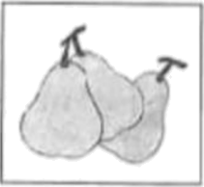 B. 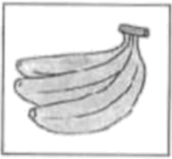 C. 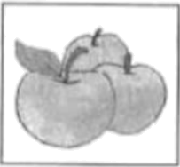
2. A. 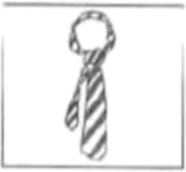 B. 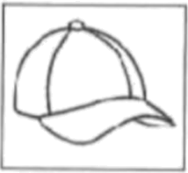 C. 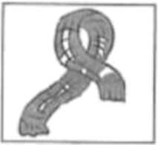
3. A. 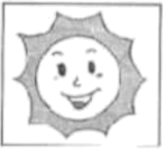 B. 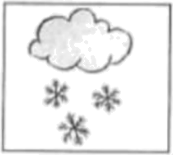 C. 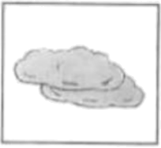
4. A. 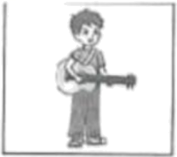 B. 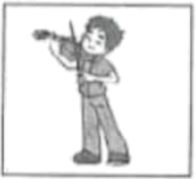 C. 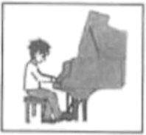
5. A. 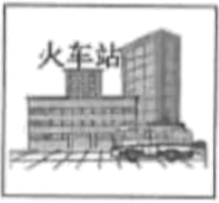 B. 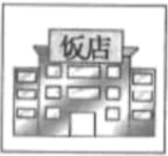 C. 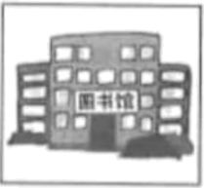
二、听句子、对话和短文。（每小题1分，共15分）
第二节 听句子，从每小题A、B、C选项中选择能对句子做出适当反应的答语。（每个句子读两遍）
6. A. That sounds good. B. Good luck. C. Not at all.
7. A. I went there by train. B. It was wonderful. C. She looked happy.
8. A. It’s a pity. B. Don’t worry. C. I’m glad you like it.
9. A. A spaceship. B. An astronaut. C. A plane.
10. A. Sorry, I won’t. B. It’s my pleasure. C. It doesn’t matter.
第三节 听对话，从每小题A、B、C选项中选择能回答所给问题的最佳选项。（每段对话读两遍）
听下面一段对话，回答第11至12小题。
11. Where does the conversation probably happen?
A. In a classroom. B. In a fruit shop. C. In a cake shop.
12. How much will the woman pay at last?
A.6 yuan. B. 8 yuan. C. 14 yuan.
听下面一段对话，回答第13至15小题。
13 Bob has had his ______ for 5 years.
A. toy car B. schoolbag C. clothes
14. What will they do with the money from the yard sale?
A. They will give it to the disabled people.
B. They will give it to the old people’s home.
C. They will give it to the children’s home.
15. They will have a yard sale ______.
A. this Wednesday morning B. next Monday morning C. this Wednesday afternoon
第四节 听短文，根据所给问题选择最佳选项。（短文读两遍）
16. Where docs Bill go hiking?
A. In the mountains in the northeast of the city.
B. In the mountains in the southwest of the city.
C. In the mountains in the southeast of the city.
17. Who often goes hiking with Bill?
A. His classmate Dick. B. His cousin Sam. C. His friend David.
18. When do the boys usually go hiking?
A. On Saturdays from 9 to 12 a. m. B. On Sundays from 9 to 12 a. m. C. On Saturdays from 9 to 12 p. m.
19. What do the boys usually wear while hiking?
A. Raincoats and sports shoes. B. Sports clothes and leather shoes. C. Sports clothes and sports shoes.
20. Why is hiking good for Bill?
A. Because he can get exercise and enjoy nature.
B. Because he can think about his problems while hiking.
C. Because he can do his homework there.
三、听短文，填表格。（每小题2分，共10分）
第五节 听短文，根据短文内容填写表格，每空一词。（短文读两遍）
School Friendship Day
When | It is on the ________ Friday of September.
How to celebrate | Prepare ________ for each other or exchange small gifts
How to celebrate | Bring favorite food or cook food in the dining hall.
How to celebrate | ________ up in the best clothes and eat the foods together.
How to celebrate | Have a party and enjoy ________.
Why | It shows students the ________ of friendship.
笔试部分（共90分）
四、完形填空。（完成26～35小题，每小题1分，共10分）
阅读下面短文，掌握其大意，然后从A、B、C、D四个选项中选择最佳选项。
One day, a little girl asked her mother, “What does the word ‘great’ mean? Who are great people and ___1___ do they become great?”
The mother asked her daughter to bring two plants and then told her to plant one of them inside the house and ___2___ outside the house. The girl did as her mother said.
The mother asked her daughter, “Which one of the two plants do you think will be safer and bigger?” The girl replied, “The plant inside the house will be safer, so it will grow bigger, ___3___ the plant outside the house is not safe at all. No one will be there to ___4___ it. It may be eaten by animals.”
The mother smiled and said, “Let’s wait ___5___. We will know the answer.”
Then the girl left for study and after five years she came back to her house. She said to her mother, “Look! ___6___ happens to this plant inside the house and it is safe.”
When the girl went outside, she was very ___7___ to see such a big tree. The girl couldn’t believe her eyes. She couldn’t understand how the plant outside was able to grow a lot bigger than the plant inside the house.
“The plant outside the house faced four ___8___ and many difficulties.” The mother ___9___ to her daughter why the plant outside was bigger. “The plant inside was safe, but it didn’t face weather changes or get enough sunlight. So it didn’t become big.”
Here is the answer ___10___ the question about being great. To become a great person, one must have experienced many difficulties and overcome those difficulties. After that, he or she is able to become great.
1. A. when B. how C. what D. where
2. A. other B. another C. the other D. others
3. A. while B. or C. if D. once
4. A. look like B. look for C. look through D. look after
5. A. exactly B. patiently C. actively D. wisely
6. A. Nothing B. Something C. Everything D. Anything
7. A. tired B. surprised C. worried D. pleased
8. A. chances B. weeks C. choices D. seasons
9. A. explained B. belonged C. turned D. smiled
10. A. for B. of C. to D. up
五、阅读理解。（完成36～55小题，每小题2分，共40分）
第一节 阅读短文，从每小题所给的A、B、C、D四个选项中，选择最佳选项。
A
The traditional Chinese lunar calendar (农历) divides the year into 24 solar terms (节气). It’s very useful for people’s life and work. Let’s have a look.
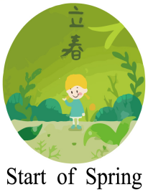 | Start of Spring, the first solar term of the year, falls on February 4th this year. After Start of Spring, the daytime is becoming longer and the weather is becoming warmer. And people eat spring pancakes and spring rolls on the day.
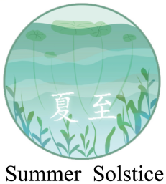 | Summer Solstice, the 10th solar term, falls on June 21st this year. Summer Solstice is not the hottest time in a year. The hottest days often come 20 to 30 days later. People have a tradition of eating noodles on the day.
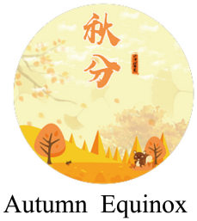 | Autumn Equinox, the 16th solar term, falls on September 22nd this year. On this day, day and night are of equal length (等长). After this day, days get shorter and nights get longer in the northern hemisphere (北半球). In South China, people eat Qiucai, a kind of amaranth (苋菜).
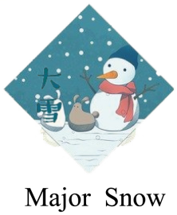 | Major Snow, or “Daxue” in Chinese, the 21st solar term, falls on December 6th this year. It marks the arrival of midwinter. People have the customs of eating lamb (羊肉) and porridge.

11 How many solar terms are in Chinese lunar calendar?
A. 20. B. 24. C. 12. D. 8.
12. What do people often eat on the day of Start of Spring?
A. Amaranth. B. Noodles. C. Spring pancakes. D. Lamb.
13. According to the passage which of the following day may be the hottest?
A. May 15th. B. October 15th. C. September 15th. D. July 15th.
14. In October, days are ________ nights in Tongliao.
A. shorter than B. longer than C. as long as D. as warm as
15. The passage may come from a book about ________.
A. Chinese famous people B. Chinese table manners
C. Chinese classical gardens D. Chinese culture and customs
B
On a cold day in winter, a 13-year-old boy, living in Qinghai Province, was heading down a mountaintop with his family. Suddenly, they saw two snow leopards (雪豹) near the Lancang River. “I see them for the first time. They look so cool!” he said.
Since the mid-20th century, the area of snow, grasslands and lakes in Sanjiangyuan has become smaller because of climate change and human activities. Many wild animals in the area have died out. Snow leopards are endangered.
Later, China set up Sanjiangyuan Nature Reserve (保护区) to better protect the area and the wildlife there. In these years, the number of wild animals has been increasing. More than 70,000 Tibetan antelopes (藏羚羊) live there now. And over 1,000 snow leopards can be found in the area. It’s higher than the average number around the world.
The local people have improved their understanding about environmental protection and have tried hard to protect the environment in Sanjiangyuan over the years. They still live on selling caterpillar fungus (冬虫夏草) they’ve found in grasslands. In the past, they carried food with them in plastic bags and left the bags and food waste behind. But now the local people have realized they should live together with nature in harmony. They often pick up waste on the grasslands. People also take their plastic bags and food waste down the mountain after eating. The local environment has taken on a new look. Many young people there said, “We will continue to guard our home and make it more beautiful.”
16. What can we know from paragraph 1 and paragraph 2?
A. Snow leopards are in danger.
B. A boy raised two snow leopards at home.
C. Two snow leopards first appeared near the Yellow River.
D. The grasslands and lakes in Sanjiangyuan have disappeared.
17. Why did China build Sanjiangyuan Nature Reserve?
A. To develop the local tourist industry. B. To improve the natural environment.
C. To provide a home for more people. D. To find the source of three rivers.
18. The local people in Sanjiangyuan has changed their way of ________.
A. making a living B. crossing the grasslands
C. carrying food with them D. dealing with waste
19. What does the underlined word “harmony” mean?
A. 智慧 B. 和谐 C. 伤害 D. 忠诚
20. What can we infer from the passage?
A. The local people won’t sell caterpillar fungus any more.
B. Many young people choose to leave Sanjiangyuan.
C. The future of Sanjiangyuan Nature Reserve will be better and better.
D. The number of Tibetan antelopes in Sanjiangyuan is the smallest.
C
The scientific method is used for simple experiments (实验) that students may do in the classroom or very difficult experiments that scientists are doing throughout the world. It is a way of thinking that helps you to avoid drawing incorrect conclusions. There are usually four steps in the scientific method, including observation (观察), hypothesis (假设), experiment and conclusion.
The first step is usually observation and asking a question about your observation. For example, you had a sick stomach and ate a piece of chocolate. Two hours later, you observed that you felt better. Here you can ask a question such as “What makes a sick stomach feel better?”
The next step is to state a possible hypothesis, such as “A piece of chocolate makes a sick stomach feel better.” A good hypothesis includes three things: it can explain the observations; it can be tested and it will usually predict new conclusions.
The third step is the experiment, to test the hypothesis. An experiment is a test which will either support or challenge the hypothesis. The hypothesis will then be true or false.
The final step is to think about what happened when you tested the hypothesis and draw a conclusion. The conclusion will either clearly support the hypothesis or it will not. If the results support the hypothesis, a conclusion can be written. If they don’t support the hypothesis, you may choose to change the hypothesis or write a new one based on what was learned during the experiment.
21. The scientific method can help you ________.
A. get rid of a sick stomach B. pass a test
C. draw correct conclusions D. feel better
22. What does a good hypothesis include?
①explaining the observations ②being tested
③doing experiments ④predicting new conclusions
A. ①②③ B. ②③④ C. ①③④ D. ①②④
23. What can we learn about the experiment from the passage?
A. An experiment can offer you a learning method.
B. An experiment is a test to either support or challenge a hypothesis.
C. An experiment is only used when scientists are trying to prove a hypothesis.
D. An experiment does not have to be part of the scientific method.
24. What does the underlined word “it” in the last paragraph refer to?
A. The conclusion. B. The observation. C. The hypothesis. D. The question.
25. Which sentence can best express the main idea of the passage?
A. What makes a sick stomach feel better?
B. The conclusion will sometimes clearly support the hypothesis.
C. How do the four basic steps in the scientific method work?
D. Learning the scientific method may help students succeed in science.
根据短文内容，从所给的选项中选出可以填入空白处的最佳选项，其中有一项为多余选项。
Almost everyone values health and wants to be healthy, but sometimes it seems hard to improve our health. ____26____
● Eat breakfast every morning.
Studies show that if you eat something in the morning, you may not be too fat or eat too much during lunch. ____27____
● Get enough sleep every day.
Poor sleep can influence your memory. ____28____ Researches show that people without enough sleep may not focus on what they do. So get enough sleep!
● ____29____
Walking is an easy way to exercise. You’d better meet friends for a walk, not for a meal. When you walk, you will enjoy the beautiful world around you. Once you try, you will find that adding a walk to your life is not difficult.
● Join social groups.
Social groups can provide help. They might include sports teams, art or music groups. ____30____ Also, being in a group keeps your mind active. An active mind is a healthy mind!
A. Take a walk every day.
B. It can also influence your learning.
C. If so, the following healthy habits may help you.
D. Here are some ways to improve the quality of sleep.
E. Eating breakfast can help people feel better through the day.
F. The people in the group can offer suggestions and help each other in hard times.
六、短文填空。（完成1～10小题，每小题1分，共10分）
阅读下面短文，根据语境或括号内所给的提示词，在每个空格内填入一个恰当的词，使短文意思完整、行文连贯。
Showing Respect for Seniors
In China, there is a special day for elderly people— the Double Ninth Festival. The festival is on the ninth day of the ninth lunar month. As the Chinese word for nine has ___31___ same sound as the word for long, people take the Double Ninth Festival to show their ___32___ (wish) of long life for elderly people.
There are many traditions for this festival. On that day, families get together and climb mountains for good luck and in the hope that elderly people will be much ___33___ (happy) and live longer. They also drink chrysanthemum wine (菊花酒) and wear a plant ___34___ is called zhuyu. Chrysanthemum wine has great medical values and it’s popular ___35___ many people. Zhuyu is ___36___ (regard) as a kind of clean plant that can clean houses and cure diseases.
Respecting elderly people is shown not only on this special day ___37___ also in daily life. For example, when an elderly person enters a room, everyone stands up and greets him or her ___38___ (polite). When there are several guests at the table, the host usually introduces ___39___ (they) from the oldest to the youngest.
Respecting elderly people is a traditional virtue (美德) in China, and Chinese people are ___40___ (pride) of it. Besides, to respect the elderly people is to respect yourself tomorrow.
七、完成句子。（完成66～70小题，每小题2分，每空1分，共10分）
根据所给中文意思完成句子，每空一词。
41. 在收获季节，农民是多么忙碌啊！
________ ________ the farmers are during the harvest time!
42. 千里之行，始于足下。
A thousand-mile journey ________ ________ the first step.
43. 从内心深处，我非常感谢我的父母。
From the ________ of my ________, I thank my parents very much.
44. 到目前为止，中国在航天科技领域已经取得了巨大进步。
So far, China has ________ great ________ in the field of space technology.
45. 他问我，当他进来时我是否正在读小说《汤姆·索亚历险记》。
He asked me if I ________ ________ the novel The Adventures of Tom Sawyer when he came in.
八、书面表达。（共20分）
46. 作为新时代的学生，我们应该注重全面发展，努力成为品德高尚、乐学善思、身心健康、兴趣广泛的人。请根据下面提示，以 “How to Be Good Students”为题目，写一篇英语短文，谈谈如何做新时代的好学生。
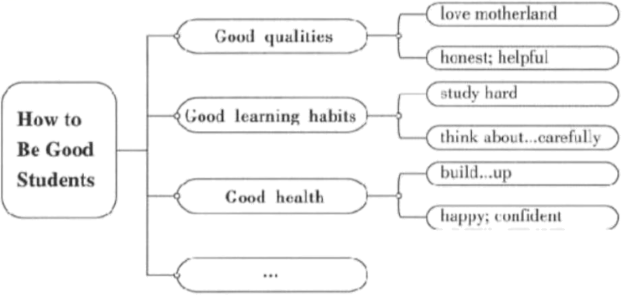
要求：
1. 语句通顺，逻辑清晰，书写规范。
2. 要包括图表中所给的提示信息并适当发挥。
3. 文中不得出现真实的人名、校名、地名。
4. 不少于80词。（短文开头已给出，不计入总词数）
How to Be Good Students
As students in the new era (时代), we are supposed to develop fully. __________________________________________________________________________________________________________________________________________________________________________________________________________________________________________________________________________________________________________________________________________________________________________________________________________________________________________________________________________________________________________________________________________________________________________________________________________________________________________________________________________________________________

