凉山州2024年初中学业水平暨高中阶段学校招生考试试题英语
注意事项：
1．答题前，考生务必将自己的姓名、座位号、准考证号用0.5毫米的黑色墨迹签字笔填写在答题卡上，并在答题卡背面上方填涂座位号，同时检查条形码粘贴是否正确。
2．选择题使用2B铅笔涂在答题卡对应题目标号的位置上；非选择题用0.5毫米黑色墨迹签字笔书写在答题卡对应题目标号的答题区域内，超出答题区域书写的答案无效；在草稿纸、试题卷上答题无效。
3．考试结束后，由监考教师将试题卷、答题卡、草稿纸一并收回。
本试卷分为A卷（100分）、B卷（50分），全卷共10页，满分150分，考试时间120分钟。
A卷（共四部分 满分100分）
第一部分 听力（共三节，满分30分）
第一节 情景反应（共5小题；每小题1.5分，满分7.5分）
听下面5个句子，每个句子后有一个小题，从题中所给的A、B、C三个选项中选出最佳应答语，并涂在答题卡上相应的位置。听完每个句子后，你将有10秒钟的时间来回答有关小题和阅读下一小题。每个句子读两遍。
1．A．I’m fine, thanks. B．I’m 12. C．Nice to meet you.
2．A．Good luck! B．Sounds good. C．Thank you.
3．A．No thanks. B．No problem, Mom. C．Not at all.
4．A．By taking the bus. B．By reading aloud. C．By playing sports.
5．A．Congratulations! B．Don’t worry. C．Sorry to hear that.
第二节 短对话理解（共5小题；每小题1.5分，满分7.5分）
听下面5段对话，每段对话后有一个小题，从题中所给的A、B、C三个选项中选出最佳选项，并涂在答题卡上相应的位置。听完每段对话后，你将有10秒钟的时间来回答有关小题和阅读下一小题。每段对话读两遍。
6．What can Anna play?
A． B． C．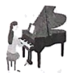
7．What does the boy want to be when he grows up?
A． B． C．
8．Where are the two speakers?
A．In a school. B．In a restaurant. C．In a store.
9．What time are they going to meet in front of the cinema?
A．At 6:30. B．At 7 : 00. C．At 7: 30.
10．Which festival are they talking about?
A．The Double Ninth Festival. B．The Dragon Boat Festival. C．The Mid-Autumn Festival.
第三节 长对话理解和短文理解（共10小题；每小题1.5分，满分15分）
听下面几段对话或独白，每段对话或独白后有几个小题，从题中所给的A、B、C三个选项中选出最佳选项，并涂在答题卡上相应的位置。听每段对话或独白前，你将有时间阅读各个小题，每小题5秒钟；听完后，各小题将给出5秒钟的作答时间。每段对话或独白读两遍。
听第一段材料，完成第11—12小题。
11．Which of the following is in the wallet?
A．A picture. B．An ID card. C．30 yuan.
12．Whose wallet is it?
A．Linda’s. B．Dick’s. C．Cindy’s.
听第二段材料，完成第13—14小题。
13．How often does Bill run?
A．Once a week. B．Twice a week. C．Every day.
14．What is Amy like now?
A．Strong. B．Shy and quiet. C．Outgoing.
听第三段材料，完成第15—17小题。
15．Where did Gina go yesterday?
A．To a village school. B．To a gift store. C．To a clothes store.
16．Why did Gina get a cold?
A．Because she didn’t bring an umbrella with her.
B．Because she didn’t wear enough clothes.
C．Because she drank too much cold water.
17．When will they visit the village school again?
A．This weekend. B．Next weekend. C．Next Wednesday.
听第四段材料，完成第18—20小题。
18．Who does Tim thank first?
A．His teachers. B．His classmates. C．His parents.
19．Which place (s) does Tim like best?
A．The school buildings. B．The playground. C．The library.
20．When did Tim probably give the speech?
A．At an opening ceremony. B．At the beginning of Grade 9. C．At a graduation ceremony.
第二部分 语言知识运用（共两节，满分45分）
第一节 单项选择（共15小题；每小题1分，满分15分）
从各题所给的A、B、C三个选项中选出可以填入空白处的最佳选项，并涂在答题卡上相应的位置。
1. —What’s ______ matter with you, Jerry?
—I have a headache.
A. a B. / C. the
2. —Maria. You have made such a great progress in English.
—Thanks, Ms. Chen. I can’t make it ______ your help.
A. with B. without C. for
3. —Ruby, when did your father go out?
—I’m not sure, but he ______ go too far. His tea is still hot.
A. can’t B. must C. might
4. — Here is my family ______. We took it last month.
— What a happy family!
A. photo B. name C. member
5. It was late. She opened the door ______ because she didn’t want to wake up her parents.
A. angrily B. heavily C. quietly
6. —Do you know the Spring Festival became a UN Floating Holiday in 2024?
—Yes. The Spring Festival ______ widely in the world nowadays.
A. is celebrated B. was celebrated C. will be celebrated
7. —Did you watch To the Wonder with your parents last night?
—No, I watched it alone. ______ of them were busy.
A. All B. Both C. Neither
8. —“One tree can’t make a forest” is a famous saying.
—Yes. It shows us that team work plays a/an ______ role in our lives.
A. important B. dangerous C. harmful
9. ______ teenagers’ eyesight, experts advise them to stay away from electronic products.
A. Protect B. To protect C. Protecting
10. —Did you have fun watching the volleyball game?
—No. A tall man stood ______ me. I couldn’t see the players at all.
A. next to B. across from C. in front of
11. —Look at the triangle on the right, if AC=3, BC=4, how long is AB?
—It’s ______.
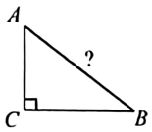
A. five B. seven C. twelve
12. —Have you ever ______ the Great Wall?
—Yes, I have. I went there on our last school trip.
A. been to B. gone to C. been in
13. ______! It’s not a big deal. Just believe yourself and everything will be OK.
A. Give up B. Cheer up C. Stay up
14. —Could you tell me ______ people call these children “little oranges”?
—Because they wear cute orange clothing and oranges are famous in Guangxi.
A. how B. when C. why
15. —Hello? This is Jenny. May I speak to Laura?
—______.
A. Have a good trip B. Sorry, she is not here C. Never mind
第二节 完形填空（共15小题；每小题2分，满分30分）
阅读下面短文，从短文后各题所给A、B、C三个选项中，选出可以填入空白处的最佳选项，并涂在答题卡上相应的位置。
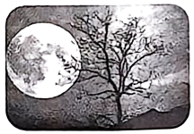
Tony is a little boy. One day, he told a ____16____ to his mother. That night he felt very upset and unhappy. He did not go out to play with his friends.
He sat on the doorstep with his head down. When he ____17____ in the sky, the moon was still big, round and bright. But it didn’t smile at him as usual, it was laughing at him. Tony thought the moon must know about his lie. He was so scared. He ran along the street to get away from it, but the moon kept ____18____ him. Finally, he rushed into the house and went to bed. The moon looked at him ____19____ the window. Tony pulled the quilt to cover his head, but he could not fall asleep. Then he hid under the bed and started thinking about the lie over and over again.
At last, he told his ____20____ all about it and promised her that he would never tell a lie. He went to bed again and fell asleep soon. The moon nodded to him with a big smile in his dream.
16. A. lie B. joke C. story
17. A. looked up B. looked down C. looked back
18. A. fighting B. helping C. following
19. A. inside B. through C. below
20. A. friend B. mother C. father
B
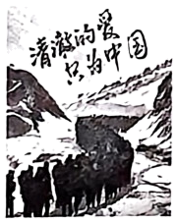
“Pure love, only for China.” When the host of the Harbin Ice and Snow World read out the words in a lost phone to find its owner, people all cheered for these ____21____ words on the wallpaper (屏保) of the phone. These words were written by Chen Xiangrong who lost his life for the safety of our country. The ____22____ of the lost phone is a student from Heilongjiang University. Her family name is Xie.
Xie knew Chen Xiangrong when she ____23____ in a high school. One day, she learned about Chen’s story from a newspaper and was deeply moved. Since then, Xie has regarded Chen as ____24____ and hoped one day she could also serve our country like him. She has kept Chen’s words “Pure love, only for China” in ____25____ phone together with a Chinese national flag as an inspiration.
To her surprise, the wallpaper ____26____ on the Internet suddenly. Even many people asked for the wallpaper. “I am very ____27____ that many young people hold the same dream as me. We all have a feeling of responsibility and big ____28____,” Xie said. “I believe that through our hard work, our country will be stronger and stronger! We will ____29____ to create a better future for our country!”
We Chinese people are confident, ambitious and responsible. “Pure love, only for China.” ____30____ these words are simple, they show our strong respect, love and loyalty to our country.
21. A. funny B. touching C. scary
22. A. owner B. wallpaper C. picture
23. A. taught B. played C. studied
24. A. a host B. a student C. an example
25. A. his B. her C. our
26. A. was broken B. got lost C. became popular
27. A. excited B. bored C. sorry
28. A. phones B. dreams C. problems
29. A. try our best B. feel free C. write words
30. A. So B. Although C. Unless
第三部分 阅读理解（共两篇，满分20分）
阅读下面的短文，从每题所给的A、B、C三个选项中选出最佳选项，并涂在答题卡上相应的位置。（共10小题；每小题2分，满分20分）
A
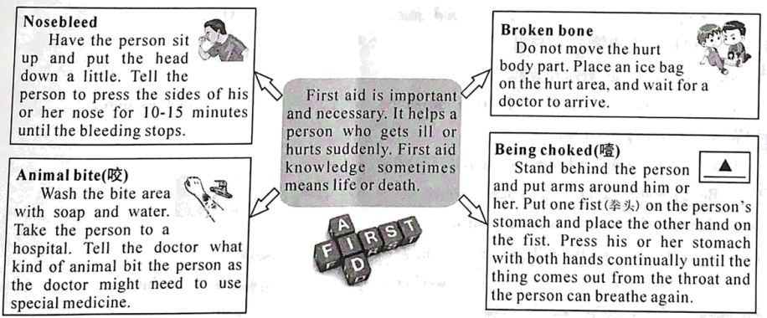
31. Which part should we press when we have a nosebleed?
A. The nose. B. The arm. C. The stomach.
32. In which situation should we put an ice bag according to the passage?
A. Nosebleed. B. Animal bite. C. Broken bone.
33. Which of the following can be put in the “______”?
A. 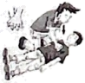 B. 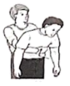 C. 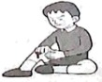
34. What can we infer (推断) from the passage?
A. If you have a nosebleed, put your head up.
B. If you are choked, do not move your body.
C. If you are bitten by a dog, clean the bite area first.
35. What’s the best title for the passage?
A. Doctors and Patients. B. Health and First-aid. C. Animals and Humans.
B
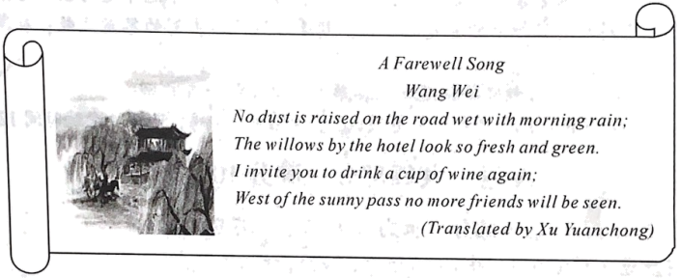
Friends are important in our lives, but we sometimes have to separate from our friends. “A Farewell (告别) Song” is about saying goodbye to a friend. It is a famous poem by Wang Wei, a great poet, who lived in Tang Dynasty. He is good at writing poems and drawing. When talking about Wang Wei, people often say there are pictures in his poems and there are poems in his pictures. His poems are full of beauty and imagination.
“No dust is raised on the road wet with morning rain”, “The willows by the hotel look so fresh and green”, a picture of silence and peace gets into our eyes. After a morning rain in spring, the road, the willows (柳树) and the hotel are completely different. The hotel looks green. The willows look fresh. Everything is nice, gentle and silent. Willow branches are considered as a typical symbol of farewell in China. In ancient times, Chinese people often used them as gifts when they said goodbye to their friends.
“I invite you to drink a cup of wine again” is the poet’s warm and real way of not wanting to say goodbye to his friend. Having another drink together is like a symbol of their goodbye. Lastly, “West of the sunny pass no more friends will be seen” shows the feeling of being alone and missing someone. It also shows his sincere love and care for his friend.
“A Farewell Song” creates a feeling of quiet sadness It mixes beautiful pictures and human feelings to deeply express the common experience of saying goodbye.
36. Who is the writer of this poem?
A. 李白 B. 王维 C. 杜甫
37. When did Wang Wei’s friend leave in the poem?
A. In spring. B. In summer. C. In autumn.
38. What is considered as a typical symbol of farewell in China?
A. A morning rain. B. A hotel. C. A willow branch.
39. Which of the following rhymes (押韵) are RIGHT for this poem?
A. aa-bb. B. ab-ab. C. ab-cd.
40. What does Wang Wei want to show in this poem?
A. To show his excitement after seeing his old friend.
B. To show his joy before separating from his friend.
C. To show a feeling of quiet sadness before farewell.
第四部分 口语应用（满分5分）
根据对话内容，从下面方框中选出适当的选项补全对话，并涂在答题卡上相应的位置。
(Rose and Jack are talking about their weekend activities. Rose=R, Jack=J)
J: Hi, Rose. What did you do last weekend?
R: Nothing much. How about you?
J: ____41____
R: A field? What did you do in the field?
J: We grew some vegetables.
R: ____42____
J: Certainly. First, dig a hole, put a small plant into it. Then, put the earth back. Finally, water the plant.
R: Oh, sounds kind of difficult. Did you feel tired?
J: Yes, a little. ____43____
R: Great! What else did you do?
J: ____44____
R: Wow! How meaningful it was!
J: We plan to go there next weekend. Would you like to join us?
R: ____45____ I can’t wait!
A. Sure. I’d love to.
B. Can you tell me how to grow vegetables?
C. But we had fun and learned a lot.
D. I worked in a field with my classmates.
E. We also helped pick grapes and oranges.
B卷（满分50分）
第五部分 写（共四节，满分50分）
第一节 单词拼写（共5小题；每小题1分，满分5分）
根据句意及所给的首字母或括号内的提示，用单词的正确形式填空，并将该单词的完整形式写在答题卡上相应的位置。每空一词。
46. —Is this your dictionary?
—No, maybe it’s h______. She is looking for it.
47. The old man lives by himself, but he doesn’t feel l________.
48. It’s only five ______ (minute) walk from here, so you needn’t take a bus.
49. Recently Tianshui malatang is very popular. It’s ______ (real) delicious.
50. On April 26, three astronauts from Shenzhou-18 ______ (succeed) in entering the space station and met the astronauts in Shenzhou-17.
第二节 短文填空（共10小题；每小题1分，满分10分）
阅读短文，从方框中选择适当的词并用其正确形式填空，使短文通顺、意思完整，并将其答案写在答题卡上相应的位置。每词限用一次。
afford by everything easy information make only smart they when
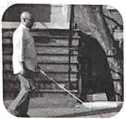
With the development of science and technology, our life is becoming more and more convenient. It seems that ____51____ has been reinvented and greatly improved. But there is one thing unlike them. It’s a blind walking stick. It was invented over 100 years ago and has been used ____52____ many blind people for a long time. However, it had remained unchanged until an engineer named Kursat decided ____53____ a change. Kursat is blind. He deeply understands the difficulties and challenges that the blind face. He put some technical knowledge into his invention and invented a ____54____ stick. He hoped his invention would help the blind.
The smart stick uses built-in speakers and different sensors (传感器) to warn about possible dangers. It helps blind people know about the environment around ____55____ by using modern technology. It makes their travel much ____56____ than before. The stick is priced at around $500. It is less than half the price of most smart phones. Most people can ____57____ it.
In the future, this invention is going to make a big difference to more blind people. “It will not ____58____ change my life, but also the life of other people.” Kursat said, “These days, we are talking about flying cars, but the blind have been using just simple sticks. As a blind person, ____59____ I am at the subway station, I don’t know which is my exit. I don’t know which bus is coming or which stores are around me. But now, the smart stick can provide a lot of ____60____ for the blind,” he said, “I believe the life of the blind will be much more convenient and safer.”
第三节 阅读表达（共15小题；满分20分）
补全短文 根据短文内容，从短文后方框中的A-F选项中，选出适当的选项补全短文，并涂在答题卡上相应的位置。选项中有一项为多余选项。

Different countries have different manners about social situations. In Mexico, people shake hands when they meet for the first time. In Brazil, people sometimes kiss. In Korea, people usually bow. Do you know Chinese fist and palm salute (拱手礼)? It is one of classic greeting manners in China. ____61____
The occasions of making fist and palm salute
For centuries China has been known as a “Liyi Zhibang”. Nowadays, Chinese usually shake hands when meeting others, but sometimes they also make fist and palm salute. ____62____ People make fist and palm salute when they visit someone during the Spring Festival or attend someone’s wedding ceremony, birthday party and so on.
The history of fist and palm salute
____63____ It stated in West Zhou Dynasty. If people met strangers, they would prepare for a fight if necessary, and hands were always ready for holding weapons (武器). Holding hands together pointed to themselves was a meaning of expressing kindness. Later it became one of traditional Chinese manners when meeting each other.
____64____
How do you make fist and palm salute properly? First, stand at attention. Then, if you are a man, right-hand half-fist, and then left-hand hold the right-hand in front of your chest. For a woman, left-hand half-fist, then right-hand put the left-hand on the top. Next, watch each other, raise both hands to brow (额头) and bend down. ____65____ Also, you could say some lucky greeting words to each other for three times.
A. Now let’s learn more about it.
B. The way to make fist and palm salute
C. When and where do people use it?
D. It is often widely used among western countries.
E. Finally, shake hands towards each other for three times.
F. Fist and palm salute has a history of more than 3000 years.
完成表格 阅读下面短文，根据短文内容，完成表格中所缺的信息，并将其答案的完整形式写在答题卡上相应的位置。每空一词。
Bring Nature Indoors
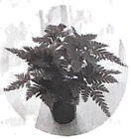
Indoor plants seem to just sit around without doing much, but in many ways they are the silent heroes of homes. Not only do they look beautiful, but they can lift our health in body and mind by making us feel good and taking away stress. What’s more, indoor plants are easy to look after and are not very expensive.
What are indoor plants?
Indoor plants, also known as houseplants, are plants that like to grow indoors. Many of these kinds are not used to growing outside, especially in winter, they grow better inside because of the warmer condition. There are many kinds of indoor plants around us, such as peace lilies, spider plants and succulents.
Why are indoor plants good for us?
There are many advantages about growing plants indoors. Plants around houses can improve our feelings. Studies have supported this and found that indoor plants can improve our creativity, focus and memory. There is also research showing that houseplants can clean the air around them by removing some harmful gases, such as HCHO (甲醛). Dr Tijana Blanusa said, “Plants catch and hold tiny polluted materials. They remove some harmful chemicals from cooking or painting. Peace lilies and devil’s ivy are the best.”
How to choose indoor plants?
We can get plants from supermarkets, garden centers or online. Younger plants are often cheaper than fully grown ones. Caring for them is always full of joy. You water them, talk to them, see them grow up… Learning about the habits of each plant can bring a new interest and attention into our lives and help to connect our homes with nature.
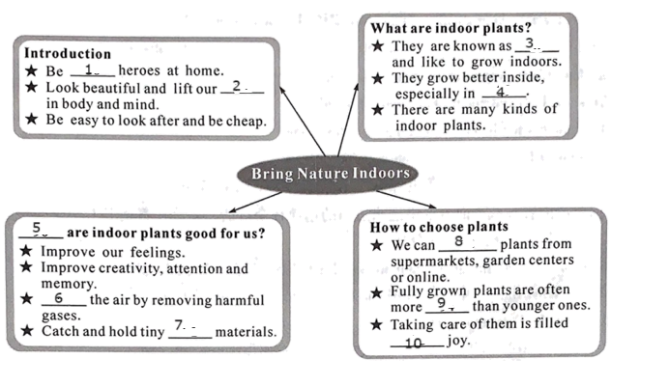
66. ________
67. ________
68. ________
69. ________
70. ________
71. ________
72. ________
73. ________
74. ________
75. ________
第四节 书面表达（满分15分）
76. “读万卷书，行万里路”。暑假将至，成都某中学计划组织学生来大美凉山开展研学之旅。假如你是李华，请根据以下内容提示，以“Welcome to Liangshan”为标题，写一篇英语短文，向即将到来的成都同学介绍一下你的家乡凉山。
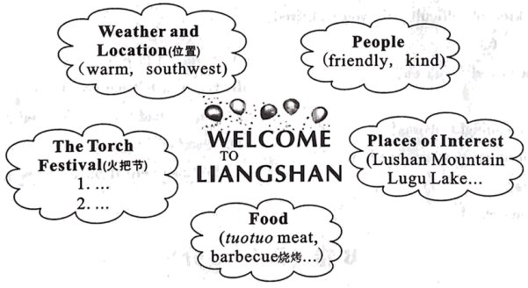
要求：1．语言表达准确，文章连贯、通顺；
2．文章应包括所给思维导图中的所有提示内容，可适当发挥；
3．文中不得出现真实姓名、校名等信息；
4．词数：80左右。文章开头和结尾已给出，不计入总词数。

Welcome to Liangshan, a place that you will never want to leave once you come...
____________________________________________________________________________________________________________________________________________________________________________________________________________________________________________________________________________________________________________________________________________________________________________
I hope all of you can enjoy yourselves in Liangshan.

