英语
A卷（共100分）
第一部分 听力（共30小题；计30分）
一、听句子，根据所听到的内容选择正确答语。每小题念两遍。（共5小题；每小题1分，计5分）
1. A. It’s great. B. I’m fine. C. That’s right.
2 A. Good job. B. Of course. C. Not at all.
3. A. Have fun! B. Sounds good! C. Let’s go!
4. A. The same to you. B. I think so. C. Thank you.
5. A. So can I. B. I’d love to. C. I’ll take it.
二、听句子，选择与所听句子内容相符的图片。每小题念两遍。（共5小题；每小题1分，计5分）
A. 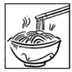 B. 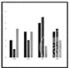 C. 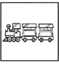 D. 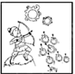 E. 
6.________ 7. ________ 8. ________ 9. ________ 10. ________
三、听对话，根据对话内容及问题选择正确答案。每小题念两遍。（共10小题；每小题1分，计10分）
11. A. Basketball. B. Football. C. Volleyball.
12. A. 4 dollars. B. 2 dollars. C. 6 dollars.
13. A. Chinese. B. French. C. Russian.
14. A. At school. B. At home. C. In the hospital.
15. A. A desk. B. Some coffee. C. Hot water.
16. A. The restaurant. B. The meal. C. The environment.
17. A. Relaxing. B. Busy. C. Boring.
18. A. A reporter. B. A host. C. A fireman.
19. A. At 8:30. B. At 9:00. C. At 9:10.
20. A. To tell the truth. B. To fix it up. C. To hide it.
四、听短文，根据短文内容选择正确答案。短文念两遍。（共5小题；每小题1分，计5分）
21. What is the summer course about?
A. Fashion. B. Drawing. C. Dress.
22. Which is the right order of the activities?
① going to the classroom ② listening to the introduction ③ having the drawing lesson
A. ①-③-② B. ②-①-③ C. ③-②-①
23. When will the designer come?
A. On Tuesday. B. On Wednesday. C. On Thursday.
24. What should the students take with them?
A. A pen. B. An ipad. C. A smartphone.
25. What are the students expected to do on the last day?
A. Take a photo. B. Design a skirt. C. Make a dress.
五、听短文，根据短文内容完成图表中所缺信息。短文念三遍。（共5小题；每小题1分，计5分）
The International Day of Peace
When is it? | On 26 every year.
What does “peace” mean? | It means no war and 27 others.
What happens on this day? | There is a minute of 28 and many activities related to peace.
What can we do every day for peace? | 29 to your own life.  ·Help 30 .  ·Stand up against bad behavior at school.
第二部分 基础知识运用（共30小题；计40分）
六、选择填空（共15小题；计20分）
A. 从以下各题的A、B、C三个选项中选择最佳选项。（共10小题；每小题1分，计10分）
1. Miss Lin teaches piano very well. With ________ help, I’ve made great progress.
A. his B. her C. their
2. Having an ice-cream in the hot summer ________ be cool.
A. must B. need C. can’t
3. Go bird-watching in Qinglong Lake, ________ you will find it fun and meaningful.
A. and B. or C. but
4. What exciting news! The 2025 World Games ________ in Chengdu.
A was held B. is held C. will be held
5. —________ do you visit your grandparents?
—Usually twice a month.
A. How long B. How often C. How far
6. China Daily named “Growth” ________ its “Word of the Year 2023”.
A. as B. after C. for
7. The astronauts of the Shenzhou-18 ________ in the Tiangong space station for about two months since they were sent into space in April this year.
A. will work B. have worked C. is working
8 —Do you know ________ AI is being used to create music?
—I’m not sure. Maybe it’s cheaper than paying a musician.
A. why B. if C. how
9. I prefer riding a bike to driving a car to work because it is ________ environmentally friendly.
A. much B. more C. most
10. The cartoon movie Chang An shows how important it is ________ life’s problems with a smile.
A. to find B. to check C. to face
B. 补全对话 （共5小题；每小题2 分,计10分）
根据对话内容，从文后中选出适当的选项补全对话。
A: Hi, Tom. What are you going to do tomorrow?
B: ___11___ But I haven’t decided which one to visit.
A: How about Chengdu Science Fiction Museum? ___12___ It says it’s a new one.
B: That’s good. Tell me more about it.
A: Look! ___13___
B: Wow, cool! ___14___
A: Haha, it’s just like something from another planet.
B: So it is. ___15___
A: Yes. How amazing!
B: Can’t wait.
A. Is it built on a lake?
B. Here’s a photo of it.
C. I plan to visit a museum.
D. I’m just reading an article about it.
E. I’ve never seen a star-shaped building like this.
七、完形填空
阅读下面两篇短文，根据短文内容，从A、B、C三个选项中选出可以填入空白处的最佳选项。（共15小题；计20分。A篇每小题2分，计10分；B篇每小题1分，计10分）
A
On Saturday afternoon, Mom asked Jim to tidy his bedroom. A few ____16____ later he came back.
“It is tidy now,” Jim said.
“Good,” said Mom. “Take some ____17____ from my drawer (抽屉) and buy some candies.”
Jim opened the drawer ____18____. He found six pens, four keys, three gloves, two tickets and a notebook.
“What are all these things?” asked Jim.
“Oh, that s my safe place,” said Mom. “Let’s go and see your room.”
They went to Jim’s bedroom. It looked nice and tidy. Then Mom looked ____19____ Jim’s bed. All Jim’s clothes, books and toys were there.
“What are all these things?” she asked.
“That’s my ____20____ place,” said Jim.
Mom laughed. “Let’s tidy your room and then we can tidy my drawer.”
16. A. minutes B. hours C. days
17. A. tickets B. gloves C. money
18. A. cheerfully B. patiently C. carefully
19. A. on B. under C. at
20. A. own B. safe C. favorite
B
Last weekend my friend Clara and I went to a special restaurant. When we arrived there, it looked like other restaurants. The only ____21____ thing was that they took our bags, phones and watches and locked them up.
Next, we followed the blind waiter, Serge, down a long and fairly dark hallway. He took us to another room. It was totally ____22____. Serge showed us to our table and ____23____ us to sit down. There were no menus. Serge just put ____24____ down on the table and told us to enjoy our meal. At first, we found it difficult to eat and drink in complete darkness. But after a while, we got ____25____ to it. Everything smelled and tasted so good that it didn’t matter ____26____ nobody could see anything.
____27____, it made the meal lots of fun. We had a really good time, laughing and trying to ____28____ what we were eating. With light music, we were soon chatting and joking with all the other ____29____.
After the meal, Serge took us ____30____ and told us what we’d eaten. It was certainly an unusual experience.
21. A. funny B. strange C. serious
22. A. silent B. empty C. dark
23. A. taught B. ordered C. helped
24. A. nothing B. anything C. something
25. A. close B. used C. ready
26. A. that B. before C. because
27. A. Actually B. Thankfully C. Finally
28. A. share B. learn C. guess
29. A. waiters B. friends C. customers
30. A. back B. away C. in
第三部分 阅读理解（共15小题；计30分）
八、阅读下面短文，根据短文内容判断句子正误。正确的涂“A”，错误的涂“B”。（共5小题；每小题2分，计10分）
阅读下面短文，根据短文内容判断句子正误。正确的涂“A”，错误的涂“B”。
CALLING ALL BIG THINKERS!
If you are interested in life’s BIG questions, why not join our online discussion group? It helps you to explore your own ideas and opinions, as well as those of others, including some of the world’s most famous thinkers! Build confidence and communication skills in a safe and friendly environment!
BIG THINKERS-AGE 12-16  Fun live discussions about life, the universe and everything in it with activities.  Sundays 10 am and 4 pm starting 6th October.  Six periods for £50.  To explore more, visit www.thethinker***.com. | 

31. Group members can discuss with the world’s most famous thinkers.
32. The discussion group can help you improve yourself.
33. A 15-year-old teenager can join in the discussions.
34. There will be some fun outdoor activities.
35. You can visit the website or call for more information.
九、阅读下面两篇短文，根据短文内容选择最佳选项。（共10小题；每小题2分，计20分）
A
a  Rather than using cash or a bank card, customers simply look at a screen which recognizes their face using the latest facial recognition software (软件). This is connected to their bank account and payments are completed within seconds. | b  If you use flight alert, you’ll never miss out on the best flight deals ever again. Simply enter your email address and preferred holiday places and we will find out the best and cheapest flight deals online and email a list to you. You’ll be amazed at the prices on offer.
c  Are you a crazy shopper who wants to know if the shirt on sale looks good? Take a photo and send it to the app and receive reviews at once from thousands of other shoppers who are on hand to tell you whether or not it is right for you. The app also stores your photos and recommends more that you might also be interested in. | d  You may have already moved into the world of online shopping. You place an order online, and then the products are sent right to your door. But what about our beloved pets? This is a website that sells pet clothes. The clothes can be sent to your home. If you are not completely satisfied with the products, then simply post them back to us for free.

36. Which of the following can best describe the latest payment in Passage a?
A. Safe. B. Cheap. C. Fast.
37. What can flight alert help people do?
A. Save money for a trip.
B. Arrive on time for a flight.
C. Decide the best travelling place.
38. What does the underlined word “it” in Passage c refer to?
A. The shirt. B. The photo. C. The app.
39. What can we learn about the website in Passage d?
A. It offers offline orders for customers.
B. It’s for pet owners to sell their pets’ clothes.
C. It allows customers to return unwanted products.
40. What can be the best title shared by the four passages?
A. Cool apps, new styles B. Life made easy C. Click for a better world
B

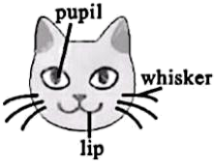
Have you ever looked at a cat’s face and wondered what it is thinking? Well, according to a new study, cats have many different facial expressions, which show how they are feeling.
The research was carried out by the scientists at the University of California, in the US. They visited a local cat café over several months to record videos of 53 cats, collecting 194 minutes of videos. They found that the cats have 276 different expressions. “Each expression was a mixture of lip different facial movements, which included licking (舔) their nose, opening their mouth, or widening the pupils of their eyes,” said the scientists. They also found cats use 26 of these facial movements in total, which can be mixed to express how they are feeling. Dogs use 27 facial movements and humans use a total of 44.
Out of the expressions they recorded, 45% were friendly and 37% were angry. “A friendly cat moves its ears and whiskers forward and closes its eyes. However, an angry cat often flattens its ears to its head, makes its pupils smaller and licks its lips,” said the team.
Although the researchers aren’t sure what the cats were trying to communicate with each other using their faces, they plan to study cats in other places to improve their understanding. They also hope that the research could help animal shelters (收容所) improve the way they look after the cats. Some pet owners even suggest the researchers develop an app for them to find out what their cats’ facial expressions really mean.
41. Which of the following uses the most facial movements?
A. Humans. B. Dogs. C. Cats.
42. Which picture shows a cat’s angry expression?
A. 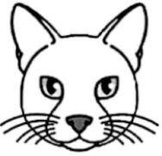 B. 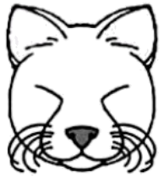 C. 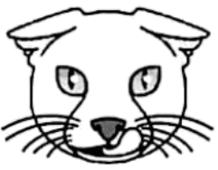
43. What might the scientists do next?
A. Use an app to study cats’ expressions.
B. Build an animal shelter to look after cats.
C. Keep on studying to know more about cats.
44. How does the writer develop the text?
A. By giving numbers and choices.
B. By showing examples and results.
C. By presenting opinions and facts.
45. What’s the writing purpose of the text?
A. To call on people to love cats more.
B. To introduce a new study about cats.
C. To tell readers why the team did the research.
B卷（共50分）
一、补全单词
根据首字母及句意写出完整单词。（共5小题；每小题1分，计5分）
46. They enjoy h______ up the mountains in the free time.
47. For a shy student, it takes c______ to give a speech in class.
48 The brain makes up 2% of our body weight but uses about a fifth of the e______ we get from food.
49. From pocket parks to forest parks, local governments have been making efforts to make China’s cities much g______.
50. Chinese archaeologist (考古学家) Fan Jinshi was h______ for her sixty years’ work to protect the Dunhuang Mogao Caves.
二、完成对话 （共10小题；每小题1分，计10分）
在空格中填上适当的单词，使对话完整正确。一空一词（含缩写词）。
（N: Nick T: Taylor）
N: Dr. Taylor, I’m Nick from Popular Science. Nowadays people are easily distracted (分心的). How come?
T: It’s “the monkey mind”. You feel it hard to stay focused, like a monkey ___51___ from thought to thought.
N: Yeah. Many people get mad with ___52___ for having so many thoughts.
T: It’s ___53___ to feel like this because humans have around 6,000 thoughts per day. So ___54___ it and make friends with your monkey mind. What if your monkey mind isn’t a ___55___? Perhaps it can remind you to be curious and kind towards your mind.
N: Umm, I see. ___56___ that, what else can we do to calm our brain?
T: When the monkey mind is getting busy, give it a job to do. Use your ___57___, like watching a flower, listening closely to the birds, smelling the air or taking deep breaths. Notice ____58____ your thoughts and feelings change.
N: That’s to say, try to focus our attention first. When our mind is calm, we can ___59___ our work again.
T: That’s true. In the daily life, developing habits helps make your brain stronger. Try drawing, reading, playing chess or else and see what ____60____. Then keep practicing to strengthen your brain’s power.
三、短文填空 （共10小题；每小题1分，计10分）
从下面方框中选出10个单词，将其正确形式填入短文，使短文意思正确通顺（每词限用一次）。
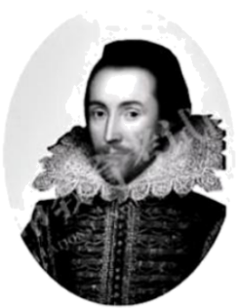
age agree decide follow lead mean
perform please solve talent they wide
William Shakespeare was born more than 450 years ago. He is ___61___ regarded as one of the greatest writers in history and is still influencing artists today. However, his language is too old-fashioned and difficult ___62___ because his time was quite different from today. This has ___63___ to a discussion: To update (更新) or not to update Shakespeare?
Some people think updating Shakespeare is necessary. They say Shakespeare’s plays are great, but what is the point if they cannot be understood? So many ___64___ modern writers have rewritten Shakespeare’s plays in the way people speak today. This makes ___65___ clearer for today’s audiences (读者). At the same time, audiences would still get as much ___66___ from the plays.
Some people ___67___. They think Shakespeare’s works are beautiful and timeless. The richness of the language and the playful use of words should be celebrated. There are good reasons why the plays are still being ___68___ today. Many of Shakespeare’s expressions are still used, for example, “All that glitters (发光) isn’t gold.” His works tell us what it ___69___ to be human. Topics such as love, kindness and friendship last through the ____70____.
What do you think? Should Shakespeare be updated?
四、阅读表达（共10小题；计10分）
A. 补全短文 （共5小题；每小题1分，计5分）
根据短文内容，从短文后的A～F选项中，选出5个适当的选项补全短文。
Taking a great photo is not easy and there are lots of things to consider. How do you choose and organize your subjects within your photo? ___71___ Here are some tips from the art, design and photography experts.
Find a focus. When taking a picture, ask yourself, “What’s the focus?” If you are taking a picture of a crowded street, choose a subject which draws your eye. ___72___ If it’s a landscape photo of a field, the focus could be a big tree.
___73___ It’s a bit boring to put your subject right in the middle. Place it a little on the left or right of your photo. Imagine your photo is divided into a three-by-three grid (网格) of boxes. One of the corners of your central square is where your focus should be.
Create colorful contrasts (对比). Color in a picture is more easily noticed if it has a contrast. ___74___ They will stand out more if they are taken beside a grey stone wall, or photographed against a bright blue sky.
Try different angles. To add more interest to a photo, try taking it from different angles. This means you need to move around, taking photos from different sides, from above or from below. For example, if you photograph a building from a plane it looks tiny but a photo of the same building looking up from the street makes it look huge. ___75___
Practice makes perfect. Try everything for the perfect shot.
A Place the photo correctly.
B. It can tell a different story.
C. Remember the rule of thirds.
D. Think about focus, color, light and more.
E. It could be a person wearing bright colors.
F. If you take a picture of yellow flowers, don’t fill your picture with them.
B. 完成图表 （共5小题；每小题1分，计5分）
根据短文内容，完成图表中所缺信息。
Humans have long tried to predict (预测) the weather. From the hunters of ancient times to today’s pilots, predicting rain or shine can shape people’s life and make a difference.
In 650 BC, the Babylonians tried to predict the weather based on the appearance of clouds. Around 340 BC, Aristotle, a famous Greek thinker and scientist, wrote Meteorologica. It introduced the types of weather, such as rain, cloud and lightning. Aristotle believed that there was water, air and fire around the Earth. It was almost 2,000 years before his ideas were replaced by new ones.
By 300 BC in China, a calendar divided the year into 24 festivals gradually, each festival related to a type of weather, like the Rain Water (the start of the spring rains), the Waking of Insects (the spring thunder awakens sleeping insects) and so on. That was useful for farmers to plan when to plant and harvest (收获).
People used lots of ways to predict the weather over the centuries. You might have heard the expressions like “Red sky at night, sailor’s delight”, which suggests a red sky in the evening is followed by good weather. This has a basis in science, as does telling wind direction through smoke from the fire. On the other hand, some thought that if sheep crowded together, it meant rain. But there isn’t any science behind it.
The science of weather prediction really took off in the 1830s with the invention of the telegraph. It sent messages over hundreds of thousands of miles, so weather maps were drawn up and storm systems were studied. The next big step came in the 1920s with the invention of the “radiosonde”, a balloon carrying weather instruments high above the ground to collect information. Experts took the information and built a picture of the weather over the following few days.
Today, supercomputers are used to take data (数据) from the world and process it very fast to work out the weather. For example, they once helped predict where Hurricane Lee, which hit the US and Canada, would land nine days in advance (提前).
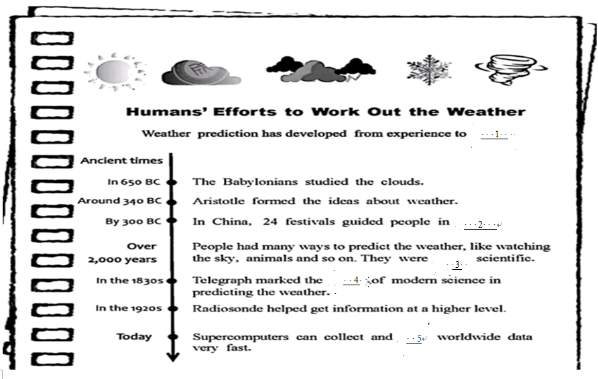
76. ________
77. ________
78. ________
79. ________
80. ________
五、书面表达（计15分）
81. 你校英语报就“团队合作”这一话题征稿。请根据以下图示，以“Be a Good Team Member”为题投稿。
Be a Good Team Member
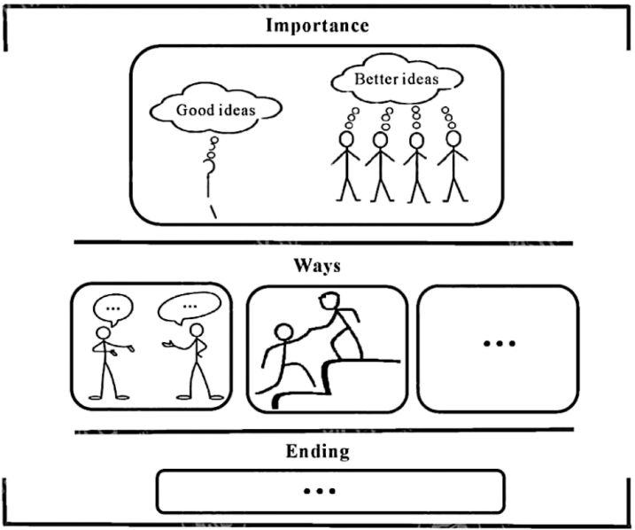
注意：
1. 词数80左右；
2. 文中不能出现真实姓名及学校名称。
_____________________________________________________________________________________________________________________________________________________________________________________________________________________________________________________________________________________________________________________________________________________________________________________________________________________________

