秘密★启用前
2024年遂宁市初中毕业暨高中阶段学校招生考试
英语试卷
试卷满分150分考试时间120分钟
注意事项:
1. 答题前,考生务必将自己的学校、姓名、准考证号用0.5毫米的黑色墨迹签字笔填写在答题卡上,并检查条形码粘贴是否正确。
2. 回答选择题时,选出每小题答案后,用2B铅笔把答题卡上对应题目的答案标号涂黑,如需改动,用橡皮擦干净后,再选涂其他答案标号;回答非选择题时,将答案写在答题卡上,写在本试卷上无效。
3. 考试结束后,将本试卷和答题卡一并交回。
第Ⅰ卷（选择题,共105分）
第一部分 听力（共两节,满分30分）
做题时,先将答案标在试卷上。听力部分结束前,你将有两分钟的时间将试卷上的答案转涂到答题卡上。
第一节（共5小题;每小题1.5分,满分7.5分）
听下面5段对话, 每段对话后有一个小题, 从题中所给的A、B、C三个选项中选出最佳选项, 并标在试卷的相应位置。听完每段对话后, 你都有 10 秒钟的时间来回答有关小题和阅读下一小题。每段对话读两遍。
1. How often does Frank play soccer?
A. Once a week. B. Twice a week. C. Twice a month.
2. What's the mom's advice?
A. Drinking some tea. B. Drinking some hot water. C. Drinking some hot tea with honey.
3. Where are they talking?
A. In a restaurant. B. In a supermarket. C. In a library.
4. Where is the hospital?
A. On Center Street. B. Across from the bank. C. Next to the bank.
5. How does the man truly feel?
A. Surprised. B. Bored. C. Interested.
第二节（共15小题;每小题1.5分,满分22.5分）
听下面5段对话或独白,每段对话或独白后有几个小题,从题中所给的A、B、C三个选项中选出最佳选项,并标在试卷的相应位置,听每段对话或独白前,你将有时间阅读各个小题,每小题5秒钟;听完后,各小题将给出5秒钟的作答时间。每段对话或独白读两遍。
听下面一段对话,回答第6、7小题。
6. When did Peter come to Chengdu?
A. 2 years ago. B. 3 years ago. C. 4 years ago.
7. How can Peter improve his spoken Chinese?
A. By watching Chinese movies.
B. By reading Chinese books.
C By communicating with Chinese people.
听下面一段对话, 回答第8、9小题。
8. Who will the girl go to Yan'an with?
A. Her friends. B. Her family. C. Sam.
9. How will they go there?
A. By plane. B. By car. C. By train.
听下面一段对话, 回答第10至12小题。
10. Where did Amy go yesterday?
A. The old people's home. B. Her friend's home.
C Her grandparents' home.
11. What did they do there?
A. They sang and read newspapers for them.
B. They cleaned the room and talked with them.
C. They danced and talked with them.
12. What do they think of caring for the old people?
A. Meaningful. B. Important. C. Helpful.
听下面一段对话, 回答第13至15小题.
13. What kind of show will be held this Saturday?
A A Chinese Art Show. B. A Chinese Talent Show. C. A Chinese Fashion Show.
14. What can Jimmy try by himself at the show?
A. Paper cutting. B. Chinese clay. C. Lantern making.
15. What time will they meet?
A. At 8:00a. m. B. At 8:30a. m. C. At 9:00a. m.
听下面一段独白, 回答第16至20小题。
16. What subject does Miss Chen teach?
A. Chinese. B. English. C. Math.
17. What does Miss Chen look like?
A. Tall and beautiful.
B. Short and beautiful.
C. Of medium height and beautiful.
18. How are Miss Chen's classes?
A. Interesting and lively. B. Relaxing and interesting. C. Funny and relaxing.
19. What did Miss Chen ask the students to do at first class?
A. To draw pictures of the teachers.
B. To draw pictures of the students.
C. To draw pictures of the parents.
20. How does the writer like Miss Chen?
A. Strict. B. Confident. C. Patient.
第二部分 英语知识运用（共两节, 满分25分）
第一节 单项填空（共 10小题; 每小题 1分, 满分10分）
从A、B、C、D四个选项中, 选出可以填入空白处的最佳选项, 并在答题卡上将该选项涂黑。
1. Everything is possible ________ you work hard.
A. as much as B. as soon as C. as long as D. as far as
2. —Hi guys! Our team won the first place in the table tennis match.
—________ exciting news it is! We are so happy about it.
A. What B. How C. What an D. How an
3. —Tina, is that our math teacher Mr. Wang?
—It ________ be Mr. Wang. He has gone to Beijing.
A. must B. mustn’t C. can’t D. can
4. —What kind of movies do you like best?
—I like the movies ________ make me feel happy and relaxed.
A. what B. which C. who D. /
5. —Excuse me, could you please tell me ________?
—It’s on sale, only 45 yuan. Do you like it?
A. how much does the jacket cost B. how much the jacket costs
C. what was the price of the jacket D. whether the price of the jacket was high
6. —Daddy, the Middle Autumn Festival is coming. Could you please tell me ________ for grandparents?
—You can buy some mooncakes, fruits and flowers for them.
A. how to buy B. what to buy C. where to buy D. when to buy
7. —Do you think ________ useful to read English magazines for English learning?
—Yes, I think it works well.
A. it B. that C. this D. its
8. —Do you know anything about One Belt One Road?
—Yes, it ________ over 10 years since it started.
A. was B. had been C. is D. has been
9. —Tim, what were you doing when I called you?
—I ________ bicycle with my sister.
A. was cutting up B. am making up C. am picking up D. was fixing up
10. —I have passed the exam. Thanks for your help.
—________
A. It’s my pleasure. B. With pleasure. C. All right. D. Never mind.
第二节 完形填空（共15小题;每小题1分,满分15分）
阅读下面两段短文, 从短文后各题所给的四个选项（A、B、C、D）中, 选出可以填入空白处的最佳选项, 并在答题卡上将该选项涂黑。
In China, more and more young people are becoming interested in Traditional Chinese Medicine (TCM) . One thousand young people took part in a survey by China Youth Daily. The survey ___11___ that more than 90% of them had tried different TCM treatments. Between Western Medicine and TCM, young people often choose TCM ___12___ it can be a more accurate treatment (精准的治疗) for different patients.
Today TCM is getting popular with young foreigners. And it also brings good to more people. Alex, a young Frenchman, is one of them. He is a big ___13___ of TCM. He came to China to learn TCM in Beijing University of Chinese Medicine in 2022. Studying TCM ___14___ Alex’s mind and lifestyle. He realizes keeping the balance of yin and yang is ___15___ and that everyone should follow the rules of nature. He used to be interested in electronic products and ___16___ late every night. But now, he lives a balanced and ___17___ life, practicing good living habits. He loves reading ___18___ about ancient Chinese culture and playing Taiji. When he plays Taiji, he can feel more relaxed and breathe better. Besides, he ___19___ drinking icy water after doing sports. For him, learning the knowledge and skills of TCM is not about becoming a ___20___ but rather about having a new lifestyle.
Alex also uses his knowledge to help his ___21___. For example, he often provides his family members with some advice about staying ___22___ after he checks their faces or tongues online. Over time, his family ___23___ understand his dream about TCM.
He said, “The more I study TCM, the better I understand ___24___ TCM is a treasure of Chinese culture.” He plans to run a traditional Chinese clinic (诊所) in France after ___25___. He will serve as a bridge between the two countries and spread TCM and Chinese culture.
11. A. advised B. showed C. answered D. agreed
12. A. or B. but C. although D. because
13. A. fan B. man C. boy D. boss
14. A. broke B. started C. helped D. changed
15. A. impossible B. important C. interesting D. exciting
16. A. get up B. wake up C. stay up D. clean up
17. A. colorful B. harmful C. careful D. peaceful
18. A. something B. everything C. anything D. nothing
19. A. likes B. keeps C. avoids D. suggests
20. A. doctor B. teacher C. cook D. worker
21. A. friends B. class C. family D. partners
22. A. calm B. healthy C. happy D. active
23. A. finally B. quickly C. simply D. hardly
24. A. what B. why C. where D. which
25. A. school B. work C. graduation D. vacation
第三部分阅读理解（共20小题; 每小题2分, 满分40分）
阅读下列短文, 从每题所给的四个选项（A、B、C、D）中, 选出最佳选项, 并在答题卡上将该选项涂黑。
A
As language learners, it’s important to use dictionaries. Paper dictionaries are often great choices for us. They lead us to think in a more exact way. However, with the rapid development of the Internet, many websites and apps offer us information about the language we are learning, so some language learners like online dictionaries better. Here is what some students think of the two kinds of dictionaries.
Lin Tao, 14 | I like to look up something in a paper dictionary better. Their explanations are so clear that I can understand them better. I don’t think some online dictionaries are believable. There are many incorrect usages which can make us confused.
Wang Lan, 15 | If we are not good at memorizing English words, we can look up their meanings online very soon. It helps us finish reading the English articles more smoothly. If we are good language learners, we can always learn more in a shorter time with an online dictionary. It saves much time.
Meng Hao, 14 | My paper dictionary is a great friend for me. Whenever I don’t know the meaning of a new word, I can learn it well by understanding the notes and the example sentences in the paper dictionary.
Tian Xiao, 13 | I don’t like carrying a heavy dictionary wherever I go. It’s really convenient to learn a language with the help of an online dictionary. We don’t need to spend much time looking up new words. Using an online dictionary makes a more effective learner.
If you want to share your opinions, please e-mail us at 18900053407youth daily@163.com. And your opinions will be carried on tomorrow’s newspaper.
26. Why does Lin Tao like paper dictionaries better?
A. There are many incorrect usages. B. Their explanations are clear.
C. It’s a great friend for him. D. He can understand the notes.
27. What are the advantages of the online dictionaries according to Tian Xiao?
A. Fast and clear. B. Correct and clear.
C. Clear and believable. D. Convenient and effective.
28. Who has the same idea among them?
A. Wang Lan and Tian Xiao. B. Wang Lan and Meng Hao.
C. Lin Tao and Wang Lan. D. Meng Hao and Tian Xiao.
29. What does the text mainly talk about?
A. Advantages of online dictionaries.
B. The development of the dictionaries.
C. Different ideas about language learning.
D. Different ideas about paper and online dictionaries.
30. Where is the text probably from?
A. Magazine. B. Newspaper. C. Textbook. D. Storybook.
B
Li Jin was born in Guangxi but raised in Sanya, Hainan. In the past 9 years, Li has made great efforts to protect the waters of Sanya. He is now spreading the knowledge of environmental protection. He does this through the Internet.
Around 2014, he began doing volunteer work to clear rubbish from the beaches and officially registered as a volunteer in May, 2017. Li took the lead in a clean-up activity on the Sanya River. In April, 2021, he used his own money to set up a volunteer service center. The center has 1,170 registered members who take part in all kinds of activities.
So far, he has spent about 3, 800 hours on volunteer activities in over 550 events. More than 2,300 people have joined in the activities with his encouragement. They have drawn the attention of both adults and children to the importance of protecting oceans and beaches. His center has organized 51 beach-cleaning activities which have seen about 1,800 people join in since it was set up.
In 2021, because of Li’s growing influence in environmental protection circles, the city government invited him to make a number of short videos. In the videos, he used simple words to explain how to protect the environment. Several of the videos have been watched millions of times.
“Although many people speak highly of my work, what I have done is not for the compliment. I just want to make a difference to environmental protection. My volunteer work would be meaningless if I was paid. It is everyone’s duty to protect environment. The work itself is of great value, so I will continue doing the environmental protection work,” he said.
31. How does Li Jin spread the knowledge of environmental protection?
A. On TV. B. In the newspaper. C. Through the Internet. D. By poster.
32. How many people joined beach-cleaning activities since Li Jin set up the center?
A. Over 550. B. About 1,800. C. More than 2,300. D. About 3,800.
33. What is the right order of the following events according to the passage?
①set up a volunteer service center ②made a number of short videos
③began to clear rubbish ④took the lead in a clean-up activity
A. ①③④② B. ①④③② C. ③①④② D. ③④①②
34. The underlined word “compliment” means__________.
A. wealth B. praise C. fame D. power
35. Which word can best describe Li Jin?
A. Responsible. B. Wise. C. Kind. D. Busy.
C.
Li Fang is an engineer during the day, but in the evening, she becomes a student at a night school in Chengdu, Sichuan Province. She is trying new hobbies with her 4-year-old daughter, including art and jazz dancing. She used to spend evenings watching her daughter play in the park. Now, she can experience new things together with her daughter at a night school.
A growing number of Chinese people go to night schools. They can get colorful courses from dancing and sports to wine tasting. These courses usually cost hardly anything. They have become popular among young people who want to look for new skills, hobbies and friends.
In the 1980s, many people studied at night schools for middle school courses. However, night schools disappeared because of the popularization of higher education. The latest fashion came to Shanghai last autumn, when more than 650,000 people competed for 10,000 places at the city’s night schools.
Night schools have also rapidly appeared in other cities. Miss Wang in Wuhan thinks night schools are good places to make friends. “I used to spend much of my time alone. Since I attended the night school, І have felt more connected with modern society. Besides, chatting to people with similar hobbies is a lot of fun,” she said.
Young people strongly wish to improve themselves and make their cultural lives colorful. That has made night schools popular.
36. What did Li Fang use to do in the evening?
A. Watch her daughter play. B. Experience new hobbies.
C. Try new things. D. Learn jazz dancing.
37. How much does it cost if young people go to night schools?
A. A little. B. Much. C. Little or nothing. D. Too much.
38. According to the numbers “650,0000” and “10,000”, we can infer _______.
A. there are more young people B. there are more night schools
C. the night schools are very popular D. the night schools are only in Shanghai
39. What does Miss Wang think of the night schools?
A. Good places to connect with society. B. Good places to spend time alone.
C. Good places to take up hobbies. D. Good places to chat with old people.
40. Why do young people attend the night schools?
A. To make friends. B. To taste wine.
C. To do sports. D. To improve themselves.
D
①Plants have roots, leaves, and flowers. They have seeds (种子), too. New plants grow from seeds. Some seeds fall on the ground. New plants grow next to the old plants. When plants grow this way, they are too crowded to get enough sunshine and water. So some of them die. But some plants spread their seeds even far from where they live. These seeds grow in new places. There are many ways of the seeds’ travel.
②The wind helps seeds to travel. Some plant seeds have little wings. When the wind blows, the seeds fly away. Soon they fall to the ground and new plants may grow there. Some plants dry up. The wind pulls them from the ground, but they are so big that they can’t fly. They roll along the ground, dropping off their seeds.
③Other plants grow near the water. Their seeds drop into the water and go away with it. They may travel many miles before they stop.
④Some seeds have special parts called “stickers”. The stickers help the seeds travel far. How? These seeds wait for an animal to walk by. Then they stick into its fur to get a free ride. Sometimes it’s a long trip. Birds carry some plant seeds to new places, too.
⑤Seeds can’t walk. They can’t run. But they can travel with the help of wind, water and animals.
41. What will happen if new plants are crowded?
A. Some of them will travel. B. Some of them will die.
C. Some of them can grow taller. D. Some of them can live better.
42. The underlined word “them” refers to ________.
A. Wings. B. Seeds. C. Plants. D. Birds.
43. What can help the seeds to travel according to the text?
A. Leaves, roots and flowers. B. Birds, stickers and wings.
C. Wind, water and other plants. D. Animals, water and wind.
44. Which can be the best title for the passage?
A. The growth of the plants. B. The kinds of the seeds.
C. The parts of the plants. D. The travel of the seeds.
45. What’s the structure of the passage?
A. 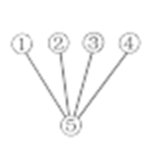 B. 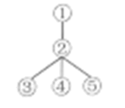 C. 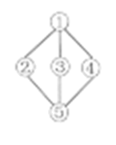 D. 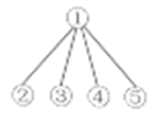
第四部分 口语运用（共5小题; 每小题2分, 满分10分）
根据对话内容，从对话后的选项中选出能填入空白处的最佳选项，并在答题卡上将该项涂黑。
A: Hi, Katherine, you look tired. ___46___
B: I planted tomatoes in the garden behind the school with my classmates just now.
A: ___47___ Why did you do that?
B: Well, because our teacher asked us to watch how tomatoes grow.
A: That’s meaningful. ___48___
B: We also planted some carrots, potatoes and so on.
A: It must be a beautiful garden. Will everyone in your class look after them?
B: Yes, we take turns to look after them.
A: ___49___
B: I hope so. It reminds me of a famous saying, “No pains, no gains”.
A: That’s right. Planting is not only a kind of labor practice but also helps us learn a lot.
B: I quite agree with you. ___50___
A: Sure, I’d love to. I’m looking forward to seeing your garden.
A. Would you like to visit our garden?
B. Sounds interesting.
C. What else did you plant?
D. I believe you’ll get a lot this autumn.
E. What’s the matter with you?
第Ⅱ卷（共45分）
第五部分综合知识运用（共四节,满分45分）
第一节词汇（共5小题;每小题1分,一空一词,满分5分）
根据句意和所给提示, 在句子右边的横线上写出空白处所缺单词的正确形式。
51. Boys and girls, work hard! I believe you will __________ (成功) in the exam.
52. Tomorrow is Linda’s ________ (nine) birthday. Let’s buy some gifts for her.
53. Don’t talk in the library. We’d better keep s________.
54. Last weekend, all of us went for a picnic e_________ Tom because he was ill.
55. Qi Jiguang is one of the greatest national h________ in China. We will remember him forever.
第二节 阅读填空（共5小题; 每小题2分, 满分10分）
根据短文内容，从短文后的选项中选出能填入空白处的最佳选项。选项中有一项为多余选项。
Adolescence (青春期) is a difficult time for teenagers. It takes place when you’re aged between thirteen and nineteen. ___56___ For example, you used to be happy to be with your parents, but now you need your own space. In the past, your parents made most decisions for you, but now you want to decide things by yourself.
In fact, these changes are perfectly normal. But it’s important to remember that they’ll influence your relationship with your parents. ___57___
First, let your parents know you love them all the time. ___58___ They may not say so, but they’ll probably feel a sense of loss.
Secondly, ___59___ You may feel these are unnecessary, but your parents’ main worry is just to keep you safe. So try your best to follow the rules and stick to them. It may feel like a trouble to always remember to phone them and let them know where you’re, but make the effort anyway.
Finally, it’s all about communication! ___60___ Tell them what you did today and let them know where you’re going. Besides, ask for advice if you need. All in all, the more you communicate with them, the more they’ll trust you.
A. follow your family rules.
B. Keep talking to your parents.
C. follow your parents’ suggestions.
D. As your body changes, you also begin to think and feel differently.
E. In their eyes, they have forever lost the little child you used to be.
F. Then how can you make sure that you get on well with your parents?
第三节语法填空（共10小题;每小题1分,满分10分）
根据下面材料，在空白处填入1个适当的单词或括号内所给单词的正确形式。
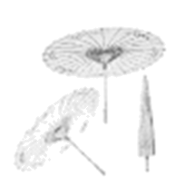
The oil-paper umbrella has a history of over 1,000 years in China. There are different ____61____ (story) about the invention of the umbrella in China. The most popular one has something to do with Lu Ban. It’s said that once he and his wife visited the West Lake. It started raining suddenly. His wife said, “Let’s have ____62____ competition. Before sunrise tomorrow, the one who comes up ____63____ a good way to visit the West Lake even on rainy days will be the winner.” Lu Ban ____64____ (think) it was easy. He collected some tools and materials. Then he spent the whole night ____65____ (build) pavilions (亭子) around the lake. He was quite proud of his work.
The next morning, ____66____ Lu Ban talked about his achievements and felt proud, his wife held something unusual in her hand. It could be opened into a round shape. Lu Ban was ____67____ (surprise). He found that the object, made of silk and bamboo, could be opened and closed ____68____ (easy). It was light, beautiful and easy to carry. Lu Ban said, “You win. Your invention can protect us from rain better.” So the umbrella ____69____ (invent).
Later, people began to use paper, which was ____70____ (cheap) than silk. To make the umbrella water-proof, people brushed a kind of oil on the surface. So the oil-paper umbrella appeared.
第四节 书面表达（满分20分）
71. 今年5月第五届“中国好家风”全国启动仪式在北京隆重举行。传承优秀家风是中华民族家国情怀的重要体现，为响应号召，你校校报英语专栏将举办“孝敬长辈，从我做起”的主题征文活动。请根据以下的结构图提示，结合自己的生活，写一篇不少于80词的短文，向该专栏投稿。
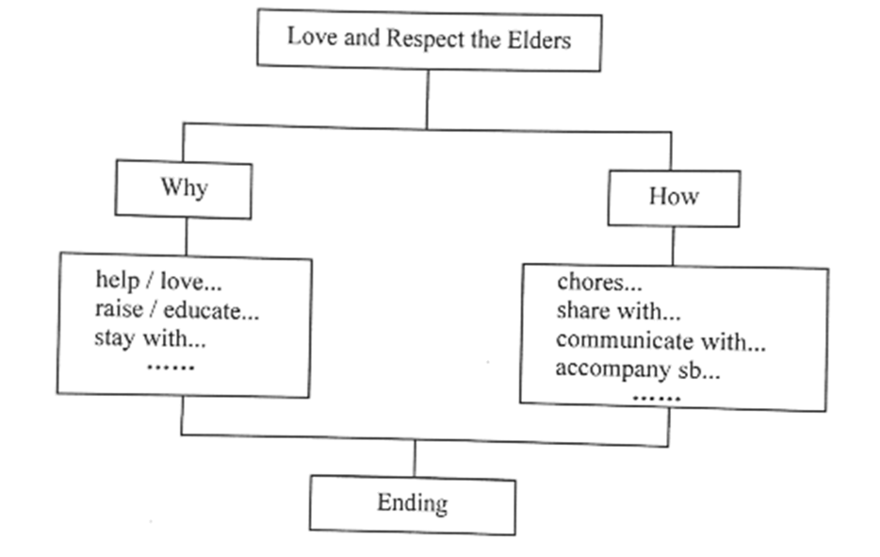
注意：
1. 文章开头已给出，不计入总词数；
2. 文章应包含所给要点提示，可适当发挥；
3 文章语句通顺，行文连贯；
4. 文中不得出现真实的人名、校名和地名。
参考词汇：virtue (n. 美德) accompany (v. 陪伴) raise (v. 养育) educate (v. 教育)
Love and Respect the Elders
As we all know, respecting and caring for our elders is not only a traditional Chinese virtue but also our duty.___________________________________________________________________________________________________________________________________________________________________________________________________________________________________________________________________________________________________________________________________________________________________________________________________________________________________________________________________________________________________________________________________________________________________________________________________________________________________________________________________________________________________________________________________________________________________________________

