2024年烟台市初中学业水平考试
英语试题
注意事项：
1.本试卷共8页，满分90分，考试用时100分钟。
2.答卷前，考生务必将自己的姓名、准考证号、座位号填写在答题卡规定的位置上。
3.选择题用2B铅笔把答题卡上对应题目的选项涂黑；如需改动，用橡皮擦干净后再选涂其它选项。
4.非选择题用0.5毫米黑色签字笔作答，答案必须写在答题卡各题目的相应位置；如需改动，先划掉原来的答案，然后再写上新答案；不能使用涂改液等。
5.考生必须保持答题卡的整洁。考试结束后，将本试卷和答题卡一并交回。
第一部分 阅读理解（共两节，满分35分）
第一节（共15小题；每小题2分，满分30分）
阅读下列短文，从短文后每题所给的A、B、C和D四个选项中，选出最佳选项。
A
Everyone knows some teachers who whole-heartedly help their students learn and grow. This year, Teacher Appreciation (感谢) Week starts from May 6. To celebrate it, we asked some kids to make cards to thank the teachers who inspired them greatly. Let’s enjoy some of their works and think about which teacher inspires you.
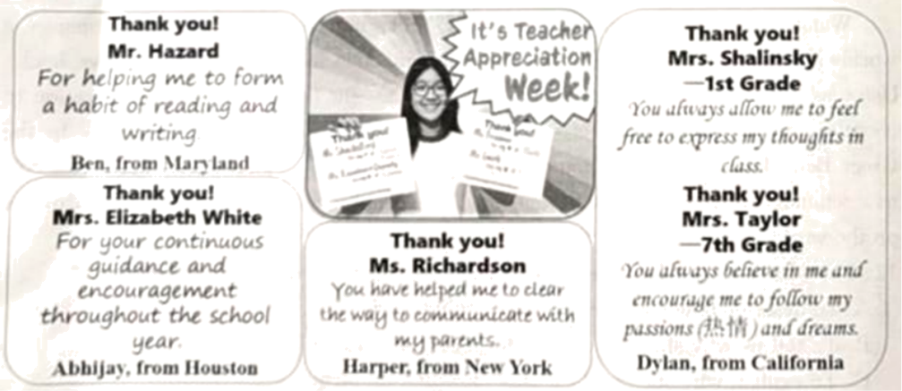
1. How did students celebrate this year’s Teacher Appreciation Week?
A. By writing thank-you cards. B. By helping their teachers.
C. By sending teachers presents. D. By telephoning their teachers.
2. What problem did Harper probably have in the past?
A. He was afraid of speaking in class. B. He had difficulty in reading and writing.
C. He didn’t get along well with his parents. D. He was too shy to communicate with others.
3. What do Mrs. Elizabeth White and Mrs. Taylor have in common?
A. They are strict. B. They are humorous.
C They are energetic. D. They are encouraging.
B
Last December, when An Lingfei, a doctor from an Inner Mongolia medical team, arrived in Kigali, the capital city of Rwanda (卢旺达), he set up a center in the Masaka District Hospital. Since then, the China-Rwanda Traditional Chinese Medicine (TCM) Treatment Center has increased in popularity.
According to An the center now receives an average of more than 30 people daily, with most of them suffering from lower back pain or knee and ankle joint (踝关节) pain. Rwanda is known as the land of a thousand hills. Locals often have to walk on mountain roads year-round, which can lead to joint stress.
“TCM has great advantages in treating these diseases, and the effects are very good.” An said. “The center now provides most kinds of TCM treatments, allowing local people to experience Eastern medicine.”
Naomin, a 60-year-old patient, is amazed by TCM. She was unable to walk due to serious pain in both knees and ankles. But after a month of treatment at the center, she is now able to walk around with a walking stick. “The treatment has been a huge help,” she said.
Another patient, Mukagatare, said that his back pain disappeared after three TCM treatments. According to him, doctors at the local hospitals had been unable to make a clear diagnosis (诊断) after many examinations, let alone reduce the pain.
Besides treating patients, the center also educates locals about TCM and Chinese culture.
Up to now, TCM has spread to nearly 200 countries and areas, with its worldwide influence continuously growing. “From treating a common cold to chronic (慢性的) and difficult diseases. TCM can all play an important role,” a Chinese expert said.
4. Where did An Lingfei set up the TCM Treatment Center?
A. In China. B. In Kigali. C. In his home. D. In Inner Mongolia.
5. Why do many locals in Rwanda suffer from joint pain?
A. Because their average ages are over sixty.
B. Because they are given a wrong diagnosis.
C. Because they can’t go to the local hospitals.
D. Because they often walk on mountain roads.
6. What improvement did Naomin achieve after a month of TCM treatment?
A. Her back pain disappeared. B. Her knees didn’t hurt anymore.
C. She could move around again. D. She didn’t need a walking stick.
7. What can we infer (推断) from the passage?
A. The local hospitals in Rwanda are not responsible.
B. There are no effective ways to treat chronic diseases.
C. TCM will have increasing popularity around the world.
D. An’s center mainly focuses on spreading Chinese culture.
C
A Long March 5 rocket took off from the Wenchang Space Launch Site in Hainan province on May 3, 2024. After flying for about 37 minutes, it successfully placed the Chang’e 6 robotic lunar probe (月球探测器) into an Earth-moon transfer trajectory (转移轨道). Several days later the probe was programmed to land on the moon’s far side and started its tasks, which would last about 53 days.
This is the world’s first try to bring samples (样本) from the moon’s far side. For China, it’s the second sample-return moon journey. Chang’e 5 successfully brought samples from the moon in the winter of 2020. Up to now, 10 moon sample-return tasks have been carried out by the United States, the former Soviet Union (前苏联) and China, but all these samples were collected from the moon’s near side.
The moon’s far side has always been a subject of scientific wonder because of its many mysteries. It’s facing away from Earth and it can never be seen from Earth. It was once called the “dark side of the moon” even though it receives just as much sunlight as the near side.
Chinese researchers have found that the soil on the far side is much thicker than that on the near side, but they haven’t found out the reason. Samples brought back by Chang’e 5 have helped scientists find that there were volcanic (火山的) activities on the near side around 2 billion years ago. Some scientists thought maybe volcanoes became inactive on the far side about 4 billion years ago. Is it true? Samples from the far side will allow them to know the answer.
“Comparing the make-up of the far side samples from Chang’e 6 with those collected from the near side will be of great scientific value to the international community,” said Martin Sweeting, a famous professor of space engineering.
8. When did Chang’e 6 begin to work on the moon?
A. On May 3, 2024. B. After flying for about 37 minutes.
C. In the winter of 2020. D. After landing on the moon’s far side.
9. How many times has China got samples from the moon’s near side?
A. Once. B. Twice. C. Five times. D. Ten times.
10. According to the passage, the moon’s far side ________.
A. receives less sunlight than the near side
B. has thicker soil compared with the near side
C. can be seen from Earth with powerful cameras
D. has more recent volcanic activities than the near side
11. What can we learn from Martin Sweeting’s words?
A. Chang’e 6 will stay longer on the moon for more tasks.
B. Chang’e 6 is carrying out a valuable task for the world.
C. Chang’e 6 will bring samples from both sides of the moon.
D. Chang’e 6 can compare samples before bringing them back.
D
Wangari Maathai, a Nobel Peace Prize winner, was born on April 1, 1940, in Kenya (肯尼亚). Growing up in the countryside, Wangari was deeply connected to the land from an early age. This early experience with the environment later inspired her life’s work, which has left an unforgettable mark on the world.
With the help of a program, Wangari received her university education in the United States. After graduation, she returned to Kenya. In 1971, she got a doctor’s degree from the University of Nairobi, becoming the first woman doctor in East and Central Africa. But her greater achievement was outside the university. In 1977, Wangari set up the Green Belt Movement, an organization focused on tree planting, environmental protection, and women’s rights. She called on Kenyan women to plant trees in their hometown. This simple act not only helped to protect the environment but also made women powerful economically (经济地) and socially.
Wangari focused not only on environmental problems. She made great efforts to fight for democracy (民主), human rights, and social fairness. Her activism (激进主义) often put her in disagreement with the Kenyan government. As a result, she was put in prison (监狱) several times, but she kept fighting bravely. It was because of her tireless work that she was awarded the Nobel Peace Prize in 2004. She became the first African woman to receive the award.
Wangari passed away on September 25, 2011, but her spirit continues to inspire a worldwide movement towards environmental protection and social fairness. Her book, Unbowed, records her life journey and the challenges she faced, offering an inspiration to countless people worldwide. Her story lives on through the millions of trees planted by the Green Belt Movement and the countless lives she touched through her hard work. It serves as a reminder that even the smallest actions, like planting a tree, can have a great influence on the world.
12. For what purpose does the writer mention Wangari’s early life in Paragraph 1?
A. To describe how she grew up in the countryside.
B. To tell us why she studied hard for a doctor’s degree.
C. To explain why she cared for environmental problems.
D. To show how she became a Nobel Peace Prize winner.
13. What does the underlined part “This simple act” mean in Paragraph 2?
A. Setting up an organization. B. Planting trees in Kenya.
C. Focusing on women’s rights. D. Fighting for democracy.
14. Why was Wangari put in prison several times?
A Because there was something harmful in her book Unbowed.
B. Because she founded the Green Belt Movement organization.
C. Because the Kenyan government was angry with her activism.
D. Because she received her university education in the United States.
15. What can we learn from Wangari’s story?
A Small actions can make great differences. B. Brave people should win the Nobel Prize.
C. Good education can help one be successful. D. We shouldn’t look down upon African women.
第二节（共5小题；每小题1分，满分5分）
阅读下面短文，从短文后的选项中，选出可以填入空白处的最佳选项。选项中有一项为多余选项。
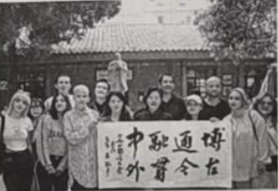
Around the 15th United Nations Chinese Language Day, which fell on April 20, some foreign students of Xi’an International Studies University practiced and enjoyed Chinese characters together with some Chinese experts and teachers. It has been a tradition for some foreign Chinese speakers and Chinese teachers to get together to mark the special day.____16____
Chinese famous writer Lu Xun once said that the beauty of Chinese characters lies in three ways: their meanings educate the mind, their sounds please the ear, and their appearances please the eye. ____17____
The history of Chinese characters can date back over 3,000 years. To improve beauty and writing efficiency (效率), different kinds of characters were developed, such as zhuanshu, lishu, caoshu, and kaishu. ____18____
Many Chinese characters not only carry meanings but also have cultural significance (意义) passed down through history. ____19____ Through them, we can closely connect the past, present, and future of our country.
According to a recent survey, more than 30 million people worldwide are learning Chinese. ____20____ As more people can speak their mother languages and Chinese, the culture of Chinese characters is likely to be better understood and enjoyed worldwide.
A. They are symbols of Chinese traditional culture.
B. The language is taught in over 190 countries and areas.
C. He is happy to see a growing interest in Chinese characters.
D. The beauty of Chinese characters is still clear and popular today.
E. They enjoy sharing their understanding and benefits of this language.
F. Another writer Yu Guangzhong also praised Chinese characters highly.
第二部分 语言知识应用（共两节，满分25分）
第一节 完形填空（共10小题；每小题1分，满分10分）
阅读下面短文，从短文后各题所给的A、B、C和D四个选项中，选出可以填入空白处的最佳选项。
I have learned four languages—English, Spanish, French and Chinese. Although I wasn’t great at ____21____ when I was a kid, I ____22____by traveling to places like Beijing, Dali and Kunming.
An ____23____ time for me was two summers ago when I went to Hangzhou. I joined a program where I became an English teacher for primary school kids. This ____24____ let me learn more about the Chinese language and traditions. Our classroom was like a melting pot (熔炉) of ideas with lots of language sharing and laughter.
My travels and ____25____ experience in Hangzhou completely changed how I see the world. It made me ____26____ the close relationship of different countries, and now I want to be a global citizen (世界公民). I want to help people from different countries understand each other, ____27____ between China and the US.
In China, we see a lot of ____28____ of American culture, such as Disney cartoon characters, McDonald’s and Coca-Cola. However, I couldn’t find many signs of Chinese culture in the US, except for Chinese ____29____. I went to some but found the food there very different from real Chinese food. I think China still has much to do to further promote (推动) its cultural influence among the American people. As for me, I will ____30____ to be one of those who can help deepen the understanding between China and the US.
21. A. English B. Spanish C. French D. Chinese
22. A. appeared B. improved C. graduated D. increased
23. A. awful B. important C. embarrassing D. expensive
24. A. class B. survey C. experience D. examination
25. A. teaching B. loving C. guiding D. communicating
26. A. change B. remind C. realize D. achieve
27. A. only B. seriously C. actually D. especially
28. A. programs B. dreams C. signs D. advertisements
29. A. restaurants B. shops C. farms D. factories
30. A. regret B. refuse C. happen D. continue
第二节 语法填空（共10小题；每小题1.5分，满分15分）
阅读下面短文，在空白处填入一个适当的单词或括号内单词的正确形式。
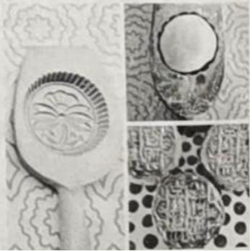
Mooncakes are one of the most popular foods during the Mid-Autumn Festival. But let’s be honest: not many of us really like to eat them, mainly ____31____ they are made in factories and often several months old by the time they ____32____ (buy). Now here’s the thing: homemade mooncakes. They’re amazing, whether you’re eating them ____33____ (you) or giving them to your friends as gifts. Yes, they require a lot of effort, but they’re worth it.
____34____ (produce) mooncakes, you’ll need a mold (模具). Molds are available in different sizes and depths. I usually use a traditional large ____35____ (wood) mold. But a plastic mold in a similar size will do just line.
Before cooking, I prepare several kinds of ingredients (原料) and make them into balls separately. The key to ____36____ (make) proper mooncakes is to gather each ball in layers (层). In my way, the middle ball is made of nut (坚果) pieces. The ____37____ (two) layer is made of mashed red bean mixed with sugar, which is lastly covered with a layer of pastry (油酥面团). It is then pressed into a mold and carefully taken out into the oven.
It’s important to follow the cooking ____38____ (instruction) carefully. To prevent breaking up, I first cook mooncakes ____39____ a high temperature to set the pattern and shape. Then, I lower the temperature and remove them ____40____ (regular) to brush the surface with egg wash.
Just look at my mooncakes! Not bad. right?
第三部分 书面表达（共两节，满分30分）
第一节 阅读表达（共5小题；每小题2分，满分10分）
阅读下面短文，完成短文后的问题。
[1] Citywalk is becoming a new travel fashion for the youth in China who are exploring cultural spots (景点). Unlike traditional travel, it aims to avoid famous tourist spots and large crowds to get a better experience.
[2] Many young people enjoy gathering a couple of good friends and hanging out in the streets when they visit a new city. They can follow a typical city route (路线), exploring old buildings, going window-shopping, drinking a cup of coffee, or enjoying local snacks.
[3] In order to show their Citywalk, more and more people prefer to share their experiences and thoughts through social media (媒体). Xiao Yiyi, a young guide in Changsha, recently shared six Citywalk routes of different cities on the Internet, providing experiences for visitors to “walk in open-air museums”. Her Changsha travel route includes more unusual sights such as historical buildings, old streets, and even some snack bars.
[4] Citywalk is spreading from the largest cities to smaller ones, encouraging more travelers and event organizers to join. Some places, such as Beijing and Shandong, have included Citywalk in their plans to develop cultural tourism and relaxing tours. Shanghai has set up Citywalk bus routes to help day-trippers reach more faraway areas first, and then continue on foot.
[5] Citywalk not only offers a way for young people to explore a city but also provides them with a new social situation, where they can share their interests and ideas and make friends easily. What’s more, Citywalk provides an opportunity for tour guides and travel companies to offer a more professional service to meet the ever-changing market requirements.
41. How is Citywalk different from traditional travel?
___________________________________________________
42. Translate the underlined sentence into Chinese.
___________________________________________________
43. Why did Xiao Yiyi share some Citywalk routes online?
___________________________________________________
44. For what purpose did Shandong include Citywalk in its plans?
___________________________________________________
45. What does Paragraph 5 mainly tell us? (no more than 6 words)
___________________________________________________
第二节 写作（满分20分）
46. 假如你是光明中学英语社团成员，本周末社团将演出课本剧《愚公移山》，校园广播站准备通知在学校访问的外国学生前去观看，请你用英语写一篇广播稿。
主要内容包括：
1.演出时间、地点；
2.课本剧内容简介及意义；
3.欢迎对演出提出意见建议。
要求：
1.词数100左右（开头和结尾已给出，不计入总词数）；
2.须包含所有要点提示，并可适当补充，以使行文连贯；
3.不得出现真实的个人姓名、校名等信息。
提示词汇：课本剧 textbook drama；《愚公移山》Yu Gong Moves the Mountains
Good morning, everyone!
This is an announcement for all the foreign students visiting our school.
____________________________________________________________________________________________________________________________________________________________________________________________________________________________________________________________________________________________________________________________________________________________________________________________________________________________________________________________________________________________________________________________________________________________________________________________________________________________________________________________________________________________________________________________________________________________________________________________
Thanks for your attention!

