机密★启用前
2024年广东省初中学业水平考试
英语
本试卷共12页，81小题，满分120分。考试用时90分钟。
注意事项：
1.答题前，考生务必用黑色字迹的签字笔或钢笔将自己的准考证号、姓名、考场号和座位号填写在答题卡上。用2B铅笔在“考场号”和“座位号”栏相应位置填涂自己的考场号和座位号。将条形码粘贴在答题卡“条形码粘贴处”。
2.作答选择题时，选出每小题答案后，用2B铅笔把答题卡上对应题目选项的答案信息点涂黑；如需改动，用橡皮擦干净后，再选涂其他答案，答案不能写在试卷上。
3.非选择题必须用黑色字迹的签字笔或钢笔作答，答案必须写在答题卡各题目指定区域内相应位置上；如需改动，先划掉原来的答案，然后再写上新的答案；不准使用铅笔和涂改液。不按以上要求作答的答案无效。
4.考生必须保持答题卡的整洁。考试结束后，将试卷和答题卡一并交回。
一、听说应用（本大题共30小题，每小题1分，共30分；A、B、C、D部分为听力理解，E部分为情景对话）
听句子（本题共5小题，每小题1分，共5分）
请根据所听内容，选择符合题意的图画回答问题，并在答题卡上将对应选项涂黑。每个句子听两遍。
1. How was the weather?
A. 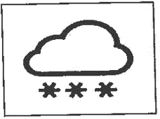B. 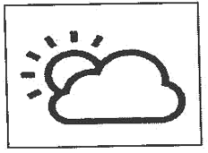C. 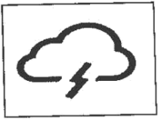
2. How did Lili travel?
A. 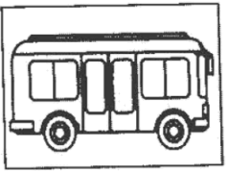B. 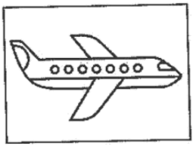C. 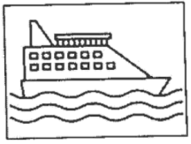
3. What does Lili’s hometown look like now?
A. 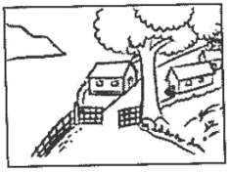B. 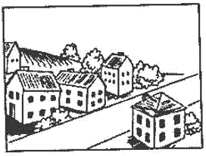C. 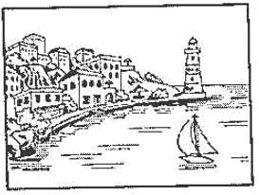
4. Where do Lili’s parents live?
A. 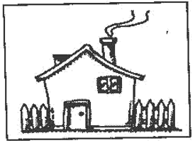B. 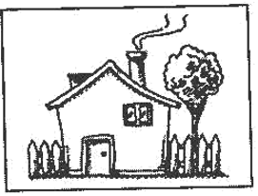C. 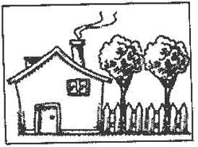
5. What did Lili’s family do on the first day of Spring Festival?
A. 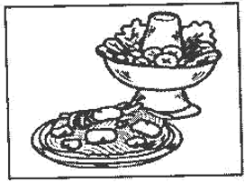B. 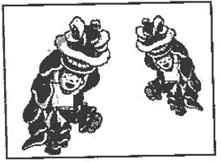C. 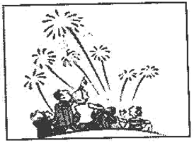
听对话（本题共10小题，每小题1分，共10分）
请根据每段对话的内容回答问题，从每小题所给的三个选项中选出一个最佳答案，并在答题卡上将对应选项涂黑。每段对话听两遍。
6. Which season do the speakers like?
A. Spring. B. Summer. C. Autumn.
7. What are the speakers talking about?
A. A flower show. B. A tennis match. C. A horse race.
8. What does Eric like most?
A. Spring rolls. B. Dumplings. C. Roast duck.
9. How does Jenny sound?
A. Surprised. B. Bored. C. Relaxed.
10. What color is Amy’s hat?
A. Yellow. B. Brown. C. White.
听第六段对话，回答第11~12小题。
11. Why has the TV stopped working?
A. The TV is too old. B. The wind blows hard. C. There are Northern Lights.
12. What are they going to do next?
A. Turn off the light. B. Color the picture. C. Go out.
听第七段对话，回答第13~15小题。
13. What kind of music does the girl like?
A. Pop music. B. Light music. C. Rock music.
14. How does the girl feel about the AI music?
A. It’s funny. B. It’s amazing. C. It’s familiar.
15. What does the boy think of AI?
A. It’s less creative than humans. B. It hasn’t got much training. C. It’s smarter than humans.
听短文（本题共5小题，每小题1分，共5分）
请根据所听内容，从每小题所给的三个选项中选出一个最佳答案，并在答题卡上将对应选项涂黑。短文听两遍。
16. How did Mary feel at first?
A Tired. B. Lonely. C. Worried.
17. What course did Mary take?
A. Dancing. B. Singing. C. Painting.
18. How often did Mary practice?
A. Twice a day. B. Twice a week. C. Twice a month.
19. Who admired Mary?
A. Her children. B. Her husband. C. Her classmates.
20. What has Mary got in the end?
A. Friendship. B. Wealth. C. Beauty.
听填信息（本题共5小题，每小题1分，共5分）
你将听到一则校园大扫除活动的通知。请根据所听内容填写下面的信息卡, 并将答案写在答题卡对应题目的答题位置上。短文听两遍。
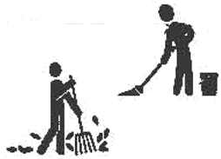A School Clean-up Activity
Time: at 21 p.m. next Monday
Requirements: ◆to bring large and 22 bags and other tools
◆to clean the area chosen by the head teacher
◆to pay special attention to the 23 and the comers
Teachers’ task: ◆to help and 24 the final work
Purposes: ◆to make the school cleaner
◆to develop students’ practical skills and 25 spirit
情景对话（本题共5小题，每小题1分，共5分）
请通读下面对话，根据对话内容，从下面的选项中选出能填入空白处的最佳选项。选项中有一项为多余选项。
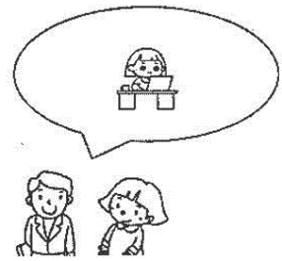
Dad: What are you doing on the computer, Ann?
Ann: ___1___
Dad: Do you know them well?
Ann: ___2___ They are my friends in real life.
Dad: Good. You know, it can be dangerous to make friends online.
Ann: Sure, Dad. ___3___
Dad: That’s right. And you may advise your friends to be careful, too.
Ann: I will tell them later. In fact, I’ll meet them this afternoon.
Dad: ___4___
Ann: To the city library. We’ll work as volunteers there for the Internet Safety Day.
Dad: I’m so proud of you. ___5___
A. Have fun there!
B. It’s my pleasure.
C. Don’t worry, Dad.
D. Where are you going?
E. I know I need to protect myself.
F. I’m chatting with my friends online.
二、语法选择（本大题共10小题，每小题1分，共10分）
请通读下面短文，掌握其大意，根据语法和上下文连贯的要求，从每小题所给的三个选项中选出一个最佳答案，并在答题卡上将对应选项涂黑。
When Peter was six, he started receiving pocket money from his mother. When he turned seven, he ___6___ £7 a week. Now at the age of fifteen, he ___7___ £15 every week. He has the raise in pocket money because he spends money wisely.
___8___ a shopping mall near Peter’s home. At weekends, he watches ___9___ movies with his friends, or takes his little brother to the play center there. He buys his grandparents small presents when he visits them. Sometimes, he takes one ___10___ bus ride to museums and zoos in another town. When he has saved enough money, Peter goes to the bookstores ___11___ great books and donates them to children in need. His mother is satisfied with ___12___ he spends his money. She thinks it is a smart choice to give Peter pocket money. “This habit ___13___ help Peter manage money well,” she says.
Peter’s mother even suggests giving pocket money to children as ___14___ as when they are four. “To learn how to deal with money is ___15___ useful life skill. Giving children pocket money in their early years teaches them the importance of budgeting.”
6. A. gets B. got C. will get
7. A. gives B. is given C. is giving
8. A. There is B. It is C. They are
9. A. excite B. excitement C. exciting
10. A. hour B. hours C. hour’s
11. A. buy B. to buy C. bought
12. A. how B. which C. whether
13. A. need B. must C. can
14. A. early B. earlier C. earliest
15. A. a B. an C. the
三、完形填空（本大题共10小题，每小题I分，共10分）
请通读下面短文，掌握其大意，从每小题所给的四个选项中选出一个最佳答案，并在答题卡上将对应选项涂黑。
Betty is a biologist. She studies brain diseases that come along with aging. Her ___16___ is not an easy one. She is trying to understand what goes wrong with the brain over time, and how people can age in a healthy way. It is very important, especially when people are living a ___17___ life now.
Betty does not have a natural gift (天赋) for math. She never ___18___ that she could be a scientist one day when she was little. Now, she has got a doctor’s degree in biology and become a famous ___19___ researcher. Betty has made it partly because she is curious about everything. This is a very ___20___ quality for a scientist. Another ___21___ is that she is a creative thinker. “After all, science is all about problem-solving,” Betty said.
Betty thinks the best part of her research is trying out an idea to see if it will work. Her heart is filled with joy when her idea is proved right and ___22___ by other scientists. But when things don’t go ___23___ as she plans, she feels no disappointment. She says mistakes may ___24___ a new idea.
Few are born to be a ___25___. According to Betty, curiosity and creativity play the biggest role.
16. A. job B. book C. excuse D. exam
17. A. slower B. longer C. quieter D. simpler
18. A. argued B. reported C. thought D. understood
19 A. social B. medical C. educational D. environmental
20. A. poor B. strange C. similar D. important
21. A. reason B. example C. purpose D. decision
22. A. changed B. accepted C. described D. questioned
23. A. safely B. crazily C. blindly D. smoothly
24. A. mix with B. turn down C. lead to D. break down
25. A. dentist B. lawyer C. coach D. scientist
四、阅读理解（本大题共15小题，每小题2分，共30分）
请阅读A、B两篇短文，从每小题所给的四个选项中选出能回答所提问题 或完成所给句子的最佳答案，并在答题卡上将对应选项涂黑。
A

Welcome to Top Discovery Space (TDS)!
This is a good place for you and your kids to have fun through different kinds of hands-on activities, including experiencing 3D-printing, doing chemistry games, growing vegetables and exploring the secrets of space.
All these activities need close parent-child cooperation. It is what we value most. We organize many activities for parents and children to do together. To make sure every visitor enjoys their time at TDS, we have to remind you to follow these rules:
 Parents should stay with their children during the visit. For children’s safety, parents must go through the instructions for the activities carefully.
All visitors are required to wear socks (no shoes allowed) within indoor areas You may ask our workers at the front desk for a pair.
Visitors are not supposed to take photos here. Our teachers will catch your unforgettable moments during your visit. Your photos will be sent to you by email if you need them.
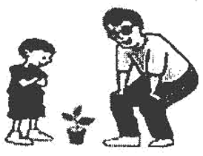 Eating and drinking is only allowed in the picnic area.
Opening time: 9:00 a.m. to 5:00 p.m. every day
Price: 50 dollars for one ticket
Please note: One ticket covers one adult and one child
Please buy one more ticket for another adult or child.

26. What can visitors do at TDS?
A. Watch 3D movies. B. Take chemistry tests.
C. Learn about space. D. Make vegetable salads.
27. What does TDS care about most?
A. Parent-child cooperation. B. Children’s learning experience.
C. Children’s health and safety. D. Teacher-student communication.
28. Who is advised to read the activity directions carefully?
A. Teachers. B. Children. C. Workers. D. Parents.
29. How many tickets do you need if you go to TDS with your parents?
A. One. B. Two. C. Three. D. Four.
30. What kind of text is this passage?
A. A story. B. A diary. C. A notice. D. A report.
B
People know animals do have feelings, but they are not sure if these feelings are correctly understood. In recent years, scientists have done research about the feelings of cows, frogs and pandas. ▲ It says that humans can tell whether a chicken is happy or sad by listening to its calls.
The researchers put a bowl behind a door. Inside the bowl, sometimes, there was something chickens love to eat, such as rice or insects. Sometimes, there was nothing. When the chickens saw food behind the door, they seemed happy and produced fast and loud sounds, known as food calls. When there wasn’t food, the chickens made low and long noises to express disappointment. The researchers recorded all these sounds and studied their waves.
Then the researchers chose 16 recordings of such chicken noises. Half were from the chickens seeing the food and half were from the chickens finding no food. The recordings were played to 194 volunteers. Sixty-nine percent of the volunteers correctly understood whether the chickens were feeling happy or not, and some of them even had no experience of taking care of chickens.
The result shows that humans have the natural ability to understand the feelings of chickens. Hopefully, this finding can bring about new technology to help with chicken-raising, a big industry in many countries. Some scientists are already working on a smart computer program that can identify chickens’ feelings. This is good news for farmers who want to make the birds happier and healthier.
31. Which of the following can be put in “________” in Paragraph 1?
A. Humans may not like animals. B. Scientists know nothing about it.
C. Nobody knows why this happens. D. A new study adds chickens to the list.
32. Which is most probably the sound wave of a happy call by a chicken?
A. 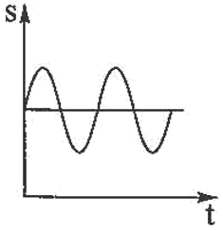 B. 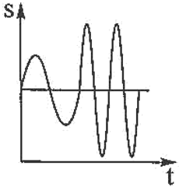 C. 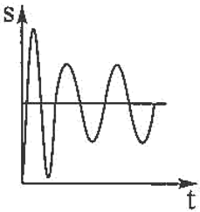 D. 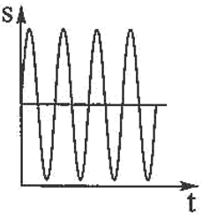
33. How did the volunteers help with the research?
A. By listening to the chicken calls. B. By taking care of the chickens.
C. By finding food for the chickens. D. By making the chickens happy.
34. What does the underlined word “identify” mean in Paragraph 4?
A. Control. B. Hide. C. Recognize. D. Hurt.
35. What is the best title for the passage?
A. Chickens’ Food Calls B. Happy Chickens, Sad Chickens
C. Farmers’ Best Choice D. Smart Farmers, Healthy Farmers
C
配对阅读。左栏是五则新闻，右栏是七位学生的读后感。请为每则新闻匹配对应的读后感，并在答题卡上将对应选项涂黑。选项中有两项为多余项。
____36____ A British scientist has discovered that, 200 to 300 million years ago, it rained non-stop for two million years on Earth.  ____37____ A fashion designer from Europe collects hair cuttings and changes them into material for clothes. The designer thinks this material helps reduce waste.  ____38____ Climate change is harming Earth greatly. People on a Pacific island have to leave their homes because the sea level is rising rapidly.  ____39____ Mexico City is facing serious drinking water problems. Many people are forced to buy expensive bottled water for drinking.  ____40____ The athletes’ village of Paris Olympics will have a special cooling system (系统). It will save 40% of the electricity and natural gas. | A. I wonder who designed this raincoat. It really helps when it rains non-stop.  B. Unbelievable! In that period, there must have been water everywhere on Earth.  C. I am planning to fly to the city to have a taste of the famous street food.  D. It sounds scary, to be honest. I don’t think this kind of clothes will become fashionable.  E. How terrible it is for the people there! Perhaps the place will disappear under water one day.  F. Who is the smart inventor of this cooling system? He or she must be a cool scientist.  G. I hope I can do something for the people there so that they will have enough drinking water.

五、短文填空（本大题共10小题，每小题2分，共15分）
请从方框内选择适当的词，并根据需要用其正确形式填空，使文章语法正确、完整连贯，并将答案写在答题卡对应题目的答题位置上。注意：每空一词，每词仅用一次，有两词为多余项。
always among and answer
believe big but city
grow seldom they whenever
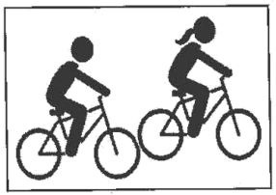
As summer comes around, outdoor activities are getting more and more popular. One of ___41___ is bike riding, or biking. The biking craze (热潮) is now sweeping through China.
Wang Jing is a student from Hangzhou. She ___42___ exercised before because she didn’t like sports much. But since her hometown hosted the Asian Games in 2023, her interest in sports has ___43___ a lot. She has realized the benefits of sports ___44___ is now a big fan of biking.
“I feel free and peaceful ___45___ I ride,” Wang said. “Biking allows me to experience the beauty along the road and the world seems to slow down,” she added. Wang is only one of those who are deeply in love with biking. In ___46___ like Chengdu and Beijing, thousands of people have started to join in the biking craze.
Will the craze in China last for a long time? The ___47___ is “Yes.” Thanks to the craze, there have been events like group rides and bike festivals. These create a sense of community ___48___ bikers. They share road information, biking experience and sometimes even meals. They are just like a ___49___ family. As biking has become a lifestyle, experts ___50___ that this biking craze will continue. They expect a sharp increase in the number of bike riders.
六、读写综合（本大题分为A、B两部分，共25分）
回答问题
请阅读下面短文，根据所提供的信息，回答五个问题，并将答案写在答题卡对应题目的答题位置上。要求所写答案语法正确、信息完整切题。
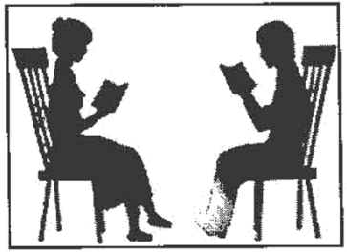
Reading a good book is a wonderful journey because the reader can live in someone else’s world for a while. Reading together with others, known as buddy (同伴) reading, will make this journey even more fantastic. During the journey, the buddies spend time doing a lot of reading activities. This not only adds to the pleasure of reading, but also deepens their understanding of the books.
Although it is all right to have students join in buddy reading with same-aged schoolmates, schools usually pair up older students with younger ones. In 2021, Green School started such a program and has achieved a great success.
Both younger and older readers in this school have learned a lot from this two-year, program. For example, when they listened to each other, they learned to be kind and patient. This experience also provided them with a chance to practice lifelong skills such as exercising leadership or communicating with others. A student called Jason said that reading to a younger buddy was really helpful. He became more confident, as he knew he was a role model for someone.
The school also became a closer community. The reading buddies felt more connected as they often met each other. The students were always excited when they saw their buddies pass by in the hallway.
Now summer vacation is coming. It’s a great time to get into books. Why not pair up with a friend, choose a book you both like and read it together?
51. What is buddy reading?
__________________________________________________
52. How do schools usually pair up buddies?
__________________________________________________
53. How long did the reading program in Green School last?
__________________________________________________
54. Why did Jason think the program was helpful?
__________________________________________________
55 What benefit did the school get from the program?
__________________________________________________
56. 书面表达
请根据要求完成短文写作，并将短文写在答题卡对应题目的答题位置上。
假设你叫李明，你校交换生Ethan在阅读中国古诗词的过程中遇到了困难，他通过学校广播节目寻找共读伙伴。请你根据以下思维导图的提示，用英文写一封邮件，表示愿意成为他的共读伙伴，并提供帮助。
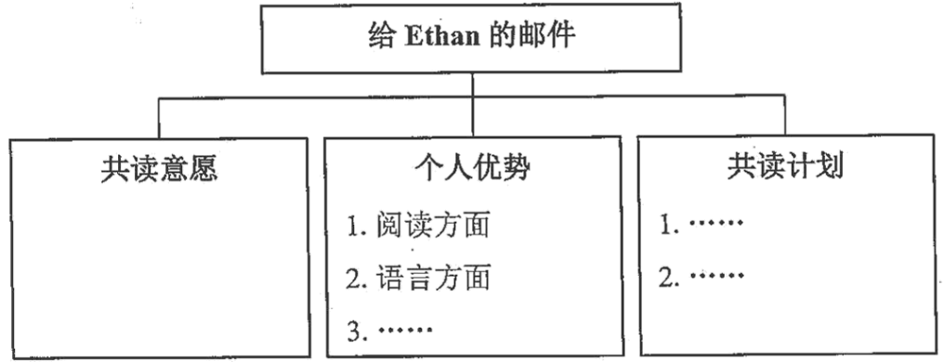
注意：
（1）可在思维导图内容提示的基础上适当拓展信息。
（2）不能照抄原文；不得在作文中出现真实校名和考生的真实姓名。
（3）语句连贯，词数80左右。作文开头和结尾已经给出，不计入总 词数，也不必抄写在答题卡上。
Dear Ethan,
I’ve learned from the school radio program that you have difficulty in reading ancient Chinese poems and need a reading buddy.
________________________________________________________________________________________________________________________________________________________________________________________________________________________________________________________________________________________________________________________________________________________________________________________________________________________________________________________________________________________________________________________________________________________________________________________________________________________________________________________________________________________________________________________________________________________________________________________________________________________________________________________________________________________________________________________________________________________________________________________________________________________________________
Looking forward to your reply.
Best wishes,
Li Ming

