江苏省南通市2024年中考英语试卷
（考试时间:120分钟满分:120分）
第Ⅰ卷（选择题共60分）
一、单项选择（本题共15小题:每小题1分,满分15分）
从 A、B、C、D四个选项中, 选出可以填入空白处的最佳选项。
1. The body language on the right means “________” in China. 
A. advice B. attention C. praise D. practice
2. Jack is crazy about sports. He ________ takes part in the school sports meeting.
A. never B. seldom C. sometimes D. always
3. Our monitor Sally never shows off, so we all think she is ________.
A. active B. modest C. polite D. energetic
4. ________ more about rare wild animals, I spent some time searching online last night.
A. To learn B. Learning C. Learned D. Learn
5. We call the Earth “Blue ________” because the ocean covers about 71 percent of it.
A. Sky B. Water C. Planet D. Mountain
6. We did not know they were in trouble at that time. ________, we would give them a hand.
A. However B. Otherwise C. In fact D. For example
7. —Must I use pink to paint my bedroom?
—No, you ________. You can use any colour you like,
A. can’t B. mustn’t C. shouldn’t D. needn’t
8. Which can be put in ▲ to show the rhyme of the poem in the picture?
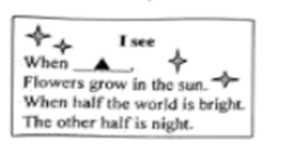
A. bees dance one by one B. birds fly in a line
C. the cloud is still alone D. the weather is so fine
9. —I don’t know what to write about the four great classical Chinese novels.
—You’d better read ________ first and then organize your own ideas.
A. reviews B. reasons C. results D. rewards
10. —I really like yesterday’s dragon boat race. What about you?
—Me too. It’s ________ one I have ever seen.
A. a more boring B. a more wonderful
C. the most boring D. the most wonderful
11. —It’s a pity! A music fan like you didn’t go to Nantong Music Festival.
—I knew it ________ several weeks ago. But I was on business.
A. is held B. will be held C. was held D. held
12. —“________.”
—That’s true, Let’s eat more healthy food.
A. Many hands make light work B. The early bird catches the worm
C. Put all your eggs in one basket D. An apple a day keeps the doctor away
13. —Mrs Lin. I’m new here. Could you please tell me ________?
—Sure. It has a long history and looks attractive.
A. what Nantong Museum is like B. how far the Haohe River is
C. how I can get to Binjiang Park D. what I can see in the Wolf Hill
14. —Can you give me some advice? I want to buy some local food for my friends.
—________. Maybe Nantong Cuibing is a nice try.
A. That’s all right B. With pleasure
C. It doesn’t matter D. I’m afraid not
15. Which map is correct according to the following dialogue?
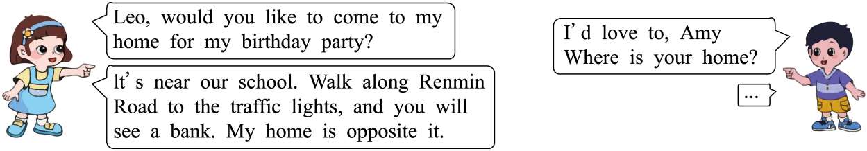
A. 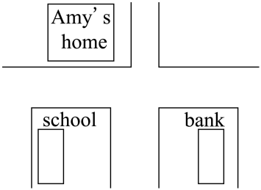 B. 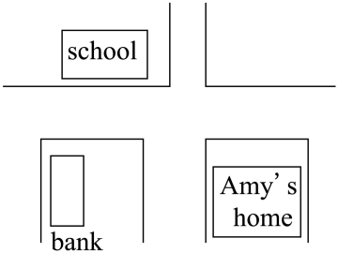
C. 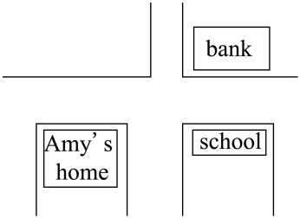 D. 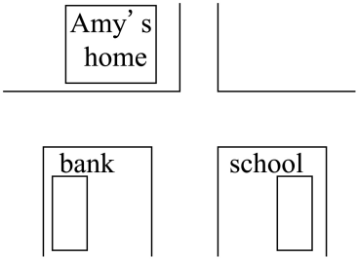
二、完形填空（本题共15小题; 每小题1分, 满分15分）
请认真阅读下面短文, 从短文后各题所给的A、B、C、D四个选项中, 选出最佳选项。
Luke lived with his grandma during the last summer holidays. He was curious about everything in her grandma’s house. One ____16____ he stole into the store room where his grandma kept her valuable collections. He knew she did not like anyone to touch her treasures, ____17____ her cup for skating. Luke walked around on tiptoe and felt the treasures one after another with excitement. He found the cup wasn’t there. “Where is it?” he thought to himself. He raised his head and found it! ____18____ it was on the top of a shelf, he wanted to feel the cup again.
With the help of a ladder, Luke reached the cup. It was much heavier than it seemed. Luke ____19____ the cup and tried to get it down. While climbing down, Luke’s elbow struck against the ladder. He lost his ____20____ and fell down to the ground heavily. The ____21____ cup slipped out of his hands and broke into two halves.
Luke was too nervous to feel the ____22____ . He stood up quickly and felt heartbroken. He picked up the broken pieces with his shaking hands, put them back to the ____23____ and left the store room quickly. Grandma was watching TV in the living room. Luke went into his bedroom quietly so that his grandma wouldn’t ____24____ him.
That night was so _____25_____ . He tossed and turned in bed. He couldn’t fall asleep till midnight. He woke up and looked at the clock many times. Time seemed to go much slower. Early in the morning, Luke knocked on grandma’s door with _____26_____.
Grandma hugged Luke thoughtfully and said, “That cup was _____27_____ to me when I was only ten years old, I won the first prize in my _____28_____ competition.” Luke followed grandma to the store room. “I’m really sorry, grandma.” Luke said _____29_____. With a smile, grandma took down the broken glass cup and used glue to stick the broken pieces together. The cup was repaired miraculously!
She continued, “When I was young, I once messed my uncle’s priceless painting. I was not as _____30_____ as you. I didn’t tell the truth at first. It made me feel upset day and night. After a week’s struggle, I admitted my fault to my uncle. That was the most unforgettable moment. I think it is honesty that matters more than mistakes.”
16. A. noon B. night C. morning D. afternoon
17. A. probably B. totally C. simply D. especially
18. A. Unless B. Since C. Though D. Before
19. A. hung B. chose C. lifted D. designed
20. A. purpose B. balance C. interest D. confidence
21. A. gold B. plastic C. wood D. glass
22. A. pain B. stress C. action D. sickness
23. A. bench B. table C. shelf D. ground
24. A. notice B. excuse C. mind D. understand
25. A. dark B. quiet C. cold D. long
26. A. joy B. courage C. trust D. wisdom
27. A. brought B. passed C. donated D. presented
28. A. painting B. skating C. first D. last
29. A. sadly B. rudely C. noisily D. angrily
30. A. brave B. careful C. friendly D. generous
三、阅读理解（本题共15小题; 每小题2分, 满分30分）
请认真阅读下列短文, 从短文后各题所给的A、B、C、D四个选项中, 选出最佳选项。
A
NOTICES
Computer problems?
An IT engineer will solve problems with computers for free every Monday. Phone “the Computer Doctor” now on 09651 378156.
Sherry, 3 years old, male  Lost in Sunshine Central Park  on Saturday 15th June  $500 for safe return  09651 371822   | Do you enjoy making things?  Come and join us!  Make a hat this Sunday (June 23)!  Time: 2:00-4:00 p.m.  Place: Room 205 Flat A  Price for materials: $2 a hat  SUNSHINE DIY CLUB
ROBOT RESTAURANT
Opens on 29 June
Lunch served: 12:30-2:30 p.m.
Dinner served: 6:30-9:30 p.m.
Starters: Tomato soup/French onion soup/Potato salad/Chicken salad 3$
Snacks (lunchtime only): Cookie/Tomato sandwich 3$
Main courses: German sausage and chips/Italian cheese/Thai chicken and rice 6$
Drinks: Mineral water/Fresh orange juice/English tea/Irish cream coffee 1$
SUNSHINE COMMUNITY CENTER
June 17

31. You can find the noticeboard in ________.
A. Sunshine DIY Club B. a community centre
C. Sunshine Central Park D. a computer company
32. If Jack has 10$ for dinner in the robot restaurant he can order _________.
A. Thai chicken and rice, Tomato soup and Irish cream coffee
B. German sausage and chips, French onion soup and Cookie
C. Tomato sandwich, Italian cheese and Fresh orange juice
D. Chicken salad, Potato salad, Italian cheese and English tea
33. From the noticeboard above we know that _________.
A. the owner spent 500 $ buying Sherry on Saturday
B. a robot cooks some dishes in the robot restaurant
C. a broken computer can be fixed for free on June 24
D. 2$ should be paid to make two hats in the DIY club
B
Some people think creativity is making something completely new, so they do not think of themselves as creative ones. However, some other people think creativity can just be expressing themselves through everyday acts and they are born creative because it is not an all-or-nothing quality or skill.
Whether or not we realize it, we all have the ability to express creativity. Sometimes the path to creative productivity is being willing to do something different.
Are you someone who loves to read comics? Perhaps it is time you create one of your own. Don’t worry if you cannot draw very well or feel that you cannot write humorous reports for characters. Nobody says this is an exam! You only have to please yourself, to gain the satisfaction that you try something new, all on your own. If you feel easy, you can of course share it with our loved ones, or post it on social media,
Are you someone who likes to express yourself in writing? Try writing a blog. This is like the new version of a diary. In your blog, you can write about your thoughts, opinions and experiences. You can also write stories or plays, if you feel up to it! The blog provides you with a platform to create something new every day, in written forms.
Are you someone who likes to be alone? Now, think about the things that make you happy. Find a small place in your room, or any place in your home, where you can spend time with yourself. It can be a small corner next to your bed or a wall. It can be a poster of your favourite rock star or photos of your friends. You can also pick a guitar if you like to play instruments, or a few storybooks if you love reading. Some of you may like flowers, candles or pretty things. Decorate your area with your favourite things in any way you like. That is creativity! And if you do feel bored with this, you can change, add or remove something.
By realizing the chances in our daily lives to inspire our creativity, no matter how small, we may become more comfortable with taking bigger creative leaps in other aspects of our lives.
34. How does the writer begin the article?
A. By asking questions. B. By giving examples.
C. By comparing opinions. D. By explaining reasons.
35. From Paragraph 3 to Paragraph 5, what does the writer suggest?
A. Trying something new. B. Avoiding something dangerous
C. Trying something difficult. D. Avoiding something expensive.
36. In what ways can we show our creativity according to the article?
① playing the piano ② receiving flowers ③ keeping calm
④ writing blogs ⑤ watching plays ⑥ decorating rooms
A. ②③⑥ B. ①③⑤ C. ①④⑥ D. ②④⑤
37. The purpose of the article is to________.
A. offer us all kinds of ideas and experiences
B. teach us knowledge of different life skills
C. encourage us to make something important
D. ask us to develop creativity through small acts
C
My friend Julie and I are keen on creating a beautiful green town.
Gardening Course
Every September, our city has a special festival. Crowds of happy people go to the park, waving ribbons in their hands. That’s because the gardening competition takes place there.
For Julie and me, it was a pity that we couldn’t take part in the competition, for that was also the first day of our high school. We buried ourselves in choosing courses. We wanted to learn all about plants, gardening and farming. Finally, a course called Agriculture and Wildlife came into our sight. We thought it would help us succeed as gardeners.
Project presentation
After a year’s study, Julie advised me to give a presentation. There was a small plastic model of my idea on the table. On the other side of the table, my teachers were waiting to see my project—the green farm.
“Good morning!” I said “During my studies I’ve learned a lot about city farming. Now. I want to do something with what I’ve learned.”
I showed them the model. “This is the high street of our town. This is an old, nine-floor car park. No one has used it for the last two years and it’s now for sale.”
I continued the presentation. They could see my designs on the big screen when I talked.
“I’ve designed a city farm using the car park building. There will be eight floors to farm fruit and vegetables. This design can help us collect rainwater to wet the soil. And we can also use energy from the sun to power the special growing lights. “
“I will hire the space out to local people and they will sell everything good enough for the environment in local shops. Also, the ninth floor will be for those who want to grow their own plants.”
My audience looked interested and my project got the highest marks in my class. But in the real world. it couldn’t happen because the car park was not available.
▲
Later, Julie helped me search the town for the perfect place for gardening, not in front of the Town Hall or the shopping centre. We tried to look for something different. Somewhere that was not the best neighbourhood, but a poor one. One where the road was full of holes and the pavement (人行道) was all broken. At last, we made it.
In the neighbourbood, we posted letters through people’s doors with gardening instructions. More and more people cared about that and began to plant vegetable gardens.
Then in the same neighbourhood, we put grass over those broken old pavements for the kids to play on. Finally, we put up a sign that said, “Have fun here.”
When we finished, we were both covered in soil and completely exhausted. But Julie put an arm around my shoulders and smiled. “Not bad!” she said. “We can do more to make our town greener!”.
38. The writer mentioned the gardening competition to ________.
A. change her gardening projects B. express her interest in gardening
C. discuss ways to get good prizes D. tell stories of gardening courses
39. Which is the most suitable for ▲ ?
A Grass Spaces B. Farming Instructions
C. Vegetable Gardens D. Gardening Experiences
40. Which of the following is the correct order of the story?
a. Julie helped find a perfect place for gardening.
b. The writer explained the green farm project.
c. Julie and the writer posted letters to neighbours.
d. Julie and the writer were busy choosing the courses.
e. Old pavements were covered with grass for kids to play on.
A. d-b-a-c-e B. d-a-b-e-c C. a-b-c-e-d D. a-d-b-c-e
41. According to the underlined sentence, Julie and the writer may ________.
A. hire out their green farms for parking and camping
B. find more open spaces to plant grass and vegetables
C. sell their grass and vegetables to the neighbourhood
D. put up more signs to ask kids to have fun on the grass
D
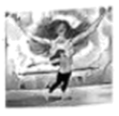
Linda is looking through the website http://www.keepingfit.com. Here is what she reads.
Researchers have found the health benefits of dancing for people in poor health condition, from improving brain health to creating community.
Becky is teaching a group of 80 adults some dancing skills. Many of her students are seated in the dancing room because they have difficulty in moving. When they are following Becky’s pretty movements, a sense of peace comes over them.
Dance as a medicine
Helen, a researcher, says that dance requires different parts of the brain to work at the same time, that is to say, dance requires more “brain power” than simpler repetitive (重复的) exercises.
She invited two groups of adults to take part in programmes for over six months. One group practised dancing and the other did a traditional exercise like cycling. Both groups improved their level of physical fitness, but the group of dancers improved more cognitive abilities, such as memory, attention and high-level thinking.
Dance described by Helen as “pleasure double-play” can lift the mood and reduce stress.
Dance as body acceptance
Besides the physical and mental benefits, dance can also help people with diseases accept what their bodies can and can’t do.
Jenny is Becky’s student. Her body went numb when she was in her mid-twenties. She had no feelings from the knees down. She suffered from serious muscle tightness and balance problems, making standing and walking difficult for her.
Jenny recently joined an online dance programme. Not only has it improved her coordination (协调性). but it has enabled her to overcome her fear of being judged (评价) for how she moves, both in the dance class and out in the world.
“I see so many people moving like me,” she says “I don’t have to be perfect in my dancing or make sure my leg lifts this way—it makes me comfortable with where I am right now.”
Dance as community
Perhaps one of the biggest benefits of dance is the sense of community it creates. Dancing with others not only makes people feel less different in their moving abilities, but also helps to fight against loneliness and problems in getting along with others.
Becky started teaching more than 22 years ago, and she has helped 300 communities in 28 countries around the world. In some countries, such as India and South Kores, people have put their own cultural dance styles into their classes.
Becky wants to create a sense of family and community for this group of people. Whenever and wherever she teaches, she hopes to make them feel joyful, get much closer to the community, and explore the limitless possibilities for the rest of their lives.
42. In which part of the website may you find this passage?
A. Culture. B. Fashion. C. Health. D. Literature,
43. From “Dance as a medicine” part, we can learn that ________.
A. the act of dancing helps to improve “brain power”
B. the act of traditional exercise requires more attention
C. dance needs more high-level thinking to lift the mood
D. dance needs more repetitive exercises than “brain power”
44. How do you understand the underlined part of this passage?
A. Jenny feels sad because she is weak in dancing.
B. Jenny wants to be perfect after practising dancing.
C. Jenny accepts the disabilities of her body after dancing.
D. Jenny thinks she should treat her leg for better dancing.
45 What’s the best title for this passage?
A. Dancing helps to cure illness B. Dancing helps to better yourself
C. Dancing helps to change moods D. Dancing helps to reduce loneliness
第Ⅱ卷（非选择题 共60分）
四、词汇（本题共15小题; 每小题1分, 满分15分）
A. 请根据括号中的中文提示、英文释义或句意, 写出句中所缺单词, 使句子通顺.
46. They ________ (借) all kinds of magazines from the library every Tuesday.
47. Choosing your future job is an important ________ (决定) in your life.
48. A trip or a sports game will help you ________ (rest after work) after your exams.
49. Tan Dun is considered as a ________ (well-known) composer for his works.
50. Try to hide ________ a strong table or in a corner of the room to protect yourself in an earthquake.
请根据句意从方框中选择合适的单词，并用其适当形式填空，使句子通顺。
two certain discuss snow I

51. —I left my dictionary at home.
—You can use ________. Here you are.
52. —Why did you recommend him to be our guide?
—He has been there ________. He knows there very well.
53. —What’s your volunteer project?
—After several ________, our group has reached agreement to interview WWF officer.
54. —Why are you worrying about eating with French students?
—I’m ________ about French table manners.
55. —Dad, the weather report says it will be a ________ day tomorrow.
—Good news. You can make a snowman with Tony.
请根据句意从方框中选择合适的动词，并用其适当时态填空，使句子通顺。
call carry rise mark shape

56. —Look! The sun ________.
—Everything is clear for us to go birdwatching.
57. —I’m afraid I may forget the charity walk next week.
—Take it easy. Mr Wu ________ you a day earlier before it.
58. —You were not in the classroom during the break time.
—I ________ books to the reading room with Judy.
59. —It’s hard for me to achieve my dream.
—Don’t give up. Everyone ________ his life and future through hard work.
60. —How much do you know about the invention of protecting ears?
—It ________ the beginning of Chester’s career in 1873.
五、短文填空（本题共 10 小题; 每小题 1 分, 满分 10分）
请认真阅读下面短文，并根据各题所给首字母的提示，写出一个合适的英语单词完整的、正确的形式，使短文通顺。
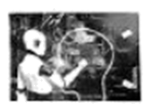
The world is changing very fast. Scientific technologies are now influencing a____61____ every field of life. A scientist once said that success in developing scientific technologies would be one of the biggest events in human history, but he thought some of them might also be the last unless we learn to avoid the risks. For m____62____ society, scientific technologies are amazing but humans may face a lot of challenges.
Will humans be controlled by scientific technologies in the future? Some people say “Yes”. They think humans will be under control completely. I____63____ computers are implanted (植入) inside brains, things will be much worse. With the d____64____ of technologies, robots have taken the place of humans in some fields and it may make some people l____65____ their jobs. What’s more, data centres need a large amount of energy to run. At the same time, it produces so much h____66____ all the time that a great deal of water is used for cooling. All these may be the risks the scientist referred to.
However, other people don’t a____67____ . They are hopeful about the relationship between scientific technologies and humans. They say that scientific technologies have done much for us and made our daily lives much easier. They can free people from doing housework, writing articles or e____68____ making films. For example, some technologies can change words into short videos easily and make it p____69____ for some common people to be directors.
Every coin has two sides. Rather than worrying about the risks of scientific technologies, we should learn to use them in a w____70____ way and manage them well.
六、阅读与回答问题（本题共 5 小题; 每小题 2分, 满分10分）
请认真阅读下面短文，并根据短文内容回答问题。
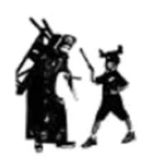
Peking Opera, also called Jingju, listed by UNESCO as an intangible cultural heritage of humanity, is the most important one among hundreds of forms of local operas in China. It arose in the late 18th century and has a history of more than two hundred years.
Peking Opera which combines singing, dancing, acrobatics and martial arts is sung and recited using Beijing dialect. The music of Peking Opera plays a key role in setting the pace of the show, creating a particular atmosphere, shaping the characters, and guiding the progress of the stories,
The art form has spread to many other countries and is enjoyed all around the world. Many children in China receive training in Peking Opera classes or practise Peking Opera. However, some artists still worry that Peking Opera is challenged by new forms of entertainment like many traditional art forms. They are trying to do something for Peking Opera.
Tao Qingmei, a traditional arts scholar at the Chinese Academy of Social Sciences, co-wrote the book The Marvelous Game with Guo Baochang. Guo, a film director, is a Peking Opera fan who has loved Jingju since he was a kid. It has been his long time wish to write a book on Peking Opera.
The boy on the new book cover is Guo Baochang’s grandson. Guo and his grandson are playing a game by dressing up in roles from the classic Peking Opera piece, Shuang Bei Deng, which is a comedy. Tao and Guo spent years writing the book because they wanted to make it easy and fun for everyone. They hope young people will get to know more about Peking Opera and fall in love with it.
Peking Opera is regarded as an expression of the aesthetic ideal of opera in the traditional Chinese society and remains a widely recognized element of the country’s cultural heritage. The stories performed in Peking Opera are often based on Chinese history, folklore and literary classics. They bring us a colourful world.
71. How long is the history of Peking Opera?
_______________________________________________________________________
72. Who wrote the book The Marvelous Game?
_______________________________________________________________________
73. Which Peking Opera piece is on the cover of the book?
_______________________________________________________________________
74. What problem is Peking Opera facing?
_______________________________________________________________________
75. What do you plan to do for traditional arts after reading this article? (请自拟一句话作答)
_______________________________________________________________________
七、书面表达（本题满分25分）
76. 假如你是李华，将参加学校英语社团举行的主题为“A Friendly Smile”的交流分享活动，谈谈班级里与微笑有关的故事，请根据下面海报中的提示，写一篇交流稿。
A Friendly Smile
Tips for your sharing
·choose anything that happened in your class
·describe the story
·express your feelings
Please join us and share your story at 8:00 a. m. next Tuesday (June 25) at the Students’ Centre.
School English Club
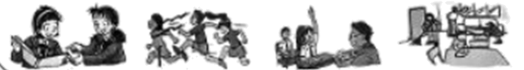
注意：1. 词数 90左右，交流稿开头和结尾已给出，不计入总词数。
2. 交流稿中请勿提及真实校名及姓名。
Hello everyone! I’m Li Hua from Class 1. Grade 9. Today I like to share a story that happened in my class. ________________________________________________________________________________________________________________________________________________________________________________________________________________________________________________________________________________________________________________________________________________________________________________________________________________________________________________________________________________________________________________________________________________________________________________________________________________________________________________________________________________________________________________________________________________________________________________________________
Do you often smile? Thank you!

