徐州市2024年初中学业水平考试
（考试时间：100分钟 满分：110分）
一、选择填空（共10小题；每小题1分，满分10分）
从下列各题所给的 A、B、C、D四个选项中，选择最佳选项。
1. In the picture, the boy is ________.
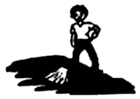
A. making the bed B. mopping the floor C. cleaning the table D. washing the dishes
2. —________ do the notebooks cost?
—They are five yuan each.
A. How much B. How many C. How often D. How long
3. Finishing a meal in 20 to 30 minutes is widely considered as the ideal ________ time.
A. sporting B. shopping C. dressing D. eating
4. —Who was calling you on the phone just now?
—________ was my cousin.
A. He B. She C. It D. This
5. How amazing! Human workers pick tea fast. Those tea-picking robots work even ________.
A. fast B. faster C. fastest D. the fastest
6. If you are lazy in spring, you ________ nothing in autumn.
A. harvested B. will harvest C. are harvesting D. have harvested
7. Simon is ________. He believes he can win the first prize in the speaking competition.
A. generous B. curious C. confident D. modest
8. I am planning to ________ the new hobby in the summer holiday. I won’t spend my spare time on my mobile phone all day long.
A. pick up B. turn up C. get up D. look up
9. Look at the black clouds. They are a sure ________ of rain.
A. chance B. view C. sign D. idea
10. Fan Jinshi has ________ a large part of her life to researching and protecting the ancient Dunhuang caves. She is known to many as the “Daughter of Dunhuang”.
A. paid B. donated C. brought D. devoted
二、完形填空（共15小题；每小题1分，满分15分）
阅读短文，从短文后各题所给的A、B、C、D四个选项中，选择最佳选项。
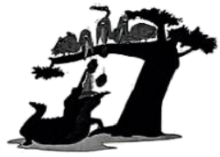
One hot day, three birds sat at the top of a tree near a river. “There’s nothing to do,” said Pink Bird. “___11___—nothing to do except sit in this big old tree,” said Black Bird. “Yes,” said White Bird. “Another ___12___ hot day.”
“Hey, birds,” said Crocodile (鳄鱼). He was listening from ___13___, floating (漂浮) on the warm water. “See those three large stones on the bank? They are about the same size. Let’s see which one of you can fly the highest while carrying one of the stones with your feet, whoever ___14___ will be the Best Flier.”
“What a great idea!” White Bird jumped out of the tree and went for the stones. The other ___15___ birds quickly followed.
“They won’t fly far with the heavy stones,” thought Crocodile. “When they fall into the ___16___, I’ll get a free lunch!”
“Ready?” shouted Crocodile. “Go!” Then he ___17___, “Or should I say lunchtime?”
The three birds lifted off ___18___ climbed high into the air.
Pink, black, and white feathers floated down from the sky.
“ ___19___ birds,” Crocodile said with a huge, toothy smile. “I can’t believe they really listened to me.” He looked up, waiting for them to fall out of the sky, but they ___20___ flying.
After a while, the three birds flew ___21___ and rested with their stones in the same tree.
“Oh, my dear! ___22___ your bodies have changed because of the big stones!” The floating Crocodile opened his mouth wide and ___23___ loud and hard, waiting for his free lunch.
“One, two, go!” The three birds let go of their big stones ___24___. All three stones dropped straight down, right into Crocodile’s huge, open, laughing mouth. The sudden ___25___ made him sink (沉) into the river. Only his eyes showed above the water.
Remember: Use our head, and we will find a way out.
11. A. Not at all B. With pleasure C. I don’t agree D. That’s right
12 A. exciting B. interesting C. boring D. moving
13. A. below B. above C. left D. right
14. A. fails B. wins C. drops D. rests
15. A. two B. three C. four D. five
16. A. lake B. sea C. stream D. river
17. A. explained B. complained C. whispered D. cried
18. A. and B. but C. so D. or
19. A. Careless B. Silly C. Lazy D. Rude
20. A. stopped B. avoided C. practised D. kept
21. A. away B. back C. high D. around
22. A. Which B. Why C. What D. How
23. A. laughed B. sang C. tasted D. breathed
24. A. all the time B. for the first time C. at the same time D. at times
25. A. noise B. wind C. weight D. laugh
三、阅读理解（共20小题；每小题2分，满分40分）
A）阅读下面四篇短文，从短文后各题所给的 A、B、C、D四个选项中，选择最佳选项。
A
Say “please”.  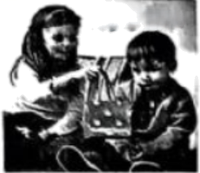 | Remember the magic words. Start with “please”, then say “thank you”. | Say “thank you”. 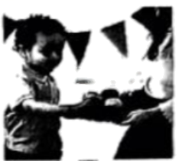
And don’t forget “excuse me”—It’s bad manners if we do. | Can I have a toy? What’s the magic word?  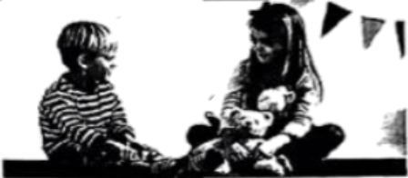
Say “excuse me”.  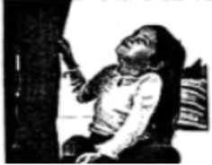 | Last we come to “sorry”. This can be so hard to say. | Say “sorry”.  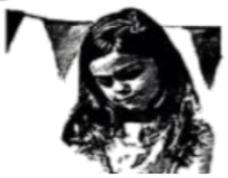

26. According to me pictures, which magic expression may be difficult for people to use?
A. Please. B. Thank you. C. Excuse me. D. Sorry.
27. What do the pictures try to teach kids?
A. Safety tips. B. Traffic rules. C. Good manners. D. Public signs.
B
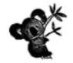
In March 2006, burglars broke into a zoo in Queensland, Australia. They planned to steal a koala. Everybody loves koalas, right? With their big round eyes, flat noses, thick fur coat and hairy ears, these cute animals have become a popular symbol of Australia. However, appearances can be tricky. The koala at the zoo was very fierce. Soon the burglars had deep scratches (抓痕) from the koala’s sharp claws (爪), so they decided to steal something easier. They stole a crocodile instead!
Koalas are interesting animals. A koala mother carries her baby, called a joey, in a warm pouch, or pocket, on her stomach. Koalas eat only the oily leaves of eucalyptus trees (桉树). These leaves are harmful to many other animals, but koalas eat about two and a half pounds (just over one kilo) every night. There is enough water in these leaves, so koalas do not drink very much. In fact, in one local Australian language the word koala means “no drink”.
28. What did the burglars steal in the end?
A. A koala. B. A crocodile. C. A joey. D. A tree.
29. What will “fierce” animals probably do?
A. They show politeness. B. They always feel hungry.
C. They sleep all day long. D. They get ready to attack.
30. From the passage we know about koalas EXCEPT ________.
A. what they look like B. when they have babies
C. what they live on D. why they seldom drink
31. What’s the best title for the passage?
A. Koalas Fight Back! B. Koalas Start to Change!
C Koalas Beat Crocodiles! D. Koalas Prefer Oily Leaves!
C
The police have many ways of catching criminals. One way of catching them is by fingerprinting. Fingerprinting is the study of the patterns on our fingertips. We have known that no two fingerprints are exactly the same for hundreds of years. However, it wasn’t until 1910 that the first criminal in the USA was convicted (被判有罪) using fingerprint evidence.
Early on the morning of September 19, 1910, Hiller’s wife noticed that the light which they usually left on was off. When Hiller went to find out what was happening, he saw a stranger at the top of the stairs. The stranger had broken in and wanted to steal. Hiller and the stranger started to fight, but the stranger had a gun. He shot Hiller twice and ran away.
Hiller’s wife ran to Hiller when she heard the gunshots but found him dead. So she called the police. Soon after, the police caught Thomas Jennings, not far from the Hillers’ house.
The only problem was no one saw the criminal. However, the police had started using fingerprinting at that time. According to Hiller’s wife, only several hours before Hiller’s death, he had painted some wood near the kitchen window. Then the police checked the wood completely and found some fingerprints in the wet paint.
During the trial (审判), the police proved that the fingerprints belonged to Jennings, and he was convicted of Hiller’s murder. Since then, fingerprinting has helped in the conviction of hundreds of thousands of criminals.
32. What helped the police convict the murderer of Hiller?
A. 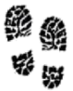 B.  C.  D. 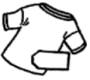
33. Which paragraph shows how Hiller was killed?
A. Paragraph 1. B. Paragraph 2. C. Paragraph 3. D. Paragraph 4.
34. What is the right order of the case?
①The stranger shot Hiller twice and ran away.
②Jennings was convicted of Hiller’s murder.
③Hiller saw a stranger at the top of the stairs.
④Hiller painted some wood near the kitchen window.
⑤The police found Jennings’ fingerprints in the wet paint.
⑥The police caught Jennings, not far from the Hillers’ house.
A. ③→④→①→⑤→⑥→② B. ③→④→⑤→①→②→⑥
C. ④→③→①→⑤→②→⑥ D. ④→③→①→⑥→⑤→②
35. How does the writer end the passage?
A. By drawing a conclusion. B. By providing a surprise ending,
C. By leading in a question. D. By showing an endless discussion.
D
After the haircut
It’s getting hot. You go to have your hair cut. The barber Tony cuts off part of your hair and sweeps it away, but your hair’s journey is not over after the haircut.
Have you ever thought of planting your old hair after it’s cut off? Some farmers do! What comes up? Not wigs (假发), but bigger and tastier crops. Hair is full of nitrogen (氮) that helps plants to grow. When cut hair is mixed into soil, the hair breaks down, slowly letting out nitrogen so it can help flowers and vegetables got big a little faster.
If you’ve got a wool sweater on, you’re wearing a sheep’s haircut. Sheep grow fine curly (弯曲的) fur called wool. All those curls make air pockets that trap heat, keeping the sheep warm. Farmers shear the sheep in summer, so the sheep don’t feel too hot. And we use the hair to make warm clothes, socks, and hats. Wool can even take in rain without feeling wet. Wool also doesn’t catch fire easily.
What does your hair say about you? Even many years after it has been cut, hair can tell surprising secrets. Because hair is made from bits of old cells, it has trace (微量) of chemicals (化学物质) that were in the body when the hair grew. When people are kept in the situation of dangerous chemicals, these traces remain in the hair, even long after they have disappeared from the body itself. Testing hair can help doctors know if there are dangerous chemicals in the food and water. Hair can tell another important secret—whose hair is it? This can be used to help solve crimes.
Hair does so many things for us. It keeps us warm and cool, helps farmers, shows mysteries, and provides endless styling fun. One thing is for sure, it’s not just for wigs any more.
36. In which part of a magazine can we probably read this passage?
A. History. B. Fashion. C. Science. D. Health.
37. How does hair help plants to grow?
A. It provides nitrogen. B. It breaks down soil. C. It takes in rainwater. D. It lets out a smell.
38. What does the underlined part “shear the sheep” mean?
A. Give enough food to the sheep. B. Wash the sheep many times.
C. Find living place for the sheep. D. Cut the wool off the sheep.
39 What’s the main idea of Paragraph 4?
A. Hair helps keep warm. B. Hair testing is important.
C. Hair can tell secrets. D. Hair helps solve crimes.
40. How is the passage organized? （P: Paragraph）
A. 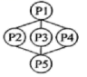 B. 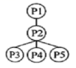 C. 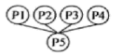 D. 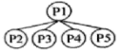
B）阅读短文，从短文后A至F六个选项中选出五个可以填入空白处的最佳选项。
Feeding pandas can cause big problems
The other day two tourists in China were banned (禁止) from visiting giant pandas all their lives. ___41___ Over the past four months, a total of 19 people have been banned from Chengdu Research Base of Giant Panda Breeding for similar reasons. ___42___
Food from tourists may make pandas sick. Giant pandas eat about 20 kilos of bamboo and bamboo shoots a day. To make sure that the pandas’ diet is healthy, their food sources (来源) are watched. ___43___ Even common foods like carrots can carry bacteria (细菌). Humans also carry bacteria, and they can put pandas’ health at risk.
___44___ Tourists’ behaviours may mess up their habits and even scare them. Imagine being in the middle of a meal and people start shouting or throwing things at you. In these cases, some pandas may feel scared. ___45___ It’s important to keep in mind that these animals need special care with their food and their living environment.
A. Bamboo is giant pandas’ favourite food.
B. So why shouldn’t tourists feed pandas?
C. It is because they fed bamboo to pandas.
D. The food provided to pandas is also strictly checked.
E. Then they become angry and even hurt the zookeepers.
F. Giant pandas spend about 10 to 16 hours of their days eating.
四、 词语运用（共15小题；每小题1分，满分15分）
A）
选用方框内的单词或词组填空，其中有一个单词或词组是多余选项。
height smiles age behind the elderly satisfied

46. Mary is sweet. She ________ often and never says a bad word about anyone.
47. I’m sorry to hear that you are not ________ with our product.
48. My sister is two years younger than me, but we are of the same ________ now.
49. Double Ninth Festival is a traditional Chinese festival for ________.
50. Math is ________ all of modern technology—from phones and cameras to planes and AI.
B）
阅读短文，在文中空白处填入1个适当的单词，或用括号内所给单词的正确形式填空。
Grandfather’s gift
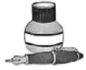
When my grandfather was a boy, he liked writing with a fountain pen. His first short story ___51___ (write) with a silver fountain pen. It was a gift from his mother for his ___52___ (ten) birthday. His name is still on the pen. In an old photo, my grandfather is dressed ___53___ a school uniform. You can see the pen through the front pocket of his shirt. It seems ___54___ he was always with his pen. No one was surprised when Grandfather ___55___ (become) a writer. So far, he ___56___ (finish) over sixty story books. People all over ___57___ world enjoy his stories, including me.
Last month, my parents and I visited Grandfather. It was an exciting time for us. Grandfather showed me his writing desk. On the last day of our visit, my grandfather asked me ___58___ (close) my eyes. Gently and ___59___ (care), he put his pen in my hands. Tears filled my eyes. At that moment I decided to be a writer, too.
I will never forget the connection I felt with my grandfather that day. It is one of the most important ___60___ (memory) of my life.
五、阅读与表达（共5小题。每小题2分，满分10分）
阅读短文，回答短文后的五个问题。
Skipping to victory
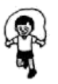
Zhou Qi is a 17-year-old student from Hangzhou. Zhejiang. Last September he broke the Guinness (吉尼斯) World Record for the most single skips in one minute, with a result of 374. The record had stood unbroken for ten years. Daisuke Mimura from Japan held it with 348 skips in 2013.
Interestingly, Zhou’s new record is not even his personal best. “My best performance was 396 times in one minute. That was done in the 2nd Primary and Secondary School Students’ Rope Skipping Championship in 2020. My coach said I had already broken the world record. It was at that time that I made up my mind to apply for the Guinness World Record,” Zhou said.
However, the road to success was far from smooth. For years, Zhou practised with a special steel rope designed for competítion. It’s light and strong. But because of the rope he used, his first Guinness application was considered invalid (无效). After online communication with the records management team, Zhou quickly changed to a common rope recognized (认证) by the Guinness World Records. He soon got used to it.
Whatever kind of rope Zhou used, his strict training stood him in good sporting condition. Zhou has been in the school rope skipping team for seven years. He has jumped rope for about four hours each day. He would also run around the playground to improve his physical strength.
Now a high school student, Zhou said he’ll put his studies first. But he won’t stop training and still hopes to beat his own record one day.
注：每题答案不超过6个词。
61. When did Zhou Qi break the Guinness World Record for the most single skips?
_________________________________________________________
62. What is Zhou Qi’s Guinness World Record for the most single skips?
_________________________________________________________
63. Why was Zhou Qi’s first Guinness application considered invalid?
_________________________________________________________
64. Which English saying will you use to describe Zhou Qi according to Paragraph 4?
_________________________________________________________
65. What is Zhou Qi’s dream?
_________________________________________________________
六、书面表达（满分20分）
66. 假定你是徐州的一名九年级学生李华。你校英文报正组织题为“A famous person in the history of Xuzhou”的征文活动，你选择的人物是苏轼（1077—1079年间任徐州知州）。请结合以下要点写一篇英语短文，参加征文活动。
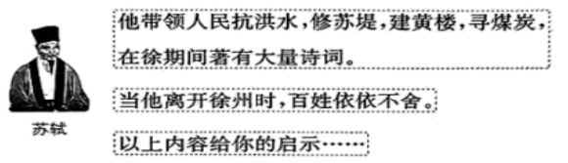
注意：
1. 征文需包括以上三个要点；
2. 词数90左右；
3. 征文中不得泄露个人信息。
提示词:苏堤 Su Causeway 黄楼 Huanglou Pavilion
________________________________________________________________________________________________________________________________________________________________________________________________________________________________________________________________________________________________________________________________________________________________________________________________________________________________________________________________________________________________________________________________________________________________________________________________________________________________________________________________________________________________________________________________________________________________________________________

