机密★启用前
2024年湖北省初中学业水平考试
英语
本试卷共12页，满分120分，考试用时130分钟。
注意事项：
1．答卷前、考生务必将自己的姓名、准考证号填写在试卷和答题卡上，并将准考证号条形码粘贴在答题卡上指定位置。
2．选择题的作答：每小题选出答案后，用2B铅笔把答题卡上对应题目的答案标号涂黑。写在试卷、草稿纸和答题卡上的非答题区域均无效。
3．非选择题的作答：用黑色签字笔直接答在答题卡上对应的答题区域内，写在试卷、草稿纸和答题卡上的非答题区域均无效。
4．考试结束后，请将试卷和答题卡一并交回。
笔试部分（90分）
一、完形填空（共15小题，每小题1分，满分15分）
阅读短文，从每小题所给的四个选项中，选出最佳选项，填入空白处。
Our art teacher George was leaving soon for his country. I was preparing a special 1 for him. It was a hand-draw n picture book about our school. I worked a long time, trying to make each picture as 2 as possible.
One day, I was drawing while my little sister Becky was watching with great 3 . Just then, my classmate Jeff dropped by.
“Hi! Peter, want to play basketball in the yard?” he asked.
“I’d like to, 4 it’s too cold outside!” I replied.
“Exactly!” he said. “It’s the perfect weather for not getting too hot.”
That’s a cool thing about Jeff. He always looks on the 5 side of almost everything.
“Let’s go!” We went out, leaving the drawings on the table.
We laughed as we returned. When I 6 the door, my heart nearly stopped. Right there, Becky was coloring my pictures.
“ 7 , Becky!” I rushed to her, but it was too late. Almost every page was colored.
“What did you do?” I shouted 8 .
“I just wanted to help.” She began to cry.
“My drawings are gone forever!” I felt frustrated (懊恼的) and 9 Jeff for help.
“Unless…” said Jeff.
“Unless what?” I asked.
“Remember the jigsaw puzzle (拼图)? We can create something new from these messy pictures.” Jeff 10 .
“Can we make it?” I doubted.
“I’m not sure, but we can have a 11 .” He encouraged.
First, we cut the drawings into shapes, such as our brown teaching buildings, green playground and so on. Then, we 12 all these pieces together and made a jigsaw. Finally, we even added more paints. Days later, a beautiful “ 13 ” appeared in front of us.
There was a 14 ending.
“Thanks, guys,” George smiled, “I love it so much. It will give me many great 15 here.”
So, you see, there lies a beam (束) of light behind every dark cloud. Jeff’s way of dealing with things did help.
1．A．gift B．photo C．letter D．lesson
2．A．easy B．large C．perfect D．famous
3．A．hope B．pride C．interest D．courage
4．A．or B．so C．and D．but
5．A．sad B．bright C．serious D．strange
6．A．opened B．fixed C．cleaned D．painted
7．A．Run B．Come C．Jump D．Stop
8．A．bravely B．angrily C．carefully D．nervously
9．A．gave up B．looked at C．turned down D．agreed with
10．A．warned B．ordered C．reported D．suggested
11．A．try B．talk C．rest D．taste
12．A．put B．hid C．read D．threw
13．A．tree B．gate C．school D．library
14．A．boring B．happy C．terrible D．common
15．A．choices B．changes C．decisions D．memories
二、阅读理解（共20小题，每小题2分，满分40分）
第一节（共15小题，每小题2分，满分30分）
阅读以下三篇短文，从每小题所给的四个选项中，选出一个与短文内容相符的最佳选项。
A
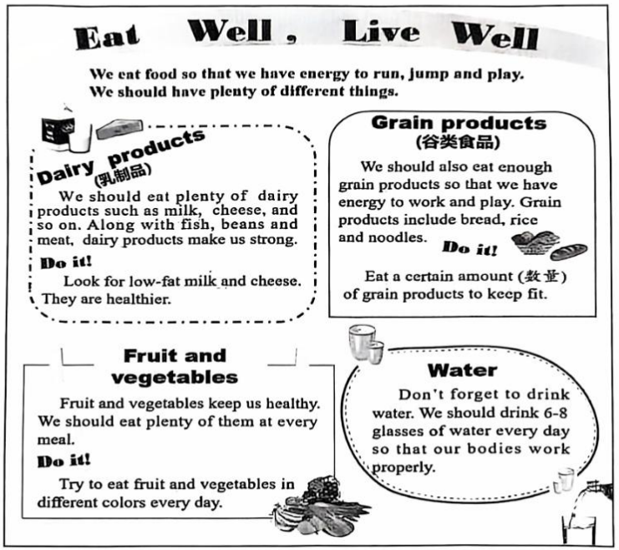
16．Which of the following is a kind of dairy products?
A．Fish. B．Beans. C．Milk. D．Noodles.
17．How many kinds of grain products are mentioned in the passage?
A．Two. B．Three. C．Four. D．Five.
18．Which is healthier than the other three according to the passage?
A．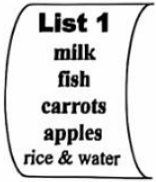 B．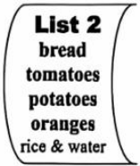 C．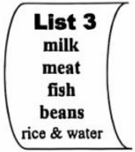 D．
19．What’s the writer’s opinion about eating well?
A．Grain products are the best of all. B．Eat plenty of food as you like every day.
C．Vegetables make our bodies work properly. D．Have different kinds of food and enough water.
20．In which part of a magazine can we probably read the passage?
A．Art. B．Sports. C．Health. D．Education.
B
The Smiths woke up earlier than usual. There was something about hiking (远足) that made them feel wide awake and excited to start the day as their eyes were open.
The family had a simple breakfast. They discussed the plan for the day at table. “Dad and I looked at a map last night,” said Mrs. Smith. “We found a nearby trail (小径). There are many interesting things along the way, and best of all, there will be a surprise at the end of the trail.”
“What kind of surprise?” asked Jenny.
“It won’t be a surprise if we tell you,” laughed her mom. “The sooner you get ready to go, the sooner you’ll find out.”
They set out for hiking soon. It was a good day for seeing wildlife. Along the trail, the trees were filled with kinds of birds flying around. Hearing a noise in the grass, they stopped and saw two rabbits crossing the trail. After a while, Mike noticed several monkeys in the trees and Mr. Smith took photos before they ran away.
Then, they continued their hiking. Jenny and Mike were discussing what kind of snake they had just seen on the way. At this moment, they came to an open area with some small pools. The kids’ eyes grew wide. They looked at their parents.
“Is this the surprise?” asked Mike in excitement.
Mr. and Mrs. Smith smiled as they walked over to one of the small pools. Steam (蒸汽) rose into the air. “They’re hot springs (温泉),” explained Mr. Smith. “The heat is produced from inside Earth.”
“Could we have a bath (洗澡) in the spring if we have our bathing suits?” asked Jenny. Mrs. Smith nodded. “Your bathing suits are in the bag.” She laughed, putting her feet into the spring water.
“I can’t believe it! Mom and Dad. This is a great surprise.” Jumped Jenny.
21．The Smiths woke up earlier because of ______.
A．the map B．the trail C．the hiking D．the breakfast
22．Which is the right order of the animals they saw on the way?
A．snakes → birds → rabbits → monkeys B．monkeys → snakes → birds → rabbits
C．rabbits → snakes → monkeys → birds D．birds → rabbits → monkeys → snakes
23．What does the underlined word “surprise” refer to (指代)?
A．An open area. B．The hot spring.
C．A nearby trail. D．The heat from inside Earth.
24．Why did the family make the plan for the day?
A．To take photos. B．To enjoy nature. C．To watch birds. D．To protect wildlife.
25．What is the best title for the passage?
A．A Natural Bath B．A Lucky Family C．A Humorous Mom D．A Beautiful Pool
C
So far, China has successfully sent a large number of satellites (卫星) and spaceships into space. Space scientists have been greatly inspired (赋予灵感) by the old stories and ancient famous people when giving them names.
Since thousands of years ago, Chinese people have dreamed of going to the moon. Chang’e Flies to the Moon is one of the most popular stories. As you can see, China’s first man-made satellite to circle around the moon was named Chang’e I. More interestingly, the moon rove r (巡视器) was named after the Jade Rabbit, who is the partner of Chang’e in the story. These old stories carry people’s best wishes and dreams. With the development of science and technology, our scientists have made them come true.
Kua Fu Runs After the Sun is another story to show how much ancient Chinese people wanted to know about the unknown world. Now, Kua Fu is going with the scientists to “visit” the sun, because we have a space project called KuaFu Mission.
Besides the ancient stories, space scientists also get ideas from ancient famous people. For example, Mozi, an ancient scientist, discovered that light travels in a straight line over 2, 000 years ago. His discovery made space study take a big step at that time. So, China’s first quantum (量子) science satellite was named Mozi, making China the first country in the world to achieve quantum communication between satellites and the ground.
From such simple things as giving names to the satellites, we can see how great our traditional culture is and what influence it has on our modern science and technology.
26．In China, space scientists get ideas from ______ when naming satellites.
①old stories ②traditional projects
③ancient famous people ④ popular inventions
A．①② B．①③ C．②④ D．③④
27．What do we know about Chang’e I according to the passage?
A．It moves around the moon. B．It protects the Jade Rabbit.
C．It “visits” the sun with the scientists. D．It is the world’s first man-made satellite.
28．How does the writer support his opinion in Paragraph 4?
A．By listing numbers. B．By comparing facts.
C．By giving an example. D．By reporting a result.
29．Which is the right structure of the passage?
(①=Paragraph 1 ②=Paragraph 2,…)
A．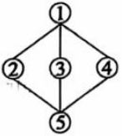 B．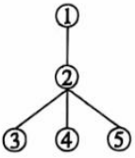 C．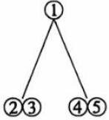 D．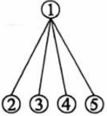
30．What’s the writer’s main purpose of writing the passage?
A．To spread the traditional Chinese culture.
B．To explain how our scientists develop the space industry.
C．To introduce the achievements in our science and technology.
D．To tell how traditional Chinese culture influences our space science.
第二节（共5小题，每小题2分，满分10分）
阅读短文，从方框内所列选项中，选出最佳选项填入对应空白处，使短文通顺、连贯。（选项中有一项多余）
Many people make journeys to different places. However, the biggest journey is the self-discovery journey. How do you start it? 31 .
●Understand what you value about yourself
32 ? It could be about how creative you are. It could also be about your wonderful skills at football. This helps you better understand your own values and abilities.
● 33
What makes you happy? It could be when you are singing on stage (舞台), when you help your dad repair his car, or even when you are doing a science project.
●Travel to different places
Traveling to a new place is a good way to discover new things. When you are on your travels, you have chances to meet kinds of people and get to know different cultures. 34 .
●Ask yourself what you want to be
What is your goal in life? How will you achieve it? 35 , and you will have a better understanding of yourself. These questions will help you reflect (深思).
The self-discovery journey is not a fixed one. With time going by, many experiences in your life can change you, which helps you grow.
A．Ask yourself these questions
B．Know what makes you excited
C．Here are some things you can do
D．What do you like most about yourself
E．Have you ever been to different places
F．They can open your eyes and increase your knowledge
三、短文填空（共10小题，每小题1分，满分10分）
阅读短文，从方框中选出恰当的单词并用其适当形式填空，使短文通顺、意义完整。每空仅填一词，每词仅用一次。
after attention clean collect come
first he helpful hold life
Do you believe picking up rubbish has become a world competition?
In November of 2023, the first Rubbish Collection World Cup was 36 in Asia. Teams from 21 countries took part in it. According to the rules, each team will have 60 minutes to 37 rubbish as much as possible. Britain finally won the 38 prize. “We hope more people around the world will pay 39 to environmental problems,” said a British team member.
When Ken, the founder (创始人) of the competition, was interviewed, he talked about how he 40 up with the idea. Several years ago, he found many sea animals died 41 they ate the rubbish in the sea. So he started to pick up rubbish on 42 way to the beach every morning.
“Picking up a piece of rubbish may save a turtle’s (海龟的) 43 . It’s also a good way to keep the beach 44 .” In his eyes, changing people’s thoughts about rubbish was more important.
“Picking up rubbish is meaningful and 45 ,” added Ken. “Now, I am glad to hear that lots of people take part in it to protect our environment.”
四、读写结合（共两节，满分25分）
第一节 任务型阅读（共5小题，每小题2分，满分10分）
阅读短文，用英文填空或回答问题。（注意每小题的词数要求）
Born in a small village, I saw how busy farmers were in spring, and what the season meant to them. Spring is a time when the land wakes up from its long sleep, and the fields are ready for crops (庄稼). If you are lazy in spring, you will get nothing in autumn. So, farmers seem to compete with time in spring.
When I was a little girl, every weekend I was busy planting crops. Whatever it was, I had fun and learned a lot. For example, when we planted potatoes, we needed to cut the sprouted (发芽的) potatoes into pieces and made sure every piece of “seed” (种子) had one or two sprouts. It was really like a math game.
Farm work is also teamwork. That’s why every spring field is busy with people of all ages working in it. While planting beans, my father dug small holes, and I carefully put some seeds into each hole. The work was hard and boring, but when we worked together, it seemed easier and more interesting.
I felt magic of life in spring as well. In a few weeks, the seeds sprouted, encouraging us to care for them by watering and so on. As time went by, they. grew into healthy plants.
Because of these wonderful childhood experiences, I hold such a special feeling for spring.
46．______ is the best season to plant crops.（仅填1词）
47．If you don’t work hard in spring, you will ______.（不超过5词）
48 & 49．Fill in the blanks according to the passage.
Spring Planting
Ideas or Feelings | Farm work
I had fun and learned a lot. | planting potatoes
Farm work is also teamwork. | 48．______(不超过5词)
49．______(不超过8词) | caring for seeds and watching their growth
50．What’s your understanding of “compete with time in spring”? Use your own words.
_________________________________________________________________ (结合自身实际，不超过20词)
第二节 书面表达（共1题，满分15分）
学校的英语校刊正在开展“畅享阅读”征文活动。请你围绕下图所示的三个问题，用英文写一篇短文投稿。
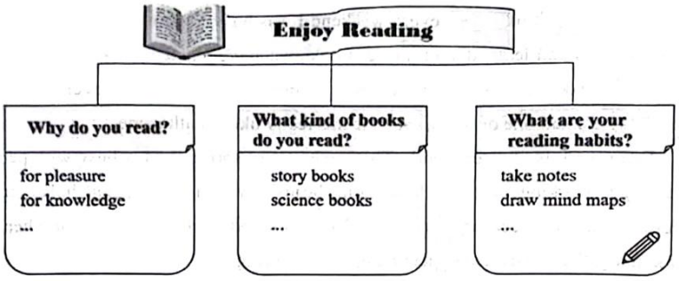
注意：
1．根据上图所给提示，适当发挥；
2．文中不得出现真实姓名和校名；
3．词数80词左右，开头已给出，不计入总词数。
I often read books in my free time. ____________________________________________________________
____________________________________________________________________________________________
____________________________________________________________________________________________
听力部分（30分）
第一节 听短对话，选择图片。（共5小题，每小题1.5分，满分7.5分）
下面你将听到5段短对话。根据你所听到的内容，从所给的A、B、C、D、E、F六个选项中，选出与你所听内容相符的图片。每段对话听一遍。
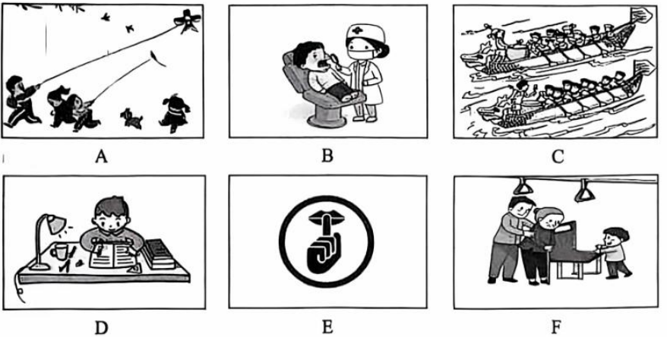
1．______ 2．______ 3．______ 4．______ 5．______
第二节 听短对话，选择答案。（共5小题，每小题1.5分，满分7.5分）
下面你将听到5段短对话。根据你所听到的内容，从每小题所给的A、B、C三个选项中选出回答问题的最佳选项。每段对话听两遍。
6．What’s the pronunciation of the word?
A．/’ru:lə/ B．/ru:d/ C．/ru:m/
7．Where does the conversation probably take place?
A．In the classroom. B．At home. C．In the restaurant.
8．Which cartoon will they watch?
A．Ne Zha. B．Mulan. C．The Monkey King.
9．What’s the probable relationship between the two speakers?
A．Friends. B．Neighbors. C．Cousins.
10．What does the woman ask the man to do?
A．Take the train. B．Pick her up. C．Call a taxi.
第三节 听长对话，选择答案。（共7小题，每小题1.5分，满分10.5分）
下面你将听到3段长对话，根据你所听到的内容，从每小题所给的A、B、C三个选项中选出回答问题的最佳选项。每段对话听两遍。
听第一段长对话，回答第11至12小题。
11．How is the weather tomorrow?
A．Cold. B．Cool. C．Warm.
12．What will the man probably buy first?
A．A scarf. B．A coat. C．A sweater.
听第二段长对话，回答第13至14小题。
13．What are Mario and Cathy doing now?
A．Doing the cooking. B．Getting some water. C．Choosing a camping place.
14．Where do they decide to camp?
A．By the water. B．Under the trees. C．Near the rocks.
听第三段长对话，回答第15至17小题。
15．What is James doing right now?
A．Planning a trip. B．Having an interview. C．Climbing a mountain.
16．What does Linda introduce about Hubei?
A．Cities and culture. B．History and people. C．Famous places and food.
17．Which activity does James probably like best?
A．Eating Wuchang fish.
B．Walking around the East Lake.
C．Visiting the Hubei Provincial Museum.
第四节 听短文，填写表格。（共3小题，每小题1.5分，满分4.5分）
下面你将听到一段短文，根据你所听到的内容，填写表格中所缺单词，每空仅填一词。短文听两遍。
Our Music Club
Activities | students | ●learn to sing  ●learn to 18  ●play the guitar
Activities | parents | ●watch our music 19 and take photos
My change | I used to be 20 . Now I am brave to talk and sing.
2024年湖北省初中学业水平考试
英语答案
一、完形填空
1-5 ACCDB 6-10 ADBBD 11-15 AACBD
二、阅读理解
第一节
16-20 CBADC 21-25 CDBBA 26-30 BACAD
第二节
31-35 CDBFA
三、短文填空
36．hold 37．collect 38．first 39．attention 40．came
41．after 42．his 43．life 44．clean 45．helpful
四、读写结合
第一节 任务型阅读
46．Spring
47．get nothing in autumn
48．planting beans
49．I felt magic of life in spring
50．we should cherish and make full use of the valuable time in spring. (答案不唯一)
第二节 书面表达
I often read books in my free time. Reading brings me both pleasure and knowledge. I enjoy exploring different worlds and ideas through books. My favorite type s of books are storybooks and science books. Storybooks take me on adventures with exciting characters, while science books teach me amazing facts about the world. I have a habit of taking notes while reading to remember important points and sometimes I draw mind maps to understand complex ideas better. This helps me appreciate the books more and learn effectively.

