2025年北京市初中学业水平考试
英语试卷
考生须知：
1.本试卷共10页，共两部分，五道大题，38道小题，满分60分，考试时间为90分钟。
2.在试卷草稿纸准确填写准确填写姓名、准考证号和座位号。
3.试题答案一律填涂或书写在答题卡上，在试卷上作答无效。
4.在答题卡上，选择题用2B铅笔作答，其他试题用黑色字迹签字笔作答。
5.考试结束，请将本试卷、答题卡和草稿纸一并交回。
第一部分
本部分共33题，共40分。在每题列出的四个选项中，选出最符合题目要求的一项。
一、单项填空（每题0.5分，共6分）
从下面各题所给的A、B、C、D四个选项中，选择可以填入空白处的最佳选项。
1. My sister is good at singing. ________ can even sing some French songs.
A. I B. He C. You D. She
2. These Chinese astronauts will stay in the space station ________ six months.
A. at B. on C. to D. for
3. —Mom, ________ I go to the cinema with my classmates this Sunday afternoon?
—Yes, of course you can.
A. can B. must C. need D. should
4. The National Library of China is ________ public library in Asia.
A. large B. larger C. largest D. the largest
5. —Steve, ________ did you begin to learn how to play chess?
—About two years ago.
A. what B. when C. why D. where
6. Janet has done a lot for us, ________ we want to write her a thank-you letter.
A. or B. but C. so D. for
7 Mary ________ a picture when her dad got home yesterday evening.
A. draws B. was drawing C. is drawing D. will draw
8. Charlie ________ his grandparents every weekend. He loves them very much.
A. visits B. was visiting C. will visit D. has visited
9. —Peter, did you play table tennis with your friends after school yesterday?
—No, I didn’t. We ________ vegetables in our school garden.
A. water B. have watered C. watered D. are going to water
10. Many international students ________ to visit our school since last year.
A. are coming B. have come C. came D. will come
11. Language learning apps ________ by more and more people these days.
A. use B. used C. are used D. were used
12. — Linda, do you know ________ for the school trip this term?
— Yes We are going to the Capital Museum.
A. where we are going B. where we went C. where are we going D. where did we go
二、完形填空（每题1分，共8分）
阅读下面的短文，掌握其大意，然后从短文后各题所给的A、B、C、D四个选项中，选择最佳选项。
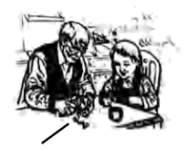
The New Year party was usually held at my aunt’s house and my favorite part was the apple cake. At the age of 11, when I first found out that my grandfather, who was never in the kitchen, was the master behind it, I was greatly ____13____ . And I thought that this was the perfect chance to get the recipe (制作方法), and that I could actually have a time to ____14____ with him.
Since then, I would go to my aunt’s early on the morning of New Year’s Day, and we’d make the cake together happily. I was amazed that Grandpa could peel an apple in one rind. And we’d mix everything and put it into the oven. Once the cake was done, the house would immediately smell like apples.
But as I got older, so did Grandpa.
One New Year’s Day, as I was taking out the apples from the shopping bag ____15____ as usual, he looked at me and said, “Sophia, what are you doing?”
I was shocked. I knew that he was beginning to forget things, but I didn’t think he would forget this. It was our ___16___ . It was our time of bonding (联络感情). My heart ached. “We’re making the apple cake. You know, we always make a cake on New Year’s Day.”
And he said, “Apple cake? Can you teach me?”
Now, I was terrified (很害怕的). Still, I ____17____ Grandpa in making the cake because I didn’t want this tradition to die. But the whole time it just didn’t feel the same.
Fast-forward to this New Year, Grandpa was in hospital, and we’d have our family get together there. To bring a bit of ____18____ to the family, I decided to make the apple cake at home by myself. But I was ____19____ myself the whole time. I was afraid the cake was going to taste terrible because it didn’t have Grandpa’s touch.
At the hospital, everyone was surrounding (围绕) him, creating some ____20____ . Grandpa looked down at the cake, and then looked back up at me and smiled. And I felt memories of our shared moments flooding back to him.
Even though he was in hospital, it felt like we had made the cake together.
13. A. surprised B. worried C. scared D. satisfied
14. A. compare B. connect C. study D. perform
15 A. cheerfully B. proudly C. nervously D. curiously
16. A. record B. rule C. interest D. tradition
17. A. served B. guided C. followed D. protected
18. A. trust B. company C. respect D. comfort
19. A. cheating B. excusing C. doubting D. thanking
20. A. space B. wealth C. magic D. warmth
三、阅读理解（每题2分，共26分）
（一）
下列每个图片代表一处旅游目的地，请根据人物的旅行计划匹配最适合的图片，并将图片所对应的选项（A、B、C、D）填在相应位置上，其中一个选项为多余选项。
A | B | C | D
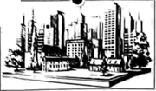 | 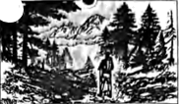 | 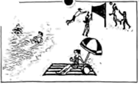 | 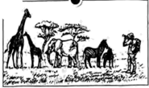
____21____ 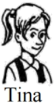 I want to travel to Africa and see the animals. I’d love to take lots of photos of elephants, giraffes and other animals. I’d like to try sleeping in a tent in the wild.
____22____ 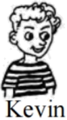 I’d like to go to North America. I love to walk in forests, climb trees and hike in the mountains. Perhaps I could go birdwatching, too. I enjoy exploring nature.
____23____ 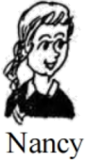 I’ve decided to tour Australia with my family. My plan is to go to the beach, swim in the sea and sit in the sun. Also, we’re going to play volleyball on the beach.
（二）阅读下列短文，根据短文内容，从短文后各题所给的A、B、C、D四个选项中，选择最佳选项。
B
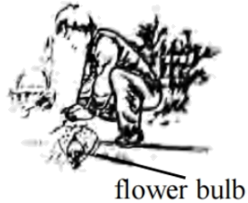
When I was young, flowers filled my mom’s garden each spring. I never thought that Mom had done much about them behind the scenes (幕后), until she shared her secret with me.
One day last November, Mom and I spent a whole morning planting flower bulbs. I dropped one in each hole and covered it over with soil. My fingers were numb (麻木的) by the time we finished. However, the ground looked just as flower bulb empty and flat as it had been before. Then Mom told me to wait. I didn’t only wait—I watched. I watched hopefully all through the winter...
On the last day of April, I went outside to find the garden full of colorful flowers. Our hard work paid off.
“My boy, tomorrow morning,” Mom said, “we will walk the neighborhood and leave a basket of flowers on each doorstep.”
“What?” I almost cried. “Are we selling our flowers?”
“Of course not,” she said excitedly. “In fact, nobody will even know they’re from us. We’ll leave them at our neighbors’ as a surprise. Doesn’t that sound fun?”
“To me, it doesn’t sound fun at all” I replied unwillingly. “They’re our flowers. We should keep them for ourselves!”
“Flowers are like kindness,” Mom said. “Their beauty is meant to be shared.”
Early the next morning, Mom woke me up. We brought the baskets and stopped near the first house. I took one basket, set it by the doorstep and rang the bell. Then we quickly ran away, ducked behind the trees and waited.
Finally, the door opened. A man came out, looking surprised. He picked up the flower basket and then smiled. Mom hugged me. I got a good feeling inside. Now I knew what she meant about beauty sharing. I couldn’t wait to get to the next house.
By the time we got home, I was grinning (咧着嘴笑) from ear to ear. The garden was empty, but my heart was full.
24. How did the writer feel when he watched the garden during the winter?
A. Empty. B. Excited. C. Hopeful. D. Bored.
25. What happened to the baskets of flowers in the end?
A. They were sold for pocket money. B. They were given to the neighbors.
C. They were collected for recycling. D. They were put up on a flower show.
26. What made the writer’s heart full?
A. The joy of spreading kindness. B. The excitement of growing flowers.
C. The honor of helping people in need. D. The happiness of getting close to nature.
C
Imagine a robot. What comes to your mind first? A machine stronger than the human body? However, this same quality is now causing a big problem—it’s creating tons of long-lasting e-waste that could flood our planet. What if, instead, the machines we use were designed to break down and disappear—just as living things do?
For a study published in Science Advances, researchers made a robotic arm and a controller using materials from animals and plants. These materials are strong enough to work but can easily break down in a natural environment. After testing, both parts were gone in soil within weeks.
Biodegradable (可生物降解的) robotics often falls under the umbrella of soft robotics, which takes ideas from nature. “This field started in materials science and chemistry rather than traditional robots that come from mechanical (机械的) engineering.” says Florian Hartmann, a materials scientist from Germany. However, many early soft robotics models still used man-made materials that cause pollution.
Wei, a scientist who studies natural materials in Hangzhou, worked together with his friend Zhang, a robotics engineer in Shanghai, to build robots for the new study. They started with cellulose (纤维素) taken from cotton. Then, they added glycerol (甘油) to make a new material that is soft and easy to change shapes. After that they allowed it to dry so it became strong, “Cellulose is cheap and easy to work with,” says Wei. They found that the controller and the robotic arm stood up to both heavy use and a week of inactivity. Finally, they buried (埋) them both in a hole. Within eight weeks these two parts were almost completely gone.
Wei and Zhang expect that robots like these can be used to deal with dangerous waste and then disappear naturally. They also hope that such robots can aid doctors in operations and then safely break down inside the body.
However, it’s important to note that the technology is still in very early stages. “If we truly want to have a biodegradable robot,” Hartmann says, “we also need to make sure its electronics and power parts are biodegradable.”
27. What is special about the robotic arm and the controller in Paragraph 2?
A. They are green. B. They are hard. C. They are intelligent. D. They are affordable.
28. What is mentioned in Paragraph 5 about soft robots?
A. Their operation. B. Their applications. C. Their challenges. D. Their performance.
29. What can we learn from the passage?
A. Soft robots are widely used to clean up e-waste.
B. Soft robots have to rest for a week after heavy use.
C. The designing of soft robots borrows ideas from nature.
D. Mechanical engineering offers new ways to run soft robots.
D
People are talking a lot about artificial intelligence (AI), viewing it as a force that could reshape how society works. But there is something important missing from this discussion. It isn’t enough to ask how it will change us. We also need to understand how we shape AI and what it can tell us about ourselves.
Every AI model we develop mirrors our rules and expresses our beliefs. A few years ago, while looking for new workers, a famous company gave up an AI-powered tool after finding it unfavorable to women. The AI was not designed to behave this way, instead, it was influenced by the historical data (数据) favoring men. Similarly, a recent study found that lending algorithms (算法) often offer less favorable terms to colored people, worsening long-standing unfairness in money-lending business. In both cases, AI isn’t creating new biases (偏见), it is mirroring the ones that are already present.
These reflections (反映) give us an important chance to take a close look at ourselves. By making these problems seen and more pressing, AI challenges us to recognize and address what causes algorithmic bias. As AI continues to develop, we must ask ourselves how we as average people want to shape its role in society. We should not only improve AI models, but also make sure that AI is developed and used responsibly.
A number of companies are already taking action. They are judging the data, rules, and beliefs that shape the behavior of AI models. Still, we cannot expect the companies to do all the work. As long as AI is trained on human data, it will reflect human behavior. That means we have to think carefully about the footprints of ourselves we leave in the world. I may value privacy, but if I give it up in a heartbeat to visit a website, the algorithms may make a very different judgment of what I really want and what is good for me. If I want meaningful human connections yet spend more time on social media and less time in the physical company of my friends, I am indirectly training AI models about the true nature of humanity.
As AI becomes more powerful, we need to take increasing care to read our principles (原则) into the record of our actions rather than allowing the two to diverge. Recognizing this allows us to make better decisions, but only when we are prepared to look closely and take responsibility for what we see.
30. Why does the writer introduce the two examples in Paragraph 2?
A. To suggest a solution. B. To stress a difference.
C. To challenge a practice. D. To support a viewpoint.
31. What does the word “diverge” in the last paragraph most probably mean?
A. Improve. B. Appear. C. Separate. D. Repeat.
32. According to the passage, what is a good example of shaping AI responsibility?
A. Guarding one’s privacy against AI models. B. Being mindful of our feeds into AI models.
C. Training algorithms to favor the latest data. D. Designing algorithms to deal with unfairness.
33 Which of the following is the best title for this passage?
A. AI Isn’t the Problem; We Are B. AI: A Tool to Reshape Our Society
C. More Open algorithms for Better AI? D. Building Trust in Human-AI Relationships
第二部分
本部分共5题，共20分。根据题目要求，完成相应任务。
四、阅读表达（第1-3题每题2分，第4题4分，共10分）
阅读短文，根据短文内容回答问题。
We do everything in a hurry—finishing our meals, completing our tasks, running to the gyms... We choose fast living because we think we have no control of time. We try to do as much as we can each day, checking off tasks on our to-do lists. Living in a rush feels like we are always pressed for time.
Our way of thinking that is focused on speed values doing more over doing things well. For a long time, we believe that speed means being productive and successful, and therefore, we keep rushing here and there in doing everything. Yet from time to time, we find ourselves in a predicament (困境) that no matter how fast we go, we never seem to be quick enough to catch up with our endless tasks and goals.
The Slow Movement thinks that the answer to our predicament is not to live faster, but to learn how to live slower. The movement began with the Slow Food Program, which was set up in 1986. It believed that we should fight against fast-food restaurants, protect traditional cooking, and encourage people to enjoy preparing and eating food.
The belief finally spread from the Slow Food Program to other parts of life. In 1999, it helped create Cittaslow—a group focused on slowing down life in cities. This belief about slowing down quickly began to influence areas like work, travel, fashion, and living in general.
The main idea of the Slow Movement is to value quality over quantity (数量) . Slow living is a lifestyle based on the Slow Movement. Its goal is to free us from endless rush that stops us from enjoying moments of rest. Slow living encourages us to live each moment whole-heartedly and give everything the time it needs, rather than try to do as many things as possible in every minute of our lives. Today, more people are drawn to the idea of the Slow Movement, thanks to social media sharing the many benefits of living slowly.
34. Why do people choose fast living?
_____________________________
35. What is the answer to our predicament, according to the Slow Movement?
_____________________________
36. What is the main idea of the Slow Movement?
_____________________________
37. Which lifestyle do you prefer, fast living or slow living? Why? (Please give two reasons.)
_____________________________
五、文段表达（10分）
从下面两个题目中任选一题，根据所给的中文和英文提示，完成一篇不少于50词的英语文段写作。文中已给出的内容不计入总词数。所给提示词语仅供选用。请不要写出真实的校名、姓名和地名。
38. 假设你是李华，你们班的英语课正在开展研究性学习，你选择研究同学们做家务的情况，为此你对班里40名同学进行了问卷调查，下图是部分统计结果。请用英语写一篇短文，简要说明图表内容，并对班级同学参与家务劳动提出建议。
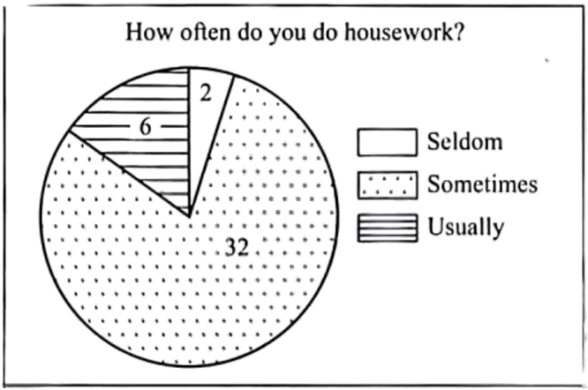
提示词语：show, chores, spend, tidy up, helpful
内容提示：
●What can you learn from the results?
●Offer some advice to your classmates on doing housework.
I did a survey on my classmates doing housework. ________________________________________________________________________________________________________________________________________________________________________________________________________________________________________________________________________________________________________________________________________________________________________________________________________________________________________________________________________________________________________________________________________________________________________________________________________________________________________________________________
39. 假设你是李华，你校正在开展“书香校园”活动，英语社团公众号打算做一期以“Dream Library”为主题的推送，为此在校内征集想法。请用英语给公众号留言，提出你的设想，并简要说明它会带来哪些好处。
提示词语：recommend, new, experience, explore, interest
内容提示：
●What is your dream library like?
●How can students benefit from your idea?
I’m Li Hua from Class 1, Grade 9. ________________________________________________________________________________________________________________________________________________________________________________________________________________________________________________________________________________________________________________________________________________________________________________________________________________________________________________________________________________________________________________________________________________________________________________________________________________________________________________________________________________________________________________________________
I hope my dream will come true. Thanks.

