英语
A卷 （共100分）
第一部分 听力（共30小题；计30分）
一、听句子，根据所听到的内容选择正确答语。每小题念两遍。（共5小题；每小题1分，计5分）
1．A．Nice to meet you. B．Of course. C．Enjoy yourself.
2．A．Thanks. B．Good job. C．I’m not sure.
3．A．My pleasure. B．Go ahead. C．Don’t worry.
4．A．Good idea! B．You’re kidding! C．How nice it is!
5．A．What’s up? B．Me too. C．Good luck.
二、听句子，选择与所听句子内容相符的图片。每小题念两遍。（共5小题；每小题1分，计5分）
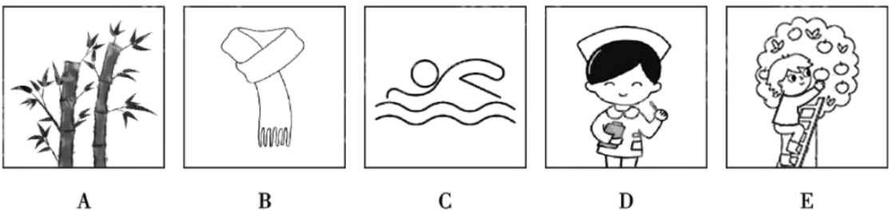
6．______ 7．______ 8．______ 9．______ 10．______
三、听对话，根据对话内容及问题选择正确答案。每小题念两遍。（共10小题；每小题1分，计10分）
11．A．Cute. B．Clever. C．Friendly.
12．A．Sunny. B．Rainy. C．Warm.
13．A．At 4:00. B．At 4:15. C．At 4:30.
14．A．One night. B．Two nights. C．Three nights.
15．A．Salesman and customer. B．Host and guest. C．Teacher and student.
16．A．Orange. B．Yellow. C．Blue.
17．A．By bus. B．By taxi. C．By bike.
18．A．Tired. B．Calm. C．Excited.
19．A．Cabbage dumplings. B．Mutton noodles. C．Beef noodles.
20．A．Go to the theatre. B．Go home. C．Take the underground.
四、听短文，根据短文内容选择正确答案。短文念两遍。（共5小题；每小题1分，计5分）
21．What is probably the speaker?
A．A teacher. B．A student. C．A musician.
22．What will the learners be able to do by the end of the course?
A．Give music lessons. B．Create their own songs. C．Write a book on music.
23．When will the music course start?
A．On May 6th. B．On May 13th. C．On May 20th.
24．What should one do to get the chance of taking the course?
A．Make a call. B．Send an e-mail. C．Hand in a form.
25．Why does the speaker give the speech?
A．To explain how to choose a course.
B．To give an introduction to a course.
C．To share the teaching plan of a course.
五、听短文，根据短文内容完成图表中所缺信息。短文念三遍。（共5小题；每小题1分，计5分）
Rules in keeping the 26 truthful and fair
Check the facts. | Ask a 27 person after getting something from someone.
Don’t lie. | Always tell people your 28 .  Ask if you can film people or record conversations.
Leave 29 out. | Just show the true and correct information.
Protect personal information. | Keep a secret if you are 30 to.
第二部分 基础知识运用（共30小题；计40分）
六、选择填空（共15小题；计20分）
A．从以下各题的A、B、C三个选项中选择最佳选项。（共10小题；每小题1分，计10分）
1. I volunteered as ________ guide in Chengdu Museum last weekend.
A. an B. the C. a
2. Xizang opened its first flight to Hong Kong ________ February 19th, 2025.
A. in B. on C. at
3. Mount Gongga is the ________ mountain in Sichuan, higher than any other in this area.
A. high B. higher C. highest
4. Miss Li always has a lot of work to do. For her, ________ is more important than a proper plan.
A. nothing B. something C. anything
5. —I’ve heard Lucy will join the art club.
—It ________ be true. She’s already in the basketball club. We can only choose one.
A. should B. can’t C. must
6. In April, some planarians (涡虫) ________ into China’s space station for scientific research.
A. were taken B. took C. were taking
7. —Tina, the phone ________. Can you answer it?
—Sure, Mum.
A. was ringing B. is ringing C. rang
8. It’s hard to say goodbye to the teachers ________ have spent the past three years with us.
A. which B. who C. what
9. —________ is the sports center closed today?
—Here’s a notice. Let’s have a look.
A. Why B. How C. Whether
10. Xu Dawei wants to pass the Civilian Mobile Library on to his son ________ it can stay open forever.
A. before B. although C. so that
B．补全对话
根据对话内容，选出适当的选项补全对话。
Amanda: Hi, Grandma. Are you having trouble with something?
Grandma: Yes. I want to post a photo online. ___11___
Amanda: Let me help you. ___12___ It says “photo/ video”.
Grandma: Ah, OK.
Amanda: After that, click on “upload”.
Grandma: Yes, click on “upload”.
Amanda: ___13___ Now, which photo do you want to upload?
Grandma: ___14___
Amanda: OK, so just double-click on that. And then write something if you want to.
Grandma: All right.
Amanda: And finally, click on “post” and that’s it! ___15___

A. Great!
B. First, click here.
C. You’ve finished!
D. I want this one here.
E. But I don’t know how.
七、完形填空阅读下面两篇短文，根据短文内容，从A、B、C三个选项中选出可以填入空白处的最佳选项。（共15小题；计20分。A篇每小题2分，计10分；B篇每小题1分，计10分）
A
On Sunday, Mum and Dad decided to clean the house. I was ___16___ when my dad asked me to clean the house together. “Is it ___17___ to clean it again? We just cleaned it last Sunday. It’s still clean.” I asked. “Yes, it’s clean,” he said, “but we’d better tidy it completely every ___18___.” We got started. I tidied my room, Mum tidied the rest of the house and Dad vacuumed (吸尘). We ___19___ cleaned the windows, the fridge and the cooker. The best part was that I ___20___ my long lost cards! When we finished, the whole house was shining! What a wonderful day!
16. A. confident B. excited C. surprised
17. A. possible B. necessary C. interesting
18. A. morning B. day C. week
19. A. never B. even C. once
20. A. found B. bought C. collected
B
Living in a new country is not easy, but not for me. My ___21___ in China are not only about learning but also about kindness.
I moved from the UK to China and began to teach in a university. Many ___22___, like visits to museums and food festivals, were organised for international students and teachers to get used to the new ___23___. Through them, I made many new Chinese friends and learned more about their language and culture. Gradually, I ___24___ the university and the city I work in.
Everyone around me is ___25___. They showed me how to use a new app, took time to go to the bank with me and helped me enter the school with QR code. One day, my family and I went out shopping. When we ___26___ to our apartment, we couldn’t enter it because the electronic lock did not work. ___27___, the manager of the building came with the master key. He tried his best but ___28___. He called a maintenance staff (维修工) to help and stayed with us ___29___ the door was opened.
The care I have ___30___ makes me feel at home. Thanks to everyone around me, my life in a new environment is less hard.
21. A. lessons B. books C. experiences
22. A. parties B. events C. clubs
23. A. environment B. work C. requirements
24. A. looked for B. fitted into C. got away from
25. A. brave B. clever C. warm
26. A. returned B. went C. came
27. A. However B. Actually C. Soon
28. A. continued B. failed C. started
29. A. until B. unless C. after
30. A. given B. received C. needed
第三部分 阅读理解（共15小题；计30分）
八、
阅读下面短文，根据短文内容判断句子正误。正确的涂“A”，错误的涂“B”。

Hailey quickly decided to see her grandfather when she learned he was in the hospital with little time left in Washington. However, she had to face a 25-minute connection (转机) at Denver International Airport. Seated in Row 45 on the flight (航班) to Denver, Hailey said to herself, “What a terrible seat for a passenger who is trying to rush off a plane!” A man sitting next to Hailey noticed her worries. Knowing the problem, the man decided to do something. He stood up and said to the other passengers, “Hi, everyone! Here is a lady who has to connect to Washington to see the most important person in her life. But she only has about 20 minutes available. Let her get off first!” With the help of the passengers, Hailey made her flight and reached the hospital in time.
31. Hailey’s grandfather had a serious health problem.
32. Hailey decided to live with her grandfather.
33. Hailey didn’t think the seat in Row 45 was a good one.
34. The man sitting next to Hailey took action to help her.
35. Hailey missed the flight to Washington in the end.
九、阅读下面两篇短文，根据短文内容选择最佳选项。（共10小题；每小题2分，计20分）
A
  From: Laura
  To: Irene; Shirley
  Sent:3 June 11:13
  Subject:
  Hi girls!
  Right, we need to start planning our summer or all the holidays will be booked up... Are you both still up for going away together somewhere? July is no good for me because I’m working but I can do August. Is August good for you two? We talked about somewhere hot and sunny, didn’t we? But where?!
  Laura
  From: Irene
  To: Laura; Shirley
  Sent:3 June 11:18
  Subject:
  I am definitely still interested in going away together! How about Greece? I was looking at my friend’s photos today and it looks great. I can’t do August because I’m going to Rome, but I might be free at the start of September.
  Shirley, what are your plans?
  Irene
  From: Shirley
  To: Irene; Laura
  Sent:3 June 14:12
  Subject:
  Oh, Greece is a great idea! I’m going to visit friends in Denmark in July, but the first week of September is good for me. Laura, can you do September? Let’s get together next week to plan it.
  So excited!
  Love
  Shirley
  From: Laura
  To: Irene: Shirley
  Sent:3 June 14:22
  Subject:
  Yes, I can do the first week of September.
  Greece! Wow, beautiful country, interesting history, delicious food... We’re going to have such a good time!
  Let’s discuss the details next week!
  Laura

36. Who sent the earliest email?
A. Irene. B. Laura. C. Shirley.
37. What is Laura worried about?
A. She has to work in July.
B The weather will turn hot soon.
C. She and her friends can’t travel together.
38. Why does Irene suggest Greece?
A. The weather there is cool.
B. She will stay nearby then.
C. Her friend’s photos interest her.
39. What have the girls agreed to do in the end?
A. Go to Greece in September.
B. Discuss where to go next week.
C. Visit friends in Denmark in July.
40. What’s the best subject for the group email?
A. Holiday plans. B. Favorite countries. C. Free time activities.
B
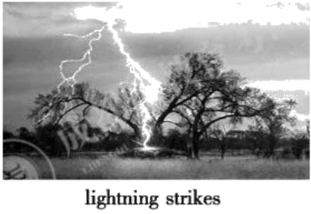
Lightning strikes kill millions of trees each year—but it turns out that some large tropical (热带的) trees can not only stay alive after they’re hit by a strike, but also benefit from its effects, according to a recent study.
Some trees are getting repeatedly hit by lightning over their lifetime. But why can they survive? Researchers don’t know for sure. However, they think that trees will be heated less if they’re more conductive. That means the energy from lightning is just moving to their neighbors, instead of staying in them. The lightning’s strong power kills the parasitic vines (寄生藤蔓) on the trees. It also kills some other trees nearby, reducing competition.
Dipteryx oleifera, a tree in Panama’s forests, has probably experienced 10 lightning strikes so far. It stays safe and sound, while most of the neighboring trees were killed. If you are in the forest where it is, you’ll know what it is—its huge size and height. “We believe the trees in Panama’s forests have five strikes on average. But, you know, some of them obviously have a ton.” Evan Gora, a forest ecologist said.
How long do these trees live in the forests? People can’t do tree ring dating in tropical forests because the trees don’t make continuous growth rings. Researchers guess many of the trees would be hundreds, or maybe even more than 1,000 years old.
What can we learn from the study? The hardest things can turn into good things can they?
41. Why can some large tropical trees survive lightning strikes?
A. They’re not often hit by lightning.
B The neighboring trees protect them.
C. The lightning energy moves away from them.
42. What may happen after the large trees are hit by lightning?
A. They win better living conditions.
B. They have more neighbors around.
C. They can stand more kinds of danger.
43. What does the tree Dipteryx oleifera look like?
A Old and weak. B. Huge and tall. C. Clean and thin.
44. Why can’t people tell the exact age of the large trees hit by lightning?
A. The weather there is terrible.
B. People don’t have proper tools.
C. Continuous growth rings can’t be found.
45. Which part of the newspaper is this text taken from?
A. Health. B. Nature. C. Technology.
B卷（共50分）
一、补全单词 根据首字母及句意写出完整单词。（共5小题；每小题1分，计5分）
46. A Chinese team has developed a small robot that can w________ for humans in the world’s deepest sea trench (海沟).
47. At the 2025 World Athletics Indoor Championships, Wu Yanni set a new national r________ of 8.01 seconds in the women’s 60m hurdles.
48. Born into a family of doctors, Liu Jiakun wasn’t interested in m________, and chose writing and painting instead.
49. Because of the archaeological (考古的) efforts over recent years, a lot of a________ have been made in the study of China’s history.
50. Butterflies not only look beautiful but also s________ plant growth. It’s important to protect them.
二、完成对话
在空格中填上适当的单词，使对话完整正确。一空一词（含缩写词）。
Li Ming and his British friend Andy are touring the Forbidden City.
L—Li Ming A—Andy
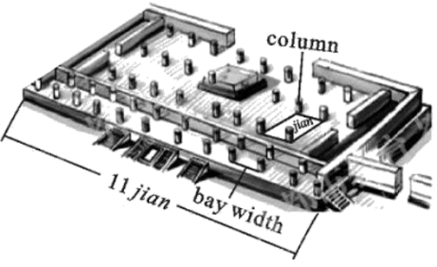
A: This palace is amazing. Ancient Chinese buildings never let you down. Each of them is a wonderful ___51___ into Chinese culture.
L: Totally agree with you. Some discoveries show that Chinese people began to develop its special construction (建筑) style as ___52___ as more than 7,000 years ago. We have one of the three greatest architectural systems (建筑体系) in the world.
A: Wow! No ___53___ there are so many fantastic ancient Chinese buildings across the country. They’re the symbols of ancient Chinese wisdom. I’ve heard there are more than 870 buildings in the Forbidden City. But how ___54___ is it on earth?
L: It’s said it has about 8,700 jian.
A: So you mean there are nearly 10 thousand ___55___ here?
L: Actually no. The Chinese character 间 “jiān” means a room today. But in ancient China, it was used as a basic unit to ___56___ the floor space of a building.
A: That’s interesting. Then how is the size of jian decided?
L: Good ___57___. Each space defined (标明界限) by four columns is one jian. However, the bay width, which means the distance between two columns, could be ___58___.
A: Really? How?
L: Well, in ancient China, the bay width of ___59___ people’s houses could usually be no more than 3.3 meters. For those working in the government, it became wider. For emperors’ palaces, such as the Forbidden City, it could reach more than 5.8 meters.
A: Oh! Now, I know ___60___ the room here is so wide. Let’s see how many jian the building in front of us has.
三、短文填空
从下面方框中选出10个单词，将其正确形式填入短文，使短文意思正确通顺（每词限用一次）。
after busy choose direct enjoy expect notice offer outside rule run they

Dashiban is a 600-year-old village in Xichang, Sichuan province. It was a ___61___ place on the Southern Silk Road and the Tea Horse Road. However, the village gradually declined. Many villagers left their hometown to search for work elsewhere.
In order to change the situation, Xichang started a project in Dashiban in 2021. To keep the village’s historical charm (魅力), it followed the ___62___ of “repairing the old as old”. The local government improved tourism infrastructure (基础设施) ___63___ unforgettable experiences of local culture and traditions.
The local government’s efforts changed the village’s appearance greatly, which has ___64___ benefited homestay (民宿) business. Chen Xiaoyu ___65___ a homestay for several years. She said she never ___66___ that she could make so much money in her hometown. The village’s change has also drawn more and more villagers working ___67___ back home to start businesses. Xiao Wenfang gave up her job in the big city and opened a restaurant with her father in the village ___68___ learning about its changes. Ethnic-themed travel photography has also become very popular in the ethnic village, following homestays and restaurants. Many tourists come to dress ___69___ in traditional clothes.
Dashiban now has 232 homestays,85 restaurants and 65 travel photography studios. Tourism has become the village’ s main industry, creating jobs for over 1,000 villagers. It received 1.9 million visitors last year. People from different cities even ___70___ this small village to live in when they are free. They just want to enjoy the easy life here.
四、阅读表达（共10小题；计10分）
A．补全短文
根据短文内容，从短文后的A～F选项中，选出5个适当的选项补全短文。
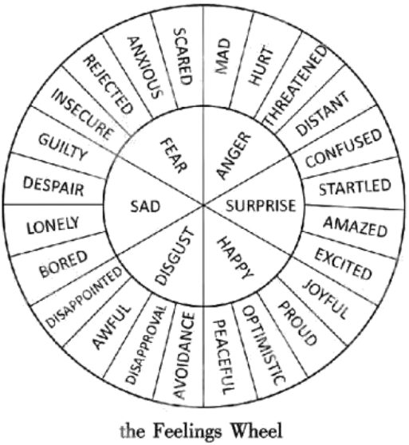
From time to time, you may suffer from being overwhelmed (难以承受的). You may feel disappointed, sad, hurt or even helpless. ___71___ Here is some advice to help you.
Know your feelings. It can be hard sometimes to find the right words to express what you’re feeling. The Feelings Wheel can help. ___72___ Recognise your primary feeling in the middle of the wheel, and then see what other feelings this connects with as you look outwards from the center. This can help you get clear about what you’ re feeling.
Accept what you feel. It is okay to feel lonely; it is okay to feel nervous; and it is okay to feel as if the world is going to end. ___73___ There’s nothing wrong with you feeling this way. Many of us do too, at different points in our lives.
Make a list. Sometimes you may feel overwhelmed when you have too many things to do. Perhaps there is too much to study, or you may have a long to-do list when organising a birthday party. ___74___ Then, list the tasks in order of importance or urgency (紧迫性). You will feel calmer when you finish the list—you would have control over the tasks and yourself!
Learning to manage overwhelming feelings takes time and practice. ___75___ Learn what works best for you. You only have one YOU!
A. Be in touch with yourself.
B. Start from the inside and move out.
C. Sit down and find out what comes first.
D. Write down the things that need to get done.
E. Dealing with such feelings doesn’t come easy.
F. It is quite natural when humans are facing stress.
B．完成图表
根据短文内容，完成图表中所缺信息。
Should books always have a happy ending?
The purpose of World Book Day is to encourage people to enjoy reading and there’s no doubt that a book’s ending is usually a big part of that joy. Even so, there are plenty of stories that don’t finish on a happy note. What do you think? Should books always have a happy ending?
Part of the reason we read in the first place is that reading makes us happy. We read to get away from troubles and worries in real life. If your reading experiences are full of sadness or other negative feelings you may give up reading. If your experiences of reading are connected to positive feelings, you could be encouraged to carry on reading. It doesn’t mean stories with happy endings cannot make you enjoy reading. They can also include surprises, which make the stories quite dramatic and exciting, even if you know everything’s going to end well. Exploring love into the characters’ lives is equally as satisfying.
In real life, the story doesn’t stop at the “happy ending”. It doesn’t end. It keeps going past that happy moment to a lifetime of more moments both good and bad. Books with unhappy endings are useful because they show you the true feelings such as sadness but in a controlled way. They can help you deal with these feelings in your life. The stories explore the painful side of love and the topic of heartbreak. Reading about these kinds of things in stories can help make us feel like we’ re not alone in our personal experiences. Some experts say that experiencing negative feelings can make you better at understanding how other people are feeling. This ability, known as empathy, helps you to connect with people and support them through hard times. It’s the “unhappy” endings that have the greatest influence.
Should books always have a happy ending?
YES  ◆Stories with happy endings bring good feelings. They help people forget troubles and worries.  ◆Stories with happy endings encourage reading. Experiences of reading may influence people’s ___76___.  ◆Stories with happy endings also make people enjoy reading. There can also be ___77___ in them. | NO  ◆Stories with unhappy endings are useful for managing difficult feelings. They present ___78___ in a certain way.  ◆Stories with unhappy endings make people ___79___ connected. They explore the painful side of love and the topic of heartbreak.  ◆ Stories with unhappy endings help ___80___ empathy. They shape people’s ideas.

五、书面表达（计15分）
81. 英语课将围绕“你最喜欢的科学探究场所”开展讨论，以下图表为你所在小组针对本校八年级学生的调查结果。请根据图表信息写一篇发言稿，内容包括：
1．调查结果描述及评析；
2．你的选择及原因。
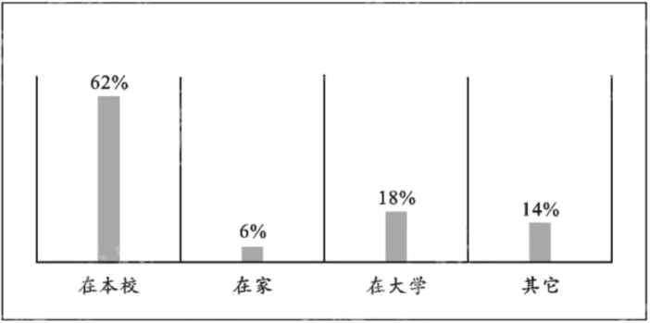
注意：
1．文中不能出现真实姓名及学校名称；
2．词数80左右，开头已给出，不计入总词数。
参考词汇：开展科学探究do scientific exploration
Hello, everyone.
__________________________________________________________________________________________________________________________________________________________________________________________________________________________________________________________________________________________________________________________________________________________________________________________________________________________________________________________________________________

