2025年潍坊市初中学业水平考试
英 语 试 题
注意事项：
1. 本试题满分110分，考试时间为90分钟；
2. 答卷前务必将试题密封线内及答题卡上面的项目填涂清楚。所有答案都必须涂、写在答题卡相应位置，答在本试卷上一律无效。
一、阅读理解（共20小题；每小题2分，满分40分）
阅读下列语篇，从每题所给的A、B、C、D四个选项中选出最佳选项。
A
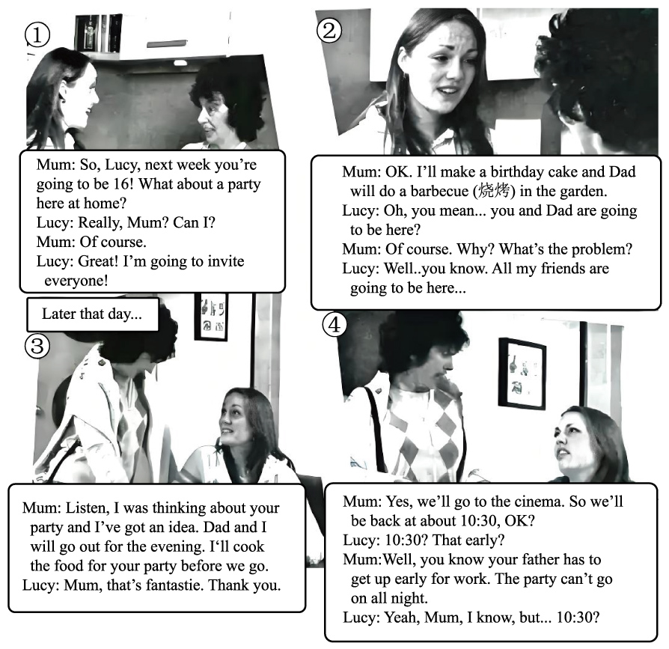
1. Where are the two speakers?
A. At home. B. At a hotel. C. In a shop. D. In a restaurant.
2. What are Lucy and her mother talking about?
A. Where to do a barbecue. B. How to hold a party. C. Whom to invite for dinner. D. When to go to the cinema.
3 What does Lucy hope to do?
A. Go to bed at 10:30. B. Make a birthday cake. C. See a movie with her parents. D. Stay with her friends alone.
B
Scientists from China’s Shanghai Jiao Tong University are developing a robot “guide dog” to help blind people. The robot dog is about the size of an English bulldog but a little wider. It has six legs instead of four. The extra legs make it more stable and help it move faster.
The robot is being tested in Shanghai. With the help of cameras and AI, the robot dog can see, listen and speak with blind people. It can help them during daily trips outside and be a “friend” at home. Blind people can also use a cane (手杖) to control the robot’s walking and running speed. The robot can even recognize the traffic lights—real guide dogs are unable to do that.
Li Fei and Zhu Sibin are helping test the robot. Li is totally blind and Zhu can only see a little. Zhu often uses a cane to move around. “The robot dog will make it easier to get into public places than with real guide dogs. I am happy to join in the test. It could change our lives in the near future,” Li said.
In China, there are about 17.31 million blind people, but there are only about 400 guide dogs. The new robot is trying to solve this problem. “We believe our robot will act as ‘a pair of eyes’ for blind people,” said Professor Gao Peng, one of the scientists. He thinks there could be a large market for these robot dogs.
4. Why do scientists develop the robot dog?
A. To help blind people. B. To improve AI technology. C. To beat the British bulldog. D. To create a six-legged machine.
5. What is paragraph 2 mainly about?
A. How the robot dog works. B. Where the robot dog can go. C. What the robot dog can do. D. When the robot dog comes out.
6. How does Li Fei help develop the robot dog?
A. He designs it. B. He helps test it. C. He brings it into public places. D. He controls it with a cane.
7. What is Professor Gao Peng’s opinion about the robot dog?
A. It can treat blindness. B. It costs a lot of money.
C. It has taken the place of real guide dogs. D. It will have a large number of customers.
C
During the 2021 Shanghai Fashion Week, a young, slim and confident model with an iron leg drew everyone’s attention. Her name was Niu Yu. She lost her right leg in the 2008 Wenchuan earthquake. She was only 11 years old then.
Niu Yu used to be in the school sports team. She loved running. But the disaster broke her dream. She had to live with an artificial leg. It wasn’t comfortable, and her leg often bled. People’s curious eyes made her even more uncomfortable. She always tried to hide her leg under jeans or dresses.
With the support of her family and friends Niu Yu slowly came out from the shadows. In 2018, right before her 21st birthday, she decided not to hide her leg any longer. To her surprise, she received lots of encouraging words. She also finished a half marathon in about 4 hours. She completed the hard 10-year journey of finding herself again.
Now Niu Yu puts her experiences on social media (媒体). She listens to disaster survivors and encourages them to look forward. In 2023, she carried the torch (火炬) at the FISU World University Games. “It is a great honour for me,” she said. “But it is also a good chance to show people the power of being brave.”
A disaster can bring wounds and pain. But we should always face them with courage. As the writer Nora Ephron once said, “Above all, be the hero of your life, not the victim (受害者).”
8. Why did Niu Yu try to hide her leg?
A. It often bled. B. It was uncomfortable. C. She wanted to be a model. D. She tried to avoid the strange eyes.
9. What’s Niu Yu’s purpose of putting her experiences on social media?
A. To become a famous star. B. To get support from others. C. To cheer up people in trouble. D. To win the hearts of more fans.
10. Which is the right order of the facts about Niu Yu according to time?
① She performed in Shanghai Fashion Week.
② She lost her right leg.
③ She finished a half marathon.
④ She carried the torch at the FISU World University Games.
A ②①④③ B. ②③①④ C. ③④①② D. ③②④①
11. What can we learn from Niu Yu?
A. Face difficulties bravely. B. Life can’t go without heroes. C. Protect yourself before disasters. D. Friendship is necessary to everyone.
D
Parrots are known for being able to copy some of the sounds that people make. They might say “hello” or “how are you?”, if they often hear those words and phrases. Some are even able to learn the names for objects and identify (识别) them. And a 4-year-old parrot in the US has been recognized by Guinness World Records after correctly identifying 12 objects in 3 minutes.
That record-breaking bird is an African grey parrot named Apollo, who lives in Florida. He can identify things like books, bugs and socks. He has become popular on TikTok, where he has about 3 million followers. And a TikTok video of Apollo asking questions in 2023 has been watched 66 million times.
The parrot is owned by a couple named Dalton and Victoria Mason. They’re video creators and they’ve been working hard to train the bird. The owners say they teach Apollo as if he were a child of preschool age. “We teach him as much as we can,” the couple told Guinness, adding that they focus on (聚焦) things that Apollo is interested in.
Researchers have found that some African grey parrots are able to do better at some cognitive (认知的) tasks than 5-year-old children. And Apollo’s owners plan to keep teaching the bird to see how much he can learn and how many more records he can break.
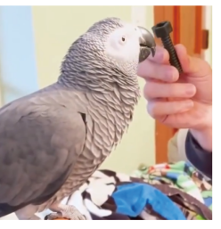
12. The parrot was recognized by Guinness because he could ________.
A. say hello to visitors B. give names to things around C. repeat the words people speak D. identify 12 things in 3 minutes
13. What can Apollo do according to paragraph 2?
A. Eat harmful bugs. B. Put on socks. C. Communicate with people. D. Sing for his followers.
14. What do we know about the couple’s method of training Apollo?
A. They play videos for him.
B. They teach him like a teenager,
C. They make him do difficult actions.
D. They pay attention to what he prefers.
15. Which might be the best title for the text?
A. TikTok: popular with birds
B. The couple: No.1 bird trainers
C. Apollo: the record-breaking parrot
D. Guinness: an organization for special animals
E
Chopsticks are a pair of sticks to be used when eating. ____16____ Chopsticks are considered one of the symbols of Chinese food culture. Here are three things you should know about them.
____17____
Chinese people started to use chopsticks about 3,000 years ago during the Shang Dynasty. During the pre-Qin period, chopsticks were called “Jia”, and in the Qin and Han dynasties, they were called “Zhu”. Because “Zhu” shares the same pronunciation with “stop” in Chinese, which is an unlucky word, by the Ming Dynasty, people began to call them “Kuai”, meaning “fast” in Chinese. ____18____
Who invented chopsticks?
____19____ One is that Jiang Ziya created chopsticks after getting an idea from a mythical (神秘的) bird. It is also said that Yu the Great, who founded the Xia Dynasty, used sticks to pick hot food in order to save time to control floods, so chopsticks came into being.
How should we behave when using chopsticks?
When eating with the elders, Chinese people usually let the elders take up chopsticks before anyone else. ____20____ It’s also bad to tap (敲) chopsticks on the edge of your bowl, because in ancient China beggars (乞丐) often did it to attract attention.
根据短文内容，从下列选项中选出能填入文中空白处的最佳选项，选项中有一项为多余选项。
A. How were chopsticks invented?
B. When were chopsticks invented?
C. This is the origin of today’s name of Chinese chopsticks.
D. Besides, playing with chopsticks is thought to be impolite.
E. They were first used in China and then introduced to other countries.
F. There is no exact historical record, but there are many folk stories about it.
二、语言知识运用（共20小题；满分35分）
A
阅读下面短文，从短文后各题所给的A、B、C、D四个选项中，选出可以填 入空白处的最佳选项。（每小题1.5分，满分15分）
In the past, most people worked on their feet and moved their bodies all day, so they had lots of exercise. They also mostly ate ____21____ foods like fruit, vegetables, fish, and meat. Today, many people ____22____ in front of a computer all day at work and often eat a lot of sweet foods, or foods that are made in factories. This can be a big ____23____ to their health.
The disease that causes most deaths in the world today—three in every ten—is heart disease. ____24____ many of these deaths need not happen, and are caused because people have not exercised or eaten well enough. Not exercising, or eating unhealthy food, can sometimes cause ____25____ dangerous disease—diabetes (糖尿病). When someone has diabetes, there is too much ____26____ in their blood. In the last twenty years, more and more people have died ____27____ diabetes—and almost 10% of the world’s population now has this disease.
Many people are also ____28____ new health problems that are caused by computers and cell phones. When people stay for too long in front of a computer, they can ____29____ get problems with their eyes, arms, necks, and backs. And when they use computers and cell phones at night, it is often more difficult for them to _____30_____. Some scientists also think that cell phones may cause health problems because of a kind of energy which they produce called radiation (辐射).
21. A. fast B. natural C. delicious D. expensive
22. A. sit B. lie C. play D. stand
23. A. risk B. ache C. accident D. disadvantage
24. A. So B. Or C. As D. But
25. A. one B. other C. another D. the other
26. A. water B. sugar C. salt D. waste
27. A. in B. on C. of D. for
28. A. crazy about B. worried about C. excited at D. disappointed at
29. A. hardly B. nearly C. clearly D. easily
30. A. sleep B. wake C. breathe D. escape
B
阅读下面短文，用括号内所给单词的适当形式填空，必要时可加助动词。
“Where’s Papa going with that axe (斧子)?” said Fern to her mother while they ____31____ (set) the table for breakfast.
“Out to the pig house,” replied Mrs. Arable. “Some pigs were born last night.”
“I don’t see why an axe ____32____ (need),” continued Fern. “Well,” said her mother, “one of the pigs is too small and weak ____33____ (live). So your father has decided to do away with it.”
“You mean kill it?” Fern shouted. “Just because it’s ____34____ (small) than the others?”
Fern ran outdoors ____35____ (quick). She caught up with her father. “Please don’t kill it!” she cried. “It’s unfair!”
Mr. Arable stopped ____36____ (walk). “Fern,” he said gently, “you will have to learn to control yourself.”
“Control ____37____ (I)?” yelled Fern. “This is a matter of life and death.” She took hold of the axe. “Fern,” said Mr. Arable, “I know more about raising pigs. A weakling usually makes trouble.”
“But the pig couldn’t help being born small, could it?” cried Fern. “If I had been very small at birth, would you have killed me?”
Mr. Arable smiled. “But this is different...” “I see no ____38____ (different)” replied Fern. “This is the worst case I ____39____ (hear) of since I was born!”
“All right,” he said. “I will let you feed it with a bottle, as _____40_____ (baby) are fed. Then you will see what trouble a pig can be.”
When Mr. Arable returned to the house, he carried a box under his arm. Fern opened the box. There, inside, looking up at her, was the newborn pig.

三、阅读表达（共4小题，满分15分；其中第44小题6分，其余每小题3分）
阅读下面短文，根据短文后的要求答题。
A well-known 75-year Harvard study shows that children who do chores can become more independent and successful when they grow up. In fact, chores are very important to children’s future development, as they bring many benefits (益处).
When children do chores, they can get a sense of achievement because they can see the results soon after finishing the chores. Especially when their parents say thanks for their help and tell them they’ve made the day easier, they will know they are useful and able to help their families. This experience can also encourage children to be more active outside of the family.
What’s more, they will learn that it is everyone’s duty (责任) to take part in the household chores. It helps to stop them from growing up spoiled (惯坏的). Life doesn’t simply offer everything on a plate. It takes much effort to turn what we want into reality.
Besides, they will learn how to manage their time through chores. Doing chores from a young age helps children to get used to them. Children learn to include them in their day with all other activities such as studies and play. Time management is a useful skill, too. When they grow up, they need to balance different parts of their life like work and family.
Chores also teach important life skills. Chores are usually related to household tasks-washing dishes, sweeping the floor, making the bed, etc. These are all life skills that children need to develop. The only way to learn is by doing.
Chores aren’t just about keeping the house clean. They are life lessons.
根据短文内容回答第1-2小题。
41. Why can children get a sense of achievement by doing chores?(12词以内)
__________________________________________________________________________________________
42. What does the underlined word it in paragraph 3 refer to?(8词以内)
__________________________________________________________________________________________
43 Please translate the underlined sentence in paragraph 5 into Chinese.
__________________________________________________________________________________________
根据短文内容，完成下面的结构图，每空两词。
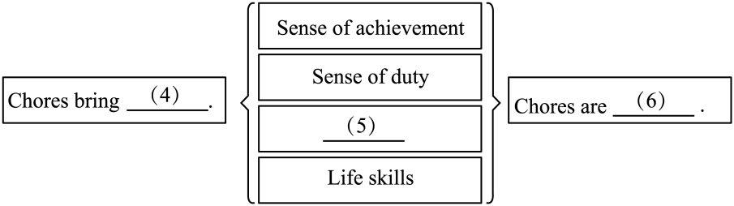
44. ________
45. ________
46. ________
四、写作（满分20分）
47. Teens Around the World是一个国际青少年交流网站，近日有人发了一个关于“家务劳动”的帖子。假设你是李华，请阅读原帖后，结合自己的生活经历和体会，用英语跟帖。
注意：
1. 80词左右；
2. 不要出现考生本人信息；
3. 禁止抄袭本试卷中所有语篇内容。
Teens Around the World
Subject: Chores
Hey, guys! We often do chores at home. Is there anything special you still remember? When did it happen? What did you do? And how did you feel? Please share with us one of your stories of doing chores. Looking forward to your replies.
Alice, Canada
________________________________________________________________________________________________________________________________________________________________________________________________________________________________________________________________________________________________________________________________________________________________________________________________________________
Li Hua, China

