
绝密▲启用前
淮安市2025年初中毕业暨中等学校招生文化统一考试
英语试题
欢迎参加中考，相信你能成功！请先阅读以下几点注意事项：
1. 本卷分为第Ⅰ卷和第Ⅱ卷，共8页。满分为120分。考试用时为120分钟。
2. 第Ⅰ卷每小题选出答案后，请用2B铅笔把答题卡上对应题目选项的答案标号涂黑，如需改动，请用橡皮擦干净后，再选涂其他答案。答案写在本试题卷上无效。

3. 做第Ⅱ卷时，用0.5毫米的黑色墨水签字笔将答案写在答题卡上每题题号的横线上。答案答在本试题卷上无效。
4. 考试结束，将试卷和答题卡一并交回。
第Ⅰ卷（选择题 共64分）
一、单项选择（共10小题；每小题1分，满分10分）
从A、B、C、D四个选项中，选出可以填入空白处的最佳选项。
1. The girl is my classmate. ________ is kind and helpful.
A. He B. She C. They D. You
2. I like dancing very much, and I want to be a ________ when I grow up.
A. cook B. doctor C. dancer D. singer
3. Cakes taste good, ________ you can’t eat too much.
A. and B. but C. or D. so
4. —________ is the red coat over there?
—100 yuan. You can try it on.
A How far B. How often C. How much D. How long
5. Jack gets up early ________ the morning. He often goes running before breakfast.
A. in B. of C. at D. on
6. The public sign  that you can see in the street means “________”.
A. Turn right B. Keep quiet C. No smoking D. No parking
7. In China, people usually have a dragon boat race to celebrate the ________.
A. Spring Festival B. Lantern Festival
C. Mid-Autumn Festival D. Dragon Boat Festival
8. Zhang Hua saved a boy out of a fire yesterday. What a ________ young man!
A. shy B. brave C. funny D. modest
9. —What will you do tomorrow?
—I ________ the museum to learn about the local history.
A. visit B. visited C. will visit D. are visiting
10. —I think listening to music is fun.
—________! It helps us relax in the free time.
A. I agree B. I’m sorry C. Don’t worry D. Good luck
二、完形填空（共15小题；每小题1分，满分15分）
请认真阅读下面短文，从短文后各题所给的A、B、C、D四个选项中，选出最佳选项。
For a long time I was sure Dad didn’t love me. Mum always wore a warm smile, but Dad always seemed ____11____. He was busy with his work every day. When at home, he just read newspapers, ____12____ talking to me.
Lots of unhappy memories about Dad stayed in my mind. There was one thing I remembered very ____13____. It was my first school science show. I was so ____14____ to join! I spent several weeks making a model ship.
The night ____15____ the show, when I was adding the last details, one part of the ship broke by accident. I ran to Dad with tears in my eyes. “Dad, please help me! ____16____ it, please!” I cried. He just took a look and said, “You should be more ____17____. Fix it yourself.” Then he went back to his newspaper.
After being refused, I couldn’t express how ____18____ I felt inside. I thought he didn’t care about my feelings at all. I had to spend the whole ____19____ fixing the model alone.
The next day at the show, my model wasn’t perfect and I didn’t ____20____ a prize. For years, I was angry with Dad. ____21____ when I grew up, I still remembered that heartbroken moment.
I didn’t understand Dad until a similar experience happened to my son. Several years ago, while my son was making a model plane, he broke one of the wings. And I decided to fix it for ____22____. Suddenly, Dad’s words came into my mind: “Fix it yourself.” At that moment, I started to understand. Dad just wanted me to ____23____ some basic skills which would be useful in the future. I gave the model plane back to my son and smiled, “Have a ____24____! You can fix it by yourself.”
Dad didn’t say nice words to me, but he had his own way to teach me a lesson—I should ____25____ myself. It was one of the most important qualities that made me a better person.
11. A. lazy B. cold C. happy D. friendly
12. A. always B. usually C. often D. seldom
13. A. widely B. clearly C. quickly D. closely
14. A. excited B. calm C. angry D. strange
15. A. to B. till C. before D. after
16. A. Fix B. Sell C. Clean D. Find
17. A. helpful B. honest C. careful D. polite
18. A. endless B. helpless C. careless D. meaningless
19. A. night B. day C. week D. month
20. A. buy B. win C. make D. need
21. A. Just B. Once C. Only D. Even
22. A. you B. her C. him D. them
23. A. share B. change C. develop D. introduce
24. A. try B. rest C. visit D. taste
25. A. take on B. turn on C. carry on D. depend on
三、阅读理解（共17小题；每小题2分，满分34分）
请认真阅读下列材料，从材料后各题所给的A、B、C、D四个选项中，选出最佳选项。
A
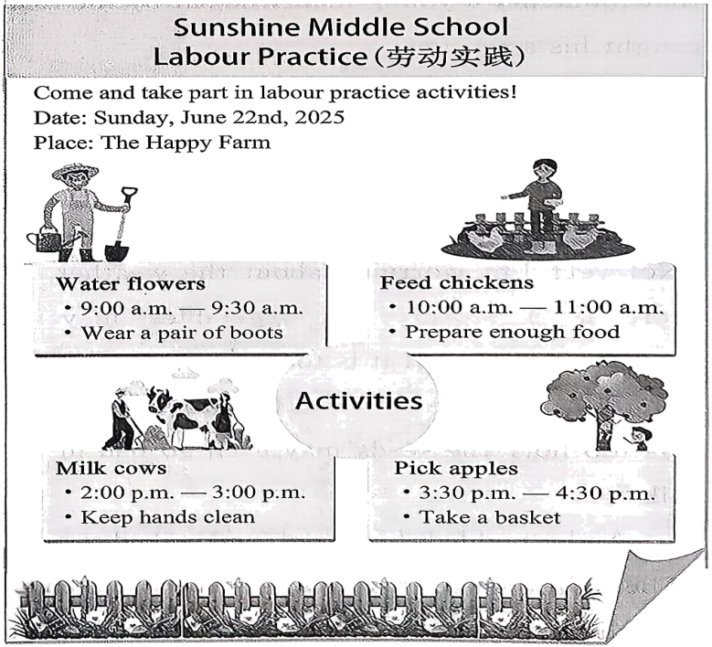
26. When will the students go to the farm?
A. On Monday. B. On Tuesday. C. On Friday. D. On Sunday.
27. How many activities will they have?
A. One. B. Two. C. Three. D. Four.
28. What will they do at 10:30 a.m.?
A. Water flowers. B. Feed chickens. C. Milk cows. D. Pick apples.
29. What do the students need to take when they pick apples?
A. Some food. B. Some water. C. A basket. D. A pair of boots.
30. The text is probably a ________.
A. poster B. letter C. ticket D. menu
B
One day, Andy was on his trip to business. While walking past a village, he saw many people busy with their work in a large field. At that moment, a young man who sat by the road caught his attention.
Andy wondered why the young man was free in such a busy season. Then he went up and asked, “Have you grown your vegetables?”
The young man shook his head and sighed, “Not yet! I’m worrying about the weather. If there is a storm, my vegetables may be destroyed. If it is too cold, the seeds may not come out from the ground at all. If it is too hot, the seeds may even go bad in the soil.”
Andy nodded his head and asked again, “Then, have you grown rice?” The young man thought for a while, and answered, “Not yet. I’m worried about the birds. They may eat the rice. I can’t take that risk.” Andy was very surprised, “So, what have you grown then?”
The farmer replied, “I haven’t grown anything. I am waiting for the best time! I must make sure that nothing is going to destroy my plants.”
Of course, the best time never came. And the young man didn’t get anything from the field at last.
In our life, many people may have the same problem. They have dreams, but they don’t take action because they worry too much about the difficulties in the future. However, if they don’t do anything, how can they achieve their dreams?
31. Where did the story happen?
A. In a village. B. In a forest. C. In a garden. D. In a park.
32 How did the young man feel when Andy talked to him?
A. Proud. B. Happy. C. Worried. D. Lonely.
33. What does “risk” in Paragraph 4 refer to (指)?
A. The rice may go bad. B. The birds may eat the rice.
C. The rice may get wet. D. The birds may fly away.
34. What did the young man get from the field at last?
A. Nothing. B. Vegetables. C. Rice. D. Tomatoes.
35. What does the story want to tell us?
A Weather is important for a farmer. B. We should wait for the best time.
C. A good plan is very necessary. D. Take action if you have a dream.
C
(“I” am a horse, the main character in the novel.)
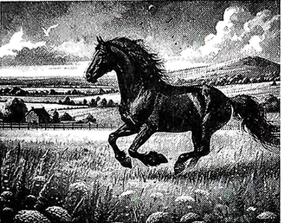
A horse fair was an interesting place. Many people went there to sell horses. You could see many kinds of young and strong horses. There were also poor and thin horses and they were worn out because of hard work.
One day, the seller took me there. He wanted to sell me at a high price. I didn’t know if I would be lucky enough to meet a master who would treat me well.
Then a man with a gentle voice came to us. He wanted to buy me at a low price, but the seller refused.
Shortly after, a tall man with a very loud voice came. He walked around me and I was afraid he would buy me. Luckily, he walked away.
After a few minutes, the man with a gentle voice came back. I was very happy to see him again.
“I’ll give twenty-four pounds. Can you sell the horse to me?” he said.
“OK! Take it,” said the seller. “He’s a quality one and if you want him for work, he’s a good choice.”
Half an hour later, we left for the new home, along country roads, until we came to the city. My new home was in a narrow street. On one side of the street, there were some small, old houses. On the other, there were some stables (马厩).
We stopped in front of a house. My new master whistled (吹口哨). The door opened. A young woman, a little girl and a boy, came out. They all looked at me.
“Is he gentle, Father?” the girl asked.
“Yes, Dolly, as gentle as a cat. You can touch him.”
She touched my shoulder, whispering sweetly, “Welcome, my new friend.”
The gentle touch and soft voice comforted me so much! They led me into a comfortable, clean stable, with plenty of food. After a meal, I lay down, thinking “I’m going to be very happy here.”
—Adapted from The Black Beauty
36. What does the underlined phrase “worn out” mean?
A. Tired. B. Surprised. C. Relaxed. D. Interested.
37. How much money did the man pay for the horse at last?
A. Ten pounds. B. Fifteen pounds.
C. Twenty-four pounds. D. Thirty pounds.
38. What can you infer (推断) from this passage?
A. The new owner was very rude. B. The horse liked his new home.
C. The seller would buy a new horse. D. The girl was afraid of the horse.
39. What may the story talk about next?
A The story of the horse seller. B. The streets around the house.
C. The weather in the city. D. The happy life in the new home.
D
If you search for places of beauty, wetlands probably won’t be high on your list. Wetlands are areas of land that are often completely wet with water. Although they might not look very pretty, the roles that they play in nature might go beyond many people’s imagination.
Wetlands appear naturally in almost every part of the world. There are many different types of wetlands on Earth. Along with rainforests, they are among the most diverse (多样的) places on Earth. Besides natural wetlands, humans are also creating man-made ones for a number of purposes about water management.
One of the main advantages of wetlands is that they can prevent floods. They do so by storing water for a certain time and then slowly releasing (释放) it over time. Wetlands operate similarly to a sponge (海绵). When it rains heavily and water levels rise, they take in the extra water which may cause floods. This prevents water from entering rivers and streams. Then, when water levels become low later, they will release it. In many cases, wetlands offer a much more natural way than dams (坝). However, it’s important to note that wetlands, like dams, don’t stop all dangers from flooding. Once there is a very heavy rainfall, wetlands may fill up and any extra water will start to run off.
Wetlands also play a part in cleaning water. Farming actions and city waste are main causes of water pollution. Wetlands include plants and organisms that can reduce this pollution by clearing out unwanted things. Wetlands have other advantages for the environment as well. They can help to feed nearby fish populations by releasing something that can be used as food for them into rivers. Also, many animals like frogs use wetlands as baby-raising grounds because they provide the place for catching food and the water required. Some birds also come to the wetlands for food and shelter. Although wetlands may not look pretty, it’s clear that they are able to do the important work which is necessary to make sure that the circle of life remains unbroken.
40. Why does the writer mention “sponge” in Paragraph 3?
A. To explain the flood-preventing work of wetlands.
B. To describe the sponge’s feature of storing water.
C. To show the wetlands can take in water quickly like a sponge.
D. To compare the similar points between wetlands and a sponge.
41. What can we learn about wetlands from the passage?
A. People create man-made wetlands to deal with water.
B. People praise wetlands for natural beauty.
C. Wetlands can solve the pollution problems.
D. Wetlands can completely prevent the dangers caused by floods.
42. Which of the following can be the best title of the passage?
A. Wetlands—Circle of Life
B. Wetlands—Home of Living Things
C. Wetlands—Friend of Earth
D. Wetlands—Cleaner of Environment
四、信息还原（共5小题；每小题1分，满分5分）
请认真阅读下面短文，从短文后的选项中选出能填入空白处的最佳选项。选项中有一项为多余选项。
How to be a good listener!
As students, we should listen carefully in class. Listening needs us to pay attention and think about what we hear. ____43____ Here are some useful tips for you to follow.
Be prepared for class. Before class starts, we should review our notes from the last class, and think about how much we know about today’s topic. When it’s time to go to class, check if we have taken all the things needed. ____44____
Listen with a purpose. ____45____ If you are clear about the problems you wish to solve in class, you may listen to them, carefully as teachers explain.
Pay attention to teachers’ body language. Lots of communication is not from talking. The body language also carries information. ____46____ When the teacher points to the blackboard and raises the voice, we should realize that this is the key one.
Take good notes. Taking notes is another good way to pay attention in class. But not everyone can take a good one. Here are some examples. It is much clearer if we keep our notes organized by subject. ____47____ Writing the date at the top of each page is helpful for the later review.
In a word, class is the key period for every student. We should make good use of it and try to become an excellent listener in class.
A. It helps you know what’s important.
B. But how can we become a good listener?
C. In this way, we will be ready for a lesson.
D. A good listener should think about what you want to learn.
E. The same body language can be read with different meanings.
F. Some students mark the differences with pens of different colours.
第Ⅱ卷（非选择题 共56分）
五、词汇运用（共11小题；每小题1分，满分11分）
A)
根据句意，从方框中选用恰当的单词或短语填空。
more than has lived on foot sleepy a pair of himself

48. Walking helps keep fit, so Lucy goes to work _________ every day.
49. As a middle school student, Simon is old enough to look after _________.
50. Mr. Green _________ in China for many years. He enjoys the life here.
51. My father’s birthday is coming. I want to buy ________ shoes for him.
52. There are ________ ten clubs in our school. You can choose one to join.
53. Daniel feels ________ in class. Mr. Green tells him to go to bed early.
B) 根据句意，用括号中所给单词的正确形式填空。
54. Millie enjoys singing and _________ (read). These hobbies make her life colourful.
55. Many ________ (tree) are planted every year to make our city beautiful.
56. Don’t ________ (spend) too much money. You can save it for a rainy day.
57. Mr Wu is my new neighbour. He lives on the ________(six) floor.
58. Last week, we ________ (watch) a fashion show in the school hall.
六、任务型阅读（共5小题；每小题2分，满分10分）
根据短文内容，回答问题。（每题答案不超过8个词）
These years, many college students choose to join the army (军队) after graduation. Zhao Huan is one of them.
When Zhao Huan was 26 years old, he joined the army and became one of the soldiers (战士) on the top of Changbai Mountain in Jilin Province. The three-year life in the army made him really strong-willed (意志坚强的).
The weather on the mountain is terrible in winter. The snow can reach as deep as 2 metres. The lowest temperature can be -40℃. There are over 200 days a year when the wind speed is nearly 12 metres per second. “It is very difficult to fall asleep with the wind outside crying like a wolf,” Zhao said. Life was hard because of the weather. When the snow cut off the roads, the soldiers needed water most. They had to heat the snow to get water to drink, cook and wash with. To save water, they only took a bath once a month.
Even so, Zhao and his team did not give up. Whatever difficulties they met, they tried their best to finish their tasks. Especially when they were on duty outside in winter, snow hit their faces and they were frozen because of the low temperature. But they put their duty before anything and stood like a statue without a slight move.
Zhao said, “Life is not easy on the top of Changbai Mountain. Thinking of the lights of thousands of homes, I think my efforts pay off. For me, all the difficulties can be overcome in the future. The experience of being a soldier here really means a lot to me.”
59. How old was Zhao Huan when he joined the army?
________________________________________
60. How is the weather on the mountain in winter?
________________________________________
61. What did the soldiers need most when the snow cut off the roads?
________________________________________
62. Did Zhao and his team give up when they met difficulties?
________________________________________
63. Why did Zhao say that the experience meant a lot to him?
________________________________________
七、短文填空（共10小题；每小题1分，满分10分）
根据短文内容及所给首字母提示，写出所缺单词，使短文意思完整、通顺，每空一词。

Rabbits are small and cute animals with white fur, long ears and soft bodies. Many people keep one as a p____64____ at home. But the rabbits in the wild are not the s____65____ as those at home. The information below may help you know more about them.
What do wild rabbits e____66____? You may think they like carrots best. However, they would rather choose green plants, such as grass and vegetables. Sometimes, they also eat crops, s____67____ farmers may not welcome them.
Where do wild rabbits live? Most of them live in the fields, forests or grasslands. They are g____68____ at digging holes. They dig underground holes which can provide space from enemies and bad weather. The holes can also be used to store food and raise the y____69____. Also, some wild rabbits may live in the bushes.
H____70____ do wild rabbits keep safe? They have many enemies, such as foxes and snakes. To survive, they use clever tricks. For example, when other animals hunt them, they will run away in a special way, so they won’t be c____71____ easily. Also, their special eyes allow them to notice d____72____ from almost every direction. Though they are not very strong, their amazing abilities help them live through the hard conditions in nature.
There are also some fun facts about wild rabbits. Can you imagine they can j____73____ as high as 2 metres? Their front teeth never stop growing, so they need to chew (咀嚼) every day to stop them from getting too long. Isn’t that amazing?
八、书面表达（满分25分）
74. 假如你是阳光中学的一名学生，你校英语节将开展以“Friendship Lights Up My Life”为主题的征文活动。请你用英语写一篇文章投稿，介绍你的朋友并分享你们的故事。文章须包含以下要点：
1. 描绘朋友的基本信息（年龄，长相，爱好等）；
2. 描述一个事例，体现朋友对你的帮助；
3. 谈谈你对友谊的理解。
注意：1. 词数100左右；
2. 文中不得出现真实的人名、校名和地名。
Friendship Lights Up My Life
_________________________________________________________________________________________________________________________________________________________________________________________________________________________________________________________________________________________________________________________________________________________________________________________________________________________________________________________________________________________________________________________________________________________________________________________________________________________________________________________________________________________

