天水市2025年初中学业水平考试
英语试卷
考生注意: 本试卷含听力, 满分为150分, 考试时间为120分钟。所有试题均在答题卡上作答, 否则无效。
I. 听力理解(分4小节, 共20小题; 每小题1分, 满分20分)
第一节: 听句子, 选择与所听内容相符的图片。每个句子读两遍。
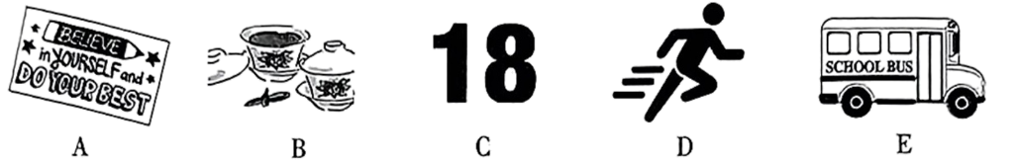
1. ___________ 2. ___________ 3. ___________ 4. ___________ 5. ___________
第二节: 听句子, 选择恰当的应答语。每个句子读两遍。
6. A. Red. B. English. C. Sunny.
7. A. I’m fine! B. See you later. C. Good morning.
8. A. Yes, please. B. My pleasure. C. Sorry.
9. A. No problem. B. Go ahead. C. Thanks.
10. A. Every day. B. In the morning. C. Last Friday.
第三节: 听对话及问题, 选择能回答所提问题的最佳答案。每段对话读两遍。
11. What day is it today?
A. Monday. B. Wednesday. C. Friday.
12. Who was playing in the football match?
A. Sam. B. Bob. C. Linda.
13. How does the man like the book?
A. Great. B. Not bad. C. Terrible.
14. When will Lucy come to Mrs. Smith’s office?
A. Tomorrow morning. B. After English class. C. In the afternoon.
15. Why won’t Peter play volleyball?
A. Because it’s rainy. B. Because he has a cold. C. Because he doesn’t like ball games.
第四节: 听短文, 根据其内容选择能回答下列问题的最佳答案。短文读两遍。
16. What’s the speech mainly about?
A. Exercise. B. Athletes. C. Sports field.
17. Who did the speaker run with?
A. Nobody. B. A sister. C. A friend.
18. How many hours should teens do physical activities a day according to experts?
A. No less than 1 hour. B. No less than 1.5 hours. C. No less than 2 hours.
19. What type of fun activities is NOT mentioned in the speech?
A. Biking. B. Swimming. C. Dancing.
20. Which of the following does the speaker want us to do?
A. Start exercising to build healthy habits for the future.
B. Wear sports shoes before you go into a sports filed.
C. Learn from athletes to be focused and never give up.
II. 语法与情景对话(共20小题; 每小题1分, 满分20分)
阅读下列各题, 从A、B、C、D四个选项中选择一个最佳答案。
1. Look at the photo of my family! ________ man in a white T-shirt is my father.
A. A B. An C. The D. /
2. The purple scarf is not the girl’s. ________ is blue.
A. Its B. Hers C. Mine D. His
3. ________ you turn down the TV, please? I’m trying to work.
A. Could B. Must C. Might D. Should
4. —________ are the trousers?
—20 pounds.
A. How many B. How long C. How far D. How much
5 Look! There ________ a notebook and three keys on the desk.
A. is B. was C. are D. were
6. Turn the heat down ________ it’ll burn.
A. or B. and C. but D. so
7. Qian Xuesen, father of China’s space program, is one of the greatest ________ in the world.
A. farmers B. astronauts C. directors D. scientists
8. A low-fat diet can ________ the risk of heart disease.
A. help B. reduce C. encourage D. support
9. There are 30 students in the art club. One third are boys. So, the club has ________ girls.
A. 10 B. 20 C. 30 D. 40
10. —Excuse me, do you know ________?
—Sure. It’s at 9:00 a.m. next Monday.
A. where I can find a supermarket B. what happened after that
C. when the concert will start D. who is the winner of the race
11. City life is full of opportunities. Country life, however, is ________ and more peaceful.
A. dearer B. quieter C. busier D. colder
12. —Can I borrow your pencil?
—Sure, ________.
A. take it easy B. let’s go C. here you are D. forget it
13. —Cindy, my sunglasses are on the floor and they are broken. What happened?
—Sorry, dear. I don’t know. I ________ in the kitchen then.
A. cook B. was cooking C. have cooked D. will cook
14. Which sign shows that you cannot feed the animals?
A.  B.  C.  D. 
15. It seems that ________ is a worldwide way to greet someone for the first time.
A. kissing B. hugging C. bowing D. shaking hands
16. Don’t worry about me—I can ________ myself.
A. look at B. look for C. look out D. look after
17. —I think students shouldn’t be allowed to use AI to help them with their homework.
—________. It depends on how they use it.
A. I hope so B. I do believe it
C. I’m not so sure D. I can’t agree more
18. The Communist Party of China (CPC) was founded on ________ 1, 1921.
A. July B. August C. September D. October
19. —When Jake found out he had to give a speech, he was ________.
—Public speaking can be stressful!
A. cool as a cucumber B. shaking like a leaf
C. on top of the world D. over the moon
20. What does the notice on the right tell us?
Recycling
Put paper cups in green bin, plastic bottles and cups in blue bin, and food waste in red bin.

A. People shouldn’t put paper cups in the green bin.
B. People cannot put unfinished cakes in the red bin.
C. Paper cups and plastic cups can be put in the same bin.
D. Plastic bottles and cups should be put in the blue bin.
Ⅲ. 完形填空(共10小题; 每小题1.5分, 满分15分)
阅读下面短文、从短文后各题所给的四个选项中选出能填入空白处的最佳答案。
Terry will never forget that day in 1968. Four-year-old Terry Hill and her younger brother Mikey were left alone in the car as their father went into a ____21____. Terry was in the back seat while Mikey was in the front seat. Mikey wasn’t wearing a seat belt. ____22____ moved over to the driver’s seat. As they waited for their father, Mikey was playing with the steering wheel (方向盘). Somehow, he hit the gear shift (换挡器). Because their car ____23____ on a small hill, it started moving back slowly. There were cars coming and going all around at that moment.
Terry tried to open the door. However, it was too ____24____ for a 4-year-old girl. She didn’t know ____25____ to do. Just then, Terry saw her dad ____26____ out of the shop. But running right in front of him was someone else: a young man. He reached the car first, ____27____ the brake (刹车) on and saved Terry and her brother just in time.
For over 50 years, Terry has always remembered how the stranger ____28____ helped them out without thinking twice. “This young guy, he runs to the car, gets the door open, moves my brother over and puts the brake on. Everything ____29____ so fast.” Terry said, “He ____30____ saw what needed to be done and acted immediately. That has made a huge influence on me for my whole life.”
21. A. shop B. school C. farm D. bank
22. A. It B. He C. She D. They
23. A. was parked B. was found C. was washed D. was bought
24. A. easy B. small C. heavy D. far
25. A. why B. where C. when D. what
26. A. driving B. rushing C. looking D. waiting
27. A. saw B. spent C. put D. touched
28. A. happily B. slowly C. bravely D. rudely
29. A. happened B. stopped C. moved D. changed
30. A. still B. also C. already D. just
IV. 阅读理解(共15小题; 每小题2分, 满分30分)
A

Sunshine Middle School
Fire Drill Notice
Time: 10:30 a.m., Friday, June 20th, 2025
How: When the alarm goes off, all the students and teachers must:
● listen to the directions carefully;
● line up quickly and quietly;
● walk carefully out of the classrooms to the playground;
● stay with your class at all times;
● wait with your teacher until he/she tells you it is safe to return to your classroom.
Safety Department
June 16th 2025
阅读以上消防演练通知，判读下列句子正误。正确填（涂）A、错误填（涂）B。
31. This is a fire drill notice of Sunshine Middle School.
32. The drill is on Friday June 16th, 2025.
33. During a fire drill, students should move in a line.
34. The students will get out of the classrooms to the school playground.
35. The students can get back to their classrooms when they think it’s safe.
B
Greening the Desert
Minqin County, located in the city of Wuwei in Gansu Province, is between China’s third and fourth largest deserts—the Badain Jaran and the Tengger. Local people plant suosuo trees, a plant that can survive in the desert, to prevent further desertification (沙漠化).
A number of local people have worked hard to turn the place into an oasis (绿洲). 27-year-old Zhong Lin is one of them. Growing up in Minqin, Zhong experienced sandstorms throughout his childhood. He once wanted to run away from his hometown and build his future in southern China.
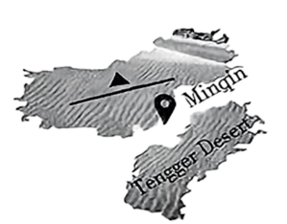
However, he changed his mind when he saw the villagers’ hard life and the terrible environment there. He said, “Suddenly I understood—running away isn’t the solution. Making a difference is the key.” After graduating from university in 2020, Zhong returned to his hometown. “If suosuo trees can take root in sandstorms, why can’t young people?” he wrote in his diary.
Since then, Zhong has tried planting suosuo trees in the desert. He planted 500 trees in 2021, but most of them died. So he studied, learned from experienced villagers, and then planted more. After three years’ efforts, the trees he planted are now growing well in the desert, turning the land green and lively.
To draw attention to his hometown’s environment, Zhong shared videos about tree planting online and started a “Please Plant a Tree in Minqin” activity. Encouraged by Zhong’s tree-planting story, more and more volunteers from all over the country have come to Minqin to plant trees. Their common goal is to turn the desert into an oasis.
阅读以上材料, 回答下列各小题。
36. According to the first paragraph, which of the following should be put in ▲ in the map?
A. Wuwei B. Badain Jaran Desert C. Gansu D. Tengger Desert
37. Why do people plant suosuo trees in the desert?
A. Because planting suosuo trees is not difficult.
B. Because suosuo trees need little water or care.
C Because suosuo trees can take root in any climate.
D. Because suosuo trees help stop further desertification.
38. What did Zhong Lin decide to do after graduation?
A. Run away from his hometown.
B. Build his future in southern China.
C. Improve the local villagers’ life and the environment.
D. Start a volunteer activity to attract more tourists to Minqin.
39. What difficulty did Zhong Lin face in 2021?
A. He only bought 500 trees. B. Villagers didn’t trust him. C. Most of the trees he planted died. D. No volunteers helped him.
40. What is the goal for the people who joined the tree-planting activity?
A. To turn the desert into an oasis. B. To enjoy the scenery of the deserts. C. To learn more about Zhong Lin. D. To share videos about tree planting.
C
Learning about AI
▲
AI works by using algorithms (算法), or step-by-step instructions, to help computers understand and work with information. For example, if you wanted to teach a computer to know different types of fruits, you would give it a lot of pictures of fruits and tell it which ones are apples, bananas, and so on. The computer would then use this information to find out what new fruits are. This process is called “machine learning”.
What can AI be used for?
AI is already being used in many different areas. For example, AI can be used to:
● diagnose and treat diseases;
● drive self-driving cars;
● recommend movies and TV shows according to your viewing history;
● help teachers give marks to papers.
The Future of AI
In the future, AI may completely change many parts of our lives and help us solve some of the world’s biggest problems. However, it’s also important to remember that AI is just a tool, and it’s up to us to decide how we use it. With responsible and ethical (合乎道德的) use, AI can make the world a better place for everyone!
PS: The copy above is created by AI!
阅读以上材料，回答下列各小题。
41. Which of the following can be put in ▲ ?
A. When was AI invented? B. How does AI work?
C. Why is AI important? D. Who uses AI the most?
42. What does the underlined word “diagnose” probably mean?
A. Spread. B. Cause. C. Recognize. D. Make.
43. How does AI recommend movies and TV shows?
A. By guessing freely. B. By using your viewing history.
C. By asking your friends. D. By creating new movies.
44. What can we learn from the passage?
A. AI isn’t a tool and it can decide how people use it.
B. AI can make a better world if we use it correctly.
C. It’s impossible for AI to solve the biggest questions.
D. AI can not help teachers to mark the papers.
45. Who wrote the passage?
A. A worker. B. An engineer. C. A writer. D. AI.
V. 任务型完形填空(共10空; 每空1分, 满分10分)
用方框中所给单词的适当形式填空，使短文通顺、正确、连贯，每个单词限用一次。
walk, to, my, excited, ask, learn, speak, activity, and, also
Dear Venus
Hi, my name is Kylie. I am 15 years old. I live in New Hampshire. I’m so ____46____ to hear all about Iceland and what it is like where you live.
In my small city, we join in many fun ____47____. I love to go hiking with my family or friends, take bike rides, and ____48____ through our nature park. We ____49____ have lots of great places where we can shop and eat.
Now I’m in the 9th grade. ____50____ school offers many different language classes such as Chinese, Spanish, ____51____ French. I chose to ____52____ Chinese because I’m interested in Chinese culture. Do you take language classes in Iceland?
What language is ____53____ in Iceland? What do you usually do in your free time? I’m looking forward ____54____ hearing back from you. If you have any questions about my life in the U.S., feel free to ____55____.
Kylie
VI. 任务型阅读理解(共5小题; 每小题2分, 满分10分)
阅读下面材料，并按要求完成第1至5小题。
The Super Power of YET!
In today’s world, many people want quick success, but real growth takes time and the right mindset. Mindset is how we think about our abilities. It plays a big role in our progress. There are two kinds of mindsets: a fixed mindset and a growth mindset.
Carol Dweck, a professor at Stanford University, studied these two mindsets:
Growth Mindset:  People believe they can improve with effort and learning. |  | Fixed Mindset:  People believe their abilities are unchangeable.
She has found that having a growth mindset benefits our learning a lot.
Learning happens in four stages:
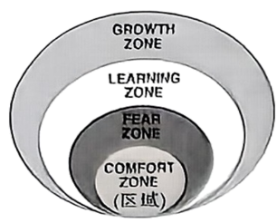
Growth Zone: They achieve their goals and take on bigger ones.
Learning Zone: They start getting new skills and confidence.
Fear Zone: People feel unsure or afraid of failure and often give up.
Comfort Zone: Things feel easy, but no growth happens here.
One of her experiments is at Parkland Soccer Club. Her group teach the players that mistakes are part of learning. If a player says, “I can’t do this.” that usually means he fears making mistakes. Then he is encouraged to say “I can’t do this, YET!” instead of “I can’t do this!”.
Challenges are…for growth. Let’s believe in ourselves, work hard, and keep improving. The superpower is “YET!”
56. What does “mindset” mean?
_______________________________________________________________________
57. What are the two kinds of mindsets?
_______________________________________________________________________
58. If a soccer player is afraid of making mistakes during a game, which “zone” is he in?
_______________________________________________________________________
59. Complete the underlined sentence. (补全文中画线句子, 使文意连贯。)(限填1词)
Challenges are ________ for growth.
60. Complete the conversation with a growth mindset. (根据文本建议, 补全下面对话。)(不超过10词)
A student: I can’t work it out!
You: Why not say, “I can’t ________”?
VII. 口语交际(共5小题; 每小题2分, 满分10分)
阅读下面的对话，根据上下文，从方框内选择恰当的选项补全对话，使对话完整、逻辑通顺。（其中有两项为多余选项）
(Li Ming is talking with his foreign friend Daisy. A is for Li Ming; B is for Daisy.)
A: Good morning, Daisy.
B: Morning, Li Ming! Do you have any plans for the future?
A: Of course! ____61____
B: Wow, sounds interesting! But I remember you were in the swimming club. When did you get interested in robots?
A: I have always loved robots. Sometimes I try making some simple robots by myself.
B: ____62____
A: Yes, I’ve been learning robotics since I was in Grade 7. You must have known that a humanoid robot (人形机器人) has made history by finishing a half-marathon for the first time in Beijing.
B: Oh, I watched the marathon on TV. ____63____
A: Sure, it is. I’d like to learn more about it. ____64____
B: Me? Emm, I want to study and design Chinese Hanfu. You know how much I love these beautiful clothes.
A: Fantastic! And one day you might set up a Hanfu factory in your country.
B: You’re right. Maybe the robots you create will wear the fashionable Hanfu I design in the future.
A: Haha, ____65____ Let’s work together to make a more wonderful world!
A. Have you ever learned robotics?
B. I want to join the swimming club!
C. What about you, Daisy?
D. I hope our dreams will come true.
E. One of my goals is to join a robotic club.
F. What an amazing race!
G. What do you think of robots?
VIII. 词汇考查(共10小题; 每小题1分, 满分10分)
根据句意, 用括号内所给单词的适当形式填空。
66. Jim’s teachers encourage __________ (he) to try new things.
67. People mustn’t __________ (smoke) in public places.
68. Our neighbours are very __________ (friend) to each other.
69. Students are asked __________ (do) this task by themselves.
70. This is Li Hua’s ________ (three) time to be a volunteer.
71. We all __________ (love) our country very much!
72. The Silk Road is becoming a top choice for international __________ (visitor).
73. Do you know when the car was __________ (invent)?
74. Lanzhou Zhongchuan International Airport ________ (open) Terminal (航站楼) 3 on March 20, 2025.
75. The more we communicate with our parents, the __________ (good) we’ll understand each other.
IX. 根据所给汉语提示完成句子(共5小题; 每空1分, 满分10分)(每空限填一词)
76. 计划时间就是节约时间。
To __________ time is to __________ time.
77. 红灯时请不要横穿马路。
__________ __________ the road when the traffic lights are red.
78. 新年是亲朋团聚的好时光。
New Year is a wonderful time when family and friends __________ __________.
79. 终身学习真太重要了！
__________ __________ lifelong learning is!
80. 人们认为，茶在六至七世纪传到了朝鲜和日本。
__________ __________ that tea was brought to Korea and Japan during the 6th and 7th centuries.
X. 书面表达(满分 15 分)
81. 睡眠对人们至关重要。你校英语期刊正在就“Better Sleep”这一主题面向全体学生征稿，请你根据下图提示，谈一谈当下的睡眠问题及解决措施，呼吁大家重视睡眠。
要求：1. 短文应包括下图提示中所有的写作要点；
2. 条理清晰，行文连贯，可适当发挥；
3. 文中不能出现真实的人名、校名等信息；
4. 词数：80左右，文章标题和开头已给出，请抄写在答题卡的相应位置（不计入总词数）。
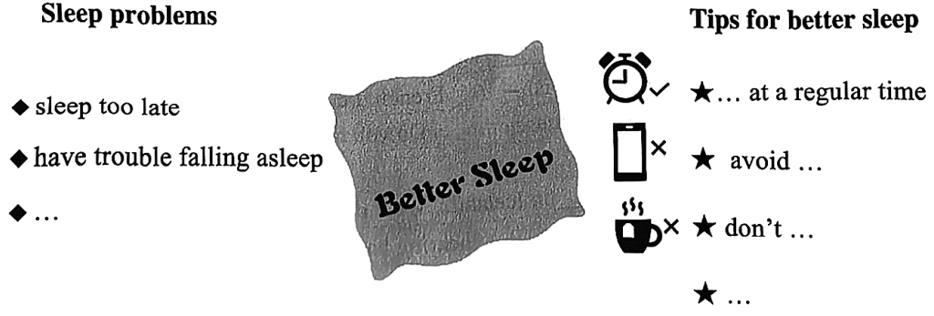
Better Sleep
Sleep is very important for people’s health. However, many people ________________________________________________________________________________________________________________________________________________________________________________________________________________________________________________________________________________________________________________________________________________________________________________________________________________________________________________________________________________________________________________________________

